COMMONWEALTH OF MASSACHUSETTS

MIDDLESEX, SS. BOARD OF REGISTRATION In Medicine

Adjudicatory Case No. 2018-006 (RM-18-0066)

) In the Matter of )
)
Eugene C. Jagella, M.D. )
)

ORDER

The Board hereby terminates the summary suspension of the Respondent's medical

license.

Dated: December 19, 2019

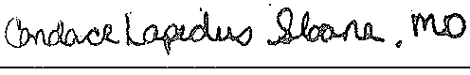Candace Lapidus Sloane, M.D. Chair

