 | Massachusetts Department of Environmental Protection  Environmental Results Program  Non-Applicability Statement  For Boilers |  |  |  |  | MassDEP Facility ID# (if known)  Facility AQ # (if known)
 | A. Facility Information
Important: When filling out forms on the computer, use only the tab key to move your cursor - do not use the return key.  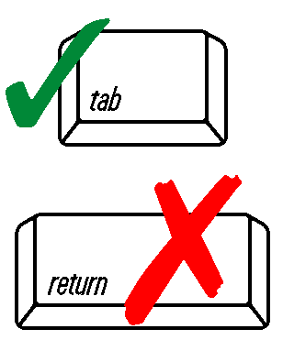 | Facility Name
 | Facility Street Address
 | City |  | State |  |  |  |  |  |  | Zip Code
 | Phone Number |  | Fax Number
 | Contact Person Name |  | Title |  |  |  | Phone Number
 | B. Do You Need to Certify?
 | If any of the following conditions apply to your facility or boiler, then you are NOT required to submit an ERP Compliance Certification for New Boilers.
 | Facility has an Operating Permit under 310 CMR 7.00 Appendix C.
 | Boiler is temporary, as defined in 310 CMR 7.03(23). Please provide the requested dates.
 | Installation Date: | Date (MM/DD/YYYY) |  |  | Expected Removal Date: |  |  |  | Date (MM/DD/YYYY)
 | All ERP boilers were removed or otherwise rendered inoperative as of: |  |  |  |  |  |  |  | Date (MM/DD/YYYY)
 | All ERP boilers were converted to wood fuel-fired boilers as of: |  |  |  |  |  |  |  | Date (MM/DD/YYYY)
 | Facility changed ownership as of: |  |  |  |  |  |  |  | Date (MM/DD/YYYY)
 | Save a copy of this statement for your records and mail the original form to:
MA DEP-ERP-CB
P.O. Box 120-165
Boston, MA 02112-0165
 | Note: Exemption from ERP does not relieve you of other environmental compliance requirements.
 | Signature |  |  |  |  |  |  | Date (MM/DD/YYYY)

