Jamaica Plain, MA 02130
Bureau of Infectious Disease and Laboratory Sciences
Massachusetts State Public Health Laboratory
305 South St.
Jamaica Plain, MA 02130

Borrelia miyamotoi Surveillance in Massachusetts, 2014 -2018
2014 - 2018 Surveillance Highlights

- 136 confirmed and probable cases of Borrelia miyamotoi were reported between 2014 and 2018. Overall, 306 suspect cases of Borrelia miyamotoi were investigated.

- Middlesex County led the state with 31 confirmed or probable cases, followed by Plymouth County (28) and Barnstable County (16).

- The majority of cases occurred in June July, August and September, only 35% of cases reported awareness of a recent tick bite.

- The most commonly reported symptoms include: fever (91%), fatigue (87%), muscle aches/pain (85%), headache (82%), chills (82%), joint aches/pains (78%), and sweats (57%). There were no known fatalities.

- People age 50 years and older continue to be at greatest risk for clinical disease (57% of patients identified with Borrelia miyamotoi were 50 or older) and 51% of the cases were male.

- For more information about Borrelia miyamotoi and other tick-borne diseases, including steps you can take to keep you and your loved ones safe, please visit www.mass.gov/dph/tick.

County | 2018 Cases  Confirmed and Probable | Frequency (%)
Barnstable | 3 | 5%
Berkshire | 1 | 2%
Bristol | 9 | 15%
Dukes | 0 | 0%
Essex | 2 | 3%
Franklin | 0 | 0%
Hampden | 1 | 2%
Hampshire | 1 | 2%
Middlesex | 17 | 28%
Nantucket | 0 | 0%
Norfolk | 8 | 13%
Plymouth | 9 | 15%
Suffolk | 6 | 10%
Worcester | 3 | 5%
State Total | 60 | 100%
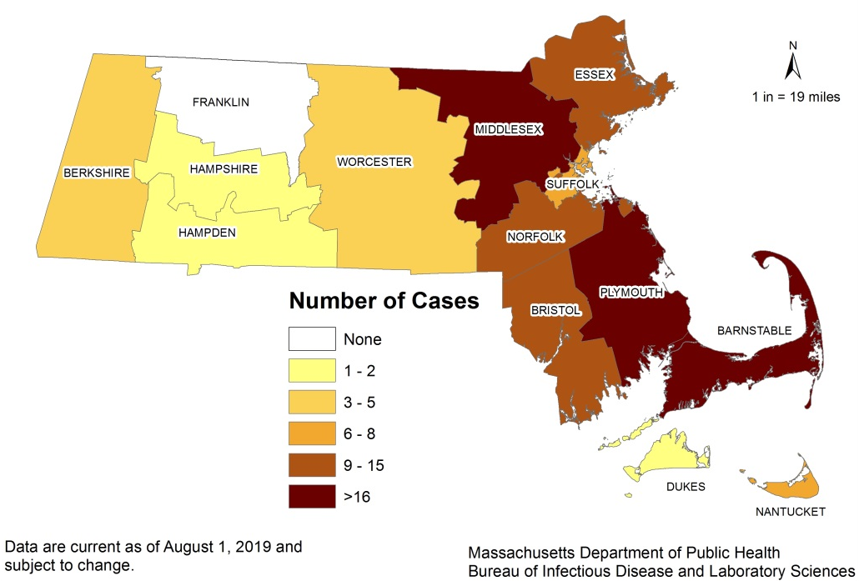
Map 1: Number of confirmed and probable Borrelia miyamotoi cases by county of residence, Massachusetts, 2014-2018.
Table 1: B. miyamotoi case counts and proportions by county of residence, Massachusetts, 2018.
Figure 1.
Number of confirmed and probable B. miyamotoi cases by month of onset, Massachusetts, 2014 -2018
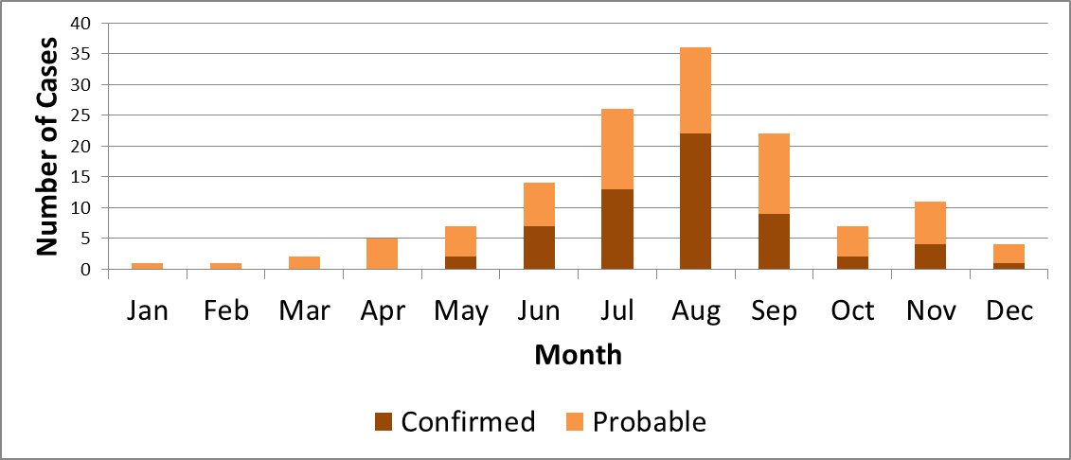

Figure 2.
Number of confirmed and probable cases of B. miyamotoi by age group, Massachusetts, 2014-2018
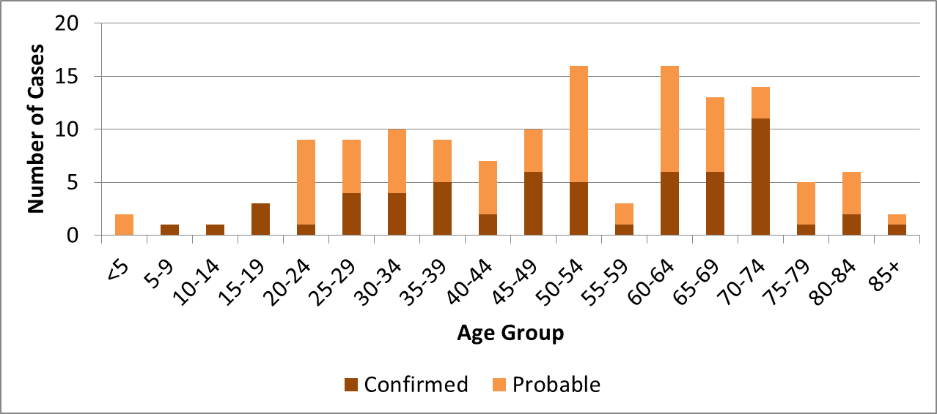

Figure 3. Number of confirmed and probable B. miyamotoi cases, by year, Massachusetts, 2014-2018
