WATER DAMAGE ASSESSMENT

Cannabis Control Commission
101 Federal Street, 13th floor
Boston, Massachusetts

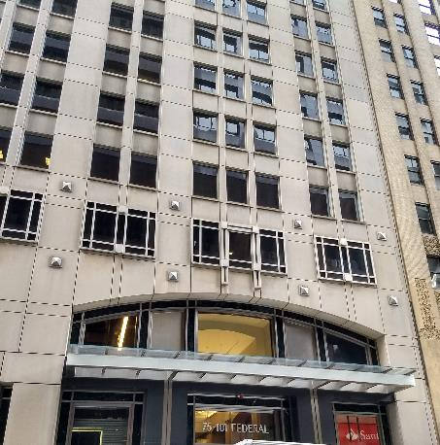

Prepared by:
Massachusetts Department of Public Health
Bureau of Environmental Health
Indoor Air Quality Program
August 2019

Background
Building: | Cannabis Control Commission (CCC)
Address: | 101 Federal Street, 13th floor, Boston
Assessment Requested by: | Lindsey Tucker, Associate Commissioner, Department of Public Health
Reason for Request: | Water damage following a flood
Date of Assessment: | July 22, 2019
Massachusetts Department of Public Health/Bureau of Environmental Health (MDPH/BEH) Staff Conducting Assessment: | Mike Feeney, Director, IAQ Program and Rachel Rochelson, Radon Intern
Building Description: | Other office tenants occupy other floors in the building.
Windows: | Not openable

Introduction
Over the weekend of July 20, 2019, the CCC reported that water service to the building at 101 Federal Street was interrupted due to City of Boston work on the water mains. Building facility staff was not made aware of this interruption. As a result, adjustments to the building cooling system were not made and the system was not monitored. High outdoor temperatures led to overwork of the building cooling system without access to a source of water for cooling. This resulted in a release of water from the cooling system on the 15th floor of the building on Saturday July 20. Water flowing down from the area of release moistened materials on most floors of the building. Because of the location of the CCC on the 13th floor, materials in this office were significantly impacted by the flood.
Reportedly, building facility staff became aware of the water release during the July 20, 2019 weekend, and began drying and other remediation measures. These included
- Use of fans to accelerate drying of carpeting and gypsum wallboard (GW);
- Removal of water-damaged ceiling tiles for later replacement;
- Removal of areas of GW, with holes drilled in some remaining wallboard to accelerate drying;
- Movement of objects from the floor such as cabinets and floor mats;
- Measurement of moisture content of GW and carpeting to identify areas needing additional treatment.

Methods
Please refer to the IAQ Manual for methods, sampling procedures, and interpretation of results (MDPH, 2015). No testing of IAQ parameters was conducted during this visit. Visual observations were made of water-damaged materials, drying procedures being used, and other conditions that may impact IAQ. Some moisture measurements in GW and carpeting were conducted as is discussed further below.

Results

Ventilation
A heating, ventilating and air conditioning (HVAC) system has several functions. First it provides heating and, if equipped, cooling. Second, it is a source of fresh air. Finally, an HVAC system will dilute and remove normally-occurring indoor environmental pollutants by not only introducing fresh air, but by filtering the airstream and ejecting stale air to the outdoors via exhaust ventilation. Even if an HVAC system is operating as designed, point sources of respiratory irritation may exist and cause symptoms in sensitive individuals.
Fresh air is provided by ceiling-mounted fresh air diffusers. A mechanical exhaust vent system removes stale air. Fan coil units (FCU) were installed along exterior walls within the building. The FCUs are designed to provide both heat and cooling. Depending on the setting, heated or chilled water is pumped through a finned tube (i.e., a coil) that is connected to the furnace/chiller by copper pipes that are installed in the pipe chase. Water runs through supply pipes into the coils, which heat/cool the air forced through the coils by the FCU fans. It is important to note that FCUs are designed to provide either heating or cooling, but do not have a fresh air supply. FCU units can only recirculate air.
To maximize air exchange, the MDPH recommends that both supply and exhaust ventilation operate continuously during periods of occupancy. In order to have proper ventilation with a mechanical supply and exhaust system, the systems must be balanced to provide an adequate amount of fresh air to the interior of a room while removing stale air from the room. It is recommended that HVAC systems be re-balanced every five years to ensure adequate air systems function (SMACNA, 1994). It is unknown when the last time this system was balanced.

Microbial/Moisture Concerns

The following was observed during the visit:
- Many water-damaged ceiling tiles had been removed (Picture 1).
- Some water-damaged tiles still needed removal (Picture 2).
- Fans were still operating in some areas to continue of GW and carpeting (Picture 3).
- Coving was still on the base of GW in some areas (Picture 4). This will prevent drying of the GW underneath the coving.
- Bubbled and peeling paint was observed on some impacted walls (Pictures 5 and 6).
- Damage was observed to fan coil unit housing covers, which appear to be made of plywood with a heavy layer of paint (Pictures 7 and 8). Additionally, some were still wet at the time of the visit (Picture 8). These pieces should be replaced since water-damaged plywood can be an ongoing source of odors, particularly if it is in the airstream of air circulation equipment.
- The area above the ceiling tiles was examined. This area is a wide-open space with metal and concrete which are non-porous. Examination and cleaning in this space in affected areas is recommended before the ceiling tile grid is put back in place.
- Furniture and items including porous items (e.g., boxes) were observed remaining on the floor in the affected area (Picture 9). These items can prevent walls/floors from drying and can prevent access for cleaning and testing. Furthermore, porous items can become colonized with mold.
The US Environmental Protection Agency (US EPA) and the American Conference of Governmental Industrial Hygienists (ACGIH) recommends that porous materials (e.g., wallboard, carpeting) be dried with fans and heating within 24 to 48 hours of becoming wet (US EPA, 2008; ACGIH, 1989). If porous materials are not dried within this time frame, mold growth may occur.

Conclusions/Recommendations
- Move or remove any items and furniture from the floor and away from walls in the affected areas to inspect underneath and behind them for additional water damage.
- Water-damaged porous materials such as boxes/papers may need to be discarded if they show signs of mold colonization such as musty odors.
- Continue drying and remediating the affected area in accordance with the EPA guideline “Mold Remediation in Schools and Commercial Buildings” (US EPA, 2008). This may include:
  - Inspecting and cleaning the area above moistened ceiling tiles.
  - Cutting out and replacing areas of GW that continue to be moistened 48 hours after the flood.
  - Replacing the covers of all damaged fan coil units such as the one shown in Pictures 7 and 8. All of these units should be inspected for odors and vacuumed of debris at this time as well.
  - Scraping any remaining peeled/bubbled paint and repainting.
  - Replacement of any carpet squares that had been moistened for over 48 hours or have any musty or moldy odors.
- Activities that may be disruptive or lead to dust and odors should be conducted during off-hours (evenings and weekends) to the greatest extent practical.
- Remove or separate staff from areas under remediation or construction to prevent exposure to dust and odors. Plastic sheeting and tape may be used for containment where needed.
- Increase cleaning in the affected areas to remove dust and debris from carpeting and flat surfaces. Clean carpeting and surfaces thoroughly once the rest of the remediation is completed.
- Consider replacing water-damaged laminate table that remained moistened despite drying efforts.
- Refer to resource manual and other related IAQ documents located on the MDPH’s website for further building-wide evaluations and advice on maintaining public buildings. These documents are available at: http://mass.gov/dph/iaq.

References
ACGIH. 1989. Guidelines for the Assessment of Bioaerosols in the Indoor Environment. American Conference of Governmental Industrial Hygienists, Cincinnati, OH.
MDPH. 2015. Massachusetts Department of Public Health. Indoor Air Quality Manual: Chapters I-III. Available at: http://www.mass.gov/eohhs/gov/departments/dph/programs/environmental-health/exposure-topics/iaq/iaq-manual/.
SMACNA. 1994. HVAC Systems Commissioning Manual. 1st ed. Sheet Metal and Air Conditioning Contractors’ National Association, Inc., Chantilly, VA.
US EPA. 2008. “Mold Remediation in Schools and Commercial Buildings”. Office of Air and Radiation, Indoor Environments Division, Washington, DC. EPA 402-K-01-001. September 2008. Available at: http://www.epa.gov/mold/mold-remediation-schools-and-commercial-buildings-guide.
Picture 1
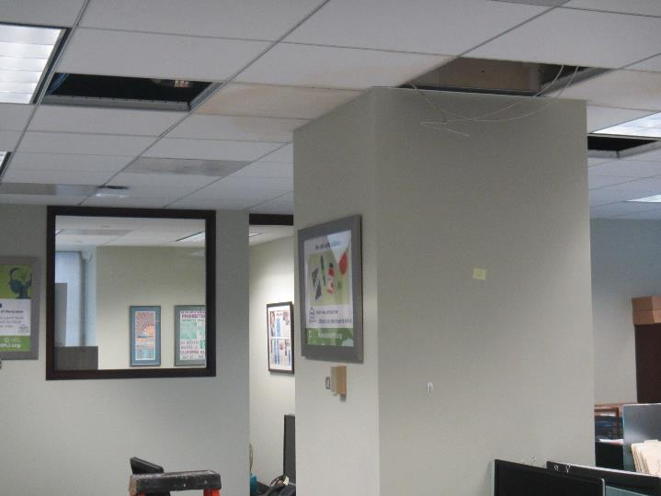
Water-damaged ceiling tiles, some removed
Picture 2
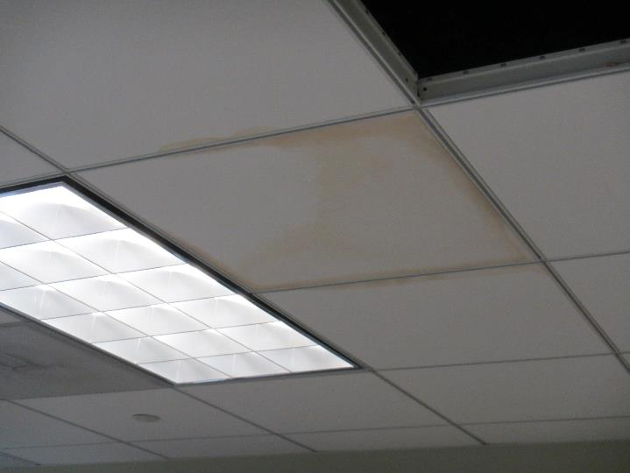
Water-damaged ceiling tile still in the ceiling grid
Picture 3
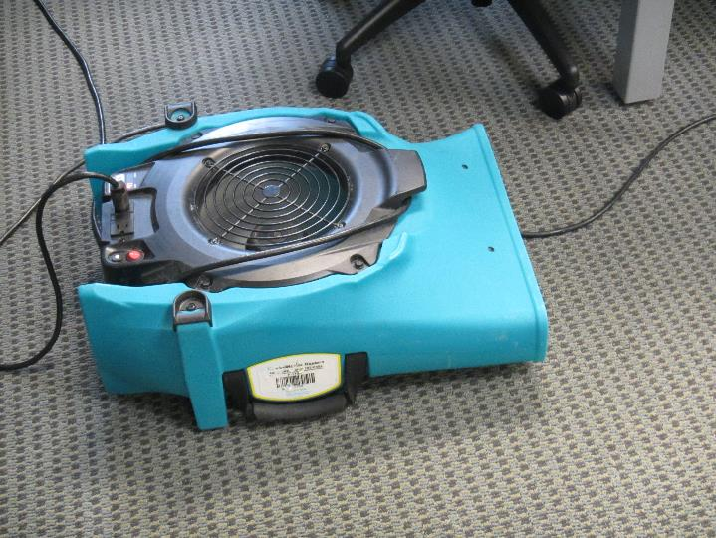
Fan used for drying carpet and GW
Picture 4
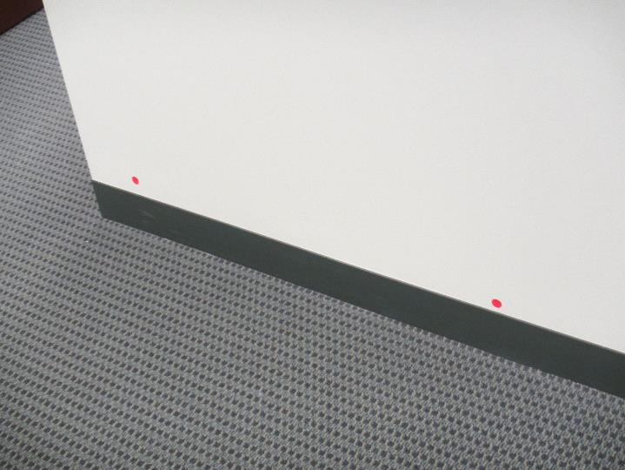
Coving remaining at the base of an impacted wall; note red dot indicating wall had been moistened
Picture 5
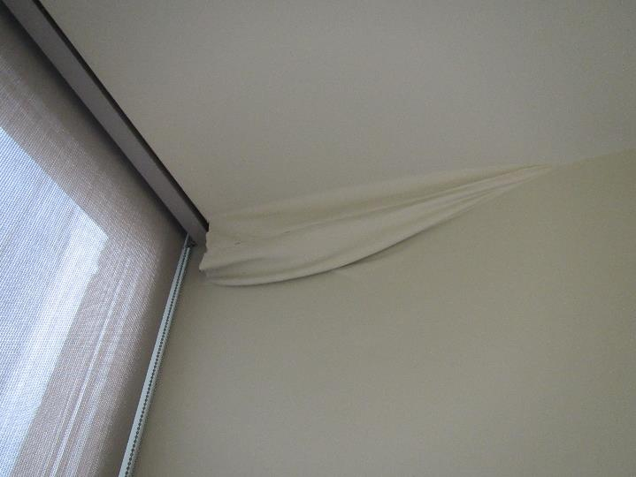
Peeling paint
Picture 6
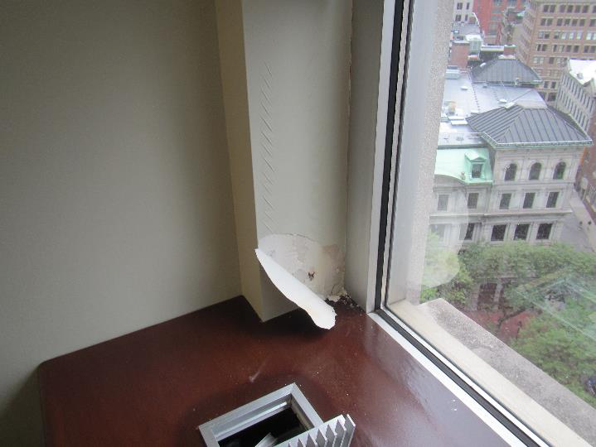
Wrinkled and peeling paint
Picture 7
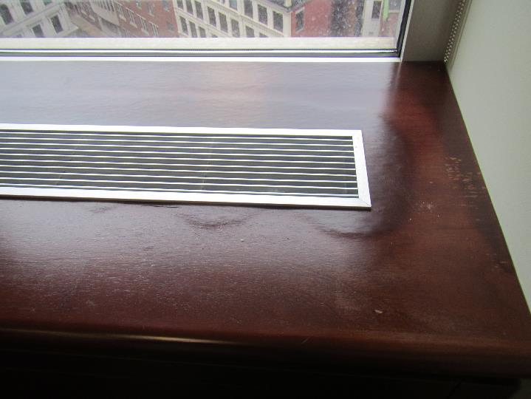
Fan coil unit cover showing swelling due to water exposure
Picture 8
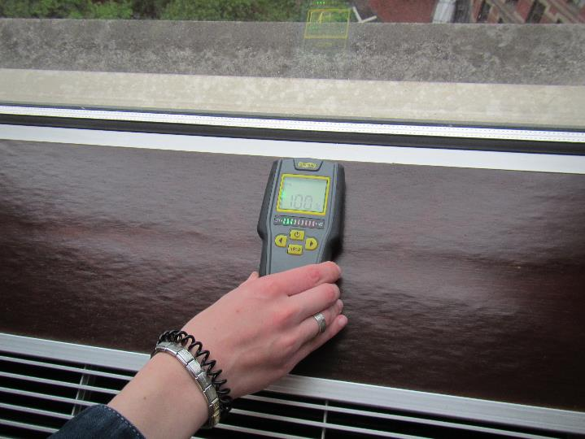
Moisture measurements in fan coil unit cover showing material is still saturated
Picture 9
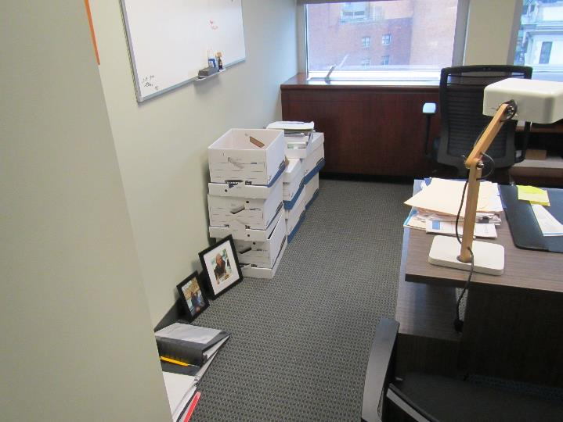
Items on the floor

