WATER DAMAGE FOLLOW-UP ASSESSMENT

Cannabis Control Commission
101 Federal Street, 13th floor
Boston, Massachusetts

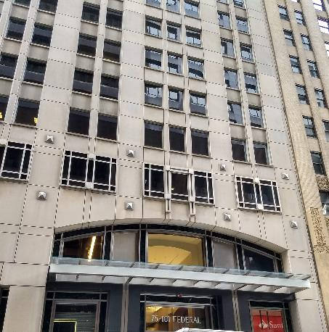

Prepared by:
Massachusetts Department of Public Health
Bureau of Environmental Health
Indoor Air Quality Program
August 2019

Background
Building: | Cannabis Control Commission (CCC)
Address: | 101 Federal Street, 13th floor, Boston
Assessment Requested by: | Ginny Platt, Senior Project Manager,  Division of Capital Asset Management & Maintenance (DCAMM),Office of Leasing and State Office Planning
Reason for Request: | To assess corrective actions following a flood
Date of Assessment: | August 22, 2019
Massachusetts Department of Public Health/Bureau of Environmental Health (MDPH/BEH) Staff Conducting Assessment: | Ruth Alfasso, Environmental Engineer/Inspector, IAQ Program
Building Description: | Other office tenants occupy other floors in the building.
Windows: | Not openable

Introduction
Over the weekend of July 20, 2019, a release of water from the cooling system on the 15th floor occurred. Water flowed down from the area of release and moistened materials on many floors of the building. Because of the location of the CCC on the 13th floor, materials in this office were significantly impacted by the flood. Facility staff began drying the affected areas when the flood was detected. The IAQ program visited the affected area on Monday July 22 to assess the status of the remediation efforts. Recommendations for further remediation actions were made both verbally at the time of the visit and in a report completed in August of 2019. That report is available on request.
The site was visited again on August 22, 2019 to assess conditions following remediation work.

Methods
Please refer to the IAQ Manual for methods, sampling procedures, and interpretation of results (MDPH, 2015). In addition, visual observations were made and some moisture measurements in gypsum wallboard and other materials were conducted as is discussed further below.

Results
A single set of measurements was collected in the central part of the affected area. The following is a summary of indoor air testing results.
- Carbon dioxide levels were measured at 846 parts per million (ppm), which is slightly above the MDPH guideline of 800 ppm.
- Temperature was 73°F, which is within the MDPH recommended range of 70°F to 78°F.
- Relative humidity was 52% which is within the MDPH recommended range of 40% to 60%.

Ventilation
A heating, ventilating and air conditioning (HVAC) system has several functions. First it provides heating and, if equipped, cooling. Second, it is a source of fresh air. Finally, an HVAC system will dilute and remove normally-occurring indoor environmental pollutants by not only introducing fresh air, but by filtering the airstream and ejecting stale air to the outdoors via exhaust ventilation. Even if an HVAC system is operating as designed, point sources of respiratory irritation may exist and cause symptoms in sensitive individuals.
Fresh air is provided by ceiling-mounted fresh air diffusers. A mechanical exhaust vent system removes stale air. Fan coil units (FCU) were installed along exterior walls within the building. The FCUs are designed to provide both heat and cooling. Depending on the setting, heated or chilled water is pumped through a finned tube (i.e., a coil) that is connected to the furnace/chiller by copper pipes that are installed in the pipe chase. Water runs through supply pipes into the coils, which heat/cool the air forced through the coils by the FCU fans. It is important to note that FCUs are designed to provide either heating or cooling, but do not have a fresh air supply. FCU units can only recirculate air.
To maximize air exchange, the MDPH recommends that both supply and exhaust ventilation operate continuously during periods of occupancy. In order to have proper ventilation with a mechanical supply and exhaust system, the systems must be balanced to provide an adequate amount of fresh air to the interior of a room while removing stale air from the room. It is recommended that HVAC systems be re-balanced every five years to ensure adequate air systems function (SMACNA, 1994). It is unknown when the last time this system was balanced.

Microbial/Moisture Concerns

Areas that had been impacted by the flood were examined:
- Moistened/stained ceiling tiles had been replaced;
- Gypsum wallboard (GW) had been replaced in areas where it had been moistened. All areas of GW were tested with a moisture meter and were dry;
- Peeling paint had been removed/repaired;
- Carpeting was dry and free from odors;
- The covers of the fan coil units that were wet at the time of the initial visit had not been replaced as recommended, however they were dry; and
- No other water-damaged material or odors were found.

Conclusions/Recommendations
Note that the CCC will be moving to a new office within the next year. The following recommendations are made with the short time of continued occupancy in mind:

- Consider adjusting the HVAC system to provide more fresh air to occupied areas. Ensure thermostats are set to “fan on” during occupied periods to provide continuous air circulation and filtration.
- Ensure the interior of fan coil units are cleaned. If odors occur from fan coil units that had been moistened, consider replacing the damaged covers to the units.
- Refer to resource manual and other related IAQ documents located on the MDPH’s website for further building-wide evaluations and advice on maintaining public buildings. These documents are available at: http://mass.gov/dph/iaq.

References
ACGIH. 1989. Guidelines for the Assessment of Bioaerosols in the Indoor Environment. American Conference of Governmental Industrial Hygienists, Cincinnati, OH.
MDPH. 2015. Massachusetts Department of Public Health. Indoor Air Quality Manual: Chapters I-III. Available at: http://www.mass.gov/eohhs/gov/departments/dph/programs/environmental-health/exposure-topics/iaq/iaq-manual/.
SMACNA. 1994. HVAC Systems Commissioning Manual. 1st ed. Sheet Metal and Air Conditioning Contractors’ National Association, Inc., Chantilly, VA.

