**SUPPLEMENTAL LIGHTING ASSESSMENT**

**Boston City Hall**

**Age Strong Office Suite**

**1 City Hall Square**

**Boston, MA**

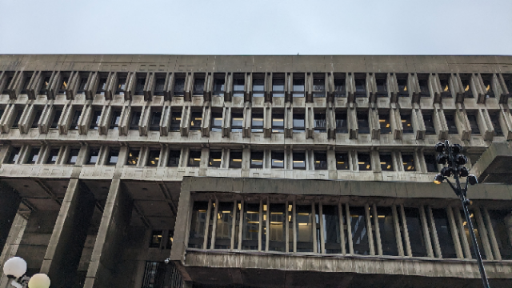

Prepared by:

Massachusetts Department of Public Health

Bureau of Climate and Environmental Health

Indoor Air Quality Program

July 2024

# BACKGROUND

|  |  |
| --- | --- |
| Building: | Boston City Hall Age Strong Commission |
| Address: | 1 City Hall Square, Boston, MA |
| Reason for Request: | Follow up to a previous visit. |
| Date of Assessment: | June 10, 2024 |
| Massachusetts Hall of Public Health/Bureau of Climate and Environmental Health (MDPH/BCEH) Staff Conducting Assessment: | Ruth Alfasso Environmental Engineer/Inspector, IAQ Program, |
| Building Description: | Boston City Hall is a large concrete building in the Brutalist Style in downtown Boston. It was built in 1968. The Age Strong Commission offices are located on the second floor, which is below ground level. They occupy two separate suites separated by a hallway. |
| Building Population: | The Age Strong Commission has approximately 40 employees. |
| Windows: | There are no windows in the area assessed. |

# METHODS

Light levels were measured with a, EXTECH Model 407026 Heavy Duty Light Meter in all areas of the office suite that are normally occupied. Please refer to the IAQ Manual for methods, sampling procedures, and interpretation of results (MDPH, 2015). This light assessment is a follow-up from a general indoor air quality assessment that was conducted on April 12, 2024. The DPH IAQ Program wanted to conduct a light level assessment because this space is all below grade and has no natural light.

# RESULTS AND DISCUSSION

## Light levels

Table 1 shows the light level ranges found in the office suite in lux. Because this space is below-ground, it relies on artificial light at all times. Facility staff reported that light fixtures were replaced with more efficient LED lighting early in 2024.

Insufficient or poor-quality light can impact occupant comfort in a space. To assess this, IAQ staff conducted light measurements at various workstations in the operations centers and at a variety of other areas within the building at tabletop level (approximately 3 feet above the floor). Work areas had light measurements ranging from 106 to 451 lux. Most measurements were close to but below 300 lux. Light quality appeared good, with no discoloring or flickering noted. The American National Standard Institute (ANSI) recommends 300-1,000 lux for general work areas. Increasing lighting may reduce the reported symptoms in these work areas. Low light conditions are associated with headaches, tired eyes, and/or irritation (NIOSH, 2013).

Also note that many of the light fixtures are slightly recessed into the ceiling, which makes light levels at work height below more variable than they would be if the lights were flush with or below the ceiling height. This is shown by the fairly wide ranges of light level in some areas as shown in Table 1. Note that in some areas occupants reported preferring lower light levels.

# CONCLUSIONS/RECOMMENDATIONS

The following additional recommendation is made to improve and maintain IAQ in the Age Strong suite.

1. Provide an adequate amount of light for workstations in accordance with staff needs and preferences. Task lighting and anti-glare computer screens may be helpful in some situations.
2. Follow any remaining recommendations from the previous full IAQ assessment.

# REFERENCES

MDPH. 2015. Massachusetts Department of Public Health. “Indoor Air Quality Manual: Chapters I-III”. Available at: <https://www.mass.gov/lists/indoor-air-quality-manual-and-appendices>.

NIOSH. 2013. Health hazard evaluation report: lighting, indoor environmental quality concerns, and job stress at a call center – California. By Wiegand D, Ramsey J, Burr G, Choi J. Cincinnati, OH: U.S. Department of Health and Human Services, Centers for Disease Control and Prevention, National Institute for Occupational Safety and Health, NIOSH HETA No. 2012-0081-3169. <https://www.cdc.gov/niosh/hhe/reports/pdfs/2012-0081-3169.pdf>

| **Location** | **Light level range (Lux)** | **Remarks** |
| --- | --- | --- |
|
| Main office area | | |
| Reception | 110-121 |  |
| Cubes | 150-269 |  |
| Lunchroom | 106-241 |  |
| Office | 275 |  |
| Seniority room | 282 |  |
| Deputy commissioner’s office | 268 |  |
| Office | 270-295 |  |
| Cubes | 271-242 |  |
| Mini conference | 290 |  |
| Office | 215-223 |  |
| Cubes | 295-305 |  |
| Conference | 230-283 |  |
| Office | 255-265 |  |
| Commissioner | 294 |  |
| Meeting area | 265 |  |
| Cubes | 230-285 |  |
| 204 suite | | |
| Main cubicle area | 345 |  |
| Back of room | 25-43 | Lights off and area unoccupied |
| Office | 400-451 |  |