**INDOOR AIR QUALITY ASSESSMENT**

**Boston City Hall**

**Age Strong Office Suite**

**1 City Hall Square**

**Boston, MA**

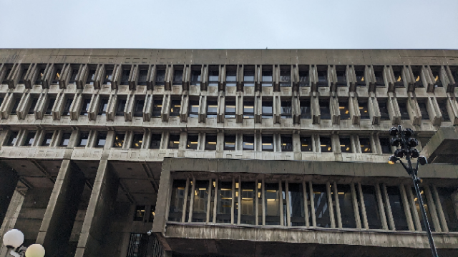

Prepared by:

Massachusetts Department of Public Health

Bureau of Climate and Environmental Health

Indoor Air Quality Program

May 2024

# BACKGROUND

|  |  |
| --- | --- |
| Building: | Boston City Hall Age Strong Commission |
| Address: | 1 City Hall Square, Boston, MA |
| Reason for Request: | Odor concerns and general indoor air quality (IAQ), referred by the Department of Labor Standards. |
| Date of Assessment: | April 12, 2024 |
| Massachusetts Department of Public Health/Bureau of Climate and Environmental Health (MDPH/BCEH) Staff Conducting Assessment: | Michael Feeney, Director, and Ruth  Alfasso Environmental  Engineer/Inspector, IAQ Program,  accompanied by David Greer, Health  Inspector, Boston Public Health  Commission (BPHC) |
| Building Description: | Boston City Hall is a large concrete building in the Brutalist Style in downtown Boston. It was built in 1968. The Age Strong Commission offices are located on the second floor, which is below ground level. They occupy two separate suites separated by a hallway. |
| Building Population: | The Age Strong Commission has approximately 40 employees. |
| Windows: | There are no windows in the area assessed. |

# METHODS

Please refer to the IAQ Manual for methods, sampling procedures, and interpretation of results (MDPH, 2015).

# RESULTS AND DISCUSSION

The following is a summary of indoor air testing results (Table 1).

* ***Carbon dioxide*** measurements were below the MDPH guideline of 800 parts per million (ppm) indicating adequate fresh air in the office suites.
* ***Temperature*** was within the recommended range of 70°F to 78°F in all areas tested.
* ***Relative humidity*** was within or slightly above the recommended range of 40% to 60% in all areas tested.
* ***Carbon monoxide*** levels were non-detectable (ND) in all areas tested.
* ***Fine particulate matter (PM2.5)*** concentrations were below the National Ambient Air Quality Standard (NAAQS) level of 35 μg/m3 in all areas tested.

**Ventilation**

A heating, ventilating, and air conditioning (HVAC) system has several functions. First, it provides heating and, if equipped, cooling. Second, it is a source of fresh air. Finally, an HVAC system will dilute and remove normally occurring indoor environmental pollutants by not only introducing fresh air, but also filtering the airstream and ejecting stale air to the outdoors via exhaust ventilation. Even if an HVAC system is operating as designed, point sources of respiratory irritation may exist and affect symptoms in sensitive individuals. The following analysis examines and identifies components of the HVAC system and likely sources of respiratory irritant/allergen exposure due to water damage, aerosolized dust, and/or chemicals found in the indoor environment.

Fresh air is supplied to offices and common areas through ceiling-mounted supply vents (Picture 1). In many rooms, the presence of vents could not be determined due to the construction of the ceilings which hide areas that would likely contain vents (Picture 2). Air is returned to the AHU through ceiling-mounted return vents (Picture 3), many of which are also likely hidden. Although it could not be determined whether every room had both a supply and a return vent, the adequacy of ventilation is generally shown through the levels of carbon dioxide, which remained below the MDPH IAQ guidance level of 800 ppm in all rooms, even those with several occupants. Given the lack of windows, supply and return ventilation should be on during all occupied periods, including when the thermostat set point temperature is being met. Also note that the construction of the ceilings in these portions of the building will also allow for air to pass between areas which would otherwise appear to be fully enclosed offices (Picture 2). It is recommended that HVAC systems be re-balanced every five years to ensure adequate air systems function (SMACNA, 2013). That is even more important in a building where many vents are hidden, and where air can transfer in unexpected ways.

If kitchen areas or other areas where food and food-heating appliances are present do not have a dedicated exhaust vent to remove smoke and odors, it is even more important than usual that occupants avoid creating smoke, odors, or excess moisture in these rooms because these odors can spread. Appliances such as microwaves, refrigerators, and toasters should be kept clean, and any spills cleaned up promptly.

**Microbial/Moisture Concerns**

No obvious signs of water infiltration, water damage, mold, or related odors were found in the suites examined. Note that the materials of construction of most of the areas examined are resistant to mold growth (concrete walls and ceilings, and various forms of floor tile).

A ductless air conditioner was noted in the smaller suite across the hall from the main area (Picture 4). No drainage tubing for condensation from this unit was noted. During operation, these units create condensation that needs to be drained, typically through a tube to a drain, sometimes using a pump. Without sufficient drainage, spills or leaks can occur, or stagnant water can lead to odors.

A water dispenser was located in a carpeted area (Picture 5). Spills or leaks from these units can moisten carpet and lead to mold growth or odors.

Note that the relative humidity in the areas examined ranged around the upper limit of the MDPH IAQ comfort range of 40-60%. This is reflective of outdoor conditions on the day of the assessment. Because of the mild temperatures on the day of the assessment, the ventilation system was probably not operating in cooling mode, so it could not be determined if the HVAC system would be able to sufficiently reduce humidity when outdoor air is warm and humid. Excess humidity, particularly if it ranges above 70% for long periods of time, is not only a comfort issue, but can lead to water damage to susceptible materials and mold growth.

## Other IAQ Concerns

### Odors and Irritants

The impetus for this site visit was concerns about odors and health impacts in the office suites. Several potential sources of irritants were noted during the assessment:

* The smaller of the two office suites has a wall with the loading dock on the other side. While no obvious breaches in this wall were noted, this wall also has the ductless air conditioner on it (Picture 4). Holes for the pipes and electrical cables for this unit may create a pathway to allow odors and pollutants from the loading dock into the suite. Loading dock pollutants may include products of combustion such as particulate matter and carbon monoxide as well as associated odors.
* There are several small air purifiers in the spaces examined (Picture 6). While the MDPH IAQ program recommends that filters for these units be changed regularly as recommended by the manufacturer, if filters have become heavily loaded with dust, changing them needs to be conducted carefully and away from occupants to avoid releasing trapped dust. Air filter changes had reportedly occurred prior to some of the occupant concerns that were the reason for this visit.
* While no measurements of total volatile organic compounds (TVOCs) were conducted in this space, a few potential sources of TVOCs were noted in the space including recent painting of the wall next to the ductless AC, and dry erase markers. In addition, boxes of heavily printed materials (Picture 7) were noted in the space. Printed materials can release TVOCs. Any volatile organic compounds can be irritating to the mucous membranes.

### General Issues

Some portions of the suite are carpeted. Carpets should be cleaned regularly in accordance with Institute of Inspection, Cleaning and Restoration Certification (IICRC) recommendations (IICRC, 2012). A vacuum cleaner was noted in the space (Picture 8). This unit does not appear to be equipped with a high efficiency particular arrestance (HEPA) filter. Use of a non-HEPA vacuum can aerosolize dust during operation.

In some locations in the office, clutter was noted on floors and flat surfaces. Clutter can allow a build-up of dust, make it harder to clean effectively, and become a harborage for pests. Some cubicles are set up to create a gap between the cube divider and the room wall (Picture 9). In the experience of the IAQ Program, these areas can collect debris and items and are frequently left out of regular cleaning programs. Personal fans were noted in the space, some of which had dusty blades which can redistribute dust during operation.

# CONCLUSIONS/RECOMMENDATIONS

The following recommendations are made to improve and maintain IAQ in the Age Strong suite.

### Ventilation Issues

1. Ensure that fresh air ventilation and return/exhaust ventilation is on and operating during all occupied periods.
2. Use filters with a minimum efficiency rating value (MERV rating) of at least 8 and higher if the equipment can handle the increased size and pressure drop.
3. Determine if every occupied office has both a supply and a return or exhaust vent. Consider adding ventilation to any offices without both a supply and a return.
4. It is not known when the ventilation systems in these office suites were last balanced. If it has been greater than 5 years, consider having the systems balanced.

### Moisture Issues

1. Determine how the ductless air conditioner shown in Picture 4 drains condensation. Check any tubing or pumps periodically to reduce the chance of leaks or stagnant water.
2. Move water dispensers to areas without carpeting or use a waterproof mat underneath them.
3. Consider monitoring humidity during the summer months to ensure that sufficient moisture removal is occurring to keep relative humidity below 70%. If humidity is frequently or chronically above 70%, make adjustments to airflow and chilling to reduce humidity, or use dehumidifiers in the space. Keep any dehumidification equipment clean and empty regularly.
4. The following documents can provide guidance that can be used to reduce the impact of hot, humid weather in any building:
   1. Preventing mold growth in Massachusetts schools during hot, humid weather: [Preventing mold growth in Massachusetts schools during hot, humid weather | Mass.gov](https://www.mass.gov/info-details/preventing-mold-growth-in-massachusetts-schools-during-hot-humid-weather)
   2. Remediation and prevention of mold growth and water damage in public schools and buildings to maintain air quality: [Remediation and prevention of mold growth and water damage in public schools and buildings to maintain air quality | Mass.gov](https://www.mass.gov/info-details/remediation-and-prevention-of-mold-growth-and-water-damage-in-public-schools-and-buildings-to-maintain-air-quality)
   3. Methods for increasing comfort in non-air-conditioned schools: <https://www.mass.gov/doc/methods-for-increasing-comfort-in-non-air-conditioned-schools/download>.

### Other Recommendations

1. Painting and other renovations should be conducted when the space is unoccupied, and additional ventilation should be provided until any odors are gone. Use the guidance in “Construction and renovation generated pollutants in occupied buildings” at <https://www.mass.gov/info-details/construction-and-renovation-generated-pollutants-in-occupied-buildings> to reduce the impacts of any construction on IAQ.
2. Investigate if there are pathways that may allow loading dock odors into the occupied space. If odors occur intermittently in the space, track when they occur and what is happening in the loading dock. Work with facility staff to seal breaches and to potentially add exhaust ventilation for loading dock activities.
3. Change air purifier filters in accordance with manufacturer's instruction. If filters are often heavily loaded with dust, change the filters away from occupants and in an area with good exhaust ventilation, or outside.
4. Keep boxes of printed materials closed when not in use.
5. Use other products that may contain TVOCS such as hand sanitizers, cleaners, and dry erase materials, sparingly. Ensure all caps or lids are tightly sealed when products are not in use.
6. Clean carpeting regularly using a HEPA-equipped vacuum.
7. Clean fans periodically to remove dust.
8. Reduce clutter to assist with thorough cleaning. Ensure that spaces between cube dividers and room walls are cleaned periodically.
9. Light levels may impact occupants’ impression of IAQ. Given that this space is below ground and has no natural light, the MDPH IAQ Program can return to measure light levels during normal occupied conditions under request.
10. Refer to resource manual and other related IAQ documents located on the MDPH’s website for further building-wide evaluations and advice on maintaining public buildings. These documents are available at: <http://mass.gov/dph/iaq>.

# REFERENCES

ASHRAE, 2019. American Society of Heating, Refrigeration and Air Conditioning Engineers (ASHRAE) Ventilation for Acceptable Indoor Air Quality. ANSI/ASHRAE Standard 62.1-2019. Atlanta, GA.

MDPH. 2015. Massachusetts Department of Public Health. “Indoor Air Quality Manual: Chapters I-III”. Available at: <https://www.mass.gov/lists/indoor-air-quality-manual-and-appendices>.

IICRC. 2012. Carpet Cleaning FAQ 4 Institute of Inspection, Cleaning and Restoration Certification. Institute of Inspection Cleaning and Restoration, Vancouver, WA.

SMACNA. 2013. HVAC Systems Commissioning Manual. 2nd ed. Sheet Metal and Air Conditioning Contractors’ National Association, Inc., Chantilly, VA.

**Picture 1**

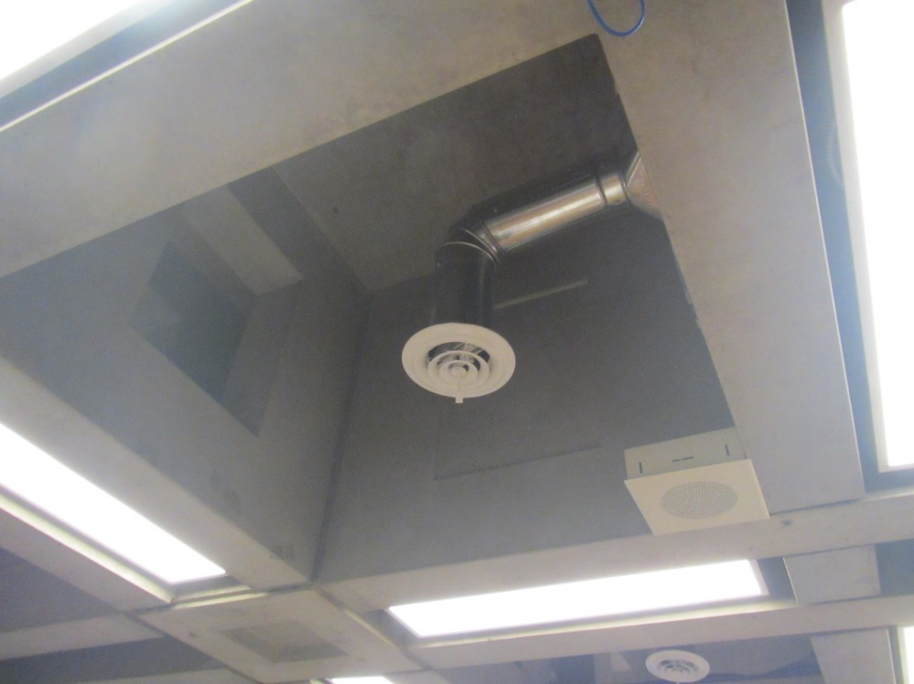

**A visible supply vent**

**Picture 2**

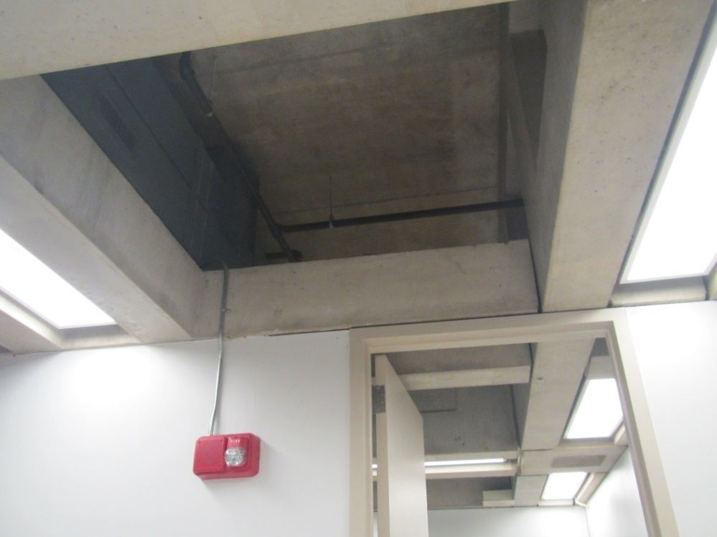

**Complex ceilings in the office suite which may hide supply and return vents and allow air transfer between offices**

**Picture 3**

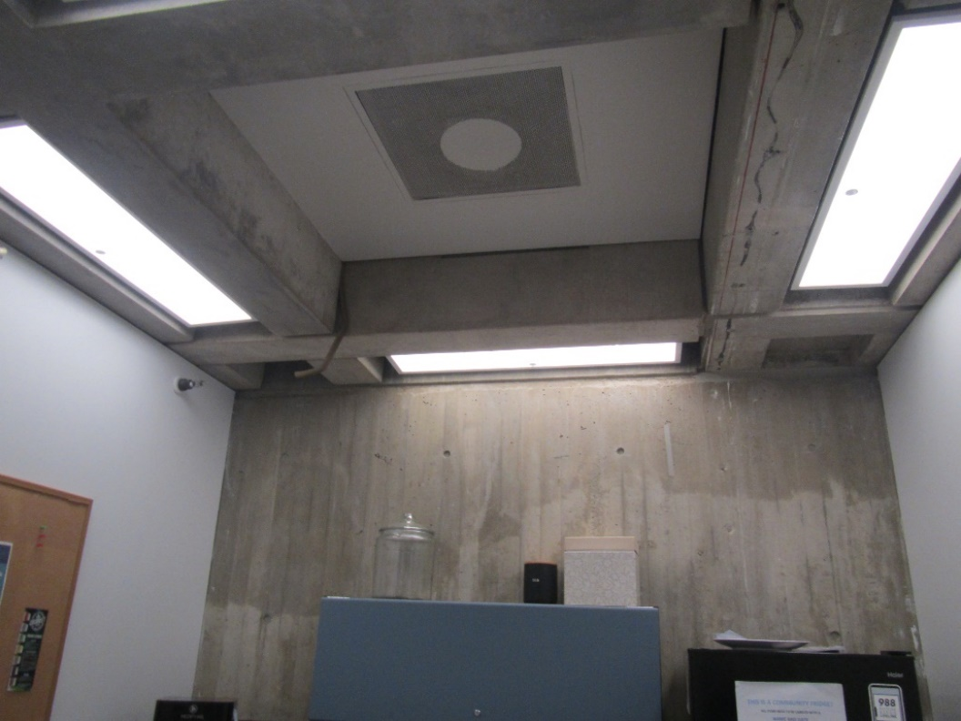

**A return or exhaust vent**

**Picture 4**

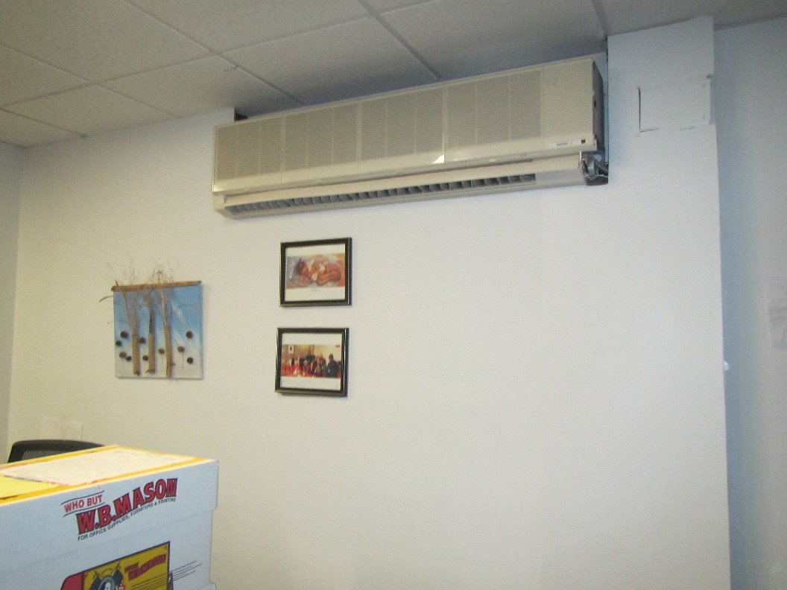

**Ductless air conditioner on the wall**

**Picture 5**

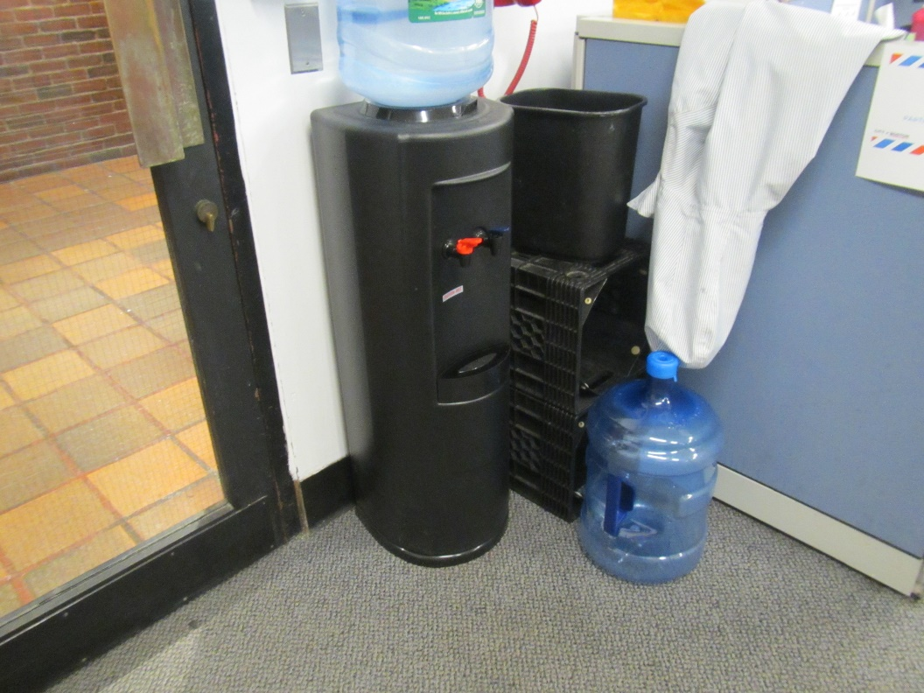

**Water dispenser on carpet**

**Picture 6**

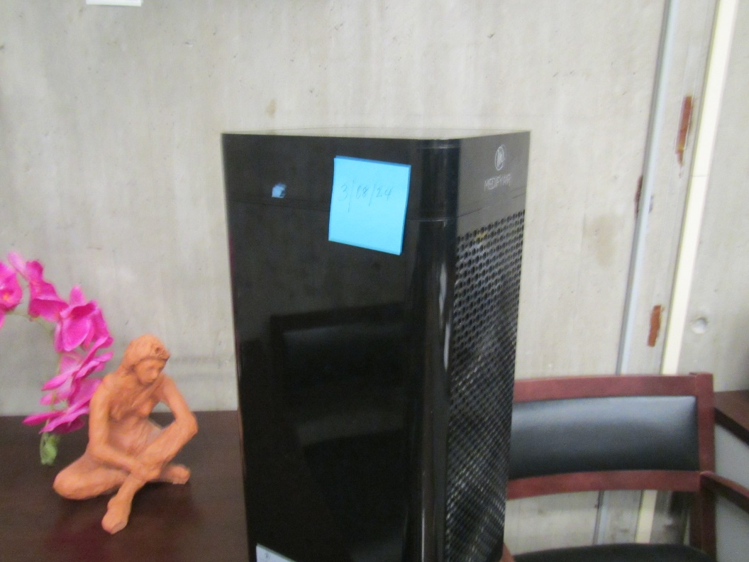

**Air purifier**

**Picture 7**

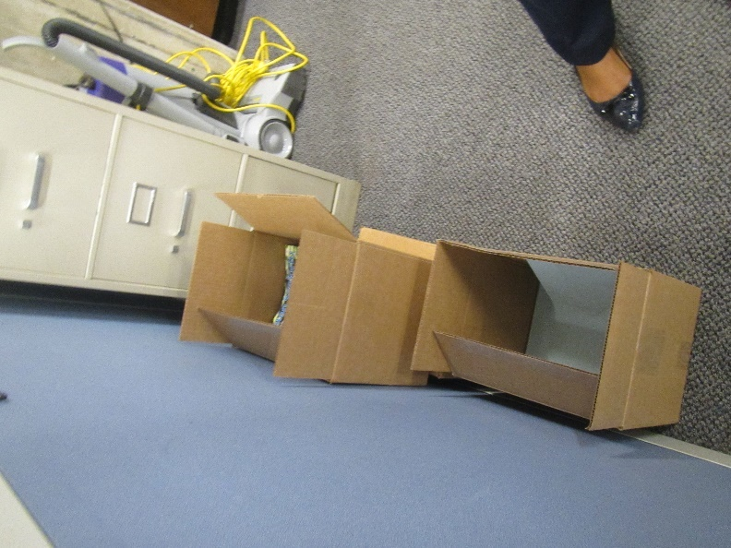

**Boxes of printed materials**

**Picture 8**

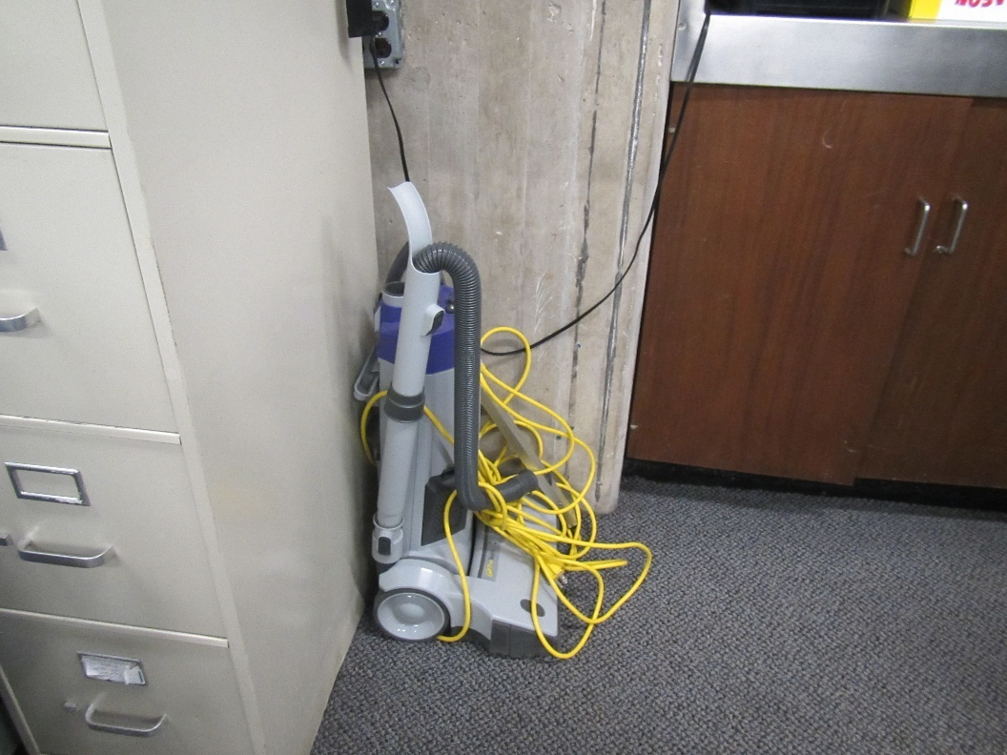

**Non-HEPA style vacuum cleaner**

**Picture 9**

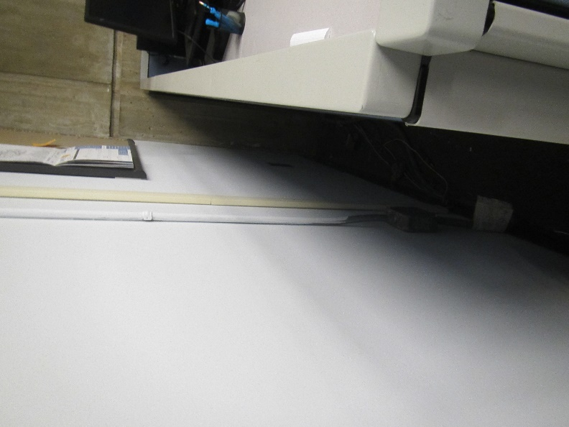

**Gap between wall and cube divider**

| **Location** | **Carbon**  **Dioxide**  **(ppm)** | **Carbon Monoxide**  **(ppm)** | **Temp**  **(°F)** | **Relative**  **Humidity**  **(%)** | **PM2.5**  **(µg/m**3**)** | **Occupants**  **in Room** | **Windows**  **Openable** | **Ventilation** | | | **Remarks** |
| --- | --- | --- | --- | --- | --- | --- | --- | --- | --- | --- | --- |
| **Intake** | **Exhaust** | |
| Background | 379 | ND | 68 | 70 | 10 |  |  |  | |  |  |
| Shea office | 732 | ND | 75 | 62 | ND | 6 | N |  | |  | Area rug, AP, shredder, fridge |
| Printer area | 462 | ND | 76 | 60 | ND | 1 | N |  | |  | Recent painting of one wall, ductless air conditioning unit on wall, carpeted, area is adjacent to loading dock, AP |
| 204 main area | 422 | ND | 76 | 59 | ND | 1 | N | Y | | Y | AP filters replaced recently, worn carpet, DEM |
| Carlson office | 427 | ND | 76 | 59 | ND | 1 | N |  | |  | Carpet |
| Dennit cube area | 561 | ND | 75 | 58 | ND | 1 | N | Y | |  | Holes in ceiling, NC |
| Querido | 626 | ND | 75 | 58 | ND | 0 | N |  | |  | AP, NC |
| Lunch room | 458 | ND | 75 | 58 | ND | 0 | N |  | |  | Microwave and fridge (full but clean) and toaster, CP, AP, NC |
| Garraty | 492 | ND | 75 | 59 | ND | 0 | N |  | |  | NC, fake plants, area rug |
| Finance area | 488 | ND | 75 | 59 | ND | 4 | N | Y | | Y | NC, fridge and microwave, food, plant |
| Frechette | 472 | ND | 75 | 59 | ND | 1 | N |  | |  | AP, DEM |
| Conference/office | 477 | ND | 75 | 59 | ND | 0 | N |  | |  | NC |
| Desgrottes | 448 | ND | 75 | 60 | ND | 1 | N |  | |  | NC, AP, coffee |
| Storage | 441 | ND | 75 | 59 | ND | 0 | N |  | |  | NC |
| Double office | 443 | ND | 74 | 60 | ND | 0 | N |  | |  |  |
| Meeting area | 652 | ND | 75 | 60 | ND | 0 | N | Y | |  | NC |
| Maltez cube area | 531 | ND | 75 | 59 | ND | 3 | N |  | |  | NC, AP |
| Constituent services | 466 | ND | 76 | 58 | ND | 4 | N | Y | |  | Food odor, NC, clutter, AP |
| Reception | 471 | ND | 76 | 58 | ND | 1 | N | Y | |  | NC |