WATER DAMAGE/MOLD INVESTIGATION

Massachusetts Department of Mental Health
25 Staniford St
Boston, Massachusetts

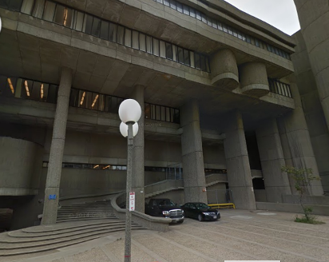

Prepared by:
Massachusetts Department of Public Health
Bureau of Environmental Health
Indoor Air Quality Program
July 2014

Background/Introduction
At the request of John O’Donnell, Project Manager, Division of Capital Asset Management and Maintenance (DCAMM), a water damage/mold investigation was conducted at the Massachusetts Department of Mental Health (MDMH), 25 Staniford Street, Boston, Massachusetts. The Massachusetts Department of Public Health (MDPH), Bureau of Environmental Health (BEH) conducted the assessment in response to concerns related to water damage and potential mold growth following a broken drain line within the space.
On July 9, 2014, a site visit to perform an investigation was made by Michael Feeney, Director of BEH’s Indoor Air Quality (IAQ) Program. Mr. Feeney was accompanied by Ruth Alfasso, Environmental Engineer/Inspector and Jason Dustin, Environmental Analyst/Inspector within BEH’s IAQ program. BEH staff were accompanied by Mr. O’Donnell and Jeffrey Dill, Facilities Manager, (DCAMM).

Methods
BEH/IAQ staff performed a visual inspection of building materials for water damage and/or microbial growth. Moisture content of porous building materials (i.e., GW and carpeting) was measured using a Delmhorst, BD-2100 Model Moisture Detector and a Tramex Moisture Encounter Plus non-invasive moisture detector. Moisture testing results are included in Table 1.

Results and Discussion
It was reported to BEH/IAQ staff that a sewer drain line in a fourth floor bathroom had become clogged. When the water had backed up the pipe, it caused the failure of a corroded fitting which discharged water above several offices on the third floor. Contractors were reportedly called immediately after MDMH staff had discovered the water damage within 24 hours of the leak. Carpeting had been removed (Picture 1) from three offices directly impacted (rooms 3088, 3089 and 3090). The plaster ceilings had also been removed. The full lath-and-plaster wall between rooms 3090 and 3089 had been removed and other walls in all three rooms had been removed up to approximately 2.5 feet high to ensure all water-impacted materials were removed in affected areas (Pictures 2 and 3). Carpeting was also removed along the adjacent wall in the hallway (Picture 4). The drain lines had been repaired (Picture 5), and contractors had reportedly disinfected the flooring once the carpet had been removed.
Moisture readings taken by BEH/IAQ staff showed that floors and remaining wall materials in the affected offices were dry (Table 1). No moist materials were detected in hallways or other adjacent areas (Table 1).
BEH/IAQ staff were also asked to inspect offices on the second floor where water had run down through to office space on that level. Materials in two offices had been damaged. Carpeting in these offices had been removed, the floors reportedly disinfected, and new carpet squares installed (Table 1). The lower 2.5 feet of water-damaged plaster wall materials had also been replaced in impacted areas (Picture 6; Table 1). Other porous materials that had been damaged, such as papers, had been removed. Building materials in rooms impacted by the overflow were tested, and no moist materials were found. Adjacent offices were also tested. Carpeting adjacent to sinks in two offices, rooms 2119 and 2122, had slightly elevated moisture readings (Table 1). The interior of the cabinet under one of the sinks was inspected, and signs of chronic dampness (peeling paint) were observed. Also of note was the appearance of efflorescence on the plaster walls just above the sink in room 2119 (Picture 6). Efflorescence is a characteristic sign of water damage to brick and mortar, but it is not mold growth. As moisture penetrates and works its way through mortar, brick or plaster, water-soluble compounds dissolve, creating a solution. As the solution moves to the surface of the material, the water evaporates, leaving behind white, powdery mineral deposits. This indicates that chronic moistening of these areas is occurring. This area should be explored to determine the source of the water infiltration and damage.
The offices with sinks were originally designed as patient examination rooms that are now used as private office space. The sinks in these rooms are not in use based upon reports from office occupants and are not necessary for the activities conducted in these offices. The sink in room 2119 had been covered with a wood panel that had dark staining consistent with mold growth (Picture 7), as did the sink cabinet. A musty odor was also detected in the vicinity of this sink. A large amount of papers were stacked on this sink cabinet and in front of the sink base which prevented the inspection of the interior of the cabinet or a thorough inspection of the carpet. Papers also provide an additional porous medium on which mold can grow. Water penetration and chronic exposure of porous and wood-based materials can cause these materials to swell and show other signs of water damage, and can lead to potential mold growth. Since the sinks are not needed in these offices, consideration should be given to removing them with all piping cut and capped appropriately. At that time, any water-damaged porous building materials, including the sink cabinets, walls and carpeting should be removed and replaced. Papers that have become water-damaged or mold-colonized should be discarded as soon as possible; clean photocopies should be made of items that are necessary to keep.
The US Environmental Protection Agency (US EPA) and the American Conference of Governmental Industrial Hygienists (ACGIH) recommends that porous materials (e.g., wallboard and carpeting) be dried with fans and heating within 24 to 48 hours of becoming wet (US EPA, 2001; ACGIH, 1989). If porous materials are not dried within this time frame, mold growth may occur.
Unused sinks and other drains, such as in unused bathrooms, may also lead to dry drain traps which can release sewer gas and odors into occupied areas. Properly removing the sinks with appropriate cut and cap of the piping will eliminate this issue; for drains that remain, they should have water added to them on a regular schedule, such as once a week, to maintain the trap seal.
Several refrigerators, water coolers, and water bottles were observed to be placed on top of carpeted areas (Picture 8). These moisten carpeting and lead to mold growth. Moving the appliances to tiled areas or placing rubber mats underneath them will protect the carpet.

Conclusions/Recommendations
Based on the observations made during this visit, it appears that all water-damaged materials from the flooding incident described in this report have been properly removed and remediation of the areas impacted appears to be proceeding appropriately. However, other issues relating to water damage and chronic moisture were observed in the building during the visit. In view of the findings at the time of the visit, the following recommendations are made:
- Continue to replace all the building materials removed from the affected offices.
- Consider removing the sinks from offices on the second floor of the building and remove/replace any water-damaged materials adjacent to sinks in these offices, including the cabinets as needed. Perform this work in a manner consistent with recommendations found in “Mold Remediation in Schools and Commercial Buildings” published by the US Environmental Protection Agency (US EPA, 2001) (http://www.epa.gov/mold/mold_remediation.html).
- Explore the source of chronic moisture in room 2119 and repair building/plumbing leaks as necessary. Disinfect areas of water leaks with an appropriate antimicrobial as needed.
- Remove and properly cap any other unused drains, and ensure that those drains that remain are filled with water at least weekly to prevent the traps from drying out and releasing sewer gas into occupied areas.
- Refer to resource manual and other related indoor air quality documents located on the MDPH’s website for further building-wide evaluations and advice on maintaining public buildings. These documents are available at: http://mass.gov/dph/iaq.

References
ACGIH. 1989. Guidelines for the Assessment of Bioaerosols in the Indoor Environment. American Conference of Governmental Industrial Hygienists, Cincinnati, OH.
US EPA. 2001. Mold Remediation in Schools and Commercial Buildings. US Environmental Protection Agency, Office of Air and Radiation, Indoor Environments Division, Washington, D.C. EPA 402-K-01-001. http://www.epa.gov/mold/mold_remediation.html
Picture

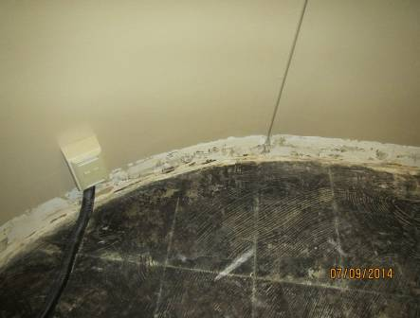

Water-damaged carpeting removed from office

Picture

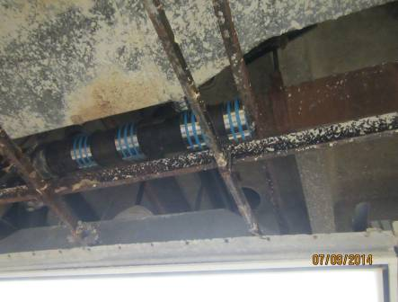

Plaster ceilings removed to make plumbing repairs

Picture

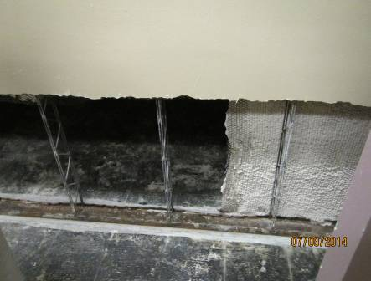

Bottom 2.5 feet of plaster walls removed in affected areas

Picture

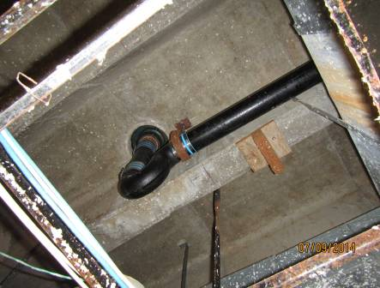

Plumbing repairs to sewer drain line
Picture 5

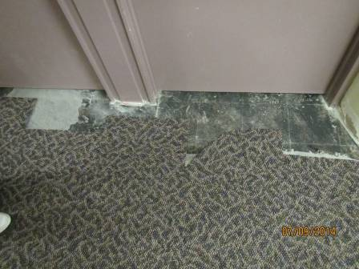

Water-damaged carpeting removed and partially replaced in the third floor hallway

Picture 6

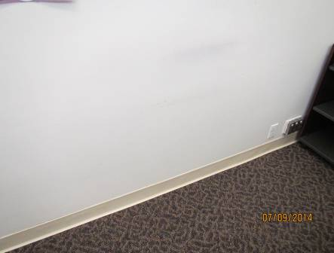

Lower 2.5 feet of water-damaged plaster wall removed and newly replaced; carpeting and coving also new
Picture 7

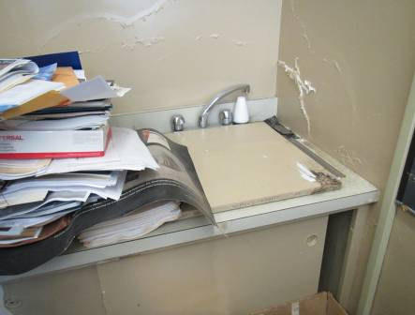

Efflorescence on walls above sink in room 2119, note papers on cabinet and sink

Picture 8

Wood covering sink in room 2119 showing dark staining typical of mold growth

Picture 9

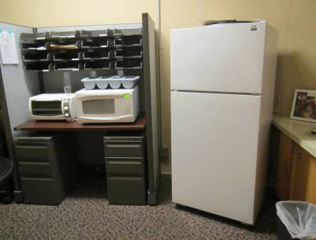

Refrigerator on carpeted surface

Location |  | Moisture testing | Relative  Humidity  (%) | Occupants  in Room | Windows  Openable | Ventilation |  | Remarks
 |  |  |  |  |  | Supply | Exhaust
 | 3088 | No moist materials | 61 | 0 | N | Y | N | Wall plaster/lathe removed 2.5 feet from the floor, carpet removed, ceiling removed
 | 3089-90 | No moist materials | 62 | 0 | N | Y | N | Wall removed between offices, wall plaster and lathe removed to 2.5 feet around, carpet and ceiling removed
 | 3087 | No moist materials | 63 | 1 | N | Y | N | No materials removed. Food, dry erase materials, Personal fan
 | Hallway near 3090 | No moist materials | 61 | 0 | N | Y | N | Carpet removed from under doors of affected rooms
 | Break area near 3090 | No moist materials |  | 0 | N | Y | N | Photocopier, refrigerator and water cooler on carpet
 | 2118 | No moist materials |  | 0 | N | Y | N
 | 2127 | No moist materials | 57 | 0 | N | Y | N | Wall removed to 2.5 feet and replaced with new lathe/plaster along affected side. Carpet replaced, Plants on fan coil unit
 | 2128 | No moist materials | 58 | 0 | N | Y | N | Wall removed to 2.5 feet and replaced with new lathe/plaster along affected side. Carpet replaced
 | 2119 | Carpet near sink slightly moist | 59 | 1 | N | Y | N | Sink in room not used but not cut/capped. Papers in piles around sink. Reported moldy/musty odor in room, items on fan coil unit. Efflorescence on walls near sink, dark staining on wood cover over sink.
 | 2126 | No moist materials | 57 | 1 | N | Y | N
 | 2122 | Carpet near sink slightly moist |  | 1 | N | Y | N | Water damage under sink
 | 2117 | No moist materials |  | 0 | N | Y | N

