INDOOR AIR QUALITY ASSESSMENT

Department of Mental Health
Lindemann Building, Room 5047
25 Staniford Street, Boston

Prepared by:
Massachusetts Department of Public Health
Bureau of Environmental Health
Indoor Air Quality Program
June 2022

BACKGROUND
Building: | Department of Mental Health (DMH) Lindemann Building
Address: | 25 Staniford Street, Boston
Assessment Requested by: | Sharon Moody, Assistant Director  Engineering & Facilities Management  DMH
Reason for Request: | Odor, Mold, and Indoor Air Quality (IAQ) concerns
Dates of Assessment: | May 25, 2022
Massachusetts Department of Public Health/Bureau of Environmental Health (MDPH/BEH) Staff Conducting Assessment: | Michael Feeney, Director, Indoor Air  Quality (IAQ) Program
Building Description: | Room 5047 is located in the Erich  Lindemann Mental Health Center, a  large Brutalist concrete building  opened in 1971.
Windows: | No windows in room 5047; windows  in the Lindemann Building do not  open.

METHODS
Please refer to the IAQ Manual for methods, sampling procedures, and interpretation of results (MDPH, 2015).

IAQ TESTING RESULTS
The following is a summary of indoor air testing results taken on May 25, 2022.
- Carbon dioxide levels were below MDPH guideline of 800 parts per million (ppm) in all areas surveyed, indicating adequate air exchange. Note that the overall occupancy of this area is low.
- Temperature was within the recommended range of 70°F to 78°F in all areas tested.
- Relative humidity was within recommended range of 40 to 60% in the areas tested.
- Carbon monoxide levels were non-detectable (ND) in all indoor areas tested.
- Fine particulate matter (PM2.5) concentrations measured were below the National Ambient Air Quality (NAAQS) limit of 35 μg/m³ in all areas tested.

Ventilation
A heating, ventilating and air conditioning (HVAC) system has several functions. First it provides heating and, if equipped, cooling. Second, it is a source of fresh air. Finally, an HVAC system will dilute and remove normally occurring indoor environmental pollutants by not only introducing fresh air, but by filtering the airstream and ejecting stale air to the outdoors via exhaust ventilation. Even if an HVAC system is operating as designed, point sources of respiratory irritation may exist and cause symptoms in sensitive individuals.
Fresh air is provided by air handling units (AHUs). Air from the AHUs is filtered, heated/cooled, and delivered to rooms via ducted supply vents. Air is returned/exhausted through vents around lights. Additional heating is provided by radiators along outside edges of the building. Each room should have a source of fresh air. In some cases, it appeared that fresh air was supplied in hallways outside offices and drawn into each office through the action of the return or exhaust vent. This may distribute odors through the building.
The assessment results indicate that the ventilation system is providing adequate fresh air for the current occupancy. It is recommended that HVAC systems be re-balanced every five years to ensure adequate air systems function (SMACNA, 1994). It is unknown when the last time this system was balanced. Note that when this building was built, the use/occupancy was different, for example some current offices may have been patient or medical exam rooms. It is not known if ventilation was adjusted to take into account these changes.

Microbial/Moisture Concerns
The main reason for this visit was water damage that occurred in room 5047, which is currently used as storage space. The source of the water damage and moistened building materials have been repaired. However, the room contains a significant number of materials that can support mold growth if sufficiently moistened including paper, cardboard, cloth and particle board. Porous materials stored in this room should be examined and discarded if they show signs of water damage including stains and odors. Materials that are not porous, such as metal and hard plastic, that show signs of water damage or odors may be able to be cleaned.
The US Environmental Protection Agency (US EPA) and the American Conference of Governmental Industrial Hygienists (ACGIH) recommends that porous materials (e.g., wallboard, carpeting) be dried with fans and heating within 24 to 48 hours of becoming wet (US EPA, 2008; ACGIH, 1989). If porous materials are not dried within this time frame, mold growth may occur. Surfaces in the room were examined for mold growth and nothing specific was identified as moldy, however due to the significant amount of water damage observed, it is likely that microbial growth has occurred or will occur on moistened porous materials.

Other IAQ Evaluations
Employees noted staining on ceiling plaster around the fresh air intake (Picture 1). As reported by DMH staff, the room had previously been used for photocopying. Photocopying can produce dusts including toner and paper fibers, and other dusts can occur due to normal office operations. As the fresh air supply operates, a static electric charge can be created on materials adjacent to the supply vent, which attracts dust, creating stains.
Note that this room is cluttered with stored materials, which makes cleaning, including dust removal and vacuuming, difficult. Stored materials should be sorted and organized, with unneeded material discarded to make cleaning easier.

CONCLUSIONS/RECOMMENDATIONS
Based on observations at the time of assessment, the following is recommended:
- Examine materials stored in Room 5047 for signs of water damage and discard any porous water-damaged materials. Clean non-porous water-damaged materials when feasible. Follow the guidelines in the EPA document “Mold Remediation in School and Commercial Buildings” (EPA, 2008) including proper disposal of water-damaged and mold-contaminated material.
- Discard all unnecessary stored materials from Room 5047 and organize the remaining storage for ease of access and cleaning.
- Once stored materials are cleaned and organized, clean the ceiling around the fresh air supply using a HEPA-filter equipped vacuum cleaner and/or a damp cloth.
- Clean the floor and other flat surfaces using a HEPA-filter equipped vacuum cleaner
to remove accumulated dusts.
- Operate supply and exhaust ventilation continuously in all areas during occupied
periods. Ensure all HVAC equipment is cleaned/maintained in accordance with
manufacturer’s instructions including filter changes.
- Refer to resource manual and other related IAQ documents located on the MDPH’s
website for further building-wide evaluations and advice on maintaining public
buildings. These documents are available at: http://mass.gov/dph/iaq.

REFERENCES
ACGIH. 1989. Guidelines for the Assessment of Bioaerosols in the Indoor Environment. American Conference of Governmental Industrial Hygienists, Cincinnati, OH.
MDPH. 2015. Massachusetts Department of Public Health. Indoor Air Quality Manual: Chapters I-III. Available at: https://www.mass.gov/lists/indoor-air-quality-manual-and-appendices
SMACNA. 1994. HVAC Systems Commissioning Manual. 1st ed. Sheet Metal and Air Conditioning Contractors’ National Association, Inc., Chantilly, VA.
US EPA. 2008. “Mold Remediation in Schools and Commercial Buildings”. Office of Air and Radiation, Indoor Environments Division, Washington, DC. EPA 402-K-01-001. September 2008. Available at: http://www.epa.gov/mold/mold-remediation-schools-and-commercial-buildings-guide.

Picture 1

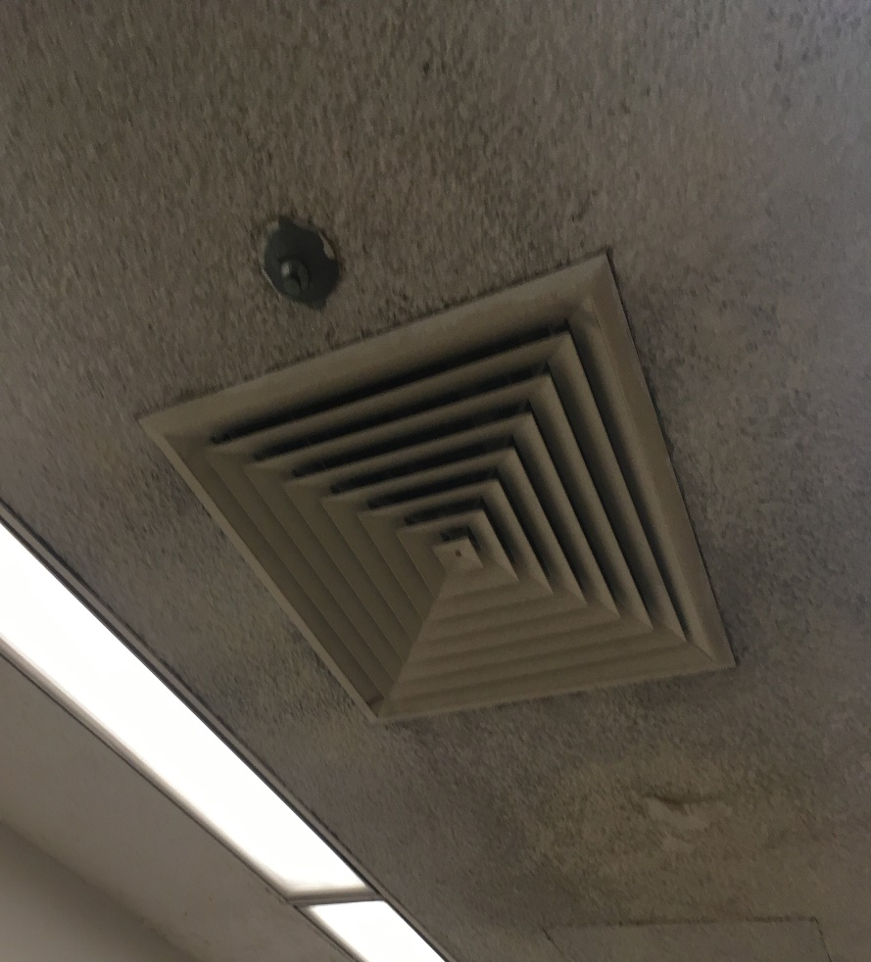
Ceiling-mounted supply vent

