INDOOR AIR QUALITY ASSESSMENT

Dorchester Division, Boston Municipal Court Department
510 Washington Street
Boston, Massachusetts

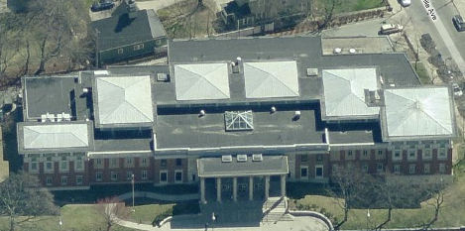

Prepared by:
Massachusetts Department of Public Health
Bureau of Environmental Health
Indoor Air Quality Program
June 2012

Background/Introduction
At the request of Mike Lane, Administrative Office of the Trial Court, the Massachusetts Department of Public Health (MDPH), Bureau of Environmental Health (BEH) provided assistance and consultation initially regarding indoor air quality (IAQ) concerns at the Dorchester Division, Boston Municipal Court Department [Dorchester Court (DC)], 510 Washington Street, Boston, Massachusetts. The request was prompted by reports of dust/particulate accumulation on interior surfaces.
On January 26, 2012, a visit to the DC to conduct an IAQ assessment was made by Mike Feeney, Director, and Sharon Lee, Environmental Analyst in BEH’s IAQ Program. BEH staff were accompanied by Mr. Lane. The DC is a three-story building that was constructed in 1926 and renovated in the 1990s. Windows are openable throughout the building.

Methods
Air tests for carbon dioxide, carbon monoxide, temperature and relative humidity were taken with the TSI, Q-Trak, IAQ Monitor, Model 7565. Air tests for airborne particle matter with a diameter less than 2.5 micrometers were taken with the TSI, DUSTTRAK™ Aerosol Monitor Model 8520. BEH staff performed a visual inspection of building materials for water damage and/or microbial growth.

Results
The DC has approximately 200 employees and can be visited by several hundred people daily. Tests in the DC were taken during normal operations, and results appear in Table 1

Discussion

Ventilation
It can be seen from Table 1 that carbon dioxide levels in the DC were below 800 parts per million (ppm) in all but one of the areas surveyed during the assessment, indicating adequate air exchange in the building. Some areas were empty or sparsely populated during the assessment; carbon dioxide levels would be expected to be higher with increased occupancy.
Mechanical ventilation for the original building is provided by air-handling units (AHUs) located in a ground floor mechanical room (Picture 1). Fresh air is drawn into the AHUs through an air intake located in a pit on the exterior of the building and delivered to occupied areas via ceiling-mounted air diffusers (Picture 2). Exhaust air is drawn into ductwork via grilled vents and returned to the mechanical room.
To maximize air exchange, the MDPH recommends that both supply and exhaust ventilation operate continuously during periods of occupancy. In order to have proper ventilation with a mechanical supply and exhaust system, the systems must be balanced to provide an adequate amount of fresh air to the interior of a room while removing stale air from the room. It is recommended that heating, ventilation and air conditioning (HVAC) systems be re-balanced every five years to ensure adequate air systems function (SMACNA, 1994).
The Massachusetts Building Code requires that each room have a minimum ventilation rate of 20 cubic feet per minute (cfm) per occupant of fresh outside air or openable windows (SBBRS, 1997; BOCA, 1993). The ventilation must be on at all times that the room is occupied. Providing adequate fresh air ventilation with open windows and maintaining the temperature in the comfort range during the cold weather season is impractical. Mechanical ventilation is usually required to provide adequate fresh air ventilation.
Carbon dioxide is not a problem in and of itself. It is used as an indicator of the adequacy of the fresh air ventilation. As carbon dioxide levels rise, it indicates that the ventilating system is malfunctioning or the design occupancy of the room is being exceeded. When this happens, a buildup of common indoor air pollutants can occur, leading to discomfort or health complaints. The Occupational Safety and Health Administration (OSHA) standard for carbon dioxide is 5,000 parts per million parts of air (ppm). Workers may be exposed to this level for 40 hours/week, based on a time-weighted average (OSHA, 1997).
The MDPH uses a guideline of 800 ppm for publicly occupied buildings. A guideline of 600 ppm or less is preferred in schools due to the fact that the majority of occupants are young and considered to be a more sensitive population in the evaluation of environmental health status. Inadequate ventilation and/or elevated temperatures are major causes of complaints such as respiratory, eye, nose and throat irritation, lethargy and headaches. For more information concerning carbon dioxide, please see Appendix A.
Temperature readings in the DC on the day of the assessment ranged from 69 ºF to 77 ºF, which were within or very close to the lower end of the MDPH recommended comfort guidelines. The MDPH recommends that indoor air temperatures be maintained in a range of 70 ºF to 78 ºF in order to provide for the comfort of building occupants. In many cases concerning indoor air quality, fluctuations of temperature in occupied spaces are typically experienced, even in a building with an adequate fresh air supply.
The relative humidity measured in the DC ranged from 18 to 24 percent, which was below the MDPH recommended comfort range in all areas surveyed. The MDPH recommends a comfort range of 40 to 60 percent for indoor air relative humidity. Relative humidity levels in the building would be expected to drop during the winter months due to heating. The sensation of dryness and irritation is common in a low relative humidity environment. Low relative humidity is a very common problem during the heating season in the northeast part of the United States.

Microbial/Moisture Concerns
Staff in the Probation Offices on the ground floor reported that a flood had moistened carpet in the hallway and office space. According to building occupants, the carpet was not removed during the remediation effort. The US Environmental Protection Agency and the American Conference of Governmental Industrial Hygienists (ACGIH) recommends that porous materials (carpeting, ceiling tiles, etc.) be dried with fans and heating within 24 to 48 hours of becoming wet (US EPA, 2001; ACGIH, 1989). If porous materials are not dried within this time frame, mold growth may occur. Water-damaged porous materials cannot be adequately cleaned to remove mold growth. The application of a mildewcide to moldy porous materials is not recommended.
Carpeting, if well maintained, is expected to have a service life of 7 to 11 years (Bishop, 2002). A number of refrigerators and water coolers were observed in carpeted areas (Picture 3). Refrigerators are sources of condensation that can result in chronic moistening. Overflow of the water basin or spills that often occur can moisten carpeting, which can lead to mold growth. It is also important that catch basins of water coolers be cleaned regularly as stagnant water can be a source of odors. Further, materials (i.e., dust) collected in the water can provide a medium for mold growth. Carpets were also observed in a number of below grade spaces. In previous instances, BEH staff recommended removal of carpet from below grade space due to chronic moisture conditions. At the time of the assessment, BEH staff observed signs of water damage on carpeting.
Plants were noted in several areas including on carpeting, which has caused water-staining (Picture 4). Plants should be properly maintained and be equipped with drip pans made of a non-porous material. Drip pans should be cleaned and inspected periodically to prevent mold growth. Plants should be located away from ventilation sources to prevent aerosolization of dirt, pollen or mold.
A number of areas were observed to have water-stained ceiling tiles (Table 1), which may result from roof or plumbing leaks or water penetration from exterior walls. Water-damaged tiles should be replaced once a leak has been repaired. New leaks should be reported to maintenance staff.

Other IAQ Evaluations
Indoor air quality can be negatively influenced by the presence of respiratory irritants, such as products of combustion. The process of combustion produces a number of pollutants. Common combustion emissions include carbon monoxide, carbon dioxide, water vapor and smoke (fine airborne particle material). Of these materials, exposure to carbon monoxide and particulate matter with a diameter of 2.5 micrometers (μm) or less (PM2.5) can produce immediate, acute health effects upon exposure. To determine whether combustion products were present indoors, BEH staff obtained measurements for carbon monoxide and PM2.5.

Carbon Monoxide
Carbon monoxide is a by-product of incomplete combustion of organic matter (e.g., gasoline, wood and tobacco). Exposure to carbon monoxide can produce immediate and acute health affects. Several air quality standards have been established to address carbon monoxide and prevent symptoms from exposure to these substances. The MDPH established a corrective action level concerning carbon monoxide in ice skating rinks that use fossil-fueled ice resurfacing equipment. If an operator of an indoor ice rink measures a carbon monoxide level over 30 ppm, taken 20 minutes after resurfacing within a rink, that operator must take actions to reduce carbon monoxide levels (MDPH, 1997).
The American Society of Heating Refrigeration and Air-Conditioning Engineers (ASHRAE) has adopted the National Ambient Air Quality Standards (NAAQS) as one set of criteria for assessing indoor air quality and monitoring of fresh air introduced by HVAC systems (ASHRAE, 1989). The NAAQS are standards established by the US EPA to protect the public health from six criteria pollutants, including carbon monoxide and particulate matter (US EPA, 2006). As recommended by ASHRAE, pollutant levels of fresh air introduced to a building should not exceed the NAAQS levels (ASHRAE, 1989). The NAAQS were adopted by reference in the Building Officials & Code Administrators (BOCA) National Mechanical Code of 1993 (BOCA, 1993), which is now an HVAC standard included in the Massachusetts State Building Code (SBBRS, 1997). According to the NAAQS, carbon monoxide levels in outdoor air should not exceed 9 ppm in an eight-hour average (US EPA, 2006).
Carbon monoxide should not be present in a typical, indoor environment. If it is present, indoor carbon monoxide levels should be less than or equal to outdoor levels. On the day of the assessment, outdoor carbon monoxide concentrations were measured at 2-3 ppm. No levels of carbon monoxide were detected inside the building during the assessment (Table 1).
While no carbon monoxide was measured indoors, the potential exist from vehicle exhaust in the prisoner transport/lock-up area. Transport vans are driven into a sally port, where prisoners are loaded/offloaded. The sally port is equipped with a dedicated exhaust system, but this unit was found deactivated at the time of the assessment. The exhaust system for the sally port should be activated continuously during use of the cell block. Spaces were observed between the roof decking and interior wall of the sally port (Picture 5). Such breaches can allow vehicle exhaust to penetrate the interior of the building.

Particulate Matter (PM2.5)
The US EPA has established NAAQS limits for exposure to particulate matter. Particulate matter is airborne solids that can be irritating to the eyes, nose and throat. The NAAQS originally established exposure limits to particulate matter with a diameter of 10 μm or less (PM10). According to the NAAQS, PM10 levels should not exceed 150 micrograms per cubic meter (μg/m³) in a 24-hour average (US EPA, 2006). These standards were adopted by both ASHRAE and BOCA. Since the issuance of the ASHRAE standard and BOCA Code, US EPA established a more protective standard for fine airborne particles. This more stringent PM2.5 standard requires outdoor air particle levels be maintained below 35 μg/m³ over a 24-hour average (US EPA, 2006). Although both the ASHRAE standard and BOCA Code adopted the PM10 standard for evaluating air quality, MDPH uses the more protective PM2.5 standard for evaluating airborne particulate matter concentrations in the indoor environment.
Outdoor PM2.5 concentrations were measured at 16 μg/m³ (Table 1). Indoor PM2.5 levels ranged from 3 to 13 μg/m³ (Table 1), which were below the NAAQS PM2.5 level of 35 μg/m³. Frequently, indoor air levels of particulates (including PM2.5) can be at higher levels than those measured outdoors. A number of mechanical devices and/or activities that occur indoors can generate particulate during normal operations. Sources of indoor airborne particulates may include but are not limited to particles generated during the operation of fan belts in the HVAC system, use of stoves and microwave ovens; use of photocopiers, fax machines and computer printing devices; operation of an ordinary vacuum cleaner and heavy foot traffic indoors.
One of the concerns prompting the investigation was the presence of dark particles/black dust on top of file cabinets and other flat surfaces in one area of the building (Table 1). The material had been observed and cleaned prior to the BEH visit. No elevated airborne particulates were measured in the building during the assessment. Occupants in the area reported that following cleaning, no addition materials were observed. The presence of these particles appears to be a cleaning issue and should be addressed through regular building cleaning and maintenance activities.

Other Concerns
Food, food containers and food preparation equipment were observed in a number of areas (Picture 6). Of note was a display of soda cans observed in one office (Table 1). Stored food attracts insects and rodents, as do crumbs or food waste in trash cans. The building shows signs of rodent infestation. Mouse wastes were noted behind computers on desks in the clerk’s office. Rodent traps were employed in some areas (Picture 7). Rodent infestation can result in indoor air quality related symptoms due to materials in their wastes. Mouse urine contains a protein that is a known sensitizer (US EPA, 1992). A sensitizer is a material that can produce allergic symptoms (e.g., running nose or skin rashes) in sensitive individuals following repeated exposures. A three step approach is necessary to eliminate rodent infestation:
- removal of the rodents;
- cleaning of waste products from the interior of the building; and
- reduction/elimination of pathways/food sources that are attracting rodents.
To eliminate exposure to allergens, rodents must be removed from the building. Please note that removal, even after cleaning, may not provide immediate relief since allergens can exist in the interior for several months after rodents are eliminated (Burge, 1995). A combination of cleaning, increases in ventilation, and filtration should serve to reduce rodent associated allergens once the infestation is eliminated. Measures should be taken to seal breaches/install door sweeps to the exterior of the building (Picture 8). Spaces as small as 1/4 inch large are enough for rodents to enter a building.
A container of permethrin and pyrethrin-based pesticide was observed (Picture 9). Pyrethrins have been associated with cross sensitivity with individuals who have ragweed allergy (US EPA, 1989). Applicators of this product should be in full compliance with federal and state rules and regulations that govern pesticide use including posting and notification requirements (333 CMR 13.10). Under no circumstances should untrained personnel apply this material. This product should not be applied prior to or during normal work hours. Under current Massachusetts law (effective November 1, 2001), the principles of integrated pest management (IPM) must be used to remove pests in state buildings (Mass Act, 2000). Pesticide use indoors can introduce chemicals into the indoor environment that can be sources of eye, nose and throat irritation.
Cleaning and sanitization products were observed in some rooms (Table 1). These products contain chemicals that can be irritating to the eyes, nose and throat of sensitive individuals. Cleaning products should be properly labeled and stored in an area inaccessible to children. In addition, a Material Safety Data Sheets (MSDS) should be available at a central location for each product in the event of an emergency. Consideration should be given to providing staff with building issued cleaning products and supplies to prevent any potential for adverse chemical interactions between residues left from cleaners.
Air deodorizers were observed in some areas. Air deodorizers contain chemicals that can be irritating to the eyes, nose and throat of sensitive individuals. Many air fresheners contain 1,4-dichlorobenzene, a VOC which may cause reductions in lung function (NIH, 2006). Furthermore, deodorizing agents do not remove materials causing odors, but rather mask odors that may be present in the area.
BEH staff noted that the condensation drain pipe for the AHU in the mechanical room was drawing air into it (Picture 10). With no water entering the drain during the heating season from the AHU, the drain trap can dry, resulting in odors from the drainage system to be drawn into the AHU and distributed into the building. Pouring water into the floor drains during the winter on a weekly basis would prevent odor capture by the AHU as described.
Dust/debris were observed around supply vents (Picture 2) and on personal fans. Dust/debris should be cleaned periodically to prevent re-aerosolization when fans and/or the mechanical ventilation system become reactivated.
Finally, occupants expressed concerns the condition of carpeting and carpet cleaning in several areas throughout the building above the ground floor. At the time of the assessment, BEH staff observed damaged carpeting, including duct tape placed over worn spots, in a number of areas (Pictures 11 and 12). Such carpets should be removed and replaced to prevent aerosolization of fibers. The Institute of Inspection, Cleaning and Restoration Certification (IICRC), recommends that carpeting be cleaned annually or semi-annually in high traffic areas (IICRC, 2005).

Conclusions/Recommendations
In view of the findings at the time of the assessment, the following is recommended:
- Operate the exhaust fan in the lock-up sally port when transport vehicles are present.
- Seal all holes/breaches in the walls of the sally port.
- Consider installing an automatic switch to activate the sally port exhaust system during use hours.
- Clean/change filters for air handling equipment as per the manufactures’ instructions or more frequently if needed. Prior to activation, vacuum interior of units to prevent the aerosolization of dirt, dust and particulates.
- Consider balancing mechanical ventilation systems every 5 years, as recommended by ventilation industrial standards (SMACNA, 1994).
- For buildings in New England, periods of low relative humidity during the winter are often unavoidable. Therefore, scrupulous cleaning practices should be adopted to minimize common indoor air contaminants whose irritant effects can be enhanced when the relative humidity is low. To control for dusts, a high efficiency particulate arrestance (HEPA) filter equipped vacuum cleaner in conjunction with wet wiping of all surfaces is recommended. Avoid the use of feather dusters. Drinking water during the day can help ease some symptoms associated with a dry environment (throat and sinus irritations).
- Ensure all plants are equipped with drip pans that are made of a non-porous material. Examine drip pans for mold growth and disinfect areas of water leaks with an appropriate antimicrobial where necessary. Move plants away from ventilation sources.
- Remove pesticides from the building.
- Implement the principles of integrated pest management (IPM) to rid the building of pests. Activities that can be used to eliminate pest infestation may include the following activities.
  - Rinse out recycled food containers. Seal recycled containers with a tight fitting lid to prevent rodent access.
  - Remove non-food items that rodents are consuming.
  - Stored foods in tight fitting containers.
  - Avoid eating at work stations. In areas were food is consumed, periodic vacuuming to remove crumbs is recommended.
  - Regularly clean crumbs and other food residues from toasters, toaster ovens, microwave ovens, coffee pots and other food preparation equipment.
  - Examine each room and the exterior walls of the building for means of rodent entry and seal them. Holes as small as ¼″ are enough space for rodents to enter an area. If doors do not seal at the bottom, install a weather strip as a barrier to rodents.
  - Reduce harborages (such as cardboard boxes) where rodents may reside.
- Refrain from using air fresheners and deodorizers to prevent exposure to VOCs.
- Consider providing staff with building-issued cleaning products.
- Pour water into the floor drains of the mechanical room once a week during the heating season.
- Routinely clean accumulated dust and debris periodically from the surface of supply/exhaust vents and blades of personal fans.
- Consider cleaning carpeting annually or semi-annually in soiled/high traffic areas as per the recommendations of the Institute of Inspection, Cleaning and Restoration Certification (IICRC). Copies of the IICRC fact sheet can be downloaded at: http://www.cleancareseminars.com/carpet_cleaning_faq4.htm (IICRC, 2005)
- Consider a long-term plan to replace carpeting that is past its useful life as funds become available.
- Refer to resource manual and other related indoor air quality documents for further building-wide evaluations and advice on maintaining public buildings; these materials are located on the MDPH’s website: www.mass.gov/dph/iaq.

References
ACGIH. 1989. Guidelines for the Assessment of Bioaerosols in the Indoor Environment. American Conference of Governmental Industrial Hygienists, Cincinnati, OH.
ASHRAE. 1989. Ventilation for Acceptable Indoor Air Quality. American Society of Heating, Refrigeration and Air Conditioning Engineers. ANSI/ASHRAE 62-1989.
Bishop, J. & Institute of Inspection, Cleaning and Restoration Certification. 2002. A Life Cycle Cost Analysis for Floor Coverings in School Facilities.
BOCA. 1993. The BOCA National Mechanical Code/1993. 8th ed. Building Officials and Code Administrators International, Inc., Country Club Hill, IL. Section M-308.1.1.
Burge, H.A. 1995. Bioaerosols. Lewis Publishing Company, Boca Raton, FL.
IICRC. 2005. Carpet Cleaning FAQ 4 Institute of Inspection, Cleaning and Restoration Certification. Institute of Inspection Cleaning and Restoration, Vancouver, WA.
Mass. Act. 2000. An Act Protecting Children and families from Harmful Pesticides. 2000 Mass Acts c. 85 sec. 6E.
MDPH. 1997. Requirements to Maintain Air Quality in Indoor Skating Rinks (State Sanitary Code, Chapter XI). 105 CMR 675.000. Massachusetts Department of Public Health, Boston, MA.
NIH. 2006. Chemical in Many Air Fresheners May Reduce Lung Function. NIH News. National Institute of Health. July 27, 2006. http://www.nih.gov/news/pr/jul2006/niehs-27.htm
OSHA. 1997. Limits for Air Contaminants. Occupational Safety and Health Administration. Code of Federal Regulations. 29 C.F.R 1910.1000 Table Z-1-A.
SBBRS. 1997. Mechanical Ventilation. State Board of Building Regulations and Standards. Code of Massachusetts Regulations. 780 CMR 1209.0
SMACNA. 1994. HVAC Systems Commissioning Manual. 1st ed. Sheet Metal and Air Conditioning Contractors’ National Association, Inc., Chantilly, VA.
US EPA. 1989. Recognition and Management of Pesticide Poisonings, 4th Edition. US Environmental Protection Agency, Office of Air and Radiation, Indoor Environments Division, Washington. pps. 25-27.
US EPA. 1992. Indoor Biological Pollutants. US Environmental Protection Agency, Environmental Criteria and Assessment Office, Office of Health and Environmental Assessment, research Triangle Park, NC. EPA 600/8-91/202. January 1992.
US EPA. 2001. Mold Remediation in Schools and Commercial Buildings. US Environmental Protection Agency, Office of Air and Radiation, Indoor Environments Division, Washington, DC. EPA 402-K-01-001. March 2001.
US EPA. 2006. National Ambient Air Quality Standards (NAAQS). US Environmental Protection Agency, Office of Air Quality Planning and Standards, Washington, DC. http://www.epa.gov/air/criteria.html.
Picture 1

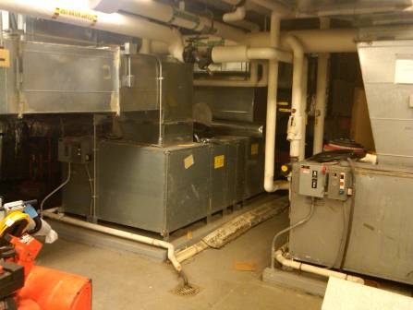

Air-handling unit

Picture 2

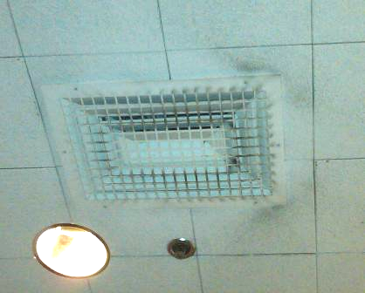

Fresh air diffuser, note dust/debris around diffuser

Picture 3

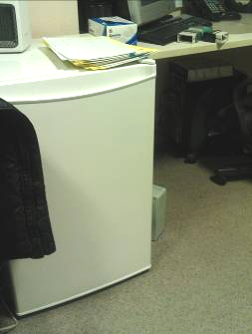

Refrigerator on carpet

Picture 4

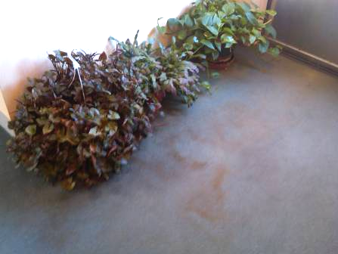

Plants on carpeting, note water-stained carpet

Picture 5

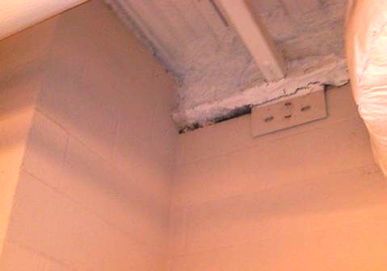

Space in wall of sally port

Picture 6

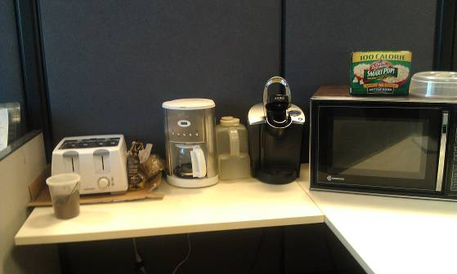

Food preparation equipment in cubicle

Picture 7

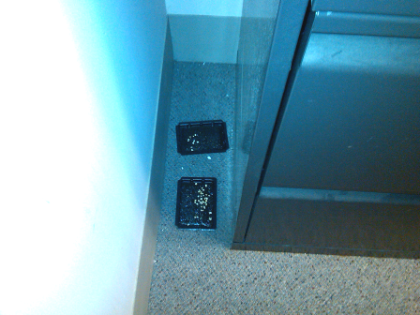

Baited traps

Picture 8

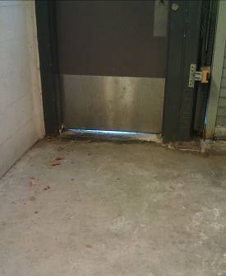

Space under door of sally port

Picture 9

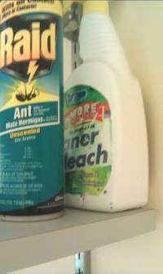

Pesticide on shelf

Picture 10

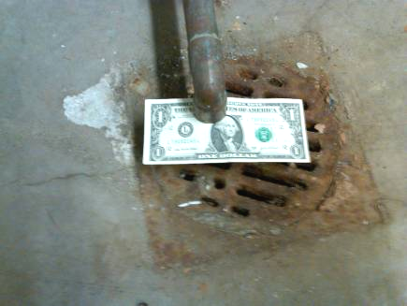

AHU condensation drain drawing air

Picture 11

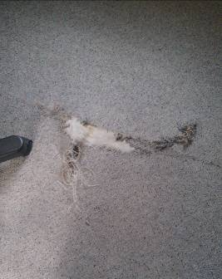

Torn carpeting

Picture 12

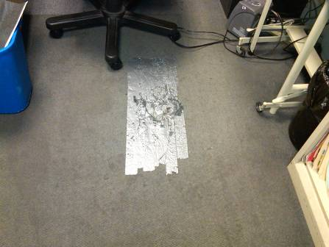

Duct tape covering damaged carpeting
Location | Carbon  Dioxide  (ppm) | Carbon Monoxide  (ppm) | Temp  (°F) | Relative  Humidity  (%) | PM2.5  (µg/m³) | Occupants  in Room | Windows  Openable | Ventilation |  | Remarks
 |  |  |  |  |  |  |  | Supply | Exhaust | Remarks
Background | 412 | 2-3 | 40 | 75 | 16 |  |  |  |  | Wind, mixed precipitation
103 | 522 | ND | 71 | 20 | 5 | 0 | Y | Y | Y | DO, CPs
105 | 502 | ND | 73 | 20 | 5 | 0 | Y | Y | Y | DO, CPs, AD
110 (Graves) | 550 | ND | 74 | 20 | 6 | 0 | Y | Y  dusty | Y | DO
112 | 654 | ND | 73 | 24 | 6 | 1 | Y | Y | Y | plants
116 | 442 | ND | 71 | 19 | 7 | 0 | Y | Y | Y
117 | 463 | ND | 72 | 19 | 7 | 0 | Y | Y | Y | DO, damaged carpeting
118 | 570 | ND | 72 | 20 | 7 | 1 | Y | Y | Y | Plants, DO, coffee maker
123 | 513 | ND | 72 | 20 | 7 | 0 | Y | Y | Y
1st session | 543 | ND | 73 | 21 | 6 | 1 | N | Y | Y | PC, damaged carpeting
1st session hall | 621 | ND | 74 | 18 | 12 | 5
204 | 519 | ND | 74 | 19 | 4 | 0 | Y | Y | In bathroom | plant on carpet
206 | 565 | ND | 75 | 19 | 4 | 0 | Y | Y | In bathroom | DO
210 | 496 | ND | 73 | 19 | 7 | 0 | Y | Y | In bathroom
214 | 549 | ND | 73 | 21 | 5 | 0 | Y | Y | N | DEM
2nd session | 506 | ND | 73 | 20 | 6 | 0 | N | Y  dusty | Y | WD-CT
3rd session | 480 | ND | 73 | 20 | 6 | 0 | N | Y  dusty | Y
4th session | 487 | ND | 73 | 20 | 5 | 0 | N | Y | Y
5th session | 472 | ND | 72 | 20 | 12 | 0 | N | Y  dusty | Y
6th session | 469 | ND | 73 | 21 | 5 | 0 | N | Y  dusty | Y
Boiler room office | 479 | ND | 76 | 20 | 9 | 0 | N | N | N | Toaster, coffee maker, maintenance items
C 242, restraining order department | 456 | ND | 72 | 20 | 9 | 2 | N | Y | Y | Damaged carpeting
C126 | 542 | ND | 74 | 20 | 7 | 0 | N | Y | Y | Occupant reported black dust on rolling file cabinet that was cleaned January 3rd , MT, 3 WD-CTs, PF
C129 | 560 | ND | 75 | 21 | 5 | 1 | N | Y  dusty | Y | DO, fridge on carpet, microwave
C136 | 524 | ND | 72 | 21 | 7 | 0 | N | Y  paper | Y | DO
C137 | 498 | ND | 73 | 20 | 7 | 0 | N | Y | Y
C138 | 527 | ND | 73 | 20 | 6 | 1 | N | Y | N | Plants
C140 | 610 | ND | 72 | 21 | 7 | 2 | N | Y  dusty | Y | DO
C152 | 559 | ND | 75 | 19 | 5 | 1 | N | Y | Y | Copier, DO
C155 | 503 | ND | 74 | 19 | 5 | 0 | N | Y | Y | DEM
C18 | 521 | ND | 74 | 20 | 8 | 0 | Y | Y | Y | AD
Clerk magistrate waiting area | 495 | ND | 74 | 19 | 10 | 4 | N | Y | Y
Clerk’s file room | 571 | ND | 75 | 21 | 6 | 2 | N | Y | Y | Copier, files, DO
DA’s office entrance | 699 | ND | 75 | 21 | 9 | 1 | N | Y | Y | 8 WD-CTs, CPs, AD
File storage | 583 | ND | 74 | 20 | 9 | 0 | N | Y | Y | DO
First session waiting area | 522 | ND | 75 | 19 | 10 | 4 | N | Y | Y
G11 | 540 | ND | 74 | 20 | 9 | 1 | Y | Y | Y | Stained carpeting, microwave, insecticide
G12 | 522 | ND | 73 | 22 | 6 | 1 | Y | Y | Y | FC-off
G125 | 912 | ND | 74 | 20 | 9 | 11 | Y | Y | Y | Passive wall vent, MT
G13 | 519 | ND | 72 | 19 | 9 | 0 | N | Y | Y
G14 | 462 | ND | 74 | 18 | 7 | 0 | Y | Y | Y | Rust-stained carpet, plants, fridge on carpet
G15 | 699 | ND | 75 | 21 | 7 | 1 | Y | Y | Y | Items, plants, Pepsi can wall
G156 | 538 | ND | 75 | 19 | 8 | 0 | N | Y  dusty | Y | WD-carpet, DEM
G16 | 703 | ND | 74 | 23 | 10 | 0 | Y | Y | Y | DO, fridge. AD-candles
G17 | 613 | ND | 74 | 22 | 10 | 1 | Y | Y | Y | DO, fridge on carpet
G4 | 579 | ND | 74 | 20 | 5 | 0 | Y  1 of 2 | Y | Y | DO
GC16 | 534 | ND | 73 | 19 | 10 | 0 | Y | Y | Y | WD-carpeting
GC19 | 563 | ND | 74 | 19 | 10 | 1 | Y | Y | Y | WD-carpeting
GC25 | 579 | ND | 73 | 20 | 8 | 0 | N | Y | Y | DO, CPs, fridge on carpet
GC32 | 697 | ND | 73 | 21 | 13 | 1 | N | Y | Y
GC33 | 591 | ND | 73 | 20 | 11 | 0 | N | Y | Y
GC36 | 630 | ND | 74 | 20 | 9 | 0 | N | Y | Y
GC37 | 695 | ND | 74 | 22 | 9 | 1 | N | Y | Y
GC38 | 634 | ND | 74 | 20 | 10 | 0 | N | Y | Y
GC41 | 729 | ND | 74 | 23 | 11 | 0 | N | Y | Y | DO
GC42 | 522 | ND | 73 | 19 | 9 | 0 | N | Y | Y | WD-carpeting
GC43 | 727 | ND | 74 | 21 | 12 | 0 | N | Y | Y
GC45 | 658 | ND | 74 | 22 | 10 | 0 | N | Y | Y
GC46 | 566 | ND | 73 | 19 | 9 | 0 | N | Y | Y | WD-carpeting
GC48 | 526 | ND | 73 | 20 | 9 | 0 | N | Y | Y | WD-carpeting
GC49 | 524 | ND | 73 | 19 | 9 | 0 | N | Y | Y | WD-carpeting
GC5 | 565 | ND | 74 | 22 | 4 | 2 | N | Y | Y | DO
GC57 | 660 | ND | 75 | 22 | 11 | 0 | N | Y  dusty | Y ajar | PF, DO, candle
GC58 | 558 | ND | 74 | 20 | 10 | 0 | N | Y  dusty | Y | Dusty PF, DO
GC59 | 680 | ND | 75 | 21 | 10 | 2 | N | Y | Y | Plant on carpeting, water cooler
GC59 | 520 | ND | 74 | 19 | 7 | 0 | N | Y  dusty | Y | PF, fridge, microwave
GC8 | 558 | ND | 74 | 22 | 4 | 0 | N | Y | Y | DO, PC below exhaust
GC9 | 632 | ND | 73 | 23 | 4 | 0 | N | Y | Y | DO, AD
Judge’s Library | 652 | ND | 77 | 20 | 3 | 2 | N | Y | Y | Fridge on carpet
Probation cubicle areas | 523 | ND | 71 | 22 | 7 | 5 | N | Y | Y | Roof leak, plants, WD-CTs, MT
Sally port | 493 | ND | 69 | 24 | 11 | 0 | N | N | Y-switch activated | Breaches in door

Service life of carpeting is dependant on the installation; amount of traffic; quality of carpet; and the proper care and cleaning.

