**INDOOR AIR QUALITY ASSESSMENT**

**Boston Police Department**

**Crime Labs**

**1 Schroeder Plaza**

**Roxbury Crossing, MA**

Boston Police Department
Crime Labs
1 Schroeder Plaza
Roxbury Crossing, MA
exterior view of building


Prepared by:

Massachusetts Department of Public Health

Bureau of Environmental Health

Indoor Air Quality Program

December 2022

# BACKGROUND

|  |  |
| --- | --- |
| Building: | Boston Police Department (BPD) Crime Lab |
| Address: | 1 Schroeder Plaza, Roxbury Crossing, MA |
| Assessment Requested by: | Rachel Kerry, CCSA, CLPE,  Criminalist II - Latent Print Unit,  Boston Police Department |
| Reason for Request: | General indoor air quality (IAQ) |
| Date of Assessment(s): | October 14, 2022  November 10, 2022  December 1, 2022 |
| Massachusetts Department of Public Health/Bureau of Environmental Health (MDPH/BEH) Staff Conducting Assessment: | Michael Feeney, Director,  and Jennifer Lajoie, Environmental  Analyst, IAQ Program |
| Building Description: | BPD is a four-story, tiered, cement  and steel frame building constructed in  1997 as an energy efficient building  with two distinct wings (north and  south). The building is located at the  south corner of Ruggles and Tremont  Streets. The second-floor south wing  contains the police laboratory. |
| Windows: | The majority of the building has energy efficient, double-paned windows, many of which can open. |

# METHODS

Please refer to the IAQ Manual for methods, sampling procedures, and interpretation of results (MDPH, 2015).

# RESULTS AND DISCUSSION

The following is a summary of indoor air testing results (Table 1).

* ***Carbon dioxide levels*** were below the MDPH guideline of 800 parts per million (ppm) in all areas assessed. Note that most areas were lightly occupied or unoccupied at the time of the assessment; carbon dioxide levels would be expected to be higher with increased occupancy.
* ***Temperature*** was within the recommended range of 70°F to 78°F in areas assessed.
* ***Relative humidity*** was the within or close to the lower end of the recommended range of 40% to 60% in the areas assessed, however see Humidity Control section of this report.
* ***Carbon monoxide*** levels were non-detectable (ND) in all areas assessed.
* ***Fine particulate matter (PM2.5)*** concentrations measured were below the National Ambient Air Quality Standard (NAAQS) level of 35 μg/m3 in all areas assessed.

## Ventilation

The BPD has a mechanical heating, ventilating, and air-conditioning (HVAC) system that is described in the previous report (Appendix A). It is recommended that HVAC systems be re-balanced every five years to ensure adequate air systems function (SMACNA, 1994). It is unknown when the last time these systems were balanced.

## Microbial/Moisture Concerns

In the previous IAQ report (Appendix A), relative humidity control was discussed. During the current assessment, relative humidity indoors ranged from 39 to 44% which is within or very close to the recommended comfort range. Of note is the difference between the outdoor air measurement and indoor measurements, which may indicate the presence of a moisture source in the building. If a given volume of air is heated, its relative humidity would be reduced. As an example, air that is 64°F with a relative humidity of 48% will have a dew point of 44°F. If the dew point remains 44°F, indicating the same amount of water per unit air, and the temperature is raised to 70°F, the resulting relative humidity would be expected to drop to 40%.

However, the relative humidity inside the BPD lab area was consistently measured in a range of 3-5% higher than would be expected based on the dew point outside. These measurements may indicate that either/both of these conditions may exist:

* an unvented water source exists inside the lab and water vapor is being distributed through the HVAC system, or
* there is insufficient exhaust ventilation from the general HVAC system.

A lack of exhaust ventilation of water vapor can cause issues with temperature control, particularly during hot, humid weather.

Given the conditions seen during the assessment, IAQ staff would expect that relative humidity in the building would be much higher (>60%) during periods of persistent hot, humid weather. Relative humidity above the MDPH IAQ comfort level of 60%, reduces the ability of the human body to regulate temperature through perspiration and can lead to increased discomfort even if the temperature is in a comfortable range. Excess humidity can also be a source of water vapor to moisten building materials and stored materials.

There is evidence that condensation has occurred, such as fresh air supply vents that show signs of debris accumulation, which can occur when condensation is present (Picture 1). Another sign that indoor air has had high relative humidity for long periods of time is the presence of bowing ceiling tiles. These often result from a gradual degradation of the ceiling tile with exposure to chronic high humidity. Bowing ceiling tiles were noted in the BPD.

It is important to note that Massachusetts experienced extended periods of high relative humidity during the summers of 2018 and 2021 (WP, 2018; NOAA, 2021). July 2021 was the wettest ever recorded in Massachusetts, and the three-month period from June through August 2021, known as the meteorological summer, was tied for the warmest on record across the United States, according to the National Oceanic and Atmospheric Administration’s Centers for Environmental Information (NOAA, 2021).

This weather resulted in condensation problems in many publicly-owned or operated buildings (HG, 2021), particularly those with below-grade spaces with wall or floors in direct contact with soil or cement slab. In these instances, the floors in direct contact with soil may have temperatures that would result in condensation wetting floors under conditions of high relative humidity.

## Other Conditions

Lab staff report periodic headaches. After conferring with staff, the incidence of headaches appears to coincide with test firing of firearms in the gun lab (Figure 1). The discharge of firearms produces superheated gunshot particle residue (GPR). GPR is expelled from the firearm to become readily aerosolized. Once airborne GPR will rise due to its heat and will readily be captured and transported by airflow. For this reason, firearm ranges are equipped with an exhaust ventilation system usually located at/near the point of round impact. Appropriately located exhaust ventilation will draw both round impact debris and GPR downrange (and away) from the shooting location. In this configuration, the shooter’s exposure to gunshot-related gasses, vapors and particles can be reduced.

In general, a firearm range should not have return/exhaust vents connected to the general ventilation system. A range may have a fresh air supply located up range from the shooter that will serve as an air supply for operating a special dedicated exhaust ventilation system that is separate from the general ventilation system. The purpose of this is to create one-way airflow from up range to down range to draw GPR away from the shooter to be ejected from the building. It is important to note that an appropriate gun range exhaust ventilation system will have filters collect metal fume to prevent discharge to the environment.

The following conditions exist in the gun lab range at the BPD:

* The firing range has a fresh air supply and series of return vents that are connected to the general ventilation system. The one general ventilation supply diffuser is located downrange with the vent configured to direct airflow ***up range*** (Picture 2).
* The firing room has specially designed water tank for pistol firing as well as a trap constructed by Savage Range Systems used for shotguns (Picture 3). The pistol tank has a dedicated exhaust vent that draws round residue and water vapor. The shotgun trap has no dedicated mechanical exhaust ventilation. Rounds impact in an area beneath the general ventilation fresh air supply that deposit into a bin filled with water (Picture 4). This equipment may also be one source of excess moisture in the building.
* The room has a fume exhaust vent located behind where firearms are discharged (Picture 5). The fume hood was not operating during any visit. In addition, IAQ staff could not identify any means to activate the fume hood. Gun lab staff reported no knowledge regarding how to activate the fume hood, therefore it is not used during test firing of firearms in this room. Without the fume hood operating, firearm residue may exit the room into adjoining labs.

Given the airflow configuration, it is possible for GPR to be transported to other locations via the general ventilation system (Picture 6).

For proper operation, the gun lab range should be depressurized by the fume hood in order to prevent GPR migration into the ceiling plenum. Without active exhaust ventilation, GPR will readily rise and enter the area above the ceiling tiles (the ceiling plenum) through seams between ceiling tiles or any spaces created by ajar ceiling tiles (such as shown in Picture 2). IAQ staff determined that the walls of the gun lab range were extended to create an airtight seal with the roof decking. However, a significant space exists between the room’s wall and decking, which may serve a path for GPR to migrate into adjoining ceiling plenum space.

IAQ staff noted a room that was formerly used as a photographic developing dark room. A plastic grill in place of a ceiling tile (Picture 7) exists in this room that serves no discernable purpose. If GPR were to travel into the ceiling plenum, it may be readily drawn into this room via the plastic grill.

Of note was the use of a sticky fly trap hanging from a ceiling around a removed sink. The drain for the sink was plugged using a cloth towel (Picture 8). Unused plumbing fixtures can be a source of leaks, sewer gas odors, and drain flies.

# CONCLUSIONS/RECOMMENDATIONS

Based on this assessment, it appears that GPR from the gun lab range is not vented from the building and is distributed by the general HVAC system and/or migration to surrounding areas via the ceiling plenum. In addition, BPD has a number of issues related to relative humidity control in the building. The capacity of mechanical ventilation equipment to provide adequate chilled air and reduce relative humidity indoors is limited. The following documents can provide guidance that can be used to reduce the impact of hot, humid weather in buildings:

* Mold Growth Prevention During Hot, Humid Weather <https://www.mass.gov/service-details/preventing-mold-growth-in-massachusetts-schools-during-hot-humid-weather>
* Remediation and Prevention of Mold Growth and Water Damage in Public Schools <https://www.mass.gov/service-details/remediation-and-prevention-of-mold-growth-and-water-damage-in-public-schools-and>
* Methods for Increasing Comfort in Non-Air-Conditioned Schools <https://www.mass.gov/doc/methods-for-increasing-comfort-in-non-air-conditioned-schools/download>

A number of recommendations were made in the previous IAQ assessment (Appendix A). These recommendations should be implemented if not already completed. The following additional recommendations are made regarding the crime labs in the building, including short-term measures that may be implemented as soon as practicable, and long-term measures that will require planning and resources to address overall IAQ concerns:

## Short Term Recommendations

### Ventilation recommendations

1. Examine if general HVAC system exhaust ventilation is functioning and repair as needed.
2. Repair the fume hood in the gun lab range. Ensure that this vent be activated by gun lab staff when firearms are fired in the gun range lab.
3. Replace the plastic grill shown in Picture 7 with a solid ceiling tile.
4. Examine other exhaust vents to determine if functional or if they can be repaired. If possible, use exhaust vent fans to vent water vapor and other pollutants.
5. Routinely clean surfaces such as supply vents to remove debris and prevent mold growth. Follow manufacturer’s instructions to avoid damage to any HVAC equipment.

### Water damage recommendations

1. Work with an HVAC contractor to determine if the HVAC system can be operated or modified to provide additional dehumidification while in chilling mode.
2. Use dehumidifiers in the building during hot, humid weather if HVAC system is not capable of reducing relative humidity levels. If used, maintain all dehumidifiers, and regularly remove water and clean receptacles to avoid stagnant water, odors, and the potential for leaks.

### Other Recommendations

1. Ensure that all ceiling tiles in the gun lab range are sitting properly in their rails.
2. Seal all spaces between the gun lab range walls and ceiling with a fire-rated material to prevent GPR migration.
3. Permanently cut and cap or otherwise seal the drainpipe in Picture 8 with an appropriate material.

## Long Term Recommendations

1. Consider reconfiguring the general HVAC system vent in the gun lab range. This reconfiguration may include (Figure 2):
   * Install an exhaust duct above the impact areas of the shotgun trap that is connected to the existing fume hood.
   * Sealing//removing all return/exhaust vent connected to the general HVAC system in the gun lab range.
2. Consult a building engineering firm to conduct a building-wide ventilation systems assessment. Based on historical issues with air exchange/indoor air quality complaints, age, physical deterioration, and availability of parts for ventilation components, such an evaluation is necessary to determine the feasibility of repair or replacement of the equipment.

# REFERENCES

HG. 2021. Mold keeps South Hadley High School shuttered. Hampshire Gazette. <https://www.gazettenet.com/South-Hadley-High-School-still-closed-amid-mold-remediation-42413519>

MDPH. 2015. Massachusetts Department of Public Health. Indoor Air Quality Manual: Chapters I-III. Available at: <https://www.mass.gov/lists/indoor-air-quality-manual-and-appendices#indoor-air-quality-manual->

NOAA. 2021. Summer 2021 neck and neck with Dust Bowl summer for hottest on record. National Oceanic and Atmospheric Administration, 1401 Constitution Avenue NW, Room 5128, Washington, DC 20230. <https://www.noaa.gov/news/summer-2021-neck-and-neck-with-dust-bowl-summer-for-hottest-on-record>.

SMACNA. 1994. HVAC Systems Commissioning Manual. 1st ed. Sheet Metal and Air Conditioning Contractors’ National Association, Inc., Chantilly, VA.

WP. 2018. ‘It’s been relentless’: Smothering summer humidity in the Northeast has crushed records. Washington Post, Washington, DC. <https://www.washingtonpost.com/news/capital-weather-gang/wp/2018/08/30/its-been-relentless-smothering-summer-humidity-in-the-northeast-has-crushed-records/>

**Figure 1**

**Gun Lab Range Current Configuration**

General HVAC Return Vents

Pistol Tank

Shot Gun Trap

Round firing direction

Fresh Air Supplies Firing Locations Exhaust Hood

**Figure 2**

**Possible Reconfigured Gun Lab Range to Draw GSP Downrange**

Sealed General HVAC Return Vents Relocated Fresh Air Supply

Pistol Tank

Shot Gun Trap

Round firing direction

New exhaust vent opening connected by flexible/ fire-rated duct Original Exhaust Hood

**Picture 1**

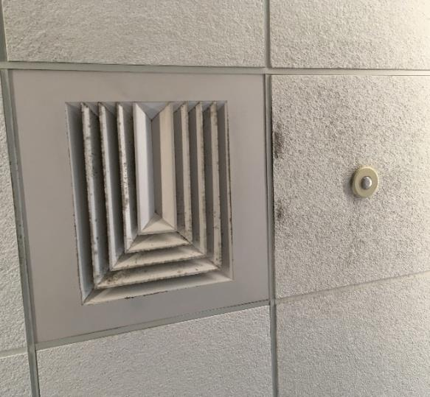

**Fresh air diffuser showing sign of condensation in the form of adhered debris to surface. Note debris on ceiling tile in airflow, which can also indicate moistening from humid air**

**Picture 2**

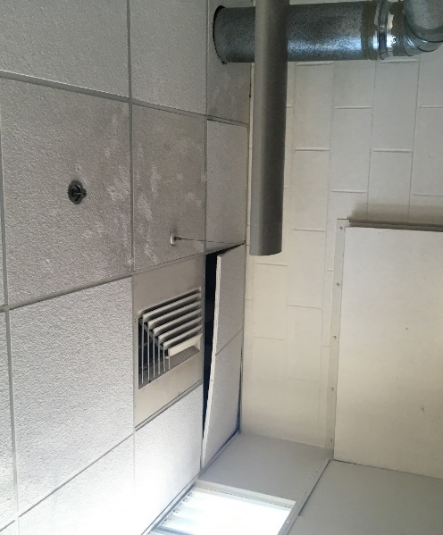

**Downrange general fresh air supply vent directing air up range. Note ajar ceiling tiles and likely GSP coating ceiling tiles**

**Picture 3**

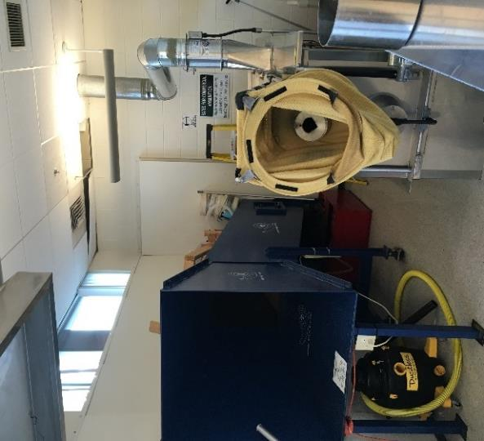

**Pistol Water Firing Tank (right) and Savage Range Systems shot trap (left)**

**Picture 4**

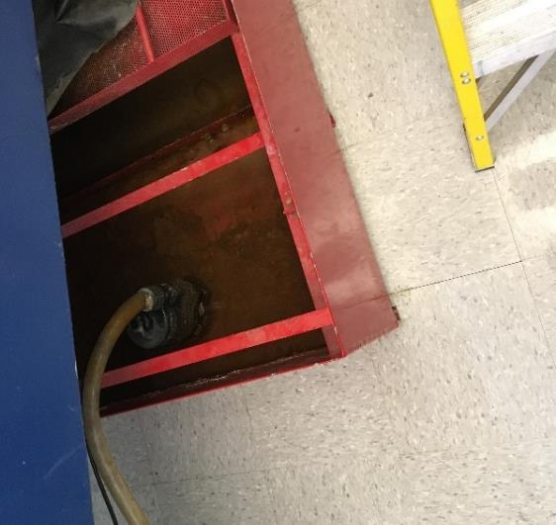

**Shot collection bin filled with water**

**Picture 5**

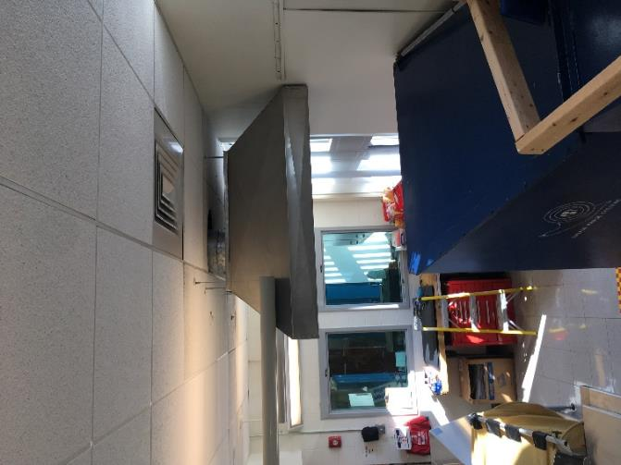

**Deactivated fume hood exhaust vent**

**Picture 6**

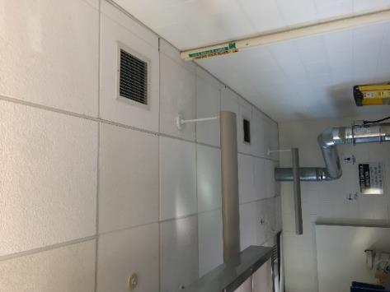

**General HVAC system exhaust vents above pistol tank (arrows)**

**Picture 7**

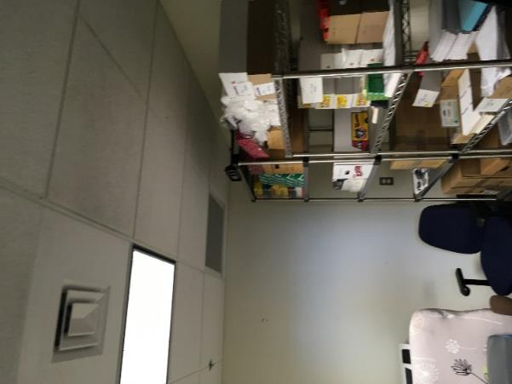

**Plastic grill in suspended ceiling**

**Picture 8**

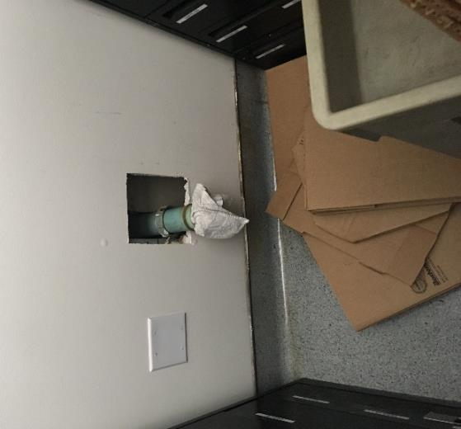

**Drainpipe sealed with towel**

| Location | **Carbon Dioxide**  **(ppm)** | **Carbon Monoxide (ppm)** | **Temp**  **(°F)** | **Relative**  **Humidity**  **(%)** | **PM2.5**  **(µg/m3)** | **Occupants** | **Window**  **Openable** | **Ventilation** | | **Remarks** |
| --- | --- | --- | --- | --- | --- | --- | --- | --- | --- | --- |
| **Supply** | **Exhaust** |
| Background | 397 | ND | 64 | 48 | ND |  |  |  |  | Sunny |
| S-227 breakroom area | 525 | ND | 70 | 44 | ND | 0 | N/A | Y | Y | Photocopier, fridge, microwave, toasters |
| S-227 | 626 | ND | 72 | 42 | ND | 0 | N/A | Y | Y | Fridge |
| S-230 | 562 | ND | 72 | 41 | ND | 0 | Y | Y | Y | solar glare |
| S-230 inner area | 569 | ND | 76 | 39 | ND | 0 | Y | Y | Y | Lab equipment |
| Photo room | 544 | ND | 73 | 40 | ND | 0 | N/A | Y | Y |  |
| Desk area off room S-227 | 630 | ND | 74 | 41 | ND | 7 | Y | Y | Y | cubicles |
| S-233 | 535 | ND | 73 | 40 | ND | 0 | N | Y | Y |  |
| S-232 | 573 | ND | 73 | 40 | ND | 0 | N | Y | Y | sink |
| S-273 | 551 | ND | 72 | 42 | ND | 0 | N/A | Y | Y |  |
| S-238 | 503 | ND | 72 | 41 | ND | 0 | N/A | Y | Y | Sink, printer |
| S-239 | 510 | ND | 72 | 41 | ND | 1 | N/A | Y | Y |  |
| S-240 | 447 | ND | 72 | 40 | ND | 0 | N | Y | Y | Gas tank, sink, eyewash station |
| S-236 | 442 | ND | 72 | 39 | ND | 0 | N | Y | Y | Sink dripping |
| S-246 | 534 | ND | 72 | 41 | ND | 0 | N | Y | N | Photocopiers, shredder |
| Breakroom 2nd lab | 581 | ND | 72 | 42 | ND | 4 | N/A | Y | Y | Evidence freezers |
| Firearms- S-210 | 569 | ND | 71 | 43 | ND | 2 | N | Y | Y |  |
| S-214 | 516 | ND | 71 | 42 | ND | 0 | N | Y | Y |  |
| S-216 | 513 | ND | 71 | 42 | ND | 0 | N | Y | Y |  |
| S-213 | 517 | ND | 71 | 42 | ND | 0 | N/A | Y | Y |  |
| S-217 | 507 | ND | 70 | 43 | ND | 0 | N | Y | Y |  |
| S-219 | 547 | ND | 70 | 43 | ND | 0 | N/A | Y | Y |  |
| S-219 inner room | 541 | ND | 70 | 44 | ND | 0 | N | Y | Y |  |
| S-218 | 541 | ND | 70 | 44 | ND | 0 | N | Y | Y |  |
| S-279 | 540 | ND | 71 | 42 | ND | 1 | N | Y | Y |  |
| S-276 | 511 | ND | 71 | 42 | ND | 0 | N | Y | Y | Fridge, Keurig, water filter |
| S-274 | 579 | ND | 71 | 43 | ND | 1 | N | Y | Y |  |
| S-263 | 508 | ND | 71 | 42 | ND | 0 | N | Y | Y |  |
| S-261 | 670 | ND | 72 | 43 | ND | 2 | N/A | Y | Y |  |
| S-259 | 525 | ND | 72 | 41 | ND | 1 | N/A | Y | Y |  |
| S-267 examination room | 433 | ND | 72 | 41 | ND | 0 | N/A | Y | Y | Eyewash station, lab, sinks |
| S-256 | 454 | ND | 71 | 42 | ND | 2 | N/A | Y | Y |  |
| S-257 | 457 | ND | 71 | 42 | ND | 0 | N/A | Y | Y |  |

**APPENDIX A**

**INDOOR AIR QUALITY ASSESSMENT**

**Boston Police Headquarters**

**One Schroeder Plaza**

**Boston, Massachusetts**

Prepared by:

Massachusetts Department of Public Health

Center for Environmental Health

Emergency Response/Indoor Air Quality Program

July 2006

1

**Background/Introduction**

In response to a request from Sandra DeBow, Deputy Director of Labor Relations, the Massachusetts Department of Public Health (MDPH), Center for Environmental Health (CEH) conducted an indoor air quality assessment at the Boston Police Headquarters (BPHQ), One Schroeder Plaza, Boston, Massachusetts. Concerns about indoor air quality, temperature control and sporadic respiratory problems prompted the request.

On August 23, 2005, Michael Feeney, Director of CEH’s Emergency Response/Indoor Air Quality (ER/IAQ) Program, made an initial visit to this building. Mr. Feeney returned on January 31 and February 1, 2006 to complete the assessment and to observe the operation of the heating, ventilating and air-conditioning (HVAC) system during the heating season.

The BPHQ is a four-story, tiered, cement and steel frame building constructed in 1997 as an energy efficient building with two distinct wings (north and south). The building is located at the south corner of Ruggles and Tremont Streets. A gasoline service station existed on the BPHQ site prior to construction. The fourth floor of the building contains the police and emergency medical services (EMS) operation centers in the north wing, with office located throughout the entire floor. The third floor contains offices and large rooms divided by cubicles. The second floor south wing contains the police laboratory. A variety of private offices and large rooms divided by cubicles exist on the second floor. The north wing of the first floor contains a day care center, cafeteria, private offices and large rooms divided by cubicles. The south wing of the first floor contains holding cells and offices. Windows in the building do not open. The majority of the building has energy efficient, double-paned windows (Picture 1). Significant sections of the building have glass block windows (Picture 2). The building has no basement and is built on a slab.

# Methods

Air tests for carbon dioxide, temperature and relative humidity were taken with the TSI, Q-Trak, IAQ Monitor. Surface temperature of building components was taken with a Thermotrace laser thermometer. Light intensity was measured with an Extech Instruments Foot Candle/Lux Meter. Air tests for airborne particle matter with a diameter less than 2.5 micrometers were taken with the TSI, DUSTTRAK™ Aerosol Monitor Model 8520.

**Results**

The BPHQ has an employee population of over 200, with several hundred visitors on a daily basis. Tests were taken under normal operating conditions and results appear in Tables 1 through 3. Testing results for light and PM 2.5 measurements are listed in Table 4. Air sampling results are listed in the Tables by location that the air sample was taken.

**Discussion**

**Ventilation**

It can be seen from Tables 1 through 3 that carbon dioxide levels were below 800 parts per million (ppm) parts of air in all areas surveyed over the course of the three visits, with the exception of the day care center and N129. The results indicate that the heating, ventilating and air-conditioning (HVAC) system is providing an adequate amount of fresh air in the majority of the BPHQ. Please note that carbon dioxide levels measurements were made during typical operations in the building. A number of areas that had carbon dioxide levels below 800 ppm were measured in unoccupied or areas with low population, which can greatly reduce carbon dioxide levels.

Fresh air is supplied by ceiling or wall mounted fresh air supply vents. Each area adjacent to windows is equipped with a baseboard radiator (Picture 3). Exhaust ventilation is provided by ceiling mounted exhaust vents. Some areas (the Latent Fingerprint Intake Office) were retrofitted into the building after construction and lack a connection to the return vent.

To maximize air exchange, the MDPH recommends that all components of the ventilation system operate continuously during business hours. Without the HVAC system operating as designed, normally occurring pollutants cannot be diluted or removed, allowing them to build up and leading to indoor air quality/comfort complaints. In order to have proper ventilation, the systems must be balanced to provide an adequate amount of fresh air to the interior of a room while removing stale air from the room. It is recommended that HVAC systems be re-balanced every five years to ensure adequate air systems function (SMACNA, 1994). The date of the last balancing of these systems was not available at the time of the assessment

The Massachusetts Building Code requires that each room have a minimum ventilation rate of 20 cubic feet per minute (cfm) per occupant of fresh outside air or openable windows (SBBRS, 1997). The ventilation must be on at all times that the room is occupied. Providing adequate fresh air ventilation with open windows and maintaining the temperature in the comfort range during the cold weather season is impractical. Mechanical ventilation is usually required to provide adequate fresh air ventilation.

Carbon dioxide is not a problem in and of itself. It is used as an indicator of the adequacy of the fresh air ventilation. As carbon dioxide levels rise, it indicates that the ventilating system is malfunctioning or the design occupancy of the room is being exceeded. When this happens a buildup of common indoor air pollutants can occur, leading to discomfort or health complaints. The Occupational Safety and Health Administration (OSHA) standard for carbon dioxide is 5,000 parts per million parts of air (ppm). Workers may be exposed to this level for 40 hours/week based on a time-weighted average (OSHA, 1997).

The MPDH uses a guideline of 800 ppm for publicly occupied buildings. A guideline of 600 ppm or less is preferred in schools due to the fact that the majority of occupants are young and considered to be a more sensitive population in the evaluation of an environmental health status. Inadequate ventilation and/or elevated temperatures are major causes of complaints such as respiratory, eye, nose and throat irritation, lethargy and headaches. For more information concerning carbon dioxide, see Appendix A.

The following temperature ranges were measured within the BPHQ.

August 23, 2005 70o to 74 o F`

January 31, 2006 69o to 74o F

February 1, 2006 70o to 72o F

Temperature readings were within or very close to the MDPH recommended comfort range of 70o to 78o F over the course of the three visits. Employees expressed concerns about temperature control (e.g., not enough heat in winter, not enough cooling in summer). A number of factors that contribute to these temperature control difficulties were identified, primarily the condition of windows and their orientation to solar glare and wind. Whether a window is exposed to solar heat or impinged by cold wind are factors that can influence the perception of temperature, particularly if an individual is seated near the window.

Temperature complaints were received in areas that had energy efficient windows as well as areas with glass block windows. As mentioned previously, the window system in most areas of the BPHQ consists of double panes of glass installed inside a metal frame. During the course of the winter 2006 visits, CEH staff measured surface temperature of the window frames and panes of both window systems in a variety of areas. Surface temperatures of interior walls were taken as a comparison. Windows that are not exposed to sunlight and are exposed to northwesterly winds during frigid weather have significantly lower temperature than interior walls (Window frame temperature ranged[1] from 48o F to 77o F; windowpane temperature ranged from 51o F to 72oF; and; interior walls 61o F to 74o F) during the winter 2006 visit. From these measurements, the location of the room and weather conditions appeared to have a significant influence on chilling of the window frames. In addition, temperature difference between the walls and window system components would not be expected, since the fenestration system appears to be double-paned energy efficient windows.

CEH staff examined the exterior of double-paned windows and found gaps in window gaskets and/or caulking, which can lead to air penetration. The glass block window systems appear to have minimal insulation, since cold drafts could be detected along cement seams.

At the base of window systems of exterior walls in each is a large baseboard heating coil (Picture 3). These baseboard-heating coils are intended to provide heat during cold weather, particularly in areas with glass block windows. CEH staff examined baseboard-heating coils on a number of floors during the winter 2006 visits and found roughly half not producing heat. This condition indicates that these units were either deactivated or not connected to the heating system appropriately.

Therefore, a number of factors exist that contribute to the difficulty in controlling temperature in the building. Please note that even with these design and construction issues, fluctuations of temperature in occupied spaces are typically experienced, even in a building with an adequate fresh air supply.

The following relative humidity ranges were measured within the BPHQ.

August 23, 2005 46% to 52%

January 31, 2006 23% to 35%

February 1, 2006 28% to 29%

The relative humidity in the BPHQ was within the MDPH recommended comfort range on August 23, 2005 and were below the MDPH recommended comfort range on January 31 and February 1, 2006. The MDPH recommends a comfort range of 40 to 60 percent for indoor air relative humidity. Relative humidity in the building would be expected to drop during the winter months due to heating. The sensation of dryness and irritation is common in a low relative humidity environment. Low relative humidity is a common problem during the heating season in the northeast part of the United States.

**Microbial/Moisture Concerns**

A distinct mold/musty odor was detected in both the men and women’s locker rooms in the operations areas. Each of these areas was carpeted. Other locker rooms in the BPHQ do not have similar odors and have tile instead of carpeting. It is not recommended that carpet be used as flooring in locker rooms since it is likely to be moistened from traffic from shower use. If carpeting is wet repeatedly it cannot sufficiently dry. Repeated water damage to porous building materials (e.g., carpeting, ceiling tiles) can result in microbial growth. The US Environmental Protection Agency (US EPA) and the American Conference of Governmental Industrial Hygienists (ACGIH) recommend that porous materials be dried with fans and heating within 24 to 48 hours of becoming wet (US EPA, 2001; ACGIH, 1989). If not dried within this time frame, mold growth may occur. Once mold has colonized porous materials, they are difficult to clean and should be removed.

Water damaged ceiling tiles were noted in some areas, which are likely the result of leaks from a roof drain (Picture 4). Water-damaged ceiling tiles can provide a source of mold and should be replaced after a water leak is discovered and repaired.

Plants were observed in a number of areas. Moistened plant soil and drip pans can provide a source of mold growth. Plants are also a source of pollen. Plants should be located away from the air stream of ventilation sources to prevent the aerosolization of mold, pollen or particulate matter throughout the area. Plants should have drip pans to prevent wetting and subsequent mold colonization. Over watering of plants should be avoided and drip pans should be inspected periodically for mold growth.

Water coolers were located over carpeting in some areas. Water spillage or overflow of cooler catch basins can result in the wetting of the carpet. In addition, some of the coolers had residue/build-up in the reservoir. These reservoirs are designed to catch excess water during operation and should be emptied/cleaned regularly to prevent microbial and/or bacterial growth.

**Other Concerns**

One area of concern was the indoor air quality within the tape room. This area consists of two rooms, the tape library and a computer equipment room. Each room is separated by a wall with an open doorway. Of note are cabinets that contain the computer equipment (Picture 5). Each cabinet is designed to draw air from the floor to cool the computer equipment. Air is drawn through the cabinet and ejected by a fan in the top of the cabinet into the room (Picture 6). In this configuration, any dust or chemicals that exist at the base of the cabinet will be aerosolized with the operation of the fan. Therefore, no materials should be stored on the floor of this room. A significant amount of cardboard boxes and other materials were found around the base of the cabinet (Picture 7). Cardboard is manufactured using a number of chemicals and mastics, which can be a source of pollutants that can be irritating to the eyes, nose and throat. This type of ventilated computer cabinet should be used in an area with sufficient exhaust ventilation to remove waste heat and aerosolized pollutants.

Building occupants expressed concerns about rodent infestation; CEH staff observed bait traps in a number of areas. Rodent infestation can result in indoor air quality related symptoms due to materials in their wastes. Mouse urine is known to contain a protein that is a known sensitizer (US EPA, 1992). A sensitizer is a material that can produce symptoms in sensitive individuals (e.g., running nose or skin rashes). A three-step approach is necessary to eliminate rodent infestation:

1. removal of the rodents;
2. cleaning of waste products from the interior of the building; and
3. reduction/elimination of pathways/food sources that are attracting rodents.

To eliminate exposure to allergens, rodents must be removed from the building. Please note that removal, even after cleaning, may not provide immediate relief since allergens can exist in the interior for several months after rodents are eliminated (Burge, H.A., 1995). A combination of cleaning, increase in ventilation and filtration should serve to reduce rodent associated allergens once the infestation is eliminated.

Of note was the existence of two concrete shafts roughly 100 feet to the north of the BPHQ (Picture 8). These airshafts likely provide exhaust ventilation for the Massachusetts Bay Transit Authority (MBTA) subway/railway tunnel connect to Ruggles Station. Each of these air shafts terminate at a level that is *below* the height of the BPHQ. Since the possibility for diesel exhaust venting from these airshafts *toward* the BPHQ during northwest wind conditions, CEH staff conducted air sampling for respirable particulates in selected areas of the building.

The US EPA has established NAAQS limits for exposure to particulate matter. Particulate matter is airborne solids that can be irritating to the eyes, nose and throat. The NAAQS originally established exposure limits for particulate matter with a diameter of 10 μm or less (PM10). According to the NAAQS, PM10 levels should not exceed 150 micrograms per cubic meter (μg/m3) in a 24-hour average (US EPA, 2000). This standard was adopted by both ASHRAE and BOCA. Since the issuance of the ASHRAE standard and BOCA Code, US EPA proposed a more protective standard for fine airborne particles. This more stringent, PM2.5 standard requires outdoor air particulate levels be maintained below 65 μg/m3 over a 24-hour average (US EPA, 2000). Although both the ASHRAE standard and BOCA Code adopted the PM10 standard for evaluating air quality, MDPH uses the more protective proposed PM2.5 standard for evaluating airborne particulate matter concentrations in the indoor environment.

Outdoor PM2.5 concentrations were measured at 9 μg/m3. PM2.5 levels measured indoor occupied areas ranged from non-detect to 6 μg/m3 (Table 4), which were below background as well as the NAAQS of 65 μg/m3. This result is likely due to several reasons:

* the BPHQ having no openable windows;
* the air intakes for the ventilation system are on the side of the building *opposite* the airshafts; and
* the BPHQ HVAC system being equipped with high efficiency particulate arrestance (HEPA) filters, which would remove most aerosolized dust from outdoor air.

Frequently, indoor air levels of particulates (including PM2.5) can be at higher levels than those measured outdoors. A number of mechanical devices and/or activities that occur in buildings can generate particulates during normal operations. Sources of indoor airborne particulates may include but are not limited to particles generated during the operation of fan belts in the HVAC system, cooking in the cafeteria stoves and microwave ovens; use of photocopiers, fax machines and computer printing devices; operation of an ordinary vacuum cleaner and heavy foot traffic indoors. In the case of the BPHQ it was reported that vacuuming during the workday occurs, which can provide a likely source of respiratory irritation.

CEH staff received reports of fatigue and lethargy in both the EMS and police operations centers. CEH staff noted during their initial visit that both operations centers appeared to be significantly darker than other work areas in the building. To assess this contingency, CEH staff conducted light measurements at various workstations in the operations centers and at variety of other areas within the building at tabletop level (3 feet above the floor). Work areas within the operations center had light measurements 5-17 foot-candles (50-170 lux) compared to other work areas, which had 29-37 foot-candles (290-370 lux) (Table 5).

Low light conditions are associated with headaches, tired eyes, and/or irritation (NIOSH, 1998). Lack of light has also been associated with seasonal affective disorder, which among its symptoms is excessive tiredness (NMHA, 2006). Some recommended illuminations standards exist. The Illumination Engineering Society (IES) of North America recommends a lighting range of 20-50 foot-candles (200-500 lux) (NIOSH, 1998). The Illuminating Engineering Society of North America (IESNA) recommends a lighting range of 30-50 foot-candles (300-500 lux) (Veitch, J.A. and Newsham, G.R. 1996). Increasing lighting in both operations centers would serve to alleviate/reduce the reported symptoms in these work areas.

Odors from scented candles were noted in several areas (see Tables). These products may contain chemicals that can be irritating to the eyes, nose and throat of sensitive individuals. Duplication machines are located in a number of areas, including a print center (Picture 9). Photocopiers can produce VOCs and ozone, particularly if the equipment is older and in frequent use. VOCs and ozone are respiratory irritants (Schmidt Etkin, 1992). Of note is that at least one machine, the Risograph®, which uses a liquid toner. In the case of the print shop, no dedicated local exhaust ventilation exists for this area. Without operating exhaust ventilation, pollutants generated by duplicating equipment would accumulate and be distributed to other areas serviced by this zone of the HVAC system.

**Conclusions/Recommendations**

The indoor air quality conditions at the BPHQ are somewhat complex and interconnected. Issues concerning the design and construction of the building make aspects of temperature control difficult. Lack of a fully functional baseboard heating system and issues identified around windows play a significant role in lack of temperature control. In addition, the combination of equipment and activities that can readily aerosolize particulates (e.g., vacuuming during dayshift) and/or chemical respiratory irritants (e.g., photocopying center and tape library) can lead to increased reports of eye and respiratory irritation. For these reasons a two-phase approach is required, consisting of short-term measures to improve air quality and long-term measures that will require planning and resources to adequately address the overall indoor air quality concerns.

The following **short-term** measures should be considered for implementation:

1. Contact HVAC engineering-firm to evaluate system and improve air exchange in the daycare center and room N129.
2. Install a duct to direct computer cabinet in the tape library suite directly into the exhaust vent system for the building.
3. Remove all accumulated cardboard and other materials from the floor of the room where the tape library computer cabinet is located.
4. Provide exhaust ventilation for the Latent Fingerprint Intake Office.
5. Provide dedicated local exhaust ventilation for printing/photocopying equipment in the print shop and graphic arts offices.
6. To improve temperature control in the winter, reestablish function of all baseboard radiators along exterior walls.
7. Consideration should be give to relocating thermostats to locations that have free airflow, or that material that cut off airflow to thermostats be relocated.
8. Use window shades/blinds as much as practical to reduce heat/cold transmission into offices.
9. Consult a ventilation engineer concerning re-balancing of the ventilation systems. Ventilation industrial standards recommend that mechanical ventilation systems be balanced every five years (SMACNA, 1994).
10. Alter the vacuuming schedule so that offices that are not occupied on a twenty-four hour basis are cleaned after hours.
11. For buildings in New England, periods of low relative humidity during the winter are often unavoidable. Therefore, scrupulous cleaning practices should be adopted to minimize common indoor air contaminants whose irritant effects can be enhanced when the relative humidity is low. To control for dusts, a HEPA filter equipped vacuum cleaner in conjunction with wet wiping of all non-porous surfaces is recommended. Drinking water during the day can help ease some symptoms associated with a dry environment (throat and sinus irritations).
12. Remove the carpet from the BPOC locker rooms. Replace this flooring with a non-porous material similar to other locker rooms that exist in the BPHQ.
13. Provide an adequate amount of light at workstations in both emergency operation centers. In order to soften fluorescent lights, consider installing glare shields on all computer screens in this area as well as an incandescent lamp
14. It is highly recommended that the principles of integrated pest management (IPM) be used to rid this building of pest. A copy of the IPM recommendations can be downloaded from the MA Department of Agricultural Resources website at: <http://www.mass.gov/agr/pesticides/pestfacts/index.htm>. Activities that can be used to eliminate pest infestation may include the following activities.
    1. Rinse out recycled food containers. Seal recycled containers in a tight fitting lid to prevent rodent access.
    2. Remove non-food items that rodents are consuming.
    3. Stored foods in tight fitting containers.
    4. Avoid eating at workstations. In areas were food is consumed, periodic vacuuming to remove crumbs are recommended.
    5. Regularly clean crumbs and other food residues from toasters, toaster ovens, microwave ovens coffee pots and other food preparation equipment;
    6. Holes as small as ¼” is enough space for rodents to enter an area. Examine each room and the exterior walls of the building for means of rodent egress and seal. If doors do not seal at the bottom, install a weather strip as a barrier to rodents
    7. Reduce harborages (cardboard boxes) where rodent may reside.
15. Continue with replacement of wet ceiling tiles and repair sources of leaking water from roof drains. Repair water damage areas in the building in a manner consistent with guidelines set forth in “Mold Remediation in Schools and Commercial Buildings” published by the US Environmental Protection Agency (US EPA, 2001).
16. Discontinue use of scented candles in the building.
17. Place plastic, water impermeable mats beneath all water coolers on carpets.

**Long Term Recommendations**

1. Consideration should be given to examining the integrity of the window system to cold air penetration. Repairs may include repair and replacement of window frame gaskets and/or recaulking of window frames to reduce cold air pathways into the building. If not feasible to repair, consideration should be given to replacing the existing window system with energy efficient, double-paned type installed in a manner to prevent cold air penetration.

**References**

ACGIH. 1989. Guidelines for the Assessment of Bioaerosols in the Indoor Environment. American Conference of Governmental Industrial Hygienists, Cincinnati, OH.

BOCA. 1993. The BOCA National Mechanical Code/1993. 8th ed. Building Officials and Code Administrators International, Inc., Country Club Hill, IL. Section M-308.1.1.

Burge, H.A. 1995. *Bioaerosols*. Lewis Publishing Company, Boca Raton, FL.

NIOSH. 1998. HETA 98–0224–2714, The Trane Company, Ft. Smith, Arkansas. National Institute for Occupational Safety and Health, Cincinnati, OH. <http://www.cdc.gov/niosh/hhe/reports/pdfs/1998-0224-2714.pdf>

NMHA. 2006. Seasonal Affective Disorder Fact Sheet. National Mental Health Association. <http://www.nmha.org/infoctr/factsheets/27.cfm>

OSHA. 1997. Limits for Air Contaminants. Occupational Safety and Health Administration. Code of Federal Regulations. 29 C.F.R 1910.1000 Table Z-1-A.

SBBRS. 1997. Mechanical Ventilation. State Board of Building Regulations and Standards. Code of Massachusetts Regulations. 780 CMR 1209.0

Schmidt Etkin, D. 1992. Office Furnishings/Equipment & IAQ Health Impacts, Prevention & Mitigation. Cutter Information Corporation, Indoor Air Quality Update, Arlington, MA.

SMACNA. 1994. HVAC Systems Commissioning Manual. 1st ed. Sheet Metal and Air Conditioning Contractors’ National Association, Inc., Chantilly, VA

US EPA. 2001. “Mold Remediation in Schools and Commercial Buildings”. Office of Air and Radiation, Indoor Environments Division, Washington, DC. EPA 402-K-01-001. March 2001. Available at: http://www.epa.gov/iaq/molds/mold_remediation.html

US EPA. 2000. National Ambient Air Quality Standards (NAAQS). US Environmental Protection Agency, Office of Air Quality Planning and Standards, Washington, DC. <http://www.epa.gov/air/criteria.html>.

US EPA. 1992. Indoor Biological Pollutants. US Environmental Protection Agency, Environmental Criteria and Assessment Office, Office of Health and Environmental Assessment, Research Triangle Park, NC. ECAO-R-0315. January 1992.

Veitch, J. A. and Newsham, G. R. 1996. Determinants of Lighting Quality II: Research and Recommendations. American Psychological Association 10th Annual Conference, Toronto, Ontario, Canada August 12, 1996. National Research Council of Canada, Ottawa Ontario. <http://www.eric.ed.gov/ERICDocs/data/ericdocs2/content_storage_01/0000000b/80/26/a1/2b.pdf>

**Picture 1**

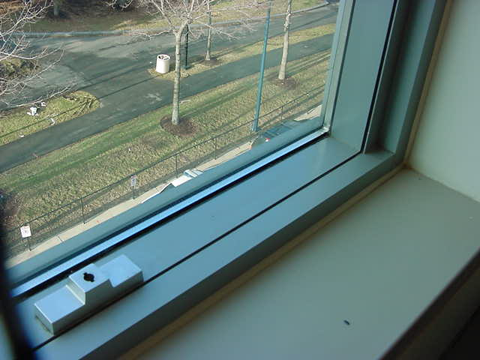

**Energy Efficient, Double-Paned Windows**

**Picture 2**

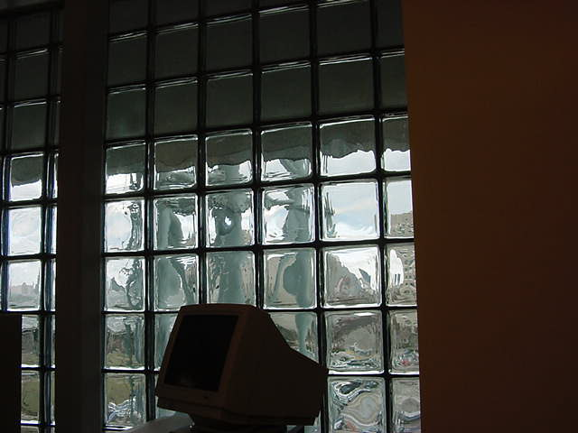

**Glass Block Windows**

**Picture 3**

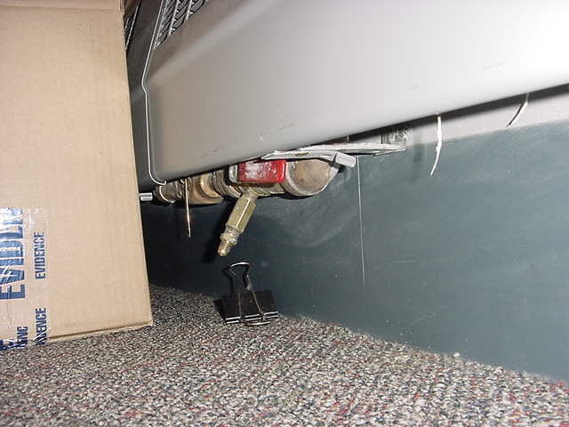

**Baseboard Radiator**

**Picture 4**

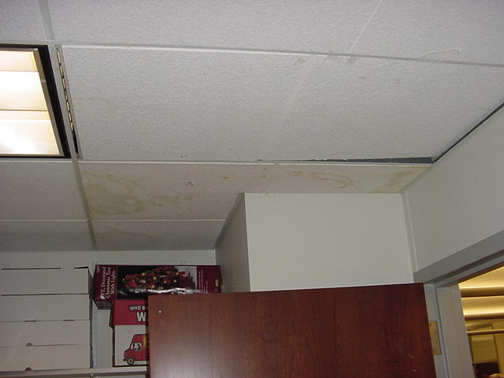

**Water Damaged Ceiling Tiles**

**Picture 5**

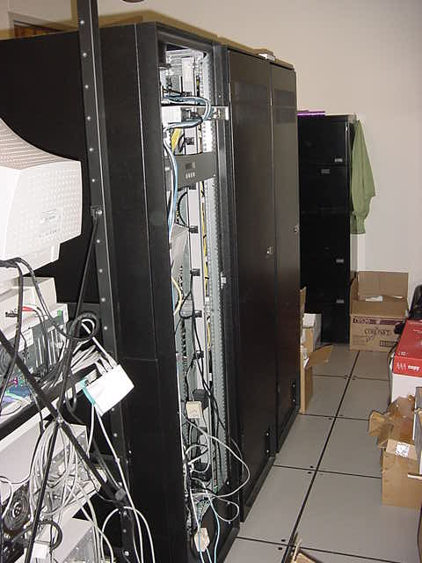

**Computer Cabinet in Tape Library Office Suite**

**Picture 6**

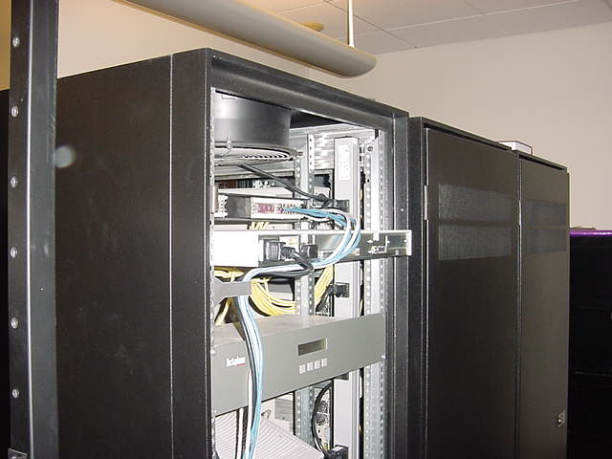

**Fan in top of Computer Equipment Cabinet**

**Picture 7**

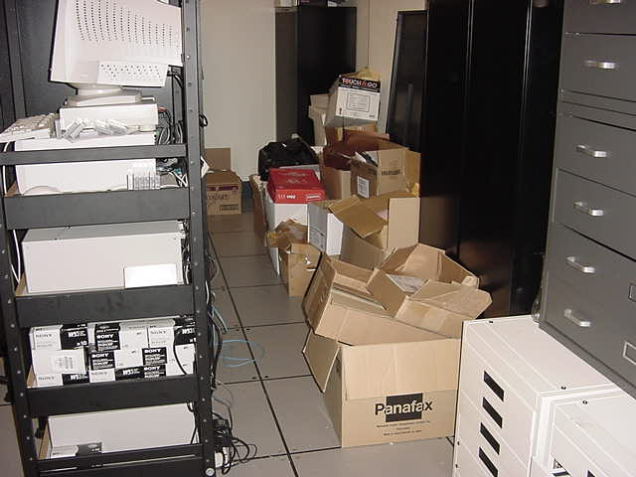

**Cardboard and Other Materials Stored at the Base of the Vented Computer Cabinet**

**Picture 8**

**Concrete Shafts Roughly 100´ to the North of the BPHQ**

**Picture 9**

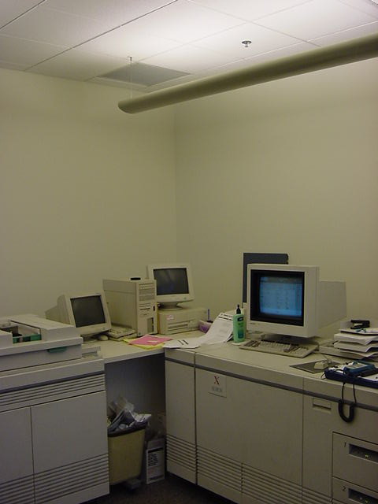

**Print Center**

| **Location** | **Carbon**  **Dioxide**  **(*ppm)** | **Temp.**  **(°F)** | **Relative**  **Humidity**  **(%)** | **Occupants**  **in Room** | **Windows**  **Openable** | **Ventilation** | | **Remarks** |
| --- | --- | --- | --- | --- | --- | --- | --- | --- |
| **Supply** | **Exhaust** |
| Outside  (Background) | 355 | 73 | 48 |  |  |  |  |  |
| Planning | 668 | 73 | 50 | 4 | Y | Y | Y | Door open |
| N439 | 600 | 72 | 49 | 0 | Y | Y | Y | Door open |
| N439-2 | 636 | 73 | 49 | 2 | Y | Y | Y | Water cooler on carpet  Plants |
| Operations/training center | 588 | 72 | 48 | 0 | Y | Y | Y | White board |
| Dispatch operations deputy supv. Office | 579 | 72 | 49 | 0 | Y | Y | Y | White board |
| EMS Lt. office | 598 | 72 | 48 | 1 | Y | Y | Y | Water cooler on carpet  Door open |
| Capt. Dispatch office 911 | 585 | 72 | 48 | 0 | Y | Y | Y | Clutter |
| Tape library | 635 | 70 | 52 | 1 | N | Y | Y | Cleaner  Cardboard stored at base of computer cabinets |
| Police Mechanical room | 599 | 70 | 46 | 2 | N | Y | Y |  |
| EMS Operations center | 639 | 71 | 52 | 8 | N | Y | Y | Water cooler on carpet |
| Stolen car area | 665 | 72 | 52 | 6 | N | Y | Y |  |
| Towed cars | 738 | 74 | 50 | 5 | N | Y | Y |  |
| Police operations center 911 | 648 | 73 | 48 | 12 | N | Y | Y | 8 radios |
| Shift commander operations division | 692 | 73 | 48 | 4 | N | Y | Y | Television monitors |
| N10 | 637 | 74 | 48 | 2 | N | Y | Y |  |
| Operations-Men’s locker room |  |  |  |  | N | Y | Y | Carpeted  Odor of ammonia disinfectant |
| Operations-Women’s locker room |  |  |  |  | N | Y | Y |  |
| N4111 | 575 | 72 | 47 | 0 | N | Y | Y | Television monitors |
| N4102 | 706 | 72 | 48 | 2 | N | Y | Y | White board |
| N4105 | 624 | 73 | 49 | 0 | N | Y | Y | Door open |
| N4100 | 675 | 72 | 49 | 6 | N | Y | Y | Plants |
| N4106 | 671 | 72 | 49 | 0 | 0 | N | Y |  |
| N4107 | 685 | 71 | 49 | 0 | N | Y | Y | Water cooler on carpet  Door open |
| S4135 | 685 | 72 | 50 | 2 | N | Y | Y |  |

| **Location** | **Carbon**  **Dioxide**  **(*ppm)** | **Temp.**  **(°F)** | **Relative**  **Humidity**  **(%)** | **Occupants**  **in Room** | **Windows**  **Openable** | **Ventilation** | | **Remarks** |
| --- | --- | --- | --- | --- | --- | --- | --- | --- |
| **Supply** | **Exhaust** |
| Outside  (Background) | 376 | 34 | 93 |  |  |  |  | Rain, ice pellets |
| S437 | 515 | 71 | 33 | 2 | N | Y | Y |  |
| S437 SW section | 582 | 71 | 33 | 2 | N | Y | Y |  |
| S416 | 681 | 72 | 33 | 1 | N | Y | Y | Door open |
| S437 NW section | 528 | 72 | 33 | 2 | N | Y | Y |  |
| S4106 | 505 | 72 | 31 | 0 | N | Y | Y | Door open |
| S4108 | 519 | 73 | 31 | 0 | N | Y | Y | Door open |
| S4113 | 526 | 72 | 30 | 0 | N | Y | Y | 1 water damaged ceiling tile  Door open |
| S Men’s Restroom | 534 | 73 | 30 | 0 | N | Y | Y |  |
| N359 front desk | 746 | 72 | 30 | 2 | N | Y | Y | Water cooler on carpet  Plants |
| N3124 | 699 | 73 | 29 | 1 | N | Y | Y | Photocopier  Door open |
| N359 cubicles south | 656 | 73 | 29 | 4 | N | Y | Y |  |
| N3121 | 681 | 73 | 29 | 1 | N | Y | Y | Door open |
| N359 cubicle center | 655 | 72 | 29 | 3 | N | Y | Y |  |
| N3129 | 666 | 72 | 29 | 1 | N | Y | Y | Door open |
| N3132 | 659 | 72 | 29 | 1 | N | Y | Y | Door open |
| Occupational Services | 693 | 72 | 29 | 7 | N | Y | Y | Plants |
| N3135 | 661 | 72 | 29 | 1 | N | Y | Y |  |
| N3137 reception | 680 | 73 | 30 | 1 | N | Y | Y |  |
| N357 | 764 | 72 | 29 | 1 | N | Y | Y | Plants |
| N3119 | 768 | 72 | 29 | 3 | N | Y | Y | Plants |
| N3118 | 797 | 73 | 30 | 2 | N | Y | Y | Plants |
| N3113 | 727 | 73 | 28 | 3 | N | Y | Y | Plants |
| N3107 photocopier room | 584 | 71 | 28 | 0 | N | Y | Y | Photocopier  Risograph  Cardboard boxes  Dedicated exhaust vent |
| N355 graphic | 599 | 71 | 28 | 3 | N | Y | Y | Dedicated exhaust vent  Door open |
| S348 | 503 | 71 | 29 | 0 | N | Y | Y |  |
| S 346 | 572 | 72 | 30 | 2 | N | Y | Y | Plants |
| S3111 | 657 | 73 | 31 | 1 | N | Y | Y | Door open |
| S311 | 585 | 73 | 30 | 0 | N | Y | Y | Door open |
| N362 | 625 | 72 | 29 | 1 | N | Y | Y |  |
| N371 | 660 | 72 | 29 | 1 | N | Y | Y | Door open |
| N369 | 628 | 72 | 35 | 3 | N | Y | Y |  |
| N366 | 609 | 72 | 30 | 0 | N | Y | Y | Door open |
| N360 NE cubicles | 634 | 72 | 29 | 4 | N | Y | Y | Photocopier |
| N360 center cubicles center N | 692 | 72 | 30 | 5 | N | Y | Y |  |
| N360 cubicles center S | 680 | 74 | 29 | 6 | N | Y | Y | White board |
| N362 | 767 | 74 | 30 | 0 | N | Y | Y | Water cooler on carpet  Vacuuming during day hours |
| N358 | 773 | 73 | 28 | 0 | N | Y | Y | Water damaged carpet  1 water damaged ceiling tile  Door open |
| N360 SW cubicles | 746 | 73 | 30 | 6 | N | Y | Y |  |
| N354 | 748 | 73 | 26 | 0 | N | Y | Y | White board |
| S3100 | 593 | 73 | 29 | 1 | N | Y | Y |  |
| S3100 cubicles | 653 | 73 | 30 | 7 | N | Y | Y |  |
| S3100 cubicles SW | 537 | 74 | 28 | 2 | N | Y | Y |  |
| S3100 superintendents | 527 | 74 | 27 | 0 | N | Y | Y | Door open |
| S333 | 637 | 74 | 28 | 2 | N | Y | Y | Photocopier  Plants |
| S3104 | 611 | 73 | 28 | 0 | N | Y | Y | Door open |
| S3105 | 650 | 73 | 27 | 1 | N | Y | Y | Door open |
| S318 | 556 | 73 | 28 | 5 | N | Y | Y | Snow blowers |
| S345 | 564 | 72 | 28 | 2 | N | Y | Y | Plants |
| S312 | 591 | 73 | 28 | 1 | N | Y | Y | Candles |
| S345 | 559 | 73 | 28 | 2 | N | Y | Y | Plants |
| N282 | 782 | 72 | 30 | 1 | N | Y | Y |  |
| N283 | 723 | 71 | 29 | 0 | N | Y | Y | Exhaust blocked with cardboard  Door open |
| N286 | 734 | 71 | 29 | 1 | N | Y | Y | Door open |
| N262 gymnasium | 710 | 71 | 30 | 5 | N | Y | Y |  |
| N262 men’s locker room back | 690 | 72 | 30 | 0 | N | Y | Y |  |
| N262 men’s locker room back | 719 | 71 | 33 | 0 | N | Y | Y |  |
| N262 men’s locker room front | 711 | 72 | 30 | 2 | N | Y | Y |  |
| N262 men’s locker room front | 768 | 72 | 31 | 1 | N | Y | Y | N228 |
| N228 | 732 | 72 | 30 | 1 | N | Y | Y | Door open |
| N226 front | 679 | 72 | 29 | 1 | N | Y | Y |  |
| N226 back | 667 | 71 | 28 | 2 | N | Y | Y | Water cooler on carpet  Photocopier |
| N217 cubicles near windows | 703 | 69 | 31 | 2 | N | Y | Y | Plants  Radiator off |
| N217center | 711 | 69 | 30 | 1 | N | Y | Y |  |
| N220 | 767 | 70 | 31 | 2 | N | Y | Y | White board |
| N217 S | 756 | 70 | 30 | 2 | N | Y | Y |  |
| N232 S | 693 | 71 | 30 | 2 | N | Y | Y |  |
| N232 center | 696 | 71 | 30 | 3 | N | Y | Y |  |
| N232 N | 708 | 71 | 30 | 2 | N | Y | Y |  |
| N228 | 705 | 71 | 30 | 1 | N | Y | Y |  |
| N228 private office | 719 | 72 | 31 | 1 | N | Y | Y |  |
| N234 | 792 | 72 | 31 | 2 | N | Y | Y |  |
| N239 N | 753 | 71 | 30 | 0 | N | Y | Y | Radiator off |
| N239 center | 788 | 71 | 30 | 3 | N | Y | Y |  |
| N239 S | 783 | 72 | 30 | 5 | N | Y | Y |  |
| N249 | 678 | 73 | 27 | 0 | N | Y | Y | Door open |
| N252 | 730 | 73 | 28 | 1 | N | Y | Y | Door open |
| S273 | 566 | 73 | 26 | 1 | N | Y | Y |  |
| S279 | 556 | 73 | 27 | 0 | N | Y | Y | Door open |
| S276 | 631 | 72 | 27 | 1 | N | Y | Y | Door open |
| S263 | 623 | 72 | 26 | 1 | N | Y | Y |  |
| S269 | 505 | 72 | 24 | 0 | N | Y | Y |  |
| S256 | 457 | 71 | 24 | 2 | N | Y | Y |  |
| S exam room | 455 | 72 | 24 | 0 | N | Y | Y |  |
| S253 chemical storage | 565 | 72 | 26 | 0 | N | Y | Y | Exhaust vent in wall  Flameproof cabinet  Acid cabinet |
| S250 | 432 | 70 | 23 | 0 | N | Y | Y |  |
| S240 | 450 | 71 | 23 | 0 | N | Y | Y |  |
| S238 | 486 | 73 | 25 | 0 | N | Y | Y |  |
| S231 | 560 | 73 | 25 | 4 | N | Y | Y |  |
| S233 | 514 | 71 | 25 | 1 | N | Y | Y | Door open |
| S230 | 567 | 72 | 25 | 2 | N | Y | Y |  |
| S233 | 555 | 73 | 26 | 1 | N | Y | Y |  |
| Latent Print Intake Office | 570 | 74 | 26 | 1 | N | Y | N | Hole in wall |
| S210 | 658 | 74 | 26 | 4 | N | Y | Y |  |
| S214 | 587 | 72 | 25 | 0 | N | Y | Y | Radiator off |
| S213 | 692 | 72 | 26 | 4 | N | Y | Y |  |
| S218 | 616 | 72 | 26 | 1 | N | Y | Y |  |
| S217 | 609 | 71 | 28 | 0 | N | Y | Y |  |
| First floor lobby | 720 | 71 | 30 | 5 | N | Y | Y |  |
| First floor cashier’s office | 795 | 72 | 31 | 2 | N | Y | Y |  |
| N140 | 760 | 72 | 30 | 1 | N | Y | Y | Door open |
| N157 | 717 | 72 | 30 | 4 | N | Y | Y |  |
| N137 | 704 | 71 | 30 | 0 | N | Y | Y | Door open |
| N136 | 712 | 71 | 29 | 1 | N | Y | Y | Door open |
| N132 S | 715 | 72 | 29 | 4 | N | Y | Y | Radiator off  Door open |
| N132 center | 737 | 72 | 29 | 3 | N | Y | Y |  |
| N132 N | 678 | 72 | 29 | 3 | N | Y | Y |  |
| N129 | 801 | 72 | 29 | 2 | N | Y | Y |  |
| N135 | 738 | 72 | 29 | 0 | N | Y | Y | Door open |
| Media Briefing Room | 670 | 72 | 28 | 0 | N | Y | Y |  |
| Cafeteria | 695 | 73 | 29 | 7 | N | Y | Y |  |
| S149 | 568 | 73 | 26 | 4 | N | Y | Y |  |
| S110A | 544 | 73 | 25 | 4 | N | Y | Y |  |
| S110 | 561 | 72 | 25 | 1 | N | Y | Y |  |
| S114 | 487 | 72 | 26 | 0 | N | Y | Y |  |
| S141 | 651 | 73 | 24 | 2 | N | Y | Y | 2 water damaged ceiling tiles |

| **Location** | **Carbon**  **Dioxide**  **(*ppm)** | **Temp**  **(°F)** | **Relative**  **Humidity**  **(%)** | **Occupants**  **in Room** | **Windows**  **Openable** | **Ventilation** | | **Remarks** |
| --- | --- | --- | --- | --- | --- | --- | --- | --- |
| **Supply** | **Exhaust** |
| Outside  (Background) | 345 | 28 | 61 |  |  |  |  |  |
| Latent Fingerprint Intake Office | 781 | 70 | 29 | 1 | N | Y | N |  |
| Daycare, north side of room | 919 | 71 | 28 | 19 | N | Y | Y |  |
| Daycare, south side of room | 1015 | 72 | 29 | 9 | N | Y | Y |  |

| **Location** | **PM 2.5**  **(ug/m3)** |
| --- | --- |
|
| Outside  (Background) | 9 |
| Boiler Room 4th Floor | 10 |
| 4th Floor Hallway South Wing | 2 |
| 4th Floor Hallway Center of Building | 4 |
| 4th Floor, Operations Hallway | 3 |
| N450 | Non-Detectable |
| 91 | 3 |
| Ems Operation Center | 2 |
| Boston Police Operations Center | 1 |
| Operations Locker Room | 1 |
| Elevator Center of Building | 2 |
| Latent Finger Print Evidence Intake Room | 5 |
| Day Care Center | 6 |

| **Location** | **Light (ft/candles)** |
| --- | --- |
|
| 4th Floor Hallway Center of Building | 172 |
| 4th Floor, Operations Hallway | 4 |
| N450 | 29 |
| 91 | 30-37 |
| Ems Operation Center | 11 |
| Boston Police Operations Center | 5-17 |
| Operations Locker Room | 23 |
| Elevator Center of Building | 51 |

*Measurements taken approximately 3feet above floor or at desk level of workstations

1. Rooms S4111, S4105 and S3104 all had window frame temperatures higher than the interior wall temperatures. Each of these window frames were exposed to direct sunlight on the day of temperature measurement.