Version: 11-8-17
Massachusetts Department of Public Health
Determination of Need
Application Form
Application Type: Transfer of Site/Change in Designated Location
Application Date: 02/28/2023 9:53 am
Applicant Name: Boston Surgery Center, LLC
Mailing Address: 85 First Ave
City: Waltham State: Massachusetts Zip Code: 02451
Contact Person: Steven Nathin, MD
Title: Managing Member
Mailing Address: 85 First Ave
City: Waltham State: Massachusetts Zip Code: 02451
Phone: 7818957901 Ext: none
Email: snathin@bostonpaincare.com

Facility Information
List each facility affected and or included in Proposed Project
1. Facility Name: Boston Surgery Center
Facility Address: 85 First Ave
City: Waltham State: Massachusetts Zip Code: 02451
Facility type: Freestanding Ambulatory Surgery Facility CMS Number: NPI 1922182419

1. About the Applicant
1.1 Type of organization (of the Applicant): for profit
1.2 Applicant’s Business Type: LLC
1.3 What is the acronym used by the Applicant’s Organization? BSC
1.4 Is Applicant a registered provider organization as the term is used in the HPC/CHIA RPO program? No
1.5 Is Applicant or any affiliated entity an HPC-certified ACO? No
1.6 Is Applicant or any affiliate thereof subject to M.G.L. c. 6D § 13 and 958 CMR 7.00 (filing of Notice of Material Change to the Health Policy Commission? No
1.7 Does the Proposed Project also require the filing of a MCN with the HPC? No
1.8 Has the Applicant or any subsidiary thereof been notified pursuant to M.G.L. c. 12C § 16 that it is exceeding the health care cost growth benchmark established under M.G.L. c. 6D § 9 and is thus, pursuant to M.G.L. c. 6D § 10 required to file a performance improvement plan with CHIA? No
1.9 Complete the Affiliated Parties Form

2. Project Description
2.1 Provide a brief description of the scope of the project.: Boston Surgery Center is currently located at 85 First Ave, Waltham, MA 02451. The Landlord of the current space notified BSC that the space no longer will be available, the lease cannot be renewed, and the lease will terminate on 03.31.2024. BSC identified new space in Waltham, approximately 1 mile from the existing space. The new space is located at 281 Winter St, 2nd floor, Waltham, MA 02451. BSC anticipates relocating to the new space , effective 1.1.2024.
2.2 and 2.3 Complete the Change in Service Form

3. Delegated Review
3.1 Do you assert that this Application is eligible for Delegated Review? Yes
3.1.a If yes, under what section? Transfer of Site or change of a designated Location

4. Conservation Project
4.1 Are you submitting this Application as a Conservation Project? No

5. DoN-Required Services and DoN-Required Equipment
5.1 Is this an application filed pursuant to 105 CMR 100.725: DoN-Required Equipment and DoN-Required Service? No

6. Transfer of Ownership
6.1 Is this an application filed pursuant to 105 CMR 100.735? No

7. Ambulatory Surgery
7.1 Is this an application filed pursuant to 105 CMR 100.740(A) for Ambulatory Surgery? No

8. Transfer of Site
8.1 Is this an application filed pursuant to 105 CMR 100.745? Yes
8.2 Current Location of Site
Facility Name: Boston Surgery Center
Physical Address: 85 First Ave
City: Waltham
State: Massachusetts
Zip Code: 02451
Facility Type: Freestanding Ambulatory Surgery capacity
8.3 Location of Proposed Site
Facility Name: Boston Surgery Center
Physical Address: 281 Winter St, 2nd floor
City: Waltham
State: Massachusetts
Zip Code: 02451
Facility Type: Freestanding Ambulatory Surgery capacity
8.4 Compare the scope of the project for each element below:
 | Current Site | Proposed Site
Gross Square Feet | 5,015 | 5,585
Primary Service Area Towns served | See Attachment 1 - Narrative | See Attachment 1 - Narrative
Patient Population (Demographics) | See Attachment 1 - Narrative | See Attachment 1 - Narrative
Patient Access | See Attachment 1 - Narrative | See Attachment 1 - Narrative
Impact on Price | See Attachment 1 - Narrative | See Attachment 1 - Narrative
Total Medical Expenditure | See Attachment 1 - Narrative | See Attachment 1 - Narrative
Provider Costs | See Attachment 1 - Narrative | See Attachment 1 - Narrative
Description | See Attachment 1 - Narrative | See Attachment 1 - Narrative

8.5 Detail all Anticipated Capital Expenditures to be incurred as a result of the proposed Transfer of Site.
Add/Del Row | Anticipated Capital Expenditure | Cost
+/- | See Attachment 1 - Narrative
+/-
+/-
+/-
 | Total Cost

9. Research Exemption
9.1 Is this an application for a Research Exemption? No

10. Amendment
10.1 Is this an application for a Amendment? No

11. Emergency Application
11.1 Is this an application filed pursuant to 105 CMR 100.740(B)? No

12. Total Value and Filing Fee
Enter all currency in numbers only. No dollar signs or commas. Grayed fields will auto calculate depending upon answers above.

Your project application is for: Transfer of Site/Change in Designated Location
12.1 Total Value of this project: $1,894,668.00
12.2 Total CHI commitment expressed in dollars: (calculated): $0.00
12.3 Filing Fee: (calculated): $0.00
12.4 Maximum Incremental Operating Expense resulting from the Proposed Project: $36,462.00
12.5 Total proposed Construction costs, specifically related to the Proposed Project, If any, which will
be contracted out to local or minority, women, or veteran-owned businesses expressed in
estimated total dollars.: $0.00

13. Factors
Required Information and supporting documentation consistent with 105 CMR 100.210
Some Factors will not appear depending upon the type of license you are applying for.
Text fields will expand to fit your response.

Documentation Check List
The Check List below will assist you in keeping track of additional documentation needed for your application.
Once you have completed this Application Form the additional documents needed for your application will be on this list. E-mail the documents as an attachment to: DPH.DON@state.ma.us

Affidavit of Truthfulness Form: Check

Documentation Ready for Filing
When document is complete click on “document is ready to file”. This will lock in the responses and date and time stamp the form.
To make changes to the document un-check the “document is ready to file” box. Edit document then lock file and submit
Keep a copy for your records. Click on the “Save” button at the bottom of the page.
To submit the application electronically, click on the “E-mail submission to Determination of Need” button.

This document is ready to file? Yes Date/time Stamp: 02/28/2023 9:53 am

E-mail submission to Determination of Need

Application Number: -22120815-AS

Use this number on all communications regarding this application.

Boston Surgery Center Determination of Need Application Form
Transfer of Site

Application Number: -22120815-AS ATTACHMENT 1

Narrative

- Transfer of Site
  - Compare the score of the project for each element below.
In compliance with the elements set forth at 105 CMR 100.745(D) and the Determination of Need Application Form, the following detailed information is provided in connection with the proposed Transfer of Site:

Primary Service Area Towns served

Over the past 12 months, approximately 40% of the patients served at Boston Surgery Center live in the following communities: Waltham, Framingham, Natick, Hudson, Boston, Marlborough, Arlington, Watertown, Concord, Holliston, Lexington, Weston, Wayland, Wellesley Hills, Sudbury, Needham, Wellesley, Newtonville, Belmont, Brookline, and Waban. Please see Exhibit A – Patient Analysis by Patient City (current 12 months) for a breakdown of these communities by percentage of unique patients, percentage of visits and percentage of net receipts.
Because the Proposed Site is within approximately 1-mile of the Current Site, Boston Surgery Center does not anticipate the Transfer of Site to result in any changes to the Primary Service Area Towns services by Boston Surgery Center. Please see Exhibit B – Map Overview of Current Site & Proposed Site.
Based on the Health Policy Commission’s Bulletin on Independent Community Hospitals for Determination of Need Applicants, HPC-2021-01 issues 04/05/2021, the only “Independent Community Hospital” within the Primary Service Area is Emerson Hospital (Concord). Other community hospitals within the Primary Service Area included: Newton-Wellesley Hospital, Beth Israel Deaconess Needham, MetroWest Medical Center, and Leonard Morse Hospital. It is Boston Surgery Center’s understanding that none of the hospitals listed herein have an interdisciplinary pain center under one roof.
Patient Population (Demographics)

Boston Surgery Center anticipates that the Transfer of Site will not impact the demographics of its patient population.

Please see the following Exhibit:
- Exhibit C: Patients and Visits by Age (current 12 months)
- Exhibit D: Patients and Visits by Region (current 12 months)
- Exhibit E: Patients and Visits by Insurance Plan (current 12 months)
- Exhibit F: Patients by Race / Ethnicity (current 12 months)

Patient Access

Physical: Patient access will be similar at the Proposed Site compared to the Current Site. The Proposed Site has one exterior entrance with a single, defined patient drop-off area at the main entrance, which facilitates a streamlined point-of-access for patients and their families. Furthermore, most patients see a Provider who already has an office located at the Proposed Site, making such patients familiar with the building and layout of the Proposed Site prior to their procedure.
Price, Expenditure and Cost: As noted below, Boston Surgery Center anticipates that the Transfer of Site will have no adverse impact on price, medical expenditure, or provider costs, and that therefore, the Transfer of Site will not adversely impact patient access with respect to these metrics.

Impact on Price

Boston Surgery Center anticipates that the Transfer of Site will not impact price. More specifically, the facility fees charged by Boston Surgery Center will not change. Most Boston Surgery Center patients are Medicare patients. Boston Surgery Center is assigned to the CMS Region 01 fee schedule for free- standing ambulatory surgery centers; the Transfer of Site will not change such assignment. With respect to commercial payors, reimbursement is based on the Commonwealth’s “Statewide Rates”; the Transfer of Site will not affect such rates. Furthermore, Boston Surgery Center does not negotiate the facility fees with any payor; rather, it accepts the CMS and commercial reimbursement for facility fees as presented by each payor on an annual basis.

Total Medical Expenditure

Boston Surgery Center anticipates that the Transfer of Site will not impact total medical expenditure. The relocated ambulatory surgery center will meet continued demand for pain management procedures for Boston Surgery Center’s patients, thereby enabling them to continue to undergo pain management procedures at Boston Surgery Center, rather than at a higher cost provider.

Provider Costs

Boston Surgery Center anticipates that the Transfer of Site will not impact the costs associated with the surgical staff or anesthesiology staff. The surgical staff and anesthesiology staff will remain the same at the Proposed Site, and the payor contracts will remain the same as well. For these reasons, provider costs will not changes as a result of the Transfer of Site.
Description

Please see Exhibit G for a detailed description of the Current Site and Proposed Site, including a floor plan of each. In summary, the Proposed Site is approximately 570 square feet larger than the Current Site (i.e., an 11% increase in floor space). That said, the number of Operating Rooms (i.e., 2 ORs) will remain the same, and therefore will not result in a change of service. The increased floor space will allow for increased social distancing between patients as well as an additional storage room for PPE and medical supplies.
Documentation of Sufficient Interest in the Proposed Site

Boston Surgery Center has executed a lease for the space at 281 Winter St. The area is appropriately zoned to provide healthcare services.
Applicant’s Corporate Documents from the Secretary of State

Per instruction from the Department of Public Health, Boston Surgery Center, LLC (Applicant), is providing a link to its corporate documents on the Massachusetts Secretary of State’s website for accessibility purposes. Please use the following link to access the Applicant’s Articles of Organization on the Secretary of State’s website:
https://corp.sec.state.ma.us/CorpWeb/CorpSearch/CorpSummary.aspx?sysvalue=TNLSPiPWJAc9cIHPPkI WJ7OB5cDqamHOESW922lpbdQ-

  - Detail all Anticipated Capital Expenditures to be incurred as a result of the proposed Transfer of Site.
Boston Surgery Center anticipates there will be no additional Capital expenditures to be incurred as a result of the proposed Transfer of Site as all equipment and furniture will be relocated from the current site to the Proposed Site.

With respect to construction, Boston Surgery Center anticipates the following:
    - Floor Plan = 5,585 square feet
    - Budgeted Construction Costs = $282.70 per sq ft
    - Estimated Construction Costs = $1,578,890
    - Cost rate for change orders = 20%

Total Estimated Construction Costs = $1,894,668
(note that this Total includes architecture fees, site development costs, permit fees, etc.)

Exhibit A

Patient Analysis by Patient City

Boston Surgery Center Patient Analysis by Patient City Visits/Revenue from Boston Surgery Center Location Current 12 Months (Jan-Dec 2022)

Patient City | Unique Patients | % of Unique Patients | % of Visits | % of Net Revenues
Waltham | 55 | 6.98% | 6.70% | 6.25%
Framingham | 36 | 4.57% | 4.17% | 4.37%
Natick | 26 | 3.30% | 2.76% | 3.93%
Hudson | 15 | 1.90% | 2.35% | 2.30%
Boston | 15 | 1.90% | 1.59% | 1.71%
Marlborough | 15 | 1.90% | 1.82% | 1.53%
Arlington | 14 | 1.78% | 2.00% | 1.73%
Watertown | 13 | 1.65% | 1.65% | 1.87%
Concord | 13 | 1.65% | 2.12% | 1.60%
Holliston | 12 | 1.52% | 1.47% | 1.90%
Lexington | 12 | 1.52% | 2.00% | 1.80%
Weston | 12 | 1.52% | 0.88% | 1.00%
Wayland | 11 | 1.40% | 1.53% | 1.70%
Wellesley Hills | 11 | 1.40% | 0.94% | 1.01%
Other | 528 | 67.01% | 68.05% | 67.52%
Total | 788 | 100% | 100% | 100%

***For all cities with a patient count of less than 11, those patients were accounted for in the “Other” demographic category to ensure patient privacy***

Exhibit A

Exhibit B

Map Overview of Current Site & Proposed Site

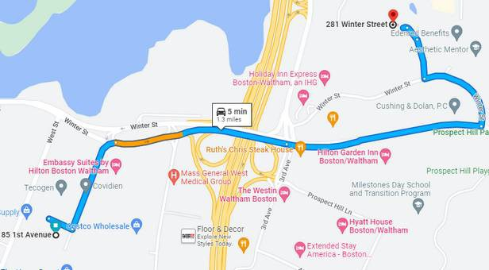

Exhibit B

Exhibit C
Patients and Visits by Age

Boston Surgery Center Patients and Visits by Age Current 12 Months (Jan – Dec 2022)

Patient Age Range | Unique Patients | Visits
18 – 40 | 107 | 199
41 – 50 | 105 | 270
51 – 60 | 172 | 425
61 – 70 | 204 | 406
71 – 80 | 159 | 320
> 81 | 41 | 82
Totals | 788 | 1,702

Exhibit C

Exhibit D

Patients and Visits by Region

Boston Surgery Center Patients and Visits by Region Current 12 Months (Jan – Dec 2022)

County | Unique  Patients | Visits | % of Total Visits
Middlesex | 415 | 888 | 52.17%
Worcester | 92 | 217 | 12.75%
Norfolk | 116 | 180 | 10.58%
Essex | 30 | 79 | 4.64%
Suffolk | 36 | 78 | 4.58%
Plymouth | 26 | 73 | 4.29%
Other MA Counties | 14 | 27 | 1.58%
Out of State | 55 | 152 | 8.93%
Total | 788 | 1,702 | 100%

***For all counties with a patient count of less than 11, those patients were accounted for in the “Other MA counties” demographic category to ensure patient privacy***

Exhibit D

Exhibit E

Patient Visits by Insurance Plan

Boston Surgery Center Patient Visits by Insurance Plan
Current 12 Months (Jan – Dec 2022)

Insurance | Visits | % of Total Visits
Medicare | 629 | 36.96%
Self Pay | 28 | 1.65%
Blue Cross | 456 | 26.79%
Tufts | 174 | 10.22%
Harvard Pilgrim | 164 | 9.64%
Other Commercial | 251 | 14.75%
Total | 1,702 | 100%

Exhibit E

Exhibit F

Patients by Race / Ethnicity

Boston Surgery Center Patients by Race / Ethnicity Current 12 Months (Jan – Dec 2022)

Race / Ethnicity | Unique Patients | % of Total Visits
African American | 21 | 2.66%
Asian | 42 | 5.33%
Hispanic or Latino | 57 | 7.23%
White | 582 | 73.86%
Other / Unknown | 86 | 10.91%
Totals | 788 | 100%

Exhibit F

Exhibit G

Current and Proposed Sites Descriptions and Floor Plans

Boston Surgery Center
Current and Proposed Site Descriptions and Floor Plans

# | Description of Space |  | Existing  Spaces |  |  | Subtotal Area (SF) | Proposed Spaces |  |  | Subtotal Area (SF) | Change in Area |  | % Change
1 |  | Business / Reception |  | 1 | 140 |  |  | 1 | 110 |  |  | -30 | -21%
2 |  | Waiting Room |  | 1 | 375 |  |  | 1 | 360 |  |  | -15 | -4%
3 |  | Nurse Director |  | 1 | 80 |  |  | 1 | 95 |  |  | 15 | 19%
4 |  | Consultation |  | 1 | 85 |  |  | 1 | 85 |  |  | - | 0%
5 |  | Environmental Services – Unrestricted |  | 1 | 50 |  |  | 1 | 50 |  |  | - | 0%
6 |  | Patient Toilet |  | 1 | 55 |  |  | 1 | 55 |  |  | - | 0%
7 |  | Prep / Recovery Positions |  | 7 | 510 |  |  | 8 | 720 |  |  | 210 | 41%
8 |  | Nurse Work / Control |  | 1 | 235 |  |  | 1 | 310 |  |  | 75 | 32%
9 |  | Clean Supply |  | 1 | 105 |  |  | 1 | 115 |  |  | 10 | 10%
10 |  | Shared Physician Office |  | 1 | 110 |  |  | 1 | 120 |  |  | 10 | 9%
11 |  | Female Staff Lockers |  | 1 | 135 |  |  | 1 | 135 |  |  | - | 0%
12 |  | Staff Toilets (proposed ASC w/ showers) |  | 2 | 100 |  |  | 2 | 110 |  |  | 10 | 10%
13 |  | Male Staff Lockers |  | 1 | 90 |  |  | 1 | 90 |  |  | - | 0%
14 |  | Staff Longue |  | 1 | 275 |  |  | 1 | 275 |  |  | - | 0%
15 |  | Soiled Holding |  | - | - |  |  | 1 | 40 |  |  | 40 | N/A
16 |  | Soiled Utility / Decontamination |  | 1 | 85 |  |  | 1 | 125 |  |  | 40 | 47%
17 |  | Clean Utility / Sterilization |  | 1 | 150 |  |  | 1 | 105 |  |  | -45 | -30%
18 |  | Clean Equipment / Supply – Semi-Restricted |  | - | - |  |  | 1 | 110 |  |  | 110 | N/A
19 |  | Operating Room # 1 |  | 1 | 350 |  |  | 1 | 256 |  |  | -94 | -27%
20 |  | Scrub Sink |  | 1 | 15 |  |  | 1 | 15 |  |  | - | 0%
21 |  | Operating Room # 2 |  | 1 | 460 |  |  | 1 | 450 |  |  | -10 | -2%
22 |  | Medication Safety Zone |  | 1 | 30 |  |  | 1 | 65 |  |  | 35 | 117%
23 |  | Environmental Services – Semi-Restricted |  | 1 | 60 |  |  | 1 | 30 |  |  | -30 | -50%
24 |  | Medical Gas Supply Room |  | 1 | 58 |  |  | 1 | 30 |  |  | -28 | -48%
 |  | Subtotal Assignable Area |  |  | 3,553 |  |  |  | 3,856 |  |  |  | 9%
25 |  | Circulation & Wall Thickness |  |  | 1,462 |  |  |  | 1,729 |  |  |  | 18%
 |  | Total ASC Area |  |  | 5,015 |  |  |  | 5,585 |  |  |  | 11%

Current Site – 85 First Avenue
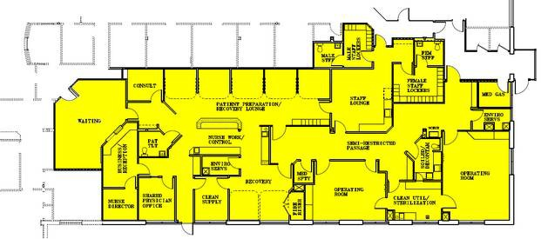

Proposed Site – 281 Winter Street

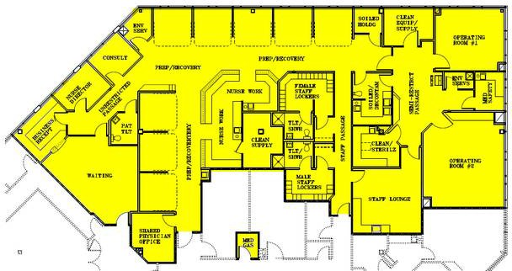

Public Announcement Concerning a Proposed Health Care Project

Boston Surgery Center, LLC (“the Applicant”), with a principal place of business at 85 Frist Ave, Waltham, MA 02451, intends to file a Notice of Determination of Need (“DoN”) with the Massachusetts Department of Public Health for a transfer of site relating to Boston Surgery Center (“Facility”), a two Operating Room Ambulatory Surgery Center located at 85 First Ave, Waltham, MA 02451. The proposed project includes relocation of the Facility to 281 Winter St, 2nd Floor, Waltham, MA 02451.
The total value of the Proposed Project based on maximum capital expenditure is $1,894,668. The Applicant does not anticipate any price or service impacts on the Applicant’s existing patient panel as a result of the Proposed Project. Any ten Taxpayers of Massachusetts may register in connection with the intended Application by no later than March 6, 2023, or 30 days from the Filing Date, whichever is later, by contacting the Department of Public Health Determination of Need Program, at dph.don@state.ma.us or 67 Forest Street, Marlborough, MA 01752.

Boston Surgery Center -22120815-AS

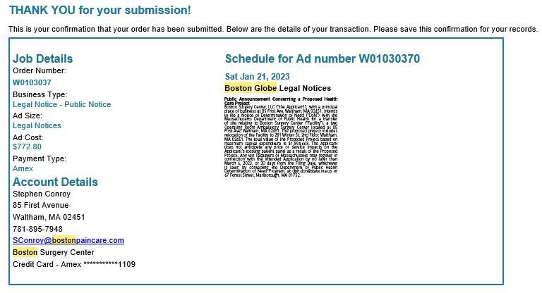

ffidavit of Truthfulness Form

Version: 7-6-17

Massachusetts Department of Public Health

Determination of Need

Affidavit of Truthfulness and Compliance

with Law and Disclosure Form 100.405 (B)

Instructions: Complete Information below. When complete check the box "This document is ready to print:". This will date stamp and lock the form. Print Form. Each person must sign and date the form. When all signatures have been collected, scan the document and e-mail to: dph.don@state.ma.us Include all attachments as requested.
Application Number: -22120815-AS
Original Application Date: 02/09/2023
Applicant Name: Boston Surgery Center, LLC
Application Type: Transfer of Site/Change in Designated Location
Applicant's Business Type: LLC
Is the Applicant the sole member or sole shareholder of the Health Facility(ies) that are the subject of this Application? Yes

The undersigned certifies under the pains and penalties of perjury:
- The Applicant is the sole corporate member or sole shareholder of the Health Facility(ies) that are the subject of this Application;
- I have read 105 CMR 100.000, the Massachusetts Determination of Need Regulation;
- I understand and agree to the expected and appropriate conduct of the Applicant pursuant to 105 CMR 100.800;
- I have read this application for Determination of Need including all exhibits and attachments, and certify that all of the information contained herein is accurate and true;
- If subject to M.G.L. c. 6D, § 13 and 958 CMR 7.00, I have submitted such Notice of Material Change to the HPC - in accordance with 105 CMR 100.405(G);
- Pursuant to 105 CMR 100.210(A)(3), I certify that both the Applicant and the Proposed Project are in material and substantial compliance and good standing with relevant federal, state, and local laws and regulations, as well as with all previously issued Notices of Determination of Need and the terms and Conditions attached therein
- I have read and understand the limitations on solicitation of funding from the general public prior to receiving a Notice of Determination of Need as established in 105 CMR 100.415;
- Pursuant to 105 CMR 100.705(A), I certify that the Applicant has Sufficient Interest in the Site or facility; and
- Pursuant to 105 CMR 100.705(A), I certify that the Proposed Project is authorized under applicable zoning by-laws or ordinances, whether or not a special permit is required; or,
  - If the Proposed Project is not authorized under applicable zoning by-laws or ordinances, a variance has been received to permit such Proposed Project; or,
  - The Proposed Project is exempt from zoning by-laws or ordinances.
LLC
All parties must sign. Add additional names as needed.

Steven Nathin <Signature on File> 02/13/2023
Name: Signature: Date:

David DiBenedetto <Signature on File> 02/13/2023
Name: Signature: Date:

Lee Silk <Signature on File> 02/13/2023
Name: Signature: Date:

Brent Young <Signature on File> 02/13/2023
Name: Signature: Date:

C. Fernando Bazoberry <Signature on File> 02/13/2023
Name: Signature: Date:

Douglas Keene <Signature on File> 02/13/2023
Name: Signature: Date:

This document is ready to print: Yes Date/time Stamp: 02/09/2023 2:09 pm

