RADON SCREENING SURVEY

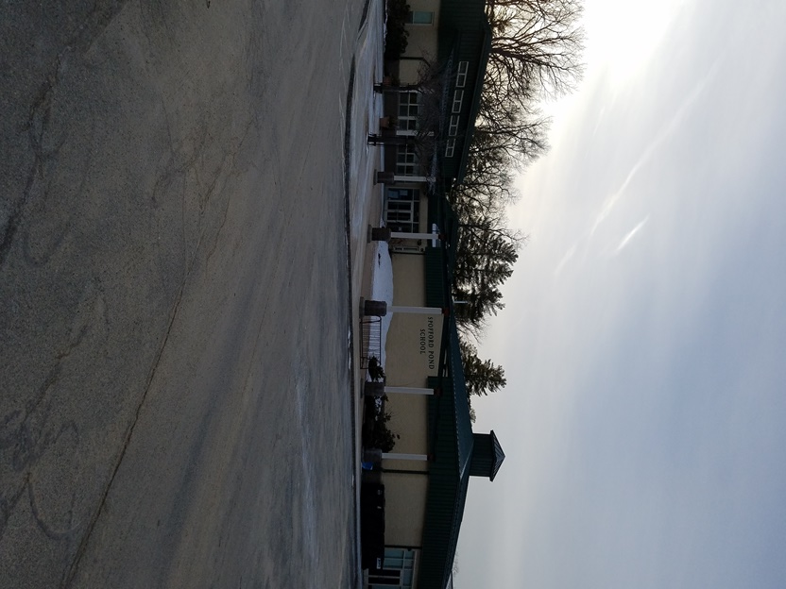

Spofford Pond Elementary School
31 Spofford Road
Boxford, MA

Prepared by:
Massachusetts Department of Public Health
Bureau of Environmental Health
Indoor Air Quality Program
Radon Assessment Unit
February, 2018

Background
Dates of Assessment: | January 29, 2018 through January 31, 2018
Building Name: | Spofford Pond Elementary School
Address: | 31 Spofford Road, Boxford, MA
Assessment Requested by: | Tri-Town School Union
Massachusetts Department of Public Health Bureau of Environmental Health (MDPH/BEH) Staff Conducting Assessment: | Lisa A. Hébert, Technical Radon Specialist, Indoor Air Quality (IAQ) Program, Radon Unit

Methods
Radon samples were collected for the purpose of this radon survey using the United States Environmental Protection Agency (US EPA) Method #402-R-92-004 Liquid Scintillation (LS). Sampling devices were obtained through AccuStar Labs, a certified radon laboratory. Eighty- seven devices were deployed throughout the building for a minimum 48-hour time period. Devices were deployed on January 29, 2018 and collected on January 31, 2018.

Results
Tests were taken during normal operations at Spofford Elementary School. Of the 87 areas where test devices were deployed, devices from 84 areas were collected and submitted to AccuStar Labs. The lab results from the survey appear in Appendix A.

Discussion
Radon Unit staff reviewed the lab results from AccuStar Labs and found all quality assurance parameters within acceptable limits. Appendix A shows that radon levels in the building ranged from less than 0.4 pCi/L to 6.6 pCi/L. Five areas screened had radon levels above the US EPA action guideline of 4 picocuries per liter of air pCi/L (Rooms 11, 37 Storage, 36, 19, E-3). Radon levels were not elevated elsewhere. Please note that three vials could not be submitted due to being disturbed/ tampered. These areas were:
• Room 37 - (Vial # 3135653)
• Copy/Mail Room – (Vial # 3135605)
• Library Stacks – (Vial # 3135697)

Radon Gas
According to the National Research Council (NRC, 2009), “low levels of radon are present in all the air we breathe.” Radon is a naturally occurring, radioactive gas that is produced by the natural decay of uranium in the soil. The average outdoor radon level is about 0.4 pCi/L (US EPA, 2009). Once radon is formed, it migrates through various pathways in the soil and can enter a building through cracks, holes, and joints in a building’s foundation (US EPA, 2009). The EPA recommends mitigation for indoor radon levels at or above 4 pCi/L.
According to the US EPA (2009), radon gas “decays into radioactive particles that can get trapped in your lungs when you breathe. As they break down further, these particles release small bursts of energy.” This activity can damage your lung tissue and increase a person’s risk of developing lung cancer (US EPA, 2009). Radon is the leading cause of lung cancer in non-smokers. In 2005, the U.S. Surgeon General issued a health advisory stating that indoor radon is the second leading cause of lung cancer (US EPA, 2013).

Recommendations
Based on the measurements and observations made during the visit, the following recommendations are made.
- It would be prudent to contact certified radon measurement and mitigation specialists to confirm the results found and to mitigate the radon in the building. The two organizations that certify radon measurement and mitigation specialists are:
  - National Radon Safety Board (NRSB) www.nrsb.org
  - American Association of Radon Scientists and Technologists (AARST) http://aarst-nrpp.com/wp/
- It would be prudent for your radon measurement specialist to test areas with disturbed/ tampered sampling devices during confirmation testing. These areas include:
  - Room 37
  - Copy/Mail Room
  - Library Stacks.
- If you have any questions or concerns, please call the Massachusetts Department of Public Health Radon Assessment Unit at (413) 586-7525.
References
National Research Council (NRC). 1999. Risk Assessment of Radon in Drinking Water, National Academy Press.

United States Environmental Protection Agency (US EPA). 2009. “A Citizen’s Guide to Radon. The Guide To Protecting Yourself and Your Family From Radon”. US Environmental Protection Agency. EPA402/K-09/001. January 2009.

United States Environmental Protection Agency (US EPA). 2013. “Home Buyers and Seller’s Guide to Radon”. US Environmental Protection Agency. EPA402/K-13/002. September 2013.

