INDOOR AIR QUALITY ASSESSMENT

Brackett Elementary School
66 Eastern Avenue
Arlington, Massachusetts



Prepared by:
Massachusetts Department of Public Health
Bureau of Environmental Health
Indoor Air Quality Program
December 2010

Background/Introduction
At the request of Mr. James Feeney, Arlington Health Department, the Massachusetts Department of Public Health (MDPH), Bureau of Environmental Health (BEH) provided assistance and consultation at the Brackett Elementary School (BES) located at 66 Eastern Avenue, Arlington, Massachusetts. The assessment was prompted by concerns related to water damage and mold growth experienced in a classroom at the BES following heavy rains during March 2010. Prior to the MDPH assessment, the Arlington Public Schools (APS) had taken a number of actions to mitigate water penetration and remove mold growth, including removal of water-damaged building materials, disinfection of the area and waterproofing of the building exterior.
On April 6, 2010, Sharon Lee, an Environmental Analyst within the BEH’s IAQ Program, visited the BES to conduct an assessment. Ms. Lee was accompanied by Mr. Feeney and Stephanie Zerchykov, School Principal, during the assessment. The BES is a three-story brick building constructed in 1999. The school consists of classrooms, a library, gymnasium and a cafeteria. Windows are openable throughout the building.

Methods
Air tests for carbon monoxide, carbon dioxide, temperature and relative humidity were conducted with the TSI, Q-Trak, IAQ Monitor, Model 7565. Air tests for airborne particle matter with a diameter less than 2.5 micrometers were taken with the TSI, DUSTTRAK™ Aerosol Monitor Model 8520. BEH staff also performed a visual inspection of building materials for water damage and/or microbial growth. Moisture content of porous building materials (e.g., carpeting, insulation) was measured with a Delmhorst, BD-2000 Model, Moisture Detector with a Delmhorst Standard Probe.

Results
The school houses approximately 450 students in kindergarten through fifth grade and 45 staff. Tests were taken during normal operations at the school and results appear in Table 1. It should be noted that the cafeteria was without heat/ventilation for a period of time during the MDPH assessment, as repairs were being made to the ventilation system.

Discussion

Ventilation
It can be seen from Table 1 that carbon dioxide levels were above 800 parts per million (ppm) in 24 of 37 areas, indicating poor air exchange in over half of the rooms surveyed. It is important to note that a few areas were sparsely occupied at the time that carbon dioxide measurements were taken. Low occupancy can reduce carbon dioxide levels. Carbon dioxide levels would be expected to be higher with increased occupancy.
Mechanical ventilation throughout the building is provided by rooftop air-handling units (AHUs; Picture 1). In classrooms and offices, fresh air is distributed via ceiling-mounted air diffusers (Picture 2) and ducted back to AHUs via ceiling mounted return vents (Picture 3). Please note, the type of vent used for some classroom return vents is identical to those used for the supply vents. Supply ductwork at the BES is fitted with multi-directional diffusers. The blades for multi-directional supply diffusers are horizontal, allowing air forced out from the ductwork to be directed in various directions so as to distribute conditioned air to an area/space. The orientation and design of the blades would result in increased resistance when air is drawn into and returned to the AHU via these diffusers. It is likely that the use of such supply diffusers as return vents is reducing exhaust efficiency and effectiveness in removing common environmental pollutants from classrooms. Without adequate exhaust ventilation, excess heat and environmental pollutants can build up and lead to indoor air/comfort complaints. Consideration should be given to replacing current diffusers with more common exhaust coverings.
To maximize air exchange, the MDPH recommends that both supply and exhaust ventilation operate continuously during periods of occupancy. In order to have proper ventilation with a mechanical supply and exhaust system, the systems must be balanced to provide an adequate amount of fresh air to the interior of a room while removing stale air from the room. It is recommended that HVAC systems be re-balanced every five years to ensure adequate air systems function (SMACNA, 1994). The date of the last balancing of these systems was unknown at the time of the assessment.
The Massachusetts Building Code requires that each room have a minimum ventilation rate of 15 cubic feet per minute (cfm) per occupant of fresh outside air or openable windows (SBBRS, 1997; BOCA, 1993). The ventilation must be on at all times that the room is occupied. Providing adequate fresh air ventilation with open windows and maintaining the temperature in the comfort range during the cold weather season is impractical. Mechanical ventilation is usually required to provide adequate fresh air ventilation.
Carbon dioxide is not a problem in and of itself. It is used as an indicator of the adequacy of the fresh air ventilation. As carbon dioxide levels rise, it indicates that the ventilating system is malfunctioning or the design occupancy of the room is being exceeded. When this happens, a buildup of common indoor air pollutants can occur, leading to discomfort or health complaints. The Occupational Safety and Health Administration (OSHA) standard for carbon dioxide is 5,000 parts per million parts of air (ppm). Workers may be exposed to this level for 40 hours/week, based on a time-weighted average (OSHA, 1997).
The MDPH uses a guideline of 800 ppm for publicly occupied buildings. A guideline of 600 ppm or less is preferred in schools due to the fact that the majority of occupants are young and considered to be a more sensitive population in the evaluation of environmental health status. Inadequate ventilation and/or elevated temperatures are major causes of complaints such as respiratory, eye, nose and throat irritation, lethargy and headaches. For more information concerning carbon dioxide, consult Appendix A.
Indoor temperature measurements ranged from 69º F to 75º F, which were within or very close to the lower end of the MDPH recommended comfort range in areas surveyed the day of the assessment (Table 1). The MDPH recommends that indoor temperatures be maintained in a range of 70º F to 78º F in order to provide for the comfort of building occupants. In many cases concerning indoor air quality, fluctuations of temperature in occupied spaces are typically experienced, even in a building with an adequate fresh air supply.
The relative humidity measured in the building ranged from 31 to 48 percent, which was below the MDPH recommended comfort range in some areas surveyed during the assessment (Table 1). The MDPH recommends a comfort range of 40 to 60 percent for indoor air relative humidity. Relative humidity levels in the building would be expected to drop during the winter months due to heating. The sensation of dryness and irritation is common in a low relative humidity environment. Low relative humidity is a very common problem during the heating season in the northeast part of the United States.

Microbial/Moisture Concerns
As discussed previously, the primary purpose of the assessment was to evaluate damage sustained in a classroom following heavy rain that occurred in March, 2010. Rain water reportedly penetrated classroom 205 through the exterior wall, causing water damage to gypsum wallboard (GW). At the time of assessment, approximately three-feet of water-damaged GW and insulation had been removed from the classroom (Pictures 4 and 5) and the remaining fixtures had reportedly been cleaned and disinfected. Waterproofing had also reportedly been applied to a portion of the exterior wall had also been reportedly waterproofed.
BEH staff examined conditions in classroom 205 and observed efflorescence in the wall cavity (Picture 6). Efflorescence is a characteristic sign of water damage to brick and mortar, but it is not mold growth. As moisture penetrates and works its way through mortar and brick, water-soluble compounds in mortar and brick dissolve, creating a solution. As the solution moves to the surface of the mortar or brick, the water evaporates, leaving behind white, powdery mineral deposits. Efflorescence observed is likely from salts that leached from the exterior brickwork.
While examining the lower roof area outside of classroom 205, BEH staff observed that the rubber membrane of the roof was not installed through the metal flashing to create a continuous surface for water to shed away from the building (Pictures 7 to 9). As a result, rain water hitting against the brick wall is likely penetrating behind the metal flashing and down the interior-facing side of the rubber membrane. Since water trapped behind the rubber membrane cannot escape, it penetrates through brickwork and causes water pooling.
While assessing the main office, BEH staff observed water-stained ceiling tiles (Picture 10) and bubbling paint near/along the wall directly below the damaged wall in classroom 205 (Picture 11). Using a Delmhorst Moisture Meter, BEH staff determined that some GW on the exterior wall was still moist. The presence of moist GW was reported to BES staff at the time of the assessment. Subsequently, it was reported to BEH staff that moistened/damaged GW was removed and replaced the weekend following the assessment.
Water-damaged ceiling tiles were observed in a number of areas in the building (Picture 12), which can indicate sources of water penetration from either the building envelope or the plumbing system. Water-damaged ceiling tiles can provide a source of mold and should be replaced after a water leak is discovered and repaired. An active leak was observed in the hallway of the BES, where a pail was being used to collect dripping water (Picture 13). At the time of assessment, BEH staff observed water stains on the metal roofing, indicating water the leak is most likely associated with a roof leak (Picture 14).
The US Environmental Protection Agency (US EPA) and the American Conference of Governmental Industrial Hygienists (ACGIH) recommend that porous materials be dried with fans and heating within 24 to 48 hours of becoming wet (US EPA, 2001; ACGIH, 1989). If not dried within this time frame, mold growth may occur. Once mold has colonized porous materials, they are difficult to clean and should be removed and discarded.
Plants were noted in classrooms. Plant soil and drip pans can serve as a source of mold growth. They should be properly maintained and be equipped with drip pans. In addition, flowering plants can be a source of pollen. Therefore, plants should be located away from the air stream of ventilation sources to prevent aerosolization of mold, pollen and particulate matter. Further, plants should not be placed on porous materials, since water damage to porous materials may lead to microbial growth.
An aquarium containing standing water was observed with microbial/algal growth in the greenhouse. Aquariums should be properly maintained to prevent microbial/algal growth as they can emit unpleasant odors.
Open seams between sink countertops and backsplashes were observed in some rooms (Table 1). If not watertight, moisture can penetrate through seams, causing damage. Improper drainage or sink overflow can lead to water penetration into countertops, cabinet interiors and areas behind cabinets. Water penetration and chronic exposure of porous and wood-based materials can cause these materials to swell and show signs of water damage. Repeated moistening of porous materials can result in mold growth.
A failing window gasket was observed ES (Picture 15). Gaskets are designed to prevent water penetration through the window system. Gaskets should be properly installed/maintained to prevent water intrusion and damage to building materials.
Water staining and moss growth was observed on the building’s exterior (Pictures 16 and 17). Such staining can be an indication that the roof’s gutter and downspout system may not be draining water sufficiently. The system should be examined to prevent damage to exterior brick and mortar. Overtime, repeated moistening can result in erosion of mortar and damage to brickwork, which can result in water penetration to the building.
Shrubbery and other plants were observed in close proximity to the foundation/exterior walls of the building (Picture 18). The growth of roots against exterior walls can bring moisture in contact with and eventually lead to cracks and/or fissures in the foundation below ground level. Over time, this process can undermine the integrity of the building envelope and provide a means of water entry into the building through capillary action through foundation concrete and masonry (Lstiburek & Brennan, 2001).

Other IAQ Evaluations
Indoor air quality can be negatively influenced by the presence of respiratory irritants, such as products of combustion. The process of combustion produces a number of pollutants. Common combustion emissions include carbon monoxide, carbon dioxide, water vapor, and smoke (fine airborne particle material). Of these materials, exposure to carbon monoxide and particulate matter with a diameter of 2.5 micrometers (μm) or less (PM2.5) can produce immediate, acute health effects upon exposure. To determine whether combustion products were present in the indoor environment, BEH staff obtained measurements for carbon monoxide and PM2.5.

Carbon Monoxide
Carbon monoxide is a by-product of incomplete combustion of organic matter (e.g., gasoline, wood and tobacco). Exposure to carbon monoxide can produce immediate and acute health effects. Several air quality standards have been established to address carbon monoxide and prevent symptoms from exposure to these substances. The MDPH established a corrective action level concerning carbon monoxide in ice skating rinks that use fossil-fueled ice resurfacing equipment. If an operator of an indoor ice rink measures a carbon monoxide level over 30 ppm, taken 20 minutes after resurfacing within a rink, that operator must take actions to reduce carbon monoxide levels (MDPH, 1997).
The American Society of Heating Refrigeration and Air-Conditioning Engineers (ASHRAE) has adopted the National Ambient Air Quality Standards (NAAQS) as one set of criteria for assessing indoor air quality and monitoring of fresh air introduced by HVAC systems (ASHRAE, 1989). The NAAQS are standards established by the US EPA to protect the public health from six criteria pollutants, including carbon monoxide and particulate matter (US EPA, 2006). As recommended by ASHRAE, pollutant levels of fresh air introduced to a building should not exceed the NAAQS levels (ASHRAE, 1989). The NAAQS were adopted by reference in the Building Officials & Code Administrators (BOCA) National Mechanical Code of 1993 (BOCA, 1993), which is now an HVAC standard included in the Massachusetts State Building Code (SBBRS, 1997). According to the NAAQS, carbon monoxide levels in outdoor air should not exceed 9 ppm in an eight-hour average (US EPA, 2006).
Carbon monoxide should not be present in a typical, indoor environment. If it is present, indoor carbon monoxide levels should be less than or equal to outdoor levels. Outdoor carbon monoxide concentrations were non-detect (ND) the day of the assessment (Table 1). No measureable levels of carbon monoxide were detected in the building during the assessment (Table 1).

Particulate Matter
The US EPA has established NAAQS limits for exposure to particulate matter. Particulate matter is airborne solids that can be irritating to the eyes, nose and throat. The NAAQS originally established exposure limits to particulate matter with a diameter of 10 μm or less (PM10). According to the NAAQS, PM10 levels should not exceed 150 microgram per cubic meter (μg/m³) in a 24-hour average (US EPA, 2006). These standards were adopted by both ASHRAE and BOCA. Since the issuance of the ASHRAE standard and BOCA Code, US EPA established a more protective standard for fine airborne particles. This more stringent PM2.5 standard requires outdoor air particle levels be maintained below 35 μg/m³ over a 24-hour average (US EPA, 2006). Although both the ASHRAE standard and BOCA Code adopted the PM10 standard for evaluating air quality, MDPH uses the more protective PM2.5 standard for evaluating airborne particulate matter concentrations in the indoor environment.
Outdoor PM2.5 concentration was measured at 17 μg/m³ (Table 1). PM2.5 levels measured indoors ranged from 8 to 20 μg/m³ (Table 1), which were below the NAAQS PM2.5 level of 35 μg/m³. Frequently, indoor air levels of particulates (including PM2.5) can be at higher levels than those measured outdoors. A number of mechanical devices and/or activities that occur indoors can generate particulate during normal operations. Sources of indoor airborne particulates may include but are not limited to particles generated during the operation of fan belts in the HVAC system, use of stoves and/or microwave ovens in kitchen areas; use of photocopiers, fax machines and computer printing devices; operation of an ordinary vacuum cleaner and heavy foot traffic indoors.

Volatile Organic Compounds
Indoor air concentrations can be greatly impacted by the use of products containing volatile organic compounds (VOCs). VOCs are carbon-containing substances that have the ability to evaporate at room temperature. Frequently, exposure to low levels of total VOCs (TVOCs) may produce eye, nose, throat and/or respiratory irritation in some sensitive individuals. For example, chemicals evaporating from a paint can stored at room temperature would most likely contain VOCs. In an effort to identify materials that can potentially increase indoor VOC concentrations, BEH staff examined classrooms for products containing these respiratory irritants.
Several classrooms contained dry erase boards and dry erase board markers. Materials such as permanent markers, dry erase markers and dry erase board cleaners may contain VOCs, such as methyl isobutyl ketone, n-butyl acetate and butyl-cellusolve (Sanford, 1999), which can be irritating to the eyes, nose and throat.
Cleaning products were also observed in a number of classrooms (Picture 19). Like dry erase materials, cleaning products contain VOCs and other chemicals. These chemicals can be irritating to the eyes, nose and throat and should be kept out of reach of students. A Material Safety Data Sheet (MSDS) should be available at a central location for each product in the event of an emergency. Consideration should be given to providing teaching staff with school issued cleaning products to ensure that MSDS information is available for all products used at the school.
Air fresheners and deodorizing materials were also observed (Picture 19). Air deodorizers contain chemicals that can be irritating to the eyes, nose and throat of sensitive individuals. Many air fresheners contain 1,4-dichlorobenzene, a VOC which may cause reductions in lung function (NIH, 2006). Furthermore, deodorizing agents do not remove materials causing odors, but rather mask odors that may be present in the area.
Photocopiers and laminators were in use in several areas. Lamination machines melt plastic and give off odors and VOCs. Similarly, photocopiers also produce VOCs and ozone, particularly if the equipment is older and in frequent use. Ozone is also a respiratory irritant (Schmidt Etkin, 1992). No dedicated exhaust system was in place to remove heat and odors produced by this equipment.

Other Conditions
A number of personal fans (Picture 20) and supply vents (Picture 21) were observed to have accumulated dust/debris. These fans and vents should be cleaned in order to prevent dust/debris from being aerosolized and redistributed throughout the room.
Open utility holes were observed around heating units in many areas (Pictures 22 and 23). Open utility holes can provide a means of egress for odors, fumes, dusts and vapors between rooms and floors.
Tennis balls were observed sliced open and placed on the base of the legs likely in an effort to reduce noise from sliding desks/chairs (Picture 24). Tennis balls are made of a number of materials that can serve as respiratory irritants. Constant wearing of tennis balls can produce fibers and cause VOCs to off-gas. Tennis balls are made with a natural rubber latex bladder, which becomes abraded when used as a chair leg pad. Use of tennis balls in this manner may introduce latex dust into the school environment. Some individuals are highly allergic to latex (e.g., spina bifida patients) (SBAA, 2001). It is recommended that the use of materials containing latex be limited in buildings to reduce the likelihood of symptoms in sensitive individuals (NIOSH, 1997).

Conclusions/Recommendations
Prior to the MDPH assessment, the APS had taken a number of actions to address water damage sustained to classroom 205. Remediation efforts included removal of water-damaged GW and insulation and disinfection of the remaining building components (i.e., metal studs and cement). Waterproofing of the exterior wall through which water was believed to have entered was also reportedly conducted. At the time of the MDPH assessment, BEH staff examined the open wall cavity and exterior wall of classroom 205 and determined the most likely pathway for water entry is likely related to the flashing and rubber membrane roof adjacent to classroom 205. Based on these observations and other conditions observed at the time of assessment, the following recommendations are made:
- Contact a building envelope/roof professional to examine the flashing and rubber membrane installation to the roof adjacent to classroom 205.
- Continue with repairs/replacement of insulation and GW in classroom 205.
- Monitor repairs to both classroom 205 and the main office to ensure further water penetration/damage is not sustained.
- Once repairs are made, remove damaged paint and refinish walls.
- Ensure active roof leaks are repaired (Pictures 12 and 13) and replace water damaged/missing ceiling tiles. Examine the area above and around these areas for mold growth. Disinfect areas of water leaks with an appropriate antimicrobial.
- Examine the roof drainage system to ensure proper water removal and prevent damage to exterior of the building.
- Repair deteriorated mortar on exterior masonry; clean existing moss growth and monitor for further moss growth, remove as needed.
- Replace failing window gaskets.
- Trim shrubbery/trees back approximately 5-feet to prevent water impingement on exterior brick.
- Improve air exchange in classrooms. An increase in the percentage of fresh air supply and/or increased exhaust capabilities is recommended. Contact an HVAC engineering firm to determine if AHUs/exhaust motors can be modified/adjusted to increase the introduction of fresh air and/or removal of stale classroom air.
- Consider replacing exhaust vents with appropriate grilled vents to aid in the removal of air from classrooms.
- Operate all ventilation systems throughout the building (e.g., gym, cafeteria, classrooms) continuously during periods of occupancy independent of thermostat control to maximize air exchange.
- Use openable windows in conjunction with mechanical ventilation to facilitate air exchange. Care should be taken to ensure windows are properly closed at night and weekends to avoid the freezing of pipes and potential flooding.
- Consider adopting a balancing schedule of every 5 years for all mechanical ventilation systems, as recommended by ventilation industrial standards (SMACNA, 1994).
- For buildings in New England, periods of low relative humidity during the winter are often unavoidable. Therefore, scrupulous cleaning practices should be adopted to minimize common indoor air contaminants whose irritant effects can be enhanced when the relative humidity is low. To control dusts, a high efficiency particulate arrestance (HEPA) filter equipped vacuum cleaner in conjunction with wet wiping of all surfaces is recommended. Avoid the use of feather dusters. Drinking water during the day can help ease some symptoms associated with a dry environment (throat and sinus irritations).
- Ensure plants have drip pans. Avoid over-watering and examine drip pans periodically for mold growth. Disinfect with an appropriate antimicrobial where necessary.
- Maintain aquariums to prevent mold/algal/bacterial growth and associated odors.
- Seal areas around sinks to prevent water damage to the interior of cabinets and adjacent wallboard. Inspect wallboard for water damage and mold growth, repair/replace as necessary. Disinfect areas with an appropriate antimicrobial, as needed.
- Routinely clean dry erase boards and trays.
- Consider providing school issued cleaning products to staff.
- Eliminate use of air fresheners and deodorizers.
- Routinely clean dust accumulation from personal fans and supply/exhaust vents.
- Seal spaces around utility holes and breaches in walls/floors with an appropriate fire-rated sealant, paying particular attention to breaches between the first floor and the crawlspace.
- Consider relocating photocopiers and lamination machines to well-ventilated area or contact an HVAC engineering firm to discuss options for installation of local exhaust ventilation to remove excess heat and odors.
- Remove tennis balls and consider replacing with latex free tennis balls and/or chair glides.
- Consider adopting the US EPA (2000) document, “Tools for Schools”, as an instrument for maintaining a good indoor air quality environment in the building. This document is available at: http://www.epa.gov/iaq/schools/index.html.
- Refer to resource manual and other related indoor air quality documents located on the MDPH’s website for further building-wide evaluations and advice on maintaining public buildings. These documents are available at: http://mass.gov/dph/iaq.

References
ACGIH. 1989. Guidelines for the Assessment of Bioaerosols in the Indoor Environment. American Conference of Governmental Industrial Hygienists, Cincinnati, OH.
ASHRAE. 1989. Ventilation for Acceptable Indoor Air Quality. American Society of Heating, Refrigeration and Air Conditioning Engineers. ANSI/ASHRAE 62-1989.
BOCA. 1993. The BOCA National Mechanical Code/1993. 8th ed. Building Officials and Code Administrators International, Inc., Country Club Hill, IL.
Lstiburek, J. & Brennan, T. 2001. Read This Before You Design, Build or Renovate. Building Science Corporation, Westford, MA. U.S. Department of Housing and Urban Development, Region I, Boston, MA.
MDPH. 1997. Requirements to Maintain Air Quality in Indoor Skating Rinks (State Sanitary Code, Chapter XI). 105 CMR 675.000. Massachusetts Department of Public Health, Boston, MA.
NIH. 2006. Chemical in Many Air Fresheners May Reduce Lung Function (#06-11). National Institutes of Health, Research Triangle Park, NC.
NIOSH. 1997. NIOSH Alert Preventing Allergic Reactions to Natural Rubber latex in the Workplace. National Institute for Occupational Safety and Health, Atlanta, GA.
OSHA. 1997. Limits for Air Contaminants. Occupational Safety and Health Administration. Code of Federal Regulations. 29 C.F.R 1910.1000 Table Z-1-A.
Sanford. 1999. Material Safety Data Sheet (MSDS No: 198-17). Expo® Dry Erase Markers Bullet, Chisel, and Ultra Fine Tip. Sanford Corporation. Bellwood, IL.
SBAA. 2001. Latex In the Home And Community Updated Spring 2001. Spina Bifida Association of America, Washington, DC.
SBBRS. 1997. Mechanical Ventilation. State Board of Building Regulations and Standards. Code of Massachusetts Regulations. 780 CMR 1209.0
Schmidt Etkin, D. 1992. Office Furnishings/Equipment & IAQ Health Impacts, Prevention & Mitigation. Cutter Information Corporation, Indoor Air Quality Update, Arlington, MA.
SMACNA. 1994. HVAC Systems Commissioning Manual. 1st ed. Sheet Metal and Air Conditioning Contractors’ National Association, Inc., Chantilly, VA.
US EPA. 2000. Tools for Schools. Office of Air and Radiation, Office of Radiation and Indoor Air, Indoor Environments Division (6609J). EPA 402-K-95-001, Second Edition. http://www.epa.gov/iaq/schools/tools4s2.html.
US EPA. 2001. “Mold Remediation in Schools and Commercial Buildings”. Office of Air and Radiation, Indoor Environments Division, Washington, DC. EPA 402-K-01-001. March 2001. Available at: http://www.epa.gov/iaq/molds/mold_remediation.html
US EPA. 2006. National Ambient Air Quality Standards (NAAQS). US Environmental Protection Agency, Office of Air Quality Planning and Standards, Washington, DC. http://www.epa.gov/air/criteria.html.
Picture 1

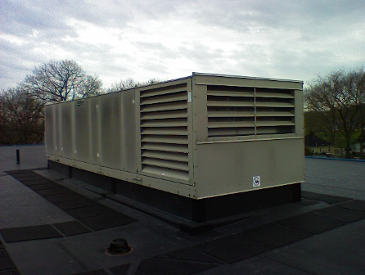

Rooftop air-handling unit

Picture 2

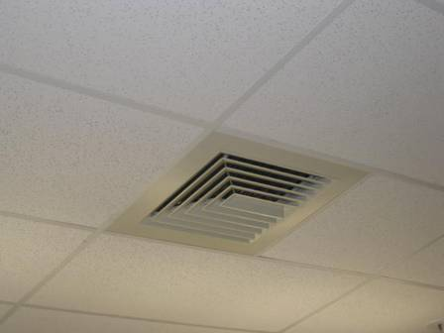

Supply diffuser

Picture 3

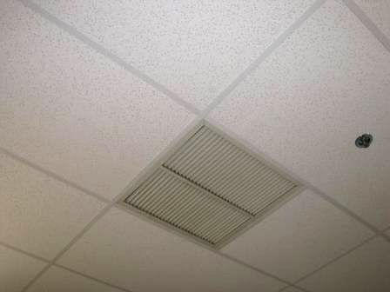

Typical return vent

Picture 4

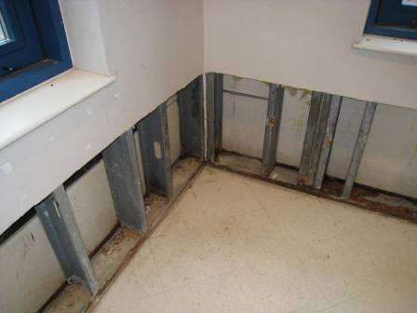

Open wall cavity, GW and insulation removed from classroom 205

Picture 5

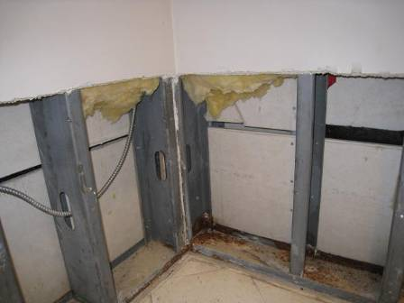

Open wall cavity, GW and insulation removed from classroom 205

Picture 6

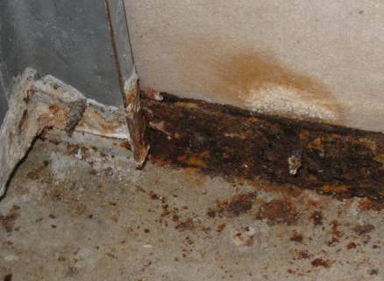

Water staining and efflorescence in the wall cavity

Picture 7

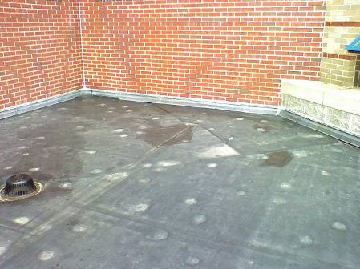

Rubber membrane roof adjacent to classroom 205

Picture 8

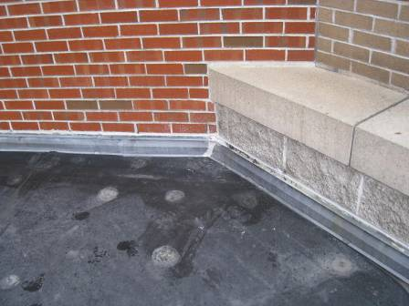

Rubber membrane roof adjacent to classroom 205, note rubber membrane not installed through metal flashing
Picture 9

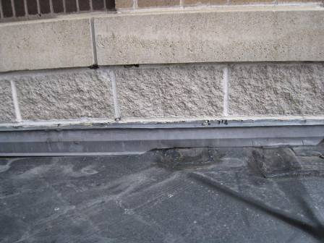

Rubber membrane roof adjacent to classroom 205, note rubber membrane not installed through metal flashing

Picture 10

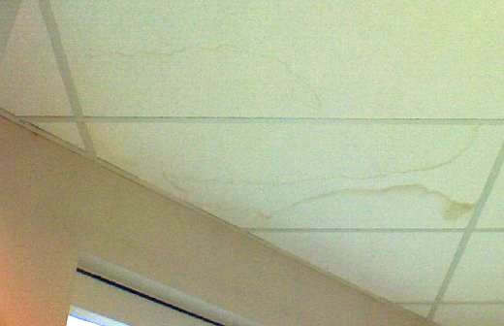

Water-damaged ceiling tiles in main office
Picture 11

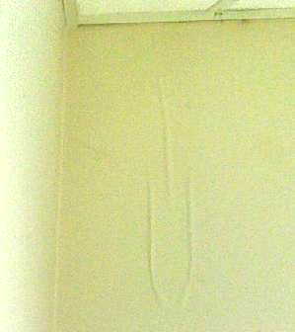

Bubbling paint on wall in main office

Picture 12

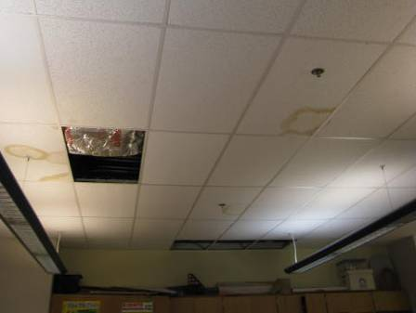

Water-damaged and missing ceiling tiles

Picture 13

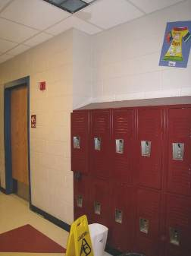

Active leak in hallway

Picture 14

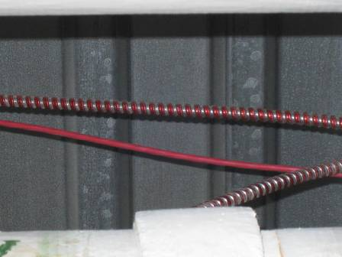

Water staining on metal roof, indicating leak

Picture 15

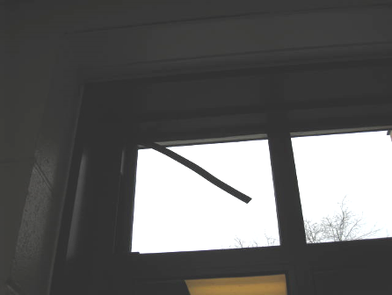

Failing window gasket

Picture 16

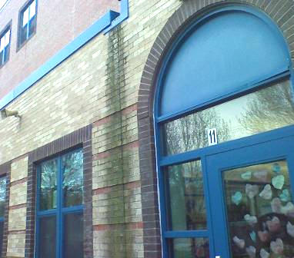

Water staining on building exterior

Picture 17

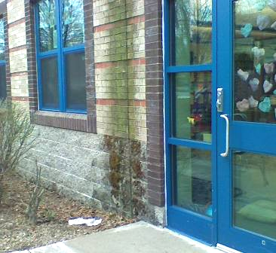

Water staining and moss growth on building exterior

Picture 18

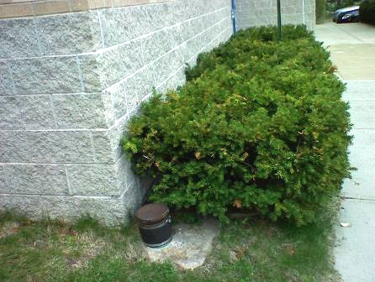

Shrubbery in close proximity to the building

Picture 19

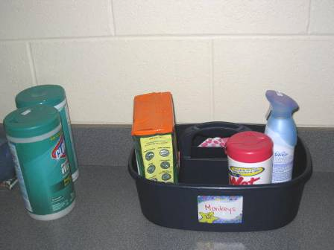

Cleaning materials and air deodorizers

Picture 20

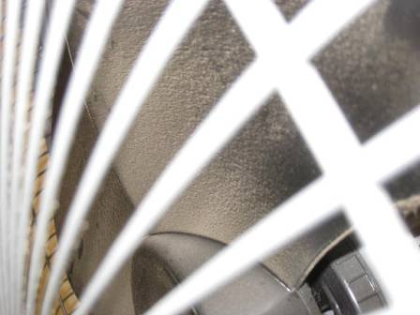

Dust occluding personal fan

Picture 21

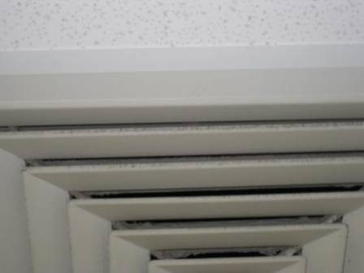

Dust on supply vent

Picture 22

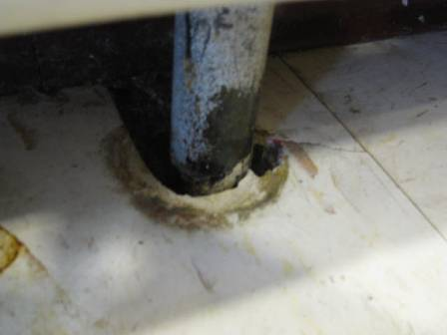

Breach around piping to heating unit

Picture 23

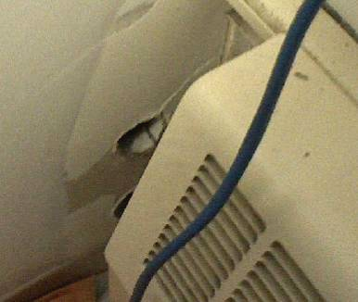

Utility hole in wall

Picture 24

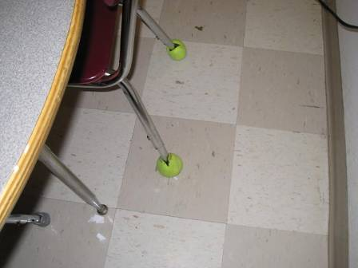

Tennis balls on chair leg
Location | Occupants  in Room | Temp  (°F) | Relative  Humidity  (%) | Carbon  Dioxide  (ppm) | Carbon Monoxide  (ppm) | PM2.5  (µg/m3) | Windows  Openable | Ventilation |  | Remarks
 |  |  |  |  |  |  |  | Supply | Exhaust | Remarks
Outside  (Background) |  | 62 | 32 | 425 | ND | 17 |  |  |  | Overcast
Gym | 0 | 71 | 32 | 494 | ND | 12 | N | Y | Y  Dusty | DO, HVAC usually off
Main office | 2 | 72 | 40 | 734 | ND | 10 | Y  1 of 6 open | Y | Y | Plants, GW wet on wall below classroom 205
Nurse waiting area | 2 | 71 | 42 | 833 | ND | 12 | N | Y | Y | DO, TB, AD
Nurse | 0 | 71 | 41 | 828 | ND | 12 | N | Y | Y | DO, breach in sink backsplash
girls/boys restrooms |  |  |  |  |  |  | N | Y | Y  OFF
103 (cafeteria) | 80 | 73 | 48 | 1173 | ND | 20 | Y  5 of 8 open | Y | Y  Off | 1 WD-CT
104 (music) | 0 | 69 | 48 | 579 | ND | 12 | Y | Y | Y | 1 WD-CT
111 (after school room) | 0 | 71 | 40 | 760 | ND | 10 | Y | Y | Y | Plants, vacuum, breach in sink backsplash
112 | 4 | 71 | 40 | 839 | ND | 10 | Y | Y | Y | DO, CPs, breach in sink backsplash
119 | 24 | 72 | 43 | 1176 | ND | 10 | Y | Y | Y | DO, PF, breach in sink backsplash, stuffed animals
120 | 25 | 72 | 44 | 1585 | ND | 14 | Y | Y | Y | Plants, CPs
121 | 20 | 72 | 42 | 1074 | ND | 14 | Y | Y | Y | PF, UF, breach in sink backsplash, plants, items, stuffed animals
201 | 14 | 74 | 38 | 810 | ND | 15 | Y  2 of 8 open | Y | Y | DO, TB, 2 WD-CTs, PF
204 | 1 | 72 | 44 | 896 | ND | 9 | Y | Y | Y | DO, MT, items
205 | 0 | 73 | 42 | 869 | ND | 8 | Y | Y | Y | GW removed from area experiencing leakage; mold growth and efflorescence observed on metal studs, portion of exterior wall waterproofed, concerns regarding flashing/roof rubber membrane
208 | 21 | 74 | 38 | 871 | ND | 8 | Y | Y | Y | DO, DEM, PF, breach in sink backsplash
209 | 19 | 74 | 35 | 651 | ND | 11 | Y  2 of 4 open | Y | Y | DO, PF, breach in sink backsplash, DEM, CPs
214 | 21 | 75 | 36 | 955 | ND | 9 | Y  2 of 7 open | Y | Y | DO, CPs, AD, UF, TB
215 | 20 | 75 | 38 | 922 | ND | 11 | Y  2 of 4 open | Y | Y | PF, TB, CPs, breach in sink backsplash, vacuum
216 | 18 | 74 | 36 | 829 | ND | 11 | Y  1 of 5 open | Y | Y | DO, PF, breach in sink backsplash, DEM, plants
218 | 20 | 74 | 40 | 1140 | ND | 9 | Y | Y | Y | DO, UF, plants, DEM, CPs, breach in sink backsplash
219 | 21 | 73 | 35 | 687 | ND | 10 | Y  1 of 6 open | Y | Y | DO, CPs, DEM, pillows
301 | 24 | 71 | 39 | 724 | ND | 12 | Y | Y | Y | TB, PF, 5 WD-CT, 3 MT, DO, DEM, CPs
302 | 20 | 72 | 34 | 550 | ND | 10 | Y  3 of 4 open | Y | Y | 1 AT, 1 MT, 3 WD-CT, CPs, DO
303 (guidance) | 1 | 74 | 38 | 821 | ND | 16 | N | Y | Y | DO, PF, 1 WD-CT
303A | 1 | 73 | 39 | 924 | ND | 15 | N | Y | Y | DO
303B | 0 | 74 | 40 | 877 | ND | 18 | Y | Y | Y | DO
304 (greenhouse) | 9 | 75 | 38 | 1014 | ND | 14 | Y | N | N | Container with water/algal growth; DO
306 (art) | 20 | 75 | 41 | 1418 | ND | 20 | Y | Y | Y | Plants, 5 WD-CTs, breaches in sink backsplash, PF
307 (Lounge) | 1 | 74 | 37 | 881 | ND | 16 | Y | Y | Y | DO, toaster, refrigerator, soda machine, 5 WD-CTs
308 (teacher’s work room) | 0 | 75 | 36 | 972 | ND | 18 | N | Y | Y | PC/PC odors, laminator
311 | 23 | 75 | 38 | 1027 | ND | 14 | Y | Y | Y | DO, PF, CPs, DEM, breach in sink backsplash
312 | 20 | 75 | 37 | 889 | ND | 10 | Y  1 of 3 open | Y | Y | Plants, PF, DEM, DO, bean bag chairs
317 | 19 | 74 | 33 | 700 | ND | 11 | Y  3 OF 6 OPEN | Y | Y | DO, TB, PF items, DEM, CPs
318 | 20 | 73 | 36 | 758 | ND | 9 | Y  2 of 4 open | Y | Y | PF, DEM, 4 WD-CT, breach in sink backsplash, pine cones
319 | 0 | 75 | 33 | 770 | ND | 15 | Y  2 of 4 open | Y | Y | ~20 students left prior to assessment; DO, PF, plants, CPs
321 | 0 | 74 | 32 | 670 | ND | 10 | Y  3 of 4 open | Y | Y | DO, breach in sink backsplash, items, TB, DEM
322 | 0 | 72 | 31 | 485 | ND | 10 | Y  4 of 4 open | Y | Y | 1 AT, 1 WD-CT

