INDOOR AIR QUALITY
POST-OCCUPANCY ASSESSMENT

EOHHS Center
Department of Children and Families (DCF)
Department of Developmental Services (DDS), and
Massachusetts Rehabilitation Commission (MRC)
220 Rear Forbes Street
Braintree, MA

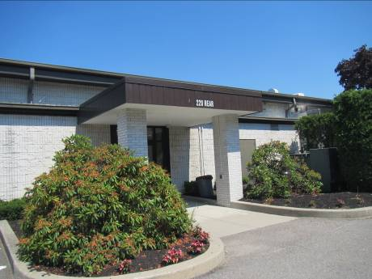

Prepared by:
Massachusetts Department of Public Health
Bureau of Environmental Health
Indoor Air Quality Program
August 2014

Background/Introduction
At the request of Peter Woodford, Senior Project Manager, Division of Capital Asset Management and Maintenance (DCAMM), the Massachusetts Department of Public Health (MDPH), Bureau of Environmental Health (BEH) conducted post-occupancy air testing at the Executive Office of Health and Human Services (EOHHS) center, 220 Rear Forbes Street, Braintree, MA. The purpose of the testing was to assess the indoor air quality (IAQ) of newly occupied space leased by Massachusetts state agencies post-occupancy. On June 30, 2014, a visit to the EOHHS center was made by Ruth Alfasso, Environmental Engineer/Inspector and Sharon Lee, Environmental Analyst/Inspector within BEH’s IAQ Program.
The building is a one-story building originally constructed in the 1970s, reportedly as a bowling alley. It was converted to office space after a period of vacancy. The building was previously occupied by a private sector tenant. Prior to the EOHHS agencies occupying the space, the offices were completely renovated, including new heating, ventilating and air-conditioning (HVAC) units. The agencies currently occupying the building are Department of Children and Families (DCF), Department of Developmental Services (DDS) and the Massachusetts Rehabilitation Commission (MRC). All of these agencies reportedly began occupying the building in March 2014. The building contains offices, open work areas, conference rooms, file rooms, storage areas, a kitchen area, a waiting area and small hearing rooms. The space has suspended ceiling tiles. The majority of areas have carpet tiles. Windows are not openable.

Methods
Air tests for carbon dioxide, carbon monoxide, temperature and relative humidity were taken with the TSI, Q-Trak, IAQ Monitor 7565. Air tests for airborne particle matter with a diameter less than 2.5 micrometers were taken with the TSI, DUSTTRAK™ Aerosol Monitor Model 8520 or the TSI DUSTTRAKTM II Model 8532. BEH/IAQ staff also performed visual inspection of building materials for water damage and/or microbial growth.

Results
The EOHHS center has a combined employee population of approximately 180, and members of the public visit the building on a daily basis. Tests were taken during normal operations and test results appear in Table 1.

Discussion

Ventilation
It can be seen from Table 1 that carbon dioxide levels were below 800 parts per million (ppm) in all 94 areas tested, indicating adequate air exchange at the time of assessment. The heating, ventilation and air-conditioning system (HVAC) consists of air-handling units (AHUs) located on the side of the building (Picture 1). Each AHU draws fresh, outdoor air into the unit, where it is filtered, heated/cooled and provided to office space via ceiling-mounted supply vents (Picture 2). Return air is drawn into an above-ceiling plenum via ceiling grates (Picture 2) and ducted back to AHUs. Note that in some offices and open areas, layout of supply and return vents do not appear to be optimal. For example, the office shown in Picture 2 has two supply vents in close proximity to one another, with a return vent also very close. This would tend to lead to short-circuiting of fresh supply air being drawn back into the return vent. Note : MDPH was not asked to do a pre-occupancy assessment of this space, otherwise this would have been noted at that time.
The HVAC system is controlled by thermostats, some of which had manual wheels for controlling temperature. It could not be determined if the HVAC system was set to automatic operation or continuous fan operation. When the fan is set to “on,” the system provides a continuous source of air circulation and filtration. The “auto” setting on the thermostat activates the HVAC system at a pre-set temperature. Once the pre-set temperature is reached, the HVAC system is deactivated. Therefore, no mechanical ventilation is provided until the thermostat re-activates the system. The MDPH typically recommends that the HVAC system be set to the fan “on” setting during occupied hours to provide continuous air circulation.
To maximize air exchange, the MDPH recommends that both supply and exhaust ventilation operate continuously during periods of occupancy. In order to have proper ventilation with a mechanical supply and exhaust system, the systems must be balanced to provide an adequate amount of fresh air to the interior of a room while removing stale air from the room. It is recommended that HVAC systems be re-balanced every five years to ensure adequate air systems function (SMACNA, 1994). It is not known when the last time the HVAC systems were balanced.
Minimum design ventilation rates are mandated by the Massachusetts State Building Code (MSBC). Until 2011, the minimum ventilation rate in Massachusetts was higher for both occupied office spaces and general classrooms, with similar requirements for other occupied spaces (BOCA, 1993). The current version of the MSBC, promulgated in 2011 by the State Board of Building Regulations and Standards (SBBRS), adopted the 2009 International Mechanical Code (IMC) to set minimum ventilation rates. Please note that the MSBC is a minimum standard that is not health-based. At lower rates of cubic feet per minute (cfm) per occupant of fresh air, carbon dioxide levels would be expected to rise significantly. A ventilation rate of 20 cfm per occupant of fresh air provides optimal air exchange resulting in carbon dioxide levels at or below 800 ppm in the indoor environment in each area measured. MDPH recommends that carbon dioxide levels be maintained at 800 ppm or below. This is because most environmental and occupational health scientists involved with research on IAQ and health effects have documented significant increases in indoor air quality complaints and/or health effects when carbon dioxide levels rise above the MDPH guidelines of 800 ppm for schools, office buildings and other occupied spaces (Sundell et al., 2011). The ventilation must be on at all times that the room is occupied. Providing adequate fresh air ventilation with open windows and maintaining the temperature in the comfort range during the cold weather season is impractical. Mechanical ventilation is usually required to provide adequate fresh air ventilation.
Carbon dioxide is not a problem in and of itself. It is used as an indicator of the adequacy of the fresh air ventilation. As carbon dioxide levels rise, it indicates that the ventilating system is malfunctioning or the design occupancy of the room is being exceeded. When this happens, a buildup of common indoor air pollutants can occur, leading to discomfort or health complaints. The Occupational Safety and Health Administration (OSHA) standard for carbon dioxide is 5,000 parts per million parts of air (ppm). Workers may be exposed to this level for 40 hours/week, based on a time-weighted average (OSHA, 1997).
The MDPH uses a guideline of 800 ppm for publicly occupied buildings. A guideline of 600 ppm or less is preferred in schools due to the fact that the majority of occupants are young and considered to be a more sensitive population in the evaluation of environmental health status. Inadequate ventilation and/or elevated temperatures are major causes of complaints such as respiratory, eye, nose and throat irritation, lethargy and headaches. For more information concerning carbon dioxide, please see Appendix A.
Temperature within the office at the time of assessment ranged from 70° F to 76° F, within the MDPH recommended comfort range. The MDPH recommends that indoor air temperatures be maintained in a range of 70° F to 78° F in order to provide for the comfort of building occupants. In many cases concerning indoor air quality, fluctuations of temperature in occupied spaces are typically experienced, even in a building with an adequate fresh air supply.
MRC staff reported temperature and heat concerns in one area of the building (area 119/121). These staff indicated concerns of lack of airflow from two specific diffusers. The diffusers are designed to project air out towards a wall, at which point air flows downward. At the time of assessment, BEH/IAQ staff detected air flowing from these diffusers when staff stood against the wall. Please note that single-pane windows were observed in MRC area 119/121. BEH staff could feel heat emanating from these windows. Use of adjustable blinds and shades and/or the application of tinting window film should help to prevent heat complaints.
The relative humidity at the time of the assessment ranged from 33 percent to 48 percent (Table 1), which is within or close to the MDPH recommended comfort range. The MDPH recommends a comfort range of 40 to 60 percent for indoor air relative humidity. Relative humidity levels would be expected to drop in the winter due to heating. The sensation of dryness and irritation is common in a low relative humidity environment. Low relative humidity is a very common problem during the heating season in the northeast part of the United States.

Microbial/Moisture Concerns
A few water-damaged ceiling tiles were observed during the assessment (Table 1). Water-damaged ceiling tiles indicate a leak from plumbing or through the building envelope and can be a source of mold. Water-damaged ceiling tiles should be replaced once a water leak is discovered and repaired.
Plants were observed in some areas (Table 1; Picture 3). Plants should be properly maintained and equipped with drip pans. Plants should be located away from ventilation sources to prevent aerosolization of dirt, pollen or mold. Plants should not be placed on carpets or other porous materials (Picture 3), since water damage to porous materials may lead to microbial growth.
BEH/IAQ staff observed refrigerators and water coolers on carpeted surfaces (Picture 4). Spills or leaks from this equipment can moisten carpet and lead to microbial growth and degradation of the carpet. MDPH typically recommends placing rubber mats or non-porous flooring (e.g., vinyl tile) beneath this equipment to protect the porous carpet from leaks and spills.
There were also several refrigerators located in the kitchen area. The gaskets of one was found to have debris and possible mold staining (Picture 5). Refrigerator gaskets are non-porous surfaces and should be cleaned with an antimicrobial cleaner. Refrigerators should be cleaned out regularly. A fish tank was observed in one office. Fish tanks need to be kept clean or they can become a source of odors.
BEH/IAQ staff examined the exterior of the building for sources of water penetration. Plants were observed in close proximity to the building’s exterior (Picture 6). Plants, shrubs, and trees in close proximity to the building hold moisture against the building exterior. The growth of roots against exterior walls can bring moisture in contact with the foundation. Plant roots can eventually penetrate the wall, leading to cracks and/or fissures in the foundation. Over time, these conditions can undermine the integrity of the building envelope and provide a means of water entry into the building via capillary action through exterior walls, foundation concrete, and masonry (Lstiburek & Brennan, 2001). The freezing and thawing action of water during the winter months can create cracks and fissures in the foundation that can result in additional penetration points for both water and pests.
BEH/IAQ staff examined the HVAC units, which are located along the side of the building. The units are in close proximity to trees and mulch (Pictures 7 and 8). Mulch is designed to hold moisture; when wet, it can also emit odors. Moisture and odors from the mulch can be drawn into ventilation equipment and subsequently distributed through the building. Trees, shrubs and plants can also be a source of pollen, debris and mold into the AHU, which can penetrate the building or clog the air filters. Consideration should be given to removing landscaping in close proximity to the building so as to maintain a space of 5 feet between shrubbery and the building and/or air intakes.

Other Indoor Air Evaluations
Indoor air quality can be negatively influenced by the presence of respiratory irritants, such as products of combustion. The process of combustion produces a number of pollutants. Common combustion emissions include carbon monoxide, carbon dioxide, water vapor, and smoke (fine airborne particle material). Of these materials, exposure to carbon monoxide and particulate matter with a diameter of 2.5 micrometers (μm) or less (PM2.5) can produce immediate, acute health effects upon exposure. To determine whether combustion products were present in the indoor environment, BEH/IAQ staff obtained measurements for carbon monoxide and PM2.5.

Carbon Monoxide
Carbon monoxide is a by-product of incomplete combustion of organic matter (e.g., gasoline, wood and tobacco). Exposure to carbon monoxide can produce immediate and acute health affects. Several air quality standards have been established to address carbon monoxide and prevent symptoms from exposure to these substances. The MDPH established a corrective action level concerning carbon monoxide in ice skating rinks that use fossil-fueled ice resurfacing equipment. If an operator of an indoor ice rink measures a carbon monoxide level over 30 ppm, taken 20 minutes after resurfacing within a rink, that operator must take actions to reduce carbon monoxide levels (MDPH, 1997).
The American Society of Heating Refrigeration and Air Conditioning Engineers (ASHRAE) has adopted the National Ambient Air Quality Standards (NAAQS) as one set of criteria for assessing indoor air quality and monitoring of fresh air introduced by HVAC systems (ASHRAE, 1989). The NAAQS are standards established by the US EPA to protect the public health from six criteria pollutants, including carbon monoxide and particulate matter (US EPA, 2006). As recommended by ASHRAE, pollutant levels of fresh air introduced to a building should not exceed the NAAQS levels (ASHRAE, 1989). The NAAQS were adopted by reference in the Building Officials & Code Administrators (BOCA) National Mechanical Code of 1993 (BOCA, 1993), which is now an HVAC standard included in the Massachusetts State Building Code (SBBRS, 2011). According to the NAAQS, carbon monoxide levels in outdoor air should not exceed 9 ppm in an eight-hour average (US EPA, 2006).
Carbon monoxide should not be present in a typical, indoor environment. If it is present, indoor carbon monoxide levels should be less than or equal to outdoor levels. Outdoor carbon monoxide concentrations were non-detect (ND) the day of the assessment (Table 1). No measureable levels of carbon monoxide were detected in the building during the assessment (Table 1).

Particulate Matter
The US EPA has established NAAQS limits for exposure to particulate matter. Particulate matter includes airborne solids, which can result in eye and respiratory irritation if exposure occurs. The NAAQS originally established exposure limits to particulate matter with a diameter of 10 μm or less (PM10). According to the NAAQS, PM10 levels should not exceed 150 micrograms per cubic meter (μg/m³) in a 24-hour average (US EPA, 2006). These standards were adopted by both ASHRAE and BOCA. Since the issuance of the ASHRAE standard and BOCA Code, US EPA established a more protective standard for fine airborne particles. This more stringent PM2.5 standard requires outdoor air particle levels be maintained below 35 μg/m³ over a 24-hour average (US EPA, 2006). Although both the ASHRAE standard and BOCA Code adopted the PM10 standard for evaluating air quality, MDPH uses the more protective PM2.5 standard for evaluating airborne particulate matter concentrations in the indoor environment.
Outdoor PM2.5 was measured at 29 μg/m³ (Table 1) on the day of the visit. PM2.5 levels measured indoors ranged from 6 to 36 μg/m³ (Table 1), which were within the NAAQS PM2.5 level of 35 μg/m³ with the exception of one of the interview rooms which had a level of 36 μg/m³; this room had a personal fan which was operating and several people had just left the area which may have contributed to aerosolized dust. Frequently, indoor air levels of particulates (including PM2.5) can be at higher levels than those measured outdoors. A number of mechanical devices and/or activities that occur in buildings can generate particulate matter during normal operations. Sources of indoor airborne particulates may include but are not limited to particles generated during the operation of fan belts in the HVAC system, use of stoves and/or microwave ovens in kitchen areas; use of photocopiers, fax machines and computer printing devices; operation of an ordinary vacuum cleaner and heavy foot traffic indoors.

Volatile Organic Compounds
Indoor air concentrations can be greatly impacted by the use of products containing volatile organic compounds (VOCs). VOCs are carbon-containing substances that have the ability to evaporate at room temperature. Total volatile organic compounds (TVOCs) can result in eye and respiratory irritation if exposure occurs. For example, chemicals evaporating from a paint can stored at room temperature would most likely contain VOCs. In an effort to identify materials that can potentially increase indoor VOC concentrations, BEH/IAQ staff examined rooms for products containing these respiratory irritants.
There are several photocopiers in the building. Photocopiers can be sources of pollutants such as VOCs, ozone, heat and odors, particularly if the equipment is older and in frequent use. Both VOCs and ozone are respiratory irritants (Schmidt Etkin, 1992). Photocopiers should be kept in well ventilated rooms, and should be located near windows or exhaust vents. It was observed that at least one area did have dedicated exhaust for the photocopier.
Hand sanitizer was found in some offices and common areas (Table 1). Hand sanitizers may contain ethyl alcohol and/or isopropyl alcohol, which are highly volatile and may be irritating to the eyes and nose. Sanitizing products may also contain fragrances to which some people may be sensitive.
Air fresheners and deodorizing materials were observed in some areas (Table 1). Air deodorizers contain chemicals that can be irritating to the eyes, nose and throat of sensitive individuals. Many air fresheners contain 1,4-dichlorobenzene, a VOC which may cause reductions in lung function (NIH, 2006). Furthermore, deodorizing agents do not remove materials causing odors, but rather mask odors that may be present in the area.
One room contained a dry erase board and related materials (Table 1). Materials such as dry erase markers and dry erase board cleaners may contain VOCs, such as methyl isobutyl ketone, n-butyl acetate and butyl-cellusolve (Sanford, 1999), which can be irritating to the eyes, nose and throat.

Other Conditions
Other conditions that can affect indoor air quality were observed during the assessment. Most areas in the offices are carpeted; the Institute of Inspection, Cleaning and Restoration Certification (IICRC) recommends that carpeting be cleaned annually (or semi-annually in soiled high traffic areas) (IICRC, 2012). Regular cleaning with a high efficiency particulate air (HEPA) filtered vacuum in combination with an annual cleaning will help to reduce accumulation and potential aerosolization of materials from the carpeting.
Upholstered furniture and plush items were seen in some areas (Table 1; Picture 9). Upholstered furniture is covered with fabric that comes in contact with human skin. This type of contact can leave oils, perspiration, hair and skin cells. Dust mites feed upon human skin cells and excrete waste products that contain allergens. In addition, if relative humidity levels increase above 60 percent, dust mites tend to proliferate (US EPA, 1992). In order to remove dust mites and other pollutants, frequent vacuuming of upholstered furniture is recommended (Berry, 1994). It is also recommended that upholstered furniture, be professionally cleaned on an annual basis. If outdoor conditions or indoor activities (e.g., renovations) create an excessively dusty environment, cleaning frequency should be increased (every six months) (IICRC, 2000).
In some areas, accumulation of items, including papers, boxes and personal items were found stored on desks, tables and counters. Large numbers of items provide a source for dusts to accumulate. These items make it difficult for custodial staff to clean. Items should be relocated and/or cleaned periodically to avoid excessive dust build up.
Food and food preparation equipment was observed in several areas of the building. Food, including crumbs remaining on food preparation equipment can attract pests and cause odors. Food should be kept in tightly-sealed containers and food preparation areas should be cleaned regularly.

Conclusions/Recommendations
In view of the findings at the time of the visit, the following recommendations are made:
- The fan setting on all thermostats should remain in the “ON” setting during business hours to provide adequate ventilation throughout the building. Ensure fresh air louvers on AHUs are working properly and adjust to increase outside air intake as needed.
- Operate and maintain HVAC systems in accordance with manufacturer’s recommendations, including regular filter changes/cleaning of all AHUs and ACs.
- Consider adopting a balancing schedule of every 5 years for all mechanical ventilation systems, as recommended by ventilation industrial standards (SMACNA, 1994).
- Consider adding additional blinds or solar film to areas that are experiencing solar gain.
- Consideration should be given to moving supply and exhaust vents such as those shown in Picture 2.
- For buildings in New England, periods of low relative humidity during the winter are often unavoidable. Therefore, scrupulous cleaning practices should be adopted to minimize common indoor air contaminants whose irritant effects can be enhanced when the relative humidity is low. To control for dusts, a high efficiency particulate arrestance (HEPA) filter equipped vacuum cleaner in conjunction with wet wiping of all surfaces is recommended. Avoid the use of feather dusters. Drinking water during the day can help ease some symptoms associated with a dry environment (throat and sinus irritations).
- Ensure leaks are repaired and remove/replace water-damaged ceiling tiles. Examine the area above and around these areas for mold growth. Disinfect areas of water leaks with an appropriate antimicrobial.
- Ensure plants have drip pans and avoid over-watering. Examine drip pans periodically for mold growth. Disinfect with an appropriate antimicrobial where necessary.
- Place protective rubber mats beneath water coolers and refrigerators or use non-porous flooring to prevent damage to carpeting.
- Clean refrigerator gaskets with an antimicrobial cleaner and ensure that refrigerators are cleaned out regularly.
- Maintain fish tanks to prevent odors and microbial growth.
- Ensure plants, trees and shrubs are located at least five feet away from exterior walls/foundation of the building and the air intakes for the AHUs.
- Remove mulch from areas near the AHUs and consider replacing with crushed stone.
- Avoid the use of scented products such as air deodorizers and fresheners.
- Clean carpeting annually or semi-annually in soiled high traffic areas as per the recommendations of the Institute of Inspection, Cleaning and Restoration Certification (IICRC, 2012). Copies of the IICRC fact sheet can be downloaded at: http://www.iicrc.org/consumers/care/carpet-cleaning/#faq.
- Clean dry-erase marker trays of accumulated dust and debris regularly using a damp cloth.
- Consider reducing, consolidating or relocating items and papers to allow for more thorough cleaning.
- Ensure that food is stored in tightly-sealed containers and that food preparation equipment is kept clean to avoid smoke, odors and attracting pests.
- Refer to resource manual and other related indoor air quality documents located on the MDPH’s website for further building-wide evaluations and advice on maintaining public buildings. These documents are available at: http://mass.gov/dph/iaq.

References
ASHRAE. 1989. Ventilation for Acceptable Indoor Air Quality. American Society of Heating, Refrigeration and Air Conditioning Engineers. ANSI/ASHRAE 62-1989.
Berry, M.A. 1994. Protecting the Built Environment: Cleaning for Health. Michael A. Berry, Chapel Hill, NC.
BOCA. 1993. The BOCA National Mechanical Code/1993. 8th ed. Building Officials and Code Administrators International, Inc., Country Club Hill, IL.
IICRC. 2000. IICRC S001. Reference Guideline for Professional On-Location Cleaning of Textile Floor Covering Materials. Institute of Inspection, Cleaning and Restoration Certification. Institute of Inspection Cleaning and Restoration, Vancouver, WA.
IICRC. 2012. Carpet Cleaning FAQ 4 Institute of Inspection, Cleaning and Restoration Certification. Institute of Inspection Cleaning and Restoration, Vancouver, WA.
Lstiburek, J. & Brennan, T. 2001. Read This Before You Design, Build or Renovate. Building Science Corporation, Westford, MA. U.S. Department of Housing and Urban Development, Region I, Boston, MA.
MDPH. 1997. Requirements to Maintain Air Quality in Indoor Skating Rinks (State Sanitary Code, Chapter XI). 105 CMR 675.000. Massachusetts Department of Public Health, Boston, MA.
NIH. 2006. Chemical in Many Air Fresheners May Reduce Lung Function. NIH News. National Institute of Health. July 27, 2006. http://www.nih.gov/news/pr/jul2006/niehs-27.htm
OSHA. 1997. Limits for Air Contaminants. Occupational Safety and Health Administration. Code of Federal Regulations. 29 C.F.R 1910.1000 Table Z-1-A.
Sanford. 1999. Material Safety Data Sheet (MSDS No: 198-17). Expo® Dry Erase Markers Bullet, Chisel, and Ultra Fine Tip. Sanford Corporation, Bellwood, IL.
SBBRS. 2011. Mechanical Ventilation. State Board of Building Regulations and Standards. Code of Massachusetts Regulations, 8th edition. 780 CMR 1209.0.
Schmidt Etkin, D. 1992. Office Furnishings/Equipment & IAQ Health Impacts, Prevention & Mitigation. Cutter Information Corporation, Indoor Air Quality Update, Arlington, MA.
SMACNA. 1994. HVAC Systems Commissioning Manual. 1st ed. Sheet Metal and Air Conditioning Contractors’ National Association, Inc., Chantilly, VA.
Sundell. 2011. Sundell, J., H. Levin, W. W. Nazaroff, W. S. Cain, W. J. Fisk, D. T. Grimsrud, F. Gyntelberg, Y. Li, A. K. Persily, A. C. Pickering, J. M. Samet, J. D. Spengler, S. T. Taylor, and C. J. Weschler. Ventilation rates and health: multidisciplinary review of the scientific literature. Indoor Air, Volume 21: pp 191–204.
US EPA. 1992. Indoor Biological Pollutants. US Environmental Protection Agency, Environmental Criteria and Assessment Office, Office of Health and Environmental Assessment, research Triangle Park, NC. EPA 600/8-91/202. January 1992.
US EPA. 2006. National Ambient Air Quality Standards (NAAQS). US Environmental Protection Agency, Office of Air Quality Planning and Standards, Washington, DC. http://www.epa.gov/air/criteria.html.
Picture 1
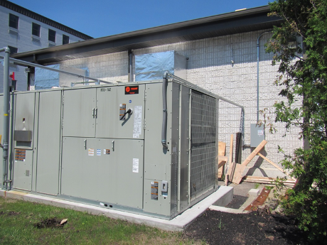
Air handling units (AHU) along the side of the building
Picture 2
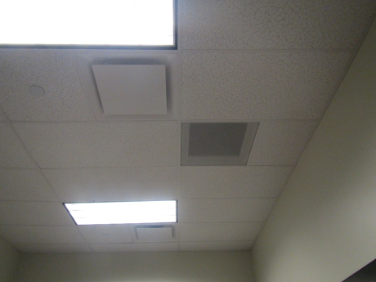
Supplies (arrows) and return vent in an office
Picture 3
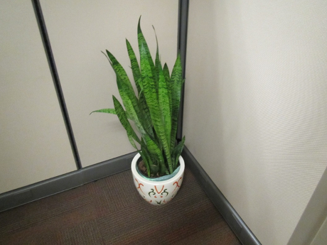
Plant on carpeted surface
Picture 4
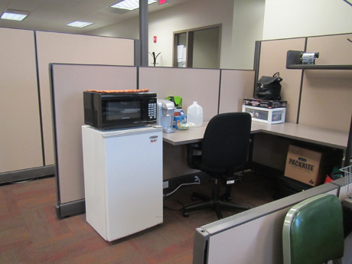
Refrigerator on carpet
Picture 5
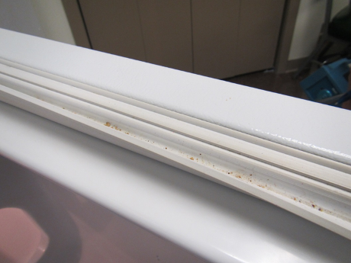
Refrigerator gasket with debris and mold staining
Picture 6
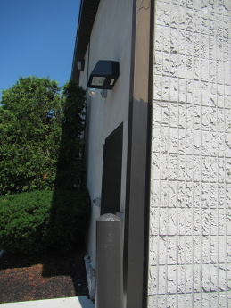
Shrubbery against the side of the building
Picture 7
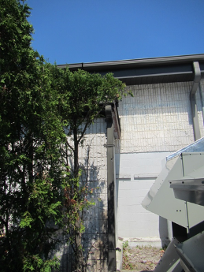
Plants in front of the AHU air intake
Picture 8
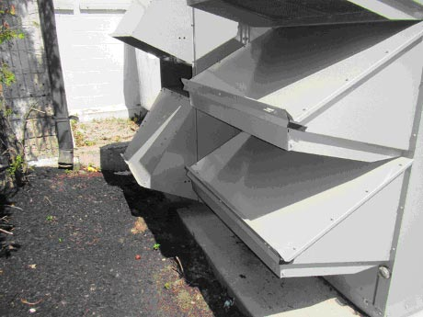
Fresh air intakes
Ventilation fresh air intakes in close proximity to mulch
Picture 9
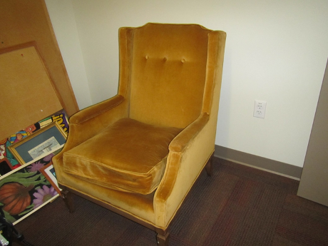
Upholstered chair in office
Location | Carbon  Dioxide  (ppm) | Carbon Monoxide  (ppm) | Temp  (°F) | Relative  Humidity  (%) | PM2.5  (µg/m³) | Occupants  in Room | Windows  Openable | Ventilation |  | Remarks
 |  |  |  |  |  |  |  | Supply | Exhaust | Remarks
Background | 388 | ND | 78 | 61 | 29 |  |  |  |  | Hot and sunny
Copy/Mail | 574 | ND | 75 | 39 | 12 | 0 | N | Y | Y | Exhaust appears to be direct
Lobby/waiting | 651 | ND | 74 | 41 | 12 | 7 | N | Y | Y
Public Ladies’ room |  |  |  |  |  |  | N | Y | Y | Bathroom odor, exhaust is on, AF
Public Men’s Room |  |  |  |  |  |  | N | Y | Y
Reception | 622 | ND | 75 | 39 | 18 | 2 | N | Y | Y | CP, food
Staff kitchen | 526 | ND | 74 | 39 | 13 | 0 | N | Y | Y | NC, 3 refrigerators (one gasket has debris), microwaves and toasters/toaster ovens.
Staff women’s room |  |  | 75 | 41 | 9 | 0 | N | Y | Y
DDS
79 | 543 | ND | 74 | 40 | 7 | 1 | N | Y | Y | WD-CT, PF
80-81 cubes | 700 | ND | 73 | 40 | 10 | 0 | N | Y | Y
82-87 cubes | 660 | ND | 73 | 41 | 10 | 2 | N | Y | Y | Fans, CPs, WD-CT
88-93 cubes | 520 | ND | 74 | 41 | 8 | 2 | N | Y | Y | Plants, fishtank
94-95 cubes | 543 | ND | 74 | 40 | 8 | 0 | N | Y | Y | PF
96-97 cubes | 556 | ND | 73 | 40 | 15 | 1 | N | Y | Y | Plants
98-99 cubes | 523 | ND | 73 | 40 | 13 | 0 | N | Y | Y | Plants, CP/AF
100-101 cubes | 547 | ND | 73 | 40 | 12 | 0 | N | Y | Y | PF on, plants, items
102-103 cubes | 538 | ND | 73 | 39 | 13 | 2 | N | Y | Y | HS
138 ASC | 565 | ND | 75 | 39 | 14 | 0 | N | Y | Y | Air flow complaint
140 | 520 | ND | 73 | 40 | 8 | 0 | N | Y | Y | DO, DEM
141 | 525 | ND | 73 | 40 | 10 | 0 | N | Y | Y | DO
145 | 549 | ND | 75 | 39 | 15 | 1 | N | Y | Y | Boxes on floor, DO
146 | 557 | ND | 75 | 39 | 13 | 1 | N | Y | Y | Heat complaints, DO, fan on,
147 | 559 | ND | 74 | 37 | 14 | 1 | N | Y | Y | Food
148 | 540 | ND | 74 | 38 | 14 | 1 | N | Y | Y | Plush chairs, DO, temperature complaints (too cold)
149 | 527 | ND | 73 | 39 | 14 | 1 | N | Y | Y | Fridge, PF
150 | 551 | ND | 73 | 39 | 14 | 1 | N | Y | Y | Perfume odor
151 | 546 | ND | 73 | 39 | 18 | 0 | N | Y | Y | Heater
152 records | 558 | ND | 73 | 39 | 13 | 0 | N | Y | Y | NC
199 unfinished closet | 726 | ND | 73 | 40 | 10 | 0 | N | Y | N
ASL interpreter area | 513 | ND | 71 | 42 | 11 | 1 | N | Y | Y
MRC
109-104 cubes | 596 | ND | 71 | 43 | 11 | 1 | N | Y | Y | Plants, HS, PF, items
111 | 556 | ND | 71 | 42 | 12 | 2 | N | Y | Y
119 | 605 | ND | 76 | 33 | 13 | 0 | N | Y | Y | PF, heat complaints
121 | 586 | ND | 75 | 35 | 11 | 0 | N | Y | Y | PF, CPs, heat complaints
153 | 476 | ND | 71 | 41 | 12 | 0 | N | Y | Y | Plant
154 | 492 | ND | 71 | 42 | 26 | 0 | N | Y | Y | Plant
155 | 488 | ND | 71 | 41 | 23 | 0 | N | Y | Y | Plant
156 | 413 | ND | 71 | 43 | 10 | 0 | N | Y | Y | DO
157 interview | 531 | ND | 71 | 43 | 14 | 0 | N | Y | Y | DO
158 interview | 531 | ND | 71 | 43 | 13 | 0 | N | Y | Y | 4 computers, DO, NC
159 | 640 | ND | 71 | 47 | 8 | 3 | N | Y | Y
164 storage | 582 | ND | 71 | 43 | 8 | 0 | N | Y | Y | DO, CPs
165 open files | 547 | ND | 70 | 43 | 7 | 0 | N | Y | Y | DO
166 legal office | 422 | ND | 70 | 43 | 9 | 0 | N | Y | Y | DO
DCF
001-004 cubes | 572 | ND | 75 | 40 | 9 | 2 | N | Y | Y
005-010 cube area | 577 | ND | 73 | 39 | 12 | 3 | N | Y | Y | Food
011-016 cubes | 550 | ND | 73 | 41 | 11 | 3 | N | Y | Y | Microwave. CPs
017-022 cubes | 555 | ND | 73 | 41 | 7 | 4 | N | Y | Y
023-034 cubes | 568 | MD | 74 | 39 | 12 | 0 | N | Y | Y | Bushes against windows outside, fridge and microwave
025-036 cubes | 568 | ND | 75 | 39 | 16 | 3 | N | Y | Y | Fridge and microwave
027-044 cubes | 541 | ND | 75 | 41 | 10 | 2 | N | Y | Y
038-047 cubes | 652 | ND | 74 | 41 | 12 | 2 | N | Y | Y | Fridge, CPs, toaster, toaster oven
040-048 cubes | 574 | ND | 75 | 40 | 10 | 3 | N | Y | Y | Microwave, fridge, AF
054-061 cubes | 632 | ND | 75 | 40 | 11 | 1 | N | Y | Y
065-072 cubes | 640 | ND | 75 | 40 | 11 | 3 | N | Y | Y | Items, CPs
073-074 cubes | 530 | ND | 75 | 40 | 13 | 1 | N | Y | Y
075-078 cubes | 575 | ND | 75 | 40 | 14 | 1 | N | Y | Y | CPs
124-127 cubes | 428 | ND | 71 | 43 | 7 | 1 | N | Y | Y | PCs, water cooler on carpet
128-135 cubes | 454 | ND | 73 | 41 | 6 | 1 | N | Y | Y | AF
131-137 | 512 | ND | 74 | 41 | 8 | 1 | N | Y | Y | CPs, microwave
160 | 501 | ND | 71 | 44 | 7 | 0 | N | Y | Y | DO
161 | 542 | ND | 71 | 44 | 8 | 0 | N | Y | Y | DO
162 interview | 560 | ND | 71 | 48 | 16 | 0 | N | Y | Y | DO, HS, NC
163 | 524 | ND | 72 | 44 | 7 | 0 | N | Y | Y | DO
168 | 600 | ND | 73 | 41 | 13 | 1 | N | Y | Y
169 | 520 | ND | 73 | 39 | 13 | 0 | N | Y | Y
170 | 492 | ND | 72 | 40 | 12 | 1 | N | Y | Y | DO
171 | 481 | ND | 72 | 40 | 12 | 0 | N | Y | Y | DO, items, food
172 hearing | 508 | ND | 72 | 41 | 13 | 0 | N | Y | Y | NC, DO
174 family hearing | 553 | ND | 73 | 41 | 15 | 0 | N | Y | Y | NC
175 | 517 | ND | 74 | 41 | 9 | 0 | N | Y | Y | DO
176 | 506 | ND | 74 | 41 | 10 | 0 | N | Y | Y | DO
177 | 591 | ND | 73 | 41 | 10 | 0 | N | Y | Y | DO
179 | 485 | ND | 72 | 40 | 12 | 1 | N | Y | Y | Heater, window/solar
180 | 502 | ND | 74 | 41 | 6 | 0 | N | Y | Y | Fridge, microwave, DO
181 | 420 | ND | 72 | 42 | 6 | 0 | N | Y | Y
182 | 418 | ND | 72 | 43 | 7 | 0 | N | Y | Y | DO
205 (storage) | 577 | ND | 74 | 39 | 13 | 0 | N | Y | Y | Bikes and toys, NC, cardboard boxes on floor
207 | 523 | ND | 73 | 41 | 8 | 0 | N | Y | Y
208 | 571 | ND | 74 | 40 | 10 | 0 | N | Y | Y | Chairs, DO
209 | 522 | ND | 74 | 39 | 11 | 0 | N | Y | Y | DO
210 | 556 | ND | 74 | 39 | 16 | 0 | N | Y | Y | DO, items
211 | 594 | ND | 73 | 40 | 11 | 0 | N | Y | Y | Plush chair, fridge on carpet
213 | 590 | ND | 73 | 40 | 12 | 1 | N | Y | Y | DO, fridge on carpet
216 | 609 | ND | 74 | 38 | 18 | 0 | N | Y | Y | Papers on floor
217 | 624 | ND | 74 | 39 | 13 | 2 | N | Y | Y | CP/AF, items
218 | 635 | ND | 74 | 39 | 18 | 2 | N | Y | Y | Area rug
220 hearing/interview | 750 | ND | 71 | 45 | 36 | 3 just left | N | Y | Y | Plant, PF
221 | 525 | ND | 75 | 38 | 10 | 0 | N | Y | Y | DO
222 supply storage | 529 | ND | 75 | 39 | 7 | 0 | N | Y | N | DO
224 | 612 | ND | 75 | 38 | 18 | 0 | N | Y | Y | DO
225 | 577 | ND | 75 | 38 | 19 | 0 | N | Y | Y | DO, CP, food
226 | 587 | ND | 75 | 39 | 18 | 0 | N | Y | Y | Food, PF, DO
227 | 664 | ND | 75 | 39 | 13 | 0 | N | Y | Y | Fabric wall hangings, DO
228 | 760 | ND | 75 | 39 | 11 | 2 | N | Y | Y | Fridge, recycling
229 and 230 locked storage |  |  |  |  |  |  | N |  |  | Stored items, mostly on shelves and in closed totes a few items on floor.
233 (files) | 502 | ND | 74 | 39 | 14 | 0 | N | Y | Y | NC, DO, files (not on floor)
235 | 521 | ND | 74 | 39 | 18 | 0 | N | Y | Y | Fridge on carpet, CP, DO

