Water Damage Investigation

Braintree High School
128 Town Street
Braintree, Massachusetts

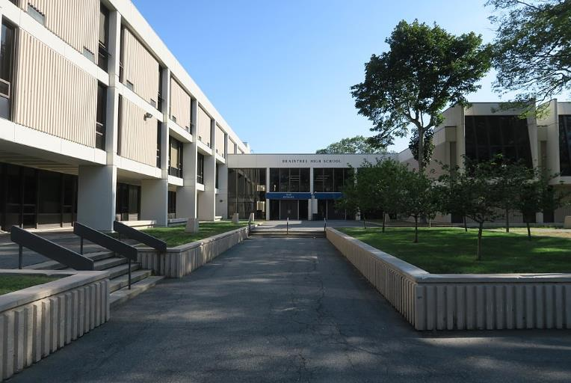

Prepared by:
Massachusetts Department of Public Health
Bureau of Environmental Health
Indoor Air Quality Program
February 2019

BACKGROUND
Building: | Braintree High School (BHS)
Address: | 128 Town Street, Braintree, Massachusetts
Assessment Coordinated via: | Dr. Frank Hackett, Superintendent, Braintree Public Schools and Marybeth McGrath, Director, Braintree Board of Health.
Reason for Request: | Indoor air quality (IAQ) concerns, with a focus on water damage/mold. Specific areas listed in the complaint were room 115, the OT/PT area, and 2nd floor science rooms in the core area of the building.
Date of Assessment: | February 19, 2019
Massachusetts Department of Public Health/Bureau of Environmental Health (MDPH/BEH) Staff Conducting Assessment: | Cory Holmes, Environmental Analyst/Inspector IAQ Program accompanied by Betsey Clifford, Science Director, Edward Cronin, Director of Finance and Operations and Thomas Mahar, Head Custodian
Date of Building Construction: | 1972
Building Description: | The areas of the BHS visited had cinderblock walls, tile floors and either concrete “honeycombed” ceilings or suspended tactile ceiling tiles or both. In the cafeteria and main hallways, original tactile ceiling tiles were replaced with modern (mineral fiber) ceiling tiles.
Windows: | Openable in perimeter classrooms, core areas do not have windows.

METHODS
Please refer to the IAQ Manual and appendices for methods, sampling procedures, and interpretation of results (MDPH, 2015).

RESULTS and DISCUSSION

Microbial/Moisture Concerns
In order for building materials to support mold growth, a source of water exposure is necessary. The US Environmental Protection Agency (US EPA) and the American Conference of Governmental Industrial Hygienists (ACGIH) recommends that porous materials (e.g., wallboard, carpeting) be dried with fans and heating within 24 to 48 hours of becoming wet (US EPA, 2008; ACGIH, 1989). If porous materials are not dried within this time frame, mold growth may occur. It is important to note that the majority of building materials observed were non-porous surfaces (i.e., cinder block, concrete, tactile ceiling tiles), which are not conducive to mold growth as opposed to porous materials such as gypsum wallboard, carpet and fibrous ceiling tiles). Below are observations made in each area evaluated:
- Room 115: Dark staining on concrete ceiling (Picture 1) indicating historic leaks from above. No visible mold was present, BEH/IAQ staff physically tried to clean the stain with an anti-microbial wipe and the stain was embedded into the concrete. Water damage and accumulated dust/ debris was noted on insulated pipes along the ceiling (Picture 2). In a few cases dark staining (likely to be mold growth) was observed (Picture 3). The pipe wrap is a porous mesh material, which is difficult to clean. The long lengths of insulation are likely to be fiberglass; however the elbows may be asbestos containing material (ACM). Where asbestos-containing materials are found damaged, these materials should be removed or remediated in a manner consistent with Massachusetts asbestos remediation laws (MDLI, 1993).
- OT/PT: Dark staining on pipe insulation was observed (Picture 4), which is likely mold growth. Accumulated dust and debris was observed on/near HVAC vents, surrounding ceiling tiles and on concrete walls/ceilings (Pictures 5 through 7). It should be noted that the composition of these ceiling tiles makes them mold-resistant, however, dust/debris buildup on the uneven surfaces if moistened repeatedly can support mold growth. The uneven surfaces of the tiles are difficult to clean as is the design of the ceilings themselves.
- Classrooms 206, 208, 226, 230, 232, 234, 240, & 242: dust/debris accumulation was noted on/around vents, surrounding ceiling tiles and walls (Pictures 8 through 11). As mentioned previously, these surfaces are non-porous and therefore are not conducive to mold growth, however, if moistened repeatedly surface debris can become mold-colonized.
- Classroom 230: A piece of filter media had been cut and secured to the terminus of the vent (Picture 12). It wasn’t known at the time of the visit how long this filter had been in place. This room also had an empty aquarium that was still damp and had debris and visible scale on the interior of glass (Picture 13). Aquariums should be well kept and properly cleaned when not in use to avoid being a source of mold/bacteria and associated odors.
- Classroom 208: had a few water-damaged ceiling tiles along the interior wall, one of which was a modern drop ceiling tile (Picture 14). The leak was reported to be an occasional occurrence depending on certain wind/weather pattern so likely originates from a breach in the building envelope.

Other Conditions
The MDPH recommends that HVAC equipment be outfitted with filters of a Minimum Efficiency Reporting Value (MERV) of 8, which are adequate in filtering out pollen and mold spores (ASHRAE, 2012). In addition, filters should be changed 2-4 times a year or in accordance with the manufacture’s recommendations. It could not be determined at the time of assessment what MERV rating the filter media used at BHS is, however filters are reportedly changed three times per year.
It should also be noted that the original acoustic ceiling tiles have already been removed in some areas of BHS and replaced with modern suspended tiles. These areas include the cafeteria and main hallways.

RECOMMENDATIONS
In view of the findings at the time of the visit, the following recommendations are made:
- Clean/wipe down non-porous surfaces (e.g., walls, ceilings/tiles) with a high efficiency particulate arrestance (HEPA) filter equipped vacuum cleaner with brush attachment and/or wet wiping of surfaces. Particular attention should be conducted around vents, which create air currents that capture airborne dust/debris.
- Water-damaged pipe insulation found to have likely mold growth should be replaced/rewrapped, however due to the age of the building caution is warranted due to the potential presence of ACM. Conduct all remediation activities in conjunction with local hazardous materials laws and regulations. In the interim, use a HEPA filter equipped vacuum cleaner with brush attachment to remove any surface dust/mold growth that may be present.
- Ensure all aquariums/terrariums are clean and maintained properly.
- Upgrade HVAC filters to MERV 8 or higher. Continue to change filters 2-4 times per year. Clean HVAC units, vents and cabinets of debris and dust when filters are changed.
- For buildings in New England, periods of low relative humidity during the winter are often unavoidable. Therefore, scrupulous cleaning practices should be adopted to minimize common indoor air contaminants whose irritant effects can be enhanced when the relative humidity is low. To control for dusts, a HEPA filter equipped vacuum cleaner in conjunction with wet wiping of all surfaces is recommended. Avoid the use of feather dusters. Drinking water during the day can help ease some symptoms associated with a dry environment (throat and sinus irritation).
- If ACM is present in the building, ensure compliance with the Asbestos Hazard Emergency Response Act (AHERA), which requires inspection of asbestos containing materials every three years as well as a semi-annual walkthrough to determine current conditions of asbestos-containing materials.
- Investigate leak in room 208 and replace water-damaged ceiling tile (see above).
- Continue with long-term plans to replace original acoustic ceiling tiles with modern suspended tile systems as funds become available.
- Clean supply, return/exhaust vents, univent grills/cabinets and personal fans periodically of accumulated dust.
- For more information on mold refer to the US EPA’s “Mold Remediation in Schools and Commercial Buildings” (US EPA, 2008). Available at: http://www.epa.gov/mold/mold-remediation-schools-and-commercial-buildings-guide.
- As the school was on February break during the visit, BEH/IAQ staff have offered to return to the building under normal operation/full occupancy to conduct general IAQ testing/evaluation.
- Refer to resource manual and other related indoor air quality documents located on the MDPH’s website for further building-wide evaluations and advice on maintaining public buildings. These documents are available at http://mass.gov/dph/iaq.

REFERENCES
ACGIH. 1989. Guidelines for the Assessment of Bioaerosols in the Indoor Environment. American Conference of Governmental Industrial Hygienists, Cincinnati, OH.
ASHRAE. 2012. American Society of Heating, Refrigeration and Air Conditioning Engineers (ASHRAE) Standard 52.2-2012 -- Method of Testing General Ventilation Air-Cleaning Devices for Removal Efficiency by Particle Size (ANSI Approved). 2012.
MDLI. 1993. Regulation of the Removal, Containment or Encapsulation of Asbestos, Appendix 2. 453 CMR 6,92(I)(i).
MDPH. 2015. Massachusetts Department of Public Health. Indoor Air Quality Manual: Chapters I-III. Available at: http://www.mass.gov/eohhs/gov/departments/dph/programs/environmental-health/exposure-topics/iaq/iaq-manual/.
US EPA. 2008. Mold Remediation in Schools and Commercial Buildings. US Environmental Protection Agency, Office of Air and Radiation, Indoor Environments Division, Washington, D.C. EPA 402-K-01-001. http://www.epa.gov/mold/mold-remediation-schools-and-commercial-buildings-guide.

Picture 1
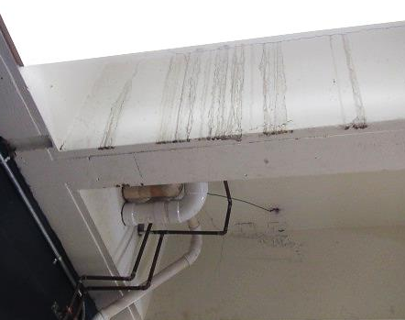
Dark staining on ceiling concrete indicating leak from above
Picture 2
Water-damaged pipe insulation
Picture 3
Water-damaged pipe insulation, dark staining indicates likely mold growth
Picture 4
Water-damaged pipe insulation, dark staining indicates likely mold growth
Picture 5
Accumulated dust/debris on concrete ceiling surfaces
Picture 6
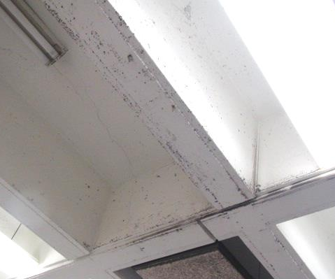
Accumulated dust/debris on concrete ceiling surfaces
Picture 7
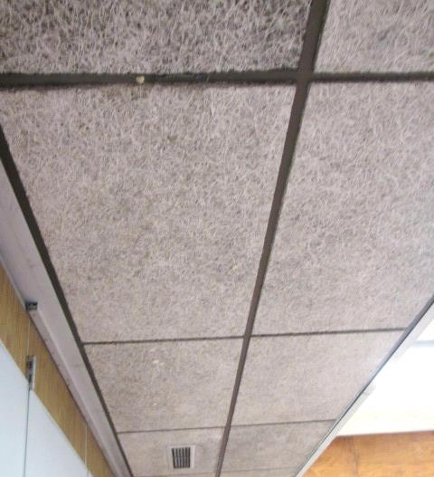
The uneven surface of tactile ceiling tiles
Picture 8
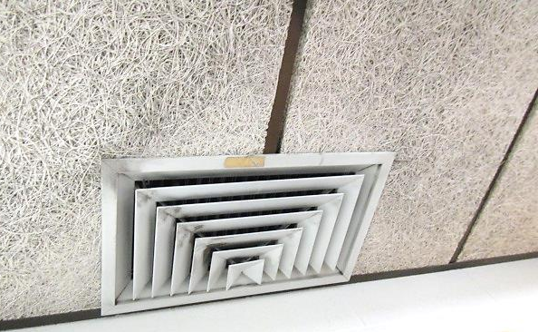
Dust/debris accumulation on vents and surrounding ceiling tiles
Picture 9
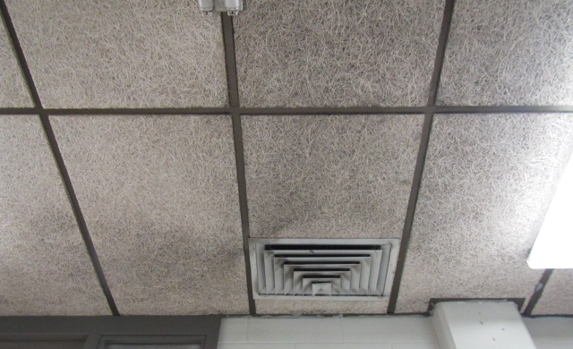
Accumulated dust/debris on vent and surrounding ceiling tiles
Picture 10
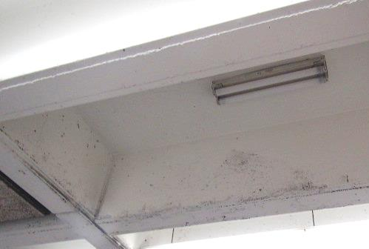
Accumulated dust/debris on ceiling
Picture 11
Accumulated dust/debris near vent
Picture 12
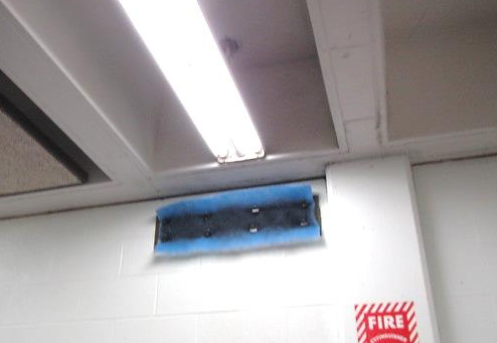
Filter media on terminus of supply vent
Picture 13
Aquarium in classroom 230
Picture 14
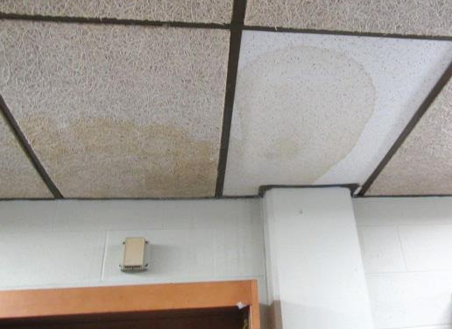
Water-damaged ceiling tiles in room 208, the tile on the right is a modern type (not tactile)

