INDOOR AIR QUALITY ASSESSMENT

Braintree Rehabilitation Hospital
250 Pond Street
Braintree, Massachusetts 02184

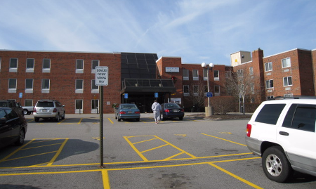

Prepared by:
Massachusetts Department of Public Health
Bureau of Environmental Health
Indoor Air Quality Program
January 2009

Background/Introduction
At the request of Ms. Lillian Jette, Hospital Complaint Manager, Division of Health Care Quality, Bureau of Health Care Safety and Quality (BHCSQ), the Massachusetts Department of Public Health (MDPH), Bureau of Environmental Health (BEH) provided assistance and consultation regarding potential indoor air quality concerns at the Braintree Rehabilitation Hospital (BRH) located at 250 Pond Street, Braintree, Massachusetts. The request was prompted by complaints of mold/mildew odors, as well as concerns regarding interior renovations and their potential impact on the health of patients. On December 4, 2008, Cory Holmes, Environmental Analyst/Regional Inspector for BEH’s Indoor Air Quality (IAQ) Program accompanied Ms. Jeannie Ouellette, Health Facility Inspector, on a site visit to the BRH to investigate the aforementioned complaints.
The BRH is a three-story red brick hospital that provides clinical and rehabilitative services. Windows are openable throughout the building. At the time of the site visit, the North Wing of the third floor was undergoing interior renovations (e.g., flooring, ceiling tiles, wall paper/paint), and the sprinkler system was being removed and replaced in sections throughout the building.

Methods
BEH staff performed a visual inspection of building materials for water damage and/or microbial growth. Moisture content of porous building materials was measured with Delmhorst, BD-2000 Model, Moisture Detector with a Delmhorst Standard Probe.

Discussion

Microbial/Moisture Concerns
BRH occupants reported dampness/mildew, specifically in the front entrance, hallways near the elevator, and room 230-A. BEH staff conducted a thorough investigation for signs of moisture, water damage and/or visible mold growth specifically in the aforementioned areas. Exposure to mold and related particulates can result in irritant symptoms, particularly in sensitive individuals (i.e. those with pre-existing conditions such as allergies, asthma and respiratory disease). In order for building materials to support mold growth, a source of water exposure is necessary (e.g., roof/plumbing leaks). Identification and elimination of water moistening building materials is necessary to control mold growth. Materials with increased moisture content over normal concentrations may indicate the possible presence of mold growth.
At the time of the assessment, BEH staff did not observe any evidence of water damage/staining of building materials (e.g., carpet, ceiling tiles, plaster) or mold growth in the main entrance, hallways or room 230-A. However, it was reported by BRH officials that skylights in the atrium/main entrance had leaked and were repaired one day prior to the BEH site visit (Pictures 1 and 2). BEH staff observed skylights on the roof of the atrium and observed areas of repair (Pictures 3 to 5).
BRH staff also reported that while the skylights were leaking, water was collected in a bucket near the reception desk to prevent soiling of the wall-to-wall carpeting. BEH staff conducted moisture testing of carpeting, wood and gypsum wallboard in the main entrance/atrium area. All materials had low (i.e., normal) moisture content. In addition, no visible mold or associated odors were detected (Table 1).
It is important to note that moisture content of materials measured is a real-time measurement of the conditions present in the building at the time of the assessment. Repeated water damage to porous building materials (e.g., GW, ceiling tiles, and carpeting) can result in microbial growth. The US Environmental Protection Agency (US EPA) and the American Conference of Governmental Industrial Hygienists (ACGIH) recommend that porous materials be dried with fans and heating within 24 to 48 hours of becoming wet (US EPA, 2001; ACGIH, 1989). If not dried within this time frame, mold growth may occur. Once mold has colonized porous materials, they are difficult to clean and should be removed.

Renovations and Other IAQ Evaluations
As previously mentioned, the North Wing of the third floor was undergoing interior renovations at the time of the assessment. Dusts/particles generated from renovation activities can provide a source of eye and respiratory irritation. The area under renovation was separated from the occupied area by a solid construction barrier consisting of gypsum wallboard (Picture 6). However, BEH staff observed spaces where light could be seen penetrating through the barrier (Pictures 7 to 9). BEH staff reported these findings to Robert Ferrisi, BRH Facilities Director and Bruce McDonough, Construction Superintendent, Carr Enterprises, Ltd., at the time of the assessment and provided a recommendation to re-seal the construction barrier with plastic polyethylene sheeting and duct tape to make the barrier as air-tight as possible. The barrier was re-sealed during the assessment, as confirmed by BEH staff (Picture 10). It is also important to note that air filtration units equipped with high efficiency particulate arrestance (HEPA) filters were employed in the renovation area to depressurize and draw pollutants and odors away from occupied areas (Picture 11).
Several sources of foul odors were detected in the building. As mentioned previously, sprinkler pipes were being replaced in the building. This activity requires the removal and draining of stagnant water that has accumulated in the pipes. Stagnant water can often be a source of microbial growth and odors. Since the BRH functions as a rehabilitation facility, odors of human wastes from occupant incontinence were also prevalent in several areas.
In a few patient rooms, exhaust ventilation was not functioning (Picture 11) and mechanical supply ventilation units (Picture 12) were found deactivated. At the time of the assessment, therefore, these areas lacked mechanical means for introducing fresh, outside air to dilute odors or remove stale air/odors. BEH staff reported the deactivated equipment to hospital officials. Hospital officials initiated an investigation with their HVAC vendor, who was on-site at the time of the assessment. BEH staff also noted difficulty of opening the window in patient room 301 to introduce fresh air.
Finally, a number of supply and exhaust vents were observed to have accumulated dust/debris. If exhaust vents are not functioning, backdrafting can occur, which can re-aerosolize accumulated dust particles. Re-activated supply vents can also aerosolize dust accumulated on vents/fan blades.

Conclusions/Recommendations
At the time of the BEH assessment, no visible water damage and/or mold growth was observed. However, several sources of odors were identified. In addition, to recommendations concerning the odors identified, included is MDPH’s guidance on Methods Used to Reduce/Prevent Exposure to Construction/Renovation Generated Pollutants in Occupied Buildings (Appendix A). The MDPH has prepared this guidance document in order to prevent/reduce the migration of renovation-generated pollutants into occupied areas.
In view of the findings at the time of the visit, the following recommendations are made:
- Restore exhaust ventilation in patient restrooms to working order. Examine rooftop exhaust motors for proper function; repair and replace parts as needed.
- Operate supply and exhaust units in patient rooms continuously during periods of occupancy. Patient rooms should be under slight positive pressure.
- Monitor atrium skylights to ensure leaks have been repaired. Make additional repairs as needed.
- Seal remediation area(s) with a temporary impermeable barrier (e.g., plastic sheeting) as part of remediation activities. Ensure barrier is as airtight as possible by sealing edges and frames securely with duct tape. Inspect for drafts and/or light penetration to ensure that the barrier is airtight. Seal both the construction and occupied sides to create a dual barrier.
- Inspect construction barriers for integrity daily. In addition, encourage staff to report any breaches in construction barriers immediately to the administration/construction personnel for prompt remediation.
- Continue to use local exhaust ventilation and isolation techniques to control remediation pollutants. Precautions should be taken to avoid the re-entrainment of these materials into occupied areas of the building.
- Clean accumulated dust and debris periodically from the surface of univent air diffusers and exhaust vents.
- Examine the window in patient room 301 for proper operation, make repairs as needed.

References
ACGIH. 1989. Guidelines for the Assessment of Bioaerosols in the Indoor Environment. American Conference of Governmental Industrial Hygienists, Cincinnati, OH.
US EPA. 2001. Mold Remediation in Schools and Commercial Buildings. US Environmental Protection Agency, Office of Air and Radiation, Indoor Environments Division, Washington, D.C. EPA 402-K-01-001. March 2001.
Picture 1

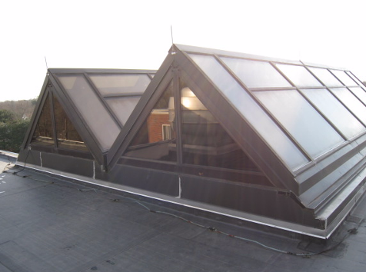

Atrium Skylights

Picture 2

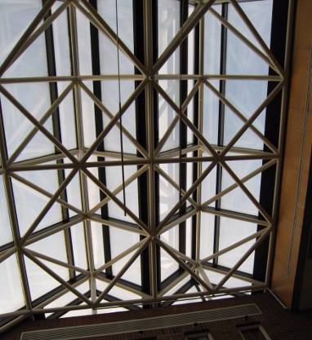

Atrium Skylights (Interior View)

Picture 3

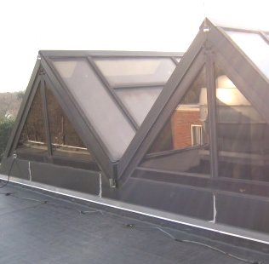

Areas of Skylight Repair/New Caulking (Arrows)

Picture 4

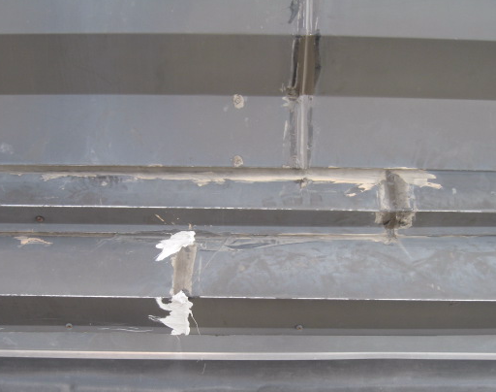

Close-Up of Areas of Skylight Repair/New Caulking

Picture 5

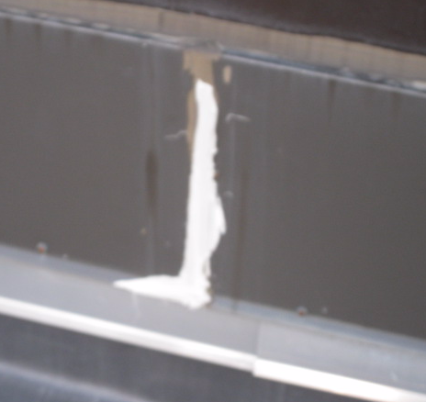

Close-Up of Areas of Skylight Repair/New Caulking

Picture 6

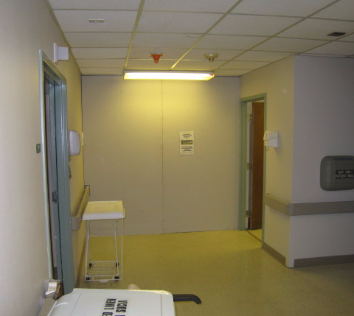

Gypsum Wallboard Construction Barrier on 3rd Floor

Picture 7

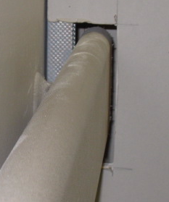

Breach in Gypsum Wallboard Construction Barrier, Note Spaces around Hand Rail

Picture 8

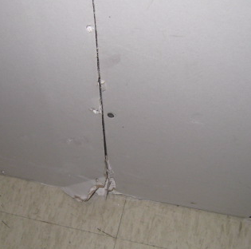

Breach in Construction Barrier, Note Space between Sections of Gypsum Wallboard

Picture 9

Breach in Construction Barrier, Note Space between Sections of Gypsum Wallboard

Picture 10

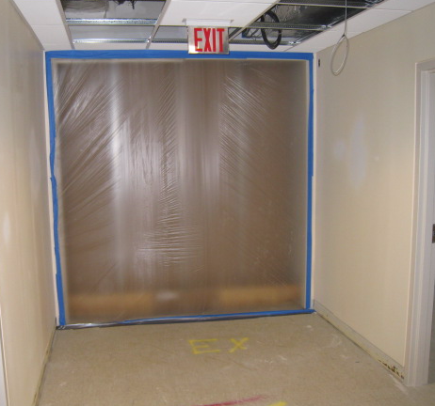

Construction Barrier Resealed With Plastic and Tape

Picture 11

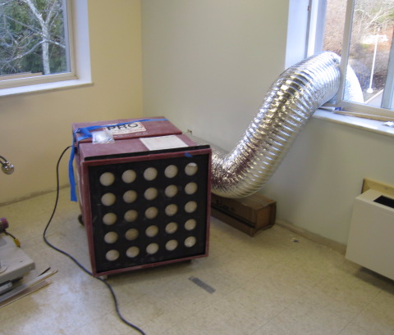

Air Filtration Unit Equipped With High Efficiency Particulate Arrestance (HEPA) Filters
In Renovation Area

Location | Moisture Measurement  (Low = Normal) | Material/Comments
3rd Floor South | No visible mold growth/water damage | Foul odors detected near nurse’s station-source: pipe drainage from sprinkler pipe replacement
Room 301 | No visible mold growth/water damage | Loose univent filter-reinstall, dusty grate  Window difficult to close  No draw detected from exhaust vent in restroom
Linen Closet  (used to store pharmaceutical cells) | No visible mold growth/water damage | No draw detected from exhaust vent on wall
Hallway near rooms 319/370 | No visible mold growth/water damage | Gypsum wallboard construction barrier, breaches between panels and cutout for hand rail-light penetration
3rd Floor North/Renovation Area | No visible mold growth/water damage | Limited interior renovation work being conducted (e.g., wiring, installation of ceiling tiles), HEPA air filtration/air scrubbers
Room 230 | No visible mold growth/water damage | Univent (supply ventilation) deactivated  Exhaust operating in restroom
Room 235 | No visible mold growth/water damage | Univent (supply ventilation) deactivated  No draw detected from exhaust vent in restroom
Location | Moisture Measurement  (Low = Normal) | Material/Comments
Room 234 | No visible mold growth/water damage | Univent (supply ventilation) deactivated  Exhaust operating in restroom
Main Entrance/Atrium | No visible mold growth/water damage  Carpeting:  No - Low  So – Low  Center - Low  East – Low  West – Low  Wooden reception desk – Low  Gypsum wallboard – Low  Wooden Trim - Low | Wall to wall carpeting, former area of leaks, skylights repaired

