
THE COMMONWEALTH OF MASSACHUSETTS
EXECUTIVE OFFICE FOR ADMINISTRATION AND FINANCE
HUMAN RESOURCES DIVISION
ONE ASHBURTON PLACE, BOSTON, MA 02108
DEVAL L. PATRICK
Governor

TIMOTHY P. MURRAY
Lieutenant Governor

JAY GONZALEZ
Secretary

PAUL DIETL
Chief Human Resources Officer

M E M O R A N D U M

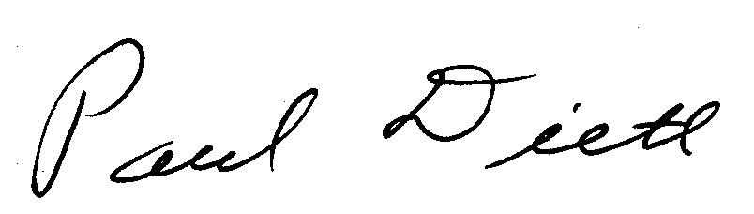
TO: Cabinet Secretaries, Division Directors, Agency Heads, Human Resources Directors, Labor Relations Directors, and Agency General Counsels

FROM: Paul Dietl, Chief Human Resources Officer

DATE: November 7, 2011

RE: Break Time for Nursing Mothers

The Human Resources Division (HRD) has been receiving questions from state agencies and state employees about federal law regarding nursing mothers break time.

The federal Patient Protection and Affordable Care Act which became effective March 23, 2010 amended the Fair Labor Standards Act to require employers to provide a nursing mother reasonable break time to express breast milk after the birth of her child. The law is enforced by the United States Department of Labor (DOL).

The Law

An employer shall provide to employees (who are not exempt from the FLSA):

- Reasonable break time for an employee to express breast milk for her nursing child for 1 year after the child’s birth each time such employee has need to express milk; and

- A place, other than a bathroom, that is shielded from view and free from intrusion from co-workers and the public, which may be used by an employee to express breast milk.

Time, Location and Compensation of the Breaks

- Employers are required to provide a reasonable amount of break time to express milk, as frequently as needed by the nursing mother. The frequency and duration of the breaks may vary.

- The location must be functional as a space for expressing milk. If the space is not dedicated to the nursing mother’s use, it must be available when needed in order to meet the statutory requirement. The space, whether permanent or temporary, must be shielded from view and free from intrusion from co-workers and the public.

- Employers are not required to compensate nursing mothers for breaks taken for the purpose of expressing milk. Where an employer already provides compensated breaks, an employee who uses that break time to express milk must be compensated in the same way that other employees are compensated for break time. In addition, the FLSA general requirement that the employee must be completely relieved from duty or else the time must be compensated as work time applies.

- Agencies may not consider nursing mother’s break time to be FMLA leave or counted against an employee's FMLA leave entitlement as nursing is not considered a “serious health condition” under the FMLA per the DOL.

Availability of Designated Nursing Mother’s Rooms

- The Bureau of State Office Buildings has two designated nursing mothers’ rooms in Boston (see below).
- To sign up to use a Bureau of State Office Buildings dedicated room, the employee should call the appropriate office:
- One Ashburton Place, 12th floor, Boston 617-727-1100 ext. 24110
- State House, 5th floor, Boston 617-727-1100 ext. 35522
- Other state-owned or state-leased facilities may also have designated rooms; check with your human resources office for more information if you need this space.

References
DOL Nursing Mothers website: http://www.dol.gov/whd/nursingmothers/

DOL Regulations: http://www.dol.gov/whd/regs/compliance/whdfs73.pdf

DOL Frequently Asked Questions: http://www.dol.gov/whd/nursingmothers/faqBTNM.htm

MA Bureau of State Office Buildings Manual
www.mass.gov/anf/docs/bsb/bsb-policy-manual-2011.doc
page 42+43

Human Resources Division
Questions regarding this memo should be directed to the Human Resources Division Legal Unit at 617-878-9787.

