INDOOR AIR QUALITY ASSESSMENT

Cyril K. Brennan Middle School
320 Rathbun Willard Drive
Attleboro MA

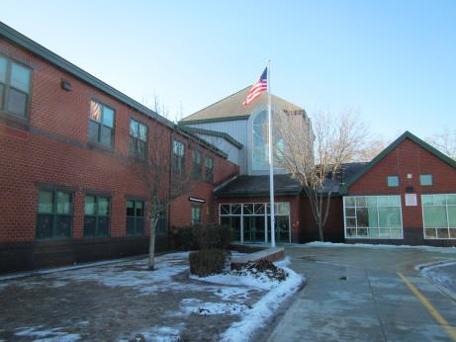

Prepared by:
Massachusetts Department of Public Health
Bureau of Environmental Health
Indoor Air Quality Program
February 2018

Background
Building: | Cyril K. Brennan Middle School (BMS)
Address: | 320 Rathbun Willard Drive, Attleboro
Assessment coordinated via: | Attleboro Health Department and Attleboro School Department
Reason for Request: | Health concerns and general indoor air quality (IAQ)
Date of Assessment: | February 8, 2018
Massachusetts Department of Public Health/Bureau of Environmental Health (MDPH/BEH) Staff Conducting Assessment: | Cory Holmes, Environmental Analyst/Inspector, IAQ Program  Ruth Alfasso, Environmental Engineer/Inspector, IAQ Program
Building Description: | The school is a two-story brick building with complex architectural details and multi-level peaked roofs. It was built in 1997. It serves about 592 students in grades 5-8 and has about 70 staff.
Windows: | Windows are nominally openable in most areas of the building; however some windows do not function properly.

Methods
Please refer to the IAQ Manual for methods, sampling procedures, and interpretation of results (MDPH, 2015).

Results
The following is a summary of indoor air testing results (Table 1).
- Carbon dioxide levels were above 800 parts per million (ppm) in about twenty percent of the areas assessed, typically full classrooms. It is important to note that the temperature on the day of assessment was below freezing (< 32°F); outside air is typically limited during extreme cold to prevent the freezing of pipes, which can result in flooding and damage to mechanical ventilation equipment/building materials. Dampers may be able to be adjusted (Figure 1) to provide more fresh air during more temperate weather. For more information regarding carbon dioxide see Appendix A.
- Temperature was within or very close to the recommended range of 70°F to 78°F in all areas assessed.
- Relative humidity was below the recommended range of 40% to 60% in all areas as is typical during the heating season in the Northeast. Low relative humidity can lead to common symptoms such as: dry skin, lips, and scalp; dry/scratchy throats and noses (nose bleeds); exacerbation of asthma, eczema, or allergies; dry/irritated eyes; and irritation of respiratory tract.
- Carbon monoxide levels were non-detectable (ND) in all indoor areas assessed.
- Fine particulate matter (PM2.5) concentrations measured were below the National Ambient Air Quality Standard (NAAQS) level of 35 micrograms per cubic meter (μg/m³) in all occupied areas.

Discussion

Ventilation
A heating, ventilating, and air conditioning (HVAC) system has several functions. First it provides heating and, if equipped, cooling. Second, it is a source of fresh air. Finally, an HVAC system will dilute and remove normally occurring indoor environmental pollutants by not only introducing fresh air, but by filtering the airstream and ejecting stale air to the outdoors via exhaust ventilation. Even if an HVAC system is operating as designed, point sources of respiratory irritation may exist and cause symptoms in sensitive individuals.
Fresh air in classrooms is supplied by unit ventilators (univents, Picture 1). Univents draw air from the outdoors through a fresh air intake located on the exterior wall of the building (Picture 2) and return air through an air intake located at the base of the unit. Fresh and return air are mixed, filtered, heated or cooled and provided to rooms through an air diffuser located in the top of the unit (Figure 1). In a few areas items were on top or in front of univents (Table 1), which can block air circulation.
In common areas such as core rooms, the office, gym, and cafeteria, fresh air is supplied by air handling units (AHU) located on the roof. Fresh air is heated or cooled as needed and ducted to ceiling-mounted supply vents (Picture 3). Exhaust/return vents on the ceilings remove air from these areas and return it to the AHU. Note that the same style vents are used in many areas for both supply and exhaust.
Exhaust in classrooms is provided by motors on the roof ducted to exhaust vents on the walls or ceilings of classrooms (Picture 4). Exhaust vents examined were found to be operating well. Note that many classroom exhaust vents are located near hallway doors; with doors open the vents can draw air from the hallway instead of the classroom.
To maximize air exchange, the MDPH recommends that both supply and exhaust ventilation operate continuously during periods of occupancy. In order to have proper ventilation with a mechanical supply and exhaust system, the systems must be balanced to provide an adequate amount of fresh air to the interior of a room while removing stale air from the room. It is recommended that HVAC systems be re-balanced every five years to ensure adequate air systems function (SMACNA, 1994).

Microbial/Moisture Concerns
Chronic water infiltration/design issues have been reported/well-documented over the years. Water-damaged ceiling tiles were observed in many classrooms (Pictures 5 and 6; Table 1) and reportedly stem from roof leaks. Ceiling tiles should be replaced when a leak is discovered and repaired. Extensive water damage was also observed in the main lobby/atrium (Pictures 7 and 8) however, there were no signs of mold/microbial growth. The materials damaged in this area are mostly paint and plaster, which do not readily grow mold. The white powdery material such as shown in Picture 8 is efflorescence, which is a mineral deposit caused by water moving through the material; it is not mold. School officials reported that major building envelope improvements (e.g., roof, siding, windows) are on a capital repair project list.
Carpets were reportedly moistened by wind-driven rain events in some areas. In room 105, the carpet was lifted up in one corner where it had reportedly been moistened in the past (Picture 9). The carpet was dry at the time of the visit and there were no signs of microbial growth on or underneath the carpet (Picture 10). Note that although this carpeting is thin and without padding, and likely to dry quickly, the IAQ program does not recommend the use of wall-to-wall carpeting in school classrooms in general, or specifically in areas likely to be moistened by leaks or condensation. Repeated moistening of carpeting can lead to microbial growth, odors, and the deterioration of carpeting which may release irritating fibers.
The United States Environmental Protection Agency (US EPA) and the American Conference of Governmental Industrial Hygienists (ACGIH) recommend that porous materials be dried within 24 to 48 hours of becoming wet (US EPA, 2008; ACGIH, 1989). If porous materials are not dried within this time frame, mold growth may occur.
Classroom sinks had gaps in the backsplash (Picture 11) in some areas which can lead to water damage to porous building materials. The area under the sink is a damp environment where condensation or leaks can moisten stored materials such as paper towels (Picture 12). In one science room, the lab sinks were covered or were used to store items (Picture 13). Items stored in active sinks may become water-damaged if the sinks are turned on or leak. If these or other sinks are not used regularly, the drains traps can dry out, which may allow sewer gases into occupied areas. Floor drains in some areas, such as underneath emergency shower stations in science classrooms may also have dry drain traps. If these drains are not filled with water through normal activities, they should be deliberately filled on a regular schedule to prevent dry traps. If there are sinks or drains that are no longer used, they should be properly capped and removed.
Plants were observed in classrooms and offices (Table 1). Plants should be well maintained, not overwatered and kept away from the airstream of ventilation equipment to prevent odors, water damage, and pests.
Refrigerators exist in breakrooms and classrooms. Refrigerators need to be cleaned out regularly to prevent microbial growth and odors. The gasket of a fridge in the staff breakroom was stained with mold (Picture 14); this should be cleaned with an antimicrobial solution, or replaced if it cannot be cleaned effectively or no longer seals completely. Refrigerators should also not be placed on porous materials such as carpeting. A microwave in a staff breakroom was found dirty from spills inside and out (Table 1). Cooking equipment should be kept clean to avoid odors and pests, and any food should be kept in tightly-sealed containers.
An examination of the outside of the building was conducted to identify potential sources of water penetration. Trees and shrubs were noted growing close to the building exterior (Picture 15) which can hold moisture against the walls and be a source of pollen and debris into the building. Tree/plant roots may penetrate the building foundation, creating and widening cracks. Over time, these conditions can undermine the integrity of the building envelope and provide a means of water entry into the building via capillary action through foundation concrete and masonry (Lstiburek & Brennan, 2001). The freezing and thawing action of water during the winter months can create cracks and fissures in the foundation. Open utility holes were also noted on the exterior of the building (Pictures 16 and 17). These breaches can allow for uncontrolled moisture, drafts and/or pests into the building.
Note that the complex shape of the building creates areas where water drains directly over the roof edges rather than through roof drains or gutters. Beneath many of these areas, the ground is covered with a lattice of brick and soil making a porous matrix for water to drain into the ground. If this material becomes compacted, shifts, or is covered with ice, water can impinge directly on the building foundation. Drainage for the building should be monitored, with repairs made as needed to ensure that water is draining away from the building.

Other Conditions
Exposure to low levels of volatile organic compounds (VOCs) may produce eye, nose, throat, and/or respiratory irritation in some sensitive individuals. BEH/IAQ staff examined spaces for products containing VOCs, noting cleaning products, air fresheners, hand sanitizers and dry erase materials in a number of areas throughout the office space (Table 1). All of these products have the potential to be irritants to the eyes, nose, throat, and respiratory system of sensitive individuals. Other sources of total volatile organic compounds (TVOCs) include copy machines and laminators (Table 1). Excess heat, odors, VOCs and ozone can be produced by photocopiers, particularly if the equipment is older and in frequent use. Ozone is a respiratory irritant (Schmidt Etkin, 1992). Laminators produce TVOCs and plastic odors. This equipment should be used in well-ventilated areas away from occupants.
In many classrooms, tennis balls had been sliced open and placed on table/chair footings to reduce noise (Picture 18; Table 1). Many, like that shown in Picture 18, were significantly deteriorated. Tennis balls are made of a number of materials that are a source of respiratory irritants. Constant wearing of tennis balls can produce fibers and lead to off-gassing of VOCs. Tennis balls are made with a natural rubber latex bladder, which becomes abraded when used as a chair leg pad. Use of tennis balls in this manner may introduce latex dust into the school environment. Some individuals are highly allergic to latex (e.g., spina bifida patients) (SBAA, 2001). It is recommended that the use of materials containing latex be limited in buildings to reduce the likelihood of symptoms in sensitive individuals (NIOSH, 1997; NIOSH, 1998).
In some areas, items were observed on the floor, windowsills, tabletops, counters, bookcases and desks (Pictures 13 and 19; Table 1). Stored items provide a source for dusts to accumulate and make it difficult for custodial staff to clean. Items should be relocated and/or be cleaned periodically to avoid excessive dust build up.
There were concerns from staff about cleaning, particularly in hidden areas such as above cabinets in classrooms. If not already in place, a tracking method should be implemented to log maintenance and cleaning requests from staff and track actions and progress on them.
Dust was observed on personal fans, univents (Picture 20), exhaust vents (Picture 21) and surrounding ceiling tiles. Univent cabinets should also be vacuumed out during filter changes. It is recommended that univents and AHUs be outfitted with pleated filters of a Minimum Efficiency Reporting Value (MERV) of 8 or higher, which are adequate in filtering out pollen and mold spores (ASHRAE, 2012). It is recommended that filters should be changed 2-4 times a year or in accordance with the manufacture’s recommendations. A filter was examined from one univent and was found accumulated with dust/debris (Picture 22). This filter had a September of 2017 date. School officials reported that univent filter changes were scheduled during February vacation. If filters are frequently found with heavy dust deposits during scheduled changes, the frequency of filter changes should be increased.
Both wall-to-wall carpeting and area rugs were present in the BMS. Carpeting should be cleaned annually or semi-annually in soiled high traffic areas as per the recommendations of the Institute of Inspection, Cleaning, and Restoration Certification (IICRC, 2012). Note that the service life of carpeting in schools is approximately 10-11 years (IICRC, 2002). Aging carpet, such as that found in BMS, can produce fibers that can be irritating to the respiratory system. In addition, tears or lifting carpet can create tripping hazards. If area rugs cannot be cleaned due to age and condition, they should be replaced. Upholstered furniture (Table 1) should also be cleaned regularly in accordance with IICRC recommendations and discarded when they become too worn or soiled to effectively clean.
Classroom 218 had a damaged interior door, with exposed fiberglass insulation (Picture 23). Fiberglass insulation can provide a source of skin, respiratory and eye irritation.
Note that the Environmental Protection Agency (EPA) conducted a National School Radon Survey in which it discovered nearly one in five schools had “…at least one frequently occupied ground contact room with short-term radon levels above 4 [picocuries per liter] pCi/L” (US EPA 1993). The BEH/IAQ Program therefore recommends that every school be tested for radon, and that this testing be conducted during the heating season while school is in session in a manner consistent with USEPA radon testing guidelines. Radon measurement specialists and other information can be found at www.nrsb.org and http://aarst-nrpp.com/wp, with additional information at: http://www.mass.gov/eohhs/gov/departments/dph/programs/environmental-health/exposure-topics/iaq/radon.

Conclusions/Recommendations
Based on the observations made during the visit, the following is recommended:
- Operate the HVAC system to provide for continuous fresh air ventilation during occupied hours. Ensure fresh air intake louvers are functioning properly to adjust outside air intake. Make adjustments/repairs as needed.
- Ensure univents are not blocked by furniture or items on top or along the front so that they may operate effectively.
- Use openable windows to supplement fresh air during temperate weather. Ensure all windows are closed tightly at the end of each day. Also ensure that windows are closed when air conditioning is operating to prevent condensation.
- Ensure all exhaust vents are operating continuously during occupied periods. Close classroom doors for best exhaust function.
- Adopt a system to report and track maintenance issues such as broken univents, leaks and cleaning issues so that concerns can be reported by the staff that observe them, and maintenance staff can report when the issues have been resolved.
- Consider adopting a balancing schedule of every 5 years for all mechanical ventilation systems, as recommended by ventilation industrial standards (SMACNA, 1994).
- For buildings in New England, periods of low relative humidity during the winter are often unavoidable. Therefore, scrupulous cleaning practices should be adopted to minimize common indoor air contaminants whose irritant effects can be enhanced when the relative humidity is low. To control for dusts, a high efficiency particulate arrestance (HEPA) filter equipped vacuum cleaner in conjunction with wet wiping of all surfaces is recommended. Avoid the use of feather dusters. Drinking water during the day can help ease some symptoms associated with a dry environment (throat and sinus irritations).
- Replace water-damaged ceiling tiles once leaks are repaired. Inspect the area above the stained tiles for water damage or odors and remediate or clean as necessary.
- Remove or remediate/clean other water-damaged materials such as the damaged paint and plaster in the atrium.
- Make plans to remove carpeting from classrooms and any other carpeting with a history of water damage.
- Render the backsplashes of sinks watertight using caulking. Avoid storing porous materials under sinks.
- Ensure drains on unused sinks and floor drains are moistened periodically to prevent the traps from drying out. If sinks are no longer needed, consider plans to have them removed and properly capped.
- Ensure plants are well maintained and not overwatered. Keep them away from the airstream of ventilation equipment.
- Ensure all refrigerators are cleaned out regularly. Clean gaskets of debris and mold staining with an antimicrobial solution or replace as needed.
- Keep cooking equipment clean and any food tightly sealed to prevent attracting pests.
- Remove trees and shrubs from within five feet of the edge of the building and especially around air intakes and windows.
- Ensure drainage from the roof is able to drain away from the building.
- Seal utility holes/breaches in exterior walls.
- Reduce or eliminate the use of air fresheners, scented cleaners, hand sanitizers and dry erase materials to reduce irritation.
- Use photocopiers and laminators in well-ventilated areas.
- Replace tennis balls on chair/table footings with latex-free glides.
- Consider reducing the amount of stored materials to allow for more thorough cleaning. Clean items regularly with a wet cloth or sponge to prevent excessive dust build-up.
- Clean univents, supply and exhaust vents and fans regularly to remove dust build up that may lead to odors when heated. If soiled ceiling tiles around vents cannot be adequately cleaned, replace.
- Clean carpeting at least once per year according to IICRC recommendations (IICRC 2012). Continue with plans to replace carpeting that is beyond its service life. Consider using non-porous flooring instead of carpeting when flooring is replaced.
- Ensure filters for AHUs are of a pleated variety, Minimum Efficiency Reporting Value (MERV) dust-spot efficiency 8 or higher, which are adequate in filtering out pollen and mold spores (ASHRAE, 2012). Filters should be changed 2-4 times a year. If filters have large accumulations of dust when changed, increase frequency.
- Consider adopting the US EPA (2000) document, “Tools for Schools”, as an instrument for maintaining a good IAQ environment in the building available at: http://www.epa.gov/iaq/schools/index.html.
- Seal hole in damaged interior door in classroom 218.
- The school should be tested for radon by a certified radon measurement specialist during the heating season when school is in session. Radon measurement specialists and other information can be found at: www.nrsb.org, and http://aarst-nrpp.com/wp.
- Refer to resource manuals and other related IAQ documents for further building-wide evaluations and advice on maintaining public buildings. Copies of these materials are located on the MDPH’s website: http://mass.gov/dph/iaq.

References
ACGIH. 1989. Guidelines for the Assessment of Bioaerosols in the Indoor Environment. American Conference of Governmental Industrial Hygienists, Cincinnati, OH.
ASHRAE. 2012. American Society of Heating, Refrigeration and Air Conditioning Engineers (ASHRAE) Standard 52.2-2012 -- Method of Testing General Ventilation Air-Cleaning Devices for Removal Efficiency by Particle Size (ANSI Approved).
IICRC. 2002. Institute of Inspection, Cleaning and Restoration Certification. A Life-Cycle Cost Analysis for Floor Coverings in School Facilities.
IICRC. 2012. Institute of Inspection, Cleaning and Restoration Certification. Carpet Cleaning: FAQ. Retrieved from http://www.iicrc.org/consumers/care/carpet-cleaning.
Lstiburek, J. & Brennan, T. 2001. Read This Before You Design, Build or Renovate. Building Science Corporation, Westford, MA. U.S. Department of Housing and Urban Development, Region I, Boston, MA.
MDPH. 2015. Massachusetts Department of Public Health. “Indoor Air Quality Manual: Chapters I-III”. Available at: http://www.mass.gov/eohhs/gov/departments/dph/programs/environmental-health/exposure-topics/iaq/iaq-manual/.
NIOSH. 1997. National Institute for Occupational Safety and Health. Alert Preventing Allergic Reactions to Natural Rubber latex in the Workplace. National Institute for Occupational Safety and Health, Atlanta, GA.
NIOSH. 1998. National Institute for Occupational Safety and Health. Latex Allergy A Prevention. National Institute for Occupational Safety and Health, Atlanta, GA.
SBAA. 2001. Latex In the Home And Community Updated Spring 2001. Spina Bifida Association of America, Washington, DC.
Schmidt Etkin, D. 1992. Office Furnishings/Equipment & IAQ Health Impacts, Prevention & Mitigation. Cutter Information Corporation, Indoor Air Quality Update, Arlington, MA.
SMACNA. 1994. HVAC Systems Commissioning Manual. 1st ed. Sheet Metal and Air Conditioning Contractors’ National Association, Inc., Chantilly, VA.
US EPA. 1993. Radon Measurement in Schools, Revised Edition. Office of Air and Radiation, Office of Radiation and Indoor Air, Indoor Environments Division (6609J). EPA 402-R-92-014. https://www.epa.gov/sites/production/files/2014-08/documents/radon_measurement_in_schools.pdf
US EPA. 2000. Tools for Schools. Office of Air and Radiation, Office of Radiation and Indoor Air, Indoor Environments Division (6609J). EPA 402-K-95-001, Second Edition. http://www.epa.gov/iaq/schools/index.html.
US EPA. 2008. “Mold Remediation in Schools and Commercial Buildings”. Office of Air and Radiation, Indoor Environments Division, Washington, DC. EPA 402-K-01-001. September 2008. Available at: http://www.epa.gov/mold/mold-remediation-schools-and-commercial-buildings-guide.
Picture 1
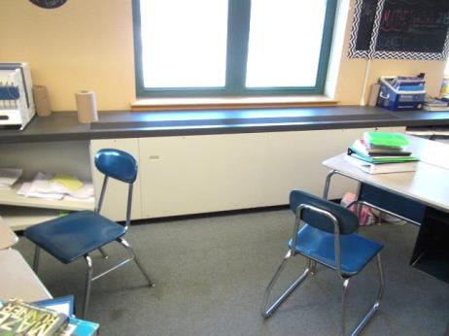
Unit ventilator (univent)
Picture 2
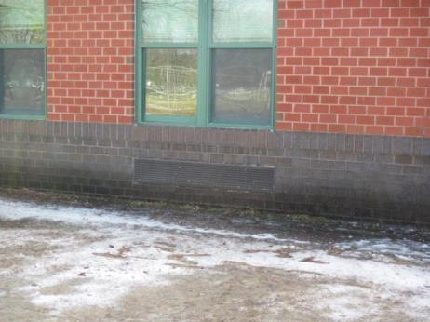
Univent fresh air intake
Picture 3
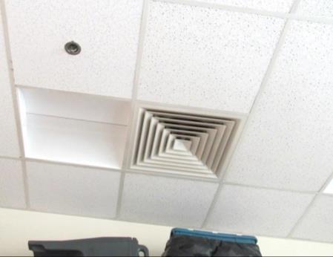
Typical vent for supply and return in office areas
Picture 4
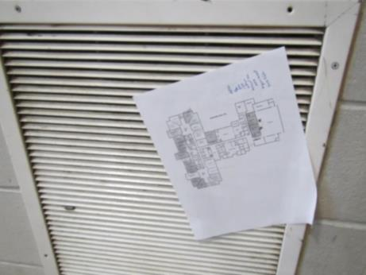
Classroom exhaust vent, paper showing that air is drawing well into vent
Picture 5
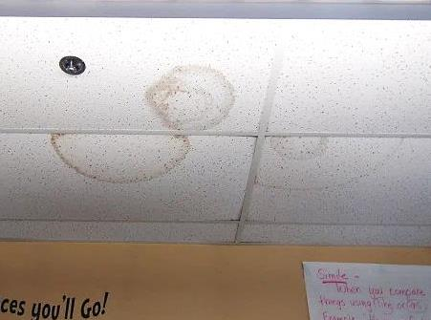
Water-damaged ceiling tiles
Picture 6
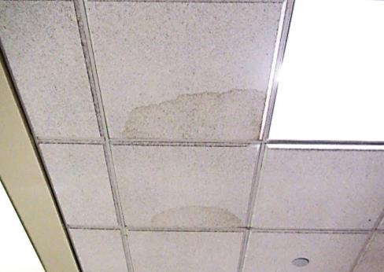
Water-damaged ceiling tiles
Picture 7
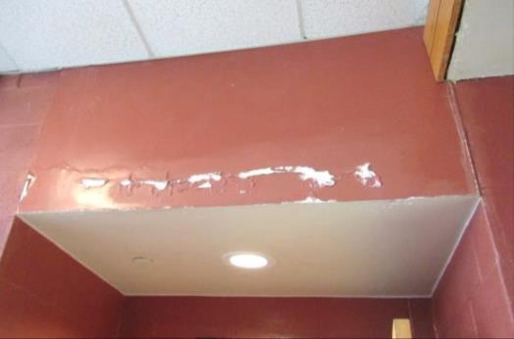
Water-damaged paint and plaster in lobby atrium area
Picture 8
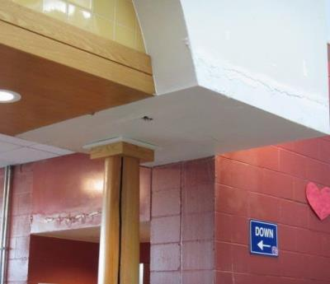
Water-damaged paint and plaster in atrium area, note efflorescence
Picture 9
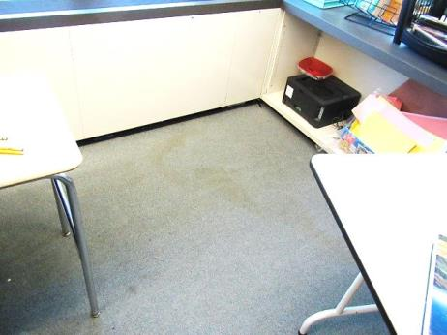
Water-stained carpeting in Room 105
Picture 10
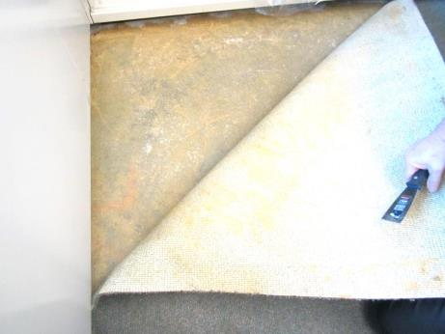
Lifted corner of carpet in Room 105; note no visible mold growth
Picture 11
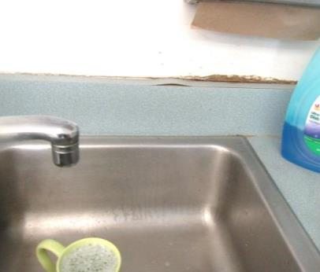
Damaged sink backsplash
Picture 12
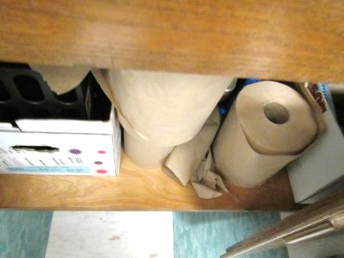
Large amounts of paper towels under sink
Picture 13
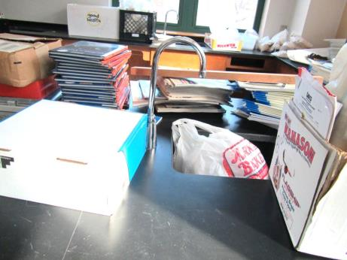
Items stored in and around science sinks in classroom
Picture 14
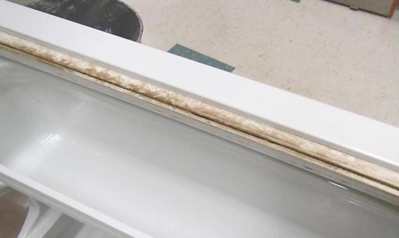
Mold-stained refrigerator gasket
Picture 15
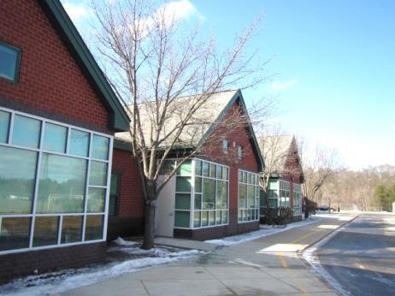
Trees in close proximity to the building
Picture 16
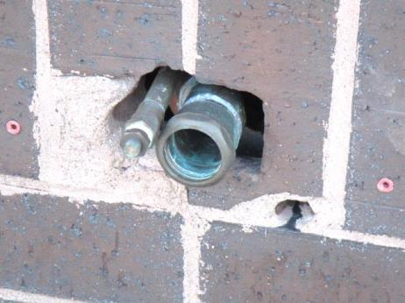
Open breaches/utility holes in exterior walls
Picture 17
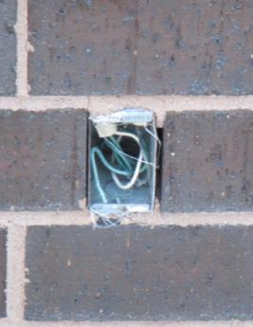
Open breaches/utility holes in exterior walls
Picture 18
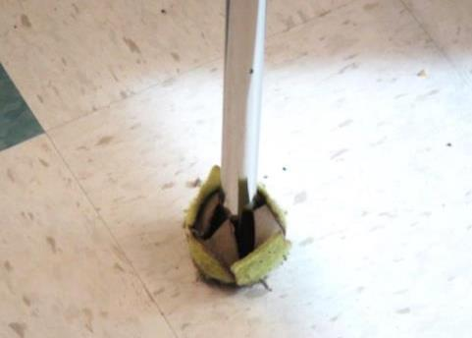
Deteriorating tennis ball on chair leg
Picture 19
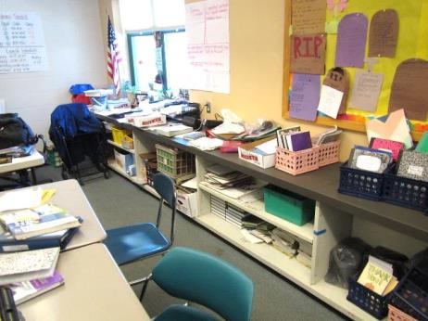
Accumulated items in a classroom
Picture 20
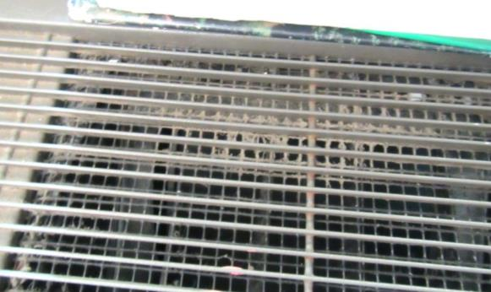
Dust/debris on univent louvers
Picture 21
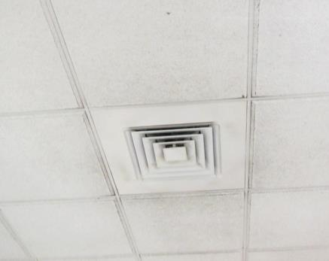
Dust/debris on exhaust vent and surrounding ceiling tiles
Picture 22
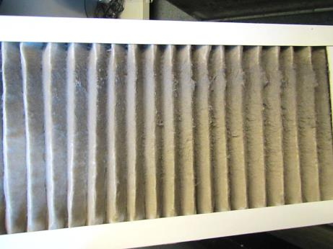
Dust/debris accumulations on univent filter
Picture 23
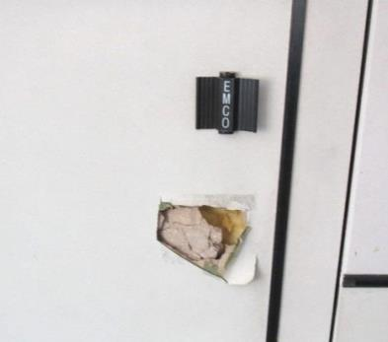
Damaged interior door in classroom 218, exposing fiberglass insulation

Location | Carbon  Dioxide  (ppm) | Carbon Monoxide  (ppm) | Temp  (°F) | Relative  Humidity  (%) | PM2.5  (µg/m³) | Occupants  in Room | Windows  Openable | Ventilation |  | Remarks
 |  |  |  |  |  |  |  | Supply | Exhaust
Background | 389 | ND | < 32 | 21 | 10 |  |  |  |  | Sunny and cold/icy
First Floor
Teacher’s Lunch | 775 | ND | 77 | 13 | 5 | 3 | Y | Y on | Y | Sink backsplash open, NC, microwave, WD CT
101 Home Ec food | 465 | ND | 72 | 13 | 5 | 0 | Y | Y | Y | Kitchen appliances, sinks, range hood, NC, TBs, food
101A | 446 | ND | 70 | 13 | 6 | 0 | N | Y | Y | Small room, carpet, DEM
102 | 505 | ND | 72 | 12 | 6 | 2 | Y | Y | Y | NC, area rug, plants, AF odor, DEM, HS
103 | 1111 | ND | 69 | 18 | 8 | 25 | Y | Y | Y | 2 WD CTs
104 | 551 | ND | 72 | 15 | 5 | 0 | Y | Y | Y | Markers, DEM, carpet and area rugs, HS, TB
105 | 1372 | ND | 71 | 23 | 6 | 22 | Y | Y on | Y | DEM, WD CTs, HS, old carpet, plant, TBs, porous items under sink, reports of wet carpet in corner-dry, no visible mold growth on/beneath, spray air freshener, AI, exhaust near open door
106 | 931 | ND | 72 | 18 | 5 | 19 | Y | Y | Y | Sink with items underneath, CP, DO, TBs, DEM, HS, carpeted, WD CT, HS, exhaust near open door
105-108 Core | 737 | ND | 72 | 14 | 6 | 0 | N | Y | Y dusty | NC, carpeted benches
107 Science | 750 | ND | 72 | 16 | 6 | 19 | Y | Y | Y | NC, 6 science sinks, emergency shower with drain, NC, glue guns, HS, DEM
108 | 719 | ND | 73 | 17 | 6 | 29 | Y | Y dusty | Y | DEM, sink, NC, plants, TBs
1A Teachers’ Lounge | 429 | ND | 71 | 14 | 6 | 0 | N | Y | Y | Laminator, PC, NC, fridge, microwave is dirty inside and outside
109 SPED | 583 | ND | 71 | 15 | 5 | 8 | Y | Y | Y | DEM, NC, TBs
110 | 566 | ND | 71 | 15 | 6 | 0 | Y | Y | Y | Area rug, TBs, DEM
111 Science/Art | 522 | ND | 70 | 13 | 6 | 0 | Y | Y | Y | UV hanging from ceiling, sink, NC, TBs, dry paint
112 | 553 | ND | 70 | 15 | 7 | 0 | Y | Y obst | Y | Flowers, NC, TBs, DEM
Core 109-113 | 518 | ND | 70 | 14 | 7 | 2 | N | Y | Y | WD CT, NC
113/114 | 510 | ND | 70 | 13 | 7 | 6 | Y | Y | Y | TB, WD CT, plant, WD sink countertop/laminate
115 | 759 | ND | 75 | 16 | 8 | 27 | Y | Y | Y | DO, 4 WD CTs, plant in standing water, hole in CT, emergency shower/floor drain
116 | 1479 | ND | 73 | 26 | 11 | 27 | Y | Y | Y | TB
117 | 1365 | ND | 74 | 22 | 8 | 33 | Y | Y | Y | UV-obstructed, area rug, TB, WD CT, AI
118 | 718 | ND | 73 | 15 | 6 | 0 | Y | Y | Y | Worn/stained carpet, HS, AI, WD room divider
Core 118-119 | 918 | ND | 73 | 16 | 6 | Many between classes | N | y | Y | NC, TBs, WD CT
119 | 1372 | ND | 72 | 21 | 6 | 24 | Y | Y | Y | Area rug, worn and stained carpet, DEM, HS
120 | 1073 | ND | 72 | 17 | 6 | 27 | Y | Y | Y | NC, TBs, DEM, items and debris on univent
121 | 1599 | ND | 72 | 18 | 7 | 27 | Y | Y | Y | NC, area rug, DEM, sink, HS, concerns about mold on top of cabinet
121 A | 556 | ND | 70 | 14 | 7 | 1 | N | Y | Y | Area rug
Restroom (Mrs. Heller) |  |  |  |  |  |  | N | Y | Y | Dusty vents, no current WD/mold growth issues
122 | 538 | ND | 71 | 11 | 7 | 0 | N | Y | Y | 2 WD CT near sink (small stains)
Cafeteria | 603 | ND | 70 | 13 | 8 | ~200 | Y | Y | Y
Boys Restroom near Cafeteria |  |  |  |  |  |  | N | Y | Y | Commode not flushed, floor drain
Band | 589 | ND | 72 | 13 | 7 | 25 | Y | Y | Y | DEM
Library | 441 | ND | 72 | 11 | 7 | 0 | Y | Y | Y | 1 WD CT, spice/AF odor, worn carpet, upholstered furniture
Library Workroom | 359 | ND | 73 | 10 | 7 | 0 | N | Y | Y | DO, sink in carpeted area
MDF room | 360 | ND | 72 | 10 | 7 | 0 | N | Y | Y | Extra large vents, NC, fake plants
MDF area Kitchen | 358 | ND | 72 | 10 | 7 | 0 | N | Y | Y | Fridge, toaster oven, microwave, NC, HS
Library Conference 1 | 336 | ND | 72 | 12 | 7 | 0 | N | Y | Y | WD CT, AI/storage, old carpet, WD wall dividers
Library Conference 2 | 335 | ND | 73 | 10 | 7 | 0 | N | Y | Y | Old carpet, 2 MT
Nurse waiting | 448 | ND | 72 | 11 | 7 | 0 | N | Y | Y | Old carpet
Nurse office | 442 | ND | 71 | 12 | 7 | 2 | N | Y | Y | AF odor
Nurse patient area | 406 | ND | 71 | 11 | 11 | 0 | N | Y | Y | HS, CP, Restrooms in back
PE office 1 | 508 | ND | 74 | 13 | 7 | 0 | N | Y | Y | 1 WD CT, NC, heater, microwave
Fitness Room | 582 | ND | 72 | 13 | 6 | 0 | Y | Y | Y
PE Office 2 | 625 | ND | 73 | 13 | 6 | 0 | Y | Y | Y | 2 MTs
Boy’s Locker Room | 579 | ND | 72 | 12 | 7 | 1 | N | Y | Y
PE storage |  |  |  |  |  | 0 | N | N | N | Supplies, balls, mats other plastic items, NC
Health Counseling | 358 | ND | 70 | 12 | 6 | 0 | Y | Y | Y | NC, area rug (worn and frayed), DEM, TB
Girls Locker Room |  |  |  |  |  | 0 | Y | Y | Y | Showers, drains (not sure if used), no WD
Main office – waiting | 482 | ND | 72 | 14 | 8 | 8 | N | Y | Y | WD CT, carpet
-rear area | 465 | ND | 72 | 12 | 7 | 3 | N | Y | Y | Carpet
-admin storage | 420 | ND | 72 | 12 | 7 | 0 | N | Y | Y | Water cooler on carpet, old PF, WD CT, DO
-closet | 388 | ND |  |  |  |  | N | N | N | Paper and supplies, NC
-principal’s conference | 364 | ND | 71 | 11 | 8 | 0 | N | Y | Y | DEM, food, carpet
-Principal | 368 | ND | 72 | 11 | 8 | 1 | N | Y | Y | Carpet
- records | 417 | ND | 72 | 11 | 8 | 1 | N | Y | Y | 2 MT, 1 WD CT, carpet, PC
- assistant principal | 418 | ND | 72 | 12 | 8 | 1 | N | Y | Y | Carpet, exhaust dusty
-conference | 445 | ND | 72 | 12 | 10 | 0 | N | Y | Y | WD CT
Upper level
7th Grade Core area | 473 | ND | 70 | 11 | 7 | 0 | N | Y | Y | Skylight, old carpet
2B Electric/Storage | 449 | ND | 70 | 12 | 7 | 0 | N | Y | Y | Boxes and books on floor, NC
2D | 547 | ND | 70 | 13 | 7 | 1 | N | Y | Y | DEM, sink, carpet
201 Art | 946 | ND | 70 | 17 | 7 | 28 | Y | Y | Y | Plants, AI, DO, kiln-vented
202 | 567 | ND | 70 | 15 | 18 | 1 | Y | Y | Y
202 A | 515 | ND | 72 | 13 | 9 | 2 | N | Y | Y | DEM, DO, plant, carpet, TBs
203 | 490 | ND | 72 | 13 | 9 | 0 | Y | Y | Y | Carpet and area rug, DEM
203-205 Core | 654 | ND | 72 | 14 |  | many | N | y | y | WD CT on upper level
204 | 500 | ND | 72 | 12 | 7 | 0 | Y | Y | Y | TBs, old carpet, DEM, CP
205 | 532 | ND | 72 | 12 | 8 | 0 | Y | Y | Y | DEM, sink, items, very stained carpet
206 | 507 | ND | 72 | 14 | 7 | 0 | Y | Y | Y | Plug-in AF, DEM, old carpet
207 Science | 621 | ND | 72 | 14 | 8 | 1 | Y | Y | Y | UV hanging from ceiling - loud, 2 WD CT, sinks, DEM, flowers, HS
208 ESL | 440 | ND | 71 | 13 | 6 | 0 | Y | Y | Y | DEM, old carpet, 4 WD CT
209 | 434 | ND | 70 | 13 | 9 | 0 | Y | Y | Y | Stained carpet, DEM, HS, area rug, sink, 2 WD CT
210 Sensory | 417 | ND | 70 | 13 | 20 | 0 | Y | Y | Y | Stuffed animals, fridge, carpet, DEM
211 | 334 | ND | 70 | 12 | 6 | 0 | Y | Y | Y | NC, emergency shower and drain, sinks are used for storage/stuff , 4 WD CT
212 small | 353 | ND | 70 | 12 | 7 | 0 | Y | Y | Y | Mat, very stained carpet, DEM
213 | 740 | ND | 71 | 16 | 7 | 11 | Y | Y | Y | DEM, stained carpet
214 | 498 | ND | 71 | 13 | 8 | 0 | Y | Y | Y | DEM, stained carpet
216 Computer Lab | 490 | ND | 72 | 12 | 6 | 0 | Y | Y | Y
217 | 519 | ND | 73 | 13 | 6 | 1 | Y | Y | Y | Plants, old/worn/soiled carpeting
218 | 1268 | ND | 71 | 21 | 6 | 0 | Y | Y | Y | Old/worn/stained carpeting, occupants just left for lunch, hole in door-exposed fiberglass insulation, MT-corner
219 | 1586 | ND | 71 | 22 | 11 | 0 | Y | Y | Y | Broken CT, 26 occupants just left for lunch
220 | 834 | ND | 71 | 17 | 7 | 0 | Y | Y | Y | Old/worn/stained carpeting, occupants just left for lunch
221 | 1049 | ND | 70 | 18 | 7 | 23 | Y | Y | Y | DO, TB
222 Computer Lab | 666 | ND | 70 | 14 | 7 | 21 | N | Y | Y | 4 WD CT
222 A | 547 | ND | 71 | 14 | 7 | 0 | Y | Y | Y | DEM, WD CT, TB, AF odor
Science (wet) | 454 | ND | 71 | 13 | 7 | 0 | Y | Y | Y | 2 WD CT, dusty tiles near exhaust, sinks, emergency shower and drain, 2 MT
Core area | 480 | ND | 72 | 13 | 6 | 2 | N | Y | Y | A few slightly WD CT, NC
Staff restroom |  |  |  |  |  |  | N | Y | Y

