INDOOR AIR QUALITY ASSESSMENT

Bridgewater Middle School
166 Mount Prospect Street
Bridgewater, MA 02324

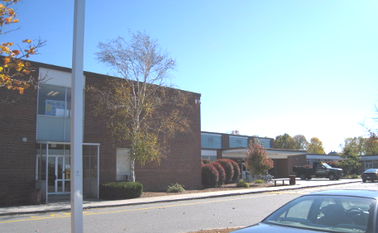

Prepared by:
Massachusetts Department of Public Health
Bureau of Environmental Health
Indoor Air Quality Program
February 2009

Background/Introduction
At the request of Mr. Al Baroncelli, Facilities Director for the Bridgewater-Raynham Regional School District (BRRSD), the Massachusetts Department of Public Health (MDPH), Bureau of Environmental Health (BEH) provided assistance and consultation in their on-going efforts to monitor and improve IAQ conditions in each of the Bridgewater-Raynham Regional schools. On October 31, 2008, Cory Holmes and Sharon Lee, Environmental Analysts/Inspectors for BEH’s Indoor Air Quality (IAQ) Program, conducted an assessment at the Bridgewater Middle School (BMS), 166 Mount Prospect Street, Bridgewater, Massachusetts. Prior to the inspection, BEH staff met with Ms. Angela Watson, Principal of the BMS. Ms. Watson explained that the health and safety committee conducted bi-monthly walkthroughs of the building to identify potential issues. The health and safety committee consists of Principal Watson, Mr. Baroncelli, faculty members and custodial staff.
The BMS is a two-story red brick building constructed in the early 1960s. An addition was built in the 1970s. The building served as the Bridgewater-Raynham Regional High School until 2006-2007, when it underwent interior renovations to become the middle school. Renovations included new mechanical ventilation components, drop ceilings8 and interior renovation of building materials. Roof and window replacement were not part of the renovation project. The school consists of general classrooms, science classrooms, gymnasium, kitchen/cafeteria, media center, art room/music room, teacher work rooms and office space. Windows are openable throughout the building.

Methods
Air tests for carbon dioxide, carbon monoxide, temperature and relative humidity were conducted with the TSI, Q-TRAK™ IAQ Monitor, Model 7565/8554. Air tests for airborne particulate matter with a diameter less than 2.5 micrometers were taken with the TSI, DUSTTRAK™ Aerosol Monitor Model 8520. BEH staff also performed a visual inspection of building materials for water damage and/or microbial growth.

Results
The BMS currently houses grades 7 and 8, with a student population of 630 and a staff of approximately 120. Tests were taken under normal operating conditions. Test results appear in Table 1.

Discussion

Ventilation
It can be seen from Table 1 that carbon dioxide levels were below 800 parts per million (ppm) in 49 of 60 areas surveyed, indicating adequate air exchange in the majority of areas in the building on the day of the assessment. It is important to note, however, that several areas with carbon dioxide levels below 800 ppm were sparsely populated, unoccupied and/or had windows open, which can greatly reduce carbon dioxide levels. Carbon dioxide levels would be expected to be higher with full occupancy and windows closed.
Classrooms have a ventilation system consisting of unit ventilators (univents) (Picture 1) and unit exhaust ventilators (unit exhaust; Picture 2) located on the exterior wall of the classrooms. The univents were operating in all but a few classrooms (Table 1). A univent is designed to draw air from outdoors through a fresh air intake located on the exterior wall of the building (Picture 3). Return air is drawn through an air intake located at the base of the unit (Figure 1). Fresh and return air are mixed, filtered, heated and provided to classrooms through an air diffuser located in the top of the unit. Unit exhausts operate in a similar fashion, drawing air into vents located along the bottom front of the unit and exhausting air to the outdoors. Unit exhaust vents were obstructed by furniture in some rooms (Table 1), which can limit air exchange.
Fresh air for common areas such as the gymnasium, cafeteria, library and administrative areas is provided by rooftop or ceiling-mounted air handling units (AHUs). AHUs draw in air from outdoor air intakes, filtered, heated and/or cooled and distributed to occupied areas via ceiling or wall-mounted air diffusers. Exhaust air is returned back to the AHUs via ceiling-mounted return vents. These systems appeared to be operating during the assessment.
To maximize air exchange, the MDPH recommends that both supply and exhaust ventilation operate continuously during periods of school occupancy. In order to have proper ventilation with a mechanical supply and exhaust system, the systems must be balanced to provide an adequate amount of fresh air to the interior of a room while removing stale air from the room. It is recommended that existing ventilation systems be re-balanced every five years to ensure adequate air systems function (SMACNA, 1994). The date of the last balancing of these systems reportedly occurred after renovations in 2007.
The Massachusetts Building Code requires a minimum ventilation rate of 15 cubic feet per minute (cfm) per occupant of fresh outside air or have openable windows in each room (SBBRS, 1997; BOCA, 1993). The ventilation must be on at all times that the room is occupied. Providing adequate fresh air ventilation with open windows and maintaining the temperature in the comfort range during the cold weather season is impractical. Mechanical ventilation is usually required to provide adequate fresh air ventilation.
Carbon dioxide is not a problem in and of itself. It is used as an indicator of the adequacy of the fresh air ventilation. As carbon dioxide levels rise, it indicates that the ventilating system is malfunctioning or the design occupancy of the room is being exceeded. When this happens a buildup of common indoor air pollutants can occur, leading to discomfort or health complaints. The Occupational Safety and Health Administration (OSHA) standard for carbon dioxide is 5,000 parts per million parts of air (ppm). Workers may be exposed to this level for 40 hours/week based on a time weighted average (OSHA, 1997).
The MDPH uses a guideline of 800 ppm for publicly occupied buildings. A guideline of 600 ppm or less is preferred in schools due to the fact that the majority of occupants are young and considered to be a more sensitive population in the evaluation of environmental health status. Inadequate ventilation and/or elevated temperatures are major causes of complaints such as respiratory, eye, nose and throat irritation, lethargy and headaches. For more information concerning carbon dioxide, please see Appendix A.
Temperature readings indoors on the day of the assessment ranged from 66 º F to 79 º F, which were mostly within the MDPH comfort guidelines. The MDPH recommends that indoor air temperatures be maintained in a range of 70 º F to 78 º F in order to provide for the comfort of building occupants. In many cases concerning indoor air quality, fluctuations of temperature in occupied spaces are typically experienced, even in a building with an adequate fresh air supply. The univent in classroom 104 was emitting excess heat; occupants in classroom 113 also reported heat comfort issues, which may indicate that the univents and/or thermostats are in need of adjustment or repair.
The relative humidity measurements ranged from 21 to 33 percent, which were below the MDPH recommended comfort range the day of the assessment. The MDPH recommends a comfort range of 40 to 60 percent for indoor air relative humidity. Relative humidity levels in the building would be expected to drop during the winter months due to heating. The sensation of dryness and irritation is common in a low relative humidity environment. Low relative humidity is a very common problem during the heating season in the northeast part of the United States.

Microbial/Moisture Concerns
Plants were noted in several classrooms. Plants can be a source of pollen and mold, which can be respiratory irritants for some individuals. Plants should be properly maintained and equipped with drip pans to prevent water damage to porous building materials, which can lead to mold growth. Plants should also be located away from ventilation sources (e.g., air intakes, univent diffusers) to prevent the entrainment and/or aerosolization of dirt, pollen or mold (Picture 4).
BEH staff examined conditions on the exterior of the building for potential sources of water pooling/penetration. Missing/damaged caulking around windows (Pictures 5 and 6) and missing/damaged mortar around exterior brick (Pictures 7 and 8) was observed. These breaches in the building envelope represent potential water penetration sources. Over time, these conditions can undermine the integrity of the building envelope and provide a means of water entry into the building via capillary action through foundation concrete and masonry (Lstiburek & Brennan, 2001). Such breaches can also provide a means of egress for drafts, as well as pests/rodents.

Other IAQ Evaluations
Indoor air quality can be negatively influenced by the presence of respiratory irritants, such as products of combustion. The process of combustion produces a number of pollutants. Common combustion emissions include carbon monoxide, carbon dioxide, water vapor and smoke (fine airborne particle material). Of these materials, exposure to carbon monoxide and particulate matter with a diameter of 2.5 micrometers (μm) or less (PM2.5) can produce immediate, acute health effects upon exposure. To determine whether combustion products were present in the school environment, BEH staff obtained measurements for carbon monoxide and PM2.5.

Carbon Monoxide
Carbon monoxide is a by-product of incomplete combustion of organic matter (e.g., gasoline, wood and tobacco). Exposure to carbon monoxide can produce immediate and acute health affects. Several air quality standards have been established to address carbon monoxide and prevent symptoms from exposure to these substances. The MDPH established a corrective action level concerning carbon monoxide in ice skating rinks that use fossil-fueled ice resurfacing equipment. If an operator of an indoor ice rink measures a carbon monoxide level over 30 ppm, taken 20 minutes after resurfacing within a rink, that operator must take actions to reduce carbon monoxide levels (MDPH, 1997).
The American Society of Heating Refrigeration and Air-Conditioning Engineers (ASHRAE) has adopted the National Ambient Air Quality Standards (NAAQS) as one set of criteria for assessing indoor air quality and monitoring of fresh air introduced by HVAC systems (ASHRAE, 1989). The NAAQS are standards established by the US EPA to protect the public health from six criteria pollutants, including carbon monoxide and particulate matter (US EPA, 2006). As recommended by ASHRAE, pollutant levels of fresh air introduced to a building should not exceed the NAAQS levels (ASHRAE, 1989). The NAAQS were adopted by reference in the Building Officials & Code Administrators (BOCA) National Mechanical Code of 1993 (BOCA, 1993), which is now an HVAC standard included in the Massachusetts State Building Code (SBBRS, 1997). According to the NAAQS, carbon monoxide levels in outdoor air should not exceed 9 ppm in an eight-hour average (US EPA, 2006).
Carbon monoxide should not be present in a typical, indoor environment. If it is present, indoor carbon monoxide levels should be less than or equal to outdoor levels. On the day of assessment, outdoor carbon monoxide concentrations were non-detect (ND). Carbon monoxide levels inside the building were also ND (Table 1).

Particulate Matter (PM2.5)
The US EPA has established NAAQS limits for exposure to particulate matter. Particulate matter is airborne solids that can be irritating to the eyes, nose and throat. The NAAQS originally established exposure limits to particulate matter with a diameter of 10 μm or less (PM10). According to the NAAQS, PM10 levels should not exceed 150 microgram per cubic meter (μg/m³) in a 24-hour average (US EPA, 2006). These standards were adopted by both ASHRAE and BOCA. Since the issuance of the ASHRAE standard and BOCA Code, US EPA proposed a more protective standard for fine airborne particles. This more stringent PM2.5 standard requires outdoor air particle levels be maintained below 35 μg/m³ over a 24-hour average (US EPA, 2006). Although both the ASHRAE standard and BOCA Code adopted the PM10 standard for evaluating air quality, MDPH uses the more protective proposed PM2.5 standard for evaluating airborne particulate matter concentrations in the indoor environment.
Outdoor PM2.5 concentrations were measured at 9 μg/m³ (Table 1). PM2.5 levels measured indoors ranged from 1 to 22 μg/m³ (Table 1), which were below the NAAQS PM2.5 level of 35 μg/m³. Frequently, indoor air levels of particulates (including PM2.5) can be at higher levels than those measured outdoors. A number of mechanical devices and/or activities that occur in schools can generate particulate during normal operations. Sources of indoor airborne particulates may include but are not limited to particles generated during the operation of fan belts in the HVAC system, cooking in the cafeteria stoves and microwave ovens; use of photocopiers, fax machines and computer printing devices; operation of an ordinary vacuum cleaner and heavy foot traffic indoors.

Volatile Organic Compounds
Indoor air quality can also be impacted by the presence of materials containing volatile organic compounds (VOCs). VOCs are substances that have the ability to evaporate at room temperature. Frequently, exposure to low levels of total VOCs (TVOCs) may produce eye, nose, throat and/or respiratory irritation in some sensitive individuals. For example, chemicals evaporating from a paint can stored at room temperature would most likely contain VOCs. In an effort to identify materials that can potentially increase indoor VOC concentrations, BEH staff examined classrooms for products containing these respiratory irritants.
The majority of classrooms contained dry erase boards and related materials. Materials such as dry erase markers and dry erase board cleaners may contain VOCs, such as methyl isobutyl ketone, n-butyl acetate and butyl-cellusolve (Sanford, 1999), which can be irritating to the eyes, nose and throat. Cleaning products were observed on countertops or below sinks in a number of classrooms. Like dry erase materials, cleaning products contain VOCs and other chemicals. These chemicals can be irritating to the eyes, nose and throat and should be kept out of reach of students.
A work room near the main office contains a photocopier. This area is not equipped with local exhaust ventilation to help reduce excess heat and odors. VOCs and ozone can be produced by photocopiers, particularly if the equipment is older and in frequent use. Ozone is a respiratory irritant (Schmidt Etkin, 1992).
In an effort to reduce noise from sliding chairs, tennis balls had been sliced open and placed on chair legs (Picture 9). Tennis balls are made of a number of materials that are a source of respiratory irritants. Constant wearing of tennis balls can produce fibers and cause TVOCs to off-gas. Tennis balls are made with a natural rubber latex bladder, which becomes abraded when used as a chair leg pad. Use of tennis balls in this manner may introduce latex dust into the school environment. Some individuals are highly allergic to latex (e.g., spina bifida patients) (SBAA, 2001). It is recommended that the use of materials containing latex be limited in buildings to reduce the likelihood of symptoms in sensitive individuals (NIOSH, 1997). A question and answer sheet concerning latex allergy is attached as Appendix B (NIOSH, 1998).
Several faculty members expressed concern with the presence of science chemicals in the prep room (Pictures 10 and 11). BEH staff were told by Principal Watson and Mr. Baroncelli, that the chemicals had been previously inventoried and were awaiting removal by a hazardous waste firm. BEH staff recommended that the doors to the prep room, which were found open and unlocked during the assessment (Picture 12), be kept closed and locked to prevent access by students.

Other Conditions
Other conditions that can affect indoor air quality were observed during the assessment. Many rooms contained air conditioners that had filters occluded with dust and debris, which can be re-aerosolized when activated (Picture 13). However, occupants reported that the ACs were not being used anymore due to the inaccessibility of outlets.
A number of classrooms contained personal fans that had accumulated dust (Picture 14) and/or chalk treys with accumulated chalk dust, dry erase particulate and/or pencil shavings (Pictures 15 and 16). These materials can be aerosolized during operation of the mechanical ventilation system or opening of windows and provide a source of eye, nose and respiratory tract irritation.
Strong odors were detected in the 2nd floor men’s faculty restroom. The restroom mechanical exhaust vents on this floor were not operating. Exhaust ventilation is necessary in restrooms to remove moisture and to prevent restroom odors from penetrating into adjacent areas.
Finally, BEH staff were asked to observe conditions in the locker rooms, which were abandoned during the 2007-2008 renovations, pending a determination of future use. The mechanical ventilation systems were found deactivated and appeared to have been deactivated for some time. Missing ceiling tiles and water-damaged ceiling and wall plaster were observed, which is typically evidence of historic leaks from the plumbing or heating system.

Conclusions/Recommendations
In view of the findings at the time of the visit, the following recommendations are made to improve indoor air quality:
- Continue to operate all ventilation systems throughout the building (e.g., gym, auditorium, classrooms) continuously during periods of school occupancy.
- Close classroom doors to facilitate air exchange.
- Monitor temperature in classrooms 104 and 113 for excess heat. Make adjustments to univent and/or thermostatic controls or repair as needed.
- Use openable windows in conjunction with mechanical ventilation to supplement air exchange. Care should be taken to ensure windows are properly closed at night and weekends to avoid the freezing of pipes and potential flooding.
- Restore exhaust ventilation to restrooms; make repairs as necessary.
- Consider adopting a balancing schedule of every 5 years for all mechanical ventilation systems, as recommended by ventilation industrial standards (SMACNA, 1994).
- For buildings in New England, periods of low relative humidity during the winter are often unavoidable. Therefore, scrupulous cleaning practices should be adopted to minimize common indoor air contaminants whose irritant effects can be enhanced when the relative humidity is low. To control for dusts, a high efficiency particulate arrestance (HEPA) filter equipped vacuum cleaner in conjunction with wet wiping of all surfaces is recommended. Avoid the use of feather dusters. Drinking water during the day can help ease some symptoms associated with a dry environment (throat and sinus irritations).
- Ensure plants have drip pans. Examine drip pans periodically for mold growth and disinfect with an appropriate antimicrobial where necessary. Remove plants from the air stream of mechanical ventilation.
- Seal around windows/frames to prevent drafts and water penetration.
- Repoint/repair exterior walls/foundation to prevent water penetration and pest entry.
- Clean accumulated dust and debris periodically from chalk/dry erase treys and blades of personal fans.
- Store cleaning products properly and out of reach of students.
- Clean/change filters of ACs per the manufacturer’s instructions or more frequently if needed.
- Continue with plans for chemical removal in science prep room. Ensure doors to prep room locked to prevent student access.
- Consider installing local exhaust ventilation in workrooms with photocopiers to remove excess heat and odors.
- Replace latex-based tennis balls with latex-free tennis balls or glides.
- If the locker rooms are to be used in the future, make repairs or consider replacing mechanical ventilation components and repair/replace water damaged building materials.
- Consider adopting the US EPA (2000) document, “Tools for Schools”, to maintain a good indoor air quality environment on the building. This document can be downloaded from the Internet at: http://www.epa.gov/iaq/schools/index.html.
- Refer to resource manuals and other related indoor air quality documents for further building-wide evaluations and advice on maintaining public buildings. Copies of these materials are located on the MDPH’s website: http://mass.gov/dph/indoor_air

References
ASHRAE. 1989. Ventilation for Acceptable Indoor Air Quality. American Society of Heating, Refrigeration and Air Conditioning Engineers. ANSI/ASHRAE 62-1989
BOCA. 1993. The BOCA National Mechanical Code/1993. 8th ed. Building Officials & Code Administrators International, Inc., Country Club Hills, IL.
Lstiburek, J. & Brennan, T. 2001. Read This Before You Design, Build or Renovate. Building Science Corporation, Westford, MA. U.S. Department of Housing and Urban Development, Region I, Boston, MA
MDPH. 1997. Requirements to Maintain Air Quality in Indoor Skating Rinks (State Sanitary Code, Chapter XI). 105 CMR 675.000. Massachusetts Department of Public Health, Boston, MA.
NIOSH. 1997. NIOSH Alert Preventing Allergic Reactions to Natural Rubber latex in the Workplace. National Institute for Occupational Safety and Health, Atlanta, GA.
NIOSH. 1998. Latex Allergy A Prevention. National Institute for Occupational Safety and Health, Atlanta, GA.
OSHA. 1997. Limits for Air Contaminants. Occupational Safety and Health Administration. Code of Federal Regulations. 29 C.F.R 1910.1000 Table Z-1-A.
Sanford. 1999. Material Safety Data Sheet (MSDS No: 198-17). Expo® Dry Erase Markers Bullet, Chisel, and Ultra Fine Tip. Sanford Corporation, Bellwood, IL.
SBAA. 2001. Latex In the Home And Community Updated Spring 2001. Spina Bifida Association of America, Washington, DC.
SBBRS. 1997. Mechanical Ventilation. State Board of Building Regulations and Standards. Code of Massachusetts Regulations. 780 CMR 1209.0.
Schmidt Etkin, D. 1992. Office Furnishings/Equipment & IAQ Health Impacts, Prevention & Mitigation. Cutter Information Corporation, Indoor Air Quality Update, Arlington, MA.
SMACNA. 1994. HVAC Systems Commissioning Manual. 1st ed. Sheet Metal and Air Conditioning Contractors’ National Association, Inc., Chantilly, VA.
US EPA. 2006. National Ambient Air Quality Standards (NAAQS). . US Environmental Protection Agency, Office of Air Quality Planning and Standards, Washington, DC. http://www.epa.gov/air/criteria.html.
US EPA. 2000. Tools for Schools. Office of Air and Radiation, Office of Radiation and Indoor Air, Indoor Environments Division (6609J). EPA 402-K-95-001, Second Edition. http://www.epa.gov/iaq/schools/tools4s2.html
Picture 1

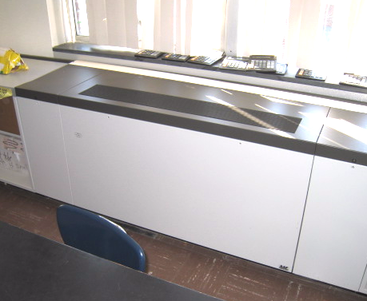

Unit Ventilator (Univent)

Picture 2

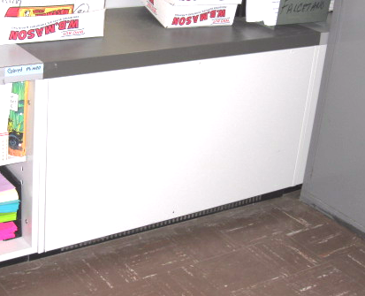

Unit Exhaust Ventilator

Picture 3

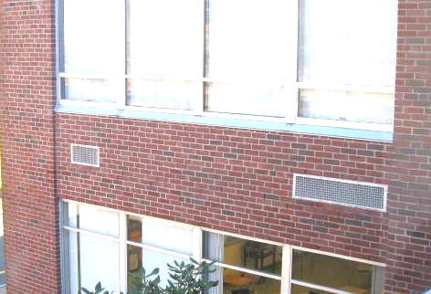

Univent Fresh Air Intake (Right) Unit Exhaust Vent (Left)

Picture 4

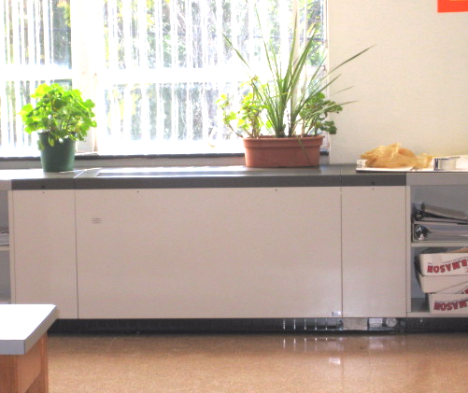

Plants Located on/near Univent Air Diffuser

Picture 5

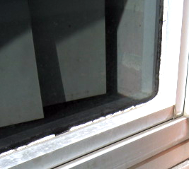

Missing/Damaged Caulking around Windows

Picture 6

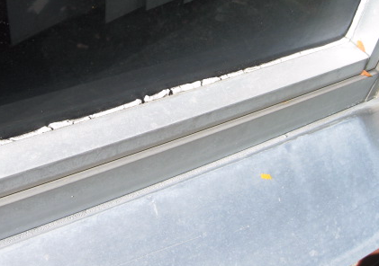

Missing/Damaged Caulking around Windows

Picture 7

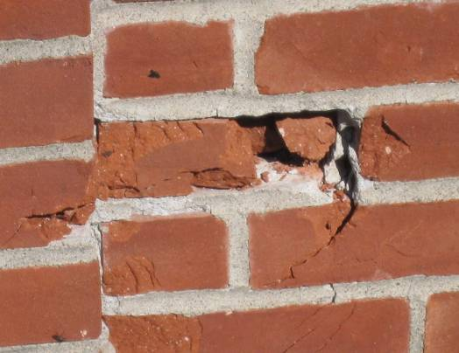

Damaged Exterior Brick/Mortar

Picture 8

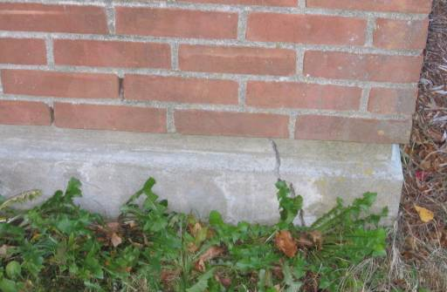

Crack in Foundation, Missing/Damaged Mortar around Brick

Picture 9

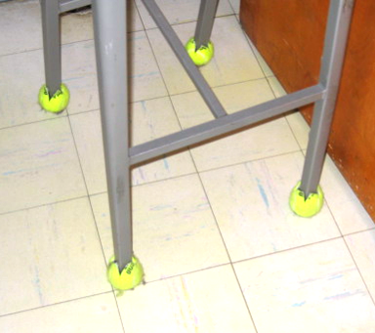

Tennis Balls on Chair/Desk Legs

Picture 10

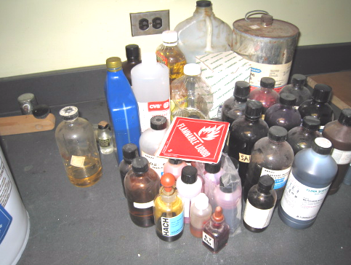

Chemicals in Science Prep Room Waiting for Removal

Picture 11

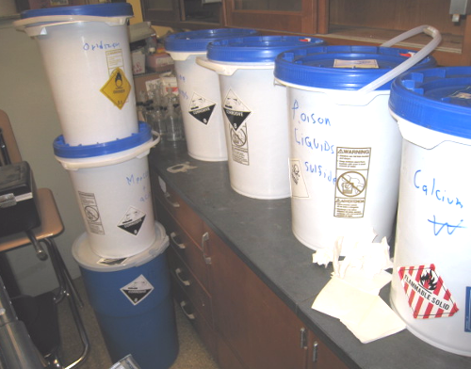

Chemicals in Science Prep Room Reportedly Waiting for Removal

Picture 12

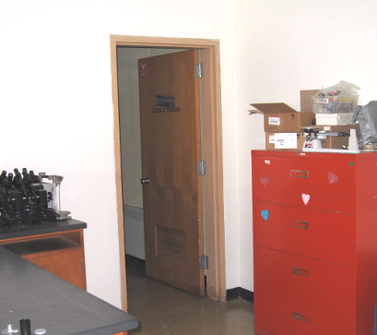

Doors to Prep Room Unlocked and Open

Picture 13

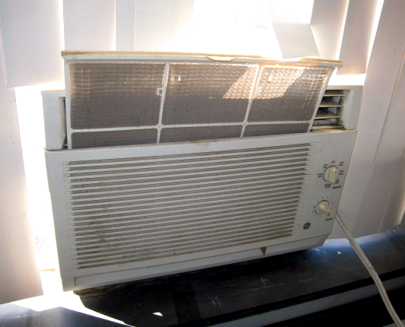

AC in Classroom, Note Filter Occluded With Dust and Debris

Picture 14

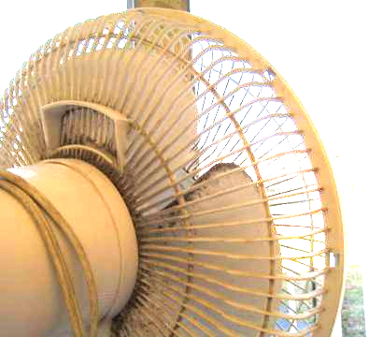

Accumulated Dust/Debris on Fan Blades

Picture 15

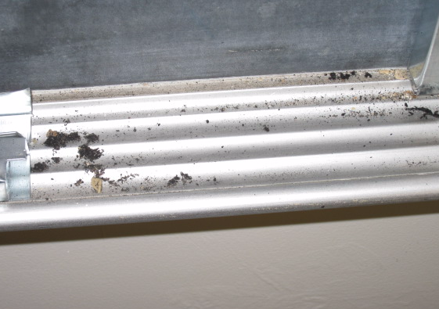

Accumulated Dry Erase Particulate

Picture 16

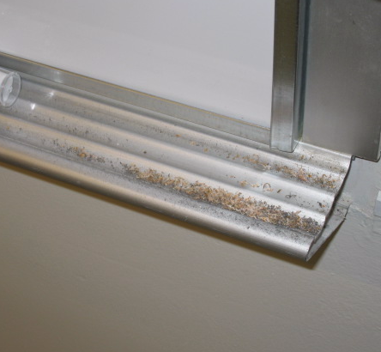

Accumulated Pencil Shavings
Location/ Room | Occupants  in Room | Temp  (°F) | Relative  Humidity  (%) | Carbon  Dioxide  (ppm) | Carbon Monoxide  (ppm) | PM2.5  (µg/m³) | Windows  Openable | Ventilation |  | Remarks
 |  |  |  |  |  |  |  | Supply | Exhaust | Remarks
background |  | 48 | 49 | 376 | ND | 9 |  |  |  | Clear, cool
Assist Principal | 0 | 70 | 29 | 664 | ND | 11 | Y | N | N | Window AC
Auditorium | 0 | 70 | 29 | 457 | ND | 4 | N | Y | Y | DO
Band | 0 | 71 | 23 | 419 | ND | 4 | Y | Y | Y | DO, WD wall plaster
Cafeteria | ~ 200 | 71 | 26 | 797 | ND | 22 | Y | Y | Y
Chemical Storage | 0 | 71 | 25 | 609 | ND | 8 | N | Y | Y | Doors left unlocked/open, chemicals stored reportedly waiting for removal
Conference Room | 0 | 69 | 26 | 500 | ND | 8 | Y | Y | Y | AP
Faculty Dining | 9 | 69 | 25 | 637 | ND | 6 | Y | Y | Y
Guidance 1 | 0 | 69 | 29 | 530 | ND | 5 | T | Y | Y | Passive supply vent, exhaust off/dusty
Guidance 2 | 0 | 69 | 28 | 664 | ND | 9 | Y | N | N
Guidance 3 | 0 | 68 | 29 | 549 | ND | 4 | Y | N | N | DO
Guidance 4 | 0 | 69 | 27 | 556 | ND | 9 | Y | N | N
Gym | 10 | 68 | 30 | 786 | ND | 17 | N | Y | Y
Library | 25 | 70 | 23 | 510 | ND | 2 | Y | Y | Y | 30 computers, plants, PF, DO odors from rug????, WD sink???
Main Office | 5 | 71 | 29 | 640 | ND | 12 | Y | N | N
Main Office Copy Room | 0 | 71 | 29 | 621 | ND | 11 | Y | N | N | PC, AC in window
Men’s Faculty Restroom |  |  |  |  |  |  | N | Y | Y | Exhaust not operating
Nurse Clinical | 2 | 77 | 21 | 575 | ND | 10 | Y | N | N | DO, 2 MTs
Nurse’s Office | 0 | 75 | 25 | 543 | ND | 6 | Y | Y | Y | Exhaust off, DO, AC-dusty, missing CT
PE Office | 2 | 68 | 26 | 570 | ND | 10 | Y | N | N | DO
Social Studies | 0 | 70 | 27 | 654 | ND | 9 | Y | N | N | DO
Workroom 1 | 0 | 72 | 28 | 508 | ND | 4 | N | N | N | PC (odors), no local exhaust
101 | 23 | 72 | 32 | 1046 | ND | 19 | Y | Y | Y | DO, plants, CP, PF, CD, accumulated items
102 | 25 | 71 | 22 | 983 | ND | 20 | Y | Y | Y | PF, DO
103 | 27 | 72 | 31 | 1138 | ND | 17 | Y | Y | Y | DO, PF
104 | 28 | 79 | 30 | 1123 | ND | 13 | Y | Y | Y | DO, excessive heat from UV
105 | 26 | 72 | 32 | 1185 | ND | 8 | Y | Y | Y | DO, CD, accumulated items
106 | 4 | 72 | 27 | 877 | ND | 13 | Y | Y | Y | Plants, PF
107 | 27 | 72 | 29 | 894 | ND | 9 | Y | Y | Y | PF-dusty, DO, CD
108 | 25 | 70 | 30 | 960 | ND | 13 | Y | Y | Y | PF
109 | 1 | 72 | 29 | 771 | ND | 4 | Y | Y | Y | DO, PF, accumulated items
110 | 27 | 72 | 31 | 1029 | ND | 7 | Y | Y | Y | DO, CD, PS, UV obstructed by furniture
111 | 0 | 68 | 27 | 529 | ND | 11 | Y | Y | Y | DO, PF
112 | 0 | 69 | 25 | 606 | ND | 7 | Y | Y | Y | DO, PF
113 | 0 | 68 | 21 | 465 | ND | 7 | Y | Y | Y | Windows open, DO, heat issues reported
114 | 6 | 69 | 26 | 600 | ND | 10 | Y | Y | Y | Plants
115 | 0 | 70 | 26 | 702 | ND | 3 | Y | Y | Y | DO, terrarium, aquarium
117 Computer Room | 26 | 71 | 27 | 752 | ND | 12 | Y | Y | Y | DO
121 | 0 | 69 | 23 | 403 | ND | 2 | Y | Y | Y | Supply off, PF, DO, AT, CP
123 | 7 | 70 | 25 | 480 | ND | 4 | Y | Y | Y | Accumulated items
124 | 2 | 70 | 24 | 413 | ND | 4 | Y | Y | Y | DO, PF
201 | 24 | 69 | 33 | 1081 | ND | 9 | Y | Y | Y | DO, PF, refrigerator
202 | 25 | 71 | 30 | 687 | ND | 11 | Y | Y | Y | PF, AC-dusty, plants, DO, window open
203 | 23 | 70 | 31 | 1238 | ND | 6 | Y | Y | Y | DO, CD
205 | 21 | 71 | 27 | 861 | ND | 21 | Y | Y | Y
206 | 26 | 72 | 30 | 883 | ND | 13 | Y | Y | Y | PF
207 | 26 | 70 | 33 | 1010 | ND | 26 | Y | Y | Y | DO, CP
208 | 9 | 71 | 24 | 621 | ND | 1 | Y | Y | Y | Window open, DO, PF
209 | 1 | 69 | 27 | 639 | ND | 3 | Y | Y | Y | DO
210 | 0 | 71 | 22 | 501 | ND | 8 | Y | Y | Y | DO
211 | 24 | 69 | 31 | 890 | ND | 12 | Y | Y | Y | PF
212 | 0 | 71 | 21 | 480 | ND | 9 | Y | Y | Y | Window open
213 | 0 | 73 | 26 | 605 | ND | 6 | Y | N | N
214 | 11 | 72 | 24 | 593 | ND | 10 | Y | Y | Y | PD, TB, DO
215 | 0 | 74 | 25 | 494 | ND | 5 | Y | N | N | AC
218 | 0 | 71 | 22 | 420 | ND | 3 | Y | Y | Y | Ventilation off
219 | 23 | 70 | 24 | 751 | ND | 7 | Y | Y | Y | DO
221 | 0 | 74 | 22 | 503 | ND | 4 | N | Y | Y | DO, Ventilation off
223 | 0 | 71 | 21 | 439 | ND | 5 | Y | Y | Y | DO
225 | 2 | 69 | 22 | 495 | ND | 7 | Y | Y | Y | DO
228 | 0 | 66 | 24 | 583 | ND | 3 | Y | Y | Y
231 | 2 | 70 | 25 | 469 | ND | 8 | Y | Y | Y | DO, plants near UV
233 | 0 | 70 | 24 | 406 | ND | 3 | Y | Y | Y | CD, PF
235 | 0 | 72 | 23 | 502 | ND | 11 | Y | Y | Y | DO

