|  |
| --- |
| INDOOR AIR QUALITY ASSESSMENT  **Bridgewater Raynham Regional High School**  **415 Center Street**  **Bridgewater, Massachusetts**  Bridgewater Raynham Regional High School 415 Center Street Bridgewater, Massachusetts  Prepared by:  Massachusetts Department of Public Health  Bureau of Environmental Health  Indoor Air Quality Program  April 2017 |

# Background

|  |  |
| --- | --- |
| **Building:** | Bridgewater Raynham Regional High School (BRRHS) |
| **Address:** | 415 Center Street, Bridgewater, MA |
| **Assessment Requested by:** | Paul Fox, Director of Facilities |
| **Date of Assessment:** | March 21, 2017 |
| **Bureau of Environmental Health (BEH) Indoor Air Quality (IAQ) Program Staff Conducting Assessment:** | Cory Holmes and Sharon Lee, Environmental Analysts |
| **Date of Building Construction:** | 2007 |
| **Reason for Request:** | General IAQ assessment |
| **Building Type:** | 3-story, red brick school building |
| **Building Population:** | Approximately 1,740 students and 150 employees |
| **Windows:** | Openable |

# IAQ Testing Results

Please refer to the IAQ Manual for methods, sampling procedures, and interpretation of results (MDPH, 2015). The following is a summary of indoor air testing results (Table 1).

* ***Carbon dioxide*** levels were above 800 parts per million (ppm) in 36 of 137 areas surveyed, indicating a lack of air exchange in a number of areas.
* ***Temperature*** was within or very close to the recommended range of 70°F to 78°F in all areas tested. However, many excessive heat control complaints were expressed on the third floor and some areas of the second floor. Heat related concerns are likely due to solar gain.
* ***Relative humidity*** was below the recommended range of 40 to 60% in all areas tested, which is typical in New England during winter months.
* ***Carbon monoxide*** levels were non-detectable (ND) in all areas tested.
* ***Fine particulate matter (PM2.5)*** concentrations measured were below the NAAQS limit of 35 μg/m3 in all areas tested.

It is important to note that relative humidity levels in the building would be expected to be low during the winter months due to atmospheric conditions and heating. Low relative humidity can lead to common symptoms such as: dry skin, lips, and scalp; dry/scratchy throats and noses (nose bleeds); exacerbation of asthma, eczema, or allergies; dry/irritated eyes; and irritation of the respiratory tract.

## Ventilation

A heating, ventilating, and air-conditioning (HVAC) system has several functions. First it provides heating and, if equipped, cooling. Second, it is a source of fresh air. Finally, an HVAC system will dilute and remove normally-occurring indoor environmental pollutants by not only introducing fresh air, but by filtering the airstream and ejecting stale air to the outdoors via exhaust ventilation. Even if an HVAC system is operating as designed, point sources of respiratory irritation may exist and cause symptoms in sensitive individuals.

Mechanical ventilation is provided by rooftop air-handling units (AHUs; Pictures 1 and 2). Outside air is drawn through a bank of pleated filters (Picture 3), heated or cooled, and delivered to occupied areas via ducted supply diffusers (Picture 4). The filters in use at the BRRHS appear to have a Minimum Efficiency Reporting Value (MERV) rating of 8, which are reportedly changed quarterly and are adequate in filtering out pollen and mold spores (ASHRAE, 2012). Return air is drawn through ceiling grates (Picture 5) and returned back to the AHUs.

To maximize air exchange, the MDPH recommends that both supply and exhaust ventilation operate continuously during periods of occupancy. It was reported that the system is automated by software/computer controlled. In order to have proper ventilation with a mechanical supply and exhaust system, the systems must be balanced to provide an adequate amount of fresh air to the interior of a room while removing stale air from the room. It is recommended that HVAC systems be re-balanced every five years to ensure adequate air systems function (SMACNA, 1994).

## Microbial/Moisture Concerns

In order for building materials to support mold growth, a source of water is necessary. A number of areas had water-damaged ceiling tiles (Picture 6, Table 1), which can indicate current or historic roof/plumbing leaks. After the source of the leak above the ceiling tiles is repaired, water-damaged ceiling tiles should be removed and replaced. Other conditions that may result in water damage or infiltration, or conditions that can lead odors or microbial growth include:

* Broken window in room F304 (Picture 7);
* Failing window gasket in room D208 and failing window caulking around the exterior of the building (Picture 8);
* Plant growth against the foundation along the exterior (Picture 9);
* Missing/damaged caulking between the sink countertop and backsplash in Room D208 (Picture 10);
* Aquariums and terrariums in several rooms. These items should be properly maintained to prevent bacteria/microbial growth; and
* Water cooler on the carpet in Room A150 (Picture 11).

Plants, which can be a source of pollen and mold and be respiratory irritants to some individuals, were observed in a number of areas. Plants should be properly maintained and equipped with drip pans to prevent water leaks and damage. They should also be located away from air diffusers to prevent the aerosolization of dirt, pollen, and mold.

## Other IAQ Evaluations

### Volatile Organic Compounds (VOCs)

Exposure to low levels of total VOCs (TVOCs) may produce eye, nose, throat, and/or respiratory irritation in some sensitive individuals. In addition to testing, IAQ staff examined rooms for products containing VOCs. IAQ staff noted air fresheners, scented hand sanitizers, cleaners, and dry erase materials within the building (Table 1). All of these products have the potential to be irritants to the eyes, nose, throat, and respiratory system of sensitive individuals and their use should be minimized. Hand sanitizer products may contain ethyl alcohol and/or isopropyl alcohol, which are highly volatile and may be irritating to the eyes and nose. These products may also contain fragrances to which some people may be sensitive.

Strong photocopier odors were noted in room H208. Excess heat, odors, VOCs, and ozone can be produced by laminators and photocopiers, particularly if the equipment is older and in frequent use. Ozone is a respiratory irritant (Schmidt Etkin, 1992). The photocopier should be relocated to the exhaust vent near the window (Picture 12).

Of particular note were conditions found in the chemical prep rooms/science areas (Picture 13 to 15). It was determined that a calibration program does not exist for the chemical lab hoods. Proper function of this equipment is essential for health and safety. Some chemical containers were found labeled with chemical formula rather than chemical name, and some materials were old/outdated/crystalized. Additionally, items were being stored in chemical lab hoods. Unused items should be properly discarded or returned to their proper storage cabinets.

### Other Conditions

Some personal fans, supply, and exhaust vents were observed to have accumulated dust/debris (Table 1, Pictures 4, 5, and 16). Particulates can be reaerosolized from these items and they should be cleaned regularly. Dust accumulation was also observed on flat surfaces in some areas (Picture 10).

In several areas, items were observed on the floor, windowsills, tabletops, counters, bookcases, and desks. The large number stored items provide a source for dusts to accumulate. These items (e.g., papers, folders, boxes) make it difficult for custodial staff to clean. Once aerosolized, they can act as irritants to eyes and the respiratory system. Items should be relocated and/or be cleaned periodically to avoid excessive dust build up.

Room F114 is used as an industrial shop class (Picture 17). However, the room was not designed for these activities. As a result, no dedicated exhausts for woodworking and soldering are available. These activities produce airborne dust, fume, and particulates and require dedicated exhaust equipment to prevent respiratory irritation.

Finally, the kiln room, D207 contains two kilns that share a single dedicated exhaust hood (Picture 18). At the time, one kiln was not working. Each kiln should have its own dedicated exhaust to ensure vapors and dusts are adequately removed during the firing process. Any dust/debris that escapes the kiln should be cleaned.

# Conclusions/Recommendations

In view of the findings at the time of the visit, the following recommendations are made:

1. Work with HVAC engineering firm to ensure system software is up to date and working properly. Adjust outside air intake to provide increased fresh air circulation and comfort. Ensure supply and exhaust ventilation operate continuously and remain unobstructed in all areas during occupied periods.
2. Consider adopting a balancing schedule of every 5 years for all mechanical ventilation systems, as recommended by ventilation industrial standards (SMACNA, 1994).
3. Install blinds, reflective shades, or solar tint to windows in areas of the building with chronic solar gain/heat complaints, particularly on the second and third floors.
4. Ensure any building envelope or plumbing leaks are repaired, and replace water-damaged ceiling tiles.
5. Repair broken window in room F304.
6. Make repairs to window gaskets (D206) and ensure window caulking is intact along exterior.
7. Remove plant growth from directly against foundation to prevent damage.
8. Seal sink countertop/backsplash with caulking in Room 208.
9. Consider placing water dispensers on non-carpeted areas or place a waterproof mat underneath them.
10. Ensure plants are properly maintained and equipped with drip pans. Plants should be located away from the airstream of air diffusers and ventilation equipment to prevent the aerosolization of dirt, pollen, and mold.
11. Ensure aquariums and terrariums are properly maintained to prevent odors and microbial growth.
12. Relocate photocopier in room H208 to the exhaust vent near window.
13. Consult with teacher and an HVAC specialist on obtaining proper exhaust equipment for woodworking and soldering in room F114.
14. Remove non-working kiln in room D207 and relocate the working kiln directly below the exhaust.
15. Conduct a building-wide chemical audit to ensure proper storage, and initiate removal of old/outdated materials. Refer to the following resources on storage and cleanout:
    1. Reducing Risks to Students and Educators from Hazardous Chemicals in a Secondary School Chemical Inventory (ACS, 2015)
    2. Toolkit for Safe Chemical Management in K-12 Schools (EPA, 2017)
    3. Proper Use and Storage of Chemicals in Schools to Protect Public Health (MDPH, 2016).
    4. Chemical Storage in Schools and Impact on Indoor Air Quality (MDPH, 2006).
16. Institute an annual calibration program for all chemical lab hoods to ensure proper function.
17. Do not store materials in lab hoods. Return materials to stock/proper storage cabinets upon completion of experiments.
18. Clean personal fans, supply, and return vents periodically of accumulated dust, perhaps quarterly after filter changes.
19. Relocate or consider reducing the amount of stored materials to allow for more thorough cleaning. Clean items regularly with a wet cloth or sponge to prevent excessive dust build-up.
20. For buildings in New England, periods of low relative humidity during the winter are often unavoidable. Therefore, scrupulous cleaning practices should be adopted to minimize common indoor air contaminants whose irritant effects can be enhanced when the relative humidity is low. To control for dusts, a high efficiency particulate arrestance (HEPA) filter equipped vacuum cleaner in conjunction with wet wiping of all surfaces is recommended. Avoid the use of feather dusters. Drinking water during the day can help ease some symptoms associated with a dry environment (throat and sinus irritations).
21. Consider reducing the use of hand sanitizers, fragrances, and dry erase materials in use within the office since all of these products have the potential to be irritants to the eyes, nose, throat, and respiratory system of sensitive individuals.
22. Refer to resource manual and other related indoor air quality documents located on the MDPH’s website for further building-wide evaluations and advice on maintaining public buildings. These documents are available at <http://mass.gov/dph/iaq>.

# References

American Chemical Society. (ACS). 2015. Reducing Risks to Students and Educators from Hazardous Chemicals in a Secondary School Chemical Inventory. American Chemical Society, Washington, DC. <http://www.acs.org/content/dam/acsorg/about/governance/committees/chemicalsafety/publications/reducing-risks-to-students-and-educators-from-hazardous-chemicals.pdf>

American Society of Heating, Refrigeration and Air Conditioning Engineers. (ASHRAE). 2012. Standard 52.2-2012 -- Method of Testing General Ventilation Air-Cleaning Devices for Removal Efficiency by Particle Size (ANSI Approved).

Massachusetts Department of Public Health. (MDPH). 2015. “Indoor Air Quality Manual: Chapters I-III”. Available at: <http://www.mass.gov/eohhs/gov/departments/dph/programs/environmental-health/exposure-topics/iaq/iaq-manual/>

Massachusetts Department of Public Health. (MDPH). 2016. Proper Use and Storage of Chemicals in Schools to Protect Public Health. Available at: <http://www.mass.gov/eohhs/docs/dph/environmental/iaq/use-and-storage-chemicals-in-schools.pdf>

Schmidt Etkin, D. 1992. Office Furnishings/Equipment & IAQ Health Impacts, Prevention & Mitigation. Cutter Information Corporation, Indoor Air Quality Update, Arlington, MA.

Sheet Metal and Air Conditioning Contractors’ National Association, Inc. (SMACNA). 1994. HVAC Systems Commissioning Manual. 1st ed. Sheet Metal and Air Conditioning Contractors’ National Association, Inc., Chantilly, VA.

United States Environmental Protection Agency (US EPA). 2017. Toolkit for Safe Chemical Management in K-12 Schools. Available at: <https://www.epa.gov/schools-chemicals/toolkit-safe-chemical-management-k-12-schools>

**Picture 1**

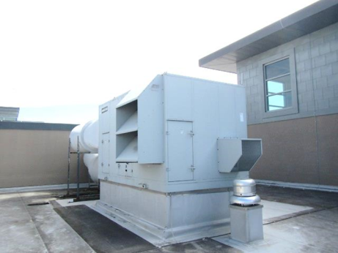

**Rooftop air handling unit (AHU)**

**Picture 2**

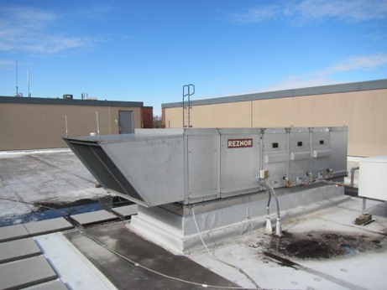

**Rooftop AHU**

**Picture 3**

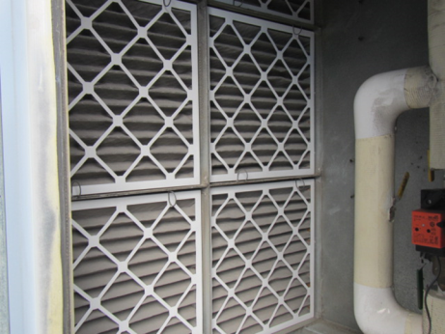

**Bank of pleated air filters in AHU**

**Picture 4**

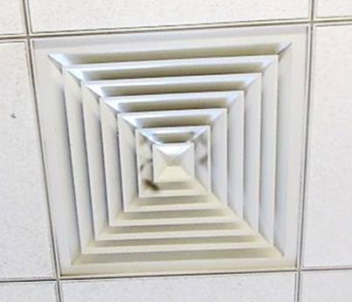

**Supply air diffuser, note dust/debris accumulation on louvers**

**Picture 5**

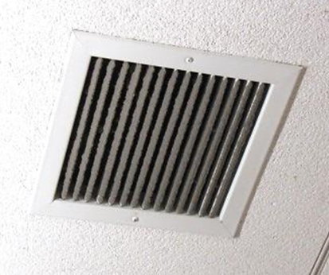

**Return grill, note dust/debris accumulation on louvers**

**Picture 6**

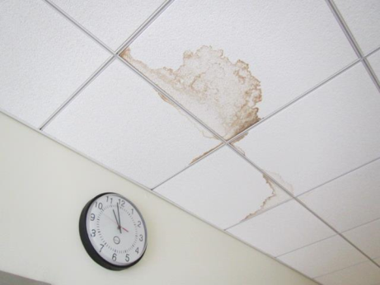

**Water-damaged ceiling tiles**

**Picture 7**

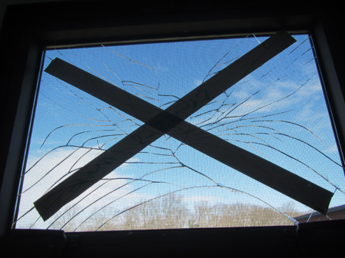

**Broken classroom window**

**Picture 8**

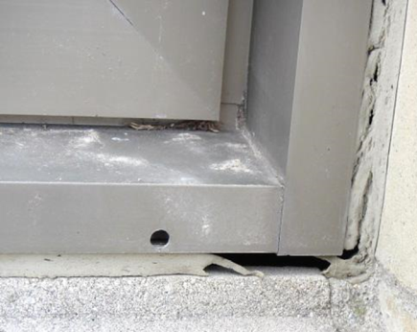

**Failing caulking around exterior window**

**Picture 9**

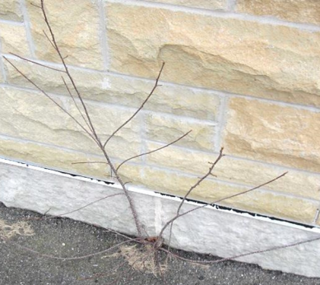

**Plant growth against the building foundation**

**Picture 10**

Title: Picture 10 - Description: Breach between sink countertop and backsplash


**Breach between sink countertop and backsplash**

**Picture 11**

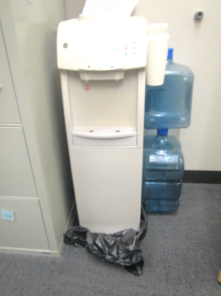

**Water cooler on carpet**

**Picture 12**

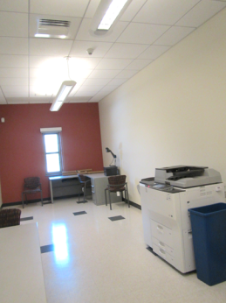

**Photocopier in front of room, note exhaust vent near window**

**Picture 13**

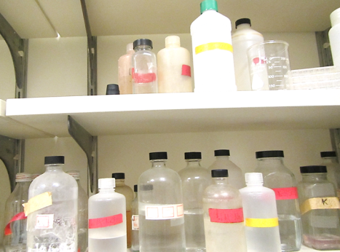

**Bottles labeled with chemical formula only, note some labels are peeling**

**Picture 14**

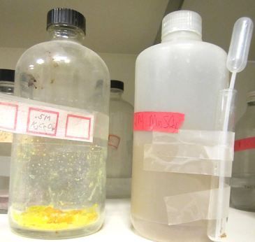

**Chemical crystallization due to evaporation**

**Picture 15**

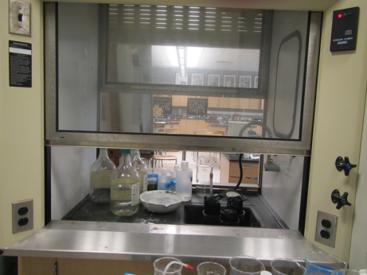

**Items stored in chemical hood**

**Picture 16**

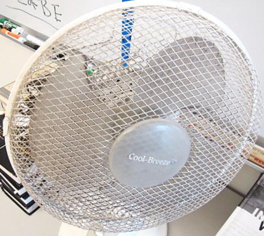

**Accumulated dust/debris on fan blades in classroom**

**Picture 17**

Title: Picture 17 - Description: Woodworking equipment lacking dedicated wood dust collection system


**Woodworking equipment lacking dedicated wood dust collection system**

**Picture 18**

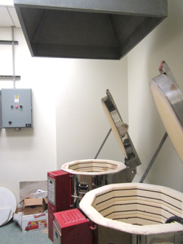

**Kiln vent shared between two kilns**

| **Location** | **Carbon**  **Dioxide**  **(ppm)** | **Carbon**  **Monoxide**  **(ppm)** | **Temp**  **(°F)** | **Relative**  **Humidity**  **(%)** | **PM2.5 (ug/m3)** | **Occupants**  **in Room** | **Windows**  **Openable** | **Ventilation** | | **Remarks** |
| --- | --- | --- | --- | --- | --- | --- | --- | --- | --- | --- |
| Background | 301 | ND | 50 | 20 | 16 |  |  |  |  | Cool, scattered clouds |
| **Third Floor** |  |  |  |  |  |  |  |  |  |  |
| E312 | 737 | ND | 74 | 14 | 11 | 0 | N | Y | Y | 2 PC, DO |
| E320 computer lab | 914 | ND | 74 | 15 | 4 | 23 | N | Y | Y | 29 computers, DO, 4 WD CTs, MT |
| F301 | 1017 | ND | 70 | 20 | 9 | 21 | Y | Y | Y | DO, DEM, CPs, PF |
| F302 | 757 | ND | 72 | 14 | 6 | 1 | Y | Y | Y | Ripped window screen, PF |
| F303 | 815 | ND | 71 | 17 | 8 | 15 | Y  2/8 open | Y | Y | DEM, DO, PF, DEM, CPs, HS |
| F304 | 653 | ND | 72 | 13 | 7 | 8 | Y | Y | Y | DO, broken window, DEM, HS, CPs |
| F305 | 1171 | ND | 72 | 20 | 8 | 26 | Y | Y  Dusty | Y | DEM, PF |
| F306 | 850 | ND | 74 | 14 | 7 | 21 | Y  4/8 | Y | Y | DEM, DO, PF |
| F307 | 983 | ND | 74 | 16 | 8 | 25 | Y  4/8 | Y | Y | PF, DEM, HS, excessive heat concerns |
| F308 | 1290 | ND | 74 | 20 | 8 | 27 | Y  2/8 | Y | Y | DEM, HS |
| F309 | 1295 | ND | 75 | 8 | 10 | 22 | Y | Y | Y | PF, HS, DEM, AT |
| F310 | 1172 | ND | 74 | 17 | 8 | 27 | Y  2/8 | Y | Y | DEM, HS, CP |
| F312 | 663 | ND | 74 | 13 | 7 | 6 | Y | Y | Y | PF, DEM |
| G301 | 376 | ND | 74 | 11 | 6 | 1 | Y | Y | Y | DEM, HS, CPs, PF, DO |
| G303 | 628 | ND | 73 | 13 | 4 | 21 | Y | Y  Dusty | Y | DEM, HS, CPs |
| G304 | 708 | ND | 73 | 15 | 6 | 23 | Y | Y | Y | Dust/debris on vents, DO |
| G305 | 719 | ND | 73 | 13 | 6 | 24 | Y | Y  Dusty | Y | CPs, DEM, PF |
| G306 | 684 | ND | 73 | 14 | 7 | 13 | Y | Y | Y | DO, DEM, HS |
| G307 | 592 | ND | 74 | 13 | 4 | 21 | Y | Y  Dusty | Y | CPs, DEM, PF |
| G308 | 437 | ND | 73 | 13 | 3 | 20 | Y | Y  Dusty | Y | PF |
| G309 | 285 | ND | 74 | 10 | 4 | 1 | Y | Y  Dusty | Y | PF, portable AC, refrigerator, DEM, HS |
| G310 | 405 | ND | 72 | 11 | 5 | 1 | N | Y | Y | DO |
| G311 | 259 | ND | 72 | 11 | 4 | 0 | Y | Y | Y | DO, DEM |
| H301 | 612 | ND | 74 | 15 | 8 | 1 | Y | Y | Y | Dust/debris on vents |
| H302 | 875 | ND | 75 | 17 | 5 | 31 | Y | Y | Y | 2 WD CT |
| H303 | 759 | ND | 74 | 16 | 6 | 26 | Y | Y | Y | DO, PF, 2 WD CT |
| H304 | 778 | ND | 74 | 17 | 7 | 22 | Y | Y | Y | PF, DO |
| H305 | 849 | ND | 69 | 21 | 6 | 18 | Y | Y | Y | Dust/debris on vents |
| Middle School Office | 753 | ND | 74 | 14 | 6 | 2 | N | Y | Y |  |
| Teacher’s Breakroom | 636 | ND | 72 | 14 | 3 | 3 | Y | Y | Y | 4 WD CT |
| **Second Floor** |  |  |  |  |  |  |  |  |  |  |
| A204 | 425 | ND | 73 | 11 | 5 | 6 | Y | Y | Y |  |
| A205 | 446 | ND | 74 | 12 | 5 | 2 | Y | Y | Y | 2 PC, DO |
| A211 | 417 | ND | 72 | 11 | 4 | 0 | Y | Y | Y | DO, dust/debris on vents |
| A212 | 935 | ND | 72 | 16 | 6 | 24 | Y  Open | Y | Y |  |
| A216 | 472 | ND | 72 | 12 | 5 | 2 | N | Y | Y |  |
| A218 | 433 | ND | 74 | 11 | 4 | 1 | N | Y | Y |  |
| Media Center | 417 | ND | 73 | 12 | 5 | 3 | Y | Y | Y |  |
| B204 | 763 | ND | 75 | 16 | 4 | 0 | Y | Y | Y | Portable AC |
| B206 | 1797 | ND | 74 | 24 | 4 | 25 | Y | Y | Y | DO, portable AC, AT |
| D204 | 602 | ND | 75 | 14 | 7 | 0 | Y | Y | Y | DO, items |
| D206 | 634 | ND | 78 | 13 | 4 | 18 | Y  1/1 open | Y | Y | 29 computers, plants, failing window gasket, DO |
| D207 kiln room |  |  |  |  |  |  |  |  | Y | DO, one dedicated exhaust for two kilns |
| D208 | 667 | ND | 75 | 14 | 8 | 14 | Y  1/8 open | Y | Y | Potting, dusty flat surfaces, PF, breach between sink backsplash and counter |
| E205 | 482 | ND | 74 | 12 | 3 | 0 | N | Y | Y | DO |
| E207 | 481 | ND | 73 | 12 | 9 | 0 | N | Y | Y | Microwave |
| E210 | 487 | ND | 74 | 13 | 4 | 1 | N | Y | Y | DO, copier |
| E212 | 672 | ND | 74 | 14 | 18 | 15 | Y | Y | Y | Strong food odor, microwave, refrigerator |
| E218 | 793 | ND | 75 | 15 | 4 | 0 | N | Y | Y | Occupants at lunch, dust/debris on vents |
| F201 | 749 | ND | 75 | 15 | 6 | 1 | Y | Y | Y | 26 occupants gone ~15 mins |
| F204 | 834 | ND | 73 | 15 | 5 | 0 | Y | Y | Y | PF, occupants at lunch |
| F206 | 730 | ND | 73 | 15 | 7 | 4 | Y | Y | Y | DO |
| F207 | 702 | ND | 74 | 16 | 6 | 1 | Y | Y | Y | 23 occupants gone ~ 10 mins |
| F208 | 730 | ND | 73 | 15 | 5 | 1 | Y | Y | Y | DO |
| G201 | 496 | ND | 74 | 12 | 5 | 0 | Y | Y | Y | PF |
| G202 | 750 | ND | 74 | 14 | 5 | 1 | Y | Y | Y | Items/papers on floor/windowsill, DO, DEM, PF |
| G203 | 831 | ND | 74 | 16 | 5 | 0 | Y | Y | Y | Class just left for lunch |
| G204 | 660 | ND | 74 | 14 | 5 | 16 | Y | Y | Y | PF, DEM |
| G205 | 723 | ND | 74 | 15 | 7 | 0 | Y | Y | Y | PF |
| G206 | 629 | ND | 74 | 14 | 5 | 20 | Y | Y  Dusty | Y | DO, PF, DEM |
| G207 | 926 | ND | 74 | 17 | 5 | 18 | Y | Y | Y | PF(2) |
| G208 | 621 | ND | 74 | 14 | 5 | 15 | Y | Y | Y | DEM, HS, PF |
| G209 | 776 | ND | 73 | 17 | 7 | 16 | Y | Y | Y | DO, dust/debris on vents |
| G210 | 763 | ND | 74 | 14 | 4 | 30 | 7 | 7 | 7 | DEM, PF, HS |
| G211 | 501 | ND | 72 | 13 | 5 | 1 | Y | Y | Y | PF |
| H201 | 876 | ND | 74 | 15 | 4 | 2 | Y | Y | Y | DO, aquarium |
| H202 | 546 | ND | 73 | 15 | 5 | 1 | Y | Y | Y | Terrarium |
| H203 | 463 | ND | 75 | 13 | 3 | 1 | Y | Y | Y | DEM, CPs, HS, PF, AD |
| H204 | 514 | ND | 73 | 14 | 3 | 14 | Y | Y | Y | DO, DEM, HS |
| H205 | 638 | ND | 73 | 14 | 4 | 20 | Y | Y | Y | DO |
| H208 | 440 | ND | 73 | 13 | 4 | 0 | Y | Y | Y | Strong copier odors |
| **First Floor** |  |  |  |  |  |  |  |  |  |  |
| Auditorium | 399 | ND | 71 | 11 | 4 | 0 | N | Y | Y |  |
| A104 | 481 | ND | 74 | 13 | 5 | 0 | Y | Y | Y |  |
| A105 | 490 | ND | 73 | 13 | 5 | 0 | N | Y | Y | DO |
| A107 | 471 | ND | 73 | 13 | 5 | 0 | Y | Y | Y |  |
| A112 | 436 | ND | 72 | 13 | 4 | 0 | Y | Y | Y | DO |
| A122 | 458 | ND | 72 | 13 | 4 | 0 | Y | Y | Y | DO |
| A135 | 503 | ND | 70 | 15 | 4 | 6 | Y | Y | Y | DO |
| A136 | 296 | ND | 71 | 13 | 4 | 1 | Y | Y | N | Plants, DO |
| A137 | 751 | ND | 71 | 18 | 2 | 2 | N | Y | Y | AD, HS |
| A140 | 381 | ND | 71 | 13 | 4 | 1 | N | Y | Y | HS |
| A150 | 297 | ND | 72 | 13 | 4 | 0 | N | Y | N | Water cooler on carpet, DO |
| A152 | 318 | ND | 71 | 13 | 4 | 1 | Y | Y | N | DO |
| B101 cafeteria | 313 | ND | 74 | 12 | 4 | 250 | Y | Y | Y |  |
| B114 | 205 | ND | 72 | 11 | 3 | 0 | Y | Y | Y | Copier, 4 WD CT, AT |
| B120 | 2672 | ND | 74 | 29 | 4 | 26 | Y | Y | Y | DEM, HS |
| B122 | 734 | ND | 75 | 15 | 4 | 10 | Y | Y | Y | DEM, 29 computers, AD |
| B124 | 929 | ND | 75 | 17 | 4 | 3 | Y | Y | Y | 27 computers, DO, DEM |
| C103 | 640 | ND | 72 | 17 | 11 | 0 | N | Y | Y |  |
| Boys Locker Room | 942 | ND | 72 | 23 | 4 | 0 | N | Y | Y | Dust/debris on vents, class just left |
| C116 | 899 | ND | 73 | 23 | 6 | 4 | N | Y | Y | Dust/debris on vents |
| C119 | 928 | ND | 73 | 21 | 4 | 1 | N | Y | Y | Dust/debris on vents, DO |
| C201 | 339 | ND | 72 | 15 | 4 | 1 | Y  2/2 open | Y | Y | Copier, PF, DO |
| C212 girls’ locker room |  |  | 72 | 17 | 4 |  |  | Y | Y |  |
| D112 | 761 | ND | 71 | 17 | 5 | 1 | N | Y | Y | Burned coffee odor |
| D121 | 692 | ND | 73 | 15 | 2 | 1 | N | Y | Y | DO |
| D128A | 645 | ND | 73 | 15 | 3 | 0 | N | Y | Y | DO |
| D129 | 655 | ND | 73 | 15 | 3 | 1 | N | Y | Y | DO |
| D138 | 985 | ND | 73 | 20 | 6 | 16 | Y | Y | Y | DO |
| D140 | 822 | ND | 74 | 15 | 4 | 1 | Y | Y | Y | DEM, DO, HS |
| E104 | 772 | ND | 71 | 16 | 5 | 0 | N | Y | Y |  |
| E105 | 730 | ND | 70 | 15 | 4 | 0 | N | Y | Y | DO, 1 WD CT |
| E107 | 731 | ND | 71 | 16 | 4 | 0 | N | Y | N | DO |
| E111 | 707 | ND | 72 | 16 | 5 | 1 | N | Y | Y |  |
| E112 | 561 | ND | 72 | 15 | 4 | 0 | Y | Y | Y | Microwave, refrigerator, temperature concern (too cold in corner) |
| E116 | 719 | ND | 72 | 15 | 5 | 1 | N | Y | Y |  |
| E120 | 551 | ND | 71 | 14 | 4 | 1 | Y | Y | Y |  |
| E121 | 505 | ND | 71 | 15 | 4 | 0 | N | Y | Y |  |
| E124 | 927 | ND | 75 | 17 | 12 | 21 | Y | Y | Y | DO |
| Gym | 782 | ND | 72 | 21 | 4 | ~50 | N | Y | Y |  |
| Main Office | 520 | ND | 71 | 14 | 5 | 3 | N | Y | Y | DO |
| Main Office Reception | 503 | ND | 74 | 13 | 5 | 1 | Y | Y | Y |  |
| F101 | 1047 | ND | 74 | 19 | 6 | 22 | Y | Y | Y | DO, PF |
| F102 | 973 | ND | 73 | 18 | 6 | 28 | Y | Y | Y | Dust/debris on vents |
| F103 | 824 | ND | 74 | 18 | 7 | 1 | Y | Y | Y | 20 occupants gone ~15 mins, dust/debris on vents |
| F106 | 717 | ND | 73 | 16 | 8 | 24 | Y | Y | Y | PF, 2 AT |
| F107 | 730 | ND | 74 | 16 | 7 | 26 | Y | Y | Y | DO, PF, AT |
| F108 | 937 | ND | 73 | 19 | 5 | 22 | Y | Y  Dusty | Y | DEM, HS, PF |
| F109 | 792 | ND | 73 | 20 | 6 | 24 | Y | Y | Y | DO |
| F110 | 623 | ND | 72 | 16 | 6 | 0 | Y  1/10 open | Y | Y | DEM, HS |
| F112 | 284 | ND | 71 | 13 | 3 | 0 | Y | Y | Y | CPs, DO, microwave |
| F114 | 330 | ND | 69 | 15 | 8 | 19 | Y  ¼ open | Y | Y | Exterior DO, no dedicated exhaust for woodworking and soldering equipment |
| G101 | 908 | ND | 74 | 19 | 12 | 30 | Y | Y | Y | DO |
| G102 | 904 | ND | 72 | 18 | 6 | 21 | Y | Y | Y | DEM, DO |
| G103 | 764 | ND | 73 | 17 | 5 | 26 | Y | Y | Y | DO, PF, dust/debris on vents |
| G104 | 497 | ND | 72 | 16 | 6 | 10 | Y | Y | Y  Dusty | DEM |
| G105 | 844 | ND | 73 | 17 | 7 | 25 | Y | Y | Y |  |
| G106 | 451 | ND | 72 | 15 | 4 |  | Y | Y | Y | PF, DEM, DO |
| G107 | 686 | ND | 73 | 16 | 7 | 24 | Y | Y | Y |  |
| G108 | 657 | ND | 72 | 7 | 4 | 19 | Y  1/10 | Y | Y | DEM, HS |
| G109 | 641 | ND | 72 | 15 | 6 | 17 | Y | Y | Y | Dust/debris on vents, DO |
| G110 | 869 | ND | 71 | 18 | 4 | 31 | Y  1/10 open | Y | Y | DEM, HS, PF |
| G111 | 653 | ND | 73 | 16 | 6 | 4 | Y | Y | Y |  |
| H101 | 681 | ND | 73 | 17 | 4 | 20 | Y | Y | Y | 3 WD CT, item storage |
| H102 | 941 | ND | 71 | 19 | 6 | 23 | Y | Y | Y | Dust/debris on vents, 1 WD CT, DO, PF |
| H103 | 633 | ND | 72 | 17 | 4 | 1 | Y | Y | Y  Dusty | Items |
| H104 | 994 | ND | 71 | 20 | 6 | 30 | Y | Y | Y | Dust/debris on vents |
| H105 | 824 | ND | 71 | 20 | 5 | 21 | Y | Y | Y  Dusty | PF, 5 WD CT, 1 AT |
| H106 | 612 | ND | 71 | 16 | 6 | 1 | Y | Y | Y | DO |
| H107 chemical storage |  |  |  |  |  |  |  | Y | Y | Chemical containers and other items stored in chemical hood, chemicals labelled with formula only, crystallization observed in bottles |
| H110 science prep |  |  |  |  |  |  |  | Y | Y |  |
| Guidance Office | 328 | ND | 71 | 13 | 4 | 0 | Y | Y | Y |  |