INDOOR AIR QUALITY ASSESSMENT

Bridgewater Raynham Regional High School
415 Center Street
Raynham, Massachusetts 02767

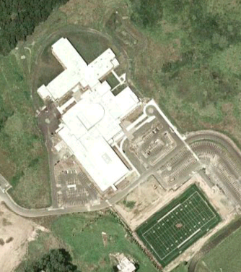

Prepared by:
Massachusetts Department of Public Health
Bureau of Environmental Health
Indoor Air Quality Program
July 2009

Background/Introduction
At the request of Mr. Al Baroncelli, Facilities Director for the Bridgewater-Raynham Regional School District, the Massachusetts Department of Public Health (MDPH), Bureau of Environmental Health (BEH) provided further assistance and consultation in monitoring and improving indoor air quality in all Bridgewater-Raynham Regional schools. On May 7, 2009, Cory Holmes, Sharon Lee, and James Tobin, Environmental Analysts/Inspectors for BEH’s Indoor Air Quality (IAQ) Program conducted an assessment at the Bridgewater Raynham Regional High School (BRRHS), 415 Center Street, Bridgewater, Massachusetts.
The BRRHS is a three-story; red-brick building that was completed in 2007. The school consists of general classrooms, science classrooms, a gymnasium, auditorium, kitchen/cafeteria, media center, art rooms, music/band rooms, teacher work rooms and office space. The auditorium, media center, lecture hall, administration/guidance offices and some computer labs are equipped with central air conditioning. Windows are openable throughout the building. Of interest is that transoms (i.e. interior windows) were installed over classroom doors. When open, transoms allow for cross-ventilation in the building.

Methods
Air tests for carbon dioxide, carbon monoxide, temperature and relative humidity were conducted with the TSI, Q-TRAK™ IAQ Monitor, Models 7565/8554. Air tests for airborne particulate matter with a diameter less than 2.5 micrometers were taken with the TSI, DUSTTRAK™ Aerosol Monitor Model 8520. BEH staff also performed a visual inspection of building materials for water damage and/or microbial growth.

Results
The BRRHS houses grades 9 through 12 with a student population of approximately 1,400 and a staff of approximately 300. Tests were taken under normal operating conditions and results appear in Table 1.

Discussion

Ventilation
It can be seen from Table 1 that carbon dioxide levels were above 800 parts per million (ppm) in 20 of 105 areas, indicating adequate air exchange in most areas surveyed in the building on the day of the assessment. It is important to note that several areas with carbon dioxide levels below 800 ppm were sparsely populated, unoccupied or had windows open, which can greatly reduce carbon dioxide levels. Carbon dioxide levels would be expected to be higher with full occupancy and windows closed.
Mechanical ventilation is provided by rooftop air-handling units (Pictures 1 and 2). AHUs draw air in through fresh air intakes. Air is filtered, heated and/or cooled by the AHU before it is distributed to occupied areas via ceiling-mounted air diffusers (Pictures 3 and 4). Exhaust air is drawn into the ceiling plenum via grates and returned back to the AHUs via ductwork (Picture 5). Some return/exhaust vents are located near classroom doors and transoms (Picture 6). Due to their location, the exhaust capabilities of these vents can be diminished when the doors and transoms are open. With the classroom doors/transoms open, the return/exhaust vent tends to draw air from the hallway into the classroom rather than remove stale air out of the classroom.
Fresh air for common areas such as the gymnasium, cafeteria, library and administrative areas is provided by rooftop or ceiling-mounted air handling units (AHUs). Elevated carbon dioxide levels were detected in the gymnasium (Table 1), which would indicate that the system was not operating during the assessment.
To maximize air exchange, the MDPH recommends that both supply and exhaust ventilation operate continuously during periods of school occupancy. In order to have proper ventilation with a mechanical supply and exhaust system, the systems must be balanced to provide an adequate amount of fresh air to the interior of a room while removing stale air from the room. It is recommended that existing ventilation systems be re-balanced every five years to ensure adequate air systems function (SMACNA, 1994). The systems were reportedly balanced in 2007.
The Massachusetts Building Code requires that each room have a minimum ventilation rate of 15 cubic feet per minute (cfm) per occupant of fresh outside air or openable windows (SBBRS, 1997; BOCA, 1993). The ventilation must be on at all times that the room is occupied. Providing adequate fresh air ventilation with open windows and maintaining the temperature in the comfort range during the cold weather season is impractical. Mechanical ventilation is usually required to provide adequate fresh air ventilation.
Carbon dioxide is not a problem in and of itself. It is used as an indicator of the adequacy of the fresh air ventilation. As carbon dioxide levels rise, it indicates that the ventilating system is malfunctioning or the design occupancy of the room is being exceeded. When this happens a buildup of common indoor air pollutants can occur, leading to discomfort or health complaints. The Occupational Safety and Health Administration (OSHA) standard for carbon dioxide is 5,000 parts per million parts of air (ppm). Workers may be exposed to this level for 40 hours/week based on a time weighted average (OSHA, 1997).
The MDPH uses a guideline of 800 ppm for publicly occupied buildings. A guideline of 600 ppm or less is preferred in schools due to the fact that the majority of occupants are young and considered to be a more sensitive population in the evaluation of environmental health status. Inadequate ventilation and/or elevated temperatures are major causes of complaints such as respiratory, eye, nose and throat irritation, lethargy and headaches. For more information concerning carbon dioxide, please see Appendix A.
Indoor temperature readings on the day of the assessment ranged from 66º F to 74º F, which were within or close to the lower end of the MDPH comfort guidelines. The MDPH recommends that indoor air temperatures be maintained in a range of 70 º F to 78 º F in order to provide for the comfort of building occupants. In many cases concerning indoor air quality, fluctuations of temperature in occupied spaces are typically experienced, even in a building with an adequate fresh air supply. A number of temperature and ventilation control complaints were expressed in the building.
The relative humidity measurements ranged from 51 to 77 percent, which were above the MDPH recommended comfort range in several areas on the day of the assessment. These elevated relative humidity levels would be expected in a building that, with the exception of select areas, lacks air-conditioning (AC) to remove excess moisture on a day when outdoor relative humidity is 90 percent. The MDPH recommends a comfort range of 40 to 60 percent for indoor air relative humidity. Without a dehumidification system or central AC, indoor relative humidity levels are difficult to maintain in a comfort range when outdoor relative humidity is high. While temperature is mainly a comfort issue, relative humidity in excess of 70 percent for extended periods of time can provide an environment for mold and fungal growth (ASHRAE, 1989). Relative humidity levels in the building would be expected to drop during the winter months due to heating. The sensation of dryness and irritation is common in a low relative humidity environment. Low relative humidity is a very common problem during the heating season in the northeast part of the United States.

Microbial/Moisture Concerns
In order for building materials to support mold growth, a source of water exposure is necessary. Identification and elimination of the source of water moistening building materials is necessary to control mold growth. A few areas throughout the school had water-damaged ceiling tiles (Table 1/Pictures 7 and 8). Water-damaged ceiling tiles can provide a source of mold growth and should be replaced after a water leak is discovered and repaired. Staff reported previous leaks in the media center. According to Mr. Baroncelli, the roofer found a number of small pinholes in the roof membrane, which were reportedly repaired. No further leaks were reported. Leaks observed in rooms A-217 and A-209 of the Media Center appear to have been from condensation on cold metal surfaces (e.g., ductwork, pipes) above the ceiling tile system.
Pooling water around a clogged drain was observed on the roof near RTU-7 (Pictures 9 and 10). Freezing and thawing of pooled water during winter months can lead to roof leaks and subsequent water penetration into the interior of the building. Pooling water can also become stagnant, leading to mold and bacterial growth as well as serving as a breeding ground for mosquitoes.
The US Environmental Protection Agency (US EPA) and the American Conference of Governmental Industrial Hygienists (ACGIH) recommend that porous materials be dried with fans and heating within 24 to 48 hours of becoming wet (US EPA, 2001; ACGIH, 1989). If porous materials are not dried within this time frame, mold growth may occur. Water-damaged porous materials cannot be adequately cleaned to remove mold growth. The application of a mildewcide to moldy porous materials is not recommended.
Several classrooms had plants. Plants should be equipped with drip pans; the lack of drip pans can lead to water pooling and mold growth on windowsills. Moistened plant soil and drip pans, however, can be a source of mold growth and should be cleaned periodicly. Plants are also a source of pollen. Plants should be located away from the air stream of ventilation sources to prevent the aerosolization of mold, pollen or particulate matter throughout the classroom.

Additional IAQ Evaluations
Indoor air quality can be negatively influenced by the presence of respiratory irritants, such as products of combustion. The process of combustion produces a number of pollutants. Common combustion emissions include carbon monoxide, carbon dioxide, water vapor and smoke (fine airborne particle material). Of these materials, exposure to carbon monoxide and particulate matter with a diameter of 2.5 micrometers (μm) or less (PM2.5) can produce immediate, acute health effects upon exposure. To determine whether combustion products were present in the building, BEH staff obtained measurements for carbon monoxide and PM2.5.

Carbon Monoxide
Carbon monoxide is a by-product of incomplete combustion of organic matter (e.g., gasoline, wood and tobacco). Exposure to carbon monoxide can produce immediate and acute health affects. Several air quality standards have been established to address carbon monoxide and prevent symptoms from exposure to these substances. The MDPH established a corrective action level concerning carbon monoxide in ice skating rinks that use fossil-fueled ice resurfacing equipment. If an operator of an indoor ice rink measures a carbon monoxide level over 30 ppm, taken 20 minutes after resurfacing within a rink, that operator must take actions to reduce carbon monoxide levels (MDPH, 1997).
The American Society of Heating Refrigeration and Air-Conditioning Engineers (ASHRAE) has adopted the National Ambient Air Quality Standards (NAAQS) as one set of criteria for assessing indoor air quality and monitoring of fresh air introduced by HVAC systems (ASHRAE, 1989). The NAAQS are standards established by the US EPA to protect the public health from six criteria pollutants, including carbon monoxide and particulate matter (US EPA, 2006). As recommended by ASHRAE, pollutant levels of fresh air introduced to a building should not exceed the NAAQS levels (ASHRAE, 1989). The NAAQS were adopted by reference in the Building Officials & Code Administrators (BOCA) National Mechanical Code of 1993 (BOCA, 1993), which is now an HVAC standard included in the Massachusetts State Building Code (SBBRS, 1997). According to the NAAQS, carbon monoxide levels in outdoor air should not exceed 9 ppm in an eight-hour average (US EPA, 2006).
Carbon monoxide should not be present in a typical, indoor environment. If it is present, indoor carbon monoxide levels should be less than or equal to outdoor levels. On the day of assessment, outdoor carbon monoxide concentrations were non-detect (ND). No measurable levels of carbon monoxide were detected inside the building (Table 1).

Particulate Matter (PM2.5)
The US EPA has established NAAQS limits for exposure to particulate matter. Particulate matter is airborne solids that can be irritating to the eyes, nose and throat. The NAAQS originally established exposure limits to particulate matter with a diameter of 10 μm or less (PM10). According to the NAAQS, PM10 levels should not exceed 150 microgram per cubic meter (μg/m³) in a 24-hour average (US EPA, 2006). These standards were adopted by both ASHRAE and BOCA. Since the issuance of the ASHRAE standard and BOCA Code, US EPA established a more protective standard for fine airborne particles. This more stringent PM2.5 standard requires outdoor air particle levels be maintained below 35 μg/m³ over a 24-hour average (US EPA, 2006). Although both the ASHRAE standard and BOCA Code adopted the PM10 standard for evaluating air quality, MDPH uses the more protective PM2.5 standard for evaluating airborne particulate matter concentrations in the indoor environment.
The outdoor PM2.5 concentration the day of the assessment was 12 μg/m³. PM2.5 levels measured inside the school were below the NAAQS PM2.5 level of 35 μg/m³ in all but one area, the boy’s 2nd floor restroom (D-wing), which measured 253 μg/m³. Indoor measurements in all other areas ranged from 5 to 29 μg/m³ (Table 1). The elevated PM2.5 level of 253 μg/m³ in the restroom appeared to be due to cigarette smoking, as a strong lingering odor of tobacco smoke was detected by BEH staff. Frequently, indoor air levels of particulates (including PM2.5) can be at higher levels than those measured outdoors. A number of mechanical devices and/or activities that occur in schools can generate particulate during normal operations. Sources of indoor airborne particulates may include but are not limited to particles generated during the operation of fan belts in the HVAC system, cooking in the cafeteria stoves and microwave ovens; use of photocopiers, fax machines and computer printing devices; operation of an ordinary vacuum cleaner and heavy foot traffic indoors.

Volatile Organic Compounds
Indoor air quality can also be impacted by the presence of materials containing volatile organic compounds (VOCs). VOCs are substances that have the ability to evaporate at room temperature. Frequently, exposure to low levels of total VOCs (TVOCs) may produce eye, nose, throat and/or respiratory irritation in some sensitive individuals. For example, chemicals evaporating from a paint can stored at room temperature would most likely contain VOCs. In an effort to identify materials that can potentially increase indoor VOC concentrations, BEH staff examined classrooms for products containing these respiratory irritants.
Science room B 206 contained a flammable storage locker. Although the locker was vented to the outside (Picture 11), several chemical storage conditions were observed that could have a negative impact on indoor air quality:
- A number of materials appeared to be of extreme age and had damaged/illegible labels (Picture 12).
- Bottles of materials were stored with glass stoppers which are not air tight, can become loosened over time and can allow materials to volatize (Picture 13).
- A number of bottles and containers were labeled by chemical formula, rather than the name of the chemical (Pictures 12 and 13). Containers should be labeled with the chemical name of their contents so that an untrained person can identify the material in case of an emergency.

The majority of classrooms contained dry erase boards and related materials. Materials such as dry erase markers and dry erase board cleaners may contain VOCs, such as methyl isobutyl ketone, n-butyl acetate and butyl-cellusolve (Sanford, 1999), which can be irritating to the eyes, nose and throat.

Conclusions/Recommendations
In view of the findings at the time of the visit, the following recommendations are made to improve indoor air quality:
- Continue to operate all ventilation systems throughout the building (e.g., gym, cafeteria, classrooms) continuously during periods of occupancy independent of thermostat control to maximize air exchange.
- Adjust the percentage of fresh air supplied to and/or exhausted by the HVAC system to improve air exchange.
- Work with an HVAC engineering firm with input from staff and building maintenance personnel, to troubleshoot and make adjustments in areas with temperature/airflow complaints.
- Close classroom doors/transoms to facilitate air exchange.
- Use openable windows (weather permitting) in conjunction with mechanical ventilation to supplement air exchange. Care should be taken to ensure windows are properly closed at night and on weekends to avoid the freezing of pipes and potential flooding.
- Consider adopting a balancing schedule of every 5 years for all mechanical ventilation systems, as recommended by ventilation industrial standards (SMACNA, 1994).
- For buildings in New England, periods of low relative humidity during the winter are often unavoidable. Therefore, scrupulous cleaning practices should be adopted to minimize common indoor air contaminants whose irritant effects can be enhanced when the relative humidity is low. To control for dusts, a high efficiency particulate arrestance (HEPA) filter equipped vacuum cleaner in conjunction with wet wiping of all surfaces is recommended. Avoid the use of feather dusters. Drinking water during the day can help ease some symptoms associated with a dry environment (throat and sinus irritations).
- Repair drain to eliminate water pooling on the roof near RTU-7.
- Repair any remaining roof leaks and replace water-damaged ceiling tiles. Monitor rooms A-217 and A-209 in the media center for condensation leaks. If leaks continue, consider insulating metal surfaces above ceiling.
- Prohibit smoking in this building in accordance with Massachusetts law M.G.L. Chapter 270, Sec. 22 (M.G.L., 1987).
- Conduct a chemical inventory in all storage areas and classrooms. Store flammable materials in a manner consistent with the local fire code. Discard hazardous materials or empty containers of hazardous materials in a manner consistent with environmental statutes and regulations. Follow proper procedures for storing and securing hazardous materials:
- Label chemical containers with the chemical name of its contents.
- Discard or replace materials of extreme age.
- Seal chemicals in screw top containers instead of ones with glass stoppers.
- Consider adopting the US EPA (2000) document, “Tools for Schools”, to maintain a good indoor air quality environment on the building. This document can be downloaded from the Internet at: http://www.epa.gov/iaq/schools/index.html.
- Refer to resource manuals and other related indoor air quality documents for further building-wide evaluations and advice on maintaining public buildings. Copies of these materials are located on the MDPH’s website: http://mass.gov/dph/indoor_air

References
ASHRAE. 1989. Ventilation for Acceptable Indoor Air Quality. American Society of Heating, Refrigeration and Air Conditioning Engineers. ANSI/ASHRAE 62-1989
BOCA. 1993. The BOCA National Mechanical Code/1993. 8th ed. Building Officials & Code Administrators International, Inc., Country Club Hills, IL.
MDPH. 1997. Requirements to Maintain Air Quality in Indoor Skating Rinks (State Sanitary Code, Chapter XI). 105 CMR 675.000. Massachusetts Department of Public Health, Boston, MA.
OSHA. 1997. Limits for Air Contaminants. Occupational Safety and Health Administration. Code of Federal Regulations. 29 C.F.R 1910.1000 Table Z-1-A.
Sanford. 1999. Material Safety Data Sheet (MSDS No: 198-17). Expo® Dry Erase Markers Bullet, Chisel, and Ultra Fine Tip. Sanford Corporation, Bellwood, IL.
SBBRS. 1997. Mechanical Ventilation. State Board of Building Regulations and Standards. Code of Massachusetts Regulations. 780 CMR 1209.0.
SMACNA. 1994. HVAC Systems Commissioning Manual. 1st ed. Sheet Metal and Air Conditioning Contractors’ National Association, Inc., Chantilly, VA.
US EPA. 2000. Tools for Schools. Office of Air and Radiation, Office of Radiation and Indoor Air, Indoor Environments Division (6609J). EPA 402-K-95-001, Second Edition. http://www.epa.gov/iaq/schools/tools4s2.html
US EPA. 2006. National Ambient Air Quality Standards (NAAQS). . US Environmental Protection Agency, Office of Air Quality Planning and Standards, Washington, DC. http://www.epa.gov/air/criteria.html.
Picture 1

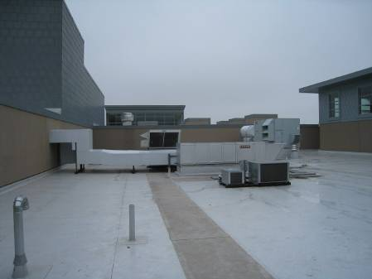

Rooftop AHUs

Picture 2

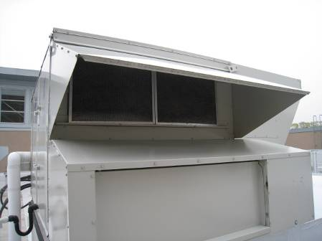

Air Intake for Rooftop AHU

Picture 3

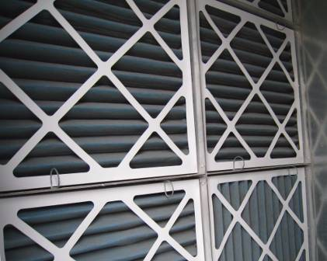

Bank of Pleated Air Filters

Picture 4

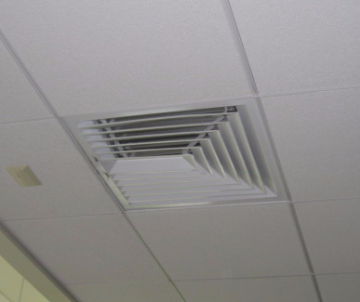

Ceiling-Mounted Air Diffuser

Picture 5

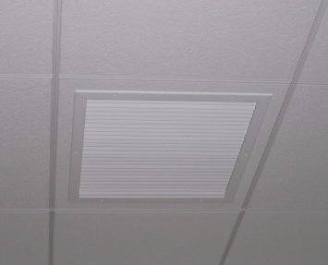

Ceiling-Mounted Return Vent

Picture 6

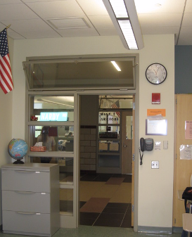

Ceiling-Mounted Return Vent, Note Proximity to Open Transom and Hallway Door

Picture 7

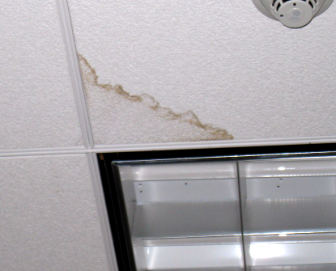

Water Stained Ceiling Tile

Picture 8

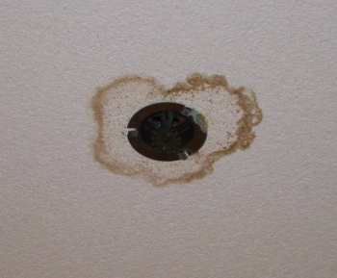

Water Stained Ceiling Tile

Picture 9

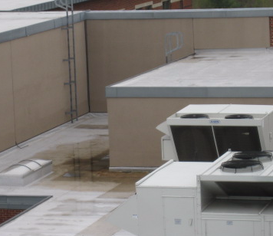

Pooling Water and Clogged Drain near RTU-7

Picture 10

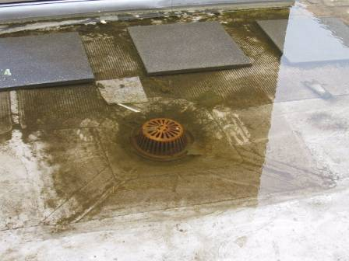

Pooling Water and Clogged Drain near RTU-t

Picture 11

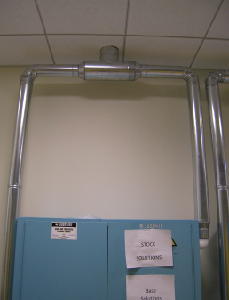

Vented Flammable Cabinet in Science Room B 206

Picture 12

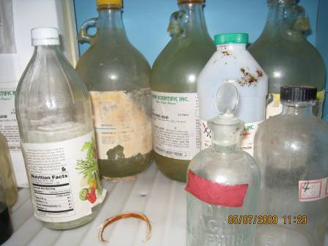

Chemical Storage, Note Damaged Label, Unreadable Label
and Container Marked With Chemical Formula
Picture 13

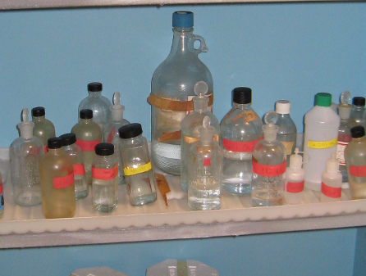

Materials Labeled With Chemical Formula and Sealed with Glass Stoppers
Location/ Room | Occupants  in Room | Temp  (°F) | Relative  Humidity  (%) | Carbon  Dioxide  (ppm) | Carbon Monoxide  (ppm) | PM2.5  (µg/m³) | Windows  Openable | Ventilation |  | Remarks
 |  |  |  |  |  |  |  | Supply | Exhaust | Remarks
background |  | 61 | 90 | 314 | ND | 12 |  |  |  | Cloudy, rainy, cool, winds: 5-16 mph gusts up to 24 mph
Media Center | 12 | 70 | 54 | 680 | ND | 5 | Y | Y | Y | Previous leaks in several areas
A 217 | 0 | 69 | 53 | 694 | ND | 5 | N | Y | Y | Previous leaks, WD CT around sprinkler head
A 209 Storage |  |  |  |  |  |  |  |  |  | Area of previous leaks
A 204 | 28 | 67 | 76 | 607 | ND | 26 | Y | Y | Y | DEM
A 124 Health Suite | 4 | 71 | 63 | 607 | ND | 9 | N | Y | Y
A 129 | 0 | 71 | 62 | 538 | ND | 10 | N | Y | Y
A 218 | 1 | 71 | 57 | 702 | ND | 5 | N | Y | Y
A 132 Speech | 0 | 70 | 57 | 640 | ND | 6 | N | Y | Y | DO
A 135 OT/PT | 8 | 70 | 58 | 751 | ND | 7 | Y | Y | Y | DO
A 136/138 | 8 | 70 | 58 | 751 | ND | 7 | Y | Y | Y
B 202 | 3 | 74 | 55 | 998 | ND | 13 | Y | Y | N | DEM
B 204 | 25 | 72 | 63 | 1252 | ND | 13 | Y | Y | Y | DO
B 206 | 1 | 73 | 57 | 978 | ND | 13 | Y | Y | Y | Flammable Storage Container for Paint
B 124 | 0 | 69 | 53 | 528 | ND | 25 | Y | Y | Y | 26 computers
B 120 | 1 | 69 | 68 | 509 | ND | 21 | Y  open | Y | Y | DO
B122 | 25 | 70 | 55 | 732 | ND | 17 | Y | Y | Y | 26 computers
C111 | 0 | 70 | 67 | 610 | ND | 22 | Y  open | Y | Y
C 201 | 1 | 72 | 53 | 777 | ND | 16 | Y | Y | Y | 1 WD CT, ventilation off
C 115 Boy’s Locker Room | 0 | 69 | 70 | 389 | ND | 27 | Y | Y | Y | Occupants gone 2 minutes
D 138 | 0 | 70 | 56 | 559 | ND | 17 | Y | Y | Y | 25 computers
D 140 | 0 | 69 | 57 | 541 | ND | 29 | Y | Y | Y
D 131 | 26 | 70 | 62 | 780 | ND | 16 | Y | Y | Y
D 129 | 22 | 71 | 59 | 943 | ND | 20 | N | Y | Y
D 206 | 2 | 73 | 61 | 805 | ND | 22 | Y | Y | Y | Window open, 24 computers, PF, DEM, DO
E 218 | 30 | 70 | 67 | 702 | ND | 11 | N | Y | Y | 26 computers, DO
E 301 Dept Head Off | 0 | 68 | 71 | 802 | ND | 9 | N | Y | Y | DO
E 307 | 1 | 68 | 69 | 566 | ND | 9 | N | Y | Y
E 312 Workroom | 0 |  |  |  |  | 21 | N | Y | Y | DO, inter DO, 2 PCs
E 308 | 0 | 69 | 66 | 603 | ND | 9 | N | Y | Y | Ventilation control complaints
E 202 | 3 | 68 | 70 | 601 | ND | 9 | Y | Y | Y | PC, DO
E 210 |  |  |  |  |  | 14 | N | Y | Y | PC, DO
E 212 Office | 1 | 68 | 70 | 568 | ND | 10 | Y | Y | Y | PC, DO
E 215 Office | 1 | 68 | 66 | 575 | ND | 8 | Y | Y | Y | DO, AD, plants
E 122 | 2 | 69 | 63 | 601 | ND | 6 | Y | Y | Y | DO
E 316/317 | 1 | 70 | 66 | 609 | ND | 7 | Y | Y | Y | DO
F 114 | 27 | 69 | 70 | 739 | ND | 8 | Y | Y | Y | Transom Closed; DEM
F 112 | 0 | 68 | 67 | 396 | ND | 9 | Y | Y | Y
F 110 | 27 | 70 | 72 | 874 | ND | 12 | Y | Y | Y | Transom Open
F 108 | 8 | 70 | 70 | 532 | ND | 11 | Y | Y | Y  above door | Transom Closed; DO
F 106 | 4 | 70 | 70 | 432 | ND | 11 | Y | Y | Y  above door | Transom Closed; DO
F 104 | 1 | 69 | 69 | 403 | ND | 11 | Y  open | Y | Y | Transom Open; DO
F 103 | 30 | 70 | 72 | 737 | ND | 15 | Y | Y | Y | Transom open, DEM odors
F 105 | 26 | 70 | 70 | 713 | ND | 14 | Y | Y | Y | Transom open, DO, DEM
F 102 | 2 | 69 | 69 | 454 | ND | 10 | Y | Y | Y  above door | Transom Open; DO
F 109 | 20 | 70 | 71 | 714 | ND | 11 | Y | Y | Y | Transom Open
F 107 | 14 | 70 | 69 | 597 | ND | 11 | Y | Y | Y | Transom Closed
F 301 | 25 | 71 | 71 | 582 | ND | 29 | Y | Y | Y | DO, DEM, transom open, 2 WD CT
F 312 | 0 | 69 | 70 | 391 | ND | 12 | Y | Y | Y | DO; WD CT near window
F 310 | 6 | 70 | 70 | 532 | ND | 11 | Y | Y | Y | Transom Closed; DO
F 309 | 13 | 69 | 69 | 503 | ND | 16 | Y  open | Y | Y | Transom Closed; DO
F 307 | 1 | 69 | 69 | 410 | ND | 14 | Y | Y | Y  above door | Transom Open; DO
F 306 | 1 | 70 | 69 | 439 | ND | 15 | Y  open | Y | Y | Transom Closed; DO
F 308 | 22 | 70 | 70 | 769 | ND | 17 | Y  open | Y | Y | Transom Closed
F 303 | 2 | 70 | 68 | 425 | ND | 16 | Y | Y | Y | Transom Closed; PF
F 304 | 20 | 69 | 76 | 809 | ND | 22 | Y | Y | Y | DEM
F 305 | 7 | 70 | 68 | 507 | ND | 16 | Y | Y | Y | Transom Closed
F 210 | 11 | 70 | 69 | 624 | ND | 18 | Y  open | Y | Y  above door | Transom Open; PF
F 207 | 23 | 71 | 68 | 592 | ND | 20 | Y | Y | Y | Transom Open
F 206 | 14 | 71 | 67 | 531 | ND | 21 | Y | Y | Y | Transom Open; DO
F 208 | 1 | 71 | 67 | 541 | ND | 21 | Y | Y | Y | Transom Open; DO
F 204 | 15 | 71 | 67 | 563 | ND | 22 | Y | Y | Y | Transom Closed; PF
F 203 | 27 | 71 | 67 | 708 | ND | 22 | Y | Y | Y | Transom Closed
F 202 | 22 | 70 | 73 | 709 | ND | 28 | Y | Y | Y | Exhaust vent dusty, transom open, DEM. PF
F 201 | 18 | 71 | 68 | 652 | ND | 24 | Y | Y | Y | Transom Open; DO
F 101 | 21 | 71 | 70 | 828 | ND | 12 | Y | Y | Y | Transom open
F 209 | 5 | 71 | 69 | 743 | ND | 17 | Y | Y | Y | DO
G 207 | 28 | 71 | 68 | 649 | ND | 20 | Y | Y | Y | DO
G 209 | 1 | 69 | 67 | 462 | ND | 22 | Y | Y | Y | Window open
G 210 | 27 | 71 | 69 | 810 | ND | 19 | Y | Y | Y
G 208 | 20 | 71 | 67 | 817 | ND | 20 | Y | Y | Y
G 206 | 19 | 71 | 69 | 908 | ND | 20 | Y | Y | Y
G 204 | 27 | 71 | 68 | 864 | ND | 23 | Y | Y | Y | Transom open
G 201 | 1 | 71 | 66 | 433 | ND | 21 | Y | Y | Y | DO
G 110 | 17 | 70 | 72 | 802 | ND | 12 | Y | Y | Y | DEM
G 108 | 31 | 72 | 71 | 1222 | ND | 13 | Y | Y | Y | DEM, Transom open
G 109 | 27 | 70 | 73 | 1013 | ND | 14 | Y | Y | Y
G 107 | 14 | 70 | 69 | 789 | ND | 16 | Y | Y | Y
G 105 | 23 | 70 | 69 | 700 | ND | 13 | Y | Y | Y
G 106 | 24 | 71 | 69 | 834 | ND | 12 | Y | Y | Y | Transom open
G 104 | 13 | 71 | 67 | 676 | ND | 13 | Y | Y | Y | Exhaust vent dusty, DEM
G 101 | 0 | 69 | 67 | 501 | ND | 11 | Y | Y | Y
G 301 | 24 | 69 | 72 | 787 | ND | 14 | Y | Y | Y | DO
G 303 | 23 | 71 | 70 | 665 | ND | 15 | Y | Y | Y | Transom open
G 305 | 1 | 70 | 68 | 428 | ND | 14 | Y | Y | Y
G 307 | 25 | 70 | 70 | 658 | ND | 16 | Y | Y | Y
G 309 | 10 | 70 | 68 | 548 | ND | 16 | Y | Y | Y | 1 WD CT
G 310 | 7 | 69 | 69 | 473 | ND | 18 | Y | Y | Y
G 308 | 17 | 70 | 70 | 680 | ND | 18 | Y | Y | Y | Window open
G 306 | 30 | 71 | 70 | 880 | ND | 20 | Y | Y | Y | Transom open
G 304 | 23 | 71 | 68 | 693 | ND | 21 | Y | Y | Y | Transom open
G 302 | 1 | 70 | 67 | 446 | ND | 22 | Y | Y | Y | Cold complaints, transom open
G 203 | 20 | 70 | 69 | 624 | ND | 18 | Y | Y | Y
Main Office outside A117 | 2 | 70 | 61 | 632 | ND | 10 | N | Y | Y
Auditorium | 20 | 70 | 51 | 562 | ND | 21 | N | Y | Y
Gym | 20 | 72 | 55 | 848 | ND | 16 | Y | Y | Y | Ventilation off
Cafeteria | ~ 200 | 71 | 63 | 815 | ND | 21 | Y | Y | Y
Second Fl D-wing boys restroom |  |  |  |  |  | 253 |  |  | Y | Smoking in the boys room
Kiln Room |  |  |  |  | ND | 20 | N | Y | Y | Dedicated local exhaust
H 303 | 31 | 67 | 76 | 555 | ND | 18 | Y | Y | Y
H 305 | 15 | 68 | 75 | 529 | ND | 15 | Y | Y | Y | DEM odors
H 310 Sci Prep |  |  |  |  |  | 15 | Y | Y | Y
H 306 Sci Prep |  |  |  |  | ND | 18 | Y | Y | Y
H 304 | 24 | 67 | 77 | 632 | ND | 19 | Y | Y | Y | DEM, DO.
H 307 Sci Prep |  |  |  |  | ND | 16 | Y | Y | Y | 1 WD CT, DO
H 302 | 0 | 66 | 77 | 384 | ND | 17 | Y | Y | Y | PF, DEM
H 301 | 0 | 67 | 77 | 431 | ND | 17 | Y | Y | Y
H 202 | 26 | 68 | 76 | 666 | ND | 27 | Y | Y | Y | DEM
H 205 | 12 | 67 | 72 | 415 | ND | 25 | Y | Y | Y | Cleaners, DEM, plants, PF
H 201 | 25 | 67 | 75 | 615 | ND | 28 | Y | Y | Y | DEM
H 203 | 23 | 67 | 75 | 547 | ND | 25 | Y | Y | Y | PF, DEM
H 101 | 31 | 68 | 74 | 586 | ND | 20 | Y | Y | Y | DO, DEM, accumulated items
H 104 | 31 | 68 | 76 | 688 | ND | 24 | Y | Y | Y | Chemical hood, projects stored, clutter
H 106 | 25 | 68 | 74 | 631 | ND | 20 | Y | Y | Y | DEM, DO.
Chem Room |  |  |  |  |  |  |  |  | Y | Bottles labeled by formulas, cabinets vented

