INDOOR AIR QUALITY ASSESSMENT

Bridgewater-Raynham Regional High School
Guidance Office Area
415 Center Street
Bridgewater, Massachusetts

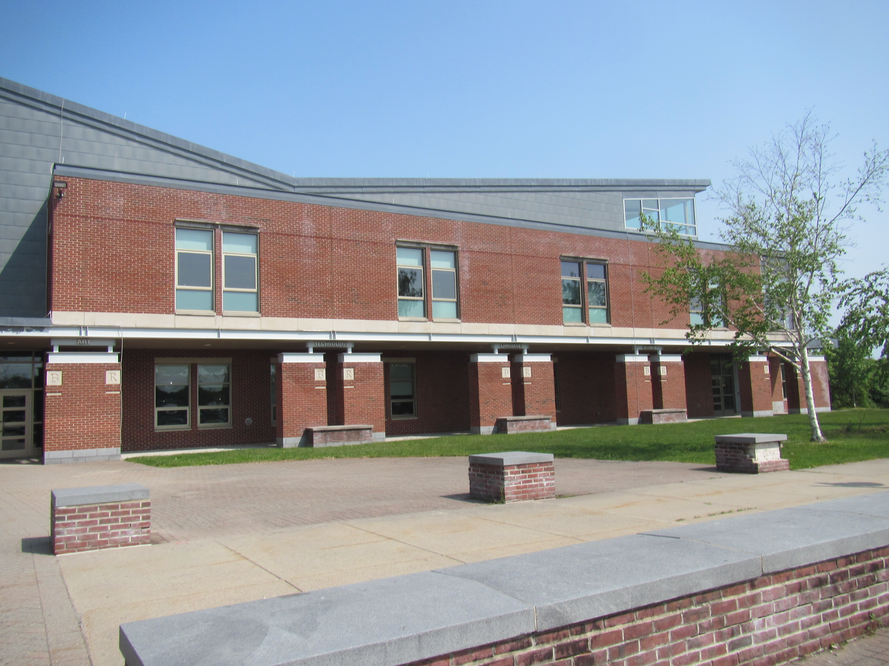

Prepared by:
Massachusetts Department of Public Health
Bureau of Environmental Health
Indoor Air Quality Program
June 2023

BACKGROUND
Building: | Bridgewater-Raynham Regional High School (BRRHS)
Address: | 415 Center St, Bridgewater, MA
Assessment Requested by: | Thomas Killgoar, Director of Facilities  Bridgewater - Raynham Regional School District
Reason for Request: | Allergy symptoms and general indoor air quality (IAQ) concerns in the Guidance Suite
Date of Assessment: | May 22, 2023
Massachusetts Department of Public Health/Bureau of Environmental Health (MDPH/BEH) Staff Conducting Assessment: | Ruth Alfasso, Environmental Engineer/Inspector, IAQ Program
Date of Building Construction: | Building was constructed in the mid-2000s.
Building Description: | The BRRHS is a large brick building with a complex shape, multiple stories, and a series of flat roof segments. The guidance office is a small suite of rooms on the first floor near the front entrance containing offices, workrooms, and an open area that serves as a library and classroom.
Windows: | Some windows are openable in the guidance suite.

METHODS
Please refer to the IAQ Manual and appendices for methods, sampling procedures, and interpretation of results (MDPH, 2015).
Note that this building was visited by the BEH/IAQ program in 2009 and 2017. The reports from those visits are available on the MDPH website at https://www.mass.gov/info-details/indoor-air-quality-reports-cities-and-towns-b#bridgewater-.

RESULTS AND DISCUSSION
The following is a summary of indoor air testing results (Table 1).
- Carbon dioxide levels were below the MDPH recommended level of 800 parts per million (ppm) in all areas assessed, indicating adequate fresh air.
- Temperature was within the MDPH recommended range of 70°F to 78°F in all areas assessed.
- Relative humidity was within the MDPH recommended range of 40 to 60% in all areas assessed.
- Carbon monoxide levels were non-detectable (ND) in all areas tested.
- Particulate matter (PM2.5) concentrations measured were below the National Ambient Air Quality (NAAQS) level of 35 μg/m³ in all areas tested.

Ventilation
A heating, ventilating and air conditioning (HVAC) system has several functions. First it provides heating and, if equipped, cooling. Second, it is a source of fresh air. Finally, an HVAC system will dilute and remove normally-occurring indoor environmental pollutants by not only introducing fresh air, but by filtering the airstream and ejecting stale air to the outdoors via exhaust ventilation. Even if an HVAC system is operating as designed, point sources of respiratory irritation may exist and cause symptoms in sensitive individuals.
Fresh air is provided by rooftop air handling units (AHU) and delivered to the space through ceiling-mounted ducted supply vents (Picture 1). Air is removed through ceiling-mounted ducted return vents (Picture 2). Facility staff report that the HVAC system in the building has been set for a minimum of 20% outside air. The guidance suite HVAC system is equipped with cooling as well as heating and was operating in cooling mode in the guidance suite at the time of the assessment. Facility staff report that good quality, pleated filters are installed in the AHU and are changed regularly.
The Minimum Efficiency Reporting Value (MERV) rating of the existing filters was not available at the time of the assessment, but facility staff report that high efficiency particulate arrestance (HEPA) filters would be installed in the specific AHU serving the guidance suite to attempt to address staff concerns about allergy symptoms. Facility staff also report that the ducts in this area of the building were examined recently by a contractor; they were not in need of cleaning at the time and no other conditions were reported that could negatively impact IAQ.
Some staff reported concerns about drafts. Facility staff reported that they plan to move or replace the ceiling-mounted supply vents to direct fresh air away from staff. Drafts can be a source of temperature complaints, noise complaints, and may lead to drying of mucous membranes and lead to eye or respiratory irritation under some conditions.
Several portable air purifiers were located in the office suite (Picture 3). The units examined appear to have HEPA filtration and some also have a carbon filter which are good choices for occupied areas. Air purifiers should be cleaned and maintained in accordance with manufacturer’s instructions. For best results, air purifiers should be located at the level of the breathing zone and directed so that the clean air delivery is directed towards people. Air purifiers that may produce ozone or release other chemicals should not be used in occupied spaces (US EPA, 2003).
To maximize air exchange, the IAQ program recommends that both supply and exhaust ventilation operate continuously during periods of occupancy. To have proper ventilation with a mechanical ventilation system, the systems must be balanced after installation to provide an adequate amount of fresh air to the interior of a room while removing stale air from the room. It is recommended that HVAC systems be re-balanced every five years to ensure adequate air systems function (SMACNA, 1994).
While the relative humidity at the time of the assessment was within the MDPH IAQ comfort range (Table 1), low relative humidity conditions may sometimes occur, particularly during the colder months where dry outside air is heated, decreasing relative humidity further. Low relative humidity is irritating to the eyes, skin, and respiratory tract, and can enhance the irritant effects of other indoor air contaminants (Lstiburek, 2002). However, the MDPH IAQ program does not recommend the use of humidifying equipment in general purpose spaces as humidity can be difficult to control, humidification may lead to condensation and microbial growth, and humidifying equipment may be a source of microbial contamination and odors if not scrupulously maintained. Drinking water during the day is recommended to reduce the impacts of low relative humidity.

Microbial/Moisture Concerns
Water-damaged ceiling tiles were observed in a few areas (Picture 4; Table 1). These reportedly result from leaks from the sprinkler system which has been an ongoing issue in this building. While all the tiles appeared dry, and none appeared to have mold colonization, water-damaged ceiling tiles should be replaced once a leak has been found and repaired.
The exterior of the building outside the guidance suite was examined for potential sources of moisture and irritants. The BRRHS is located adjacent to a heavily wooded area, however, the landscaping next to the building is kept short. Some of the sealant around the windows into the guidance suite is worn and peeling (Picture 5). This could allow unconditioned air into the building and lead to water damage to the building envelope.

Other Conditions
A few missing and ajar ceiling tiles were observed in some areas (Table 1). These breaches can provide a pathway for dust, debris, and particulates from the ceiling plenum into occupied areas, which can be a source of eye, skin, or respiratory irritation.
Most areas were carpeted (Table 1). Carpeting should be vacuumed regularly with a HEPA-filter-equipped vacuum cleaner to avoid particulates from causing further irritation or serving as a reservoir for microbial colonization. Also, carpeting and rugs should be cleaned at least once per year according to IICRC recommendations (IICRC 2012). The carpeting in the guidance suite was reportedly deep cleaned by a restoration contractor within the last two months. Carpeting examined appeared to be in good condition.
Exposure to low levels of total volatile organic compounds (TVOCs) may produce eye, nose, throat, and/or respiratory irritation in some sensitive individuals. BEH/IAQ staff examined rooms for products containing VOCs. BEH/IAQ staff noted hand sanitizers and dry erase materials in use within the building. These products have the potential to be irritants to the eyes, nose, throat, and respiratory system of sensitive individuals.

RECOMMENDATIONS
In view of the findings at the time of the visit, the following recommendations are made:

Ventilation Recommendations
- Continue to operate all supply and exhaust ventilation equipment continuously during occupied hours.
- Continue to change AHU filters regularly. If HEPA filters are installed into the
AHU serving the guidance department, monitor to ensure the system is capable of operating with those more restrictive filters.
- Ensure all supply and exhaust/return vents are free of obstructions to facilitate airflow. If drafts are a concern, relocate vents or change to a style with directional vanes away from occupants. Occupants can also rearrange furniture to avoid excess airflow.
- Clean the interior of AHUs during regular filter changes using a HEPA-filtered vacuum cleaner with brush attachment or compressed air.
- For buildings in New England, periods of low relative humidity during the winter are often unavoidable. Therefore, scrupulous cleaning practices should be adopted to minimize common indoor air contaminants whose irritant effects can be enhanced when the relative humidity is low. To control dusts, a high efficiency particulate arrestance (HEPA) filter equipped vacuum cleaner in conjunction with wet wiping of all surfaces is recommended. Avoid the use of feather dusters. Drinking water during the day can help ease some symptoms associated with a dry environment (throat and sinus irritations).

Water Damage Recommendations
- Continue to repair sprinkler leaks as needed. Replace water-damaged ceiling tiles after leaks have been repaired.
- Repair window sealant.

Other Recommendations
- Reduce use of products and equipment that create irritating volatile organic compounds (VOCs) and only use in well-ventilated areas. Avoid using any air fresheners, deodorizers and scented products.
- Change filters and maintain portable air purifiers/HEPA units in accordance with manufacturers’ recommendations. Avoid using any portable air purifiers that could produce ozone.
- Replace missing and/or broken suspended ceiling tiles.
- Clean carpeting annually or semi-annually in soiled high traffic areas as per the recommendations of the Institute of Inspection, Cleaning and Restoration Certification (IICRC, 2012).
- Consider forming an IAQ committee in each school building district wide. Committees should have an IAQ liaison/teacher representative, a member of maintenance/facilities and administration that conduct regular walk-throughs to identify on-going and/or potential environmental issues.
- Utilize the US EPA’s (2000), “Tools for Schools”, as an instrument for maintaining a good IAQ environment in the building available at: https://www.epa.gov/iaq-schools.
- For guidance on maintaining an asthma-friendly healthy school environment, please consult the MDPH Asthma Prevention and Control Program’s Clearing the Air: An Asthma Toolkit for Healthy Schools.
- Refer to resource manual and other related IAQ documents located on the MDPH’s website for further building-wide evaluations and advice on maintaining public buildings. These documents are available at: http://mass.gov/dph/iaq.

REFERENCES
ASHRAE. 2012. American Society of Heating, Refrigeration and Air Conditioning Engineers (ASHRAE) Standard 52.2-2012 -- Method of Testing General Ventilation Air-Cleaning Devices for Removal Efficiency by Particle Size (ANSI Approved).
IICRC. 2012. Institute of Inspection Cleaning and Restoration Certification. Institute of Inspection, Cleaning and Restoration Certification. Carpet Cleaning: FAQ.
Lstiburek, J. 2002. RR-0203: Relative Humidity. Building Science Corporation, Westford, MA. https://www.buildingscience.com/documents/reports/rr-0203-relative-humidity/view
MDPH. 2015. Massachusetts Department of Public Health. Indoor Air Quality Manual: Chapters I-III. Available at: Indoor air quality – manual and appendices | Mass.gov
SMACNA. 1994. HVAC Systems Commissioning Manual. 1st ed. Sheet Metal and Air Conditioning Contractors’ National Association, Inc., Chantilly, VA.
US EPA. 2003. “Ozone Generators that are Sold as Air Cleaners: An Assessment of Effectiveness and Health Consequences”. United States Environmental Protection Agency, Office of Air and Radiation, Indoor Environments Division, Washington, DC. Last updated September, 2018. https://www.epa.gov/indoor-air-quality-iaq/ozone-generators-are-sold-air-cleaners
US EPA. 2000. Tools for Schools. Office of Air and Radiation, Office of Radiation and Indoor Air, Indoor Environments Division (6609J). EPA 402-K-95-001, Second Edition. https://www.epa.gov/iaq-schools.
Picture 1
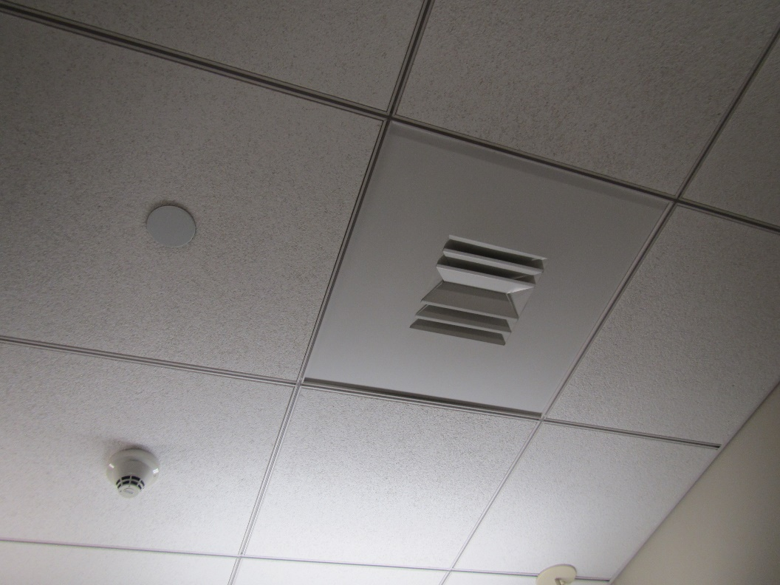
Typical supply vent in the guidance suite; note two-directional vanes
Picture 2
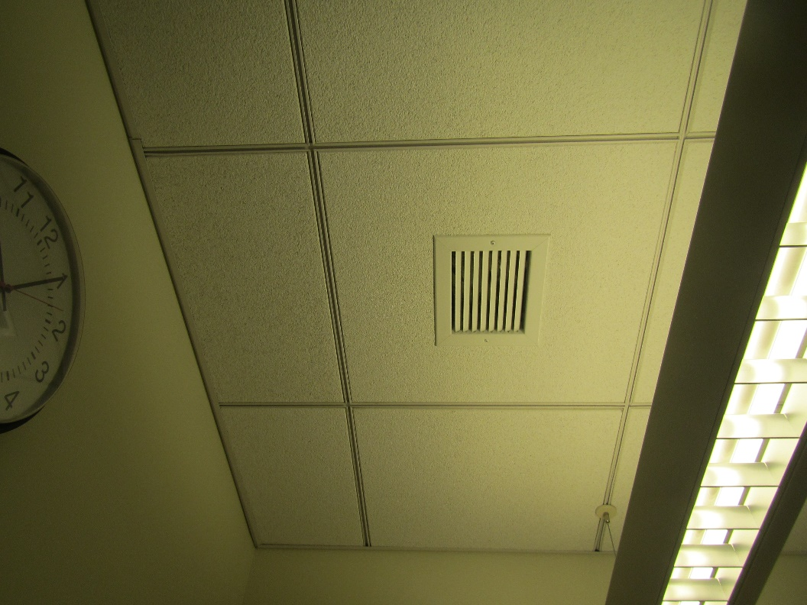
Typical return vent in the guidance suite
Picture 3
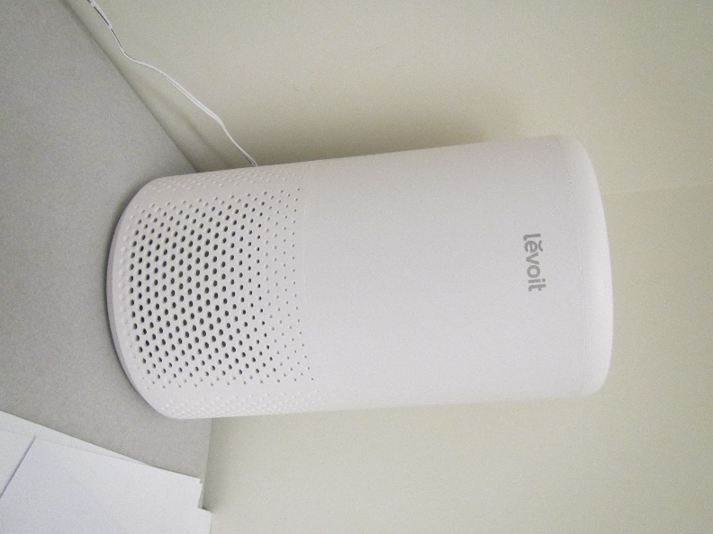
One style of air purifier; this unit has a HEPA filter and carbon filter
Picture 4
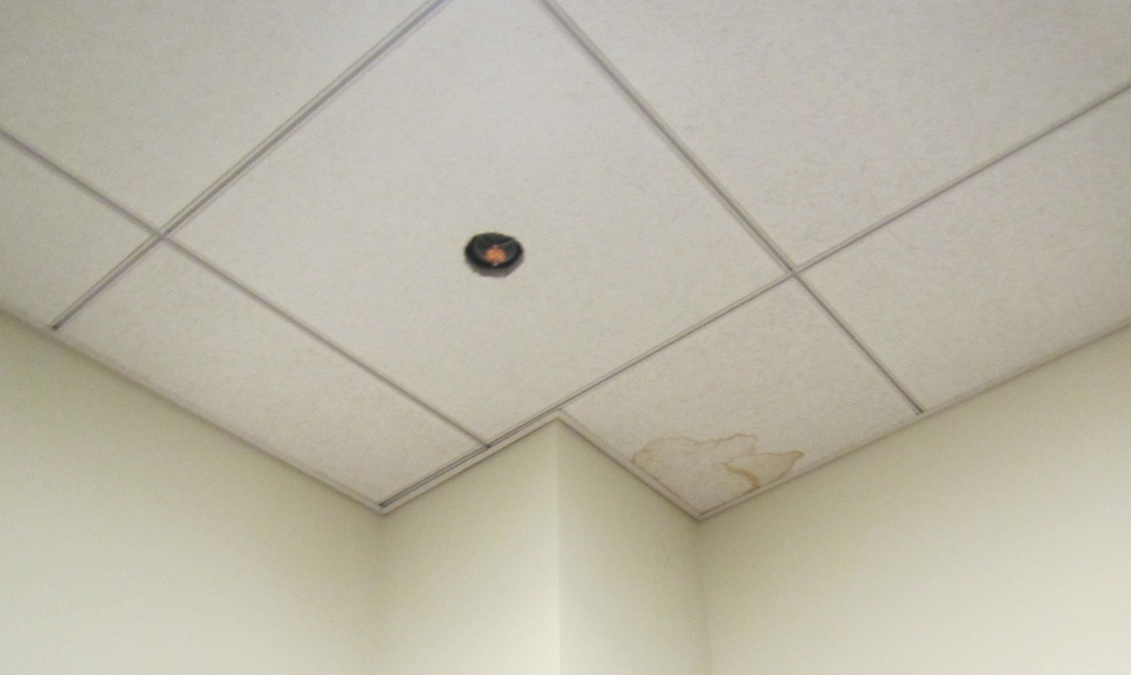
Water-damaged ceiling tile near sprinkler head
Picture 5
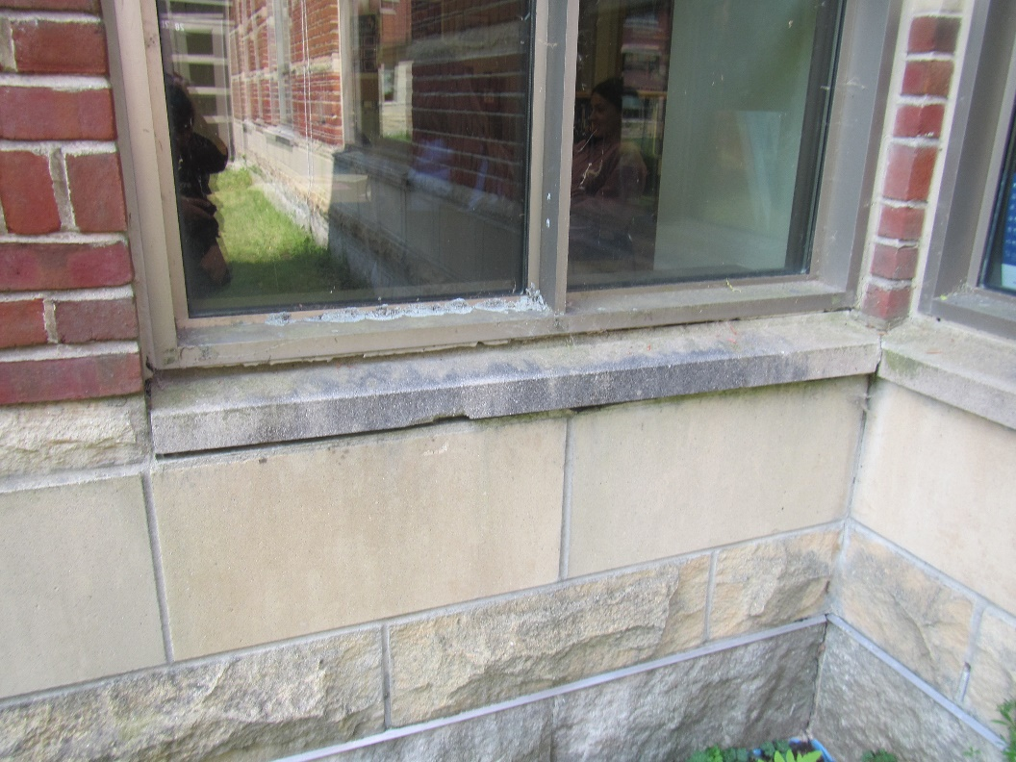
Damaged window sealant and lichen growth on window frame
Location | Carbon  Dioxide  (ppm) | Carbon Monoxide  (ppm) | Temp  (°F) | Relative  Humidity  (%) | PM2.5  (µg/m³) | Occupants  in Room | Windows  Openable | Ventilation |  | Remarks
 |  |  |  |  |  |  |  | Intake | Exhaust
Background | 369 | ND | 68 | 42 | 9 |  |  |  |  | Sunny and breezy
A152 | 567 | ND | 73 | 46 | 3 | 3 | Y | Y | Y | Carpet
A151 | 568 | ND | 72 | 46 | 1 | 0 | N | Y | Y | Carpet
A150 storage/files | 541 | ND | 72 | 47 | 4 | 0 | N | Y | Y
Reception area | 573 | ND | 71 | 48 | 3 | 3 | N | Y | Y | Carpet, books, HS, WD CT
A143 | 552 | ND | 71 | 48 | 3 | 0 | N | Y | Y | Carpet, AP
A142 | 571 | ND | 72 | 47 | 4 | 1 | N | Y | Y | HS, carpet
A141 | 592 | ND | 72 | 46 | 3 | 0 | N | Y | Y | Carpet, items
A137 | 559 | ND | 72 | 47 | 3 | 1 | N | Y | Y | Artificial plants, salt lamp, carpet
Open Classroom Area | 586 | ND | 71 | 47 | 2 | 16 | Y | Y | Y | Carpet, HS
Files/Storage | 576 | ND | 71 | 48 | 4 | 0 | N | Y | Y | Not carpeted, 1 WD CT
A149 Conference/  Lounge | 468 | ND | 70 | 47 | 4 | 0 | N | Y | Y | Carpet, DEM, HS, microwave, fridge
A136 | 574 | ND | 70 | 46 | 3 | 1 | Y | Y | Y | Carpet, missing ceiling tile, food

