INDOOR AIR QUALITY ASSESSMENT

Maxwell Library
Bridgewater State University
10 Shaw Road
Bridgewater, MA

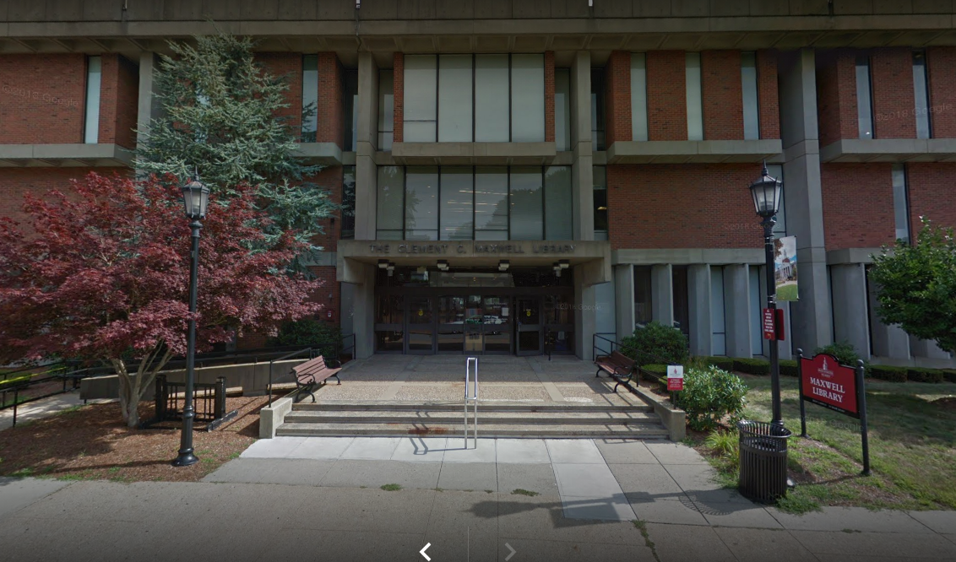

Prepared by:
Massachusetts Department of Public Health
Bureau of Environmental Health
Indoor Air Quality Program
October 2021

Background
Building: | Maxwell Library (ML) at Bridgewater State University (BSU)
Address: | 10 Shaw Road, Bridgewater, MA
Assessment Requested by: | Karen Jason, Director for Operations,  BSU
Reason for Request: | General indoor air quality (IAQ) and water damage concerns.
Date of Assessment: | September 28, 2021, and September 30, 2021
Massachusetts Department of Public Health/Bureau of Environmental Health (MDPH/BEH) Staff Conducting Assessment: | Michael Feeney, Director, and Ruth  Alfasso, Environmental Engineer, IAQ  Program
Building Description: | The ML is a concrete and brick  building with three stories above  ground and an occupied basement. The  library contains book stacks,  classrooms, study areas, offices and  accessory areas. There is a café on the  lowest level. The building was  originally constructed in the early  1970s.
Windows: | Not openable

Methods
Please refer to the IAQ Manual for methods, sampling procedures, and interpretation of results (MDPH, 2015).

IAQ Testing Results
The following is a summary of indoor air testing results (Table 1).
- Carbon dioxide levels were below the MDPH guideline of 800 parts per million (ppm) in most areas surveyed. However some areas with high occupancy, such as full classrooms, had readings above 800 ppm indicating they need more fresh air.
- Temperature was within the recommended range of 70°F to 78°F in all areas tested.
- Relative humidity was above the recommended range of 40 to 60% in the areas tested.
- Carbon monoxide levels were non-detectable (ND) in all areas tested indoors.
- Fine particulate matter (PM2.5) concentrations measured were below the National Ambient Air Quality (NAAQS) limit of 35 μg/m³ in all areas tested.

Ventilation
A heating, ventilating and air conditioning (HVAC) system has several functions. First it provides heating and, if equipped, cooling. Second, it is a source of fresh air. Finally, an HVAC system will dilute and remove normally-occurring indoor environmental pollutants by not only introducing fresh air, but by filtering the airstream and ejecting stale air to the outdoors via exhaust ventilation. Even if an HVAC system is operating as designed, point sources of respiratory irritation may exist and cause symptoms in sensitive individuals.
Fresh air is provided by air handling units (AHUs) located in mechanical rooms on the lower level and top floor. Fresh air is drawn from vents at the front of the building (Picture 1), heated or cooled as needed, and supplied to rooms and common areas via ducts to ceiling mounted supply vents (Picture 2). Additional heating is supplied by radiators, typically located along the outside edge of the building (Picture 3). Return air is drawn into ceiling-mounted vents and brought back to AHUs.
The assessment results indicate that the ventilation system is providing adequate fresh air for the current occupancy in most areas. In some highly-occupied offices and classrooms, additional fresh air and exhaust ventilation is recommended (Table 1).
It is important to note that HVAC systems are designed to heat and cool a predetermined volume of air drawn from outdoors via fresh air intakes installed in AHUs. If the volume of air is added to the interior of a building that is not part of the HVAC system from outdoors (known as unconditioned air) the ability of the HVAC system to maintain heating and cooling consistently will be impaired. Such a condition exists at the ML.
Of note regarding the volume of air conditioned by the HVAC system is the designs of exterior doors in the ML. The building has a main entrance and two other entrance doors on the west side of the building. All three of these entrances have an outer and inner door, which can limit air from outdoors from entering the ML. The rear of the building has two additional doors at the base of stairwells. After initial construction, the stairwell doors were likely redesigned as universal access doors with the installation of automatic door openers. Access doors that lead into the ground floor from the stairwell are typically pegged open. During both days of this visit, the rear stairwell doors were in constant use by patrons accessing library services as well as a coffee vending stand located on the ground floor. The use of the stairwell doors results in significant amounts of unconditioned air entering the ML to be captured by the HVAC system and then redistributed throughout the building, which significantly reduces air chilling control during hot, humid weather. If the same use pattern of the stairwell doors exists during cold weather months, heat control would also become difficult due to the introduction of large volume of cold, unconditioned air.
It is recommended that HVAC systems be re-balanced every five years to ensure adequate air systems function (SMACNA, 1994). It is unknown when the last time these systems were balanced.

Microbial/Moisture Concerns
Concerns regarding moisture and microbial growth were one of the reasons for this assessment. IAQ staff did not observe mold growth or detect musty odors in the ML, nor was any microbial growth seen during spot checks of books in stacks throughout the building. ML staff did report that a number of books were discarded as part of the ongoing remediation process, which had begun prior to IAQ staff visits.
IAQ staff visited the ML on September 28, 2021, when outdoor relative humidity was measured at 78% (Table 1). Relative humidity indoors ranged from 64-73% on floor 1-3 (Table 1) and 70-76% on the ground floor, apart from the Testing Lab that appeared to have an air chilling device separate from the general HVAC system (Tables 1 and 2). IAQ staff returned on September 30, 2021, when outdoor relative humidity was measured at 43% (35% lower than during the first visit). During the second visit, indoor relative humidity measurements were in a range of 45-50% (Table 3). Based on these observations, weather condition played a prominent role in raising indoor relative humidity.
As noted above, at the time of the initial visit, indoor relative humidity was consistently above the MDPH IAQ comfort level of 60%, and in many areas was above 70%. Elevated relative humidity reduces the ability of the human body to regulate temperature through perspiration and can lead to increased discomfort even if the temperature is in a comfortable range. Excess humidity can also be a source of water vapor to moisten building materials and stored materials.

Building materials prone to condensation
The key to managing condensation in hot, humid weather indoors is understanding dew point. When warm, moist air passes over a cooler surface, condensation can form. Condensation is the collection of moisture on a surface at or below the dew point. The dew point is the temperature that air must reach for saturation to occur. If a building material/component has a temperature below the dew point, condensation will accumulate on that material. Over time, condensation can collect and form water droplets.
A method to locate areas in a building prone to condensation (floors and walls in direct contact with soil on the ground floor) is to measure air and building material temperatures using a laser thermometer (Table 2). If a wide temperature range exists between measurements, the building materials at the colder end of the range may be prone to becoming moistened with condensation if exposed to hot, humid weather for extended periods of time. According to the test results in Table 2, a number of rooms on the lowest level of the ML had surface temperatures that were either at or below the dew point and would be moistened with condensation. The ground floor areas would appear to be prone to condensation if exposed to hot, humid weather for extended periods of time as noted previously.
According to American Society of Heating, Refrigerating and Air-Conditioning Engineers (ASHRAE), if relative humidity exceeds 70% for extended periods of time, mold growth may occur due to wetting of building materials even in the absence of liquid water droplets (ASHRAE, 1989). It is recommended that porous material be dried with fans and heating within 24 to 48 hours of becoming wet (US EPA, 2008, ACGIH, 1989). If porous materials are not dried within this time frame, mold growth may occur. Water-damaged porous materials cannot be adequately cleaned to remove mold growth.

Sources of moisture to the building interior
The main source of excess indoor humidity in this building is from high outdoor relative humidity. It is important to note that Massachusetts has experienced extended periods of relative humidity during the summer of 2021. This July was the wettest ever recorded in Massachusetts, and the three-month period from June through August, known as the meteorological summer, was tied for the warmest on record across the United States (HG, 2021) and the fourth wettest on record, according to the National Oceanic and Atmospheric Administration’s Centers for Environmental Information. The three-month period also was the third warmest (NOAA, 2021).
This weather resulted in a number of buildings having condensation problems in below-grade space with wall or floors in direct contact with soil or cement slab floors. In these instances, the floors in direct contact with soil may have temperatures that would result in condensation wetting floors in high relative humidity conditions.
This humid air is drawn into the HVAC system where the air conditioning can reduce humidity levels. However, due to the size of the building and the construction/age of the HVAC system, only a small reduction in humidity can be achieved. When outdoor humidity is high for a significant period of time, like it has been over the summer of 2021, indoor humidity can rise to uncomfortable levels and stay elevated.
A significant source of relative humidity entering the building is the stairwell doors noted in the Ventilation section of this report. As noted previously, the stairwell doors are not equipped with a large vestibule area, and the inner door is reported to be pegged open to the hallway (Picture 4). A stairwell to the upper floors is also situated in the door area. During the assessment, a large number of people were seen passing through these doors in both directions, making these doors a large source of moist air directly into the lower level of the building as well as through the stairwells to upper floors. In addition, at the time of the visit, there were fans being used to bring in additional ventilation in hallways served by these doors, which will increase the infiltration of humid air from outside. Water entrained on shoes and clothing during rainstorms is also brought into the building through these doors. The hallway adjacent to the doors on the lower level was visibly wet on the day of the visit (Picture 5). It was not known whether this was primarily due to condensation or water entrainment, but both show that excess humidity is a potential issue on this lower level due to weather and building configuration.
An additional potential source of humidity is the coffee vendor in the common area on the lower level. If inadequate direct-vented exhaust is not supplied to this area to remove water vapor and odors from cooking, this excess moisture will linger. If exhaust ventilation is not balanced with sufficient make-up air from the conditioned supply, the difference in pressure may drive the infiltration of unconditioned air through the doors as described above.
The exterior of the building was examined. In some locations, trees were close to or overhanging the building (Picture 6), which can reduce the ability of the building envelope to dry. Trees can also be a source of debris which can clog gutters and roof drains. The roof of the building is flat with a rubber membrane. The roof membrane appeared to be in fair condition. Some areas of the roof appear to have sagged lower than the roof drains (Pictures 6 through 8) leading to water pooling on the roof. Debris was also noted on the roof (Picture 8), which can lead to clogging of drains and damage to the membrane. Scuppers from the roof did not appear overloaded. Ensuring that the roof is in good condition will reduce the potential for water leaks inside.
No evidence of water leaks to the building interior was noted during the visit. No ceiling stains, either of ceiling concrete or suspended ceiling tiles were noted in the building. There was also no evidence of water leaking through windows, which has been noted in buildings with similar construction.

Other water-related issues
In an effort to reduce humidity on all floors of the building, large portable dehumidifiers were in use in the building (Picture 9). Dehumidifiers can be an effective way to further reduce humidity. They should be used whenever the outdoor humidity or indoor conditions warrant it. During the heating season, humidity levels are likely to drop, dehumidification will no longer be needed, and these units should be removed until they are needed again. Levels of humidity that are too low can lead to feelings of dryness and irritation of skin and the respiratory tract and may increase the potential for irritation from dusts and other materials. The dehumidifiers in use collect water into a receptacle such as a plastic trash can. To ensure that these vessels do not become a source of moisture and odors, they need to be emptied and cleaned regularly, including any attached hoses.
Plants were observed in several offices (Picture 10), including some placed directly on radiators. Plants should be well maintained, not overwatered and kept away from the airstream of ventilation equipment to prevent odors, water damage, and pests.
Water coolers and small refrigerators were noted in carpeted areas (Picture 11). These appliances can spill or leak and damage carpeting. Wherever possible, water coolers, refrigerators and similar items should be located in non-carpeted areas or on waterproof mats.

Other IAQ Evaluations
Exposure to low levels of total volatile organic compounds (TVOCs) may produce eye, nose, throat, and/or respiratory irritation in some sensitive individuals. To determine if VOCs were present, BEH/IAQ staff examined rooms for products containing VOCs. BEH/IAQ staff noted cleaners, hand sanitizers, air fresheners and other products in use within the building (Table 1). All of these products have the potential to be irritants to the eyes, nose, throat, and respiratory system of sensitive individuals.
Cooking equipment, including microwave ovens, and coffee machines, were located in various offices and common areas (Table 1). Food such as bowls of fruit and candy were found during the assessment. Food areas and cooking equipment need to be kept clean, and food should not be left in the open during unoccupied periods, to prevent odors and pests.
In a few areas, stored materials and accumulated items make it more difficult for custodial staff to clean. Items should be stored neatly and moved periodically to allow for wet-wiping and vacuuming of surfaces. Items should also not be stored on top of radiators or in the airstream of ventilation equipment as heating and moving air can cause items to release dusts and odors.
Some supply and return/exhaust vents were dusty at the time of the visit. Thorough cleaning of ventilation equipment surfaces should be conducted during the year. Personal fans also had settled dust, which can be reaerosolized when the fan is activated.
Air purifiers were noted in some areas, including both larger building-supplied units and smaller units in individual offices. These units need to be maintained in accordance with manufacturers’ instructions including cleaning and any filter changing. Air purifiers that produce ozone should not be used in occupied areas.
Most offices were carpeted. Carpets and area rugs should be vacuumed regularly with a high efficiency particulate air (HEPA)-filter-equipped vacuum cleaner and cleaned annually (or semi-annually in soiled/high traffic areas) in accordance with Institute of Inspection, Cleaning and Restoration Certification (IICRC) recommendations (IICRC, 2012).
Fabric covered furniture was also present in many common areas. Items such as chairs and couches need to be cleaned periodically to remove the build-up of dust, dirt and debris.

Conclusions/Recommendations
The ML has a number of issues related to moisture in the building. The capacity of mechanical ventilation equipment to provide adequate chilled air and reduce relative humidity indoors is limited. It is important to note that during the extreme relative humidity and rain of this summer, management of buildings in such weather conditions can be challenging. The following documents can provide guidance that can be used to reduce the impact of hot, humid weather in buildings.
- Preventing mold growth in Massachusetts schools during hot, humid weather: https://www.mass.gov/service-details/preventing-mold-growth-in-massachusetts-schools-during-hot-humid-weather
- Remediation and prevention of mold growth and water damage in public schools and buildings to maintain air quality: https://www.mass.gov/service-details/remediation-and-prevention-of-mold-growth-and-water-damage-in-public-schools-and
- Methods for Increasing Comfort in Non-Air-Conditioned Schools: https://www.mass.gov/doc/methods-for-increasing-comfort-in-non-air-conditioned-schools/download
It is also important to note that the use as well as design of the building has been altered since its original construction. The conversion of the rear stairwell doors combined with the increased foot traffic created by the ground level coffee vendor results in significant foot traffic through the rear ground level entrances instead of the other front and side entrance exterior doors.
To address building problems, two sets of recommendations are made: short-term measures that may be implemented as soon as practicable and long-term measures that will require planning and resources to address overall IAQ concerns. In view of the findings at the time of the visit, the following recommendations are provided:

Short Term Recommendations

Ventilation recommendations
- Continue to operate supply and exhaust ventilation continuously in all areas during occupied periods. Ensure all HVAC equipment is cleaned/maintained in accordance with manufacturer’s instructions including filter changes. Avoid placing items, especially plants, on top of radiators.
- Work with an HVAC contractor to determine if additional fresh air can be supplied to highly occupied classrooms.
- Ensure that exhaust ventilation in the coffee shop area is adequate to remove water vapor and odors from cooking, and that sufficient conditioned make-up air is being supplied.
- Have the HVAC system balanced every 5 years in accordance with SMACNA recommendations (SMACNA, 1994).
- The U.S. Department of Education has released new guidance encouraging the use of American Rescue Plan (ARP) funds to improve ventilation systems and make other indoor air quality improvements in schools. More information can be found at this link https://www.ed.gov/coronavirus/improving-ventilation.

Water-damage recommendations
- Work with an HVAC contractor to determine if the HVAC system can be operated or modified to provide additional dehumidification while in chilling mode.
- Consider methods to reduce the amount of outside air brought into the building through the doors on the lower level, including:
  - Using heavy-duty plastic sheeting to create a temporary “airlock” for the entry hall.
  - Reducing access to these doors,
  - Installation of an add-on vestibule area for each door,
  - Avoid using fans to bring in unconditioned outside air on days with heavy rain or high humidity,
  - Add additional walk-off mats to help capture water from shoes and clothes. Clean any such mats frequently to prevent odors.
- Continue to use dehumidifiers in the building until outdoor conditions are cooler and drier and building heating is being used.
- Maintain all dehumidifiers and regularly remove water and clean receptacles to avoid stagnant water, odors, and the potential for leaks.
- Trim trees and plants away from the building at last 5 feet and remove any overhanging branches to protect the roof and roof drains.
- Repair the roof to improve drainage where possible.
- Inspect the roof periodically, and remove debris, to ensure the membrane is in good condition and the drains are operating.
- Avoid storing porous materials on the floor, particularly on the lower level, to avoid moistening through condensation.
- Consider the use of waterproof mats underneath all water dispensers and refrigerators to protect carpet. Keep refrigerators clean.
- Keep indoor plants in good condition, avoid overwatering, and keep them away from on top of radiators and the airstream of ventilation equipment.
- Consider the use of waterproof mats underneath all water dispensers and refrigerators to protect carpet. Keep refrigerators clean.
- Remediate any water-damaged building materials in accordance with the EPA guideline “Mold Remediation in Schools and Commercial Buildings” (US EPA, 2008). Clean non-porous water-stained surfaces, including walls and floors and remove any debris. Discard water-damaged porous items.

Other recommendations
- For buildings in New England, periods of low relative humidity during the winter are often unavoidable. Therefore, scrupulous cleaning practices should be adopted to minimize common indoor air contaminants whose irritant effects can be enhanced when the relative humidity is low. To control for dusts a HEPA-filter-equipped vacuum cleaner in conjunction with wet wiping of all surfaces is recommended. Avoid the use of feather dusters. Drinking water during the day can help ease some symptoms associated with a dry environment (throat and sinus irritations).
- Reduce the use of cleaning products, sanitizers, and other items that contain VOCs. Minimize the use of scented products.
- Clean dust and debris from ventilation equipment, including supply and exhaust vents, radiators and the blades of personal fans to prevent aerosolization of dust.
- Clean and maintain air purifiers in accordance with manufacturers’ instructions.
- Reduce the amount of accumulated items on surfaces to allow for regular cleaning.
- Clean carpeting annually or more frequently per the recommendations of the Institute of Inspection, Cleaning and Restoration Certification (IICRC).
- Refer to resource manual and other related IAQ documents located on the MDPH’s website for further building-wide evaluations and advice on maintaining public buildings. These documents are available at: http://www.mass.gov/dph/iaq.

Long Term Recommendations

- As noted, the foot traffic into the ML rear entrances in the rear stairwells appears to have a significant impact on both the HVAC system maintaining temperature and controlling relative humidity. A number of options to remedy this issue could consist of the following options:
  - Consider relocating the coffee vendor to another building to reduce foot traffic through the rear stairwell doors.
  - Install a vestibule over each of the rear doors to have an outer/inner door to reduce unconditioned outdoor air entry.
  - The design of the pathway inside of vestibule with high-foot traffic frequently in the configuration of a 90º dog-leg and automatic opening doors to prevent direct wind impingement on the interior door.
  - Consider converting the rear stairwell doors to secure fire exits and permanently redirect foot traffic to other entrances.
  - Redirect foot traffic during extended periods (2+days) of predicted hot, humid weather and concentrate the use of dehumidifiers at points sources near the rear ground floor doors to intercept unconditioned outdoor air prior to entry into the ML interior space.
- Consideration should be given to consulting a building engineering firm for advice and to conduct a building-wide HVAC assessment. Based on historical issues with air exchange/IAQ complaints, age, physical deterioration and availability of parts for ventilation components, such an evaluation is necessary to determine the operability and feasibility of replacing the equipment.

REFERENCES
ACGIH. 1989. Guidelines for the Assessment of Bioaerosols in the Indoor Environment. American Conference of Governmental Industrial Hygienists, Cincinnati, OH.
ASHRAE. 1989. Ventilation for Acceptable Indoor Air Quality. American Society of Heating, Refrigeration and Air Conditioning Engineers. ANSI/ASHRAE 62-1989.
HG. 2021. Mold keeps South Hadley High School shuttered. Hampshire Gazette. https://www.gazettenet.com/South-Hadley-High-School-still-closed-amid-mold-remediation-42413519
IICRC. 2012. Institute of Inspection, Cleaning and Restoration Certification. Carpet Cleaning: FAQ.
MDPH. 2015. Massachusetts Department of Public Health. Indoor Air Quality Manual: Chapters I-III. Available at: https://www.mass.gov/lists/indoor-air-quality-manual-and-appendices#indoor-air-quality-manual-.
NOAA. 2021. Summer 2021 neck and neck with Dust Bowl summer for hottest on record. National Oceanic and Atmospheric Administration, 1401 Constitution Avenue NW, Room 5128, Washington, DC 20230 https://www.noaa.gov/news/summer-2021-neck-and-neck-with-dust-bowl-summer-for-hottest-on-record.
SMACNA. 1994. HVAC Systems Commissioning Manual. 1st ed. Sheet Metal and Air Conditioning Contractors’ National Association, Inc., Chantilly, VA.
US EPA. 2008. “Mold Remediation in Schools and Commercial Buildings”. Office of Air and Radiation, Indoor Environments Division, Washington, DC. EPA 402-K-01-001. September 2008. Available at: http://www.epa.gov/mold/mold-remediation-schools-and-commercial-buildings-guide.

Picture 1
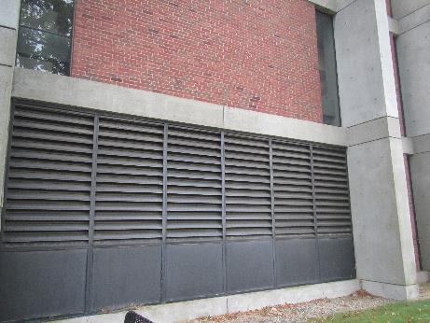
Some of the fresh air vents for the Maxwell Library
Picture 2
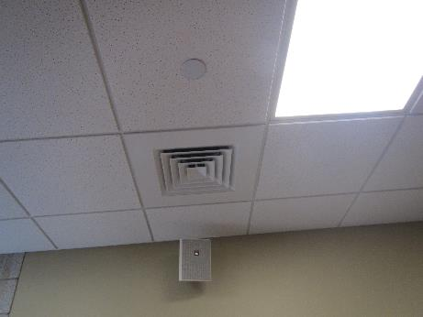
Example of one style of ceiling-mounted fresh air vent
Picture 3
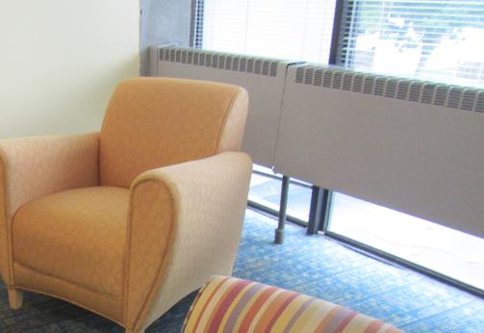
Radiator along window in an open area
Picture 4
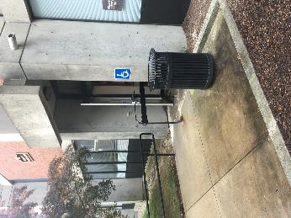
One of the universal-accessible doors to the lower level of the library
Picture 5
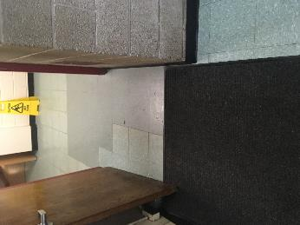
View of the hallway from an accessible door, note open interior door and wet floor sign
Picture 6
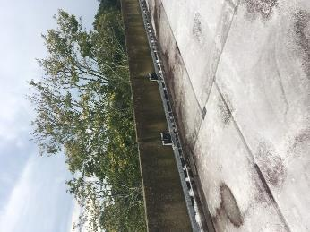
Tree next to building and overhanging roof
Picture 7
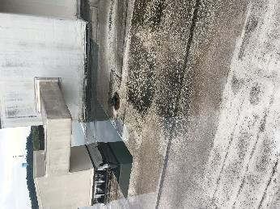
Water pooling on the roof next to roof drain
Picture 8
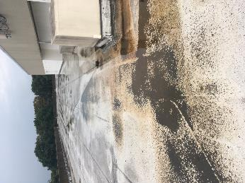
Water pooling and debris on the roof
Picture 9
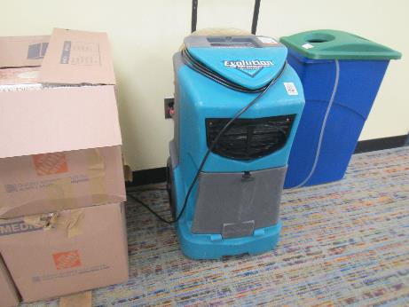
Dehumidifier and water collection vessel
Picture 10
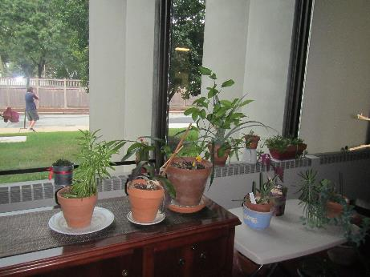
Plants in an office, including on the radiator
Picture 11
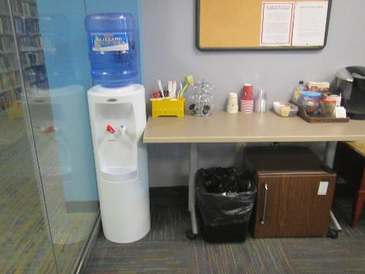
Water cooler and refrigerator on carpet
Location | Carbon  Dioxide  (ppm) | Carbon Monoxide  (ppm) | Temp  (°F) | Relative  Humidity  (%) | PM2.5  (µg/m³) | Occupants  in Room | Windows  Openable | Ventilation |  | Remarks
 |  |  |  |  |  |  |  | Supply | Exhaust
Background | 487 | 0.7 | 73 | 78 | 11 |  |  |  |  | Intermittent heavy showers
3rd floor
3rd floor next to atrium | 740 | ND | 73 | 66 | 2 | 5 | N | Y | Y
309 classroom | 727 | ND | 73 | 66 | 3 | 0 | N | Y | Y
301 admin | 703 | ND | 73 | 66 | 7 | 0 | N | Y | Y
301 A | 674 | ND | 73 | 64 | 2 | 1 | N | Y | Y | Heater, printer
300 | 694 | ND | 72 | 65 | 2 | 1 | N | Y | Y | Dehumidifier (unplugged)
300 rear | 661 | ND | 72 | 66 | 5 | 0 | N | Y | Y | Contains small restroom, items on floor
300 B | 644 | ND | 71 | 66 | 7 | 0 | N | Y | Y
300 A | 660 | ND | 71 | 67 | 2 | 0 | N | Y | Y | Next to elevator
Oversize stacks | 733 | ND | 72 | 67 | 4 | 0 | N | Y | Y
330 BSU honors main | 745 | ND | 72 | 67 | 3 | 0 | N | Y | Y | Fruit, water cooler on carpet
330 conference | 742 | ND | 72 | 65 | 2 | 0 | N | Y | Y | DEM
330 B | 722 | ND | 72 | 65 | 2 | 0 | N | Y | Y
330 C | 727 | ND | 72 | 66 | 2 | 1 | N | Y | Y
330 G | 728 | ND | 73 | 66 | 2 | 3 | N | Y | Y | Open area
330 E | 688 | ND | 73 | 65 | 2 | 0 | N | Y | Y | Plant
330 F | 713 | ND | 72 | 65 | 2 | 1 | N | Y | Y | PF
330 H |  |  |  |  |  |  | N | Y | Y | Photocopier room, appears to have direct exhaust vent
Stacks QE section | 762 | ND | 72 | 66 | 4 | 2 | N | Y | Y
312 main | 751 | ND | 72 | 67 | 4 | 0 | N | Y | Y | MT
312 B | 752 | ND | 72 | 67 | 4 | 1 | N | Y | Y
312 G | 753 | ND | 71 | 68 | 4 | 0 | N | Y | Y
312 F | 746 | ND | 71 | 68 | 3 | 0 | N | Y | Y
312 D | 788 | ND | 71 | 68 | 3 | 0 | N | Y | Y | Coffee, DEM
311 M | 841 | ND | 71 | 69 | 4 | 1 | N | Y | Y | Lounge area
312 office | 789 | ND | 72 | 68 | 4 | 1 | N | Y | Y | Refrigerator on carpet
312 A | 780 | ND | 72 | 68 | 4 | 1 | N | Y | Y
310 | 786 | ND | 72 | 68 | 4 | 2 | N | Y | Y
2nd floor
2nd floor open area | 777 | ND | 73 | 64 | 4 | 17 | N | Y | Y | Large open space with plush chairs, AP
Stacks K-12 textbooks | 748 | ND | 71 | 65 | 4 | 0 | N | Y | Y
215 | 772 | ND | 71 | 69 | 3 | 0 | N | Y | Y
215 C | 767 | ND | 71 | 70 | 4 | 1 | N | Y | Y
215 F | 765 | ND | 71 | 70 | 4 | 1 | N | Y | Y
215 G | 747 | ND | 71 | 70 | 4 | 0 | N | Y | Y | Plants, food odors, area rug
215 P | 760 | ND | 70 | 71 | 4 | 0 | N | Y | Y | Plant
215 B | 766 | ND | 71 | 72 | 6 | 1 | N | Y | Y
Stacks juvenile non-fiction | 741 | ND | 70 | 68 | 5 | 0 | N | Y | Y
Atrium area | 848 | ND | 72 | 70 | 7 | 5 | N | Y | Y
205 classroom | 1100 | ND | 73 | 71 | 6 | 18 | N | Y | Y | Door open
206 classroom | 1153 | ND | 72 | 71 | 4 | 10 | N | Y | Y
203 classroom | 1157 | ND | 73 | 71 | 4 | 18 | N | Y | Y
223 group study | 733 | ND | 73 | 65 | 4 | 0 | N | Y | Y | HS
201 dean | 960 | ND | 73 | 67 | 8 | 1 | N | Y | Y | DEM, PF on, CP
200 | 903 | ND | 73 | 66 | 3 | 2 | N | Y | Y | Dried or fake plants
200 A | 787 | ND | 73 | 64 | 4 | 0 | N | Y | Y | Microwave, plants
200 B | 777 | ND | 73 | 65 | 4 | 1 | N | Y | Y
200 D | 769 | ND | 73 | 64 | 3 | 0 | N | Y | Y | Salt lamp
200 E | 757 | ND | 73 | 64 | 3 | 0 | N | Y | Y | Plants, DEM
200 F conference | 744 | ND | 73 | 66 | 4 | 0 | N | Y | Y | Plants
200 G | 773 | ND | 73 | 66 | 3 | 1 | N | Y | Y | Plants, PF
Stacks LB area | 811 | ND | 73 | 63 | 11 | 0 | N | Y | Y
2nd floor work counter area | 828 | ND | 73 | 64 | 4 | 10 | N | Y | Y | Dehumidifier and bucket
1st floor
Stacks science journals | 741 | ND | 72 | 67 | 3 | 0 | N | Y | Y
1st floor open area | 717 | ND | 72 | 67 | 3 | 15 | N | Y | Y | Dehumidifier
Behind rolling stacks | 721 | ND | 72 | 68 | 4 | 3 | N | Y | Y
Maps area | 729 | ND | 72 | 68 | 4 | 2 | N | Y | Y
123 | 717 | ND | 72 | 68 | 5 | 1 | N | Y | Y
124 office of teaching and learning | Locked |  |  |  |  |  | N | Y | Y
119 document delivery | 759 | ND | 71 | 69 | 3 | 1 | N | Y | Y | Printers
Loans area | 743 | ND | 71 | 67 | 3 | 1 | N | Y | Y | Plants, PF
120 A | 747 | ND | 71 | 68 | 5 | 0 | N | Y | Y
Reference | 745 | ND | 71 | 69 | 2 | 2 | N | Y | Y
109 | 783 | ND | 71 | 69 | 3 | 0 | N | Y | Y | Disorganized papers
110 | 787 | ND | 71 | 69 | 4 | 1 | N | Y | Y | PF – dusty, occupant complaints about temperature
104 | 772 | ND | 71 | 70 | 4 | 0 | N | Y | Y | Large area
112 | 772 | ND | 71 | 70 | 4 | 0 | N | Y | Y | Instruction area with computers at each desk
Reference stacks | 765 | ND | 71 | 69 | 3 | 0 | N | Y | Y
117 classroom | 1013 | ND | 71 | 73 | 4 | 10 | N | Y | Y
116 classroom | 874 | ND | 71 | 71 | 4 | 1 | N | Y | Y
1st floor entry vestibule | 723 | ND | 71 | 71 | 5 | 0 | N | N | N | Good door sweeps
103 heritage room | 756 | ND | 70 | 70 | 4 | 0 | N | Y | Y
100 | 729 | ND | 71 | 71 | 3 | 0 | N | Y | Y | Photo copier, HS
100 B | 732 | ND | 71 | 71 | 4 | 1 | N | Y | Y | HS
100 A | 760 | ND | 71 | 70 | 5 | 1 | N | Y | Y | AP, kettle
101 Dean | 727 | ND | 71 | 70 | 5 | 1 | N | Y | Y | PF, plant, water cooler on carpet PF
Dean’s office | 755 | ND | 71 | 70 | 4 | 0 | N | Y | Y | Many plants including on heaters, DEM
Ground floor level
013 A | 1179 | ND | 74 | 70 | 5 | 16 | N | Y | Y | floor 71ºF
013 B | 884 | ND | 72 | 68 | 6 | 2 | N | Y | Y | floor 68 -71 ºF
021 main | 677 | ND | 73 | 63 | - | 1 | N | Y | Y | HS
021 microwave room | 658 | ND | 73 | 71 | - | 0 | N | Y | Y
021 office | 673 | ND | 73 | 71 | - | 1 | N | Y | Y
019 E | 657 | ND | 73 | 70 | - | 1 | N | Y | Y | CF – on, floor 71 ºF
019 D | 645 | ND | 73 | 70 | - | 0 | N | Y | Y | Floor 70 ºF, plants, area rug, fridge and microwave
019 C | 652 | ND | 73 | 70 | - | 0 | N | Y |  | CF on, fridge and microwave, floor 71 ºF

Location | Air Temp  (ºF) | Relative Humidity  (%) | Dew Point  (ºF) | Floor Temp  (ºF) | Floor /Wall Junction Temp  (ºF) | Ventilation |  |  | Air to Floor Temp  Difference  (ºF) | Comments
 |  |  |  |  |  | Windows openable | Supply | Exhaust
Background (outdoors) | 73 | 78 | 65 |  |  |  |  |  |  | RH indoors 57-74  DP 55 -64
G01 | 70 | 76 | 62 | 63 | 63 | N | Y | Y | 7
G02 | 70 | 76 | 62 | 62 | 63 | N | Y | Y | 8 | Floor wet, temperature at dew point
G05 | 70 | 76 | 62 | 62 | 64 | N | Y | Y | 8 | Floor wet, temperature at dew point
G06 | 70 | 75 | 62 | 62 | 62 | N | Y | Y | 8 | Floor wet, temperature at dew point
D01 E | 70 | 75 | 62 | 62 | 62 | N | Y | Y | 8 | Floor wet, temperature at dew point
DO1 W | 70 | 74 | 62 | 62 | 60 | N | Y | Y | 8 | Floor wet, temperature at dew point
G15 | 70 | 74 | 62 | 63 | 64 | N | Y | Y | 7
L1 | 71 | 75 | 63 | 64 | 64 | N | Y | Y | 7
L2 | 71 | 74 | 63 | 64 | 64 | N | Y | Y | 7
L3 | 71 | 74 | 63 | 64 | 65 | N | Y | Y | 7
L4 | 71 | 76 | 63 | 63 | 65 | N | Y | Y | 8 | Floor wet, temperature at dew point
L5 | 71 | 75 | 63 | 63 | 64 | N | Y | Y | 8 | Floor wet, temperature at dew point
L6 | 71 | 74 | 64 | 62 | 62 | N | Y | Y | 9
Breakroom | 71 | 74 | 62 | 62 | 62 | N | Y | Y | 9
Assessment lab | 71 | 70 | 61 | 63 | 64 | N | Y | Y | 8
Testing lab L | 72 | 62 | 59 | 62 | 63 | N | Y | Y | 10
Testing Lab R | 72 | 57 | 55 | 65 | 64 | N | Y | Y | 17
Testing lab office | 72 | 60 | 57 | 63 | 64 | N | Y | Y | 9
001L | 72 | 71 | 62 | 63 | 63 | N | Y | Y | 9
Adaptive lab | 72 | 71 | 62 | 63 | 63 | N | Y | Y | 9
AAC | 72 | 70 | 62 | 62 | 62 | N | Y | Y | 10 | Floor wet, temperature at dew point
L12 | 70 | 73 | 63 | 59 | 60 | N | Y | Y | 11 | Floor wet, temperature below dew point
019 | 72 | 73 | 63 | 65 | 65 | N | Y | Y | 7
019B | 72 | 73 | 63 | 65 | 65 | N | Y | Y | 9

Location | Air Temp  (ºF) | Relative Humidity  (%) | Dew Point  (ºF) | Comments
Background (outdoors) | 64 | 43 | 41 | RH 45-50% indoors  Dew point 47-50 ºF
Outdoors at fresh air intake | 65 | 50 | 45
3rd floor center | 70 | 46 | 48 | 47-50 ºF
3rd SW | 70 | 49 | 50
3rd NW | 70 | 45 | 47
3RD NE | 69 | 48 | 48
3RD SE | 70 | 50 | 50
3RD S | 70 | 44 | 47
2nd NE | 69 | 48 | 49
2nd NW | 68 | 47 | 47
2nd NW stairwell | 69 | 48 | 48
2nd NE stairwell | 69 | 49 | 49
1st NE | 70 | 47 | 49
1st N | 70 | 50 | 50
1st NW | 69 | 48 | 48
1st SW | 69 | 47 | 48
1st near front door | 69 | 45 | 47
G center | 70 | 45 | 48
G Starbucks | 71 | 47 | 50
G 013A Exit door | 71 | 49 | 50
G NE stairwell | 71 | 45 | 48
G back hallway | 71 | 46 | 49 | No supply or exhaust vents  Large floor fan in use to dry floor
G NW stairwell | 70 | 47 | 49
G NW | 70 | 47 | 49

