**Massachusetts Department of Public Health**

**Bureau of Infectious Disease and Laboratory Sciences**

**Surveillance Data Overview of Sexually Transmitted Infections, Massachusetts, 2000-2024**

*Please note that while the content of this report is the same as the pdf version, the format and pagination have been modified significantly to optimize use with screen readers to ensure access for blind or visually impaired audiences.*

Massachusetts Department of Public Health

Bureau of Infectious Disease and Laboratory Sciences

Division of STD Prevention and HIV Surveillance

March 2024

**Bureau of Infectious Disease and Laboratory Sciences**

**Division of STD Prevention and HIV Surveillance**  
**Massachusetts Department of Public Health**

**Jamaica Plain Campus/State Public Health Laboratory**

305 South Street  
Jamaica Plain, MA 02130

**Questions about this report**

Tel: (617) 983-6490

**To reach the Reporting and Partner Services Line[1]**

Tel: (617) 983-6999

Contents

Slide 1 (title page) – Brief Surveillance Data Overview of Sexually Transmitted Infections, Massachusetts, 2000-2024 3

Slide 2 - Outline 3

Slide 3 (title page) - Massachusetts STI Trends,Chlamydia: 2000 - 2024 3

Slide 4 - Rate of Confirmed Chlamydia Cases, Massachusetts, 2000 to 20241 3

Slide 5 - Confirmed Chlamydia Rates by Gender1,Massachusetts, 2015 to 20242 5

Slide 6 - Chlamydia Among Individuals of Transgender Experience,1, 2 Massachusetts, 2015-20243 6

Slide 7 - Confirmed Chlamydia Rates by County and Statewide,Massachusetts, 2022-20241 7

Slide 8 - Massachusetts STI Trends, Gonorrhea: 2000 - 2024 8

Slide 9 - Rate of Confirmed Gonorrhea Cases, Massachusetts, 2000-20241 8

Slide 10 - Rate of Confirmed Gonorrhea Cases by Gender1,Massachusetts, 2015-20242 9

Slide 11: Gonorrhea Among Individuals of Transgender Experience1, Massachusetts, 2015-20242 10

Slide 12: Confirmed Gonorrhea Rates by County and Statewide,Massachusetts, 2022-20241 11

Slide 13: Massachusetts STI Trends,Infectious Syphilis: 2000 - 2024 12

Slide 14: Confirmed and Probable Infectious Syphilis1 Rates, Massachusetts, 2000-20242 12

Slide 15: Confirmed and Probable Infectious Syphilis1 Rates by Gender,2 Massachusetts, 2015-20243 13

Slide 16: Infectious Syphilis1 Reported Cases by Race/Ethnicity2, Massachusetts, 2015-20243 15

Slide 17: Confirmed and Probable Infectious Syphilis1 Among Individuals of Transgender Experience2, Massachusetts, 2015-20243, 4 16

Slide 18 – Confirmed and Probable Infectious Syphilis1 Rates by Stage of Infection, Massachusetts, 2010–20242 17

Slide 19 – Confirmed and Probable Infectious Syphilis1 Rates by Stage of Infection, Massachusetts, 2015-20242 18

Slide 20 - Infectious Syphilis1 Reported Cases by Sexual Risk Categories, Massachusetts, 2015-20242 19

Slide 21 - Congenital Syphilis Cases and Rate of Confirmed and Probable Infectious Syphilis1 Among Persons of Reproductive Potential Ages 15 to 49 Years, Massachusetts, 2010-20242 20

Slide 22 Closing Slide 21

**Slide Descriptions**

# Slide 1 (title page) – Brief Surveillance Data Overview of Sexually Transmitted Infections, Massachusetts, 2000-2024

# Slide 2 - Outline

Sexually Transmitted Infection (STI) Trends and Descriptions:

* General STI Trends Through 2024
  + Chlamydia
  + Gonorrhea
  + Infectious syphilis

# Slide 3 (title page) - Massachusetts STI Trends,Chlamydia: 2000 - 2024

# Slide 4 - Rate of Confirmed Chlamydia Cases, Massachusetts, 2000 to 20241

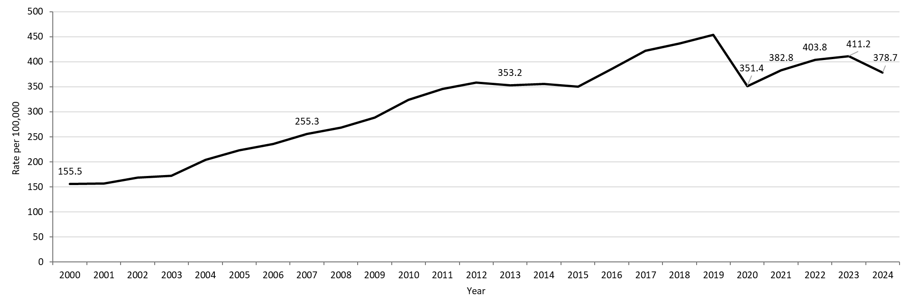

**Table: Chlamydia Annual Case Counts**

|  |  |
| --- | --- |
| **Year** | **Count** |
| 2000 | 9,872 |
| 2001 | 9,969 |
| 2002 | 10,755 |
| 2003 | 11,041 |
| 2004 | 13,120 |
| 2005 | 14,386 |
| 2006 | 15,253 |
| 2007 | 16,566 |
| 2008 | 17,441 |
| 2009 | 18,796 |
| 2010 | 21,211 |
| 2011 | 22,851 |
| 2012 | 23,930 |
| 2013 | 23,789 |
| 2014 | 24,143 |
| 2015 | 23,944 |
| 2016 | 26,478 |
| 2017 | 29,177 |
| 2018 | 30,360 |
| 2019 | 31,633 |
| 2020 | 24,701 |
| 2021 | 26,912 |
| 2022 | 28,384 |
| 2023 | 28,910 |
| 2024 | 26,623 |

**Footnotes For Slide 4**

Data are current as of 06/02/2025 and are subject to change.

Data Source: Massachusetts Department of Public Health/Bureau of Infectious Disease and Laboratory Sciences/ Division of STD Prevention and HIV Surveillance.

Population denominators estimated by the University of Massachusetts Donahue Institute using a modified Hamilton-Perry model (Strate S, et al. Small Area Population Estimates for 2011 through 2020 report, Oct 2016).

1. Please consider the impact of the COVID-19 pandemic on infectious disease screening, treatment and surveillance in the interpretation of 2020-2023 data.

## Slide 5 - Confirmed Chlamydia Rates by Gender1,Massachusetts, 2015 to 20242

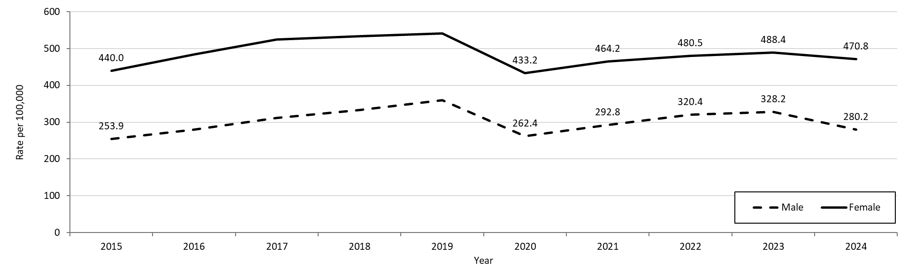

**Table: Chlamydia Annual Case Counts by Current Gender**

|  |  |  |
| --- | --- | --- |
| **Year** | **Females** | **Males** |
| 2015 | 15,489 | 8,414 |
| 2016 | 17,094 | 9,318 |
| 2017 | 18,644 | 10,463 |
| 2018 | 19,062 | 11,252 |
| 2019 | 19,408 | 12,155 |
| 2020 | 15,677 | 8,949 |
| 2021 | 16,799 | 9,989 |
| 2022 | 17,388 | 10,928 |
| 2023 | 17,675 | 11,194 |
| 2024 | 17,037 | 9,557 |

**Note:** There were cases reported among transgender individuals in 2014 through 2024. In 2024, there were 9 cases of chlamydia among transgender identified individuals and 17 other individuals with unknown gender not included on this slide.

**Footnotes For Slide 5**

Data are current as of 06/02/2025 and are subject to change.

Data Source: Massachusetts Department of Public Health/Bureau of Infectious Disease and Laboratory Sciences/ Division of STD Prevention and STD-HIV Surveillance.

Population denominators estimated by the University of Massachusetts Donahue Institute using a modified Hamilton-Perry model (Strate S, et al. Small Area Population Estimates for 2011 through 2020 report, Oct 2016).

1. In 2024, there were 9 individuals of transgender experience reported in our data system who do not have current gender documented. These cases were excluded since population estimates for individuals of transgender experience are not available at this time.  There were 17 other individuals with unknown gender which are not included in this slide.

2. Please consider the impact of the COVID-19 pandemic on infectious disease screening, treatment and surveillance in the interpretation of 2020-2023 data.

## Slide 6 - Chlamydia Among Individuals of Transgender Experience,1, 2 Massachusetts, 2015-20243

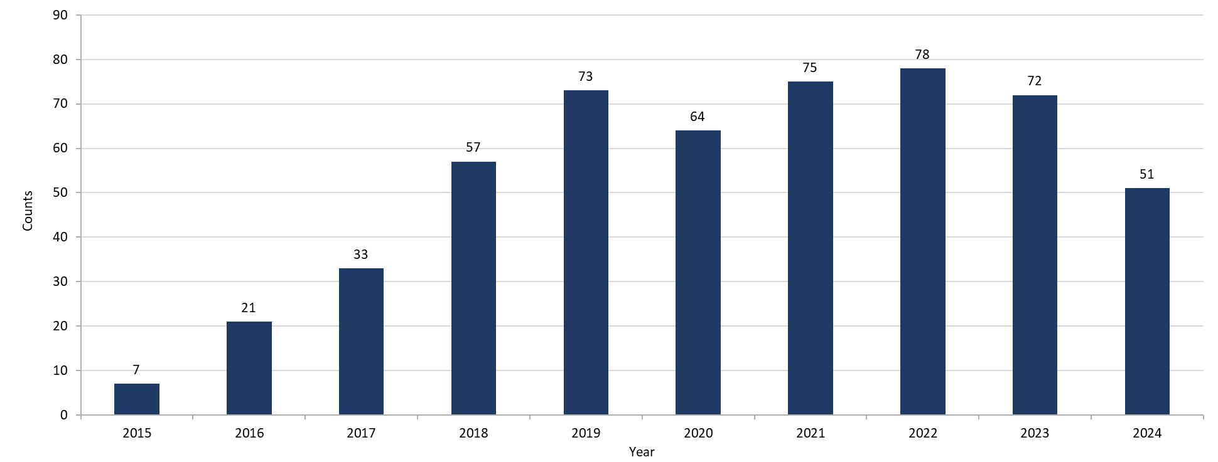

**Footnotes for Slide 6**

Data are current as of 06/02/2025 and are subject to change.

Data Source: Massachusetts Department of Public Health/Bureau of Infectious Disease and Laboratory Sciences/ Division of STD Prevention and HIV Surveillance.

1. Prior to 2015 MA DSTDP was not able to capture expanded gender identity including individuals of transgender experience within our data system.
2. All individuals of transgender experience are included in this graph regardless of current gender.
3. Please consider the impact of the COVID-19 pandemic on infectious disease screening, treatment and surveillance in the interpretation of 2020-2023 data.

## Slide 7 - Confirmed Chlamydia Rates by County and Statewide,Massachusetts, 2022-20241

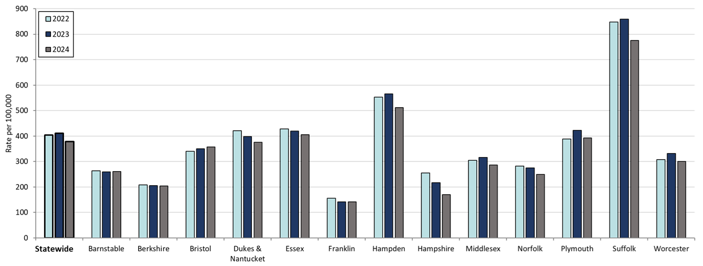

**Table: Rates of Chlamydia by County and Statewide**

|  |  |  |  |
| --- | --- | --- | --- |
| **County** | **2022** | **2023** | **2024** |
| Barnstable | 263.8 | 259.39 | 260.7 |
| Berkshire | 207.7 | 206.16 | 203.9 |
| Bristol | 339.8 | 350.48 | 357.7 |
| Dukes/Nantucket | 421.7 | 398.8 | 375.8 |
| Essex | 427.5 | 419.47 | 404.9 |
| Franklin | 156.3 | 142.2 | 142.2 |
| Hampden | 553.2 | 565.45 | 511.1 |
| Hampshire | 254.5 | 216.87 | 170.0 |
| Middlesex | 304.8 | 316.36 | 286.0 |
| Norfolk | 282.8 | 275.08 | 248.9 |
| Plymouth | 388.8 | 422.18 | 392.4 |
| Suffolk | 848.3 | 858.72 | 776.0 |
| Worcester | 308.2 | 331.4 | 300.0 |
| Statewide | 403.8 | 411.24 | 378.7 |

**Footnotes for Slide 7**

Data are current as of 06/02/2025 and are subject to change.

Data Source: Massachusetts Department of Public Health/Bureau of Infectious Disease and Laboratory Sciences/ Division of STD Prevention and HIV Surveillance.

Population denominators estimated by the University of Massachusetts Donahue Institute using a modified Hamilton-Perry model (Strate S, et al. Small Area Population Estimates for 2011 through 2020 report, Oct 2016).

1. Please consider the impact of the COVID-19 pandemic on infectious disease screening, treatment and surveillance in the interpretation of 2020-2023 data.

## Slide 8 - Massachusetts STI Trends, Gonorrhea: 2000 - 2024

## Slide 9 - Rate of Confirmed Gonorrhea Cases, Massachusetts, 2000-20241

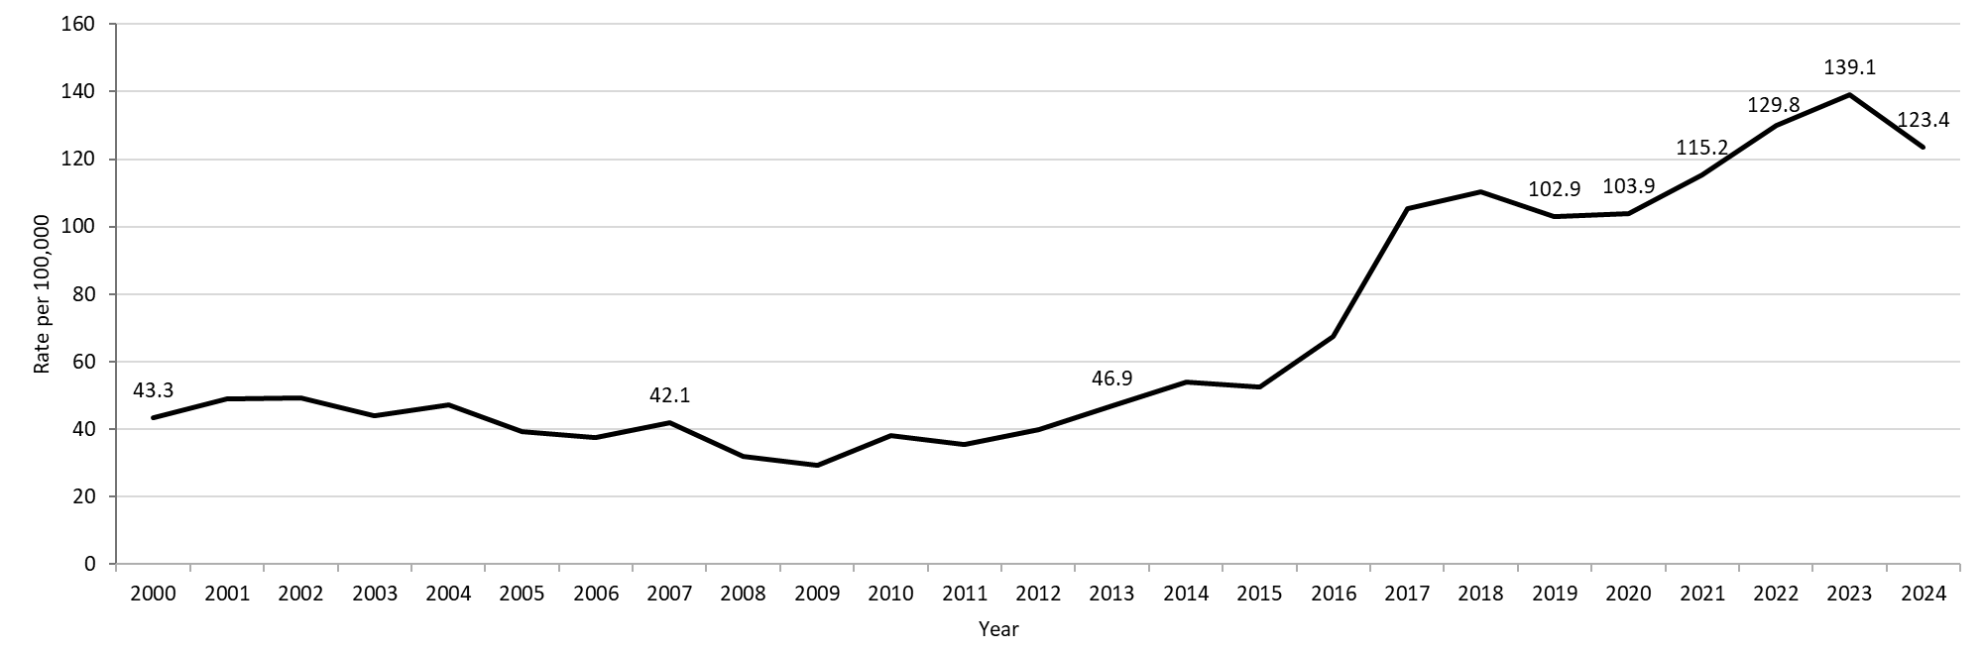

**Table: Gonorrhea Annual Case Counts**

|  |  |
| --- | --- |
| **Year** | **Count** |
| 2000 | 2,748 |
| 2001 | 3,121 |
| 2002 | 3,156 |
| 2003 | 2,819 |
| 2004 | 3,038 |
| 2005 | 2,542 |
| 2006 | 2,429 |
| 2007 | 2,729 |
| 2008 | 2,077 |
| 2009 | 1,917 |
| 2010 | 2,495 |
| 2011 | 2,345 |
| 2012 | 2,665 |
| 2013 | 3,156 |
| 2014 | 3,657 |
| 2015 | 3,592 |
| 2016 | 4,638 |
| 2017 | 7,293 |
| 2018 | 7,660 |
| 2019 | 7,170 |
| 2020 | 7,303 |
| 2021 | 8,099 |
| 2022 | 9,218 |
| 2023 | 9,779 |
| 2024 | 8,678 |

**Footnotes for Slide 9**

Data are current as of 06/02/2025 and are subject to change.

Data Source: Massachusetts Department of Public Health/Bureau of Infectious Disease and Laboratory Sciences/ Division of STD Prevention and HIV Surveillance.

Population denominators estimated by the University of Massachusetts Donahue Institute using a modified Hamilton-Perry model (Strate S, et al. Small Area Population Estimates for 2011 through 2020 report, Oct 2016).

1. Please consider the impact of the COVID-19 pandemic on infectious disease screening, treatment and surveillance in the interpretation of 2020-2023 data.

## Slide 10 - Rate of Confirmed Gonorrhea Cases by Gender1,Massachusetts, 2015-20242

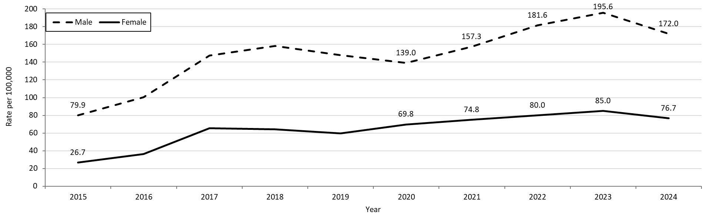

**Table: Gonorrhea Annual Case Counts by Current Gender**

|  |  |  |
| --- | --- | --- |
| **Year** | **Females** | **Males** |
| 2015 | 940 | 2,648 |
| 2016 | 1,283 | 3,344 |
| 2017 | 2,328 | 4,952 |
| 2018 | 2,293 | 5,347 |
| 2019 | 2,132 | 5,002 |
| 2020 | 2,526 | 4,741 |
| 2021 | 2,707 | 5,367 |
| 2022 | 2,894 | 6,196 |
| 2023 | 3,077 | 6,672 |
| 2024 | 2,776 | 5,867 |

**Note:** There were cases reported among transgender individuals in 2014 through 2024. In 2024, there were 26cases of gonorrhea among transgender identified individuals and 9 other individuals with unknown gender not included on this slide.

**Footnotes for Slide 10**

Data are current as of 06/02/2025 and are subject to change.

Data Source: Massachusetts Department of Public Health/Bureau of Infectious Disease and Laboratory Sciences/ Division of STD Prevention and STD-HIV Surveillance.

Population denominators estimated by the University of Massachusetts Donahue Institute using a modified Hamilton-Perry model (Strate S, et al. Small Area Population Estimates for 2011 through 2020 report, Oct 2016).

1. In 2024, there were 26 individuals of transgender experience reported in our data system who do not have current gender documented. These cases were excluded since population estimates for individuals of transgender experience are not available at this time. There were 9 other individuals with unknown gender which are not included in this slide.

2. Please consider the impact of the COVID-19 pandemic on infectious disease screening, treatment and surveillance in the interpretation of 2020-2023 data.

## Slide 11: Gonorrhea Among Individuals of Transgender Experience1, Massachusetts, 2015-20242

**Graph shows the number of confirmed gonorrhea cases among transgender individuals in Massachusetts between 2015 and 2024. The case counts are 6, 31, 32, 49, 68, 58, 48, 68, 71, and 91 for 2015, 2016, 2017, 2018, 2019, 2020, 2021, 2022, 2023, and 2024, respectively. 
**

**Footnotes for Slide 11**

Data are current as of 06/02/2025 and are subject to change.

Data Source: Massachusetts Department of Public Health/Bureau of Infectious Disease and Laboratory Sciences/ Division of STD Prevention and HIV Surveillance.

1. All individuals of transgender experience are included in this graph regardless of current gender.

2. Please consider the impact of the COVID-19 pandemic on infectious disease screening, treatment and surveillance in the interpretation of 2020-2023 data.

## Slide 12: Confirmed Gonorrhea Rates by County and Statewide,Massachusetts, 2022-20241

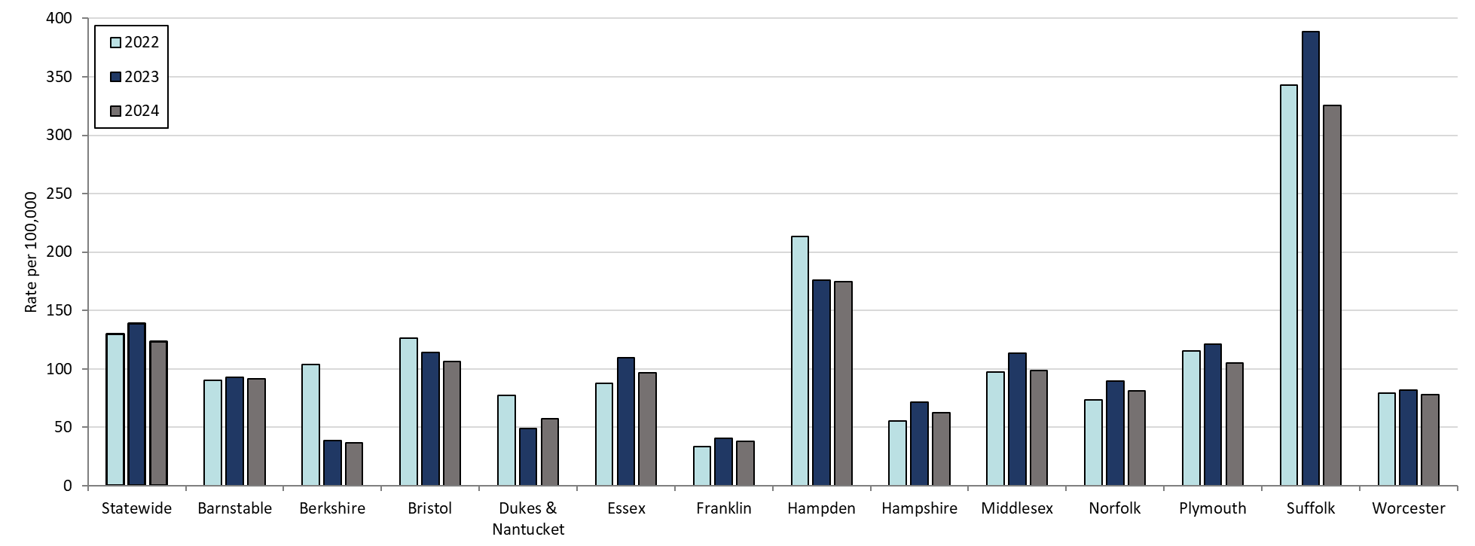

**Table: Rates of Gonorrhea by County and Statewide**

|  |  |  |  |
| --- | --- | --- | --- |
| **County** | **2022** | **2023** | **2024** |
| Barnstable | 90.4 | 92.6 | 91.7 |
| Berkshire | 103.9 | 38.8 | 36.4 |
| Bristol | 126.2 | 114.1 | 106.4 |
| Dukes/Nantucket | 77.5 | 48.8 | 57.4 |
| Essex | 87.8 | 109.4 | 96.9 |
| Franklin | 33.8 | 40.8 | 38.0 |
| Hampden | 213.4 | 175.8 | 175.0 |
| Hampshire | 55.5 | 71.5 | 62.2 |
| Middlesex | 97.6 | 113.4 | 98.8 |
| Norfolk | 73.4 | 89.5 | 81.3 |
| Plymouth | 115.7 | 120.9 | 104.7 |
| Suffolk | 343.0 | 388.6 | 325.6 |
| Worcester | 79.3 | 81.9 | 77.8 |
| Statewide | 129.8 | 139.1 | 123.4 |

**Footnotes for Slide 12**

Data are current as of 06/02/2025 and are subject to change.

Data Source: Massachusetts Department of Public Health/Bureau of Infectious Disease and Laboratory Sciences/ Division of STD Prevention and HIV Surveillance.

Population denominators estimated by the University of Massachusetts Donahue Institute using a modified Hamilton-Perry model (Strate S, et al. Small Area Population Estimates for 2011 through 2020 report, Oct 2016).

1. Please consider the impact of the COVID-19 pandemic on infectious disease screening, treatment and surveillance in the interpretation of 2020-2023 data.

## Slide 13: Massachusetts STI Trends,Infectious Syphilis: 2000 - 2024

## Slide 14: Confirmed and Probable Infectious Syphilis1 Rates, Massachusetts, 2000-20242

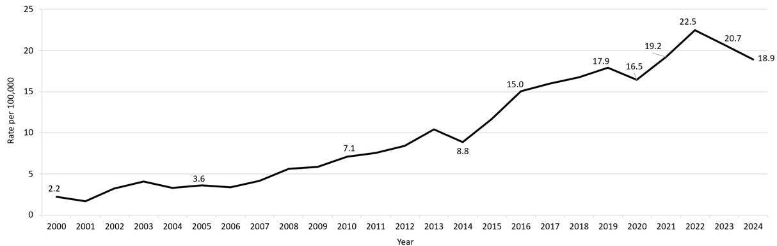

**Table: Infectious Syphilis Annual Case Counts**

|  |  |
| --- | --- |
| **Year** | **Count** |
| 2000 | 141 |
| 2001 | 105 |
| 2002 | 207 |
| 2003 | 258 |
| 2004 | 209 |
| 2005 | 231 |
| 2006 | 217 |
| 2007 | 268 |
| 2008 | 367 |
| 2009 | 379 |
| 2010 | 465 |
| 2011 | 500 |
| 2012 | 561 |
| 2013 | 701 |
| 2014 | 600 |
| 2015 | 798 |
| 2016 | 1,034 |
| 2017 | 1,107 |
| 2018 | 1,167 |
| 2019 | 1,244 |
| 2020 | 1,159 |
| 2021 | 1,352 |
| 2022 | 1,593 |
| 2023 | 1,449 |
| 2024 | 1,329 |

**Footnotes for Slide 14**

Data are current as of 06/02/2025 and are subject to change.

Data Source: Massachusetts Department of Public Health/Bureau of Infectious Disease and Laboratory Sciences/ Division of STD Prevention and STD-HIV Surveillance.

Population denominators estimated by the University of Massachusetts Donahue Institute using a modified Hamilton-Perry model (Strate S, et al. Small Area Population Estimates for 2011 through 2020 report, Oct 2016).

1. Infectious syphilis is defined as primary, secondary and early latent stages of syphilis within one year of infection.

2. Please consider the impact of the COVID-19 pandemic on infectious disease screening, treatment and surveillance in the interpretation of 2020-2023 data.

## Slide 15: Confirmed and Probable Infectious Syphilis1 Rates by Gender,2 Massachusetts, 2015-20243

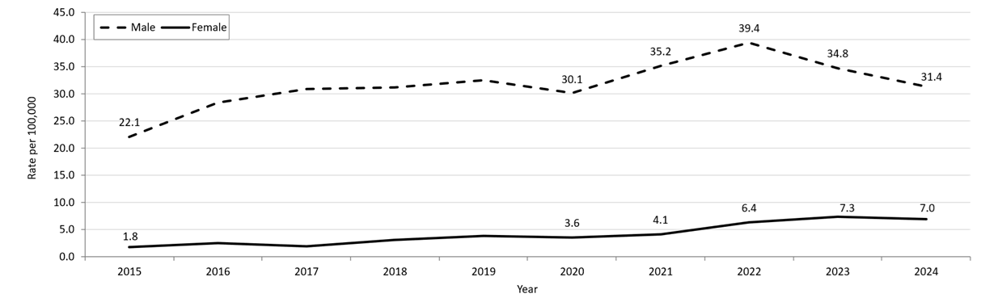

**Table: Infectious Syphilis Annual Case Counts by Current Gender**

|  |  |  |
| --- | --- | --- |
| **Year** | **Females** | **Males** |
| 2015 | 65 | 732 |
| 2016 | 87 | 947 |
| 2017 | 67 | 1,040 |
| 2018 | 110 | 1,055 |
| 2019 | 139 | 1,102 |
| 2020 | 130 | 1,028 |
| 2021 | 150 | 1,201 |
| 2022 | 233 | 1,357 |
| 2023 | 264 | 1,183 |
| 2024 | 253 | 1,071 |

**Note:** Infectious syphilis is defined as primary, secondary and early latent stages of syphilis within one year of infection.

There were cases reported among transgender individuals in 2015 through 2024. They are classified on this slide based on their current gender. In 2024, there were 5 cases of infectious syphilis among transgender identified individuals not included on this slide as MA DSTDP does not have current gender information for those individuals.

**Footnotes for Slide 15**

Data are current as of 06/02/2025 and are subject to change.

Data Source: Massachusetts Department of Public Health/Bureau of Infectious Disease and Laboratory Sciences/ Division of STD Prevention and STD-HIV Surveillance.

Population denominators estimated by the University of Massachusetts Donahue Institute using a modified Hamilton-Perry model (Strate S, et al. Small Area Population Estimates for 2011 through 2020 report, Oct 2016).

1. Infectious syphilis is defined as primary, secondary and early latent stages of syphilis within one year of infection.

2. In 2024, there were 5 individuals of transgender experience reported in our data system who do not have current gender documented. These cases were excluded since population estimates for individuals of transgender experience are not available at this time.

3. Please consider the impact of the COVID-19 pandemic on infectious disease screening, treatment and surveillance in the interpretation of 2020-2023 data.

## Slide 16: Infectious Syphilis1 Reported Cases by Race/Ethnicity2, Massachusetts, 2015-20243

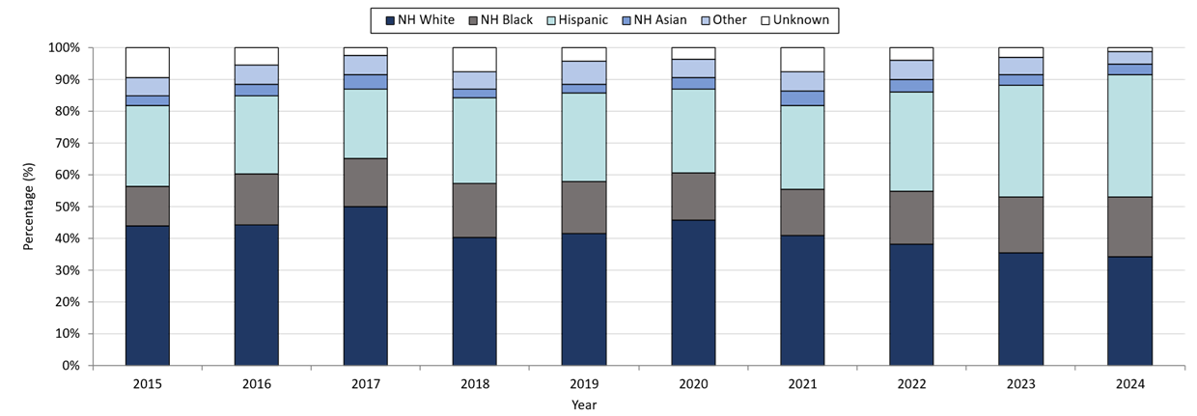

**Table: Infectious Syphilis Annual Case Counts**

|  |  |
| --- | --- |
| **Year** | **Count** |
| 2015 | 789 |
| 2016 | 1,034 |
| 2017 | 1,107 |
| 2018 | 1,167 |
| 2019 | 1,244 |
| 2020 | 1,159 |
| 2021 | 1,352 |
| 2022 | 1,593 |
| 2023 | 1,449 |
| 2024 | 1,329 |

**Note:** Infectious syphilis is defined as primary, secondary and early latent (non-primary/non-secondary) stages of syphilis within one year of infection.

**Footnotes for Slide 16**

Data are current as of 06/02/2025 and are subject to change.

Data Source: Massachusetts Department of Public Health/Bureau of Infectious Disease and Laboratory Sciences/ Division of STD Prevention and STD-HIV Surveillance.

Note: National Notifiable Diseases Surveillance System (NNDSS) Congenital Syphilis case definition was updated in 2014.

1. Infectious syphilis is defined as primary, secondary and early latent stages of syphilis within one year of infection.

2. Other Race/Ethnicity includes individuals who identify as American Indian/ Pacific Islander/ Alaskan Native.

3. Please consider the impact of the COVID-19 pandemic on infectious disease screening, treatment and surveillance in the interpretation of 2020-2023 data.

## Slide 17: Confirmed and Probable Infectious Syphilis1 Among Individuals of Transgender Experience2, Massachusetts, 2015-20243, 4

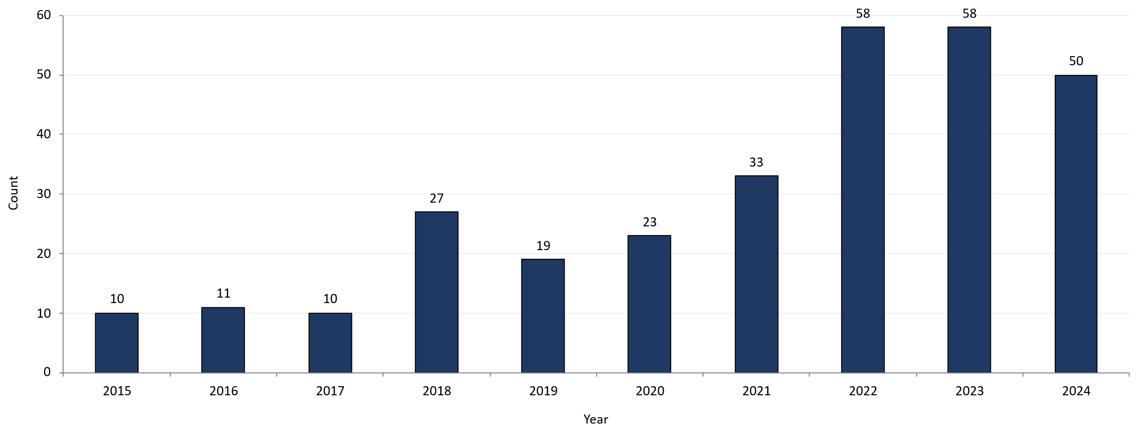

**Footnotes for Slide 17**

Data are current as of 06/02/2025 and are subject to change.

Data Source: Massachusetts Department of Public Health/Bureau of Infectious Disease and Laboratory Sciences/ Division of STD Prevention and STD-HIV Surveillance.

1. Infectious syphilis is defined as primary, secondary and early latent stages of syphilis within one year of infection.

2. All individuals of transgender experience are included in this graph regardless of current gender.

3. Please consider the impact of the COVID-19 pandemic on infectious disease screening, treatment and surveillance in the interpretation of 2020-2023 data.

4. In 2022, a retrospective verification project was conducted to improve data quality in capturing current gender information.

## Slide 18 – Confirmed and Probable Infectious Syphilis1 Rates by Stage of Infection, Massachusetts, 2010–20242

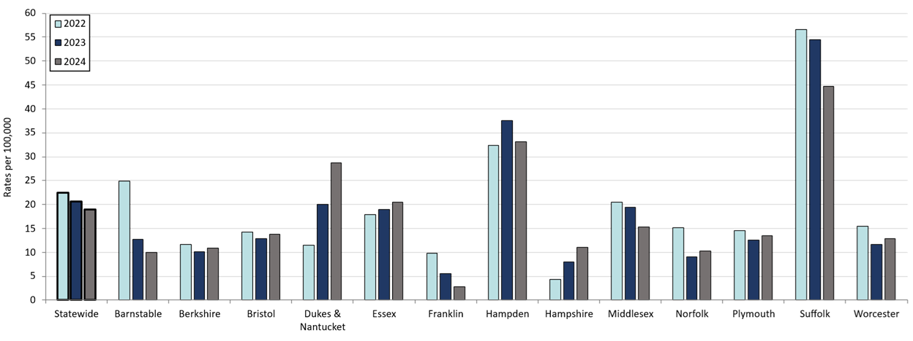

**Table: Confirmed and Probable Infectious Syphilis Rates by County and Statewide**

|  |  |  |  |
| --- | --- | --- | --- |
| **County** | **2022** | **2023** | **2024** |
| Barnstable | 24.9 | 12.7 | 10.0 |
| Berkshire | 11.6 | 10.1 | 10.9 |
| Bristol | 14.2 | 12.8 | 13.8 |
| Dukes/Nantucket | 11.5 | 20.1 | 28.7 |
| Essex | 17.9 | 19.0 | 20.5 |
| Franklin | 9.9 | 5.6 | 2.8 |
| Hampden | 32.4 | 37.6 | 33.1 |
| Hampshire | 4.3 | 8.0 | 11.1 |
| Middlesex | 20.5 | 19.4 | 15.3 |
| Norfolk | 15.2 | 9.1 | 10.3 |
| Plymouth | 14.5 | 12.6 | 13.4 |
| Suffolk | 56.6 | 54.4 | 44.7 |
| Worcester | 15.5 | 11.7 | 12.8 |
| Statewide | 22.5 | 20.7 | 18.9 |

**Footnotes for Slide 18**

Data are current as of 06/02/2025 and are subject to change.

Data Source: Massachusetts Department of Public Health/Bureau of Infectious Disease and Laboratory Sciences/ Division of STD Prevention and STD-HIV Surveillance.

Population denominators estimated by the University of Massachusetts Donahue Institute using a modified Hamilton-Perry model (Strate S, et al. Small Area Population Estimates for 2011 through 2020 report, Oct 2016).

1. Infectious syphilis is defined as primary, secondary and early latent stages of syphilis within one year of infection.

2. Please consider the impact of the COVID-19 pandemic on infectious disease screening, treatment and surveillance in the interpretation of 2020-2023 data.

## Slide 19 – Confirmed and Probable Infectious Syphilis1 Rates by Stage of Infection, Massachusetts, 2015-20242

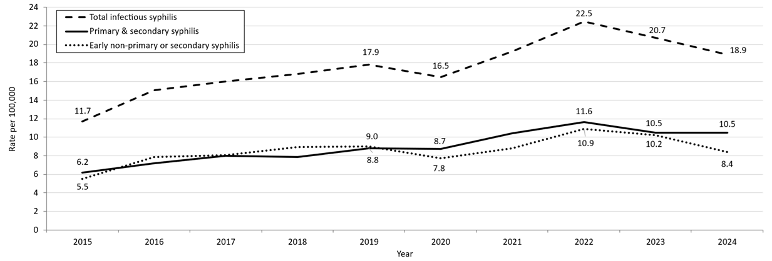

**Table: Infectious Syphilis Annual Case Counts**

|  |  |
| --- | --- |
| **Year** | **Count** |
| 2015 | 798 |
| 2016 | 1,034 |
| 2017 | 1,107 |
| 2018 | 1,167 |
| 2019 | 1,244 |
| 2020 | 1,159 |
| 2021 | 1,352 |
| 2022 | 1,579 |
| 2023 | 1,449 |
| 2024 | 1,329 |

**Note:** Infectious syphilis is defined as primary, secondary and early latent (non-primary/non-secondary) stages of syphilis within one year of infection.

**Footnotes for Slide 19**

Data are current as of 06/02/2025 and are subject to change.

Data Source: Massachusetts Department of Public Health/Bureau of Infectious Disease and Laboratory Sciences/ Division of STD Prevention and STD-HIV Surveillance.

Population denominators estimated by the University of Massachusetts Donahue Institute using a modified Hamilton-Perry model (Strate S, et al. Small Area Population Estimates for 2011 through 2020 report, Oct 2016).

1. Infectious syphilis is defined as primary, secondary and early latent stages of syphilis within one year of infection.

2. Please consider the impact of the COVID-19 pandemic on infectious disease screening, treatment and surveillance in the interpretation of 2020-2023 data.

## Slide 20 - Infectious Syphilis1 Reported Cases by Sexual Risk Categories, Massachusetts, 2015-20242

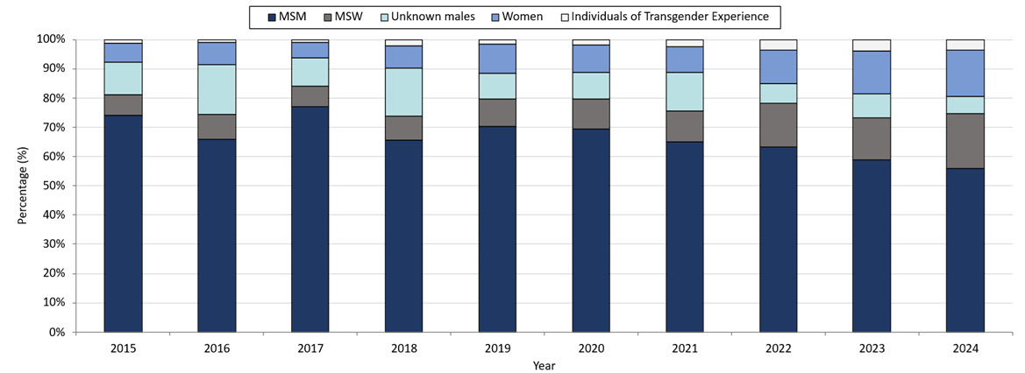

**Table: Infectious Syphilis Annual Case Counts**

|  |  |
| --- | --- |
| **Year** | **Count** |
| 2015 | 798 |
| 2016 | 1,034 |
| 2017 | 1,107 |
| 2018 | 1,167 |
| 2019 | 1,244 |
| 2020 | 1,159 |
| 2021 | 1,352 |
| 2022 | 1,593 |
| 2023 | 1,449 |

**Note:** Infectious syphilis is defined as primary, secondary and early latent (non-primary/non-secondary) stages of syphilis within one year of infection.

**Footnotes for Slide 20**

Data are current as of 06/02/2025 and are subject to change.

Data Source: Massachusetts Department of Public Health/Bureau of Infectious Disease and Laboratory Sciences/ Division of STD Prevention and STD-HIV Surveillance.

Note: National Notifiable Diseases Surveillance System (NNDSS) Congenital Syphilis case definition was updated in 2014.

1. Infectious syphilis is defined as primary, secondary and early latent stages of syphilis within one year of infection.

2. Please consider the impact of the COVID-19 pandemic on infectious disease screening, treatment and surveillance in the interpretation of 2020-2023 data.

3. The MSM (men who have sex with men) category includes MSMT, MSMW, MSMWT, and MST with “W” referring to women and “T” referring to individuals of transgender experience.

## Slide 21 - Congenital Syphilis Cases and Rate of Confirmed and Probable Infectious Syphilis1 Among Persons of Reproductive Potential Ages 15 to 49 Years, Massachusetts, 2010-20242

**Congenital Syphilis Cases and Rate of Confirmed and Probable Infectious Syphilis Among Individuals Thought to be Capable of Pregnancy Ages 15 to 49 Years, Massachusetts, 2010-2024
Graph depicts the case count for confirmed and probable congenital syphilis cases reported in Massachusetts between 2010 and 2023. The case counts are 1, 0, 1, 4, 3, 4, 4, 0, 0, 9, 10, 9, 11,14, and 18 for 2010, 2011, 2012, 2013, 2014, 2015, 2016, 2017, 2018, 2019, 2020, 2021, 2022, 2023, and 2024, respectively. Additionally, the graph shows a line depicting the rate per 100,000 population of confirmed and probable infectious syphilis among individuals thought to be capable of pregnancy ages 15 to 49 years which starts with a rate of 1.7 in 2010 and peaks in 2024 with a rate of 12.0 cases per 100,000 population.

Note: Infectious syphilis is defined as primary, secondary and early latent (non-primary/non-secondary) stages of syphilis within one year of infection.**

**Table: Infectious Syphilis Cases Among Persons of Reproductive Potential**

|  |  |
| --- | --- |
| **Year** | **Count** |
| 2010 | 28 |
| 2011 | 42 |
| 2012 | 43 |
| 2013 | 46 |
| 2014 | 50 |
| 2015 | 50 |
| 2016 | 74 |
| 2017 | 55 |
| 2018 | 85 |
| 2019 | 114 |
| 2020 | 101 |
| 2021 | 105 |
| 2022 | 173 |
| 2023 | 196 |
| 2024 | 198 |

**Note:** Infectious syphilis is defined as primary, secondary and early latent (non-primary/non-secondary) stages of syphilis within one year of infection.

**Footnotes for Slide 21**

Data are current as of 06/02/2025 and are subject to change.

Data Source: Massachusetts Department of Public Health/Bureau of Infectious Disease and Laboratory Sciences/ Division of STD Prevention.

Population denominators estimated by the University of Massachusetts Donahue Institute using a modified Hamilton-Perry model (Strate S, et al. Small Area Population Estimates for 2011 through 2020 report, Oct 2016).

Note: National Notifiable Diseases Surveillance System (NNDSS) Congenital Syphilis case definition was updated in 2014.

1. Infectious syphilis is defined as primary, secondary and early latent stages of syphilis within one year of infection.

2. Please consider the impact of the COVID-19 pandemic on infectious disease screening, treatment and surveillance in the interpretation of 2020-2023 data.

3. Persons of Reproductive Potential refers to individuals thought to be capable of pregnancy ages 15 to 49 years and not known to be assigned sex male at birth.

## Slide 22 Closing Slide

If you have questions or to request more information: call the Massachusetts Department of Public Health, Division of STD Prevention, at 617-983-6940.

1. Providers may use this number to report individuals newly diagnosed with a notifiable sexually transmitted infection, including HIV, or request partner services. Partner services is a free and confidential service for individuals recently diagnosed with a priority infection. The client-centered program offers counseling, linkage to other health and social services, anonymous notification of partners who were exposed and assistance with getting testing and treatment. For more information, see: <https://www.mass.gov/service-details/partner-services-program-information-for-healthcare-providers>)