**INDOOR AIR QUALITY ASSESSMENT**

**Brimfield Town Hall Annex**

**23 Main Street**

**Brimfield, MA**

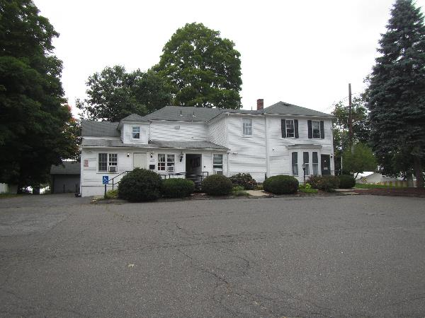

Prepared by:

Massachusetts Department of Public Health

Bureau of Climate and Environmental Health

December 2024

# Background

|  |  |
| --- | --- |
| Building: | Brimfield Town Hall Annex (BTHA) |
| Address: | 23 Main Street, Brimfield, MA |
| Assessment Requested by: | Brimfield Board of Health |
| Reason for Request: | General indoor air quality (IAQ) assessment and employee concerns |
| Dates of Assessment: | August 29, 2024, and September 18, 2024 |
| Massachusetts Department of Public Health/Bureau of Climate and Environmental Health (MDPH/BCEH) Staff Conducting Assessment: | Michael Feeney, Senior Bureau Advisor and Thomas Murphy, Environmental Analyst, BCEH |
| Date of Building Construction: | 1819 with an addition added later. |
| Building Description: | Two-story wooden building originally constructed as a residence. |
| Windows: | Openable |

# Background

The Brimfield Town Hall Annex (BTHA) was originally constructed as a two-story hip roofed home in 1819. The original house was constructed of cut timber. It appears support beams are connected in a mortice and tenon connection with no visible fasteners (Picture 1).

The interior of the building was converted into a medical office around 1986. An addition to the rear of the building was added at some point in time. Original plaster walls in the interior of the 1819 building are presumed to have been removed, with the first floor subdivided to create areas found in a typical medical office, including examination rooms, patient waiting rooms, meeting rooms, and clerical offices. The entire second floor was renovated as living space, including bathroom, kitchen, and laundry facilities, all equipped with plumbing and electrical services necessary for use.

The 1819 building had a dirt floor cellar with fieldstone walls. The BTHA has undergone a number of evaluations by various consultants as well as renovations to address concerns which can be found in detail on the town’s website <https://www.brimfieldma.org/home/building-committee/pages/structural-reports>. The following repairs were observed during the assessment of the 1819 building cellar:

* Installation of a cement slab on the floor of the 1819 cellar (Picture 2).
* Installation of permanent metal posts to support mortise and tenon joints of floor support beams (Picture 3, Figure 1), described as “W-shaped steel beams, HSS steel tubes and steel lally columns” (JSE, 2023).
* Use of 15 jack posts [also called “temporary screw jacks (JSE. 2023) and shoring jacks SA, 2012)] beneath the front of the building (Picture 4). [Please note that use of jack posts is cited in one report as “temporary” in both reports (JSE, 2023; S.A., 2012)].
* Installation of spray foam insulation in seams at various locations in the foundation (Picture 5).

Each of these renovations appear to be an effort to reinforce the building structure and prevent water damage.

The Town of Brimfield contracted with a consult who made the following recommendations:

1. Basement Humidity - Install a properly-sized basement dehumidifier(s).
2. Roof gutters - Maintain a clean and properly sized roof gutter system. Attach extenders to the ends of the downspouts to move water further away from the foundation.
3. Foundation- Repair any damage areas of the foundation walls to stop any water from entering the home (sic).

These recommendations were implemented.

# Methods

Please refer to the IAQ Manual and appendices for methods, sampling procedures, and interpretation of results (MDPH, 2015).

# Results and Discussion

The following is a summary of indoor air testing results (Table 1).

* ***Carbon dioxide*** measurements were above the MDPH recommended level of 800 parts per million (ppm) in some areas surveyed.
* ***Temperature*** was within the MDPH recommended range of 70°F to 78°F at the time of assessment.
* ***Relative humidity*** was above the MDPH recommended range of 40 to 60% in most areas tested.
* ***Carbon monoxide*** levels were non-detectable (ND) in all areas tested.
* ***Particulate matter (PM2.5)*** concentrations measured were below the National Ambient Air Quality (NAAQS) level of 35 μg/m3 in all areas tested.

## Ventilation

A heating, ventilating, and air conditioning (HVAC) system has several functions. First it provides heating and, if equipped, cooling. Second, it is a source of fresh air. Finally, an HVAC system will dilute and remove normally occurring indoor environmental pollutants by not only introducing fresh air, but also filtering the airstream and ejecting stale air to the outdoors via exhaust ventilation.

The BTHA has no general mechanical ventilation system. Heat is provided by baseboard units. The BTHA space is not configured to use cross-ventilation to provide comfort for building occupants due to its original construction. Some windows in the BTHA do not have the capacity to be opened to provide fresh air during temperate weather.

To provide cooling, rooms have window mounted air-conditioners (WACs). WACs recirculate air in a room, but do not provide significant fresh air. WACs are equipped with filters that need to be cleaned periodically. In at least one room the “check filter” light was on (Table 1). During filter cleaning, cooling fins should be examined for dust/debris and cleaned/vacuumed as needed to ensure efficient operation and to prevent mold growth and associated odors.

A ductless air conditioner was observed in one room. These systems are effective at cooling but do not provide air exchange.

## Microbial/Moisture Concerns

### Sources of moisture

The BTHA has a significant amount of stored materials in the basement which are susceptible to water damage. Any water-damaged porous material (e.g., paper records) not dried within 48 hours should be discarded and replaced to avoid microbial colonization. If damaged items are still needed or valuable, a document restoration contractor should be consulted regarding the potential for reclaiming items. Due to the potential for becoming moistened and mold-colonized, storage of paper and cardboard is not recommended in below grade space.

The following are possible pathways for moisture/odors to enter the BTHA from the basement or crawlspace:

* Holes created in the floor above the crawlspace for installing computer wire and phone service (Picture 6).
* The crawlspace ceiling has exposed wood without any insulation (Picture 7). Insulation was seen hanging or missing from the floor underside. Intact insulation would prevent airflow into rooms above the crawlspace.
* A large number of filing cabinets were noted in the BTHA. A filing cabinet can weigh between 200 to 400 pounds when fully loaded. Floors in the BTHA were found slanted and warped due to the weight of these filing cabinets. This additional weight on the floor can result in the opening of seams between interior walls and floors, which may provide a pathway for crawlspace and basement moisture/air to enter occupied space.

As previously noted, the second floor was converted into a living space, with the installation of plumbing drains for sinks, a shower, and a washing machine. All these drains are equipped with traps to prevent sewer gas from entering occupied spaces. These traps consist of a u-shaped pipe which collects water, forming a seal. Wetting drain traps regularly to maintain the airtight water seal is particularly important when heavy rains occur. As large amounts of water enter storm/sewer pipes, air and other water vapor/odors/pollutants can be forced up drainpipes, which would be prevented from entering the occupied space by a wet drain trap.

A ductless air conditioner, which was observed in the Collector’s office, is equipped with tubing and sometimes a pump to drain the condensation generated through operation. Leakage of water can occur when the condensate line is blocked or damaged, or the pump malfunctions. Ductless air conditioner tubing and pumps should be checked regularly to ensure proper drainage and repaired/cleaned when necessary.

Plants were noted in some rooms (Table 1). Plants, soil, and drip pans can serve as sources of mold/bacterial growth. Plants should be properly maintained, over-watering of plants should be avoided, and drip pans should be inspected periodically for mold growth.

The US Environmental Protection Agency (US EPA) and the American Conference of Governmental Industrial Hygienists (ACGIH) recommend that porous materials (e.g., ceiling tiles, carpet) be dried with fans and heating within 24 to 48 hours of becoming wet (US EPA, 2008; ACGIH, 1989). If not dried within this time frame, mold growth may occur. Once mold has colonized porous materials such as cardboard, books or ceiling tiles, they are difficult to clean and should be discarded. Frequently solid/non-porous items can be cleaned to remove water stains and microbial growth.

### High relative humidity due to hot, humid weather

One significant source of excess indoor humidity in this building is from high outdoor relative humidity. During past summers, several periods of extended hot, humid weather have occurred, in conjunction with extended periods of heavy rain. If a building such as the BTHA does not have adequate exhaust ventilation and air chilling capacity to remove and reduce relative humidity, then hot, moist air can linger to increase discomfort as well as possibly wet materials that may lead to mold growth.

The key to managing condensation in hot, humid weather indoors is understanding dew point. When warm, moist air passes over a cooler surface, condensation can form. Condensation is the collection of moisture on a surface at or below the dew point. The dew point is the temperature that air must reach for saturation to occur. If a building material/component has a temperature below the dew point, condensation will accumulate on that material. If this material is porous, such as carpeting, it may become colonized by mold.

Hot humid summers are becoming more frequent due to climate change. Massachusetts has experienced hot, humid, and rainy summers in 2018, 2021, 2023, and 2024. July of 2021 was the wettest ever recorded in Massachusetts, and the three-month period from June through August, known as the meteorological summer, was the fourth wettest on record, according to the National Oceanic and Atmospheric Administration’s (NOAA) Centers for Environmental Information (NOAA, 2021). The summer of 2023 was also hot, and wet, being measured as the second rainiest on record (WBUR, 2023). And the summer of 2024 has also had significant stretches of hot, humid weather. These conditions are challenging for buildings, particularly those without central air conditioning like the BTHA.

This weather resulted in condensation issues in many publicly owned or operated buildings, particularly those with below-grade space with walls or floors in direct contact with soil or cement slab floors. In these instances, the floors in direct contact with soil may have temperatures that would result in condensation wetting floors in high relative humidity conditions.

In general, if the BTHA space had mechanical ventilation, humid outdoor and return air would be drawn into the HVAC system where the functioning of the air conditioning would reduce humidity levels. The BTHA has no such system. In addition, WACs do not have sufficient capacity to provide any meaningful reduction of relative humidity. When outdoor humidity is high for a significant period, like it has been over the summer of 2024, indoor humidity can rise to uncomfortable levels and remain elevated.

### Building envelope concerns

As previously mentioned, the BTHA has a full basement that exists beneath the 1819 wing. The addition has a dirt crawlspace which contains an open well (Picture 8). In addition to exposure to hot, humid weather over the past decade, the interior of the building can have indoor relative humidity raised by water vapor from this open well.

Other conditions exist outdoors which may be sources of water entry into the cellar or addition crawlspace:

* Roof downspouts empty within 5 feet of foundation walls (Picture 9). Downspout rainwater should drain at a minimum distance of 5 feet from foundation walls to prevent water entering the cellar and crawlspace (Lstiburek, J. & Brennan, T. 2001).
* Plants and bushes were observed in contact with and near the exterior foundation. Plants near the building can cause water damage to the BTHA’s foundation. Additionally, plants shading exterior walls can slow drying. Water can eventually penetrate the foundation, subsequently freezing and thawing during the winter. This freezing/thawing action can weaken and damage the BTHA’s exterior components.
* The ground around the building does not slope away from the foundation walls. It is recommended that the ground should slope away from the wall at 5% (6 in. per 10 ft.) (Lstiburek, J. & Brennan, T. 2001).
* Given the large amount of rain that has occurred in New England, even with gutters installed, they may not have the capacity to collect and drain rainwater at a sufficient rate to reduce foundation and exterior wall moistening.

The Treasure’s Office storage room has skylight windows which are especially vulnerable to water penetration. The skylight windows should be examined for any openings to prevent potential water damage of porous materials including the large amount of stored cardboard boxes and wall-to-wall carpeting in the room.

Trees were noted very close to the BTHA (Picture 10). The presence of large trees is likely enhancing water retention, preventing drying of the exterior, and affecting drainage as well as overhanging the roof. These trees pose several hazards:

* Leaves and other debris accumulate around gutters, which inhibits rainwater drainage. Clogged gutters and/or ineffective drains can lead to water moistening exterior walls.
* Trees prevent sunlight from drying walls and soil.
* The trees are a possible danger to the BTHA due to the distance from exterior walls:
  + The recommended safe distance that any tree should be planted is the minimum of the expected maximum growth height of the species from the exterior of a building (BI, 2015).
  + Soil subsidence may also be caused by tree roots, which can undermine the structure of a building to cause wall and floor cracking and related damage. To prevent subsidence, a sufficient distance appropriate for the tree species is recommended (Williams, 2006).
  + Severe weather may result in the tree falling onto the building or the tree roots damaging the foundation. Due to the height of the trees, each is likely located closer than recommended distances.
* In general, a tree root system will spread out in all directions from its trunk. In some cases, tree roots can extend for over 100 feet from its trunk. Any structure disrupting the root structure may make the tree unstable if subjected to high winds from a certain direction. Based on the location, the foundation walls likely disrupt the roots of several trees.
* The Federal Emergency Management Agency (FEMA) provides several recommendations in order to prepare for severe thunderstorms. Of note FEMA recommends “Cut down or trim trees that may be in danger of falling on your [building]” (FEMA, 2018).

### Mold Testing Recommendations

The presence of mold found by a test does not necessarily indicate a problem. Visual evidence of mold growth and/or the presence of musty odors are reliable indicators of mold problems that are correlated with health risks in buildings where indoor environmental complaints have been made. Mold spores waft through the indoor and outdoor air continually. There is no practical way to eliminate all mold and mold spores in the indoor environment; the way to control indoor mold growth is to control moisture (US EPA, 2024).

There is no means by which to determine whether an individual’s symptoms or reactions were caused by mold by conducting environmental air testing for mold. While mold, spores, and other associated materials can make allergies and asthma symptoms worse, different people react differently to mold and mold spores. In addition to mold, reactions experienced by individuals could be caused by bacteria, other compounds in the air caused by the breakdown of wet building materials, or something different altogether (NIOSH, 2024; California DPH, unknown; Mendell, M. J., Mirer, A. G., Cheung, K., & Douwes, J. 2011; WHO. 2009).

The U.S. Environmental Protection Agency (EPA) does not recommend mold testing. DPH follows the guidelines contained in the U.S. EPA Mold Remediation in Schools and Commercial Buildings report for cleaning and removing water-damaged materials. US EPA’s guidelines recommend, in most cases, that if visible mold growth is present, mold sampling is not necessary. A number of international, Federal, and state agencies either do not have or recommend against conducting mold testing as part of mold remediation (see **REFERENCES** headings: **Agencies with guidelines recommending against mold testing,** and **Reference from government agencies, industrial hygiene groups and or other environmental professional guidelines that denote that no mold exposure limits have been established for mold in workplace, government buildings or residences).** Forexample, the U.S. Department of Housing and Urban Development (HUD) does not recommend conducting environmental mold testing:

*“No matter what kind of mold you have, you need to get rid of it and fix the moisture problems that made it grow. Most experts think it’s better to spend your time and money on cleaning up the problem than testing” (HUD. 2024).*

Multiple worker safety agencies and organizations have no worker safety air levels established for exposure to species of mold. The following agencies and professional industrial hygiene agencies have not established mold exposure levels in the workplace that would justify air testing. The following industrial safety guidelines do not list any mold species and air level concentrations:

* US Occupational Safety And Health Administration has not established any mold Permissible Exposure Limits (PELs) for mold air levels.
* American Conference of Governmental Industrial Hygienists (ACGIH) has no established Threshold Limit Values (TLVs) for mold air levels.
* National Institute of Occupational Safety and Health (NIOSH) has no established Recommended Exposure Limits (RELs) for mold air levels.
* American Industrial Hygiene Association (AIHA) has no established Workplace Environmental Exposure Levels (WEELs) for mold air levels.

Additionally, even if worker safety exposure limits existed for mold, such guidelines **would not apply** to non-employees in a building. These individuals include: students in primary education schools; students in secondary education facilities; adults outside worker ages as defined by OSHA; individuals with chronic health conditions; patients in any medical facility; adults who are customers, or visitors to the workplace; and other members of the general public.

For non-employees, there are **no established mold exposure limits** (international, Federal, or state regulations, building standards or guidelines) on how much mold can exist in air before health impacts are expected for the general population. Additionally, international, Federal, state or building standards agencies have not established mold remediation clean-up levels that must be achieved after mold remediation efforts are completed.

This means that even if tests are conducted, there is no way to compare results or determine whether the measured level could cause health effects or meet clean up levels. Multiple Federal agencies, including the US EPA, US Department of Housing and Urban Development and the US Federal Emergency Management Agency (FEMA) have not established mold exposure standards nor recommend environmental mold testing in any water damage/flood recovery guidelines. With no established safety exposure limits, air testing will not influence how mold remediation efforts would be conducted.

To remove mold from buildings, of primary importance is to identify, repair and/or limit the moisture source causing damage in the building. Once the moisture source is remediated, then discarding and/or cleaning of mold contaminated materials can be completed.

## Other Conditions

The BTHA has carpeting in some rooms. The service life of carpeting in schools is approximately 10-11 years (IICRC, 2002), and will be similar in an environment such as the BTHA. Aging carpet can produce fibers that can be irritating to the respiratory system. In addition, lifting carpet can create tripping hazards. Carpets should be cleaned annually (or semi-annually in soiled/high traffic areas) in accordance with Institute of Inspection, Cleaning and Restoration Certification (IICRC) recommendations, (IICRC, 2012). Regular cleaning with a high efficiency particulate air (HEPA) filtered vacuum in combination with an annual cleaning will help to reduce accumulation and potential aerosolization of materials from carpeting. Area carpeting should be cleaned on a frequent basis and replaced as needed as it begins to wear out.

Cardboard boxes were noted on the floor in rooms (Table 1). Large amounts of items in offices and common areas can prevent effective cleaning and may become attractive to pests as harborage.

A fireplace was observed in the Select Board office. If not properly sealed, the chimney connected to the fireplace can be a source of entry for respiratory irritants (dust and debris), water infiltration, hot/humid air, and pests. The fireplace and chimney should be sealed if they are no longer being used or they should be maintained in fully usable condition.

Personal fans were also noted in a few rooms (Table 1). If dust accumulates on the blades, it can be aerosolized during use. Fans should be checked and cleaned periodically to remove any dust/debris.

At least one air purifier was observed in the BTHA. These should be maintained, including filter changes, in accordance with manufacturer’s instructions. Air purifiers that may produce ozone should not be used in any occupied areas (EPA, 2003).

# Conclusions and Recommendations

The BTHA has a number of issues related to moisture in the building. Management of buildings in such weather without a centralized HVAC system equipped with cooling capacity can be challenging during periods of extended hot, humid weather like the summer of 2024. The following documents can provide guidance that can be used to reduce the impact of hot, humid weather in buildings.

* Mold Growth Prevention During Hot, Humid Weather <https://www.mass.gov/service-details/preventing-mold-growth-in-massachusetts-schools-during-hot-humid-weather>
* Remediation and Prevention of Mold Growth and Water Damage in Public Schools <https://www.mass.gov/service-details/remediation-and-prevention-of-mold-growth-and-water-damage-in-public-schools-and>
* Methods for Increasing Comfort in Non-air-conditioned Schools <https://www.mass.gov/doc/methods-for-increasing-comfort-in-non-air-conditioned-schools/download>

To remedy building problems, two sets of recommendations are made: **short-term** measures that may be implemented as soon as practicable and **long-term** measures that will require planning and resources to address overall IAQ concerns:

## Short Term Recommendations

1. It is recommended that porous material be dried with fans and heating within 24 to 48 hours of becoming wet (US EPA, 2008, ACGIH, 1989). If porous materials are not dried within this time frame, mold growth may occur. Water-damaged porous materials cannot be adequately cleaned to remove mold growth. If porous materials are not dried within this time frame, they should be removed and discarded.
2. Have the open well below the Board of Health office sealed permanently.
3. Remove spray foam from foundation seams and replace with an appropriate mortar material.
4. Seal all wire and pipe utility holes that exist in the ceiling of the crawlspace with an appropriate fire-rated material to prevent airflow.
5. Due to the age and construction of the BTHA, consideration should be given to reducing the amount of filing cabinets that are likely causing floor sagging/warping in all areas of the building.
6. Considerations should be given to reducing the number of stored records to prevent possible mold growth on cardboard and paper stored in the cellar of the building. To accomplish this goal, consulting the MA Secretary of States webpage for a schedule of records retention is recommended. Records retention schedule can be found at this webpage: <https://www.sec.state.ma.us/divisions/archives/records-management/municipal-records.htm>
7. Ensure that all sink and floor drains have sufficiently wetted traps. Pour water into each drain a minimum of once a week to maintain trap integrity. Consider sealing or properly abandoning any sinks and drains that are no longer needed, particularly on the second floor of the BTHA.
8. Ensure all WAC units are draining properly; inspect periodically.
9. Do not store porous items or other materials in the basement level of the building during summer months in direct contact with floors or exterior walls. Such materials include cardboard, paper, and other porous materials.
10. Use dehumidifiers in the building until outdoor conditions are cooler and drier and building heating is being used. Maintain all dehumidifiers and regularly remove water and clean receptacles to avoid stagnant water, odors, and the potential for leaks.
11. Clean/change filters of WAC units per manufacturers’ recommendations.
12. Regularly clean/vacuum any vents and personal fans to avoid aerosolizing accumulated particulate matter.
13. Trim back trees from overhanging roof and all plants/bushes to a distance of at least 5 feet away from the BTHA foundation walls.
14. Keep plants in good condition, avoid overwatering, and keep them away from the airstream of ventilation equipment.
15. Ensure that condensation from ductless air conditioner is draining properly. Check collector pans, piping and any associated pumps for clogs and leaks. Clean and inspect periodically to prevent stagnant water build-up and remove debris that may provide a medium for microbial growth.
16. Clean carpeting annually (or semi-annually in soiled high traffic areas) per the recommendations of the Institute of Inspection, Cleaning and Restoration Certification (IICRC, 2012).
17. Consider replacing any weathered area carpeting and floor carpeting that is beyond its service life (i.e., > 11yrs.).
18. In the winter in New England, periods of low relative humidity indoors are often unavoidable. Therefore, scrupulous cleaning practices should be adopted to minimize common indoor air contaminants whose irritant effects can be enhanced when the relative humidity is low. To control for dusts, a high efficiency particulate arrestance (HEPA) filter equipped vacuum cleaner in conjunction with wet wiping of all surfaces is recommended. Avoid the use of feather dusters. Drinking water during the day can help ease some symptoms associated with a dry environment (throat and sinus irritation).
19. Seal the chimney and fireplace in the Select Board room if no longer in use.
20. Maintain air purifiers in accordance with manufacturer's instructions. Avoid using any air purifiers that may produce ozone (e.g., ionizers). Consider locating air purifiers so the outlet of the units is in the breathing zone of occupants.
21. Refer to resource manual and other related IAQ documents located on the MDPH’s website for further building-wide evaluations and advice on maintaining public buildings. These documents are available at: <http://mass.gov/dph/iaq>.

## Long Term Recommendations

1. Consider removing all trees preventing solar drying of BTHA exterior walls and roof.
2. Consider regrading ground around building exterior to drain water away from the building.
3. Ensure that downspout drains are at least five feet away from the building foundation. Consider other activities to improve water drainage from courtyards.
4. Consider installing appropriate insulation in the ceiling of the crawlspace.

# REFERENCES

## General References

ACGIH.1989. Guidelines for the Assessment of Bioaerosols in the Indoor Environment. American Conference of Governmental Industrial Hygienists, Cincinnati, OH.

BI. 2015. A List of Trees and the Recommended Safe Distance from Buildings. Bickers Insurance, Littlehampton, West Sussex, UK. <https://www.bickersinsurance.co.uk/about-us/latest-news/property-owners-news/a-list-of-trees-and-the-recommended-safe-distance-from-buildings/>

FEMA. 2018. How to Stay Safe When a Thunderstorm Threatens. Federal Emergency Management Agency, Washington, DC. FEMA V-1009/May 2018.

IICRC. 2002. Institute of Inspection, Cleaning and Restoration Certification. A Life-Cycle Cost Analysis for Floor Coverings in School Facilities.

IICRC. 2012. Carpet Cleaning: FAQ. Institute of Inspection, Cleaning and Restoration Certification, Las Vegas, NV.

JSE. 2023. Structural Inspection Brimfield Town Hall Annex and Town Buildings, Johnson Structural Engineering Inc. Rochdale, MA. <https://www.brimfieldma.org/sites/g/files/vyhlif4181/f/pages/2023.05.18_jse_sow_brimfieldtownhallannexbuildingassessment.pdf>

Lstiburek, J. & Brennan, T. 2001. Read This Before You Design, Build or Renovate. Building Science Corporation, Westford, MA. U.S. Department of Housing and Urban Development, Region I, Boston, MA. [Read This Before You Design, Build or Renovate](https://www1.eere.energy.gov/buildings/publications/pdfs/building_america/32114.pdf)

Lstiburek, J. 2002. RR-0203: Relative Humidity. Building Science Corporation, Westford, MA. <https://www.buildingscience.com/documents/reports/rr-0203-relative-humidity/view>

Massachusetts Department of Public Health (MDPH). 2015. Indoor Air Quality Manual: Chapters I-III. Available at: <https://www.mass.gov/lists/indoor-air-quality-manual-and-appendices>.

NOAA. 2021. Summer 2021 neck and neck with Dust Bowl summer for hottest on record. National Oceanic and Atmospheric Administration, 1401 Constitution Avenue NW, Room 5128, Washington, DC 20230 <https://www.noaa.gov/news/summer-2021-neck-and-neck-with-dust-bowl-summer-for-hottest-on-record>.

SA. 2012. Structural Review Brimfield Town Hall Annex. Szewczak Associates. Avon, CT. [2012.04.02_szewczak_associates_annex_structural_condition_survey_2012_1.pdf](https://www.brimfieldma.org/sites/g/files/vyhlif4181/f/pages/2012.04.02_szewczak_associates_annex_structural_condition_survey_2012_1.pdf)

US EPA. 2003. “Ozone Generators that are Sold as Air Cleaners: An Assessment of Effectiveness and Health Consequences”. United States Environmental Protection Agency, Office of Air and Radiation, Indoor Environments Division, Washington, DC. Last updated September, 2018. <https://www.epa.gov/indoor-air-quality-iaq/ozone-generators-are-sold-air-cleaners>.

US EPA. 2008. “Mold Remediation in Schools and Commercial Buildings”. Office of Air and Radiation, Indoor Environments Division, Washington, DC. EPA 402-K-01-001. September 2008. Available at: <http://www.epa.gov/mold/mold-remediation-schools-and-commercial-buildings-guide>.

WBUR. 2023. “It's been a summer of rain and flooding misery in Mass.” WBUR local news. September 12, 2023. <https://www.wbur.org/news/2023/09/12/summer-flooding-rain-massachusetts>.

Williams, A. 2006. The Distance at Which Trees Can Affect a Building is Quite Significant. The Architects’ Journal. <https://www.architectsjournal.co.uk/home/the-distance-at-which-trees-can-affect-a-building-is-quite-significant/130858.article>

## Mold Testing References

ACGIH, 1989. Guidelines for the Assessment of Bioaerosols in the Indoor Environment. American Conference of Governmental Industrial Hygienists, Cincinnati, OH

CA DPH, unknown. California Department of Public Health Statement on Building Dampness, Mold, and Health. [California Department of Public Health Statement on Building Dampness Mold and Health](https://www.cdph.ca.gov/Programs/cls/dehl/ehl/CDPH%20Document%20Library/MoldDampStatement2017_ENG.pdf)

HUD. 2024. Help Yourself to a Healthy Home. US Department of Housing and Urban Development. Washington, DC. PAGES and Cover002.indd (hud.gov)

Mendell, M. J., Mirer, A. G., Cheung, K., & Douwes, J. 2011. Respiratory and allergic health effects of dampness, mold, and dampness-related agents: a review of the epidemiologic evidence. Environmental Health Perspectives 119(6):748. <https://pubmed.ncbi.nlm.nih.gov/21269928/>

NIOSH, 2024. [Mold, Testing, and Remediation | Workplace Mold | CDC](https://www.cdc.gov/niosh/mold/testing-remediation/index.html)

US EPA, 2008. “Mold Remediation in Schools and Commercial Buildings”. Office of Air and Radiation, Indoor Environments Division, Washington, DC. EPA 402-K-01-001. September 2008. Available at: <http://www.epa.gov/mold/mold-remediation-schools-and-commercial-buildings-guide>

U.S. EPA, 2024, Frequent Questions on Mold and Moisture, Updated: October 14, 2024. [Mold Frequently Asked Questions | US EPA](https://www.epa.gov/mold/mold-frequently-asked-questions)

WHO, 2009. WHO Guidelines for Indoor Air Quality: Dampness and Mould. World Health Organization Copenhagen: WHO Europe. WHO guidelines for indoor air quality : dampness and mould <https://www.who.int/publications/i/item/9789289041683>

## Agencies with guidelines recommending against mold testing

APHC. Residential Indoor Mold and Residential Mold Air Sample Results What Do They Mean? FACT SHEET 55-026-0319. U.S. Army Public Health Center, Industrial Hygiene Field Services Program, Aberdeen Proving Ground, Maryland.

CA HESIS. 2005. Molds in Indoor Workplaces. California Hazard Evaluation System and Information Service. P.2 Molds in Indoor Workplaces: Fact Sheet for Workers and Employers (ca.gov) Nov. 2005

CDC. 2024. Mold. Centers for Disease Control. Atlanta, GA. [Mold | Mold | CDC](https://www.cdc.gov/mold-health/about/index.html).

CTDPH. 2012. Get The Mold Out: Mold Clean-Up Guidance for Residences Fact Sheet. Connecticut Department of Public Health Environmental & Occupational Health Assessment Program Environmental Health Secon 410 Capitol Avenue, MS # 11EOH. [Get The Mold Out_ fact sheet082012](https://portal.ct.gov/-/media/departments-and-agencies/dph/dph/environmental_health/eoha/pdf/getthemoldoutpdf.pdf)

FEMA, unk. Homeowner’s and Renter’s Guilder o Mold Cleanup after Disasters. <https://www.fema.gov/sites/default/files/documents/fema_hm-cdc-homeowners-and-renters-mold-guide_english.pdf>

Health Canada. Guide to addressing moisture and mould indoors. <https://www.canada.ca/en/health-canada/services/publications/healthy-living/addressing-moisture-mould-your-home.html>

MDHHS. 2010. Mold Fact Sheet. Maine Department of Health and Human Services, Bangor, ME. <https://www.maine.gov/dhhs/mecdc/infectious-disease/epi/disease/documents/pdf/mold.pdf>

MNDPH. 2024. Testing For Mold. [Testing For Mold - MN Dept. of Health (state.mn.us)](https://www.health.state.mn.us/communities/environment/air/mold/moldtest.html)

NHDHHS. 2013. Mold and moisture. New Hampshire Department of Health and Human Services, Concord, NH. [https://www.dhhs.nh.gov/sites/g/files/ehbemt476/files/documents/2021-11/holu-dphs-mold-policy-letter.pdf](https://www.dhhs.nh.gov/sites/g/files/ehbemt476/files/documents/2021-11/holu-dphs-mold-policy-letter.pdf#:~:text=Although%20a%20handful%20of%20states%20have%20passed%20their,when%20ever%20you%20see%20mold%20or%20smell%20mildew.)

NIOSH. 2024. Mold, Testing, and Remediation. National Institute of Occupational Safety and Health, Cincinnati, OH.

NYDOL. Mold Assessment and Remediation in New York State. Mold Assessment and Remediation in New York State. New York Department of Labor. [p227.pdf (ny.gov)](https://dol.ny.gov/system/files/documents/2021/03/p227.pdf)

ODHS. Unk. FAST FACTs: Household Mold. Oregon Department of Human Services, Public Health Division, Office of Environmental Public Health: Toxicology Consulting Services. [Moldfactsheet.pdf (oregon.gov)](https://www.oregon.gov/oha/ph/HealthyEnvironments/TrackingAssessment/EnvironmentalHealthAssessment/Documents/Moldfactsheet.pdf)

OSHA. Mold. US Occupational Safety and Health Administration. [Mold - Recognize Mold Hazards | Occupational Safety and Health Administration (osha.gov)](https://www.osha.gov/mold/hazards)

USAPHC. 2018. Technical Guide 278 Industrial Hygiene Public Health Mold Assessment Guide. US Army Public Health Center, Public Health 6582 Magrath Ave BLDG 2059 Fort Carson, Colorado. <https://ph.health.mil/PHC%20Resource%20Library/TG278.pdf> .

VTDH. 2024. Mold Inside Home and Other Buildings. <https://www.healthvermont.gov/sites/default/files/document/env-hh-mold-indoors.pdf>

WSDH. Unk. Mold. Washington State Department of Health, [Mold | Washington State Department of Health](https://doh.wa.gov/community-and-environment/contaminants/mold)

## References from government agencies, industrial hygiene groups, and/or other environmental professional guidelines that denote that no mold exposure limits have been established for mold in workplace, government buildings or residences.

AIHA. 2019. FAQs About Spore Trap Air Sampling for Mold for Direct Microscopical Examination Mold Analysis Document. American Industrial Hygiene Association, Falls Church, VA. <https://aiha-assets.sfo2.digitaloceanspaces.com/AIHA/resources/FAQs-About-Spore-Trap-Air-Sampling-for-Mold-for-Direct-Examination-Guidance-Document.pdf>

APHC. Residential Indoor Mold and Residential Mold Air Sample Results What Do They Mean? FACT SHEET 55-026-0319. U.S. Army Public Health Center, Industrial Hygiene Field Services Program, Aberdeen Proving Ground, Maryland.

FEMA, unk. Homeowner’s and Renter’s Guilder o Mold Cleanup after Disasters. <https://www.fema.gov/sites/default/files/documents/fema_hm-cdc-homeowners-and-renters-mold-guide_english.pdf>

MDHHS. 2010. Mold Fact Sheet. Maine Department of Health and Human Services, Bangor, ME. <https://www.maine.gov/dhhs/mecdc/infectious-disease/epi/disease/documents/pdf/mold.pdf>

OHHN. 2023. Mold Basics. Ohio Healthy Homes Network, Columbus, Ohio. [Mold Basics | Ohio Healthy Homes Network (ohhn.org)](https://www.ohhn.org/mold-basics/)

WDHS. 2021. Controlling Mold and Moisture Household Mold Guidance for Local Health Professionals Wisconsin Department of Health Services, Indoor Air and Radon Program Division of Public Health, Bureau of Environmental and Occupational Health. <https://www.dhs.wisconsin.gov/publications/p02069.pdf>

WHO, 2009. WHO Guidelines for Indoor Air Quality: Dampness and Mould. World Health Organization Copenhagen: WHO Europe. WHO guidelines for indoor air quality : dampness and mould <https://www.who.int/publications/i/item/9789289041683>

**Figure 1**

Mortise Tenon

**Mortise and Tenon Joint**

**http://en.wikipedia.org/wiki/Mortise_and_tenon**

**Picture 1**

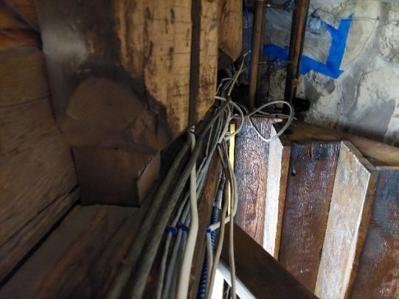

**Floor beams and mortise/tenon joint in cellar ceiling**

**Picture 2**

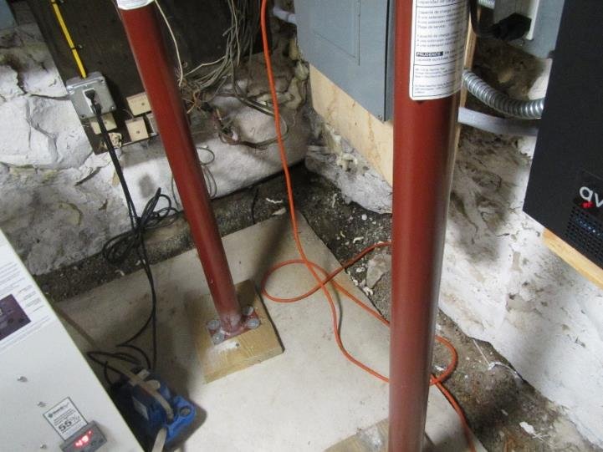

**Cement slab on the floor of the 1819 cellar, note space between floor and wall**

**Picture 3**

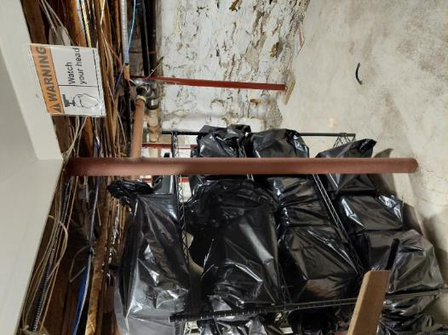

**Permanent metal posts to support mortise and tenon joints**

**Picture 4**

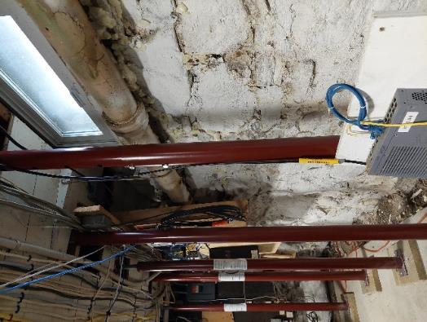

**Jack posts in cellar installed on wood square that rest on cement slab on the floor of the 1819 cellar**

**Picture 5**

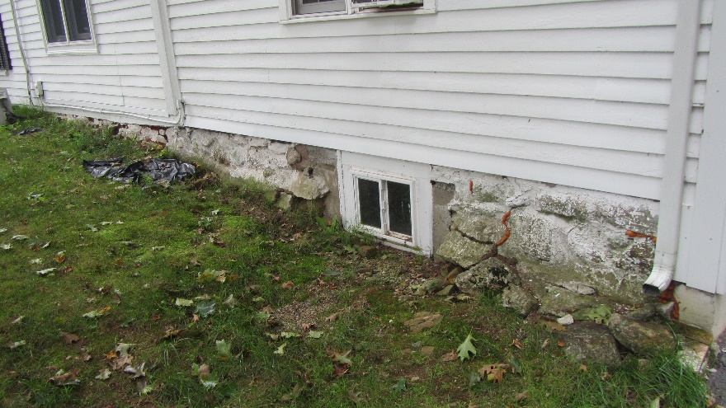

**Seams in various locations of the foundation with spray foam insulation**

**Picture 6**

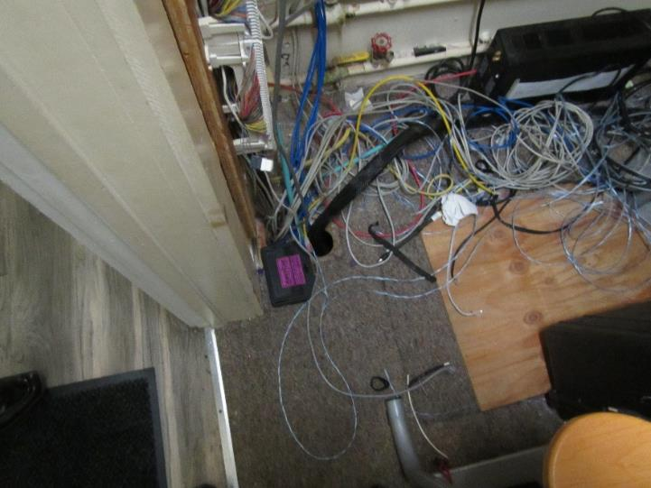

**Hole in first floor closet for computer wire that is open to the crawlspace**

**Picture 7**

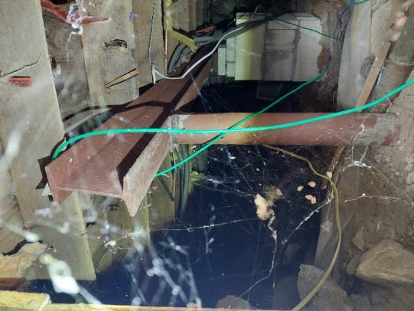

**Crawlspace ceiling missing insulation**

**Picture 8**

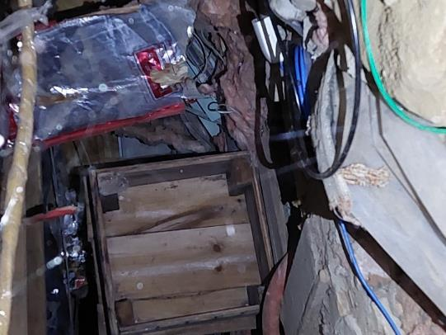

**Open well in crawlspace below the Board of Health office**

**Picture 9**

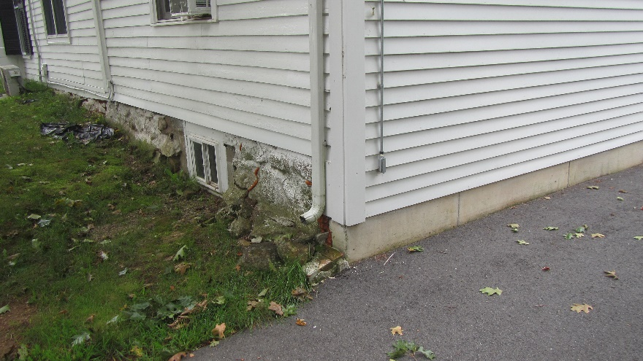

**Roof downspouts that empty adjacent to the foundation**

**Picture 10**

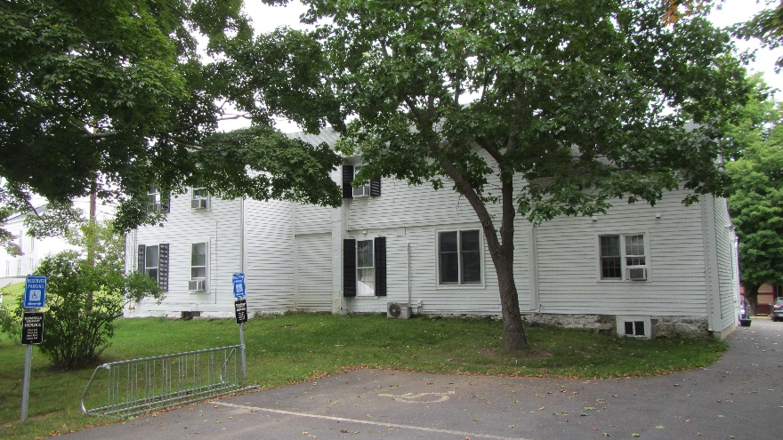

**Trees shading BTHA exterior walls and overhanging the roof**

| **Location/ Room** | **Carbon**  **Dioxide**  **(ppm)** | **Carbon Monoxide**  **(ppm)** | **Temp**  **(°F)** | **Relative**  **Humidity**  **(%)** | **PM2.5**  **(****µg/m3)** | **Occupants**  **in Room** | **Windows**  **Openable** | **Ventilation** | | **Remarks** |
| --- | --- | --- | --- | --- | --- | --- | --- | --- | --- | --- |
| **Supply** | **Exhaust** |
| Background | 422 | ND | 70 | 64 | 5 |  |  |  |  | Overcast |
| Assessors | 692 | ND | 76 | 60 | ND | 1 | N | N | N | Filter light on WAC, plants, area carpet |
| Basement | 608 | ND | 75 | 55 | ND | 0 | Y | N | N | Dehumidifier, jack posts |
| Board of Health | 1067 | ND | 73 | 64 | 2 | 3 | N | N | N | WAC, area carpet, open well underneath floor |
| Building Department | 635 | ND | 75 | 59 | 2 | 0 | N | N | N | WAC, personal fan |
| Collector | 1310 | ND | 72 | 61 | 1 | 3 | Y | N | N | Ductless air conditioner, air purifier, plant, |
| Conservation Commission | 761 | ND | 76 | 62 | ND | 1 | Y | N | N | WAC, cardboard boxes on floor, carpeted |
| Highway Department | 675 | ND | 75 | 60 | 1 | 0 | N | N | N | WAC, area carpet |
| Select Board | 1090 | ND | 71 | 64 | 1 | 2 | Y | N | N | WAC, air purifier, plants, unsealed chimney, area carpet |
| Storage Area with Kitchen | 747 | ND | 75 | 61 | ND | 0 | Y | N | N | WAC, kitchen sink, attached bathroom with sink, shower, and toilet |
| Treasurer | 556 | ND | 77 | 56 | ND | 1 | Y | N | N | WAC, AP, area carpet |
| Treasurer’s Office Storage Area | 605 | ND | 77 | 64 | ND | 0 | Y | N | N | Carpeted, large amount of stacked cardboard boxes on floor, skylight windows |
| Town Clerk | 872 | ND | 73 | 61 | ND | 2 | N | N | N | WAC, holes in floor |
| Unused Bathroom Storage Area | 762 | ND | 77 | 59 | ND | 0 | Y | N | N | Abandoned toilet, shower, sink |