**INDOOR AIR QUALITY ASSESSMENT**

**Brimfield Town Hall (closed)**

**21 Main Street**

**Brimfield, MA**

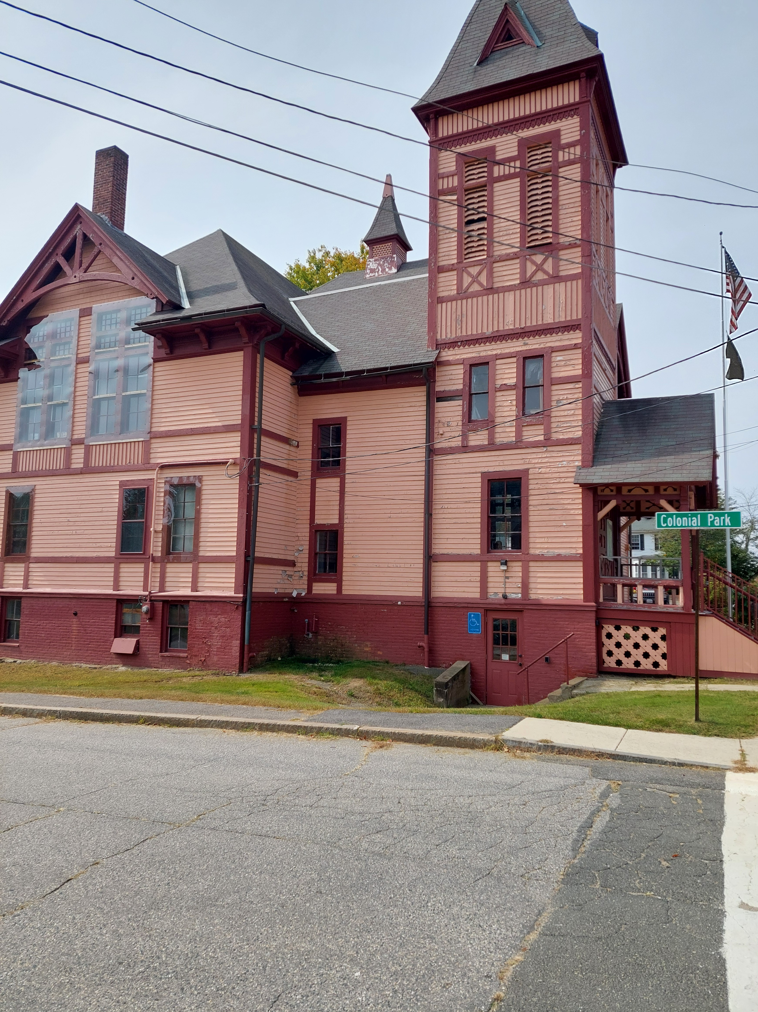

Prepared by:

Massachusetts Department of Public Health

Bureau of Climate and Environmental Health

January 2025

**BACKGROUND**

|  |  |
| --- | --- |
| **Building:** | Brimfield Town Hall (BTH) |
| **Address:** | 21 Main Street, Brimfield, MA |
| **Assessment coordinated via:** | Brimfield Board of Health |
| **Reason for Request:** | Water damage and general indoor air quality (IAQ) concerns |
| **Date of Assessment:** | September 18, 2024 |
| **Massachusetts Department of Public Heath/Bureau of Climate and Environmental Health (MDPH/BCEH) Staff Conducting Assessment:** | Michael Feeney, Senior Advisor, BCEH, and Thomas Murphy, Environmental Analyst, Division of Environmental Health Regulations and Standards (DEHRS) |
| **Building/Site Description:** | The BTH is a two-story wood-clad building with a basement located next to the Brimfield Town Hall Annex. It was originally constructed in the late 1870s. Later renovations included wall-to-wall carpeting over maple tongue-in-groove floors. The basement contains a cable TV studio constructed from gypsum wallboard with wall-to-wall carpeting. The Brimfield Police Department was formerly located in another renovated section of the basement. |
| **Building Population:** | The building is currently closed and is used for records storage. |
| **Windows:** | Openable |

# METHODS

MDPH staff conducted a visual inspection of rooms with reported mold odors to identify sources of moisture that would moisten materials in the building to cause mold growth. Please refer to the IAQ Manual and appendices for methods, sampling procedures, and interpretation of results (MDPH, 2015).

**RESULTS AND DISCUSSION**

Measurements for IAQ parameters are shown in Table 1 and summarized below:

* ***Temperature*** was below the lower end of the recommended range of 70°F to 78°F in all areas tested.
* ***Relative humidity*** was above the recommended range of 40% to 60% in all areas tested.

## Ventilation

It is important to note that the BTH was originally constructed at a time when it was likely not intended to be occupied during hot, humid weather that occurs in summer months. In its original configuration, the building likely was intended to use cross-ventilation to provide comfort for building occupants. The BTH is equipped with windows on opposing exterior walls. This design allows for airflow to enter an open window, pass through a room, and exit the building on the other side. With all windows, and hallway doors or transoms, open, airflow can be maintained in a building regardless of the direction of the wind. The system fails if the windows or hallway doors are closed.

Heat is provided by radiators beneath windows. The basement has a forced hot air system that appears to have provided heating for the former Brimfield Police Department (BPD) space.

A window mounted air conditioner (WAC) was also observed in the former BPD space to provide cooling. WACs recirculate air in a room, but do not provide significant fresh air. WACs are equipped with filters that need to be cleaned periodically. During filter cleaning, cooling fins should be examined for dust/debris and cleaned/vacuumed as needed to ensure efficient operation and to prevent mold growth and associated odors.

There is a television studio equipped with a wall-mounted ductless air-conditioning unit. These systems are effective at cooling but do not provide air exchange.

Flue pipes for combustion equipment in the basement had open holes (Picture 1). In this condition, products of combustion may escape from the flue into the indoor environment. In one case, the hole was stained indicating the release of products of combustion into the furnace room (Picture 2). In addition, joints of flue ductwork do not appear to be sealed with mastic (Picture 3).

## Microbial/Moisture Concerns

### Basement conditions

Buildings constructed with fieldstone foundations tend to become moistened with condensation during hot, humid weather. For this reason, building materials used when the BTH was constructed were typically materials that are resistant to mold growth, that may include stone, hardwood, brick with mortar joints, plaster and/or cement.

Sometime in the past, the basement was renovated to be the BPD, and a section was turned into a TV studio. Some of the materials used in these renovations can potentially serve as mold growth media if sufficiently moistened. These materials include wall-to-wall carpeting, gypsum wallboard (GW), and engineered woods, such as plywood and wood paneling. In addition, the TV studio was constructed with spline ceiling tiles in places and curtains. The GW in the TV Studio appears to be installed directly against the fieldstone foundation (Picture 4). Each of these building materials may become mold colonized if moistened for over 24-48 hours. In addition to building materials, cardboard boxes containing paper were noted to be stored on cement floors.

Ductless air conditioners, such as the one observed in the TV Studio, are equipped with tubing and sometimes a pump to drain the condensation generated through operation. Leakage of water can occur when the condensate line is blocked or damaged, or the pump malfunctions. Ductless air conditioner tubing and pumps should be checked regularly to ensure proper drainage and repaired/cleaned when necessary.

Note that relative humidity indoors at the time of the assessment was higher than that measured outdoors, however the dew point outdoors (62ºF) was higher than indoors (56ºF). Dew point is a measure of humidity that indicates the temperature a surface would need to be at or below to start accumulating condensation. It can be calculated based on temperature and relative humidity. Dewpoint is an important measurement when determining if there is the potential for building materials to become moistened when cooler surfaces, such as those in contact with the ground, meet warmer, humid air. When dewpoint inside is higher than that of outside air, it is increasingly likely that sources of moisture are present inside the building, however even with a lower dew point inside, there may be additional moisture that can be mitigated to prevent water damage and mold growth.

No means of mechanical fresh air or natural ventilation from openable windows exists in the TV studio or other locations in the basement. In addition, the basement can be subject to significant moisture accumulation from the following sources:

* The basement has water vapor sources from seldom used restrooms as well as sinks with dry drain traps.
* The building foundation consists of stack fieldstone without parged walls (the application of a cement coating applied over a wall surface, such as over a foundation, or exterior wall). In this condition rainwater and soil water vapor can readily enter the basement. Efforts to reduce water penetration were implemented by application of spray foam insulation applied between foundation stone seams. In the experience of MDPH staff, foam insulation tends to hold moisture against stone which then shifts the water to enter the building through unsealed seams. To reduce this issue, the roof should drain away from the foundation wall (using gutters and downspouts) as much as possible. Downspouts should discharge at least five feet from the foundation walls.
* If a building lacks adequate exhaust ventilation and air chilling capacity to reduce relative humidity from outside air, then hot, moist air can be introduced into a building through normal occupancy and linger to increase occupant discomfort. Excess humidity can also moisten materials that may lead to mold growth, particularly in areas that are in direct contact with soil (e.g., basement floor and walls).

### Mold Testing Recommendations

The presence of mold does not necessarily indicate a problem. Visual evidence of mold growth and/or the presence of musty odors are reliable indicators of mold problems that are correlated with health risks in buildings where indoor environmental complaints have been made. Mold spores waft through the indoor and outdoor air continually. There is no practical way to eliminate all mold and mold spores in the indoor environment; the way to control indoor mold growth is to control moisture (U.S. EPA, 2024).

There is no means by which to determine whether an individual’s symptoms or reactions were caused by mold by conducting environmental air testing for mold. While mold, spores, and other associated materials can make allergies and asthma symptoms worse, different people react differently to mold and mold spores. In addition to mold, reactions experienced by individuals could be caused by bacteria, other compounds in the air caused by the breakdown of wet building materials, or something different altogether (NIOSH, 2024; California DPH, unknown; Mendell, M. J., Mirer, A. G., Cheung, K., & Douwes, J. 2011; WHO. 2009).

The U.S. Environmental Protection Agency (EPA) does not recommend testing. DPH follows the guidelines contained in the U.S. EPA Mold Remediation in Schools and Commercial Buildings report for cleaning and removing water-damaged materials. US EPA’s guidelines recommend, in most cases, that if visible mold growth is present, mold sampling is not necessary. A number of international, US Federal, and state agencies either do not have or recommend against conducting mold testing as part of mold remediation (see References with headings of: Agencies with guidelines recommending against mold testing and References from government agencies, industrial hygiene groups and/or other environmental professional guidelines that denote that no mold exposure limits have been established for mold in workplaces, government buildings, or residences). For example, the U.S. Department of Housing and Urban Development (HUD) does not recommend conducting environmental mold testing.

*“No matter what kind of mold you have, you need to get rid of it and fix the moisture problems that made it grow. Most experts think it’s better to spend your time and money on cleaning up the problem than testing”* (HUD, 2024).

In addition, multiple worker safety agencies and organizations have no worker safety air levels established for exposure to species of mold. The following agencies and professional industrial hygiene agencies have not established mold exposure levels in the workplace that would justify air testing. The following industrial safety guidelines do not list any mold species and air level concentrations:

* US Occupational Safety and Health Administration has not established any mold Permissible Exposure Limits (PELs) for mold air levels.
* American Conference of Governmental Industrial Hygienists (ACGIH) has no established Threshold Limit Values (TLVs) for mold air levels.
* National Institute of Occupational Safety and Health (NIOSH) has no established Recommended Exposure Limits (RELs) for mold air levels.
* American Industrial Hygiene Association (AIHA) has no established Workplace Environmental Exposure Levels (WEELs) for mold air levels.

In addition, even if worker safety exposure limits existed for mold, such guidelines **would not apply** to non-employees in a building. These individuals include students in primary education schools; students in secondary education facilities; adults outside worker ages as defined by OSHA; individuals with chronic health conditions; patients in any medical facility; adults who are invitees, customers, or visitors to the workplace and other members of the general public.

For non-employees, there are **no established mold exposure limits** (international, Federal, or state regulations, building standards or guidelines) on how much mold can exist in air before health impacts are expected for the general population. In addition, no international, Federal, state, or building standards agency have established mold remediation clean-up levels that must be achieved after mold remediation efforts are completed.

This means that even if tests are conducted, there is no way to compare results or determine whether the measured level could cause health effects or meet clean-up levels. Multiple Federal agencies, including the US EPA, US Department of Housing and Urban Development and the US Federal Emergency Management Agency (FEMA) have not established mold exposure standard or recommend environmental mold testing in any water damage/flood recovery guidelines. With no established worker or general public safety exposure limits, air testing will not influence how mold remediation efforts would be conducted.

In order to remove mold from buildings, of primary importance is to identify, repair and/ or limit the moisture source causing damage in the building. Once the moisture source is remediated, then discarding and/or cleaning of mold contaminated materials can be completed.

## Other Concerns

Basement areas had carpeting that appeared to be several decades old. In many areas, this carpeting was visibly very worn, frayed, wrinkled, and stained. The service life of carpeting in schools is approximately 10-11 years (IICRC, 2002), and will be similar in an environment such as a town hall. Aging carpet can produce fibers that can be irritating to the respiratory system. In addition, torn or lifting carpet can create tripping hazards. Carpeting should be cleaned annually or semi-annually in soiled high traffic areas as per the recommendations of the Institute of Inspection, Cleaning and Restoration Certification (IICRC, 2012).

A wooden post was noted in the basement hallway outside the TV studio that appears to have split (Picture 5). While not confirmed, this split post may be beneath a freestanding safe on the first floor (Picture 6). An insulated pipe with an uncapped end was noted (Picture 7; Table 1). This material may contain asbestos and should be examined by a Massachusetts licensed asbestos inspector.

Below-grade space in Massachusetts may also be a source of exposure to radon. Due to the presence of the TV studio in that basement and possible use by students, it is recommended to have the TV studio tested in a manner similar to schools. The Environmental Protection Agency (EPA) conducted a National School Radon Survey in which it discovered nearly one in five schools had “…at least one frequently occupied ground contact room with short-term radon levels above 4 [picocuries per liter] pCi/L” (US EPA, 1993). BCEH therefore recommends that every school be tested for radon, and that this testing be conducted during the heating season while school is in session in a manner consistent with USEPA radon testing guidelines. Radon measurement specialists and other information can be found at [www.nrsb.org](http://www.nrsb.org) and <http://aarst-nrpp.com/wp>, with additional information at: <https://www.mass.gov/radon>.

**CONCLUSIONS/RECOMMENDATIONS**

The BTH has a number of issues related to moisture in the building. Management of buildings without a centralized HVAC system equipped with cooling capacity. air conditioning can be challenging during periods of extended hot, humid weather. Additionally, the BTH has undergone feasibility studies, assessments and engineering studies concerning its current condition and its possible renovation. These can be found at <https://www.brimfieldma.org> which is the town’s website. With regard to possible mold issues, the following documents can provide guidance that can be used to reduce the impact of hot, humid weather in buildings.

* Mold Growth Prevention During Hot, Humid Weather <https://www.mass.gov/service-details/preventing-mold-growth-in-massachusetts-schools-during-hot-humid-weather>
* Remediation and Prevention of Mold Growth and Water Damage in Public Schools <https://www.mass.gov/service-details/remediation-and-prevention-of-mold-growth-and-water-damage-in-public-schools-and>
* Methods for Increasing Comfort in Non-air-conditioned Schools <https://www.mass.gov/doc/methods-for-increasing-comfort-in-non-air-conditioned-schools/download>

To remedy building problems, two sets of recommendations are made: **short-term** measures that may be implemented as soon as practicable and **long-term** measures that will require planning and resources to address overall IAQ concerns:

**Short Term Recommendations**

### Ventilation recommendations

1. Use openable windows and hallway doors for cross ventilation during periods of temperate weather when the building is in use.
2. Keep windows closed during heavy rain and hot humid weather to prevent water damage and avoid opening windows in areas where air conditioning is operating. Ensure all windows are tightly closed when the building is unoccupied.
3. Seal all holes in furnace flues with an appropriate heat and fire-rated sealant or replace flues with appropriate materials.

### Water damage recommendations

1. Remove spray foam from foundation seams and replace with cement or other appropriate mortar type of materials.
2. Examine gypsum wallboard along the foundation for mold growth and remove any that shows signs of mold growth including dark sports or moldy odors. If GW is in contact with foundation fieldstone, consider cutting GW back to prevent wetting during hot, humid weather
3. Consider replacing GW with cement board or other materials not prone to mold growth.
4. It is recommended that porous material be dried with fans and heating within 24 to 48 hours of becoming wet (US EPA, 2008, ACGIH, 1989). If porous materials are not dried within this time frame, mold growth may occur. Water-damaged porous materials cannot be adequately cleaned to remove mold growth. If porous materials are not dried within this time frame, they should be removed and discarded. Follow the guidance in “Mold Remediation in Schools and Commercial Buildings” published by the US EPA (2008) when performing mold remediation. Copies of this document can be downloaded from the US EPA website at: <https://www.epa.gov/mold/mold-remediation-schools-and-commercial-buildings-guide> .
5. Considerations should be given to reducing the number of stored records to prevent possible mold growth on cardboard and paper stored in the basement of the BTH. To accomplish this goal, consulting the MA Secretary of States webpage for a schedule of records retention is recommended. Records retention schedule can be found at this webpage: <https://www.sec.state.ma.us/divisions/archives/records-management/municipal-records.htm>
6. Do not store porous items or other materials in the basement level of the building during summer months in direct contact with floors or exterior walls. Such materials include cardboard, paper, and other porous materials. These materials should be stored up off the floor and away from walls on shelving or other equipment.
7. To prevent moisture penetration into the basement, the following actions should be considered:
   1. Seal all cracks in cement and asphalt around the front of the building.
   2. Ensure that the gutter/downspout on roof edges does not empty rainwater against the foundation wall.
   3. Seal all cracks in the foundation and the foundation/cement/tarmac junctions with an appropriate sealing compound.
   4. Remove foliage to at least five feet from the foundation.
   5. Improve the grading of the ground away from the foundation at a slope of 6 inches per every 10 feet (Lstiburek, J. & Brennan, T.; 2001).
   6. Install a water-impermeable layer on ground surface (clay cap) to prevent water saturation of ground near foundation (Lstiburek, J. & Brennan, T.; 2001).
8. Seal open holes in that exist in floors and walls between the basement and upper floors. This includes any utility holes. Ensure that the door to the basement remains closed at all times and use weatherstripping to increase airtightness.
9. Ensure that all sink and floor drains have sufficiently wetted traps. Pour water into each drain a minimum of once a week to maintain trap integrity. Consider sealing or properly abandoning any sinks and drains that are no longer needed, particularly on the second floor of the BTH.
10. Ensure that condensation from ductless air conditioners and WACs are draining properly. Check collector pans, piping and any associated pumps for clogs and leaks. Clean and inspect periodically to prevent stagnant water build-up and remove debris that may provide a medium for microbial growth.
11. Clean/change filters of air conditioning units per manufacturers’ recommendations.

### Other recommendations

1. If carpet is retained, clean carpeting annually (or semi-annually in soiled high traffic areas) per the recommendations of the Institute of Inspection, Cleaning and Restoration Certification (IICRC, 2012).
2. Consider replacing any carpeting that is installed in the basement that is beyond its service life (i.e., > 11yrs.). If carpet is to be removed, confirm that no asbestos-containing floor tiles exist in underflooring. If asbestos tile exists, compliance with all applicable asbestos removal and disposal laws is recommended.
3. Consult a building engineer to determine the integrity of the split support post in the basement and the effect of the safe located on the floor above it.
4. If the pipe in Picture 7 contains asbestos, remediate the material in a manner consistent with MA asbestos remediation and disposal laws and regulations.
5. Due to the use of the TV studio, the basement should be tested for radon by a certified radon measurement specialist during the heating season when the building is occupied. Radon measurement specialists and other information can be found at: [www.nrsb.org](http://www.nrsb.org/), and <http://aarst-nrpp.com/wp>.
6. Refer to resource manuals and other related indoor air quality documents for further building-wide evaluations and advice on maintaining public buildings. These materials are located on the MDPH’s website at <https://www.mass.gov/lists/indoor-air-quality-manual-and-appendices>.

## Long-Term Recommendations

1. Consult a building engineer on the appropriate method to regard the BTH exterior to reduce rainwater penetration through the foundation.
2. Consult with a building engineer on further methods to permanently render the basement as watertight as feasible.
3. Consider a plan to replace aging carpeting in the building.

# REFERENCES

## General References

Bishop. 2002. Bishop, J. & Institute of Inspection, Cleaning and Restoration Certification. A Life Cycle Cost Analysis for Floor Coverings in School Facilities.

IICRC. 2012. Carpet Cleaning: FAQ. Institute of Inspection, Cleaning and Restoration Certification, Las Vegas, NV. <https://iicrc.org/>

Lstiburek, J. & Brennan, T. 2001. Read This Before You Design, Build or Renovate. Building Science Corporation, Westford, MA. U.S. Department of Housing and Urban Development, Region I, Boston, MA. [Read This Before You Design, Build or Renovate](https://www1.eere.energy.gov/buildings/publications/pdfs/building_america/32114.pdf)

Lstiburek, J. 2002. RR-0203: Relative Humidity. Building Science Corporation, Westford, MA. <https://www.buildingscience.com/documents/reports/rr-0203-relative-humidity/view>

Massachusetts Department of Public Health (MDPH). 2015. Indoor Air Quality Manual: Chapters I-III. Available at: <http://www.mass.gov/eohhs/gov/departments/dph/programs/environmental-health/exposure-topics/iaq/iaq-manual/>.

SMACNA. 1994. HVAC Systems Commissioning Manual. 1st ed. Sheet Metal and Air Conditioning Contractors’ National Association, Inc., Chantilly, VA.

US EPA. 1993. Radon Measurement in Schools, Revised Edition. Office of Air and Radiation, Office of Radiation and Indoor Air, Indoor Environments Division (6609J). EPA 402-R-92-014.

**Mold Testing References**

ACGIH, 1989. Guidelines for the Assessment of Bioaerosols in the Indoor Environment. American Conference of Governmental Industrial Hygienists, Cincinnati, OH

ASHRAE, 1985. ASHRAE Transactions. Optimum Relative Humidity Ranges for Health. American Society of Heating, Refrigeration and Air Conditioning Engineers. Vol. 91, Part 1B.

CA DPH, unknown. California Department of Public Health Statement on Building Dampness, Mold, and Health. [California Department of Public Health Statement on Building Dampness Mold and Health](https://www.cdph.ca.gov/Programs/cls/dehl/ehl/CDPH%20Document%20Library/MoldDampStatement2017_ENG.pdf)

HUD. 2024. Help Yourself to a Healthy Home. US Department of Housing and Urban Development. Washington, DC. PAGES and Cover002.indd (hud.gov).

IICRC, 1997. IICRC S001 Standards Reference Guide for Professional On-location Cleaning of Installed Textile Floor Covering Materials. 3rd ed. The Institute of Inspection, Cleaning and Restoration Certification, Vancouver, WA.

Mendell, M. J., Mirer, A. G., Cheung, K., & Douwes, J. 2011. Respiratory and allergic health effects of dampness, mold, and dampness-related agents: a review of the epidemiologic evidence. Environmental Health Perspectives 119(6):748. <https://pubmed.ncbi.nlm.nih.gov/21269928/>

NIOSH, 2024. [Mold, Testing, and Remediation | Workplace Mold | CDC](https://www.cdc.gov/niosh/mold/testing-remediation/index.html)

US EPA, 2008. “Mold Remediation in Schools and Commercial Buildings”. Office of Air and Radiation, Indoor Environments Division, Washington, DC. EPA 402-K-01-001. September 2008. Available at: <http://www.epa.gov/mold/mold-remediation-schools-and-commercial-buildings-guide>

U.S. EPA, 2024, Frequent Questions on Mold and Moisture, Updated: October 14, 2024. [Mold Frequently Asked Questions | US EPA](https://www.epa.gov/mold/mold-frequently-asked-questions)

WHO, 2009. WHO Guidelines for Indoor Air Quality: Dampness and Mould. World Health Organization Copenhagen: WHO Europe. WHO guidelines for indoor air quality: dampness and mould <https://www.who.int/publications/i/item/9789289041683>

**Agencies with guidelines recommending against mold testing**

APHC. Residential Indoor Mold and Residential Mold Air Sample Results What Do They Mean? FACT SHEET 55-026-0319. U.S. Army Public Health Center, Industrial Hygiene Field Services Program, Aberdeen Proving Ground, Maryland. [Microsoft Word - IAQ and Mold Sample Result Fact Sheet_Version 4 HRCD 28 Mar](https://ph.health.mil/PHC%20Resource%20Library/IAQandMoldSampleResultFactSheet.pdf)

CA HESIS. 2005. Molds in Indoor Workplaces. California Hazard Evaluation System and Information Service. P.2 Molds in Indoor Workplaces: Fact Sheet for Workers and Employers (ca.gov) Nov. 2005 <https://www.cdph.ca.gov/Programs/CCDPHP/DEODC/OHB/HESIS/CDPH%20Document%20Library/molds.pdf>

CDC. 2024. Mold. Centers for Disease Control. Atlanta, GA. [Mold | Mold | CDC](https://www.cdc.gov/mold-health/about/index.html).

CTDPH. 2012. Get the Mold Out: Mold Clean-Up Guidance for Residences Fact Sheet. Connecticut Department of Public Health Environmental & Occupational Health Assessment Program Environmental Health Secon 410 Capitol Avenue, MS # 11EOH. [Get The Mold Out_ fact sheet082012](https://portal.ct.gov/-/media/departments-and-agencies/dph/dph/environmental_health/eoha/pdf/getthemoldoutpdf.pdf)

FEMA, 2015. Homeowner’s and Renter’s Guilder to Mold Cleanup after Disasters. <https://www.fema.gov/sites/default/files/documents/fema_hm-cdc-homeowners-and-renters-mold-guide_english.pdf>

Health Canada. Guide to addressing moisture and mould indoors. <https://www.canada.ca/en/health-canada/services/publications/healthy-living/addressing-moisture-mould-your-home.html>

MDHHS. 2010. Mold Fact Sheet. Maine Department of Health and Human Services, Bangor, ME. <https://www.maine.gov/dhhs/mecdc/infectious-disease/epi/disease/documents/pdf/mold.pdf>

MNDPH. 2024. Testing for Mold. [Testing For Mold - MN Dept. of Health (state.mn.us)](https://www.health.state.mn.us/communities/environment/air/mold/moldtest.html)

NHDHHS. 2013. Mold and moisture. New Hampshire Department of Health and Human Services, Concord, NH. <https://www.dhhs.nh.gov/sites/g/files/ehbemt476/files/documents/2021-11/holu-dphs-mold-policy-letter.pdf>

NIOSH. 2024. Mold, Testing, and Remediation. National Institute of Occupational Safety and Health, Cincinnati, OH.

NYDOL. Mold Assessment and Remediation in New York State. Mold Assessment and Remediation in New York State. New York Department of Labor. [p227.pdf (ny.gov)](https://dol.ny.gov/system/files/documents/2021/03/p227.pdf)

ODHS. Unknown. FAST FACTs: Household Mold. Oregon Department of Human Services, Public Health Division, Office of Environmental Public Health: Toxicology Consulting Services. [Moldfactsheet.pdf (oregon.gov)](https://www.oregon.gov/oha/ph/HealthyEnvironments/TrackingAssessment/EnvironmentalHealthAssessment/Documents/Moldfactsheet.pdf)

OSHA. Mold. US Occupational Safety and Health Administration. [Mold - Recognize Mold Hazards | Occupational Safety and Health Administration (osha.gov)](https://www.osha.gov/mold/hazards)

USAPHC. 2018. Technical Guide 278 Industrial Hygiene Public Health Mold Assessment Guide. US Army Public Health Center, Public Health 6582 Magrath Ave BLDG 2059 Fort Carson, Colorado. <https://ph.health.mil/PHC%20Resource%20Library/TG278.pdf> .

VTDH. 2024. Mold Inside Home and Other Buildings. <https://www.healthvermont.gov/sites/default/files/document/env-hh-mold-indoors.pdf>

WSDH. Unknown. Mold. Washington State Department of Health, [Mold | Washington State Department of Health](https://doh.wa.gov/community-and-environment/contaminants/mold)

**References from government agencies, industrial hygiene groups and/or other environmental professional guidelines that denote that no mold exposure limits have been established for mold in workplace, government buildings or residences.**

AIHA. 2019. FAQs About Spore Trap Air Sampling for Mold for Direct Microscopical Examination Mold Analysis Document. American Industrial Hygiene Association, Falls Church, VA. <https://aiha-assets.sfo2.digitaloceanspaces.com/AIHA/resources/FAQs-About-Spore-Trap-Air-Sampling-for-Mold-for-Direct-Examination-Guidance-Document.pdf>

APHC. Residential Indoor Mold and Residential Mold Air Sample Results What Do They Mean? FACT SHEET 55-026-0319. U.S. Army Public Health Center, Industrial Hygiene Field Services Program, Aberdeen Proving Ground, Maryland. [Microsoft Word - IAQ and Mold Sample Result Fact Sheet_Version 4 HRCD 28 Mar](https://ph.health.mil/PHC%20Resource%20Library/IAQandMoldSampleResultFactSheet.pdf)

FEMA, 2015. Homeowner’s and Renter’s Guilder to Mold Cleanup after Disasters. <https://www.fema.gov/sites/default/files/documents/fema_hm-cdc-homeowners-and-renters-mold-guide_english.pdf>

MDHHS. 2010. Mold Fact Sheet. Maine Department of Health and Human Services, Bangor, ME. <https://www.maine.gov/dhhs/mecdc/infectious-disease/epi/disease/documents/pdf/mold.pdf>

OHHN. 2023. Mold Basics. Ohio Healthy Homes Network, Columbus, Ohio. [Mold Basics | Ohio Healthy Homes Network (ohhn.org)](https://www.ohhn.org/mold-basics/)

WDHS. 2021. Controlling Mold and Moisture Household Mold Guidance for Local Health Professionals Wisconsin Department of Health Services, Indoor Air and Radon Program Division of Public Health, Bureau of Environmental and Occupational Health. <https://www.dhs.wisconsin.gov/publications/p02069.pdf>

WHO, 2009. WHO Guidelines for Indoor Air Quality: Dampness and Mould. World Health Organization Copenhagen: WHO Europe. WHO guidelines for indoor air quality: dampness and mould <https://www.who.int/publications/i/item/9789289041683>

**Picture 1**

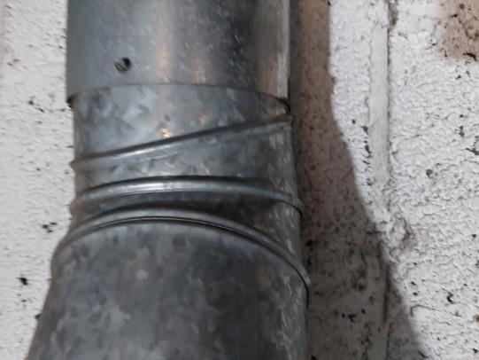

**Open hole in furnace flue**

**Picture 2**

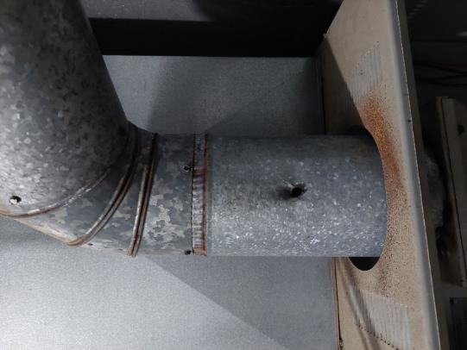

**Hole in flue showing staining consistent with release of products of combustion**

**Picture 3**

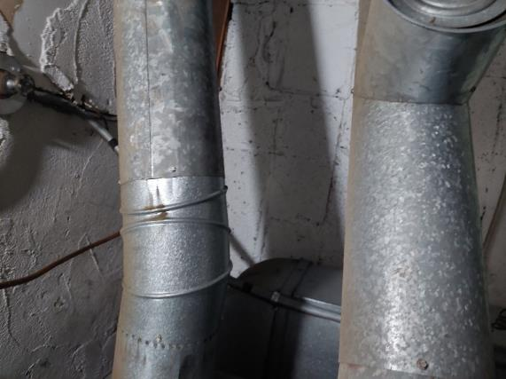

**Flue duct joint; note lack of sealant**

**Picture 4**

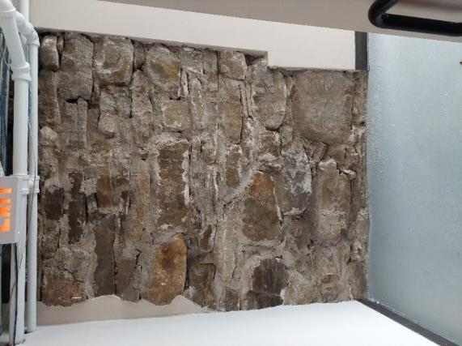

**Gypsum wallboard that appears to be installed against foundation fieldstone**

**Picture 5**

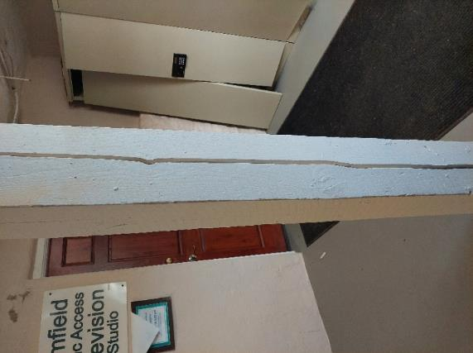

**Split wood support post outside basement TV studio hallway**

**Picture 6**

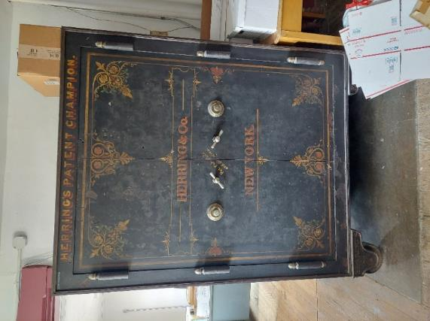

**Safe in room above split wood post**

**Picture 7**

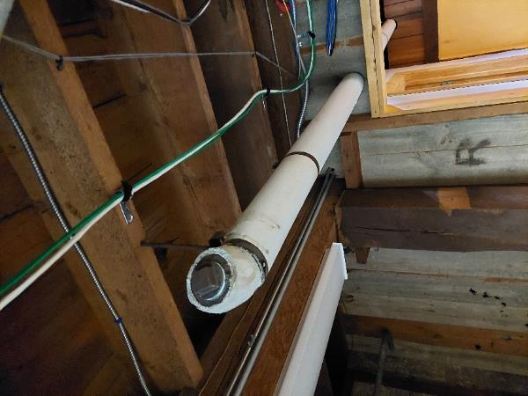

**Pipe in basement hallway**

| **Location/ Room** | **Temp**  **(°F)** | **Relative**  **Humidity**  **(%)** | **Remarks** |
| --- | --- | --- | --- |
|
| Background (outside) | 74 | 65 | Overcast |
| Former Police Department | 65 | 69 | Window air conditioner, water-damaged carpet, carpeted |
| Furnace Room | 66 | 69 | Vent, flue pipe and other piping need to be sealed appropriately, not carpeted |
| Public Access TV Office | 65 | 70 | Ductless AC, carpet tile, bowed ceiling tiles, hole/damaged ceiling tile, water-damaged ceiling tile |
| Public Access TV Studio | 65 | 72 | Carpeted |
| Public Access TV Exterior Hallway | 66 | 68 | Split support post, area carpet, uncapped pipe |
| Town Meeting Room | 66 | 64 | Not carpeted |
| Town Select Board and Clerk Office | 66 | 65 | Window air conditioner, vault, cardboard boxes on floor, not carpeted |
| Treasurer’s Storage Room | 66 | 68 | Carpeted, large number of cardboard boxes on floor, file cabinets |

**Comfort Guidelines**

|  |  |
| --- | --- |
| Temperature: | 70 - 78 °F |
| Relative Humidity: | 40 - 60% |