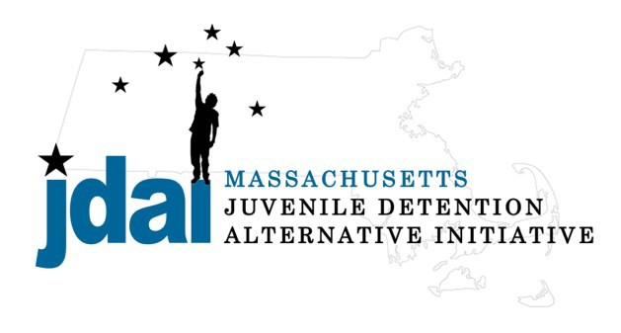Bristol County Bench Card: Alternatives to Secure Detention

An Alternative to Detention is a location or supervision that allows a juvenile with an open delinquency matter, including violation of probation, to remain out of hardware secure detention pending further court action.

Family/ Communit y Supervision:
- Straight Release– Personal Recognizance
- Release to an Alternative/Extended Family Member

Low Sup ervision:
Increasing Supervision
- Bristol County Triage Program (New Bedford): Individual case review with DYS, DCF and New Bedford Public Schools
- Life Skills/ Afterschool: Bridging the Gap (Attleboro) 5 Mechanic Street, Attleboro, MA 02703 508-226-8624, Rev. Dr. Daniel Dore

Medium Supervision:
- Release with Pre-Trial Probation Conditions
- Release with Electronic Monitoring/ GPS

Medium – High Supervision:
- DYS: Shelter Care Options (Placement to Be Determined by DYS)
  - Old Colony YMCA: Brokton Boys Shelter Care 320 Main Street, 3rd floor Brockton, MA 02401 508-584-5700, Matt Selines (Males Only)
  - Grafton Girls, Key, Inc., 30 Institute Road, North Grafton, MA 01536, 508-839-4648, Meghan Rondeau (Females Only)
- Substance Abuse : Statewide Information and Referral 866-705-2807
  - Detox & Stabilization: MYR, Community Health link, 26 Queen Street, Worcester, MA 01610, 508-860-1244, Melonie Amir
  - Detox & Stabilization: CASTLE, High Point Treatment Center, 30 Meadowbrook Road, Brockton, MA 02301, 508-638-6009, Kim Fischer

Additional placement or services options may be available if the youth is involved with a state agency.

JDAI Massachusetts Alternative to Detention Committee has gathered these resources from the Bristol JDAI Community. JDAI Massachusetts, and its affiliated partners, do not specifically endorse or recommend the services provided by the listed agen- cies and entities. Please send updates or corrections to j dai@state.ma.us . Updated: January 2016

