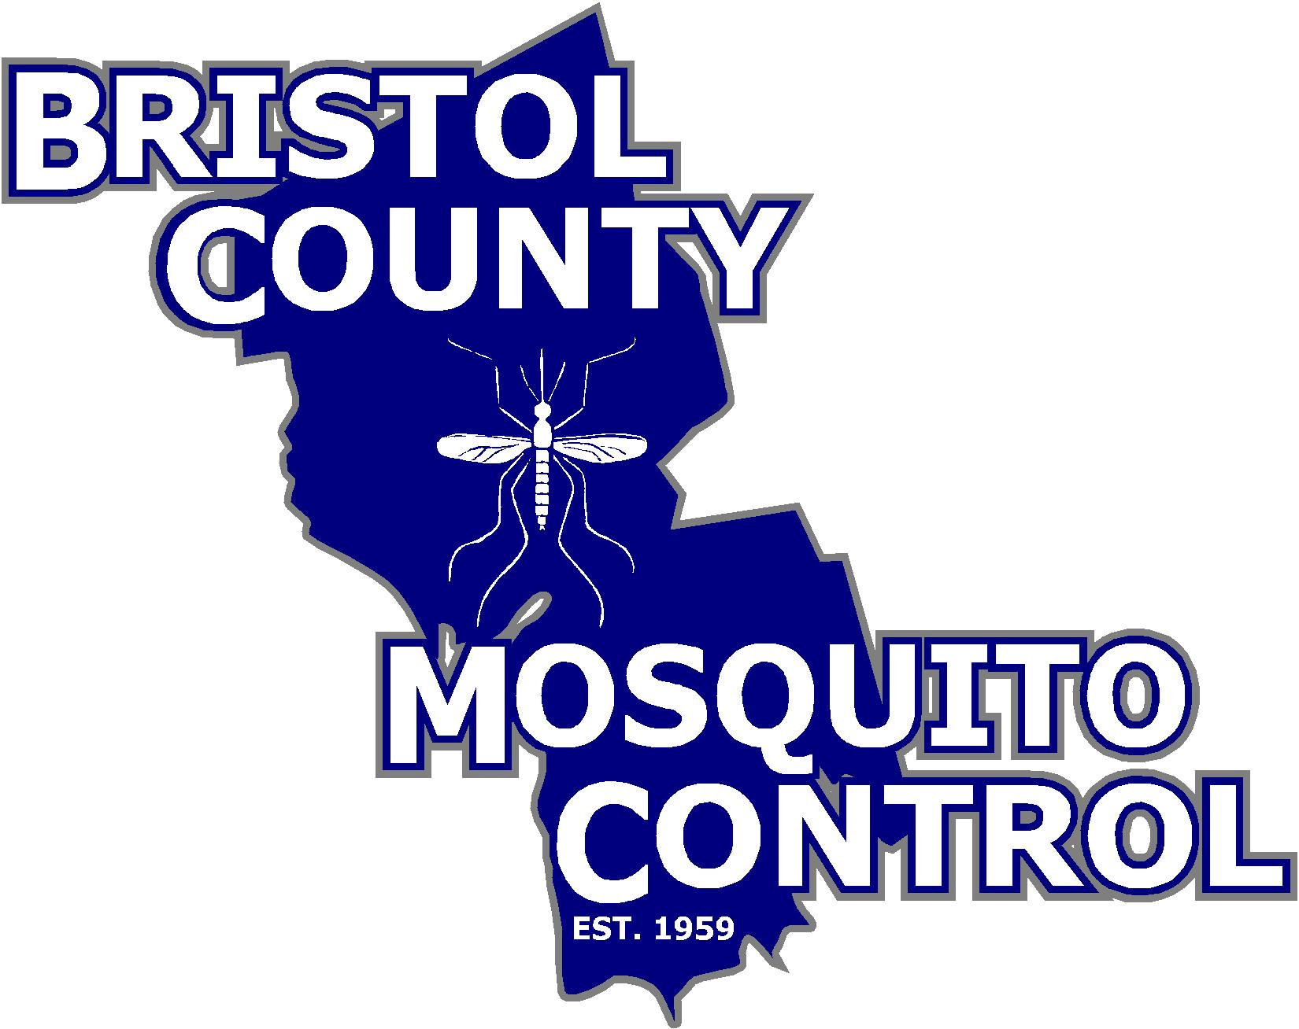
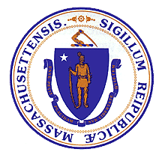
The Commonwealth of Massachusetts
State Reclamation and Mosquito Control Board

______________________________________

Bristol County Mosquito Control Project
38R Forest Street Attleboro, MA 02703
TEL: (508) 823-5253 FAX: (508) 828-1868

TO: Whom it may concern

FROM: Bristol County Mosquito Control Commission

DATE: July 6, 2023

RE: Meeting Agenda

The next full meeting of the Bristol County Mosquito Control Project Commission will be July 13, 2023 at 38R Forest Street Attleboro, Massachusetts at 7:00am.

Join Zoom Meeting
https://us02web.zoom.us/j/85289519217?pwd=Zit1NnhYRmp3M25CVXpVUjFSditoUT09

Meeting ID: 852 8951 9217
Passcode: 059152

- Call to Order/ Attendance

- Public Comment / Input Period

- Vote to approve the June 14, 2023 Meeting minutes

- Commissioner Activities
  - SRMCB meeting review
  - Wetlands Coordinator Position

- Project Activities
  - Field and Surveillance Update

6. New and Unfinished Business

7. Date of next Commission Meeting

8. Adjournment

