INDOOR AIR QUALITY ASSESSMENT

Bristol County Mosquito Control Program
140 North Walker Street
Taunton, Massachusetts

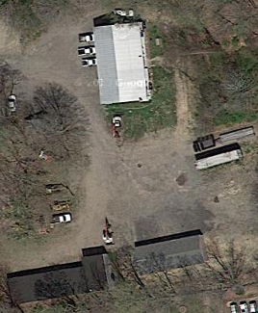

Prepared by:
Massachusetts Department of Public Health
Bureau of Environmental Health
Indoor Air Quality Program
October 2014

Background/Introduction
At the request of Gerry Covino, Project Manager, Division of Capital Asset Management and Maintenance (DCAMM), the Massachusetts Department of Public Health (MDPH), Bureau of Environmental Health (BEH) provided assistance and consultation regarding indoor environmental concerns at the Bristol County Mosquito Control Program (BCMCP), 140 North Walker Street, Taunton, Massachusetts. On September 10, 2014, a visit to conduct an assessment was made to the BCMCP by Cory Holmes, Environmental Analyst/Regional Inspector within BEH’s Indoor Air Quality (IAQ) Program. The assessment was prompted by employee concerns regarding general IAQ/building conditions.
The BCMCP is located in a one-story, 1950s era cinder block and metal roof building. The BCMCP has reportedly occupied the building for 35 to 40 years. The structure appears to have originally been built as a 5-bay garage. At some point, the northernmost bay garage door was sealed and converted into office space (Picture 1). The interior of this office contains wall-to-wall carpet installation, wooden paneling, and openable windows. Several of the windows have been rendered inoperable due to either the installation of plexi-glass or the installation of window-mounted air conditioners. The space contains office space, a conference room, storage space, and vehicle bays. The BCMCP also utilizes a flat-roofed concrete structure, called the lower garage, that serves as a vehicle workshop, and maintenance and pesticide storage areas (Picture 2).

Methods
Air tests for carbon dioxide, carbon monoxide, temperature, and relative humidity were taken with the TSI, Q-Trak, IAQ Monitor 7565. Air tests for airborne particle matter with a diameter less than 2.5 micrometers were taken with the TSI, DUSTTRAK™ Aerosol Monitor Model 8520. Screening for volatile organic compounds was conducted using a RAE Systems Mini-RAE Lite PID. BEH/IAQ staff also performed a visual inspection of building materials for water damage and/or microbial growth.

Results
The BCMCP has 11 to 13 staff members and has occasional visitors/clients daily. Tests were taken during normal operations. Results appear in Table 1.

Discussion

Ventilation
It can be seen from Table 1 that carbon dioxide levels were above 800 parts per million (ppm) in both occupied areas surveyed, indicating poor air exchange in these areas at the time of the assessment (Table 1). Other areas surveyed were all below 800 ppm (Table 1); however, these areas were unoccupied at the time of the assessment, which greatly reduces carbon dioxide levels. With increased occupancy, carbon dioxide levels would be expected to be higher.
The mechanical ventilation system for office areas is provided by an air-handling unit (AHU) located in a mechanical room (Picture 3). Other AHUs are located in the vehicle bay of the main building and in the vehicle maintenance bay of the lower garage respectively. It is important to note that these existing mechanical ventilation systems do not introduce fresh/outside air into the building nor do they exhaust stale air from occupied spaces. These units only heat and recirculate air. Openable windows are the sole means of providing fresh air to the building. However, since several of the windows have been rendered inoperable due to the installation of plexi-glass and/or window-mounted air conditioners, there is no direct means of providing fresh/outside air to these areas. In addition, there was reportedly no preventative maintenance (PM) program on existing ventilation equipment.
Minimum design ventilation rates are mandated by the Massachusetts State Building Code (MSBC). Until 2011, the minimum ventilation rate in Massachusetts was higher for both occupied office spaces and general classrooms, with similar requirements for other occupied spaces (BOCA, 1993). The current version of the MSBC, promulgated in 2011 by the State Board of Building Regulations and Standards (SBBRS), adopted the 2009 International Mechanical Code (IMC) to set minimum ventilation rates. Please note that the MSBC is a minimum standard that is not health-based. At lower rates of cubic feet per minute (cfm) per occupant of fresh air, carbon dioxide levels would be expected to rise significantly. A ventilation rate of 20 cfm per occupant of fresh air provides optimal air exchange resulting in carbon dioxide levels at or below 800 ppm in the indoor environment in each area measured. MDPH recommends that carbon dioxide levels be maintained at 800 ppm or below. This is because most environmental and occupational health scientists involved with research on IAQ and health effects have documented significant increases in indoor air quality complaints and/or health effects when carbon dioxide levels rise above the MDPH guidelines of 800 ppm for schools, office buildings and other occupied spaces (Sundell et al., 2011). The ventilation must be on at all times that the room is occupied. Providing adequate fresh air ventilation with open windows and maintaining the temperature in the comfort range during the cold weather season is impractical. Mechanical ventilation is usually required to provide adequate fresh air ventilation.
Carbon dioxide is not a problem in and of itself. It is used as an indicator of the adequacy of the fresh air ventilation. As carbon dioxide levels rise, it indicates that the ventilating system is malfunctioning or the design occupancy of the room is being exceeded. When this happens, a buildup of common indoor air pollutants can occur, leading to discomfort or health complaints. The Occupational Safety and Health Administration (OSHA) standard for carbon dioxide is 5,000 parts per million parts of air (ppm). Workers may be exposed to this level for 40 hours/week, based on a time-weighted average (OSHA, 1997).
The MDPH uses a guideline of 800 ppm for publicly occupied buildings. A guideline of 600 ppm or less is preferred in schools due to the fact that the majority of occupants are young and considered to be a more sensitive population in the evaluation of environmental health status. Inadequate ventilation and/or elevated temperatures are major causes of complaints such as respiratory, eye, nose and throat irritation, lethargy and headaches. For more information concerning carbon dioxide, please see Appendix A.
Indoor temperature measurements at the time of the assessment ranged from 72°F to 77°F (Table 1), which were within the MDPH recommended comfort range. The MDPH recommends that indoor air temperatures be maintained in a range of 70°F to 78°F in order to provide for the comfort of building occupants. In many cases concerning indoor air quality, fluctuations of temperature in occupied spaces are typically experienced, even in a building with an adequate fresh air supply.
Indoor relative humidity measurements at the time of the assessment ranged from 60 to 66 percent (Table 1), which were at or above the MDPH recommended comfort range and close to outside levels due to air conditioners not operating. The MDPH recommends a comfort range of 40 to 60 percent for indoor air relative humidity. Humidity levels in the building would be expected to drop during the heating season. The sensation of dryness and irritation is common in a low relative humidity environment. Low relative humidity is a very common problem during the heating season in the northeast part of the United States.

Microbial/Moisture Concerns
In order to become colonized with mold, a material must be exposed to water and remain wet. If sufficiently wet, porous materials can support mold growth (US EPA, 2001). In addition, relative humidity in excess of 70 percent for extended periods of time can provide an environment for mold and fungal growth in building materials (ASHRAE, 1989).
Water-damaged gypsum wallboard ceilings were observed in storage/vehicle bays; some areas had visible mold growth (Table 1; Pictures 4 and 5). Water-damaged ceiling tiles were also observed in a few areas (Table 1; Picture 6). Water-damaged building materials indicate leaks from either the roof or plumbing system and can provide a source for mold growth. Water-damaged ceiling tiles should be replaced after a water leak is discovered and repaired.
The US Environmental Protection Agency (US EPA) and the American Conference of Governmental Industrial Hygienists (ACGIH) recommend that porous materials (e.g., carpeting, gypsum wallboard) be dried with fans and heating within 24 to 48 hours of becoming wet (US EPA, 2001; ACGIH, 1989). If not dried within this time frame, mold growth may occur. Once mold has colonized porous materials, they are difficult to clean and should be removed/discarded.
The restrooms appear to have local exhaust vents; however, they were not operating at the time of the assessment. Restroom exhaust vents are necessary to remove excess moisture and odors.

Other IAQ Evaluations
Indoor air quality can be negatively influenced by the presence of respiratory irritants, such as products of combustion. The process of combustion produces a number of pollutants. Common combustion emissions include carbon monoxide, carbon dioxide, water vapor, and smoke (fine airborne particle material). Of these materials, exposure to carbon monoxide and particulate matter with a diameter of 2.5 micrometers (μm) or less (PM2.5) can produce immediate, acute health effects upon exposure. To determine whether combustion products were present in the indoor environment, BEH/IAQ staff obtained measurements for carbon monoxide and PM2.5.

Carbon Monoxide
Carbon monoxide is a by-product of incomplete combustion of organic matter (e.g., gasoline, wood, and tobacco). Exposure to carbon monoxide can produce immediate and acute health effects. Several air quality standards have been established to address carbon monoxide and prevent symptoms from exposure to these substances. The MDPH established a corrective action level concerning carbon monoxide in ice skating rinks that use fossil-fueled ice resurfacing equipment. If an operator of an indoor ice rink measures a carbon monoxide level over 30 ppm, taken 20 minutes after resurfacing within a rink, that operator must take actions to reduce carbon monoxide levels (MDPH, 1997).
The American Society of Heating Refrigeration and Air-Conditioning Engineers (ASHRAE) has adopted the National Ambient Air Quality Standards (NAAQS) as one set of criteria for assessing indoor air quality and monitoring of fresh air introduced by HVAC systems (ASHRAE, 1989). The NAAQS are standards established by the US EPA to protect the public health from six criteria pollutants, including carbon monoxide and particulate matter (US EPA, 2006). As recommended by ASHRAE, pollutant levels of fresh air introduced to a building should not exceed the NAAQS levels (ASHRAE, 1989). The NAAQS were adopted by reference in the Building Officials and Code Administrators (BOCA) National Mechanical Code of 1993 (BOCA, 1993), which is now an HVAC standard included in the Massachusetts State Building Code (SBBRS, 2011). According to the NAAQS, carbon monoxide levels in outdoor air should not exceed 9 ppm in an eight-hour average (US EPA, 2006).

Carbon monoxide should not be present in a typical, indoor environment. If it is present, indoor carbon monoxide levels should be less than or equal to outdoor levels. On the day of the assessment, outdoor carbon monoxide concentrations were non-detect (ND) (Table 1). No measurable levels of carbon monoxide were detected inside (Table 1). Although no measureable levels of carbon monoxide were measured indoors during the assessment, the potential exists for it to be present in the vehicle bays, which are attached to each of the buildings (main and lower garage). There are no means for local exhaust ventilation. Carbon monoxide detectors have been installed in these areas, however providing exhaust ventilation would prevent unnecessary exposure.

Particulate Matter

The US EPA has established NAAQS limits for exposure to particulate matter. Particulate matter includes airborne solids, which can result in eye and respiratory irritation if exposure occurs. The NAAQS originally established exposure limits to particulate matter with a diameter of 10 μm or less (PM10). According to the NAAQS, PM10 levels should not exceed 150 micrograms per cubic meter (μg/m3) in a 24-hour average (US EPA, 2006). These standards were adopted by both ASHRAE and BOCA. Since the issuance of the ASHRAE standard and BOCA Code, US EPA established a more protective standard for fine airborne particles. This more stringent PM2.5 standard requires outdoor air particle levels be maintained below 35 μg/m³ over a 24-hour average (US EPA, 2006). Although both the ASHRAE standard and BOCA Code adopted the PM10 standard for evaluating air quality, MDPH uses the more protective PM2.5 standard for evaluating airborne particulate matter concentrations in the indoor environment.
Outdoor PM2.5 was measured at 14 μg/m³ (Table 1). PM2.5 levels measured indoors ranged from 14 to 32 μg/m³ (Table 1), which were below the NAAQS PM2.5 level of 35 μg/m³. The highest measurement of 32 μg/m³ was measured in the lower garage where vehicle maintenance is conducted. Frequently, indoor air levels of particulate matter (including PM2.5) can be at higher levels than those measured outdoors. A number of mechanical devices and/or activities that occur in buildings can generate particulate matter during normal operations. Sources of indoor airborne particulate matter may include but are not limited to particles generated during the operation of fan belts in the HVAC system, use of stoves and/or microwave ovens in kitchen areas; use of photocopiers, fax machines and computer printing devices; operation of an ordinary vacuum cleaner and heavy foot traffic indoors.

Volatile Organic Compounds
Indoor air concentrations can be greatly impacted by the use of products containing volatile organic compounds (VOCs). VOCs are carbon-containing substances that have the ability to evaporate at room temperature. Total volatile organic compounds (TVOCs) can result in eye and respiratory irritation if exposure occurs. For example, the application of pesticides, the use of certain cleaning products or chemicals evaporating from a paint can stored at room temperature would most likely contain VOCs. In an effort to determine whether VOCs were present in the building, air monitoring for TVOCs was conducted.
Outdoor air samples were taken for comparison. Outdoor TVOC concentrations were non-detect (ND; Table 1). At the time of the assessment, no measurable levels of TVOCs were detected in the main building (Table 1). Slight levels of TVOCs ranging from 0.4 - 1.3 ppm were detected in the lower garage (Table 1), due to stored materials (e.g., cleaners, pesticides, automotive products).
Large printers were located in the conference room. VOCs and ozone can be produced by photocopiers and printers, particularly if the equipment is older and in frequent use. Ozone is a respiratory irritant (Schmidt Etkin, 1992). Photocopiers and printers should be used in well-ventilated areas or in areas with local exhaust ventilation to help reduce/remove excess heat, and odors.

Other Conditions
Other conditions that can affect IAQ were observed during the assessment. Some parts of the building contain wall-to-wall carpet that is likely over 15 to 20 years old. It was reported that the BCMCP does not have a regular carpet-cleaning program. The Institute of Inspection, Cleaning and Restoration Certification (IICRC), recommends that carpeting be cleaned annually (or semi-annually in soiled high traffic areas) (IICRC, 2012). In addition, carpets have a finite life expectancy (about 10 years in general) that can be rapidly reduced due to failure to maintain the carpeting properly.
Missing light covers were noted in a number of areas (Picture 7) and florescent bulbs were improperly stored (e.g. leaning against the wall/unsecured) in the mechanical room (Picture 8) and vehicle bay (Picture 9). Fixtures should be equipped with access covers installed with bulbs fully secured in their sockets. Blubs should also be stored properly to prevent breakage of glass, which can cause injuries and may result in the release of mercury and/or other hazardous compounds.
Accumulated dust/debris was noted on supply diffusers, return grates, and surrounding ceiling tiles in several areas. Dust that has collected on diffusers/grills can be re-aerosolized when mechanical ventilation equipment is reactivated. Dust can be irritating to the eyes, nose, and respiratory tract.
Finally, the pesticide storeroom is equipped with a local exhaust fan (Picture 10). However, no make-up air vent exists to draw in outside air. Therefore, it is important to keep the bay door open at all times unless/until a make-up air vent is installed.

Conclusions/Recommendations
The conditions found within the BCMCP raise a number of IAQ issues. The lack of fresh air introduction via the mechanical ventilation system coupled with the lack of operable windows can result in a lack of air circulation and lead to poor IAQ complaints. For these reasons, a two-phase approach is recommended for remediation. The first consists of short-term measures to improve air quality and the second consists of long-term measures that will require planning and resources to adequately address overall IAQ concerns.

Short-Term Recommendations
- Consult with an HVAC engineer to determine if existing AHUs can be retro-fitted to provide fresh/outside air.
- Restore openable windows in areas that lack functioning windows to provide a source of fresh/outside air. In the interim, open windows wherever possible to introduce outside/fresh air; utilize stand-up fans and open office/interior doors to circulate air.
- Window-mounted air conditioners can also be utilized to introduce a limited amount of outside air/circulation if operated in the “fan only” mode.
- Restore exhaust ventilation in restrooms, make repairs as necessary.
- Develop and implement a preventative maintenance plan for all HVAC equipment including regular filter changes. Consider upgrading filters to the recommended minimum 40% dust-spot efficiency (MERV 9) accounting for manufacturer limitations with pressure drop.
- Ensure building/plumbing leaks are repaired and replace any remaining water-damaged ceiling tiles and other building materials. Disinfect areas of water leaks with an appropriate antimicrobial, as needed.
- Remove/replace water-damaged/mold-colonized gypsum wallboard in accordance with isolation and ventilation procedures included in “Mold Remediation in Schools and Commercial Buildings” published by the US Environmental Protection Agency (US EPA, 2001) for more information on mold. This document can be downloaded from the US EPA website at: http://www.epa.gov/mold/mold_remediation.html.
- Clean carpeting annually or semi-annually in soiled high traffic areas as per the recommendations of the Institute of Inspection, Cleaning and Restoration Certification (IICRC, 2012).
- Replace carpeting over 10 years old. Consider a non-porous surface (e.g., vinyl floor tiles) or carpet squares for easier maintenance/replacement.
- Periodically clean supply diffusers and exhaust/return grates to avoid re-aerosolizing particulates. In addition, clean surrounding surfaces (e.g., walls, ceilings, tiles) several times a year/as needed. If ceiling tiles cannot be adequately cleaned, replace.
- For buildings in New England, periods of low relative humidity during the winter are often unavoidable. Therefore, scrupulous cleaning practices should be adopted to minimize common indoor air contaminants whose irritant effects can be enhanced when the relative humidity is low. To control dusts, a high efficiency particulate arrestance (HEPA) filter equipped vacuum cleaner in conjunction with wet wiping of all surfaces is recommended. Avoid the use of feather dusters. Drinking water during the day can help ease some symptoms associated with a dry environment (throat and sinus irritations).
- Replace covers for fluorescent light fixtures. Store florescent light bulbs properly in a secure manner in order to prevent accidental breakage.
- Install make-up air vent for pesticide storage room. In the interim, ensure that bay door is open to provide sufficient make-up air.
- Refer to resource manuals and other related indoor air quality documents for further building-wide evaluations and advice on maintaining public buildings. These materials are located on the MDPH’s website: http://mass.gov/dph/iaq.

Long-Term Recommendations
- Consider installing a new HVAC system that incorporates both exhaust ventilation and fresh air intake to remove common indoor pollutants and alleviate health complaints. Consideration should be taken during design to account for the location of local exhaust vents for point source pollutants such as copy areas and restrooms.
- Work with HVAC engineer to install local exhaust ventilation in vehicle bays and ensure sufficient make-up air is provided.

References
ACGIH. 1989. Guidelines for the Assessment of Bioaerosols in the Indoor Environment. American Conference of Governmental Industrial Hygienists, Cincinnati, OH.
ASHRAE. 1989. Ventilation for Acceptable Indoor Air Quality. American Society of Heating, Refrigeration and Air Conditioning Engineers. ANSI/ASHRAE 62-1989.
BOCA. 1993. The BOCA National Mechanical Code/1993. 8th ed. Building Officials and Code Administrators International, Inc., Country Club Hill, IL.
IICRC. 2012. Institute of Inspection, Cleaning and Restoration Certification. Carpet Cleaning: FAQ. Retrieved from http://www.iicrc.org/consumers/care/carpet-cleaning/#faq.
MDPH. 1997. Requirements to Maintain Air Quality in Indoor Skating Rinks (State Sanitary Code, Chapter XI). 105 CMR 675.000. Massachusetts Department of Public Health, Boston, MA.
OSHA. 1997. Limits for Air Contaminants. Occupational Safety and Health Administration. Code of Federal Regulations. 29 C.F.R 1910.1000 Table Z-1-A.
Schmidt Etkin, D. 1992. Office Furnishings/Equipment & IAQ Health Impacts, Prevention & Mitigation. Cutter Information Corporation, Indoor Air Quality Update, Arlington, MA.
SBBRS. 2011. Mechanical Ventilation. State Board of Building Regulations and Standards. Code of Massachusetts Regulations, 8th edition. 780 CMR 1209.0
Sundell. 2011. Sundell, J., H. Levin, W. W. Nazaroff, W. S. Cain, W. J. Fisk, D. T. Grimsrud, F. Gyntelberg, Y. Li, A. K. Persily, A. C. Pickering, J. M. Samet, J. D. Spengler, S. T. Taylor, and C. J. Weschler. 2011. Ventilation rates and health: multidisciplinary review of the scientific literature. Indoor Air, Volume 21: pp 191–204.
US EPA. 2001. Mold Remediation in Schools and Commercial Buildings. US Environmental Protection Agency, Office of Air and Radiation, Indoor Environments Division, Washington, D.C. EPA 402-K-01-001. March 2001.
US EPA. 2006. National Ambient Air Quality Standards (NAAQS). US Environmental Protection Agency, Office of Air Quality Planning and Standards, Washington, DC. http://www.epa.gov/air/criteria.html.
Picture 1
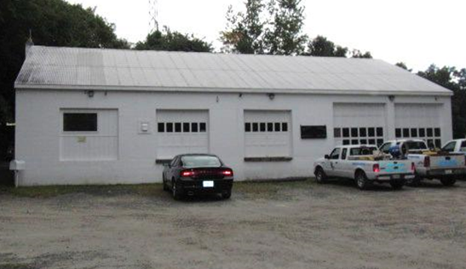
Bristol County Mosquito Control Program building, note northernmost garage door sealed for office space
Picture 2

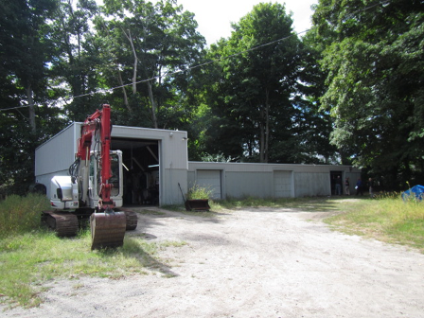
Lower garage containing the maintenance shop and pesticide storage area (end bay)
Picture 3
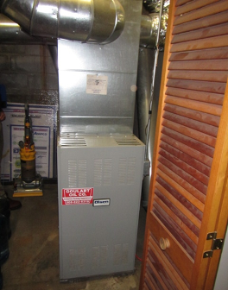
Air handling unit in mechanical room

Picture 4
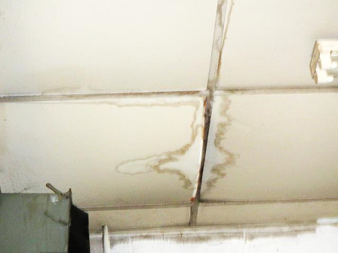
Water-damaged/mold-colonized gypsum wallboard ceiling in storage/vehicle bay
Picture 5
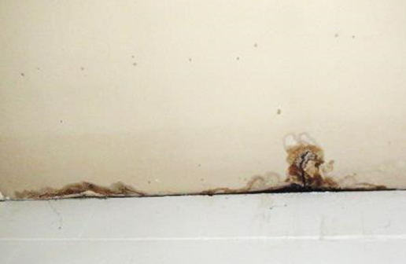
Water-damaged/mold-colonized gypsum wallboard ceiling in storage/vehicle bay

Picture 6
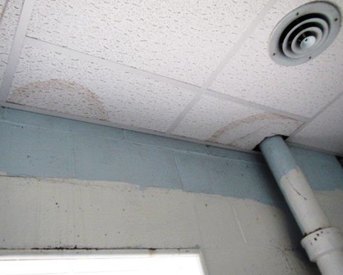
Water-damaged ceiling tiles
Picture 7
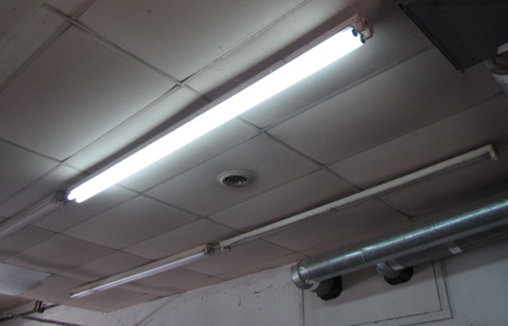
Missing light covers
Picture 8
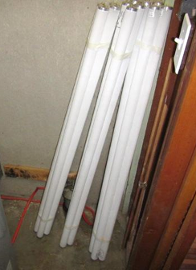
Florescent bulbs in mechanical room

Picture 9
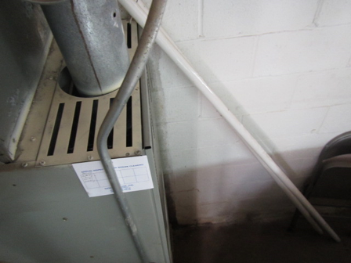
Florescent bulbs in vehicle bay
Picture 10
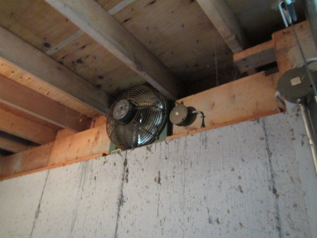
Local exhaust fan in pesticide storage room
Location | Carbon  Dioxide  (ppm) | Carbon Monoxide  (ppm) | Temp  (°F) | Relative  Humidity  (%) | TVOCs  (ppm) | PM2.5  (µg/m³) | Occupants  in Room | Windows  Openable | Ventilation |  |  | Remarks
 |  |  |  |  |  |  |  |  | Intake | Exhaust |  | Remarks
Background | 338 | ND | 71 | 68 | ND | 14 |  |  |  |  |  | Overcast, cool
Main Building
Conference Room | 1032 | ND | 74 | 64 | ND | 18 | 6 | Y | N |  | N | 1 openable window, 2 sealed with plexiglass, 2 large PCs
Forman’s Office | 744 | ND | 74 | 63 | ND | 18-23 | 0 | N | N |  | N | AC, old/soiled/wrinkled carpeting
Mechanical Room |  |  |  |  |  |  |  |  |  |  |  | AHU, filter storage, florescent bulbs against wall, carbon monoxide monitor
Admin Office | 1400 | ND | 77 | 66 | ND | 16-24 | 3 | N | N |  | N | AC
Garage/Lunchroom | 554 | ND | 74 | 60 | ND | 24 | 0 | N | N |  | N | WD/mold-colonized GW ceiling, light penetration under doors, carbon monoxide monitor on wall, exposed pipe insulation, spaces under garage doors
Garage Lower | 520 | ND | 72 | 64 | ND | 32 | 0 | N | N |  | N | Space under garage doors, fluorescent bulbs leaning against wall, hole in exhaust duct, no light covers
Mens Restroom |  |  |  |  |  |  |  | N | N |  | Y | No draw exhaust
Ladies Restroom |  |  |  |  |  |  |  | N | N |  | Y | No draw exhaust
Entomologist Office | 572 | ND | 74 | 62 | ND | 19 | 0 | N | N |  | N | Portable AC
Lower Garage
Pesticide Room |  | ND |  |  | 0.5-0.7 | 14 |  | N | N |  | Y | Local exhaust fan, no make-up air vent, garage door open
Vehicle Maintenance Room |  | ND |  |  | 0.4-1.0 | 16 |  | N | N |  | N | Garage door open, gas can storage
Interior Rooms |  | ND |  |  | 1.3 | 18 |  | N | N |  | N | Used oil/chemical storage, WD walls

