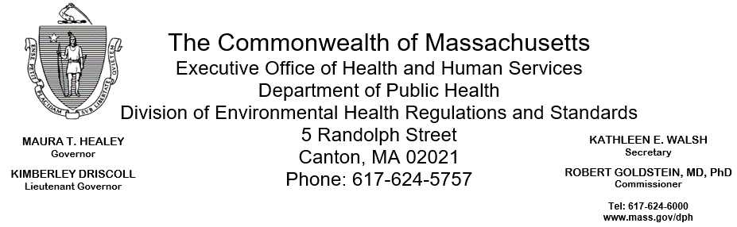

March 17, 2025

Paul Heroux, Sheriff
Bristol County Sheriff’s Office
Dartmouth Women’s Center
400 Faunce Corner Road
North Dartmouth, MA 02747 (electronic copy)

Re: Facility Inspection – Dartmouth Women’s Center, North Dartmouth

Dear Sheriff Heroux:

The Massachusetts Department of Public Health (Department) Division of Environmental Health Regulations and Standards (EHRS) conducted an inspection of the Dartmouth Women’s Center on February 26, 2025, accompanied by Michael Moreira, Fire Safety/Environmental Health and Safety Officer and Officer Justin Samanica, in accordance with Department regulations 105 CMR 451.000: Minimum Health and Sanitation Standards and Inspection Procedures for Correctional Facilities.

The inspection identified 17 total deficiencies: 1 deficiency under the Required Standards (.100 and .200 series), 6 repeat deficiencies under the Required Standards, 1 deficiency under the Recommended Standards (.300 series), and 9 repeat deficiencies under the Recommended Standards.

Overview

Section 1 provides details of all deficiencies, including repeat deficiencies, found during the inspection. These are categorized by Required Standards, Recommended Standards, or additional applicable regulatory standards.
Section 2 provides information on areas that EHRS found to be compliant.
Section 3 documents the areas that EHRS did not inspect.
Section 4 provides information on submitting a Plan of Correction for the identified deficiencies.
Section 5 outlines observations and recommendations related to the inspection.

SECTION 1: Health and Safety Deficiencies

Deficiencies under the Required Standards (.100 and .200 series)
1 new deficiency and 6 repeat deficiencies (indicated by an *) were found during the inspection:

- Food Service Area | Kitchen | 105 CMR 451.200* | Maintenance and Operation; Premises, Structure, Attachments, and Fixtures - Methods: Facility not in good repair, floor paint damaged in walk-in refrigerator. Standard found in 105 CMR 590; FC 6-501.11.
- A Wing | Showers | 105 CMR 451.123 | Maintenance: Floor drain clogged in shower # 3
- B Wing | Bathroom | 105 CMR 451.123* | Maintenance: Ceiling paint damaged
- C Wing | Bathroom | 105 CMR 451.123* | Maintenance: Ceiling paint damaged
- C Wing | Bathroom Janitor’s Closet | 105 CMR 451.123* | Maintenance: Unlabeled chemical bottle
- D Wing | Bathroom | 105 CMR 451.123* | Maintenance: Ceiling paint damaged
- D Wing | Bathroom Janitor’s Closet | 105 CMR 451.123* | Maintenance: Unlabeled chemical bottle

Deficiencies under the Recommended Standards (.300 series)
1 new deficiency and 9 repeat deficiencies (indicated by an *) were identified during the inspection:

- Laundry |  | 105 CMR 451.353 | Interior Maintenance: Left side washing machine out-of-order
- A Wing |  | 105 CMR 451.353* | Interior Maintenance: Floor paint damaged in hallway
- A Wing | Bathroom Janitor’s Closet | 105 CMR 451.353* | Interior Maintenance: Unlabeled chemical bottle
- A Wing | Cells | 105 CMR 451.320* | Cell Size: Inadequate floor space in all cells, cells double-bunked
- B Wing |  | 105 CMR 451.353* | Interior Maintenance: Wall mounted phones rusted
- B Wing | Cells | 105 CMR 451.320* | Cell Size: Inadequate floor space in all cells, cells double-bunked
- C Wing | Day Room | 105 CMR 451.353* | Interior Maintenance: Floor paint damaged
- C Wing | Cells | 105 CMR 451.320* | Cell Size: Inadequate floor space in all cells, cells double-bunked
- D Wing | Day Room | 105 CMR 451.353* | Interior Maintenance: Floor paint damaged
- D Wing | Cells | 105 CMR 451.320* | Cell Size: Inadequate floor space in all cells, cells double-bunked

SECTION 2: Areas Found to be in Compliance

EHRS inspected 18 additional areas of the facility which were found to be in compliance.

Section 3: Areas EHRS did not inspect

EHRS inspected all areas of the facility.

SECTION 4: Plan of Correction

This facility does not comply with the Department’s Regulations cited above. In accordance with 105 CMR 451.404, please submit a plan of correction within 10 working days of receipt of this notice. The Plan of Correction must include:

- Specific corrective steps to be taken
- A timetable for the corrective actions for larger projects
- The date by which correction will be achieved
- Any interim measures being implemented to ensure the health and safety of incarcerated individuals and facility staff
- The plan should be signed by the Superintendent or Administrator and submitted to my attention, at the address listed above.

SECTION 5: Observations and Recommendations

- The inmate population was 55 at the time of inspection.

To review the specific regulatory requirements please visit our website at www.mass.gov/dph/dcs and click on "Correctional Facilities" 105 CMR 451.000 is available in both PDF and RTF formats. For more specific information about the food standards, you can download the merged food code, which can be found here.

An inspection may also include observations of other conditions which could constitute a threat to the health or safety of inmates or employees, including but not limited to the standards set forth by the Department as follows, and report on such pursuant to 451.402(B). You can use these links below to review these standards:
- 105 CMR 205.000: Minimum Standards Governing Medical Records and Conduct of Physical Examinations in Correctional Facilities
- 105 CMR 480.000: Minimum requirements for the Management of Medical or Biological Waste
- 105 CMR 500.000: Good Manufacturing Practices for Food

This inspection report is true and accurate to the best of my knowledge.

Sincerely,

Patrick Wallace
Environmental Health Inspector, EHRS, BCEH

