Mold/Water Damage Investigation

Broad Meadows Middle School
50 Calvin Road
Quincy, Massachusetts

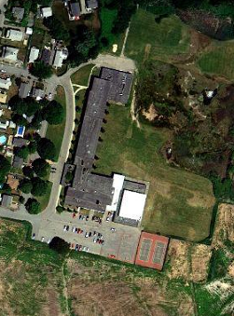

Prepared by:
Massachusetts Department of Public Health
Bureau of Environmental Health
Indoor Air Quality Program
November 2010

Background/Introduction
At the request of John Drummey, Massachusetts Inspector General's Office, the Massachusetts Department of Public Health (MDPH), Bureau of Environmental Health (BEH) provided assistance and consultation regarding indoor air quality at the Broad Meadows Middle School, 50 Calvin Road, Quincy, Massachusetts. On August 22, 2010, Michael Feeney, Director of BEH’s Indoor Air Quality (IAQ) Program visited the school to conduct an assessment. Mr. Feeney was accompanied by Kevin Murphy, Coordinator of Plant Facilities, Quincy Public Schools, during the assessment. The request was prompted by mold growth reported to be growing on the surface of a ceiling in an office adjacent to the band room.

Methods
BEH staff performed a visual inspection of building materials for water damage, odor/water vapor pathways and microbial growth.

Results and Discussion
The ceiling of the band room office that reportedly had mold-colonization around its exhaust vent was examined by BEH staff. At the time of the visit, all ceiling paint had been removed down to the plaster surface and it was without viable signs of mold growth. Of note was a stale, musty odor in the area of the band room and adjacent hallway. After examining the hallway and exterior of the building around the band room, it was discovered that the school contains a dirt crawlspace that runs beneath the building (Picture 1). Designing a building with a dirt floor crawlspace in this area of Quincy presents a number of issues related to water infiltration and associated odors. The band room is located roughly 200 feet from the edge of a salt marsh (Picture 2). At high tide, the depth of the crawlspace appears to be below the water level of the salt marsh; this likely results in the soil of the crawlspace becoming saturated due to tidal influence.
Other conditions also subject the crawlspace to water penetration (e.g. the design of exterior walls and surrounding landscape). The wall around the band room contains several inverted right angles (Picture 3), which would tend to direct rainwater towards the base of the exterior wall. No asphalt/cement apron exists at the base of the wall to direct rainwater away from its base. With meteorological condition involving southerly winds and driving rain, the wall of the band room would direct rainwater to the grass/soil adjacent to its foundation where it would readily be absorbed and penetrate into the crawlspace. The experience of BEH staff demonstrates that dirt floor crawlspaces are typically designed with a mechanical exhaust system to depressurize below grade areas to prevent odors from migrating into occupied areas above. No such system could be identified at the BMMS. Without a functional crawlspace exhaust system, mechanical ventilation systems in above spaces (e.g., band room office exhaust vent), can draw odors and water vapor from the dirt floor crawlspace.
In order to identify the source of water vapor causing the reported mold growth on the band room office ceiling, BEH staff examined the band room, its offices and the adjacent hallway for pathways for moisture to migrate from the dirt floor crawlspace. The following pathways were identified:
- The band room contains two unit ventilators (univents) (Picture 4). Within the cabinet floors of the univents were utility holes through which heating pipes pass (Picture 5). The diameter of the hole in the floor is larger than the diameter of the heating pipe, which allows for odors and water vapor to be drawn from the crawlspace and distributed into the band room via the univent.
- Outside the band room is an elevator that appeared to have been installed after the initial construction of the building (Picture 6). When an elevator is retrofitted into a building, a base with solid walls (typically cement block) is customarily built to form the bottom of the elevator shaft. This provides fire protection and prevents debris from the area below the elevator entering occupied areas. No such structure appears to exist below the elevator (Picture 7). Without a walled elevator shaft in the crawlspace, odors, dirt/debris and water vapor can readily enter the elevator shaft and be distributed into the hallway, as well as the elevator mechanical room.
- The door to the mechanical room has a number of spaces around its frame (Picture 8). These spaces allow for odors and water vapor to be drawn into the band room by the exhaust vent in the office and operation of the univents.
- The elevator mechanical room walls have a number of penetrations which open directly into the elevator shaft. As the elevator moves within its shaft, air can be drawn into the shaft and pushed out into the mechanical room through any breaches in the wall (Picture 9).
- An access hatch for the crawlspace was observed outside of the band room. The frame around the hatch appears to be corroded from repeated moisture exposure, which in turn has created spaces around the hatch and frame. These spaces are another means for crawlspace odors and water vapor to enter occupied space around the band room.
All of these pathways are likely sources of moisture/odors reported by occupants in the vicinity of the band room.
It is also worthwhile to note that there is a roof drain pipe encased inside a wooden box in the elevator mechanical room (Picture 10). The wood around this drain pipe appears to be rotted from repeated water damage and can also provide a source of mold growth and odors.

Conclusions/Recommendations
Several recommendations to address mold concerns at the school were given at the time of the assessment. They are reiterated below along with other recommendations to improve indoor air quality. In addition, MDPH guidance documents on mold remediation and preventing mold growth during summer months are attached as Appendix A and Appendix B, respectively. The MDPH has prepared these guidance documents in order to reduce or minimize exposure opportunities to mold in buildings and to prevent/reduce the migration of remediation-generated pollutants into occupied areas.
Conditions observed in the building can negatively affect indoor air quality. Some of these conditions can be remedied by actions of building occupants/operators. Other remediation efforts will require alteration to the building structure and equipment. For these reasons, a two-phase approach is required, consisting of short-term measures to improve air quality and long-term measures that will require planning and resources to adequately address overall indoor air quality concerns.

Short-Term Recommendations
- Remove water-damaged materials in a manner consistent with recommendations made in “Mold Remediation in Schools and Commercial Buildings” published by the US Environmental Protection Agency (US EPA, 2001). This document can be downloaded from the US EPA website at: http://www.epa.gov/iaq/molds/mold_remediation.html.
- Seal open utility holes around pipes in univent cabinets using a fire rated expandable foam.
- Seal the holes and other penetrations in walls of the elevator mechanical room with a fire rated expandable foam.
- Install weather-stripping around the frame and a door sweep at the bottom of the door of the elevator mechanical room to make door/frame as airtight as possible.
- Ensure that the exhaust fan inside of the elevator mechanical room is operating during periods of school occupancy.
- Repair/replace crawlspace access hatch to render as airtight as possible.
- Identify whether a crawlspace exhaust system exists and operate as designed, make repairs as needed.
- Ensure leaks are repaired and repair/replace water-damaged wooden box in elevator mechanical room.

Long-Term Recommendations
- If no mechanical exhaust system for the crawlspace exists, consult with an HVAC engineering firm to examine the feasibility of a retrofit.
- Examine the feasibility of enclosing the base of the elevator to prevent odor and water vapor migration into occupied space.
- Consider installing an apron around the base of the band room wall to direct water away from the foundation.

References
US EPA. 2001. “Mold Remediation in Schools and Commercial Buildings”. Office of Air and Radiation, Indoor Environments Division, Washington, DC. EPA 402-K-01-001. March 2001. Available at: http://www.epa.gov/iaq/molds/mold_remediation.html
Picture 1

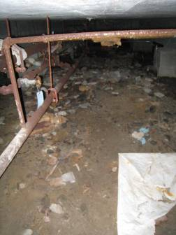

Dirt Floor Crawlspace beneath the Band Room Hallway

Picture 2

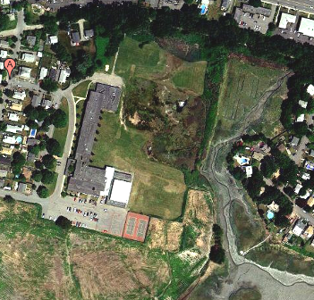

Broad Meadow Elementary School Located Within 200 Feet of Edge of Salt Marsh

Picture 3

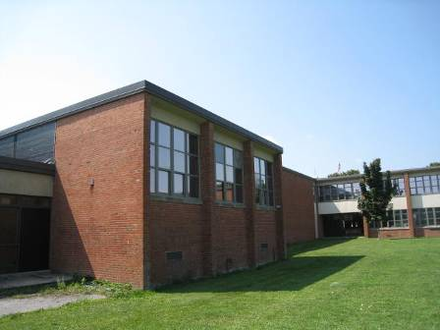

Band Room Exterior Wall with Right Angles Facing Inward

Picture 4

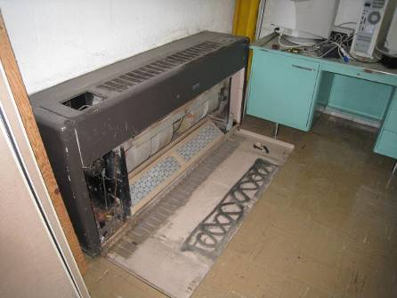

Band Room Univent

Picture 5

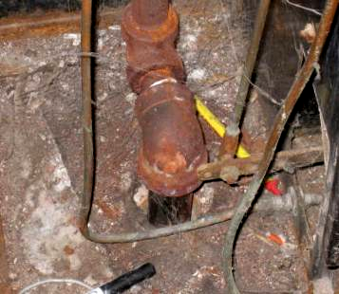

Utility Holes around Pipes in the Floor of Univent Cabinets Allowing Communication between First Floor and Dirt Crawlspace

Picture 6

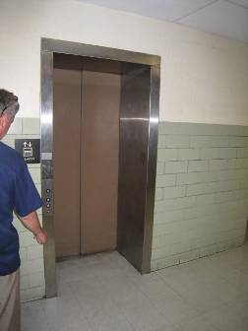

Retrofitted Elevator in Hallway

Picture 7

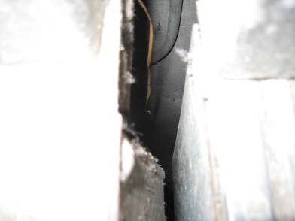

View between Elevator Car and Hallway Floor into Crawlspace

Picture 8

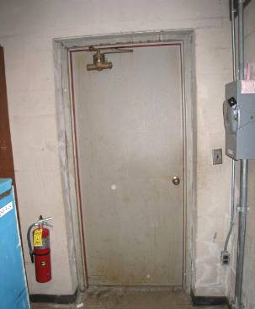

Inside View of Elevator Mechanical Room Door in Band Room (Note Spaces around Door)

Picture 9
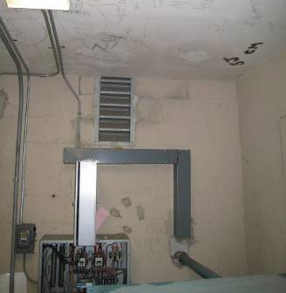
Elevator Pressure Equalization Vent

Space around Conduit

Openings in the Elevator Mechanical Room Wall Shared with Elevator Shaft

Picture10

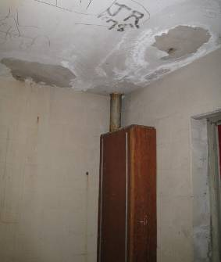

Water-Damaged Wooden Box in the Elevator Mechanical Room

