INDOOR AIR QUALITY ASSESSMENT

Broadmeadow Elementary School
120 Broadmeadow Road
Needham, Massachusetts 02492

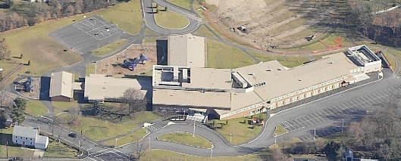

Prepared by:
Massachusetts Department of Public Health
Bureau of Environmental Health
Emergency Response/Indoor Air Quality Program
June 2007

Background/Introduction
At the request of the Needham School Department (NSD), the Massachusetts Department of Public Health (MDPH), Bureau of Environmental Health (BEH) conducted an indoor air quality assessment at the Broadmeadow Elementary School (BES), 120 Broadmeadow Road, Needham, Massachusetts. On March 2, 2007, Cory Holmes and Sharon Lee, Environmental Analysts for BEH’s Emergency Response/Indoor Air Quality (ER/IAQ) Program, visited the building to conduct an IAQ assessment.
The BES is a red brick building constructed in 1953. In 2003, the BES underwent renovations and a new wing was added. The school consists of two one-story classroom wings and a two-story classroom wing that branches off the core of the building. The two-story wing houses the main entrance, media center, an auditorium, music room and administrative offices. The school also contains a cafeteria and gymnasium, which are located off the two-story wing.

Methods
Air tests for carbon monoxide, carbon dioxide, temperature and relative humidity were conducted with the TSI, Q-Trak, IAQ Monitor, Model 8551. Air tests for airborne particle matter with a diameter less than 2.5 micrometers were taken with the TSI, DUSTTRAK™ Aerosol Monitor Model 8520. Screening for total volatile organic compounds (TVOCs) was conducted using an HNu, Model 102 Snap-on Photo Ionization Detector (PID). BEH staff also performed a visual inspection of building materials for water damage and/or microbial growth.

Results
The school houses students grades K-5 with a student population of approximately 585 and a staff of approximately 85. Tests were taken during normal operations at the school and results appear in Table 1.

Discussion
Ventilation
It can be seen from Table 1 that carbon dioxide levels were above 800 parts per million (ppm) in 16 of 30 areas surveyed, indicating less than optimal ventilation in about half the areas surveyed during the assessment. Mechanical ventilation is provided by rooftop air-handling units (AHUs). Fresh air is continuously distributed via wall or ceiling-mounted air diffusers (Pictures 1 and 2). At the time of the assessment, some of the air diffusers were obstructed by various classroom items inhibiting airflow (Picture 1).
Mechanical exhaust is provided by AHUs that are ducted to ceiling or wall-mounted return vents. In some cases, the location of exhaust vents can limit exhaust efficiency. In several classrooms vents are located above hallway doors (Pictures 3 and 4). When classroom doors are open, exhaust vents will tend to draw air from both the hallway and the classroom, reducing the effectiveness of the exhaust vent to remove common environmental pollutants.
Room 132 had no means of fresh air from either mechanical ventilation or windows. The room does, however, contain a ceiling-mounted exhaust vent. It is recommended that fresh air be provided either mechanically or naturally via air exchange through a passive door vent or a door undercut by 1 to 2-inches.
Elevated carbon dioxide levels were measured in the gymnasium (820 ppm), which indicates a lack of air exchange, particularly since it is a large volumous area. As communicated to BEH staff, the HVAC system was intentionally deactivated due to excessive noise during gym class.
To maximize air exchange, the MDPH recommends that both supply and exhaust ventilation operate continuously during periods of school occupancy. In order to have proper ventilation with a mechanical supply and exhaust system, the systems must be balanced to provide an adequate amount of fresh air to the interior of a room while removing stale air from the room. It is recommended that HVAC systems be re-balanced every five years to ensure adequate air systems function (SMACNA, 1994). The mechanical ventilation systems at BES reportedly occurred after renovations in 2003.
The Massachusetts Building Code requires a minimum ventilation rate of 15 cubic feet per minute (cfm) per occupant of fresh outside air or have openable windows in each room (SBBRS, 1997; BOCA, 1993). The ventilation must be on at all times that the room is occupied. Providing adequate fresh air ventilation with open windows and maintaining the temperature in the comfort range during the cold weather season is impractical. Mechanical ventilation is usually required to provide adequate fresh air ventilation.
Carbon dioxide is not a problem in and of itself. It is used as an indicator of the adequacy of the fresh air ventilation. As carbon dioxide levels rise, it indicates that the ventilating system is malfunctioning or the design occupancy of the room is being exceeded. When this happens, a buildup of common indoor air pollutants can occur, leading to discomfort or health complaints. The Occupational Safety and Health Administration (OSHA) standard for carbon dioxide is 5,000 parts per million parts of air (ppm). Workers may be exposed to this level for 40 hours/week, based on a time-weighted average (OSHA, 1997).
The MPDH uses a guideline of 800 ppm for publicly occupied buildings. A guideline of 600 ppm or less is preferred in schools due to the fact that the majority of occupants are young and considered to be a more sensitive population in the evaluation of environmental health status. Inadequate ventilation and/or elevated temperatures are major causes of complaints such as respiratory, eye, nose and throat irritation, lethargy and headaches. For more information concerning carbon dioxide, consult Appendix A.
Temperature measurements ranged from 68º F to 73º F, which were within or very close to the lower end of the MDPH recommended comfort range. The MDPH recommends that indoor air temperatures be maintained in a range of 70º F to 78º F in order to provide for the comfort of building occupants. Although temperatures were within the recommended comfort range in most areas assessed, occupants expressed temperature control complaints to BEH staff during the assessment. In many cases concerning indoor air quality, fluctuations of temperature in occupied spaces are typically experienced, even in a building with an adequate fresh air supply.
The relative humidity measured in the building ranged from 29 to 36 percent, which was below the MDPH recommended comfort range. The MDPH recommends a comfort range of 40 to 60 percent for indoor air relative humidity. Relative humidity levels in the building would be expected to drop during the winter months due to heating. The sensation of dryness and irritation is common in a low relative humidity environment. Low relative humidity is a very common problem during the heating season in the northeast part of the United States.

Microbial/Moisture Concerns
A hairline crack in the foundation was observed in storeroom 016 (Picture 5). It was reported to BEH staff that porous materials such as cardboard, paper and gypsum wallboard (GW) (Picture 6) had previously become water-damaged and colonized with mold. At the time of the assessment, the damaged GW had been removed and the area was dry and free of any visible mold and/or associated odors. In addition, porous materials were no longer being stored in this area.
Breaches were observed between the counter and sink backsplashes in some classrooms (Picture 7/Table 1). If not watertight, water can penetrate through these seams. Water penetration and chronic exposure of porous and wood-based materials can cause these materials to swell and show signs of water damage, which can subsequently lead to mold growth.
Several classrooms had a number of plants. Moistened plant soil and drip pans can be a source of mold growth. Plants should be equipped with drip pans; the lack of drip pans can lead to water pooling and mold growth on windowsills. Plants are also a source of pollen. Plants should be located away from the air stream of ventilation sources to prevent the aerosolization of mold, pollen or particulate matter throughout the classroom (Picture 8).

Other IAQ Evaluations
Indoor air quality can be negatively influenced by the presence of respiratory irritants, such as products of combustion. The process of combustion produces a number of pollutants. Common combustion emissions include carbon monoxide, carbon dioxide, water vapor and smoke (fine airborne particle material). Of these materials, exposure to carbon monoxide and particulate matter with a diameter of 2.5 micrometers (μm) or less (PM2.5) can produce immediate, acute health effects upon exposure. To determine whether combustion products were present in the school environment, BEH staff obtained measurements for carbon monoxide and PM2.5.
Carbon monoxide is a by-product of incomplete combustion of organic matter (e.g., gasoline, wood and tobacco). Exposure to carbon monoxide can produce immediate and acute health affects. Several air quality standards have been established to address carbon monoxide and prevent symptoms from exposure to these substances. The MDPH established a corrective action level concerning carbon monoxide in ice skating rinks that use fossil-fueled ice resurfacing equipment. If an operator of an indoor ice rink measures a carbon monoxide level over 30 ppm, taken 20 minutes after resurfacing within a rink, that operator must take actions to reduce carbon monoxide levels (MDPH, 1997).
The American Society of Heating Refrigeration and Air-Conditioning Engineers (ASHRAE) has adopted the National Ambient Air Quality Standards (NAAQS) as one set of criteria for assessing indoor air quality and monitoring of fresh air introduced by HVAC systems (ASHRAE, 1989). The NAAQS are standards established by the US EPA to protect the public health from six criteria pollutants, including carbon monoxide and particulate matter (US EPA, 2006). As recommended by ASHRAE, pollutant levels of fresh air introduced to a building should not exceed the NAAQS levels (ASHRAE, 1989). The NAAQS were adopted by reference in the Building Officials & Code Administrators (BOCA) National Mechanical Code of 1993 (BOCA, 1993), which is now an HVAC standard included in the Massachusetts State Building Code (SBBRS, 1997). According to the NAAQS, carbon monoxide levels in outdoor air should not exceed 9 ppm in an eight-hour average (US EPA, 2006).
Carbon monoxide should not be present in a typical, indoor environment. If it is present, indoor carbon monoxide levels should be less than or equal to outdoor levels. On the day of assessment, outdoor carbon monoxide concentrations were non-detect (ND) (Table 1). Carbon monoxide levels measured in the school were ND (Table 1).
The US EPA has established NAAQS limits for exposure to particulate matter. Particulate matter is airborne solids that can be irritating to the eyes, nose and throat. The NAAQS originally established exposure limits to particulate matter with a diameter of 10 μm or less (PM10). According to the NAAQS, PM10 levels should not exceed 150 microgram per cubic meter (μg/m³) in a 24-hour average (US EPA, 2006). These standards were adopted by both ASHRAE and BOCA. Since the issuance of the ASHRAE standard and BOCA Code, US EPA proposed a more protective standard for fine airborne particles. This more stringent PM2.5 standard requires outdoor air particle levels be maintained below 35 μg/m³ over a 24-hour average (US EPA, 2006). Although both the ASHRAE standard and BOCA Code adopted the PM10 standard for evaluating air quality, MDPH uses the more protective proposed PM2.5 standard for evaluating airborne particulate matter concentrations in the indoor environment.
Outdoor PM2.5 concentrations were measured at 12 μg/m³ (Table 1). PM2.5 levels within the school ranged from 1 to 11 μg/m³, which were below the NAAQS of 35 μg/m³ (Table 1). Frequently, indoor air levels of particulates can be at higher levels than those measured outdoors. A number of mechanical devices and/or activities that occur in schools can generate particulates during normal operation. Sources of indoor airborne particulate may include but are not limited to particles generated during the operation of fan belts in the HVAC system, cooking in the cafeteria stoves and microwave ovens; use of photocopiers, fax machines and computer printing devices, operating an ordinary vacuum cleaner and heavy foot traffic indoors.
Indoor air quality can also be negatively influenced by the presence of materials containing volatile organic compounds (VOCs). VOCs are carbon-containing substances that have the ability to evaporate at room temperature. Frequently, exposure to low levels of total VOCs (TVOCs) may produce eye, nose, throat and/or respiratory irritation in some sensitive individuals. For example, chemicals evaporating from a paint can stored at room temperature would most likely contain VOCs. In an effort to determine whether VOCs were present in the building, air monitoring for TVOCs was conducted during the assessment. An outdoor air sample was taken for comparison. Outdoor TVOC concentrations were ND (Table 1). Indoor TVOC concentrations were ND in all areas surveyed (Table 1).
In an effort to identify materials that can potentially increase indoor TVOC concentrations, BEH staff examined classrooms for products containing these respiratory irritants. The majority of classrooms contained dry erase boards and dry erase board markers. Materials such as dry erase markers and dry erase board cleaners may contain VOCs, such as methyl isobutyl ketone, n-butyl acetate and butyl-cellusolve (Sanford, 1999), which can be irritating to the eyes, nose and throat. Cleaning products were found on countertops and in unlocked cabinets beneath sinks in some classrooms (Picture 9). Like dry erase materials, cleaning products contain VOCs and other chemicals that can be irritating to the eyes, nose and throat of sensitive individuals.
Finally of note was the amount of materials stored inside classrooms. In some classrooms items were observed on windowsills, tabletops, counters, univents, bookcases and desks. The stored materials in classrooms provide surfaces for dust to accumulate. Accumulation of these items (e.g., papers, folders, boxes) makes cleaning difficult for custodial staff.

Conclusions/Recommendations
In view of the findings at the time of the visit, the following recommendations are made:
- Continue to operate both supply and exhaust ventilation continuously during periods of school occupancy, independent of classroom thermostat control to maximize air exchange. Consult the school’s heating, ventilation and air conditioning (HVAC) engineer concerning an increase in the introduction of outside air.
- Evaluate mechanical ventilation system in the gymnasium for proper function (excessive noise) and make repairs/adjustments as needed.
- In order to improve thermal comfort/temperature control it is highly recommended that school staff work in conjunction with the facilities department and their HVAC vendor to examine make adjustments/repairs to the HVAC system.
- Consider installing mechanical ventilation to room 132. If not feasible the hallway door should be undercut (approximatley1-2-inches) or a passive door vent should be installed to provide air exchange.
- Consider having the ventilation system balanced by an HVAC engineer every five years (SMACNA, 1994).
- Remove obstructions from supply vents to facilitate airflow.
- Close classroom doors to maximize air exchange.
- Change filters for HVAC equipment as per manufacturer’s instructions or more frequently if needed.
- For buildings in New England, periods of low relative humidity during the winter are often unavoidable. Therefore, scrupulous cleaning practices should be adopted to minimize common indoor air contaminants whose irritant effects can be enhanced when the relative humidity is low. To control for dusts, a high efficiency particulate arrestance (HEPA) filter equipped vacuum cleaner in conjunction with wet wiping of all surfaces is recommended. Avoid the use of feather dusters. Drinking water during the day can help ease some symptoms associated with a dry environment (throat and sinus irritations).
- Continue to monitor foundation crack in storeroom 016 for leakage, make repairs as needed.
- Seal areas around sinks to prevent water damage to the interior of cabinets and/or porous building materials.
- Ensure plants have drip pans. Examine drip pans periodically for mold growth and disinfect with an appropriate antimicrobial where necessary. Remove plants from the air stream of mechanical ventilation.
- Store cleaning products properly and out of reach of students. Ensure spray bottles are properly labeled. All cleaning products used at the facility should be approved by the school department with MSDS’ available at a central location.
- Relocate or consider reducing the amount of materials stored in classrooms to allow for more thorough cleaning. Clean items regularly with a wet cloth or sponge to prevent excessive dust build-up.
- Consider adopting the US EPA (2000) document, “Tools for Schools”, as an instrument for maintaining a good indoor air quality environment in the building. This document is available at: http://www.epa.gov/iaq/schools/index.html.
- For more information on mold, Consult “Mold Remediation in Schools and Commercial Buildings” published by the US Environmental Protection Agency (US EPA, 2001) for more information on mold. This document can be downloaded from the US EPA website at: http://www.epa.gov/iaq/molds/mold_remediation.html.
- Refer to resource manual and other related indoor air quality documents located on the MDPH’s website for further building-wide evaluations and advice on maintaining public buildings. These documents are available at: http://www.state.ma.us/dph/MDPH/iaq/iaqhome.htm.

References
ASHRAE. 1989. Ventilation for Acceptable Indoor Air Quality. American Society of Heating, Refrigeration and Air Conditioning Engineers. ANSI/ASHRAE 62-1989

BOCA. 1993. The BOCA National Mechanical Code/1993. 8th ed. Building Officials & Code Administrators International, Inc., Country Club Hills, IL.

MDPH. 1997. Requirements to Maintain Air Quality in Indoor Skating Rinks (State Sanitary Code, Chapter XI). 105 CMR 675.000. Massachusetts Department of Public Health, Boston, MA.
OSHA. 1997. Limits for Air Contaminants. Occupational Safety and Health Administration. Code of Federal Regulations. 29 C.F.R 1910.1000 Table Z-1-A.

Sanford. 1999. Material Safety Data Sheet (MSDS No: 198-17). Expo® Dry Erase Markers Bullet, Chisel, and Ultra Fine Tip. Sanford Corporation. Bellwood, IL.
SBBRS. 1997. Mechanical Ventilation. State Board of Building Regulations and Standards. Code of Massachusetts Regulations. 780 CMR 1209.0.

SMACNA. 1994. HVAC Systems Commissioning Manual. 1st ed. Sheet Metal and Air Conditioning Contractors’ National Association, Inc., Chantilly, VA.

US EPA. 2000. Tools for Schools. Office of Air and Radiation, Office of Radiation and Indoor Air, Indoor Environments Division (6609J). EPA 402-K-95-001, Second Edition. http://www.epa.gov/iaq/schools/tools4s2.html
US EPA. 2001. “Mold Remediation in Schools and Commercial Buildings”. Office of Air and Radiation, Indoor Environments Division, Washington, DC. EPA 402-K-01-001. March 2001. Available at: http://www.epa.gov/iaq/molds/mold_remediation.html
US EPA. 2006. National Ambient Air Quality Standards (NAAQS). US Environmental Protection Agency, Office of Air Quality Planning and Standards, Washington, DC. http://www.epa.gov/air/criteria.html.

Picture 1

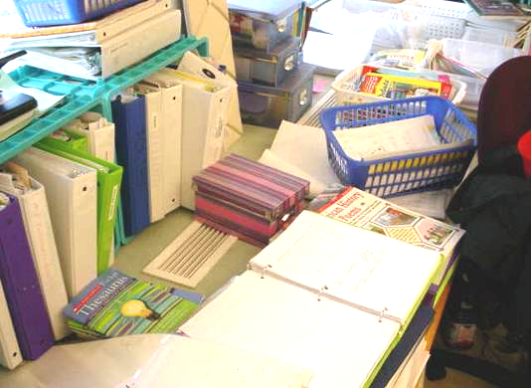

Wall-Mounted Supply Vent, Note Obstruction by Classroom Items

Picture 2

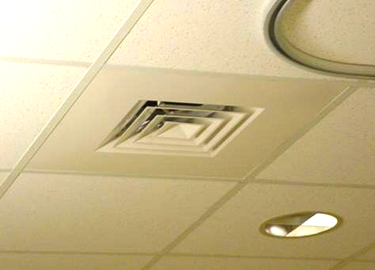

Ceiling-Mounted Supply Vent
Picture 3

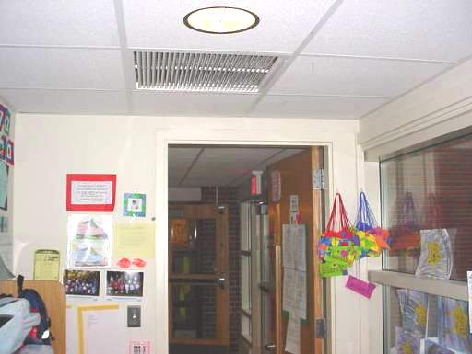

Ceiling-Mounted Return Vent

Picture 4

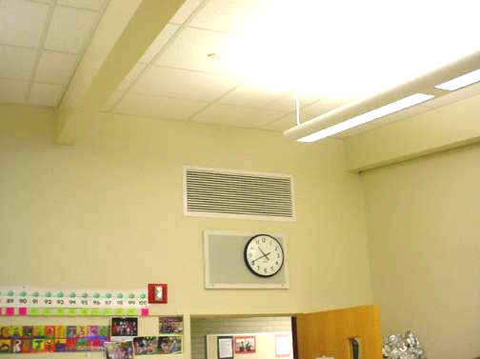

Wall-Mounted Return Vent
Picture 5

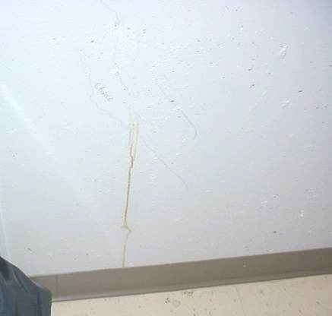

Hairline Crack in Foundation in Lower Level Storeroom 016

Picture 6

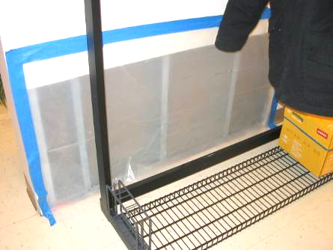

Section of Gypsum Wallboard Removed Due to Previous Water Damage
Picture 7

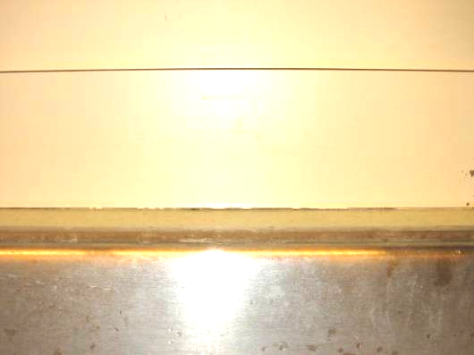

Breach between Sink Countertop and Backsplash

Picture 8

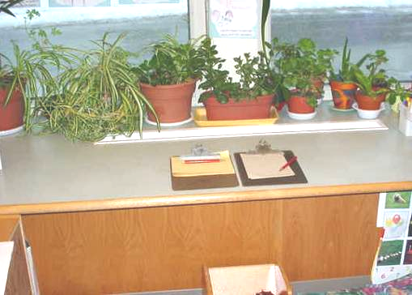

Plants in the Air Stream of Ventilation Equipment
Picture 9

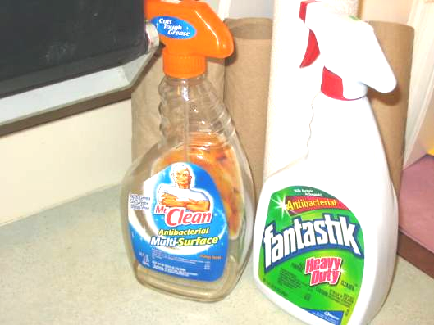

Spray Cleaning Products on Countertop in Classroom
Location/ Room | Occupants  in Room | Temp  (°F) | Relative  Humidity  (%) | Carbon  Dioxide  (ppm) | Carbon Monoxide  (ppm) | TVOCs  (ppm) | PM2.5  (µg/m3) | Windows  Openable | Ventilation |  | Remarks
 |  |  |  |  |  |  |  |  | Supply | Exhaust | Remarks
background |  | 40 | 98 | 359 | ND | ND | 12 |  |  |  | Heavy rain, winds ENE 20 mph
123 | 24 | 70 | 36 | 805 | ND | ND | 3 | Y | Y | Y | DO, plants near supply vent, accumulated items, DEM, pets, nests, plants
121 | 23 | 69 | 34 | 743 | ND | ND | 3 | Y | Y | Y | Plants near vent, pets
119 | 20 | 69 | 35 | 794 | ND | ND | 3 | Y | Y | Y | DO, DEM
132 | 2 | 70 | 35 | 818 | ND | ND | 6 |  | N | Y | DO
110 Nurse Suite | 2 | 71 | 32 | 580 | ND | ND | 4 | Y | Y | Y | DO,
151 | 24 | 70 | 33 | 798 | ND | ND | 9 | Y | Y | Y | DEM
152 | 22 | 70 | 33 | 812 | ND | ND | 11 | Y | Y | Y | DO, plants, DEM
Media Center | 20 | 71 | 32 | 630 | ND | ND | 5 | Y | Y | Y | DEM
Tech Center | 19 | 71 | 33 | 754 | ND | ND | 2 | Y | Y | Y | DO, plants, DEM
162 | 1 | 72 | 32 | 728 | ND | ND | 8 | Y | Y | Y | DO, PC
182 | 19 | 72 | 32 | 920 | ND | ND | 7 | Y | Y | Y | DEM
170 | 20 | 71 | 33 | 920 | ND | ND | 3 | Y | Y | Y | Supply obstructed by items
016 ETC | 1 | 71 | 30 | 485 | ND | ND | 2 |  |  |  | Store room crack in foundation previous area of water damage/mold growth
4 | 22 | 72 | 33 | 940 | ND | ND | 5 | Y | Y | Y | Pets, plants
Gym | 21 | 69 | 29 | 820 | ND | ND | 8 | N | Y | Y | DEM, vent off
61 | 0 | 70 | 32 | 755 | ND | ND | 2 | Y | Y | Y | DO, occupants at lunch, DEM
35 | 23 | 72 | 35 | 936 | ND | ND | 4 | Y | Y | Y | DEM, plants
Cafeteria | 100 | 70 | 33 | 647 | ND | ND | 3 | Y | Y | Y
124 | 0 | 72 | 35 | 852 | ND | ND | 1 | Y | Y | Y | DO, pets, food container re-use
125 | 19 | 70 | 34 | 752 | ND | ND | 1 | Y | Y | Y | DO, DEM, cleaning products, breach sink/countertop
127 | 21 | 68 | 35 | 840 | ND | ND | 2 | Y | Y | Y | DO, DEM, UF, cleaners, accumulated items
Music | 3 | 69 | 33 | 818 | ND | ND | 2 | Y | Y | Y | Plants, DEM, UF
144 | 22 | 69 | 32 | 691 | ND | ND | 3 | Y | Y | Y | DEM, plants
Art | 1 | 70 | 32 | 658 | ND | ND | 5 | Y | Y | Y | DO, DEM, plants, breach sink/countertop
163 | 2 | 73 | 31 | 934 | ND | ND | 3 | N | Y | Y | DO, DEM, acuumulated items
183 | 18 | 72 | 30 | 889 | ND | ND | 2 | Y | Y | Y | Plants near vent, cleaning products, breach sink/countertop
177 | 19 | 71 | 32 | 953 | ND | ND | 2 | Y | Y | Y | Supply obstructed by various items, plants near vent, breach sink/countertop
OT | 0 | 70 | 30 | 442 | ND | ND | 2 | N | Y | Y | DEM, PC
56 | 21 | 71 | 34 | 1022 | ND | ND | 1 | Y | Y | Y | DEM, food container re-use
2 | 24 | 71 | 34 | 1064 | ND | ND | 2 | Y | Y | Y | Cleaning products, breach sink/countertop

