PRELIMINARY ASSESSEMENT

East Junior High School
464 Centre Street
Brockton, MA 02302

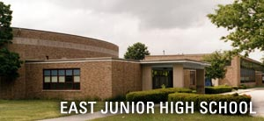

Prepared by:
Massachusetts Department of Public Health
Bureau of Environmental Health
Indoor Air Quality Program
April 2008

Background/Introduction
At the request of a parent, the Massachusetts Department of Public Health (MDPH), Bureau of Environmental Health (BEH) provided assistance and consultation regarding indoor air quality concerns at the East Junior High School (EJHS) located at 464 Centre Street, Brockton, Massachusetts. The request was prompted by concerns related to water damage, mold growth and other air quality and sanitary conditions in the building.
On April 1, 2008, a visit to conduct an indoor air quality assessment was made to the EJHS by Cory Holmes and James Tobin, Environmental Analysts in BEH’s Indoor Air Quality (IAQ) Program. BEH staff were accompanied by Doreen Quaglia, Sanitary Inspector, Brockton Health Department (BHD) and Principal Barbara Lovell during the assessment. This preliminary report focuses on water damage/mold remediation. A report regarding general indoor air quality conditions will follow. During the course of the assessment, visible mold growth was discovered behind vinyl wall covering the walls of the auditorium, and one ceiling tile in the gymnasium hallway.
The building was previously evaluated by the Massachusetts Department of Labor and Workforce Development (MDLWD), Division of Occupational Safety (DOS) in June, 2005. The MDLWD report described excessive levels of humidity in the auditorium, causing condensation accumulation on walls and floors and mold proliferation on ceiling and wall tiles (MDLWD, 2005). The report also indicated that the mechanical ventilation system was deactivated at the time of the inspection, which would likely contribute to the mold proliferation and associated odors (MDLWD, 2005). To address these issues, DOS listed the following corrective actions:
- address the roof/pointing leak in the auditorium;
- conduct mold remediation using the US EPA Mold Remediation in Schools and Public Buildings guidance document;
- provide training and personal protective equipment to employees conducting those activities; and
- replace damaged tiles (MDLWD, 2005).

Methods/Results
BEH staff performed a visual inspection of building materials for water damage and/or microbial growth. Moisture content of porous building materials (i.e., gypsum wallboard, plaster, ceiling/wall tiles), was measured with Delmhorst, BD-2000 Model, Moisture Detector with a Delmhorst Standard Probe. Moisture measurements are listed in Table 1.

Discussion
In order for building materials to support mold growth, a source of water exposure is necessary (e.g., roof/plumbing leaks, humidity/condensation). As indicated in the DOS report, the auditorium is prone to condensation (MDLWD, 2005). In a subsequent correspondence provided to DOS by Brockton Public Schools (BPS), the mechanical ventilation systems in the auditorium are now activated on a daily basis to circulate air. In addition, replacement of the roof was put on a capital improvements budget (BPS, 2006). Stained and damaged ceiling tiles are removed by custodial staff (BPS, 2006).
Identification and elimination of water moistening building materials is necessary to control mold growth. Materials with increased moisture content over normal concentrations may indicate the possible presence of mold growth. Musty odors were detected and visible mold growth and water damaged building materials (ceiling/wall tiles, plaster ceiling/walls) were observed in the auditorium. BEH staff conducted moisture testing of materials in a number of areas likely impacted by water damage. Plaster and ceiling/wall tiles in this area were found to have low (i.e., normal) moisture content at the time of the assessment (Table 1), indicating they were dry. However, elevated (i.e., saturated) moisture content and visible mold growth was observed on gypsum wallboard (GW) behind vinyl wall covering along the right side of the auditorium (Pictures 1 through 3). Vinyl wallpaper is a water impermeable material that can “trap” moisture. In addition, one ceiling tile in the gymnasium hallway had visible mold growth at the time of the assessment (Picture 4), which should also be removed/replaced.
At the time of the assessment, Mr. Holmes recommended to Principal Lovell that she coordinate with the BPS maintenance department to schedule remediation of the water damaged/mold colonized materials in the auditorium. In order to protect occupants and prevent exposure, Mr. Holmes recommended that any remediation of water-damaged/mold contaminated materials be conducted during unoccupied periods and in a manner consistent with recommendations in “Mold Remediation in Schools and Commercial Buildings” published by the US Environmental Protection Agency (US EPA, 2001). This information was also communicated with the BHD.
It is important to note that moisture content of materials is a real-time measurement of the conditions present in the building at the time of the assessment. Repeated water damage to porous building materials (e.g., GW, ceiling tiles, and carpeting) can result in microbial growth. The US Environmental Protection Agency (US EPA) and the American Conference of Governmental Industrial Hygienists (ACGIH) recommend that porous materials be dried with fans and heating within 24 to 48 hours of becoming wet (US EPA, 2001; ACGIH, 1989). If not dried within this time frame, mold growth may occur. Once mold has colonized porous materials, they are difficult to clean and should be removed/discarded.

Conclusions/Recommendations
In order to prevent potential mold and related spore movement and to reduce contaminant migration to adjacent areas during remediation, the following recommendations should be implemented. Work should be conducted at a time when occupants are not present in the area.
- Consider consulting a professional remediation specialist for mold remediation. Remove/replace water-damaged/mold colonized porous materials in auditorium (e.g., ceiling tiles, GW, vinyl wall covering). This measure will remove actively growing mold colonies that may be present. It is recommended that this work be conducted at a time when building occupants are not present in the area. Once work is completed, ensure that the area is thoroughly cleaned and disinfected with an appropriate antimicrobial. Dust and particulates generated from remediation should be vacuumed with a high efficiency particulate arrestance (HEPA) filtered vacuum cleaner.
- Conduct remediation activities in a manner consistent with recommendations in “Mold Remediation in Schools and Commercial Buildings” published by the US Environmental Protection Agency (US EPA, 2001). This document can be downloaded from the US EPA website: http://www.epa.gov/iaq/molds/mold_remediation.html.
- Ensure that the general mechanical ventilation system is deactivated and/or sealed (i.e., supply and return vents) in areas of remediation.
- Remove and replace water damaged/mold colonized ceiling tile(s) in gymnasium hallway.
References
ACGIH. 1989. Guidelines for the Assessment of Bioaerosols in the Indoor Environment. Code Administrators International, Inc., Country Club Hill, IL.
BPS. 2006. Corrective Action Response Form submitted to the Massachusetts Department of Labor and Workforce Development, Division of Occupational Safety by Brockton Public Schools, Dated February 15, 2006.
MDLWD. 2005. Indoor Air Quality (IAQ) Survey 05S0229, East Middle School, 464 Center Street, Brockton, MA 02301. August 26, 2005. Massachusetts Department of Labor and Workforce Development, Division of Occupational Safety, West Newton, MA.
US EPA. 2001. Mold Remediation in Schools and Commercial Buildings. US Environmental Protection Agency, Office of Air and Radiation, Indoor Environments Division, Washington, D.C. EPA 402-K-01-001. March 2001.
Picture 1

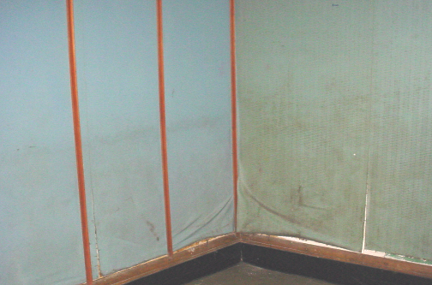

Water Damaged/Peeling Vinyl Wall Covering in Auditorium (Stage Side Right)

Picture 2

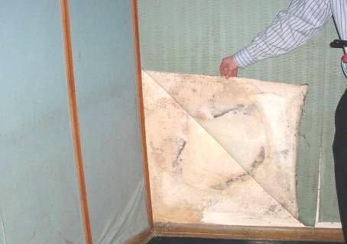

Water Damaged/Mold Colonized Gypsum Wallboard behind Vinyl Wall Covering in Auditorium (Stage Side Right)

Picture 3

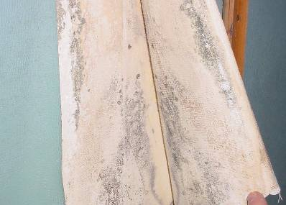

Close-Up of Visible Mold (Accumulated Dark Material) behind Vinyl Wall Covering in Auditorium (Stage Side Right)

Picture 4

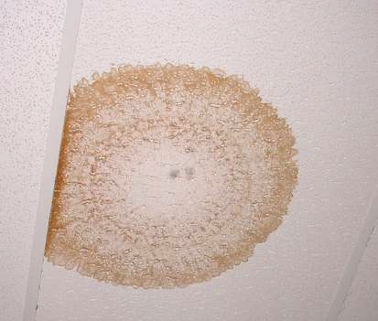

Visible Mold (Accumulated Dark Material)
on Water Damaged Ceiling Tile in Gymnasium Hallway

Table 1
Results of Moisture Measurements, East Junior High School, Brockton, MA
April 1, 2008

Location | Building Material | Moisture Measurement | Comments
Auditorium | Wall plaster | Low (i.e., normal)
Auditorium | Ceiling/wall tiles (rear) | Low (i.e., normal)
Auditorium | Gypsum Wallboard (Stage Side Right) | High (i.e., elevated) | Visible mold growth on Gypsum Wallboard behind vinyl wall covering
Gym Hallway | Ceiling tiles, wall | Low (i.e., normal) | Visible mold growth on one tile, no visible mold growth above ceiling tiles, dark stains on wall

