**INDOOR AIR QUALITY ASSESSMENT**

**Brockton Public Library**

**304 Main Street**

**Brockton, Massachusetts**

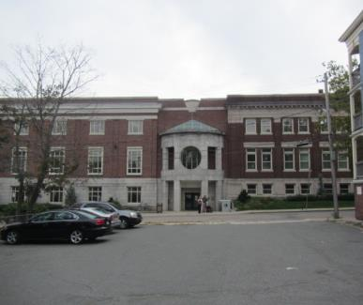

Prepared by:

Massachusetts Department of Public Health

Bureau of Environmental Health

Indoor Air Quality Program

November 2016

# Background

|  |  |
| --- | --- |
| Building: | Brockton Public Library (BPL) |
| Address: | 304 Main Street, Brockton |
| Assessment Requested by: | Brockton Public Library Staff, Union SEIU |
| Reason for Request: | General indoor air quality (IAQ) assessment |
| Date of Assessment: | September 23, 2016 |
| Massachusetts Department of Public Health/Bureau of Environmental Health (MDPH/BEH) Staff Conducting Assessment: | Mike Feeney, Director and Cory Holmes, Environmental Analyst/Inspector, IAQ Program |
| Date of Building Construction: | 1913, renovations/addition 2001-2003 |
| Building Description: | The main BPL, located in downtown Brockton, is a three-story brick structure built in 1913, originally as a high school. Extensive renovations and an addition were made to the BPL from 2001 to 2003. |
| Building Population: | The BPL has approximately 30 employees with members of the public visiting on a daily basis. |
| Windows: | Openable |

# Methods

Please refer to the IAQ Manual and appendices for methods, sampling procedures, and interpretation of results (MDPH, 2015).

# Results and Discussion

The following is a summary of indoor air testing results (Table 1).

* ***Carbon dioxide*** measurements were below the MDPH recommended level of 800 parts per million (ppm) in all areas surveyed.
* ***Temperature*** was within or close to the MDPH recommended range of 70°F to 78°F at the time of assessment.
* ***Relative humidity*** ***(RH)*** was above the MDPH recommended range of 40 to 60% in over half the areas tested.
* ***Carbon monoxide*** levels were non-detectable in all areas tested, with the exception of the garage, which had a slight level of 1.9 ppm, likely due to outside traffic.
* ***Particulate matter (PM2.5)*** concentrations measured were below the National Ambient Air Quality (NAAQS) level of 35 μg/m3 in all areas tested.

It was reported at the time of assessment that the HVAC system was awaiting parts (replacement cooling coil) for repair. These test results, indicate that the system needs to be repaired/adjusted to remove moisture from the air.

## Ventilation

A heating, ventilating, and air conditioning (HVAC) system has several functions. First it provides heating and, if equipped, cooling. Second, it is a source of fresh air. Finally, an HVAC system will dilute and remove normally occurring indoor environmental pollutants by not only introducing fresh air, but also filtering the airstream and ejecting stale air to the outdoors via exhaust ventilation. The act of cooling/providing AC is two-fold; the system chills the air via cooling coils while also typically removing moisture from the air.

Moisture removal is important since the sensation of heat conditions increases as RH increases (the relationship between temperature and RH is called the *heat index*). As indoor temperatures rise, the addition of more RH will make occupants feel hotter. If moisture is removed, the comfort of the individuals is improved.

While temperature is mainly a comfort issue, RH in excess of 70 percent for extended periods of time can provide an environment for mold and fungal growth (ASHRAE, 1989). As discussed further in the **Microbial/Moisture Concern** portion of the report, visual evidence indicates elevated indoor RH levels experienced over the summer have resulted in condensation formation on the surface of metal supply/return vents throughout the building. Condensation moistening dust/debris collected on diffuser surfaces (and surrounding surfaces such as ceiling tiles) can become a source of mold growth.

The HVAC system consists of rooftop air-handling units (AHUs, Picture 1), and a number of variable air volume (VAV) boxes located throughout the building (Picture 2). AHUs draw outside air into the building. The VAV boxes circulate and distribute air to occupied spaces via ducted ceiling vents (Picture 3). Return air is vented through ceiling or wall-mounted vents back to AHUs.

## Microbial/Moisture Concerns

As mentioned, reducing indoor humidity is important, since molds can grow when indoor RH levels exceed 70% for long periods of time. Symptoms commonly associated with molds include allergic reactions and respiratory irritation. Some people with chronic respiratory conditions, such as asthma, are more likely to experience health symptoms. Controlling moisture is the key to preventing mold growth and potential health symptoms.

In order for building materials to support mold growth, a source of water is necessary. The main source of water in the building is uncontrolled moisture brought in from the outside by the HVAC system. This moisture is leading to condensation issues on cool, uninsulated metal surfaces (i.e., supply vents) throughout the building. In numerous areas, dust/debris has built up on vents, which can grow mold if wet repeatedly (Picture 4). A few vents were rusted/corroded, a sign of chronic moisture exposure (Picture 5). Visible mold growth was also observed on surrounding ceiling tiles and plaster in some areas (Pictures 6 and 7).

Several sources/pathways for unconditioned outside air/moisture into the building were identified. The ground floor kitchen contains a local exhaust fan in the exterior wall (Picture 8). This type of vent typically contains a louvered vent that closes when not operating (Picture 9), in order to prevent the infiltration of outside air. This vent did not have a louvered vent (Picture 10), which allows outdoor air to enter the kitchen. The garage is an unconditioned space that had spaces around the door (Pictures 11 and 12), which drafts/moisture can readily infiltrate into occupied areas.

## Other Conditions

Other conditions that can affect IAQ were observed during the assessment. Some areas have area carpets. The Institute of Inspection, Cleaning, and Restoration Certification (IICRC) recommends that carpeting be cleaned annually (or semi-annually in soiled high traffic areas) (IICRC, 2012). Regular cleaning with a high efficiency particulate air (HEPA) filtered vacuum in combination with an annual cleaning will help to reduce accumulation and potential aerosolization of materials from carpeting.

# Conclusions and Recommendations

In view of the findings at the time of the visit, the following recommendations are made:

1. Continue with plans to make HVAC repairs and have ductwork cleaned. This should be carefully planned in stages for both thermal comfort and work disruption reasons. In addition, once completed the system should be thoroughly “blown out” and all areas should be thoroughly cleaned (using a high efficiency particulate arrestance (HEPA) filter equipped vacuum cleaner in conjunction with wet wiping of all surfaces).
2. Clean supply/return vents throughout the building. If they cannot be adequately cleaned, resurface/paint or replace.
3. Change all water-damaged/stained ceiling tiles.
4. Clean visible mold on ceiling plaster in the Microfilm room, scrape and refinish if needed.
5. Consider adopting a balancing schedule of every 5 years for all mechanical ventilation systems, as recommended by ventilation industrial standards (SMACNA, 1994).
6. For buildings in New England, periods of low RH during the winter are often unavoidable. Therefore, scrupulous cleaning practices should be adopted to minimize common indoor air contaminants whose irritant effects can be enhanced when the RH is low. To control for dusts, a HEPA filter equipped vacuum cleaner in conjunction with wet wiping of all surfaces is recommended. Avoid the use of feather dusters. Drinking water during the day can help ease some symptoms associated with a dry environment (throat and sinus irritation).
7. Ensure that procedures are in place and encourage occupants to report HVAC/maintenance issues so that they can be logged and repaired promptly.
8. Install closeable/louvered vents (Picture 9), or remove/seal vent if not needed.
9. Seal around garage doors with weather-stripping/sealant to prevent moisture/drafts into occupied areas. Check for tightness by monitoring for light and/or drafts around doors.
10. Ensure building envelope/exterior and plumbing leaks are repaired and make repairs to water damaged ceiling/wall plaster.
11. Clean vents periodically of accumulated dust/debris.
12. Clean carpeting annually or semi-annually in soiled high traffic areas as per the recommendations of the Institute of Inspection, Cleaning and Restoration Certification (IICRC, 2012).
13. For more information about mold/remediation consult Mold Remediation in Schools and Commercial Buildings” published by the US Environmental Protection Agency (US EPA, 2008).
14. Refer to resource manual and other related indoor air quality documents located on the MDPH’s website for further building-wide evaluations and advice on maintaining public buildings. These documents are available at <http://mass.gov/dph/iaq>.

# REFERENCES

American Society of Heating, Refrigerating, and Air-Conditioning Engineers (ASHRAE). 1989. Ventilation for Acceptable Indoor Air Quality. ANSI/ASHRAE 62-1989.

Institute of Inspection, Cleaning and Restoration Certification (IICRC). 2012. Carpet Cleaning: FAQ. Retrieved from <http://www.iicrc.org/consumers/care/carpet-cleaning>.

Massachusetts Department of Public Health (MDPH). 2015. Indoor Air Quality Manual: Chapters I-III. Available at: [http://www.mass.gov/eohhs/gov/departments/dph/programs/environmental-health/exposure-topics/iaq/iaq-manual/](http://www.mass.gov/eohhs/gov/departments/dph/programs/environmental-health/exposure-topics/iaq/iaq-manual/" \o "Indoor Air Quality Manual: Chapters I-III.).

Sheet Metal and Air Conditioning Contractors’ National Association, Inc. (SMACNA). 1994. HVAC Systems Commissioning Manual. 1st ed. Sheet Metal and Air Conditioning Contractors’ National Association, Inc., Chantilly, VA.

US EPA. 2008. Mold Remediation in Schools and Commercial Buildings. US Environmental Protection Agency, Office of Air and Radiation, Indoor Environments Division, Washington, D.C. EPA 402-K-01-001. <http://www.epa.gov/mold/mold-remediation-schools-and-commercial-buildings-guide>.

**Picture 1**

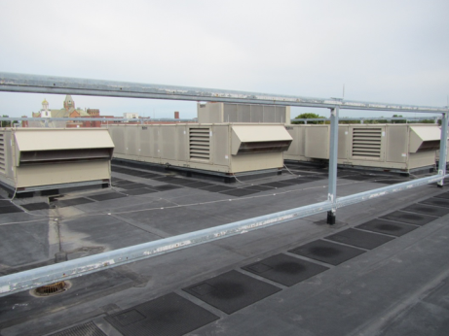

**Rooftop air handling units**

**Picture 2**

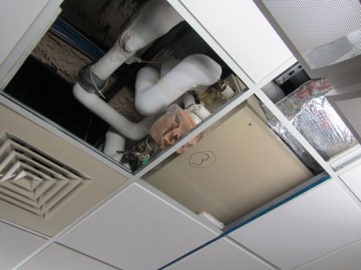

**VAV boxes above ceiling tile system**

**Picture 3**

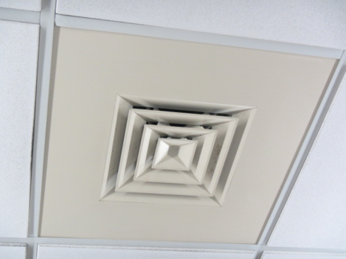

**Supply diffuser**

**Picture 4**

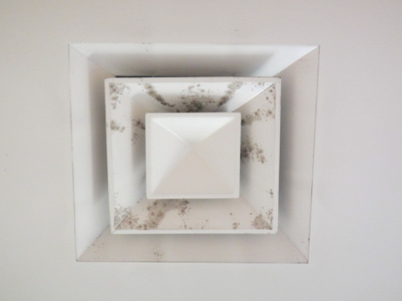

**Debris/likely mold growth on vent**

**Picture 5**

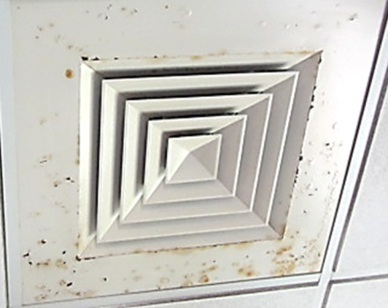

**Rust/corrosion on metal vents, a sign of chronic moisture exposure**

**Picture 6**

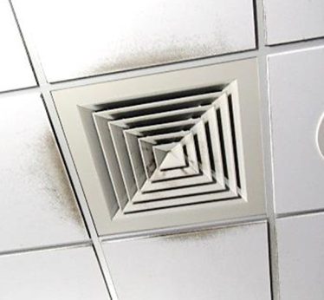

**Soiled ceiling tiles around supply diffusers**

**Picture 7**

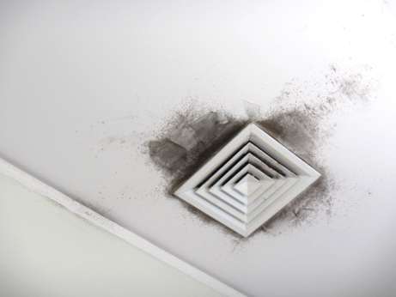

**Mold growth/discolored on ceiling plaster in the Microfilm room**

**Picture 8**

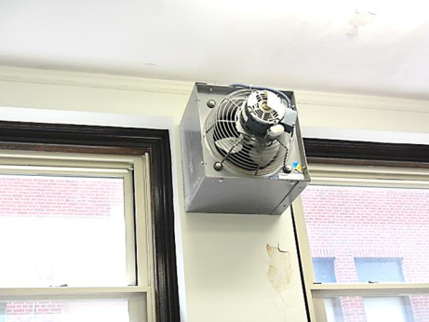

**Local exhaust vent in basement kitchen**

**Picture 9**

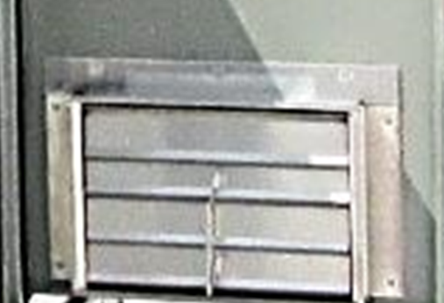

**Example of a local exhaust fan/vent louver at another building**

**Picture 10**

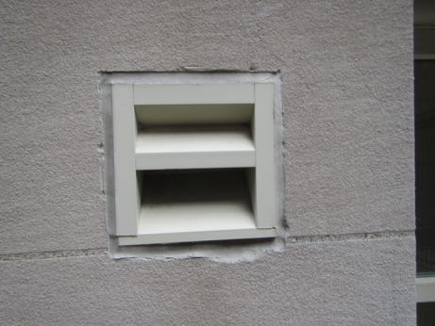

**Exterior opening of kitchen exhaust vent, note lack of louver**

**Picture 11**

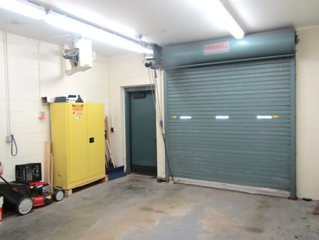

**Unconditioned garage**

**Picture 12**

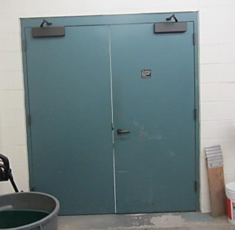

**Spaces around garage door to library basement offices**

| Location | Carbon  Dioxide  (ppm) | Carbon Monoxide  (ppm) | Temp  (°F) | Relative  Humidity  (%) | PM2.5  (µg/m3) | Occupants  in Room | Windows  Openable | Ventilation | | Remarks |
| --- | --- | --- | --- | --- | --- | --- | --- | --- | --- | --- |
| Supply | Exhaust |
| Background | 382 | ND-2 | 64 | 57 | 10 |  |  |  |  |  |
| **Ground Floor** |  |  |  |  |  |  |  |  |  |  |
| Kitchen | 406 | ND | 70 | 55 | 3 | 0 | Y | Y | Y | Peeling paint, dehumidifier, local exhaust vent in wall |
| Multi-Purpose Room | 442 | ND | 67 | 63 | 2 | 0 | N | Y | Y |  |
| Technical Processing | 475 | ND | 75 | 52 | 4 | 2 | Y | Y | Y | MTs, heat complaints, dust/debris/mold on vents |
| Garage | 501 | 1.9 | 73 | 57 | 4 | 0 | N | N | N | Unconditioned space, spaces around interior doors |
| Children’s Department Head | 478 | ND | 75 | 52 | 4 | 0 | Y | Y | Y | Dust/debris/mold on vents/CTs, rusted vents |
| Children’s Workroom | 436 | ND | 73 | 54 | 4 | 0 | N | Y | Y | dust/debris/mold on vents, rusted vents, dehumidifier |
| Children’s Library | 514 | ND | 71 | 55 | 2 | 15 | Y | Y | Y | Rusted/dust/debris/mold on vents |
| Story Room | 461 | ND | 69 | 58 | 4 | 0 | Y | Y | Y | Dust/debris/mold on vents/CTs, severely corroded vents |
| **2nd Floor** |  |  |  |  |  |  |  |  |  |  |
| Periodicals Room | 425 | ND | 69 | 57 | 4 | 0 | N | Y | Y | Vintage volumes |
| Mystery/Fiction | 492 | ND | 70 | 59 | 3 | 0 | N | Y | Y |  |
| Magazines | 480 | ND | 70 | 60 | 3 | 3 | Y | Y | Y | Plants |
| Paperbacks | 477 | ND | 69 | 62 | 3 | 1 | N | Y | Y |  |
| Circulation Checkout | 477 | ND | 69 | 62 | 3 | 2 | N | Y | Y |  |
| Teen Zone | 415 | ND | 69 | 63 | 3 | 0 | Y | Y | Y |  |
| Movies Music Room | 500 | ND | 69 | 63 | 2 | 3 | Y | Y | Y |  |
| **3rd Floor** |  |  |  |  |  |  |  |  |  |  |
| Teens | 462 | ND | 68 | 64 | 3 | 1 | Y | Y | Y | dust/debris/mold on vents/CTs |
| Non-Fiction/Bio | 471 | ND | 67 | 65 | 2 | 5 | N | Y | Y |  |
| Reference | 471 | ND | 68 | 66 | 2 | 5 | N | Y | Y | dust/debris/mold on vents/CTs |
| Computer Area | 483 | ND | 68 | 66 | 3 | 5 | Y | Y | Y |  |
| Historical Room | 491 | ND | 69 | 65 | 3 | 2 | Y | Y | Y | Vintage volumes |
| Reading Room | 490 | ND | 70 | 62 | 3 | 0 | Y | Y | Y |  |
| Caffrey Room | 402 | ND | 70 | 61 | 3 | 0 | Y | Y | Y | WD walls, peeling paint |
| Driscoll Gallery | 406 | ND | 70 | 62 | 2 | 0 | Y | Y | Y |  |
| Microfilm Room | 402 | ND | 70 | 62 | 3 | 0 | Y | Y | Y | Dust/debris/mold on vent/plaster ceiling |
| Library Staff | 388 | ND | 69 | 69 | 3 | 0 | Y | Y | Y | Dust/debris/mold on vents/CTs (Dept Head office) |