ODOR ASSESSMENT

Brookfield Historical Commission Building
7 Prouty Street
Brookfield, Massachusetts

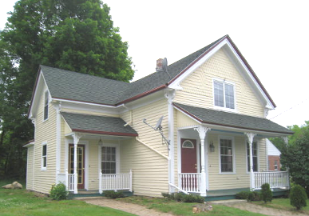

Prepared by:
Massachusetts Department of Public Health
Bureau of Environmental Health
Indoor Air Quality Program
July 2012

Background/Introduction
At the request of Cindy Thompson, Health Agent for the Brookfield Board of Health, the Massachusetts Department of Public Health (MDPH), Bureau of Environmental Health (BEH) conducted an indoor air quality (IAQ) assessment at the Brookfield Historical Commission Building (BHCB), 7 Prouty Street, Brookfield, Massachusetts. The request was prompted by health complaints (e.g., respiratory illness, exacerbation of allergies and headaches) among several occupants thought to be associated with odors and mold concerns.
On May 25, 2012, a visit to conduct an IAQ assessment was made to the BHCB by Michael Feeney, Director of BEH’s IAQ Program and Kathleen Gilmore, Environmental Analyst/Regional Inspector for BEH’s IAQ Program. Ms. Thompson and Mr. Bill Thompson, custodian for BHCB, accompanied BEH staff during the visit.
The BHCB is a two-story, wood-clad building originally constructed as a private residence in the late 1800s. The building underwent extensive renovation in 2009 - 2010 prior to purchase by the Town of Brookfield in the summer of 2011. Renovations included installation of a shingled roof, replacement windows and doors, gypsum wallboard, vinyl linoleum in the kitchen and bathrooms, and wall-to-wall carpeting in all other rooms of the building (Table 1, Picture 1). In addition, it appears that the floorboards of the kitchen were replaced with plywood onto which linoleum tile was installed. The original floorboards on the first floor were left in place, which were then covered with wall-to-wall carpeting. The basement has a combination of flagstone and cement foundation. Radiators provide heat for the building. Windows are openable throughout the building.

Methods
Air tests for temperature and relative humidity were conducted with the TSI, Q-Trak, IAQ Monitor, Model 7565. BEH staff also performed visual inspection of building materials to identify the source of odors, water damage and/or microbial growth.

Results
The BHCB is office space occupied by members of the Historical Commission and the Merrick Public Library. On the day of the assessment the building was unoccupied. Results of tests taken appear in Table 1.

Discussion

Ventilation
No mechanical ventilation systems exist in the building. The sole source of fresh air is through openable windows. Mr. Thompson reported that windows are open only when the building is occupied. With the lack of supply and general exhaust ventilation, pollutants that exist in the interior space can build up and lead to indoor air quality and comfort complaints.
Temperature readings ranged from 70°F to 77°F, which were within the MDPH recommended range at the time of assessment (Table 1). The MDPH recommends that indoor air temperatures be maintained in a range of 70°F to 78°F in order to provide for the comfort of building occupants. In many cases concerning indoor air quality, fluctuations of temperature in occupied spaces are typically experienced.
The relative humidity ranged from 51 to 63 percent at the time of assessment (Table 1), which were within the MDPH recommended comfort range in the occupied space; the basement had higher relative humidity (63%). The MDPH recommends a comfort range of 40 to 60 percent for indoor air relative humidity. While temperature is mainly a comfort issue, relative humidity in excess of 70 percent for extended periods of time can provide an environment for mold and fungal growth (ASHRAE, 1989). Relative humidity levels in the building would be expected to drop during the winter months due to heating. The sensation of dryness and irritation is common in a low relative humidity environment. Low relative humidity is a very common problem during the heating season in the northeast part of the United States.

Odor Assessment
Upon entering the building a distinct odor was detected by BEH staff. Brookfield town officials reported that the odors seem to be more prevalent during the heating season. BEH staff identified the wall-to-wall carpet as the source of this odor. The renovation of the building envelope likely reduced air infiltration/exfiltration in the building. With no mechanical ventilation, and reduced natural ventilation, indoor pollutants cannot be removed from the building and can build up and become irritating to the eyes, nose and respiratory system. Both heat and moisture can exacerbate odors from wall-to-wall carpeting. The lower side of the wall-to-wall carpeting installed on the first floor is repeatedly exposed to water vapor/moisture present in the basement through space in the floor boards (Picture 2).

Microbial/Moisture Concerns in the Basement
There was a musty odor on entering the basement and evidence of moisture and water damage on the foundation walls and wood beams. The basement did not contain any stored porous materials or items, but visible mold was present on pipe insulation (Pictures 3 and 4).
The basement is subject to water penetration through the foundation’s southern wall. The stone foundation walls may be water penetrable and allow accumulated surface water (pooling rain) from the exterior of the building to enter the basement. Cracks and crevices in the foundation (Picture 5) as well as damaged/deteriorated windows (Picture 6) can undermine the integrity of the exterior walls and provide a means of water entry by capillary action into the building.
Three basement windows were sealed with plywood. The remaining two windows were open with one containing a portable fan (Picture 7) that was not operating at the time of assessment. The fan was positioned to draw outside air into the basement. BEH staff recommended that the fan be positioned to exhaust air from the basement to the outdoors instead. According to Mr. Thompson, the basement windows are open during the spring and summer. This practice may increase moisture and allow water penetration into the basement during hot, humid weather.
The first floor carpet was installed over the existing wood flooring that has gaps between the floor slats (Pictures 8 and 9) providing a means for mold-associated odors/particulates, and water vapor in the basement to migrate into first floor carpeted areas of the building. This condition can moisten wood below the carpet with the underside of the carpet creating a vapor barrier, which prevents drying. Moistened carpeting/wood can provide suitable conditions for mold colonization to occur. In addition, other open penetrations in the first floor were present, creating pathways for odors from the basement to migrate into occupied areas.
It was noted that, boxes of papers, books, picture frames and other porous materials were being stored in the first floor office space that appeared to be mold colonized (Picture 10). According to Mr. Thompson, these items had been stored previously in the basement of the Merrick Library and had been recently transferred to the BHCB.
In order to become colonized with mold, a material must be exposed to water and remain moist. If sufficiently moistened, porous materials such as books, paper, insulation covering, and carpeting can support mold growth (US EPA, 2001). The US EPA and the American Conference of Governmental Industrial Hygienists (ACGIH) recommend that porous materials be dried with fans and heating within 24 to 48 hours of becoming wet (US EPA, 2001; ACGIH, 1989). If porous materials are not dried within this time frame, mold growth may occur. Once mold has colonized porous materials, they are difficult to clean and should be removed and discarded.
BEH staff conducted a perimeter inspection of the building’s exterior to identify potential sources of water penetration. Basement windows are below grade and surrounded by window wells that contain grass, plant growth and debris (Pictures 11 and 12), which can result in the accumulation of rainwater and potential water penetration into the basement. In addition, the growth of grass and roots against exterior walls can bring moisture in contact with the foundation, eventually leading to cracks and/or fissures in the below ground level. Over time, these conditions can undermine the integrity of the building envelope and provide a means of water entry into the building through capillary action through foundation concrete and/or masonry (Lstiburek & Brennan, 2001).
Rain gutters and downspouts were installed along a section in the front of the building. The gutters were found to be clogged with leaves and other debris resulting in poor drainage capacity. The entire building structure should be retrofitted with gutters and rainspouts directed at least five feet away from the building and kept clear of debris.

Conclusions/Recommendations
Based on these observations, it appears that the odor source is the wall-to-wall carpeting and water-damaged/mold-colonized stored materials. In addition, a moisture pathway exists for water vapor from the basement to moisten carpeting in occupied areas. In view of the findings at the time of the visit, the following recommendations are made:
- Remove the wall-to-wall carpeting from the building to remedy odors. Clean residue from floor beneath the carpet and allow to air dry. Replace with a nonporous material.
- Repair or replace deteriorated basement windows.
- Seal all holes and cracks in the interior basement walls to reduce water intrusion and vapor migration.
- All floor penetrations in the office space should be sealed using an appropriate fire-rated sealing compound.
- In order to aid in the prevention of water vapor accumulation in the basement, the portable window fan should exhaust air from the basement to the outdoors.
- Consider using dehumidifiers in the basement area during hot, humid weather to reduce relative humidity. Ensure that dehumidifiers are maintained and cleaned as per manufacture’s instructions to prevent mold growth.
- Remove water-damaged or mold-contaminated porous materials stored in the first floor office space. Documents of historical significance may be stored in air-tight containers to prevent mold colonization/growth and distribution of spores and odors to the space. A professional restoration contractor may be able to provide services to remediate water-damaged historical documents.
- Remedy all exterior building envelope conditions that contribute to water infiltration into the building, such as:
  - Seal cracks in the exterior foundation of the building.
  - Routinely clean existing gutters to improve drainage. The building should be retrofitted with gutters/downspouts that direct rainwater at least five feet away from the building and kept clear of debris.
  - Remove grass, plants and debris from window wells. Consider installing rain shields over basement window wells to prevent water penetration into the basement.
- Refer to resource manuals and other related indoor air quality documents for further building-wide evaluations and advice on maintaining public buildings. Copies of these materials are located on the MDPH’s website: http://mass.gov/dph/iaq

References
ACGIH. 1989. Guidelines for the Assessment of Bioaerosols in the Indoor Environment. American Conference of Governmental Industrial Hygienists, Cincinnati, OH.
ASHRAE. 1989. ASHRAE Standard: Ventilation for Acceptable Indoor Air Quality. Sections 5.11, 5.12. American Society of Heating, Refrigerating and Air-Conditioning Engineers, Inc. Atlanta, GA.
Lstiburek, J. & Brennan, T. 2001. Read This Before You Design, Build or Renovate. Building Science Corporation, Westford, MA. U.S. Department of Housing and Urban Development, Region I, Boston, MA.
US EPA. 2001. “Mold Remediation in Schools and Commercial Buildings”. Office of Air and Radiation, Indoor Environments Division, Washington, DC. EPA 402-K-01-001. March 2001. Available at: http://www.epa.gov/iaq/molds/mold_remediation.html
Picture 1

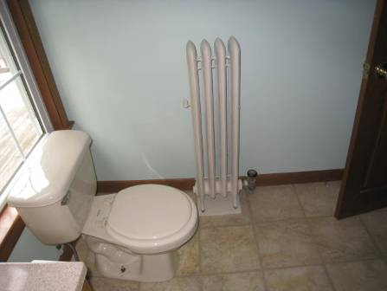

Vinyl Linoleum in Bathroom

Picture 2

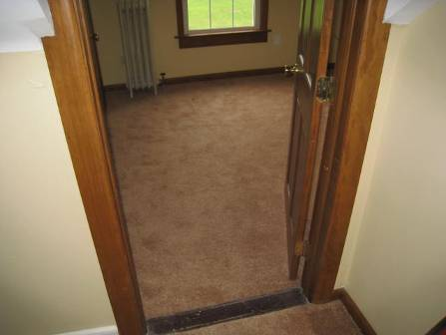

Wall-to-Wall Carpeting

Picture 3

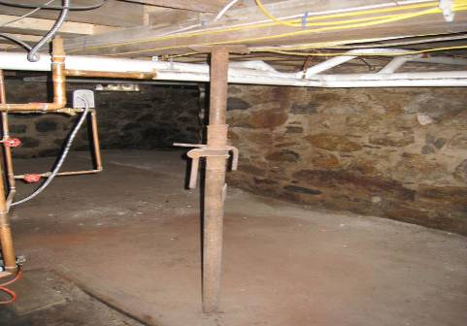

Building Basement

Picture 4

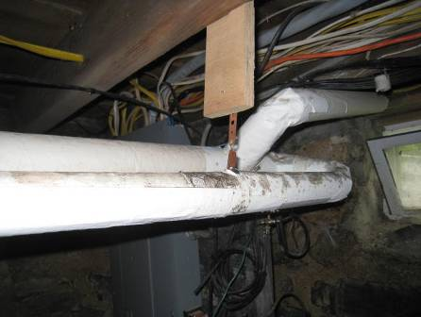

Pipe Insulation with Visible Mold (Arrow)

Picture 5

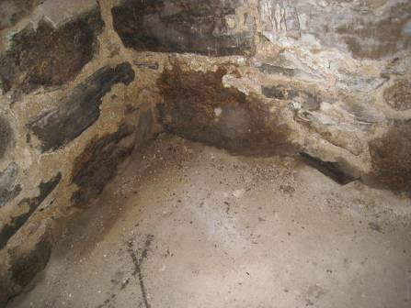

Water-Damaged Foundation and Crevice (Arrow) in Interior Corner of Basement

Picture 6

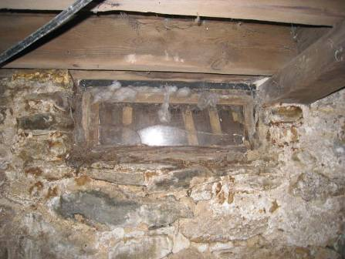

Deteriorated Basement Window

Picture 7

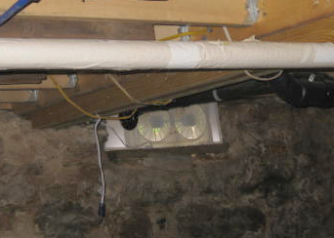

Window Fan in Basement

Picture 8

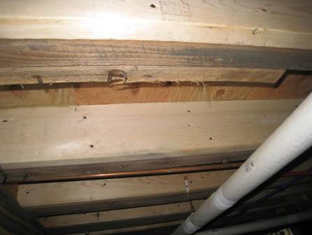

Sub-Flooring below First Floor Kitchen Area

Picture 9

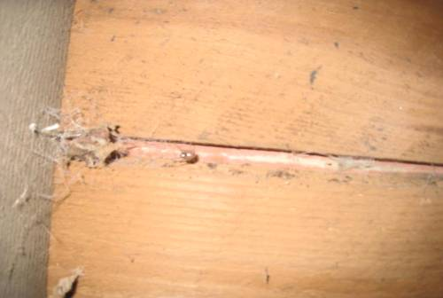

Gaps in First Floor Wood Slats below Carpeted Area (Arrow)

Picture 10

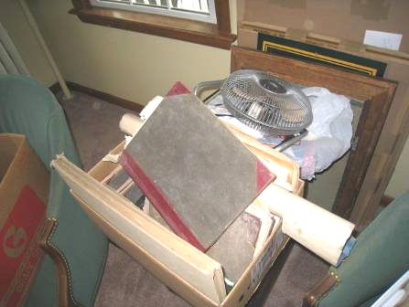

Books, Paper and other Porous Materials in First Floor Office Space

Picture 11

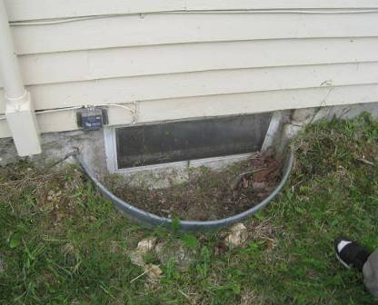

Below-grade Window Well with Grass and Debris

Picture 12

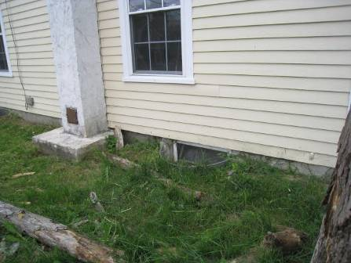

Grass, Plants and Debris Surrounding Basement Window
Location/ Room | Temp  (°F) | Relative  Humidity  (%) | Windows  Openable | Remarks
Background | 72 | 76 |  | Partly sunny, humid
Basement | 70 | 63 | Y | 2 Windows open, 3 Windows sealed with plywood
Kitchen | 75 | 53 | Y | Vinyl linoleum floor, Odor
1st Floor Bathroom | 74 | 55 | Y | Vinyl linoleum floor
1st Floor Office Space | 77 | 51 | Y | Carpet, Strong odor
2nd Floor Room 1 | 70 | 57 | Y | Carpet
2nd Floor  Room 2 | 70 | 57 | Y | Carpet
2nd Floor,  Room 3 | 70 | 55 | Y | Carpet
2nd Floor Bathroom | 70 | 55 | Y | Vinyl linoleum floor

Air infiltration is the unintentional or accidental introduction of outside air into a building through spaces around exterior windows and door frames. Air exfiltration is the unintentional or accidental passage of indoor air through spaces around exterior windows and door frames.

