 | Massachusetts Department of Environmental Protection  Bureau of Resource Protection – Title 5 Permitting  BRP WP 58a  Approval of a Nitrogen Aggregation Loading Plan |  | Please do not mail.  Submit through ePlace.  See instructions.
Please read the Instructions and Supporting Materials before filling out this form.

Note: Any and all areas identified as “restricted” or “credit land” for the purposes of one application for aggregate nitrogen loading cannot be used for another application pursuant to 310 CMR 15.216.

DEP anticipates that preparation of nitrogen loading plans may require both technical (including hydrogeologic) and legal expertise.
 | A. General Information
Important: When filling out forms on the computer, use only the tab key to move your cursor - do not use the return key.  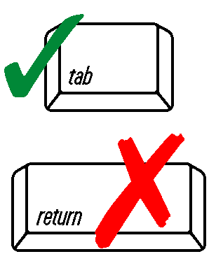 | 1. Applicant:
 | Name
 | Doing Business as (dba)
 | Street Address | City/Town
 | State | Zip Code
 | Telephone
 | 2. Facility Address / Location (if different from Applicant):
 | Address
 | City/Town | State
 | Zip Code
 | 3. Contact Person (if different from Applicant):
 | Contact Person
 | Consultant Firm
 | Address
 | City/Town | State
 | Zip Code | Telephone
 | 4. Does this project require a filing under 310 CMR 11.00, The Massachusetts Environmental Policy Act?
 | Yes No
 | If yes, has a filing been made? Yes No | If yes, EOEA File #
 | A. General Information (cont.)
 | 5. A nitrogen aggregation application for MassDEP approval is for a region-wide Community Plan.
 | The Community Plan may be for either a Nitrogen Sensitive Area or for a new residential construction where the use of both on-site systems and on-site-drinking water supply wells are proposed (private well areas). This application is for:
A Zone II
An Interim Wellhead Protection Area
Private well area for new residential construction
 | 6. A map for the area covered by the plan is required. Is the map attached?
 | Yes No
 | 7. A buildout analysis under current zoning for the area of the community subject to the plan is required. Is the buildout analysis enclosed?
 | Yes No
 | 8. The nitrogen loading limitation of 440 gpd per acre equivalency demonstration is required. Are the calculations enclosed?
 | Yes No
 | 9. If the Community Plan is for a Zone II, the DEP Nitrogen Loading Computer Model analysis is required.
 | Is the Zone II analysis enclosed? Yes No
 | Are Planning Board comments attached? Yes No
 | 10. A nitrogen loading management plan including land use regulations (e.g., zoning or health regulations) is required. Is the management plan enclosed?
 | Yes No
 | B. Certification
 | “I certify under penalty of law that this document and all attachments, to the best of my knowledge and belief, are true, accurate, and complete. I am aware that there are significant penalties for submitting false information, including the possibility of fine and imprisonment for knowing violations.” | Applicant’s signature
 |  | Print Name
 |  | Name of Preparer
 |  | Date

