 | Massachusetts Department of Environmental Protection  Bureau of Resource Protection – Title 5 Permitting  BRP WP 63 Disposal System Construction Permit for State or Federal Facilities |  | Please do not mail.  Submit through ePlace.  See instructions.
Important: When filling out forms on the computer, use only the tab key to move your cursor - do not use the return key.  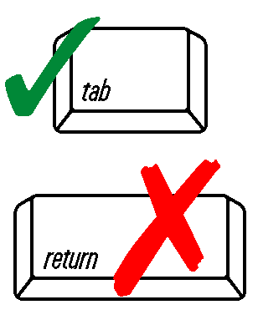 | A. General Information
 | 1. Applicant:
 | Name
 | Address
 | City/Town | State |  | Zip Code
 | Telephone
 | 2. Facility Address/Location (if different from applicant):
 | Address
 | City/Town | State |  | Zip Code
 | 3. System Designer Information (Registered Sanitarian [RS] or Professional Engineer [PE] for systems under 2,000 gallons per day; PE for systems 2,000 gallons or more per day):
 | Name | Company Name
 | Address
 | City/Town | State |  | Zip Code
 | Telephone
 | 4. Registration:
 | P.E.
 | Sanitarian
 | Registration Number
 | 5. The legal entity which will own facility is: State/County Federal Other:
 |  | Specify
6. Does this project require a filing under 301 CMR 11.00 and MGL c. 30, ss 61-62H, the
Massachusetts Environmental Policy Act? Yes No
 | If yes, has a filing been made? Yes No
 | If yes, EOEA File #
 | A. General Information (cont.)
 | 7. Two complete set of plans and specifications, including a locus map, properly stamped and signed by a Massachusetts Registered Professional Engineer or Massachusetts Registered Sanitarian must accompany the application. Plans must be prepared in accordance with the provisions of 310 CMR 15.220.
 | Are plans and specifications enclosed? Yes No
 | 8. Has a site evaluation been performed which includes, among other things, a percolation test and a soil evaluation by an approved soil evaluator? Yes (Attach all forms) No
 | 9. Does the system design require approval of pumping prior to the septic tank pursuant to 310 CMR 15.229? Yes No
 | 10. If applying for a Local Upgrade Approval, pursuant to 310 CMR 15.401 through 15.403, a completed DEP approved Local Upgrade Approval form must be submitted with this application.
 | Yes, Local Upgrade Approval Form attached | No, not requesting Local Upgrade Approval
 | Note: System upgrades which cannot be performed in accordance with 310 CMR 15.404 and 15.405 require a variance which must be processed in accordance with 310 CMR 15.410 through 15.417.
11. If applying for a variance to Title 5 in accordance with 310 CMR 15.410 the applicant must prove that the strict enforcement of the provision of the Code for which the variance is being sought would result in manifest injustice and that the same degree of environmental protection required under the code can be achieved without strict application of the particular provision.

Also, for new construction, the applicant must prove that enforcement of the provision would deprive the owner of substantially all beneficial use of the property in order to be considered manifestly unjust.

Is documentation in support of meeting this requirement attached? Yes No
 | 12. Variance(s) from the following Title 5 provision(s) is/are being sought:
13. If applying for a local variance approval (BRP WP 59b) which requires notification of the abutter to the subject property, a copy of the certified notification sent to the abutters must accompany this application.

Is proof of notification attached? Yes No
 | B. Certification
 | "I certify under penalty of law that this document and all attachments, to the best of my knowledge and belief, are true, accurate, and complete. I am aware that there are significant  penalties for submitting false information, including the possibility of fine and imprisonment for knowing violations." | Applicant’s signature
 |  | Print Name
 |  | Name of Preparer
 |  | Date

