 | Massachusetts Department of Environmental Protection  Bureau of Bureau of Resource Protection – Title 5 Permitting  BRP WP 64a Approval of Tight Tank for State and Federal Facilities and Facilities Specifically Required by MassDEP to Apply |  |  |  |  | Please do not mail.  Submit through ePlace.  See instructions.
 | Please read the Instructions and Supporting Materials before filling out this form.
 | A. General Information
Important: When filling out forms on the computer, use only the tab key to move your cursor - do not use the return key.  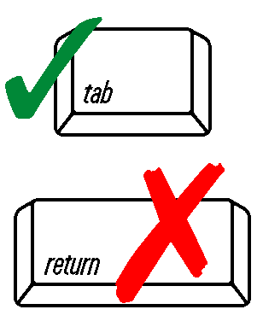 | 1. Applicant:
 | Name
 | Address
 | City/Town |  | State |  | Zip Code
 | Telephone
 | 2. Facility Address/Location (if different from Applicant):
 | Address
 | City/Town | State |  | Zip Code
 | 3. System Designer Information (RS or PE):
 | Name
 | Company
 | Address
 | City/Town |  | State |  | Zip Code
 | Telephone
 | 4. Registration:
 | P.E.
 | Sanitarian
 | Registration #
 | 5. Does this project require a filing under 301 CMR 11.00 and MGL C.30 ss 61-62H, the Massachusetts Environmental Policy Act? Yes No
 | If yes, has a filing been made? |  | Yes No
 | If Yes, EOEA File #
 | A. General Information (cont.)
 | 6. The legal entity which owns this facility is:
 | Individual Municipality Private Partnership
 | Federal State/County Corporation
 | Other:
 | Specify
 | 7. Two (2) complete sets of plans and specifications, properly stamped and signed by a Massachusetts Registered Professional Engineer or Massachusetts Registered Sanitarian must accompany the application. The plans must be prepared in accordance with 310 CMR 15.260(2).
 | Are plans and specifications enclosed? |  |  |  | Yes No
 | Have the plans been revised? |  |  |  | Yes No
 | 8. If applying for a tight tank (BRP WP 64a) and the system has failed, documentation must be submitted supporting the determination that no other feasible alternative exists to upgrade the system in accordance with 310 CMR 15.201 through 15.293.
 | Is the documentation attached? |  |  |  | Yes No
 | 9. If applying for a tight tank (BRP WP 64a) for new construction or for increased flow to existing systems, and the system is for boat waste pump-out facilities, documentation must be submitted supporting the determination that no other feasible alternative exists.
 | Is the documentation attached? |  |  |  | Yes No
 | 10. If applying for a tight tank (BRP WP 64a) for new construction or for increased flow to existing systems and the system serves buildings necessary for the operation of a public water supply, documentation must be submitted supporting the determination that it is not feasible to connect to a sewer or to construct a system in compliance with 310 CMR 15.000.
 | Is the documentation attached? |  |  |  | Yes No
 | 11. If applying for a tight tank (BRP WP 64a), a plan for the disposal of the contents, including the method and frequency of disposal and a written statement from a licensed septage transporter specifying a disposal site and method of disposal, must accompany this application.
 | Is the documentation attached? |  |  |  | Yes No
 | B. Certification
 | "I certify under penalty of law that this document and all attachments, to the best of my knowledge and belief, are true, accurate, and complete. I am aware that there are significant penalties for submitting false information, including the possibility of fine and imprisonment for knowing violations."
 | Applicant’s signature |  | Name of Preparer
 | Print Name |  | Date

