 | Massachusetts Department of Environmental Protection  Bureau of Resource Protection – Reclaimed Water Use Permit  BRP WP 84 Supplemental Application Form for Reclaimed Water Use  Application for Reclaimed Water Use Permit |  | Please do not mail.  Submit through ePlace. See Instructions.
 | A. Additional Requirements for Reclaimed Water Use
Important: When filling out forms on the computer, use only the tab key to move your cursor - do not use the return key.  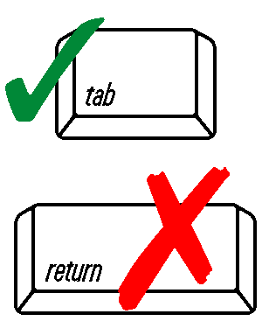 | 1. Has a Reuse Management Plan been prepared?
 | Yes If yes, please attach copy.
 | No
 | 2. Will the reclaimed water be used by persons other than the permittee?
 | Yes If yes, a Service & Use Agreement must be submitted with the application.
 | No
 | 3. Has the reclaimed water system been prepared in accordance with all applicable requirements of 248 CMR 10.00: Uniform State Plumbing Code?
 | Yes
 | No
 | 4. List the Reclaimed Water Use(s) as defined by 314 CMR 20.17.
 | B. Certification
 | I attest under the pains and penalties of perjury that I have personally examined and am familiar with the information contained in this document and all attachments, and that this document and all attachments were prepared under my direction or supervision in accordance with a system designed to assure that qualified personnel properly gather and evaluate the information submitted. Based on my diligent inquiry of the person or persons who manage the system, or those persons directly responsible for gathering the information, the information contained in this submittal is, to the best of my knowledge and belief, true, accurate, and complete. I am authorized to make this attestation on behalf of this permittee. I am aware that there are significant penalties for submitting false, inaccurate or incomplete information, including, but not limited to, the possibility of fine and imprisonment for knowing violations.
 | Signature of Applicant | Printed Name of Applicant
 | Date Signed
 | Name of Preparer | Title of Preparer
 | Telephone | email

