**COMMONWEALTH OF MASSACHUSETTS**

**EXECUTIVE OFFICE OF HEALTH AND HUMAN SERVICES**

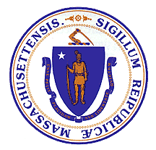

**Department of Public Health**

**Bureau of Substance Addiction Services**

**Electronic Licensing System**

**DCO RESPONSE USER MANUAL**

**Table of Contents**

1. Accessing BSAS eLicensing 3

Go to BSAS eLicensing 3

Managing your Virtual Gateway Account 3

Virtual Gateway Account Secret Questions 4

Update Virtual Gateway Account Email 5

2. Responding to a DCO 6

Viewing Pending DCOs 6

Responding with your Corrective Action Paln 8

Submitting your Corrective Action Plan 9

Responding with your Corrective Action Evidence 10

Submitting your Corrective Action Evidence 12

3. View Closed DCO Line Items 14

# Accessing BSAS eLicensing

Log in to the Virtual Gateway. If you do not have an account, contact Alex Kearns, Special Projects Coordinator for the Bureau of Substance Addiction Services at **Alex.Kearns@mass.gov** for instructions on how to create a Virtual Gateway account.

## Go to BSAS eLicensing

To proceed to the BSAS eLicensing system, click on the BSAS eLicensing Link shown in the figure below:

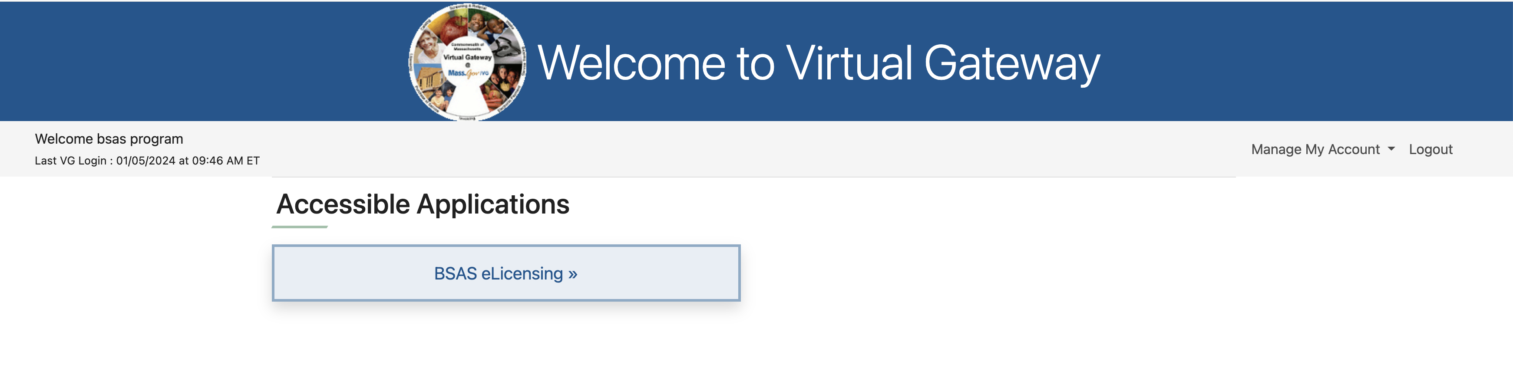

## Managing your Virtual Gateway Account

Once you log in to the Virtual Gateway you can manage your account using the link on the right side of the page under the Manage My Account section as shown below.

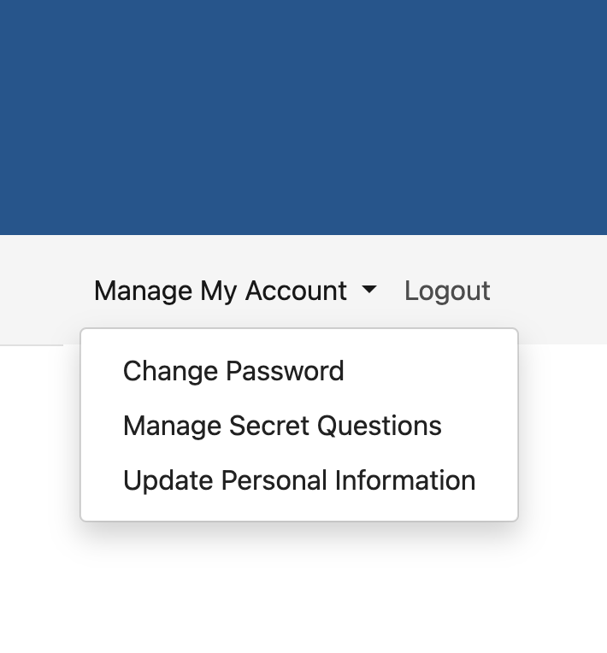

## Virtual Gateway Account Secret Questions

If you have not done so you should provide answers to your secret questions by clicking the Answer My Secret Questions link. **Please note** that you will not be able to use the Forgot Password feature if you have not provided answers to your secret questions.

You will be asked to provide answers to five out of seven secret questions. Once you have provided the answers click on the Submit button.

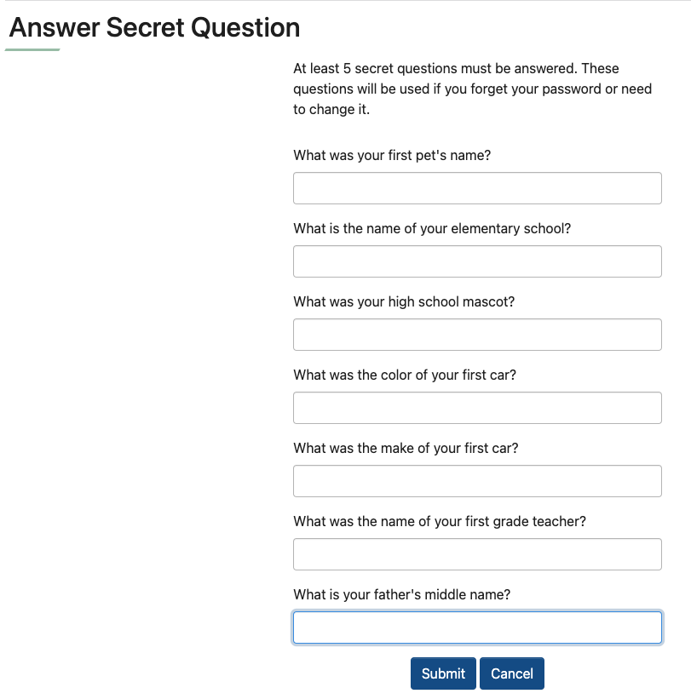

## Update Virtual Gateway Account Email

If your email address has changed make sure to update it by clicking on the Update My Personal Information link. It is important to update your email if it has changed so you will still be able to receive temporary password emails when you use the Forgot Password feature on your account.

Update your email address and click Submit.

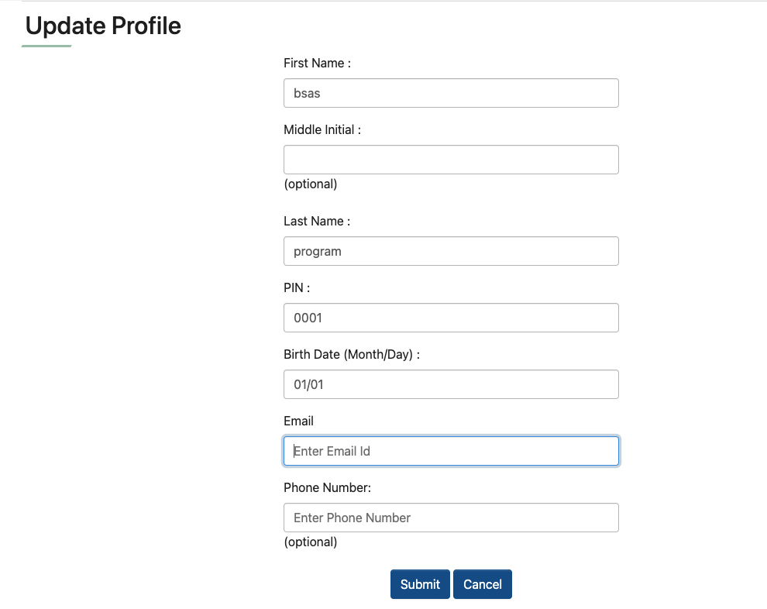

# Responding to a DCO

Once you access BSAS eLicensing as described above, select the program that you received a DCO notification for from the list of your organization’s programs. The system will then display the program menu page shown below.

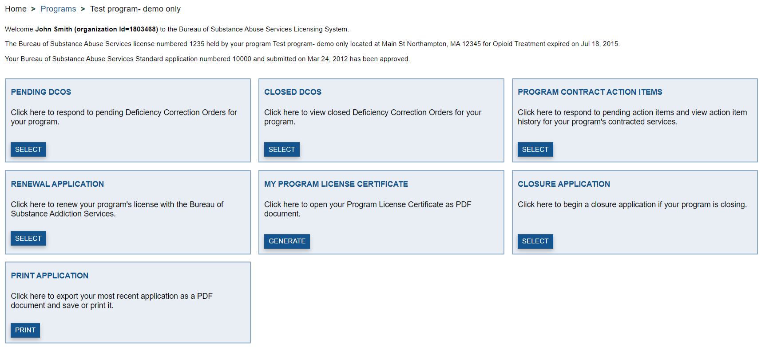

## Viewing Pending DCOs

Click the “Select button” button on the Pending DCOs card and the system will display the Open Program DCO Line Items page shown in the figure below. This page will list all DCO Line Items that need to be responded to or that are under review by BSAS. You will see the status of each Line Item in its heading. The different status and their meanings are listed below.

* Corrective Action Plan Due – The Corrective Action Plan has not been responded to and needs to be submitted by the due date listed in the heading.
* Corrective Action Plan Under Review – The Corrective Action Plan has been submitted but has not been approved by BSAS. The Evidence of Corrective Action is due by the date shown in the heading.
* Evidence of Corrective Action Due – The Corrective Action Plan has been submitted and has been approved by BSAS. The Evidence of Corrective Action is due by the date shown in the heading.
* Corrective Action Evidence Under Review – The Corrective Action Plan and the Evidence of Corrective Action have been submitted and are under review by BSAS.

The Description of Non-Compliance and the Instructions for Response will be displayed on each Line Item. These provide information on what the issues are and how they need to be addressed.

There are two responses required for each line item, each with its own due date. The Corrective Action Plan response is the program’s plan to address the issues identified in the Description of Non-Compliance. Its due date comes first and is generally within 14 days of the issuance of the DCO, depending on the nature of the issue. The Corrective Action Evidence response is proof submitted by the program that it has completed the steps in its Corrective Action Plan. Its due date is generally 60 days from the issuance of the DCO, depending on the nature of the issue.

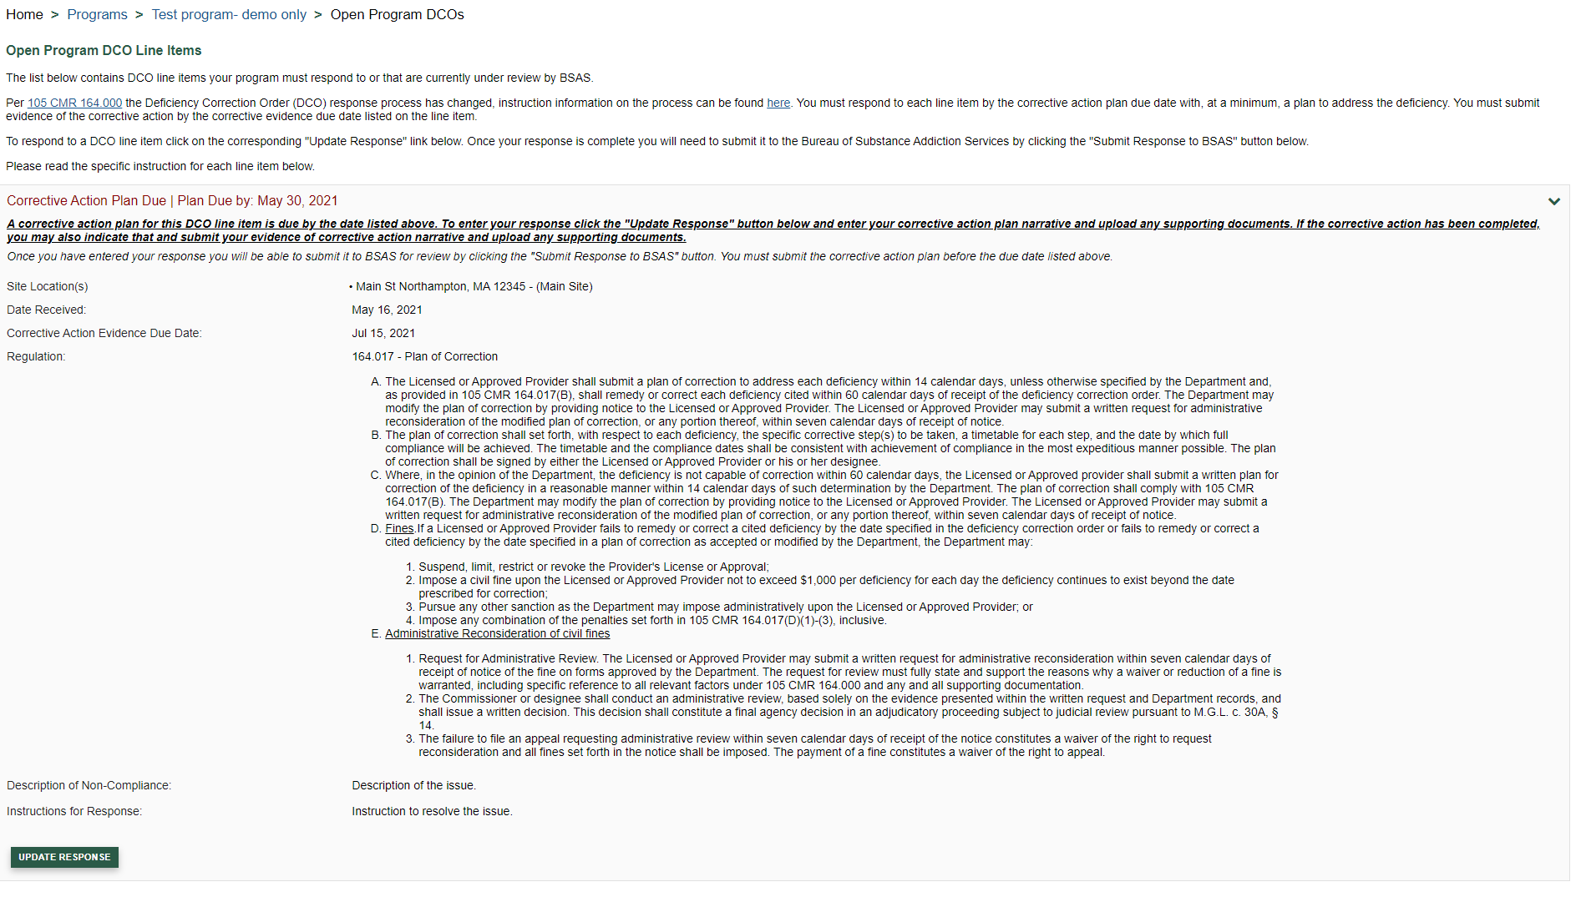

## Responding with your Corrective Action Plan

Click on the “Update Response” button for the DCO line item you are responding to and the system will display the DCO Line Item response form shown below. You may enter a narrative response for your Corrective Action Plan and upload any required documents. If the corrective action has been completed, you may click the “Corrective Action Is Completed” checkbox. This will allow you to provide your narrative response for your Evidence of Corrective Action and will indicate that the steps outlined in the Corrective Action Plan have been completed.

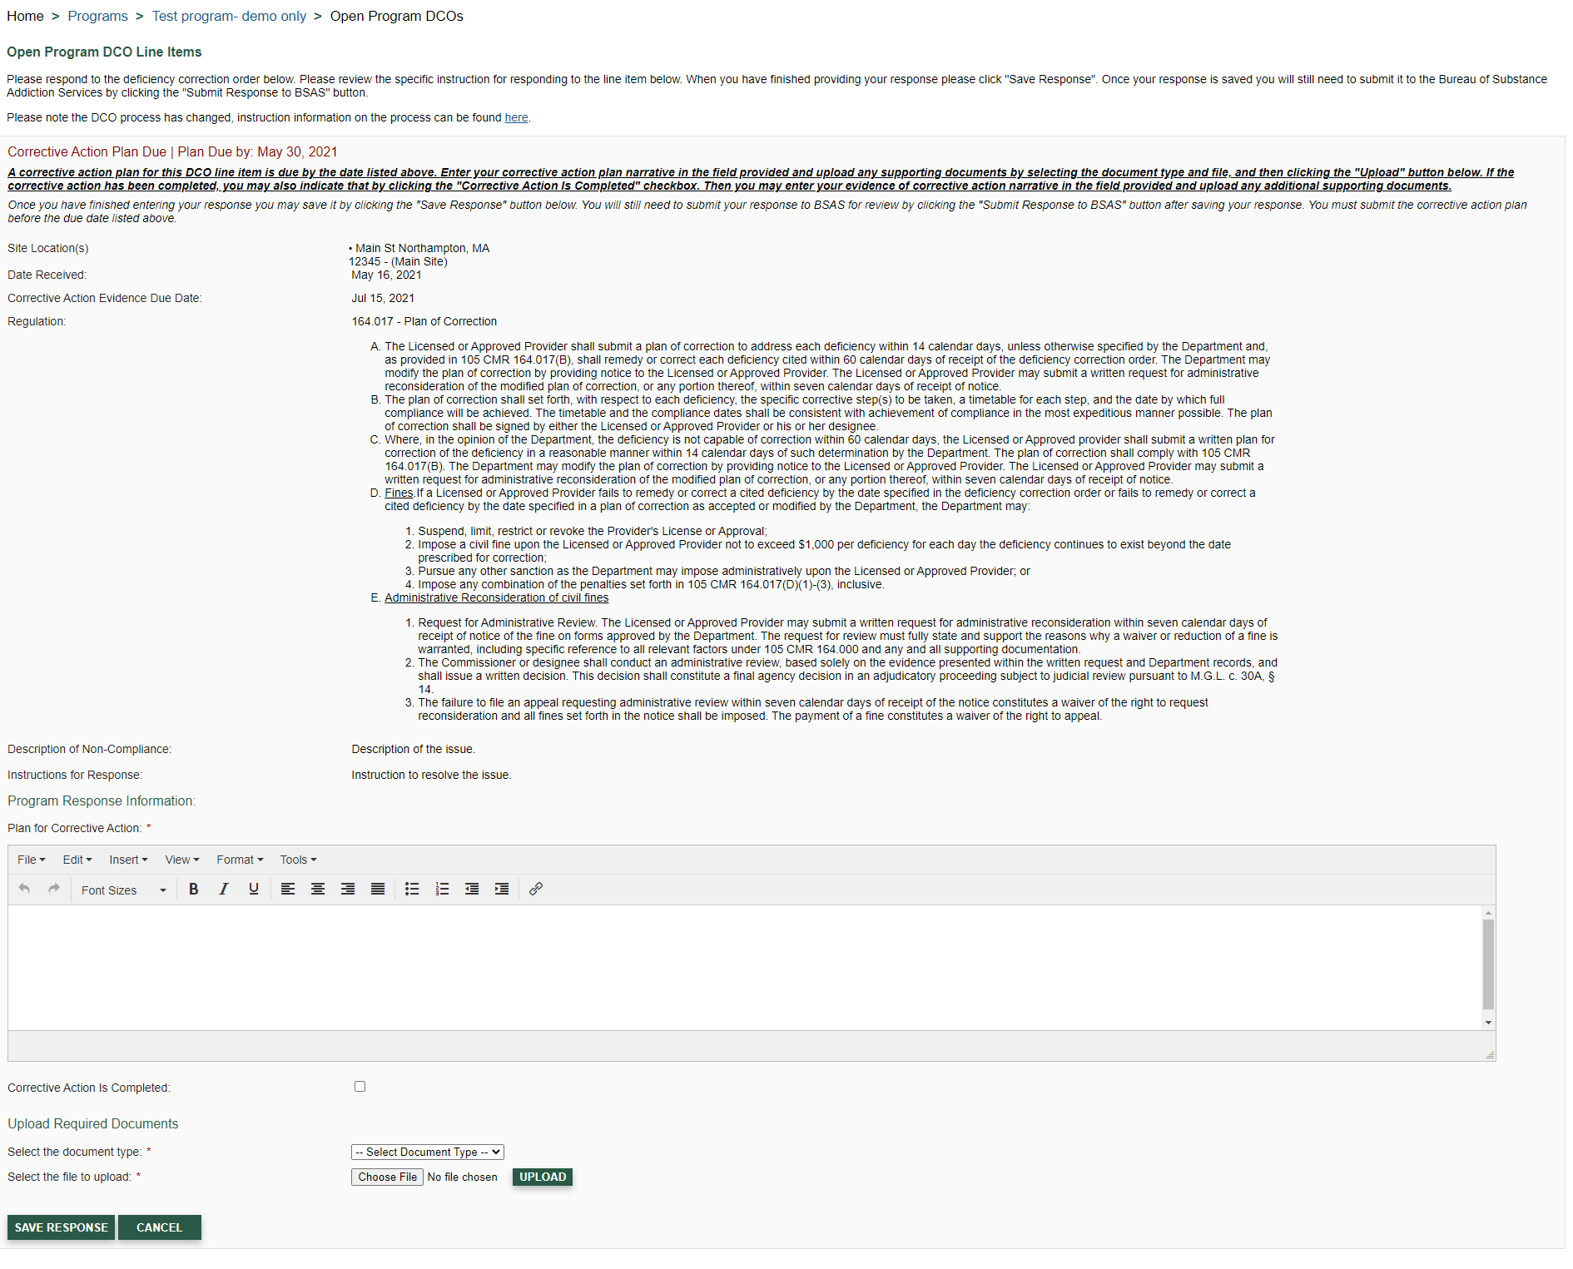

To save your response click the “Save Response” button. Saving your response does not submit it for review by BSAS. This allows you to save your work and return to update your response later.

## Submitting your Corrective Action Plan

To submit your response to your BSAS, click the “Submit Response to BSAS” button, shown below. You may also edit your response before submitting it by clicking the “Update Response” button. You must submit your Corrective Action Plan by the Plan Due date listed in the Line Item heading.

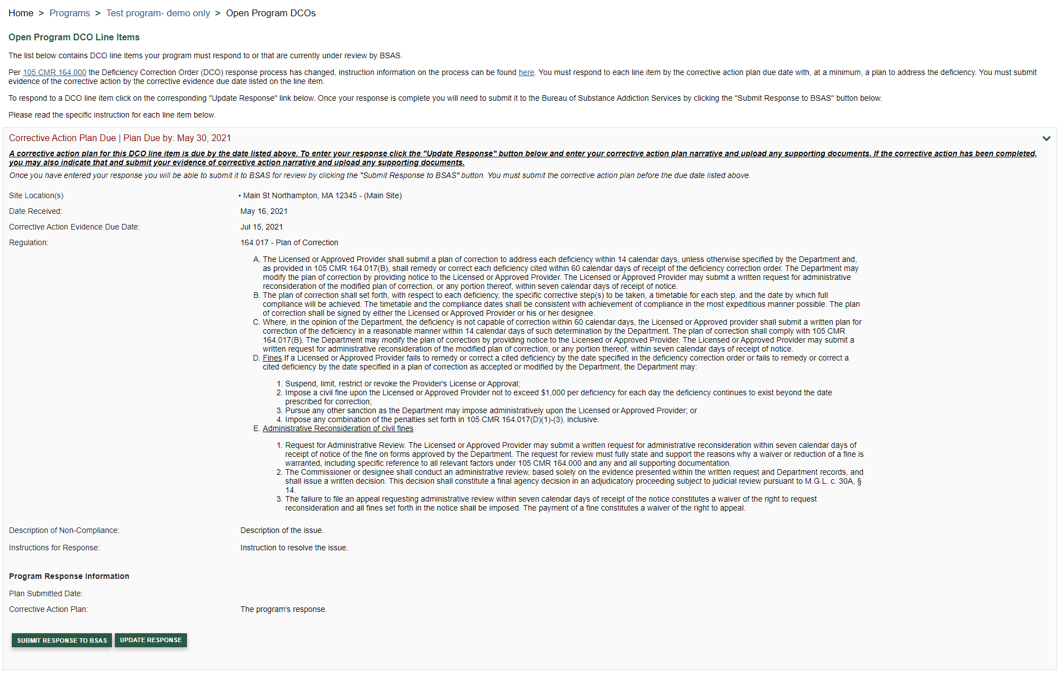

Once your Corrective Action Plan response is submitted you will see the line item displayed with the status of Corrective Action Plan Under Review, as shown in the following section. If the Plan is approved the status will be updated to Corrective Action Evidence Due and your program’s Program Director will receive an email notification. If the Corrective Action Plan is not deemed to be sufficient the line item will be resubmitted to your program and you will need to update your response as described above. The program’s Program Director will receive an email notification with the reason for resubmission.

## Responding with your Corrective Action Evidence

Whether your Corrective Action Plan has not been approved by BSAS or not, you may submit your Corrective Action Evidence response. Please note that the evidence of corrective action must be submitted by the Evidence Due date shown in the Line Item heading. To begin your Evidence of Corrective Action response, click the “Update Response” button.

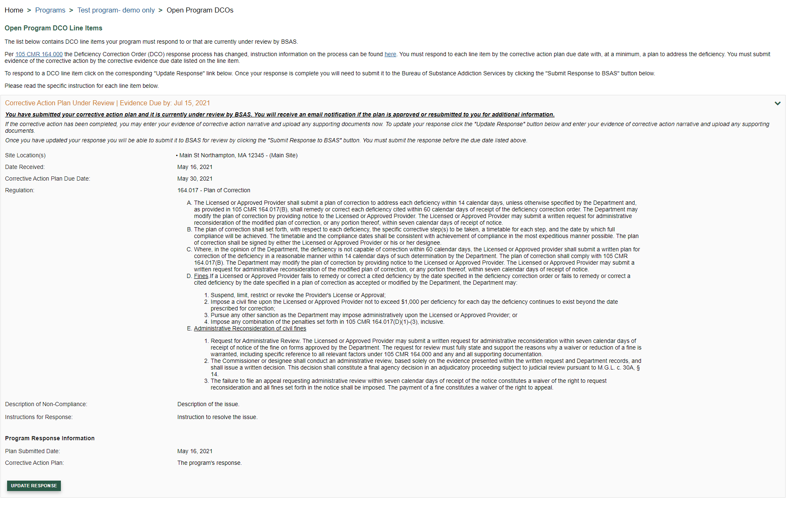

After clicking the “Update Response” button you will be able to provide your narrative for the Evidence of Corrective Action. You may also upload any supporting documentation by selecting a document type, choosing a file, and clicking the “Upload” button in the Upload Required Documents section. To save your response click the “Save Response” button.

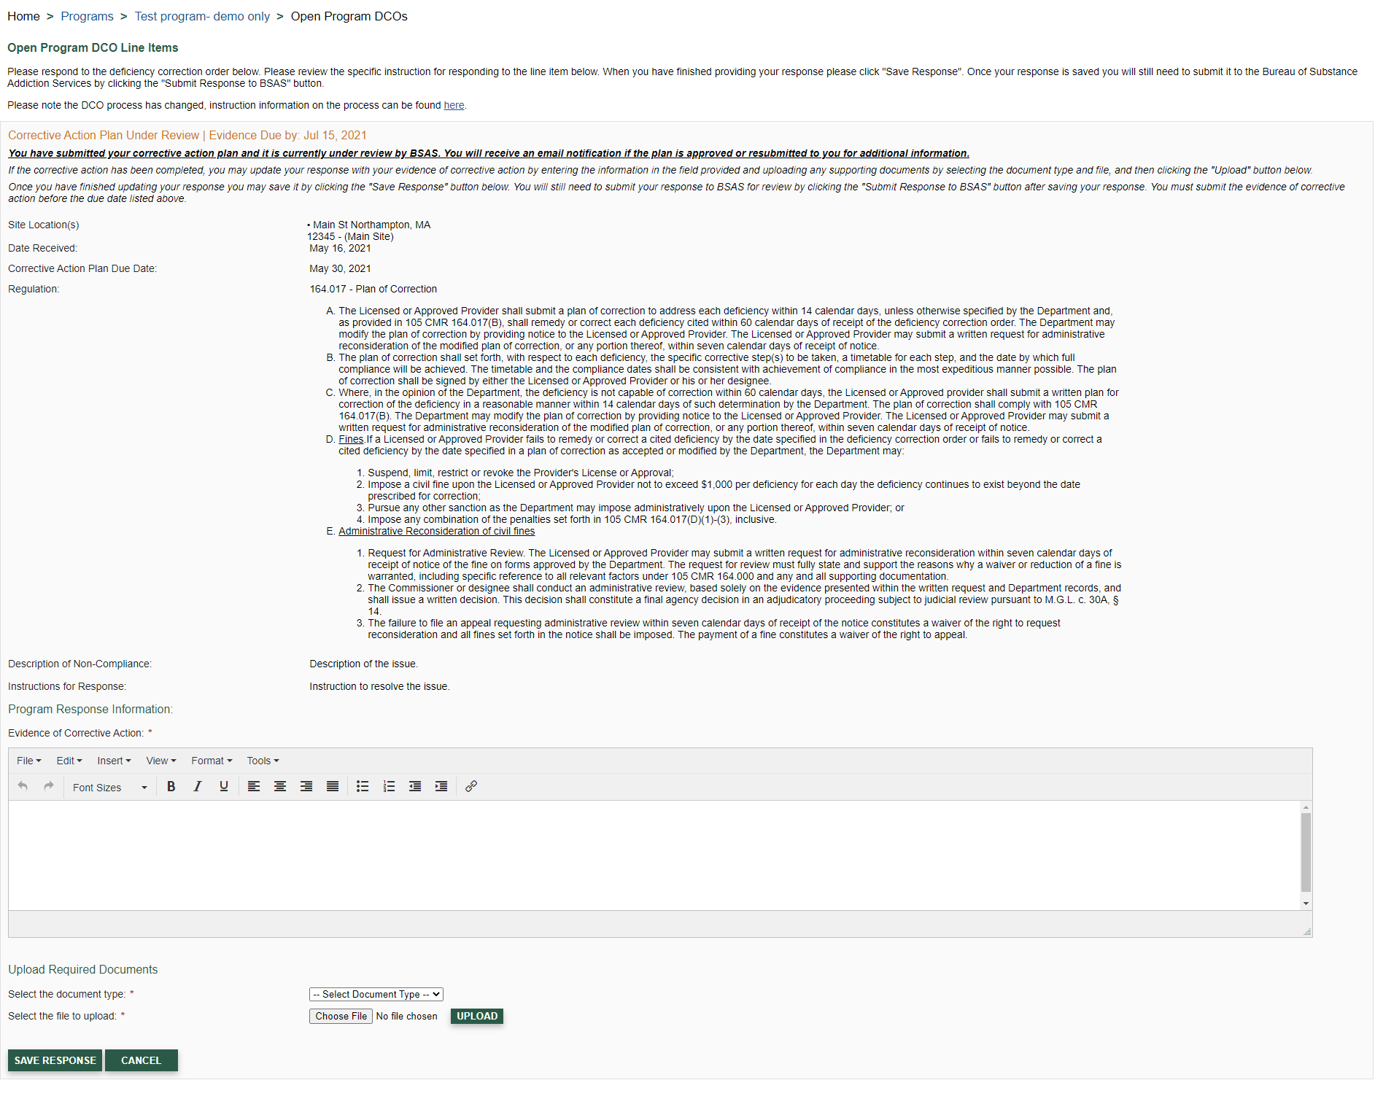

## Submitting your Corrective Action Evidence

To submit your Evidence of Corrective Action response to BSAS, click the “Submit Response to BSAS” button, as shown below. You must submit your Evidence of Corrective Action by the Evidence Due date listed in the Line Item heading.

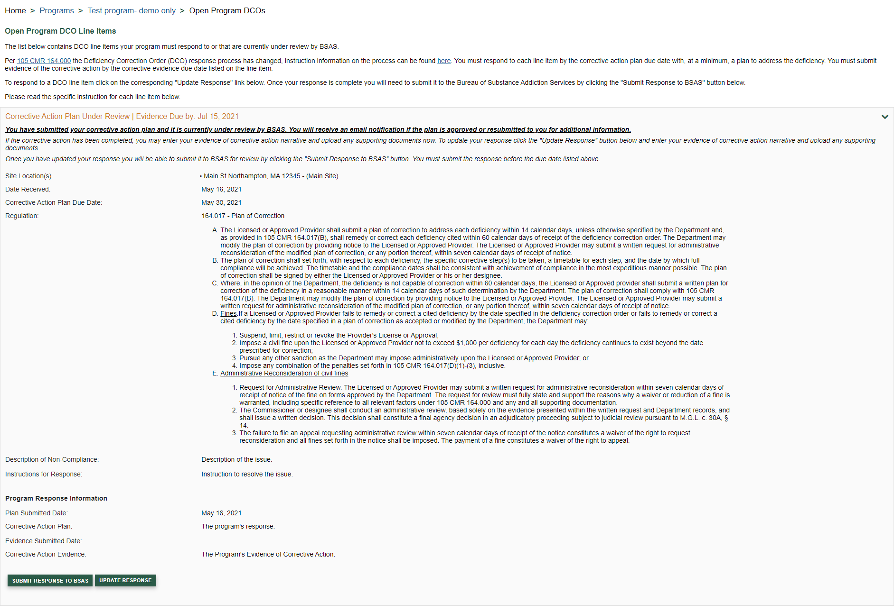

Once the Evidence of Corrective Action is submitted for review, the line item will be displayed with a status of Corrective Action Under Review, as shown below. The line item will remain on this page until it is closed by BSAS staff, at which point the program’s Program Director will receive an email notification. If the Evidence of Corrective Action is not deemed to be sufficient the line item will be resubmitted to your program and you will need to update your response as described above. The program’s Program Director will receive an email notification with the resubmission reason.

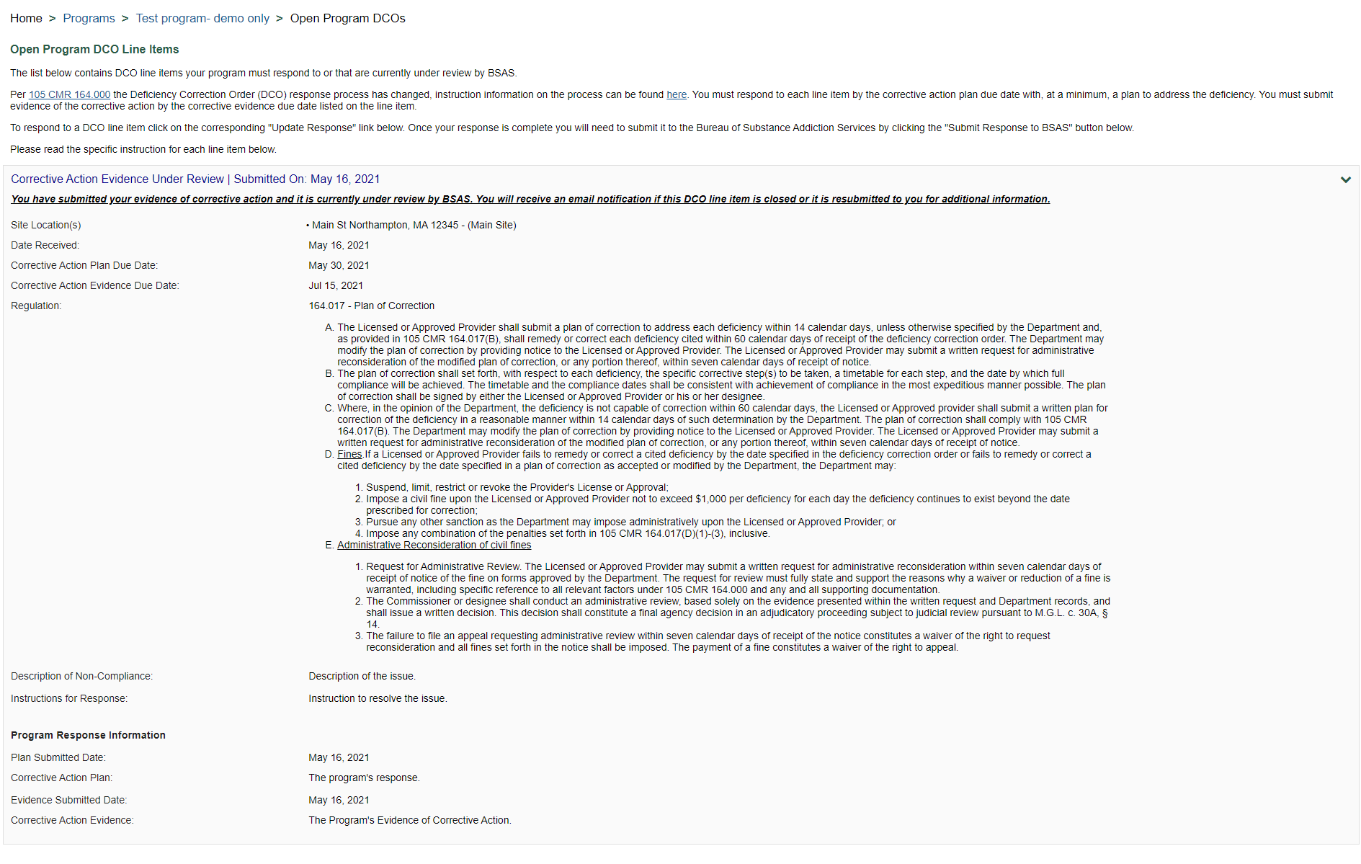

# View Closed DCO Line Items

Once a line item is closed by BSAS staff, it will be visible on the Closed DCO Line Items page shown below.

