**COMMONWEALTH OF MASSACHUSETTS**

**EXECUTIVE OFFICE OF HEALTH AND HUMAN SERVICES**



**Department of Public Health**

**Bureau of Substance Addiction Services**

**Electronic Licensing System**

**Program Licensing Involuntary Termination Appeals User Manual**

Table of Contents

1. Accessing BSAS eLicensing 3

Go to BSAS eLicensing 3

Managing your Virtual Gateway Account 3

Virtual Gateway Account Secret Questions 4

Update Virtual Gateway Account Email 5

2. Program Menu 6

3. Open Appeals 6

a) Program response required 7

b) Program response Upload Documents 7

c) Response Submitted 9

d) Under Review 10

e) Decisions 11

# Accessing BSAS eLicensing

Log in to the Virtual Gateway. If you do not have an account, contact Alex Kearns, Special Projects Coordinator for the Bureau of Substance Addiction Services (BSAS) at [**Alex.Kearns@mass.gov**](mailto:Alex.Kearns@mass.gov)for instructions on how to create a Virtual Gateway account.

## Go to BSAS eLicensing

To proceed to the BSAS eLicensing system, click on the BSAS eLicensing Link shown in the figure below:

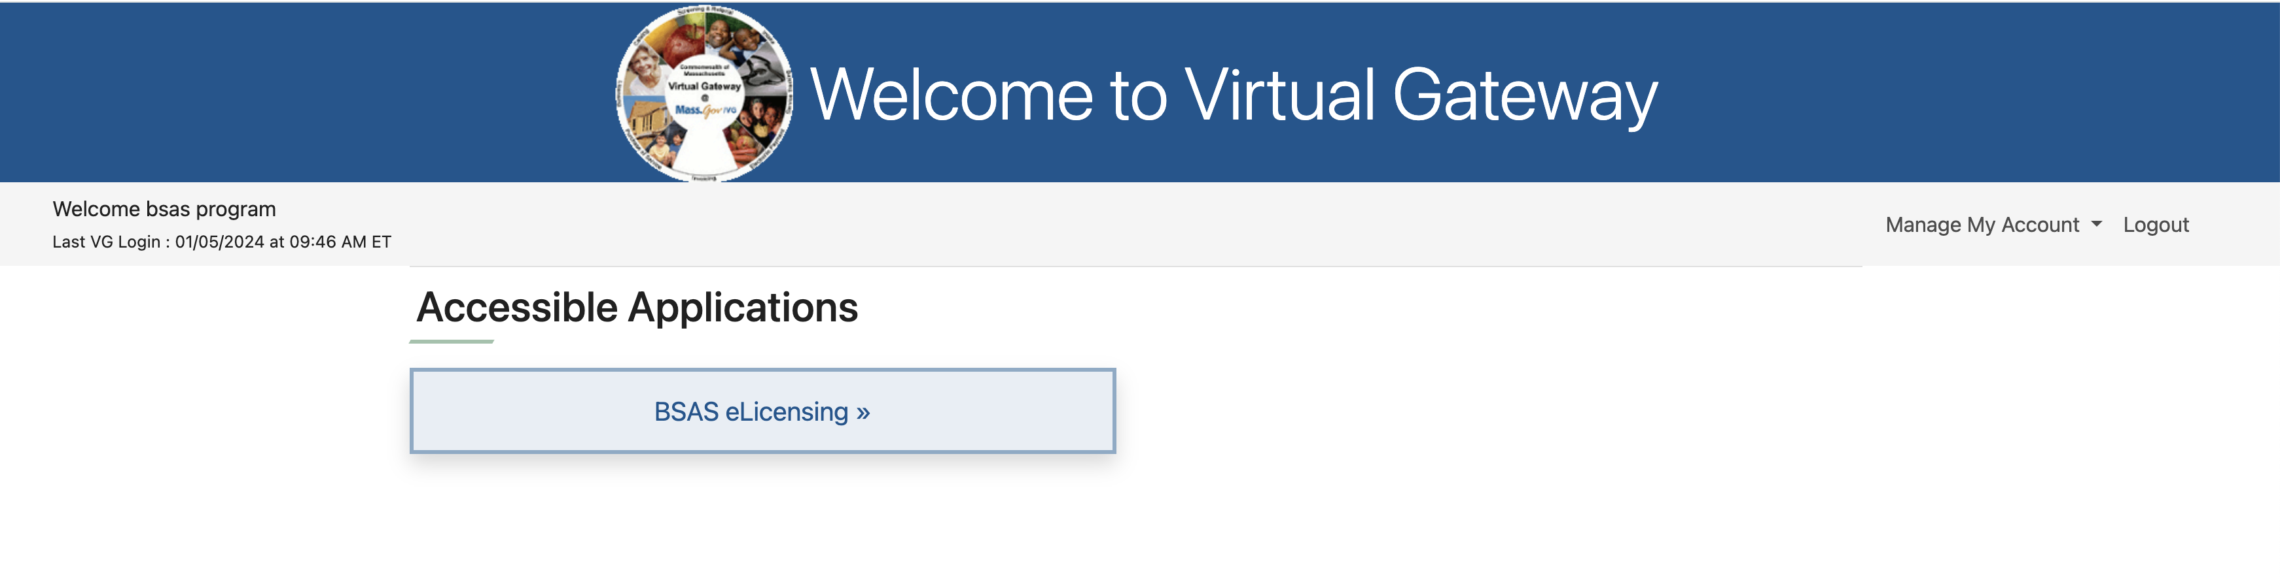

## Managing your Virtual Gateway Account

Once you log in to the Virtual Gateway you can manage your account using the link on the right side of the page under the Manage My Account section as shown below.

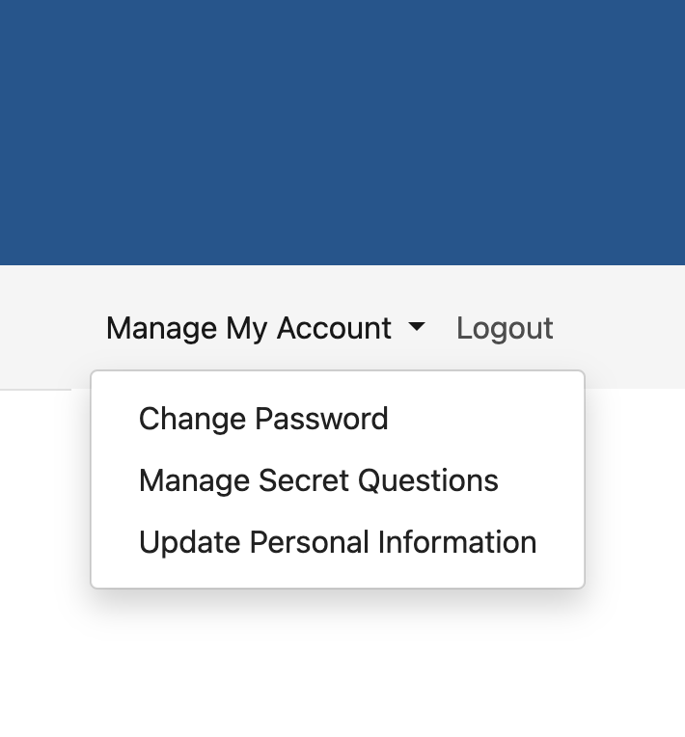

## Virtual Gateway Account Secret Questions

If you have not done so you should provide answers to your secret questions by clicking the Answer My Secret Questions link. **Please note** that you will not be able to use the Forgot Password feature if you have not provided answers to your secret questions.

You will be asked to provide answers to five out of seven secret questions. Once you have provided the answers click on the Submit button.

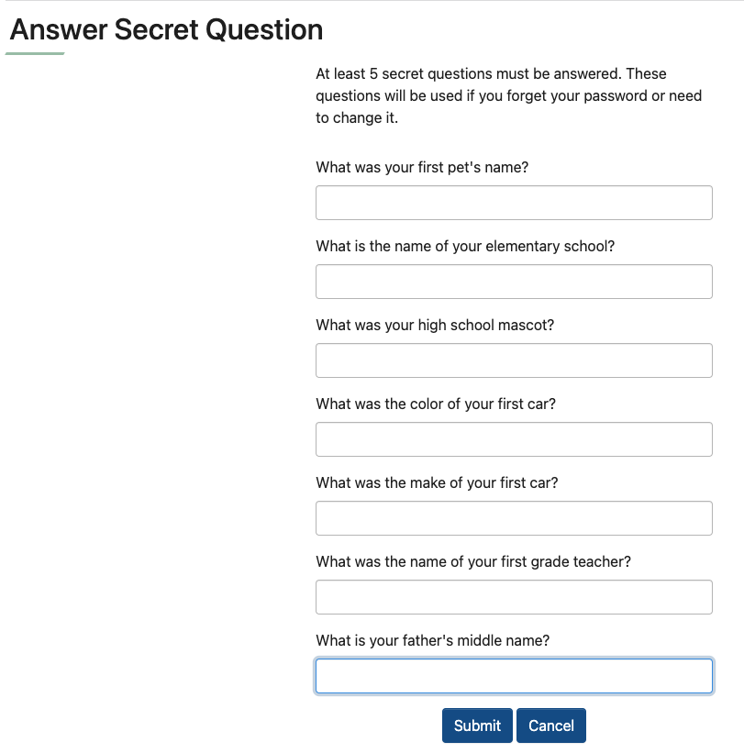

## Update Virtual Gateway Account Email

If your email address has changed make sure to update it by clicking on the Update My Personal Information link. It is important to update your email if it has changed so you will still be able to receive temporary password emails when you use the Forgot Password feature on your account.

Update your email address and click Submit.

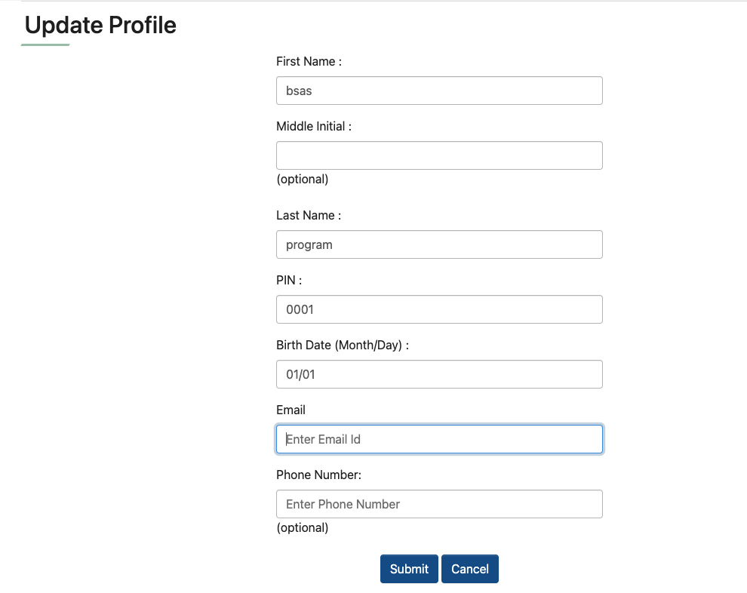

# Program Menu

**Note:** External users can access the Involuntary Termination Appeals functionality in BSAS eLicensing after they have been granted access to the ‘BSAS Program Appeal Staff Role’ role for their program.

OTP Program Directors should request that their Agency’s Virtual Gateway Access Administrator (VG AA) add the ‘BSAS_Program_Appeal_Staff’ role to their existing role and request access for additional staff identified by the program director who works on patient appeals. The BSAS Provider URF is available here: [User Request Forms | Mass.gov](https://www.mass.gov/info-details/user-request-forms) If you or your Agency’s VG AA have questions, please contact [Alex.Kearns@mass.gov](mailto:Alex.Kearns@mass.gov) for assistance.

Below is the External program menu showing the Appeals card, when the user clicks ‘Select’, the user is taken to the Appeals View page. The page lists all the Appeals submitted to the program.

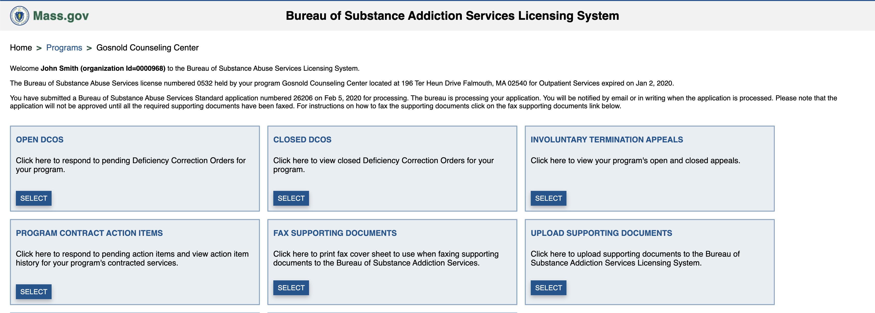

# Open Appeals

Upon receipt of an appeal from the patient, BSAS will create the appeal record in BSAS eLicensing. A system-generated email notification will be sent to the program director and other staff with the program appeal staff role that an appeal has been opened. The email will indicate the Appeal ID#, Appeal Type (Emergency/Non-Emergency), Program Name, documents to be submitted by the program, and if a medically supervised hold is required. To view the details of the appeal including the patient's name (or patient ID#), users must log into BSAS eLicensing in the Virtual Gateway and click on the Appeals card from the main menu (see screenshot above.) The program director or staff with access to appeals must log in to view the patient associated with the open appeal and to view how the program should respond to the open appeal.

## Program response required

Open Appeals with a response due from the Program to BSAS will be labeled ‘Response is due to BSAS’. To respond, users may click the ‘Update Response’ button to submit their response to BSAS. Users have the option to upload their responses. The screenshots below display Emergency and Non-Emergency appeals in the ‘Response is Due to BSAS’ status and the ‘Update Response’ button.

**Emergency Appeal**

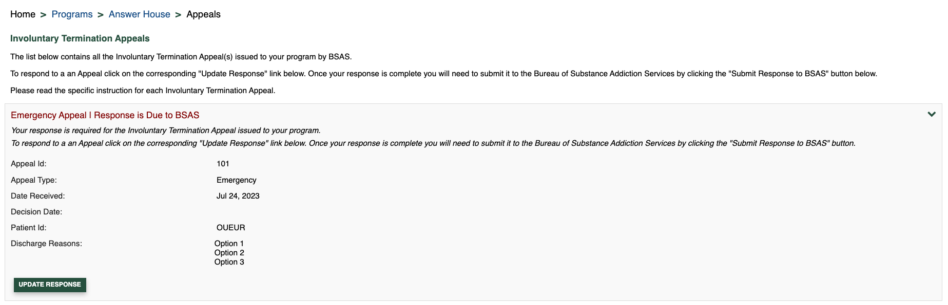

**Non-Emergency Appeal**

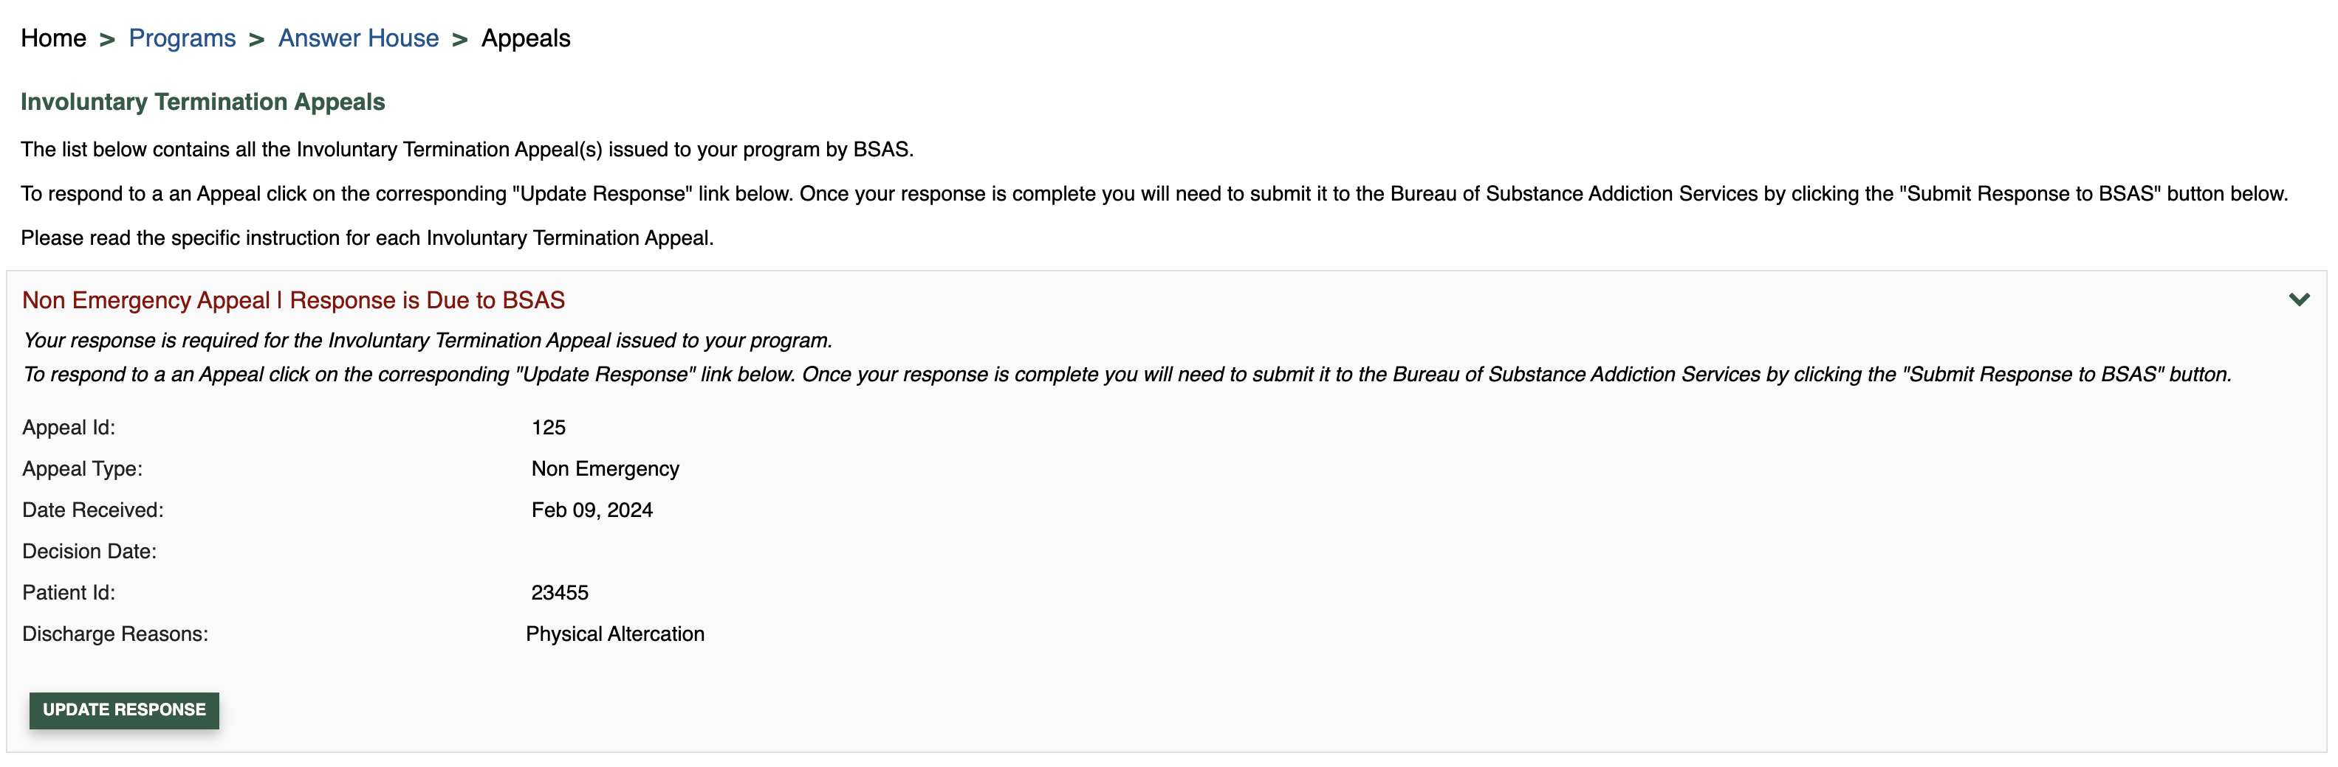

## Program response Upload Documents

After clicking ‘Update Response’ the system displays the page to submit the response to BSAS. Users may upload documents requested by BSAS by selecting the Document Type and a file and clicking Upload. We recommend uploading PDFs. Once documents are uploaded, the user can click “Submit Response to BSAS”. Successfully uploaded documents will be displayed in the uploaded document section of the page. The screenshots below show the document upload form for Emergency and Non-Emergency appeals.

**Emergency Appeal**

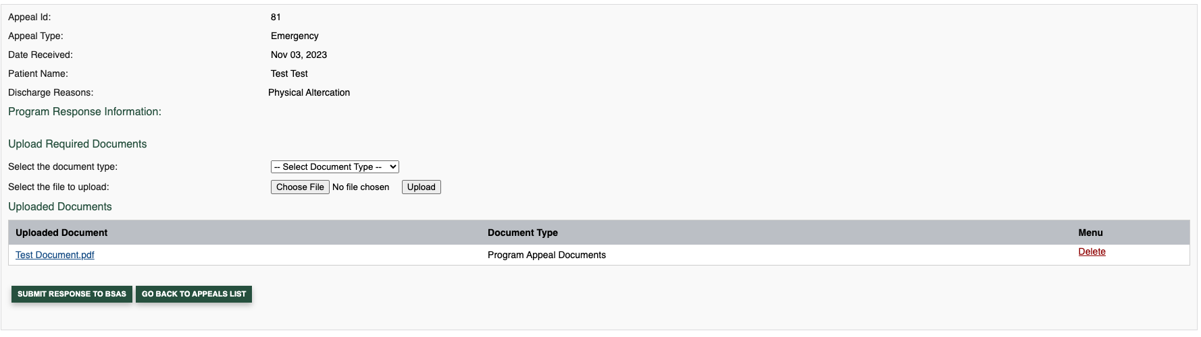

**Non-Emergency Appeal**

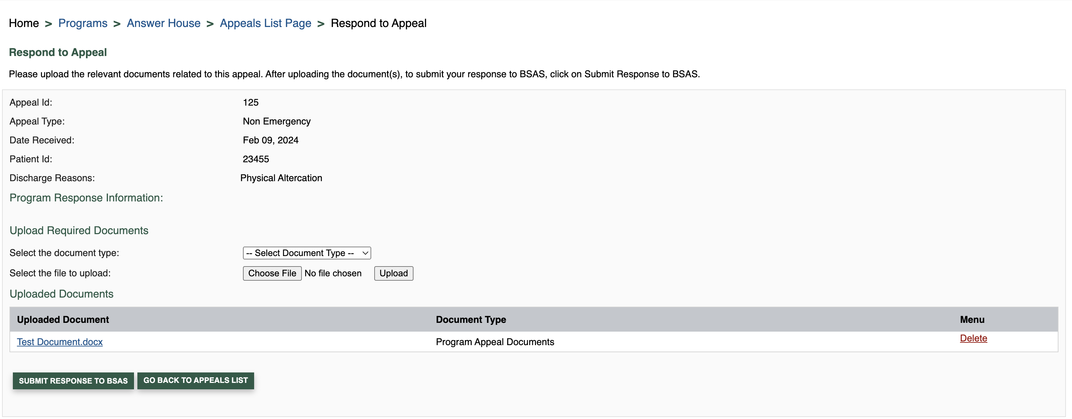

## Response Submitted

After the response is submitted to BSAS, the status changes to “Response submitted to BSAS” and displays the date submitted. Users can still upload additional documents until BSAS starts to review the appeal and marks All Documentation Received. The screenshots below show Emergency and Non-Emergency appeals whose responses are submitted to BSAS.

**Emergency Appeal**

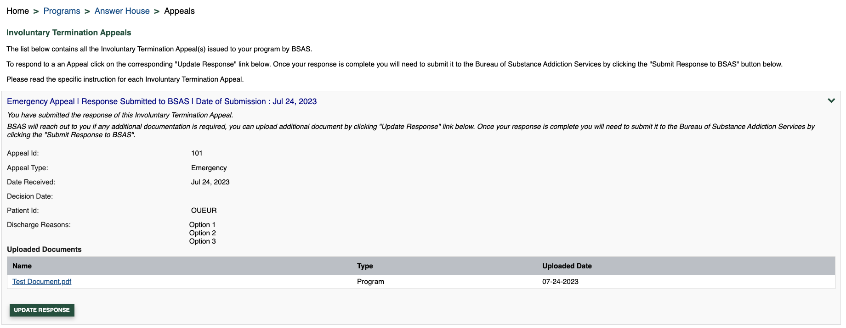

**Non-Emergency Appeal**

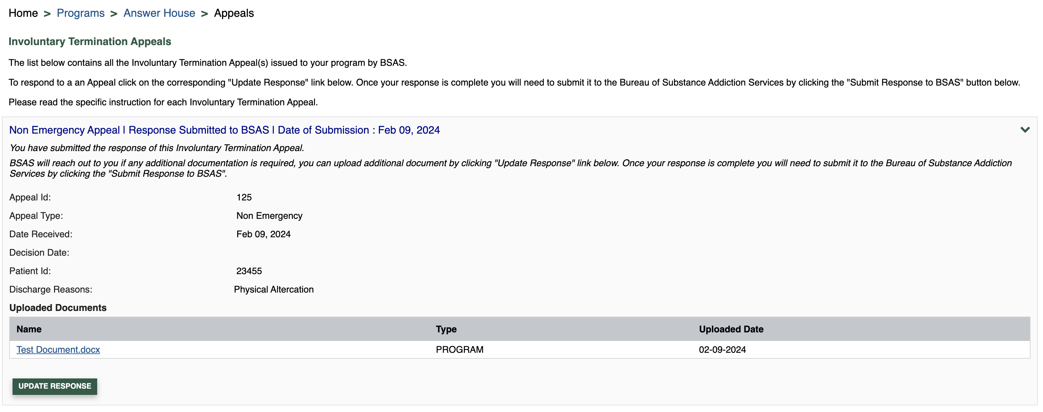

## Under Review

After all the documentation is received the status of the appeal changes to ‘Under Review’. The screenshots below show Emergency and Non-Emergency appeals under the review.

**Non-Emergency Appeal**

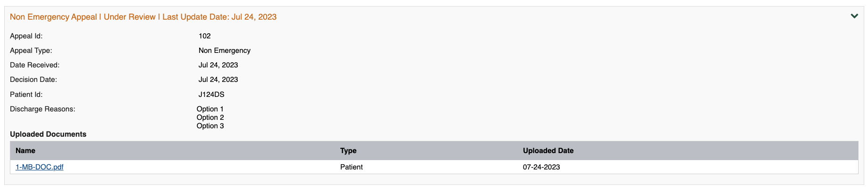

**Emergency Appeal**

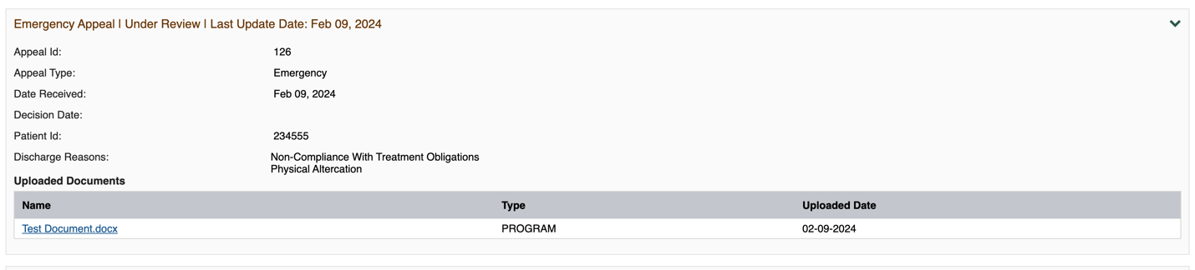

## Decisions

External users who have worked on the appeal and the Program Director will receive an email notification when a decision on an appeal has been made by BSAS. Users with access will be directed to log in to BSAS eLicensing to review the decision documents. The decision notification and any documents uploaded to appeal will be displayed, the program is required to print and share the decision with the patient and maintain a copy of the decision in the patient record. The screenshots below show Emergency and Non-Emergency with a variety of possible decisions including upheld, overturned, and remand to rehearing which is displayed in the screenshots below.

**Requested to Re-hearing Decision-Emergency Appeal** 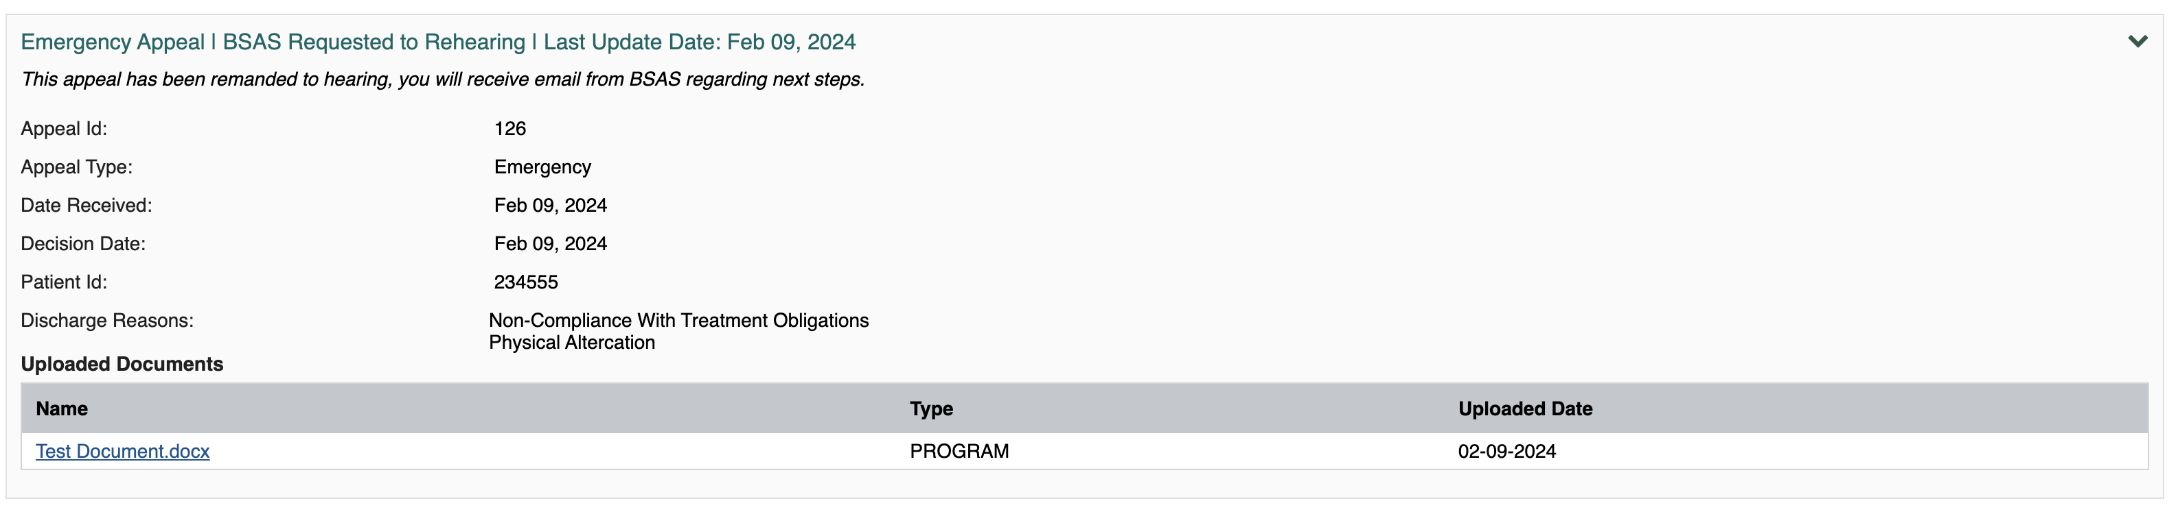

**Request to Rehearing Decision Non-Emergency Appeal**

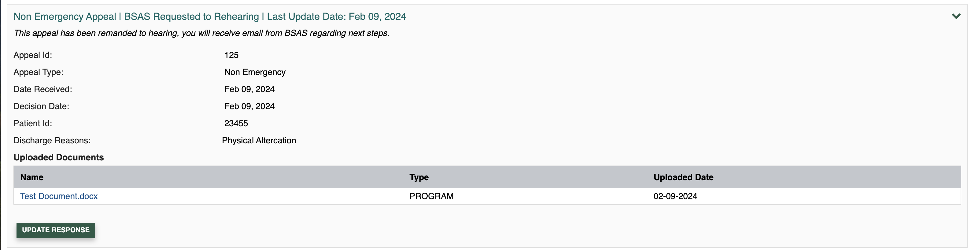

**Uphold Decision Emergency Appeal**

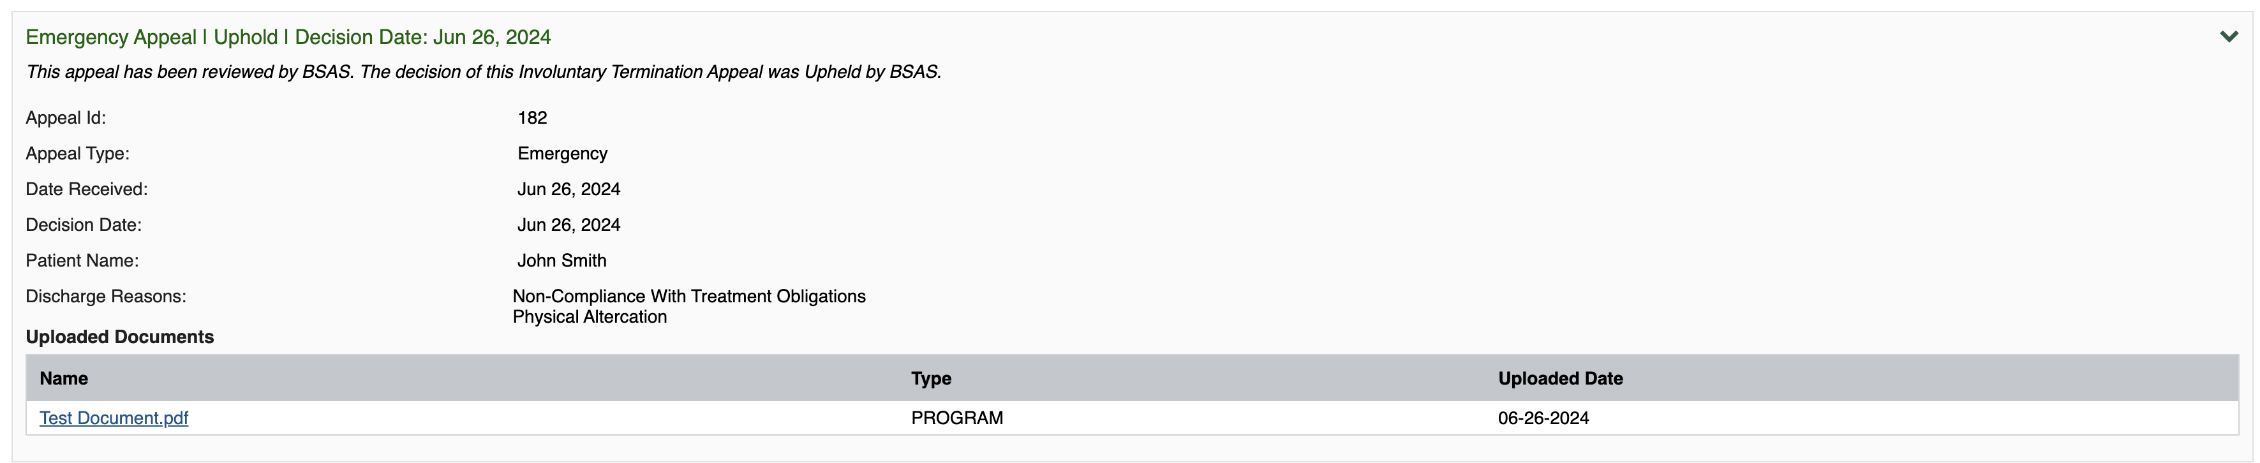

**Uphold Decision Non-Emergency Appeal**

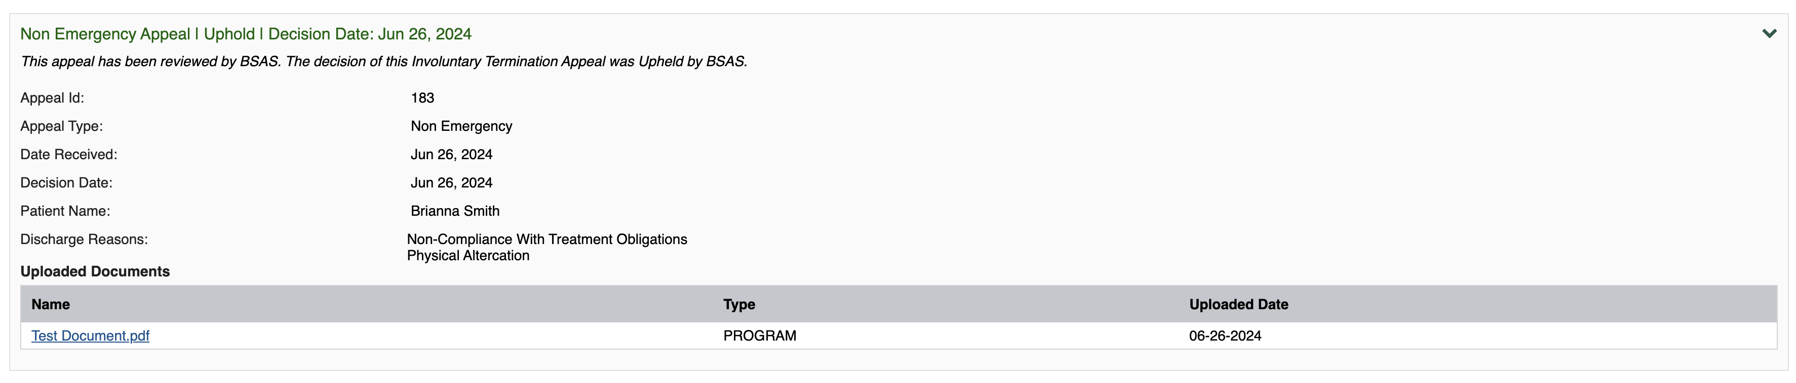

**Overturn Decision Emergency Appeal**

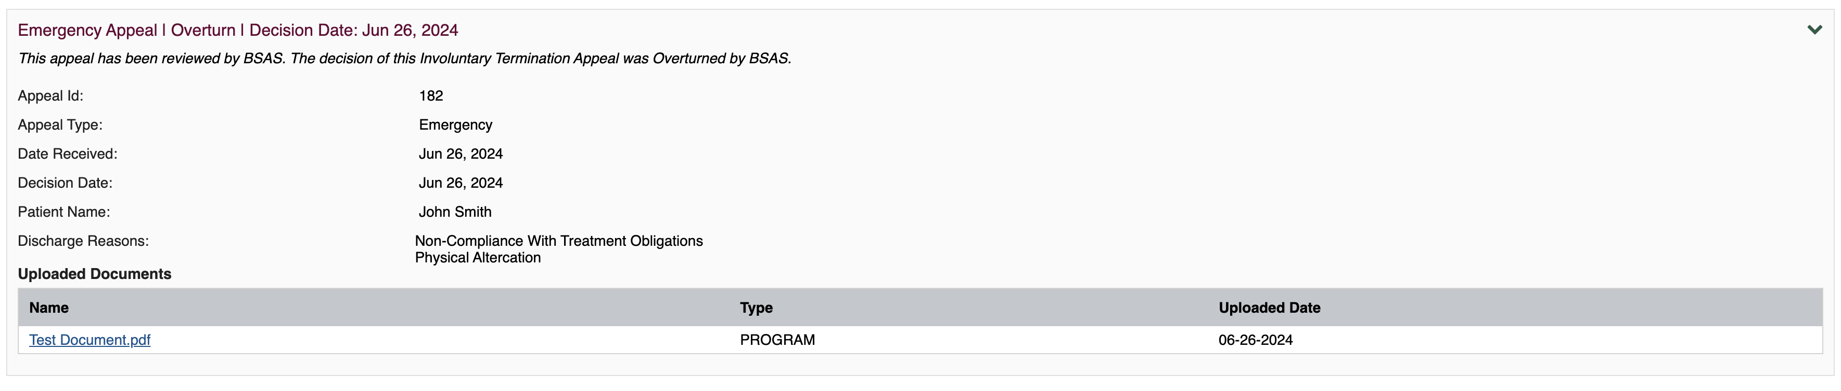

**Overturn Decision Non-Emergency Appeal**

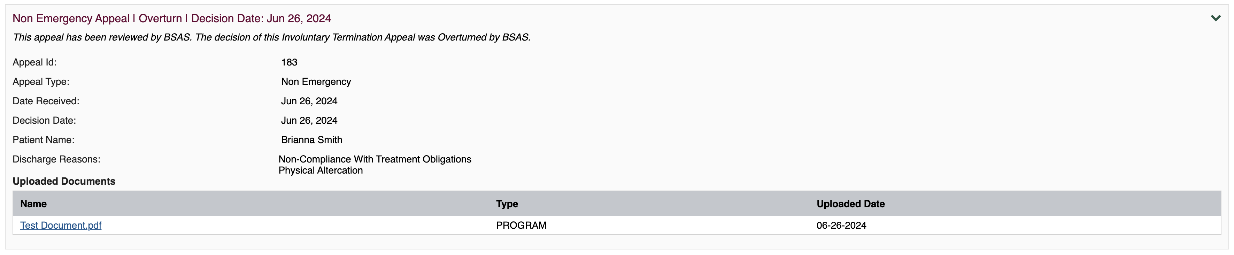

If you have questions on the appeal process, please email Michael Gurney ([Michael.Gurney@mass.gov](mailto:Michael.Gurney@mass.gov)).

If you need technical assistance with BSAS eLicensing please email Alex Kearns ([Alex.Kearns@mass.gov](mailto:Alex.Kearns@mass.gov)).