COMMONWEALTH OF MASSACHUSETTS
EXECUTIVE OFFICE OF HEALTH AND HUMAN SERVICES

Department of Public Health
Bureau of Substance Abuse Service
Electronic Licensing System

PROGRAM USER MANUAL

Table of Contents
Accessing BSAS eLicensing 4
Go to BSAS eLicensing 4
Managing your Virtual Gateway Account 4
Update Virtual Gateway Account Email 5
New Program License Application 7
Program Type 7
Service setting - Standard 8
Service setting – Penal Facility 9
Correctional Facility Information 10
Program and Organization Information 10
Service Locations 12
Licenses and Accreditations 13
Qualified Service Organizations 13
Program Service - 24 Hour Diversionary Acute Treatment Services 15
Program Service - Outpatient Services 16
Program Services - Opioid Treatment 17
Program Services - Residential Rehabilitation 18
Special Populations 19
Responsible Officials 19
Governing Body 20
Advisory Board 21
Program Staff and Schedule 23
Health and Safety Documents 28
Application Documents 30
Application Fee 30
Submit Application 33
After Application Submission 33
Fax Supporting Documents 34
Application PDF Copy 36
Renewal Application 38
Amendment Application 39
Closure Application 40
Closure Type 41
Closure Information 41
Program Closure Questions 42
Submit Closure Application 42
After Closure Application Submission 43

Accessing BSAS eLicensing
Log in to the Virtual Gateway. If you do not have an account, contact Alex Kearns, Special Projects Coordinator for the Bureau of Substance Addiction Services at alex.kearns@state.ma.us for instructions on how to create a Virtual Gateway account.

Go to BSAS eLicensing
To proceed to the BSAS eLicensing system, click on the BSAS eLicensing Link shown in the figure below:
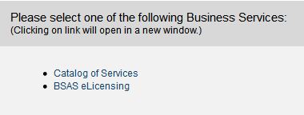

Managing your Virtual Gateway Account
Once you log in to the Virtual Gateway you can manage your account using the link on the right side of the page under the Manage My Account section as show below.
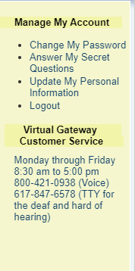

Virtual Gateway Account Secret Questions
If you have not done so you should provide answers to your secret questions by clicking the Answer My Secret Questions link. Please note that you will not be able to use the Forgot Password feature if you have not provided answers to your secret questions.
On the next page you will be asked to provide answers to five out of seven secret questions. Once you have provided the answers click on the Submit button.
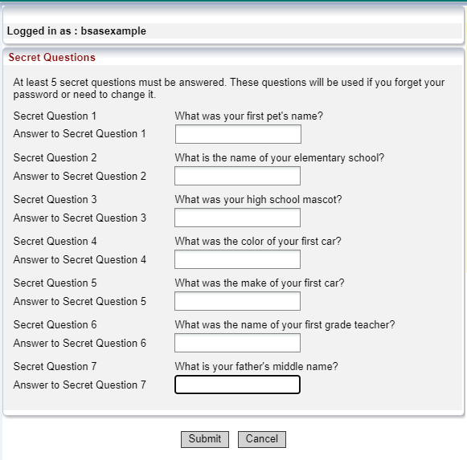

Update Virtual Gateway Account Email
If your email address has changed make sure to update it by clicking on the Update My Personal Information link. It is important to update your email if it has change so you will still be able to receive temporary password emails when you use the Forgot Password feature on your account.
On the next page update your email address and click Submit.
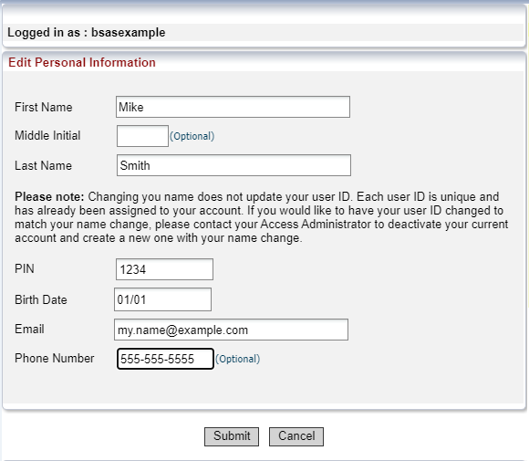

New Program License Application
Once you access BSAS eLicesing as described above, the system will display the menu page shown below:
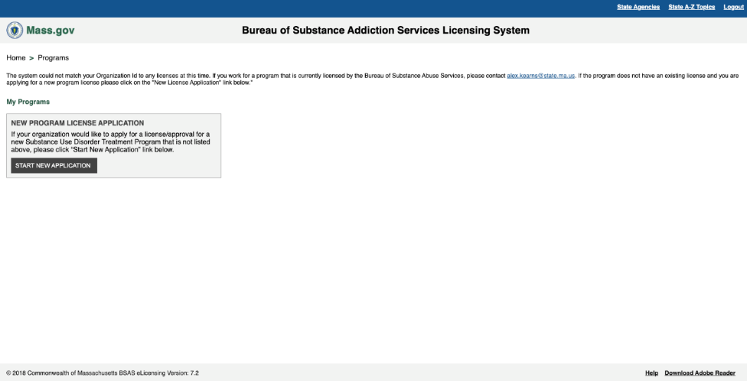
Read the instructions and click on the “Start New Application” button. The system will now prompt you to choose the program type as shown below.

Program Type
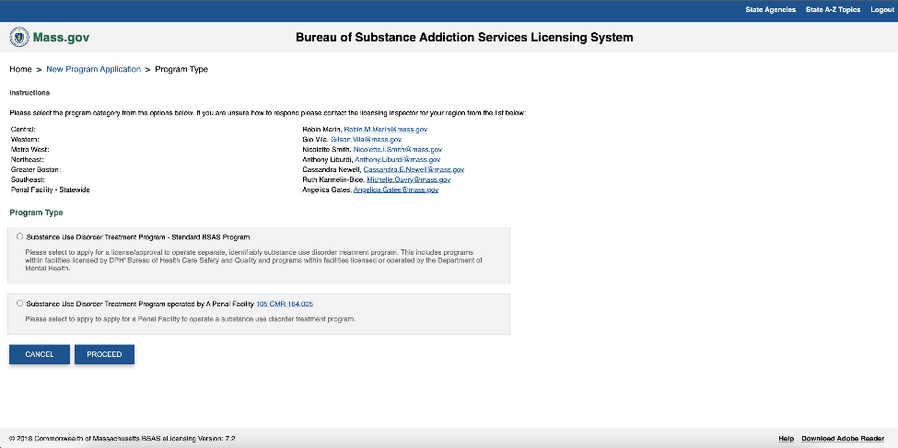

You may choose between a standard program and a program operated by a penal facility. A standard program is any program not operated by the Massachusetts Department of corrections, or a Massachusetts house of corrections. Choose the appropriate program type and click the proceed button. The system will now prompt you to choose a service setting for your program as shown below.

Service setting - Standard
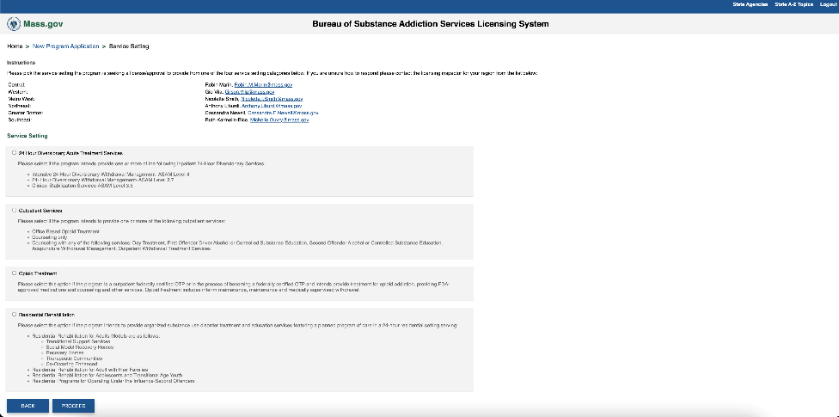
Your program must fall under one of these four service settings – 24 Hour Diversionary Acute Treatment Services, Outpatient Services, Opioid Treatment, or Residential Rehabilitation. Read the descriptions for these service settings, choose the appropriate service setting and click the proceed button.

Service setting – Penal Facility
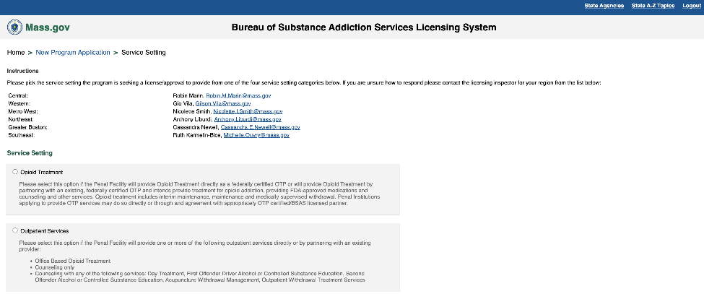
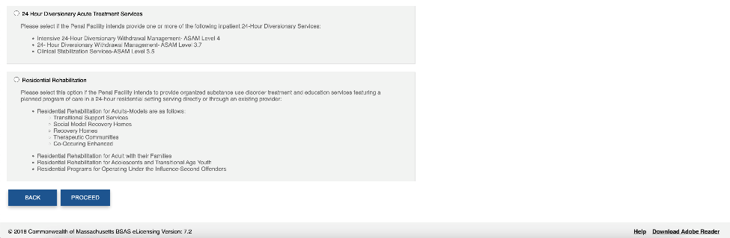

Your program must fall under one of these four service settings – 24 Hour Diversionary Acute Treatment Services, Outpatient Services, Opioid Treatment, or Residential Rehabilitation. Read the descriptions for these service settings, choose the appropriate service setting and click the proceed button.

If your program is operated by a penal facility, you will see an additional page to choose the type (Department of Correction or House of Correction) and the location of the penal facility.

Correctional Facility Information

After choosing the type and location, click the proceed button to move to the Program and Organization Information Page.

Program and Organization Information
The Program and Organization Information page is divided into three sections. The first section is the organization information section.
In this section, enter the information about the parent organization of the program, such as the organization name, type, mailing address and phone number. If the organization is a corporation, you will also need the enter the EIN/TIN number and the incorporation state. If the program is a penal facility, the organization name, type and incorporation state will be read-only fields and the organization mailing address will be pre-populated.

In the second section, you will need to enter information about the main site of the program such as the program name, addresses and contact numbers as shown below. If the program is a penal facility, the program operating address will be pre-populated.

In the third section, enter the hours of operation for the program main site for each day. If the main site is closed or open 24 hours for that day, tick off the appropriate checkbox.

Once you have entered all the information, click the save and proceed button to move to the service locations page as shown below. Please note that if your program is a residential rehabilitation program, you will not see the service locations page and instead move to the licenses and accreditations page.

Service Locations

If your program has service locations, click on the “Add Service Location” button. A service location is any location other than the program main site where the program provides services. If the service location is a mobile unit, you will need to check the corresponding box, and then enter the license plate number for the vehicle. Note that if the location is a mobile unit, the operating address should be the address where the vehicle is garaged. Enter the service location’s address, contact numbers, and hours of operation, Then, click on “Add service location” again. You may continue to add locations in the same way. You may also edit or delete any previously entered locations by clicking the corresponding edit or delete button.

Once you have finished entering service locations, click on the “Save & Proceed” button to move to the Licenses and Accreditations Page as shown below.

Licenses and Accreditations

On this page add information about licenses, registrations, accreditations or OTP certifications held by the program. If a license, registration, accreditation or OTP certification is applicable because your program has it, or has a pending application for it, click yes on the corresponding item, and enter the information for it, or indicate if an approval is pending. To upload a copy of the license, registration, accreditation or OTP certification, choose a file from your computer by clicking on choose file, and then click the corresponding upload button. After entering the information for the main site and any service locations, click the proceed button. The system will redirect you to the Qualified Service Organization Information page as shown below.

Qualified Service Organizations

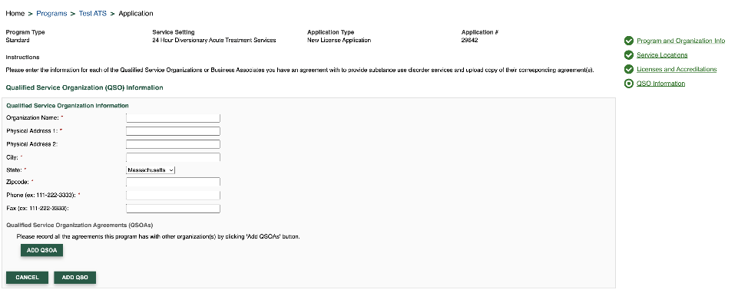

Enter information about any Qualified Service Organizations or Business Associates that your program is working with to provide substance use disorder services. Click on Add QSO to begin. Enter the name, physical address, phone, and fax numbers. Then record the agreements the program has with this organization, by clicking add QSOA. You will need to select the service type, and the start and end dates of the agreement. After entering each Agreement, click Add QSO. You may continue to add Organizations and agreements in the same way. You may edit or delete any previously entered Organizations by clicking the corresponding edit or delete button. After adding information about Qualified Service Organization, click the Save & Proceed button. The system will now prompt you to upload documents for each Qualified Service Organization Agreement as shown below.

For each QSOA, click the choose file button to choose a file from your computer and then click upload to upload it to the system. Click the save and proceed button to move to the Program Services Page.

Program Service - 24 Hour Diversionary Acute Treatment Services
The Program Services page will be different depending on the service setting of the program. If the service setting for your program is 24 Hour Diversionary Acute Treatment Services, you will see the page shown below.

Record the services and medications provided by your 24 Hour Diversionary Services program at the main site, if additional service locations have been entered you will be prompted to record services for these locations. Enter the number of beds and genders supported for each service. Leaving the number of beds as zero will indicate that the service is not being provided. Next, select the medications are available at the program, which treatment setting they are available in, and which entity provides the medication. The entity responsible for the medications may be the program itself or one of the Qualified Service Organizations entered earlier in the application. Lastly, indicate whether there are non-opioid withdrawal management treatment options at this location.

Program Service - Outpatient Services
If the service setting for your program is Outpatient Services, you will see the page shown below.

Record the services and medications provided by your Outpatient Services program at the main site, and each of its service locations. For each location select the services provided by the program by checking the corresponding checkboxes. If your program is providing counseling, indicate which medications are used, and what entity is responsible for the medications. The entity responsible may be the program itself or one of the Qualified service organizations entered earlier in the application. If your program provides Outpatient withdrawal treatment services, indicate which medications are available, and what entity is responsible for the medications, and whether non-opioid withdrawal management treatment options are available. If your program is providing Office based opioid treatment services, indicate whether the service is provided for maintenance, withdrawal, or both. Then select the medications, and entity responsible for the medications.

Program Services - Opioid Treatment
If the service setting for your program is Opioid Treatment, you will see the page shown below.

Record the services and medications provided by your OTP program at the main site, and each of its service locations. Check whether counseling is provided, and which entities are providing counseling. Also, check what medications are available at the location, which entity is providing them, and if they are being stored overnight at the location. The entity responsible for the medications may be the program itself or one of the Qualified service organizations entered earlier in the application.

Program Services - Residential Rehabilitation
If the service setting for your program Residential Rehabilitation, you will see the page shown below.

Record the services provided by your Residential Rehabilitation Services program, by checking the corresponding checkboxes. For each service that the program is providing, enter the number of beds, indicate which genders are supported, and whether or not pharmacological therapies are offered. Once you are done entering this information, click on the save and proceed button to move to the special populations page as shown below.

Special Populations

Check all the special populations served for the main site, and each service location. Definitions for each special population can be viewed by hovering over the question mark tooltip next to the option. Click the “Save & Proceed” button. The system will redirect you to the Responsible Officials page as shown below.

Responsible Officials
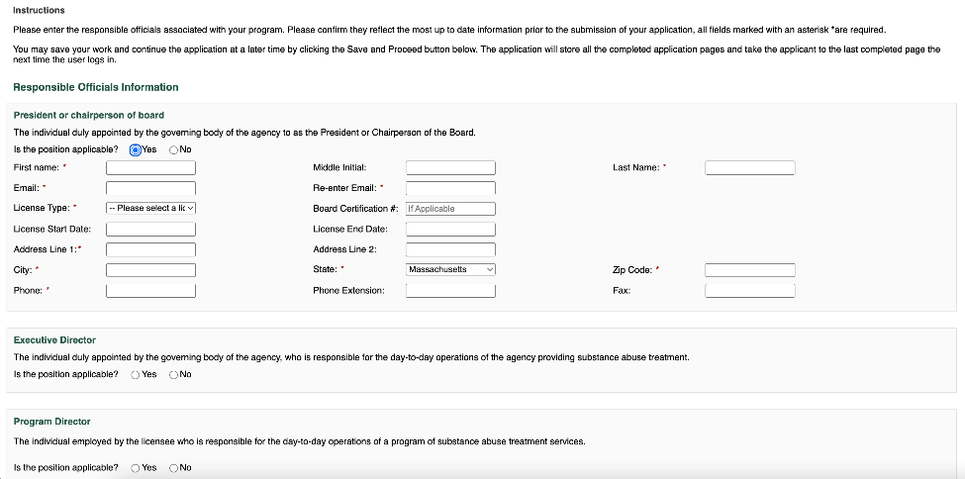

Read the descriptions for each of the positions displayed and choose whether they are applicable or not for your program. For those that are, enter the name, contact information, and license and certification information. Once you are done entering all the responsible officials, click the “Save & Proceed” button to proceed to the Governing Body page shown below. Please note that you will skip this page if your program has a DPH-DHCQ or a DMH License, or if it is operated by a Massachusetts Department, Agency or Institution.

Governing Body

Enter information about governing body members including name, expertise type and role, start date, city, state of residence, and phone number, then click Add. You may continue to add members in the same way. Note that you must enter at least two governing body members. You may also edit or delete any previously entered members by clicking the corresponding edit or delete button. Once you are done, proceed to the advisory board page shown below. Please note that you will only see this page if none of the governing body members resided in Massachusetts.

Advisory Board

On this page, you will enter information about the advisory board members including name, expertise type, start date, city, state of residence, and phone number, then click Add. You may continue to add members in the same way. You may also edit or delete any previously entered members by clicking the corresponding edit or delete button. Please note that you must enter at least two advisory board members. Click the “Proceed” button to move to the Program Questions page as shown below.
Program Questions

On this page, you will need to provide answers to various questions about your program. The questions are divided into different categories, and you can move to a previous category by clicking the corresponding tab. You may be asked to provide a narrative response (as shown above), upload supporting documents, or affirm a statement to answer the question (shown below). The question will be associated to one or more regulations, which you can view by clicking that regulation number. To move to the next tab, click Save and Proceed.

After answering all of the questions, click the “Save & Proceed” button in the last category to proceed to the program staff page.

On the program staff page, you will add information on staff members for your program. The staff entry page is divided into three sections and the information is saved in the system after completing each section. The first section of the staff entry page is shown below.

Program Staff and Schedule
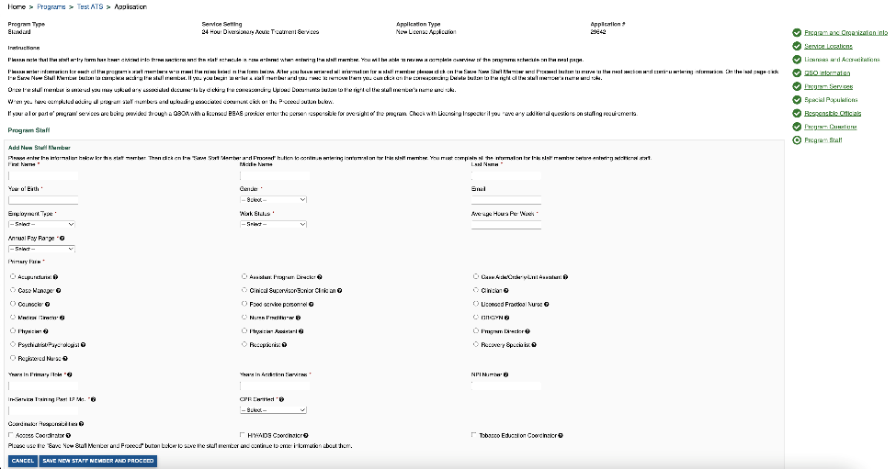
Here, enter the staff member’s personal and professional information. Then proceed to the next section shown below by clicking the “Save New Staff Member and Proceed” button.

On this section, add information about the degrees, licenses, certifications, and schedule for the staff member. For each day the staff member is working, enter the service location, service, and the hours worked by the staff member for the day evening and overnight shifts, and indicate if the staff member is an emergency designee or not. Proceed to the next section shown below by clicking the “Save Staff Member and Proceed” button.

On this section, enter demographic information. The answers to these questions must strictly come from the staff member and should not be guessed. Please note that this is being collected to support workforce development programs in the field of substance addiction services. Click the “Save Staff Member” button to save the save member. The system will now prompt you to upload documents for the staff member as shown below.

Supporting documents for the staff member, such as resumes, CPR certifications, licenses and training materials can be uploaded here. To upload a document, choose the document type, add any comments, choose the file from your computer and click the “Upload” button. When you are done uploading documents, click on “Return to Staff Page”. Form the page shown below you can add more staff in the same way. You can also edit, delete or upload documents for already entered staff by clicking the corresponding button to the right of their name.

Once you have entered all staff members, click the proceed button. The system will display the schedule for your program based on the staff schedule you entered.
The system will display the schedule for each service provided at each service location. Click on the corresponding tabs to view the schedule for each day of the week. If the schedule is correct, you may proceed to the Health and Safety Documents Information page shown below. If not go back to the previous page and edit the schedule of the staff member that is incorrect. Please note that you will skip the Health and Safety Documents Information page if your program has a DPH-DHCQ or a DMH License, or if it is operated by a Massachusetts Department, Agency or Institution.

Health and Safety Documents

Enter information about important Health and Safety Documents including their issue and expiration dates. If a particular document is not applicable Based on Governmental Rules or Regulations, you may skip it by checking the check box. After entering all information, click the “Save & Proceed” button. The system will now prompt you to upload the Health and Safety Documents.

Upload copies of these documents by selecting the files from your computer, and clicking on the corresponding upload button. After uploading all the documents, click the “Save & Proceed” button to proceed to the Application Documents page as shown below.

Application Documents
On this page, you will see all of the documents uploaded during the application process. Review the instructions carefully to see if you missed uploading any documents. To upload the missing or additional documents for your application, click on Upload document. This will display the upload form. Choose the type, and associated application record, and add any comments, choose the file to upload, and then click Upload. Once all the documents are uploaded, click the “Save & Proceed” button to move to the Application Fee Payment page shown below. If there is no fee for your application, you will skip this page.

Application Fee

Pay the fee associated with the application by clicking on pay fee. This will take you to an external payment processing website shown below, where you will be able to make the payment either by credit, debit or ACH/Bank Account.

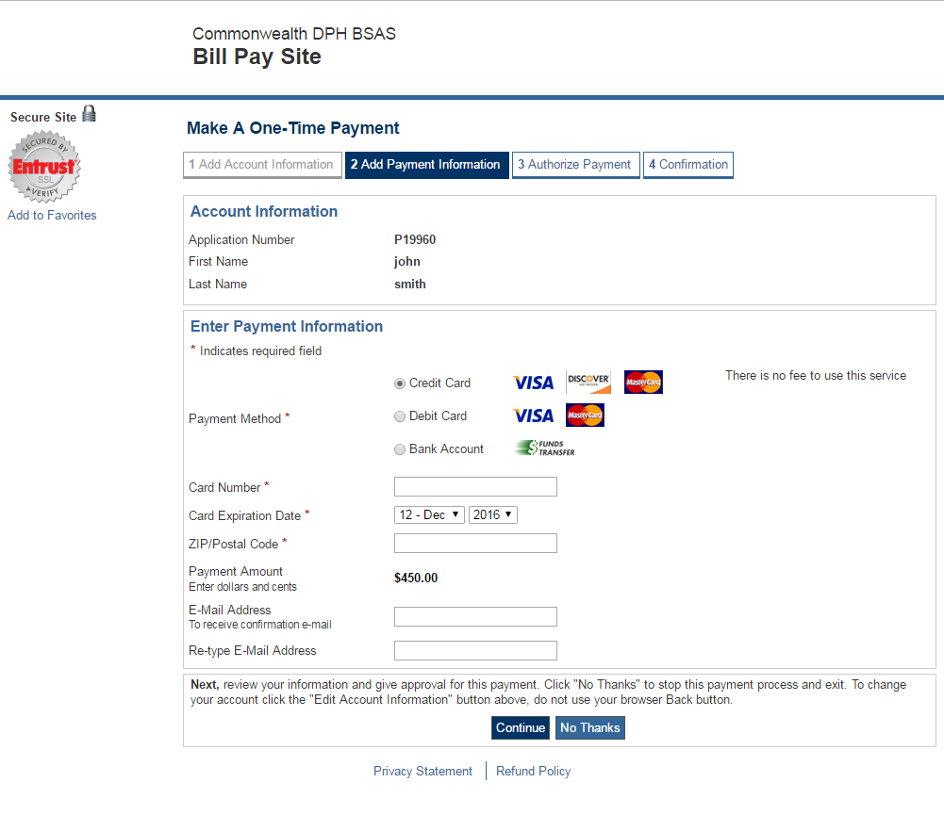
Enter your payment information and click the “Continue” button. You will then proceed to the payment review page shown in the figure below:
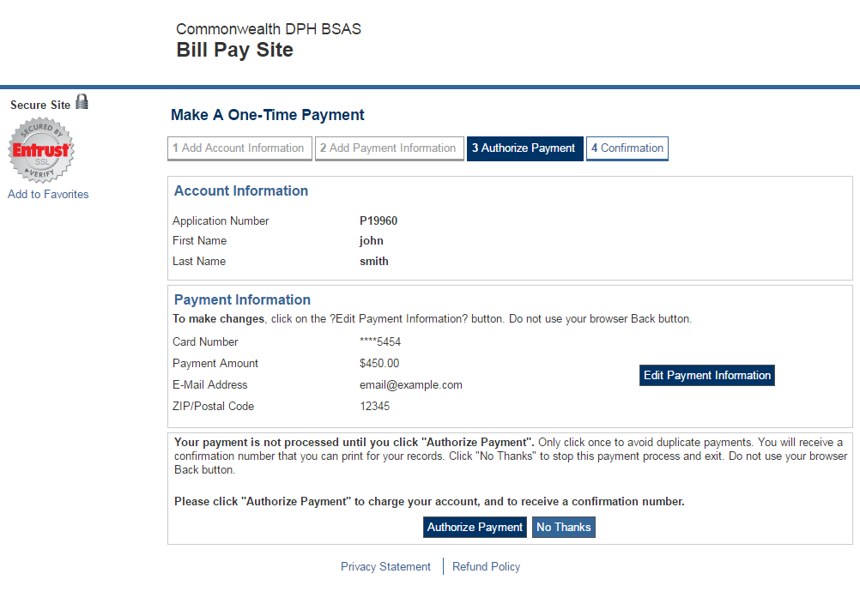
Review your payment information and click the “Authorize Payment” button to complete the payment. You will then be taken to the Application Submit page as shown in the figure below:

Submit Application

Note that you may not modify your application once it is submitted for processing, so make sure that all the information entered is correct and up to date. Agree to the application attestation by clicking the “I agree” checkbox and click on the “Submit” button to submit your application. Once your application is submitted, you will be redirected to the menu page shown below.

After Application Submission

Fax Supporting Documents
Now that you have submitted your application, if necessary, you may click on the Fax Supporting Documents button to generate fax cover sheets to use when faxing any additional documents. The system displays the fax supporting documents page shown in the figure below.
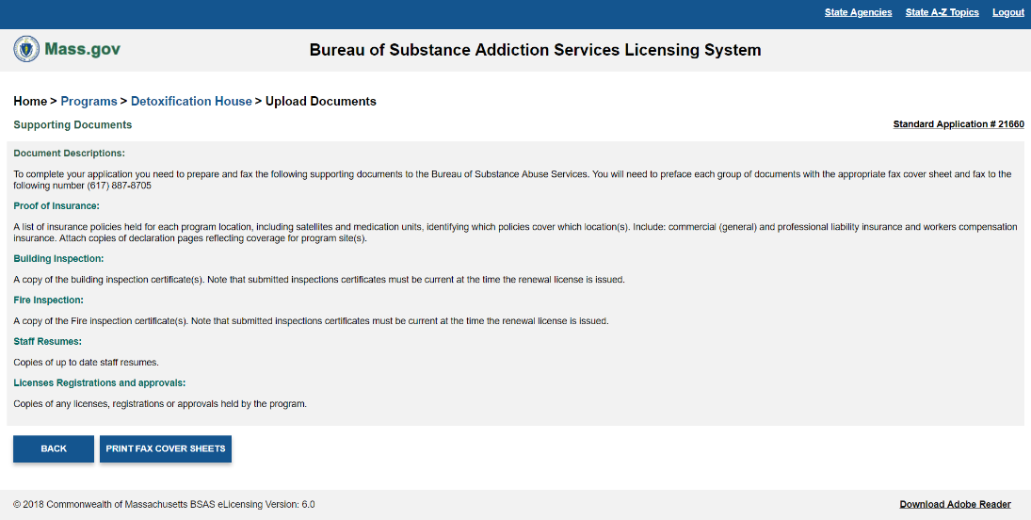

Read the instructions and prepare all the required documents, then click the Print Fax Cover Sheets button. A new window will open up a PDF file that contains the fax cover sheets as shown in the figure below.
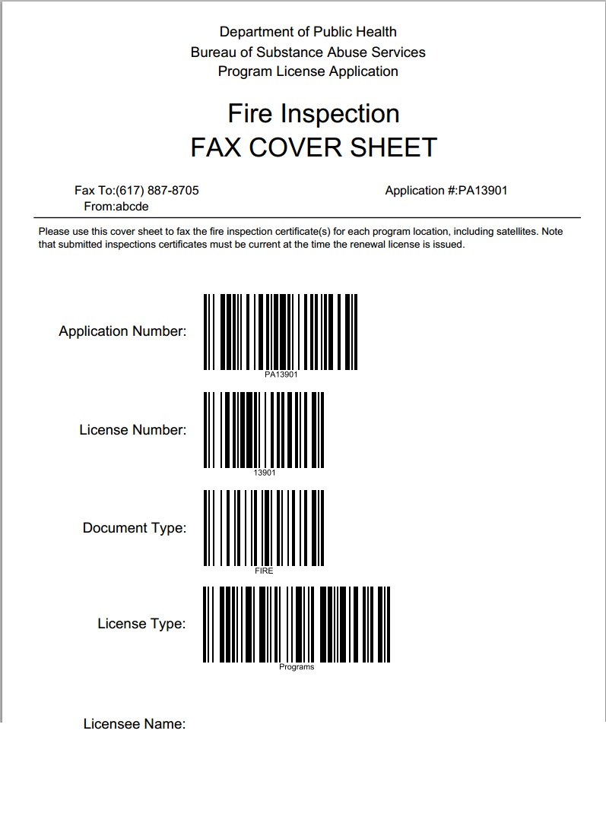
Print all the cover sheets. Follow the instructions to fax the documents with the cover sheets to the fax number printed at the top of the sheets.
Upload Documents After Application Submission
You may also upload any additional documents at this time. To do this, go back to the main menu and click the Upload Documents button. The system will display the Upload Documents for Program Applications shown below.

To upload the missing or additional documents for your application, click on Upload document. This will display the upload form. Choose the type, and associated application record, and add any comments, choose the file to upload, and then click Upload.

Application PDF Copy
You may also generate a pdf copy of your application to print or save for your records. To do this, go back to the main menu and click the Print Application button. The system will display the Upload Documents for Program Applications shown below:

Renewal Application
Once you access BSAS eLicesing as described above, select the program that you need to renew from the list of your organization’s programs and the system will display the menu page shown below:
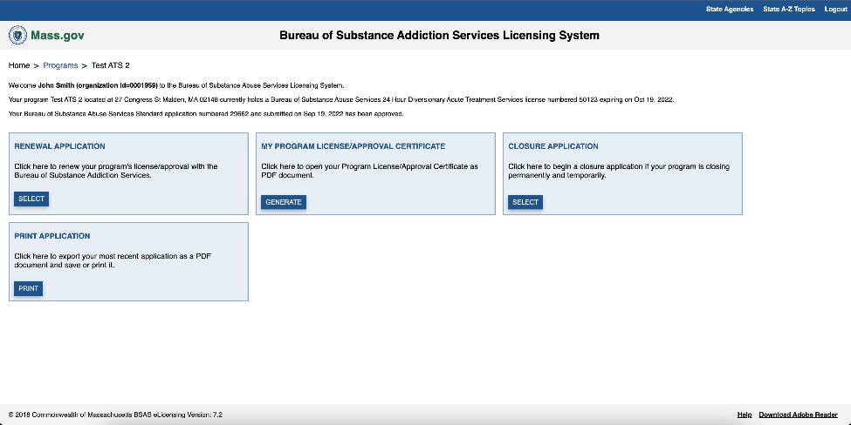
Click the “Select” button on the Renewal Application Card and the system will display the renewal application confirmation page.

Click the Proceed button to start the renewal application. The renewal application steps are identical to those of a new application except the pages are prepopulated with existing data for ease of use. For detailed instructions about the steps refer to section 1 of this document.

Amendment Application
Once you access BSAS eLicesing as described above, select the program you need to amend from the list of your organization’s programs and the system will display the menu page shown below:
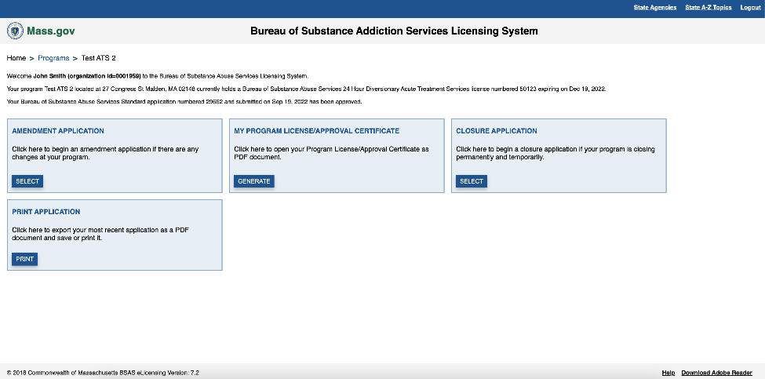

Click the “Select” button on the Amendment Application Card and the system will display the amendment application confirmation page.
Click the Proceed button to start the amendment application. The amendment application steps are identical to those of a new application except the pages are prepopulated with existing data for ease of use. For detailed instructions about the steps refer to section 1 of this document.

Closure Application
Once you access BSAS eLicesing as described above, select the program you need to close from the list of your organization’s programs and the system will display the menu page shown below:

Click the “Select” button on the Closure Application Card and the system will display the amendment application confirmation page as shown below.

Click the proceed button to confirm and start the closure application. The system will display the program closure type page where you will be required to choose between a temporary or permanent closure.

Closure Type

Choose the type and click the proceed button. The system will then display a more detailed Program Closure Information page shown below.

Closure Information

Enter the program closure information and click the Save & Proceed button. The system will display the Program Closure Questionnaire page shown below.

Program Closure Questions

Answer the questions and click the Save & Proceed button. The system will then display the Submit Closure page shown below.

Submit Closure Application
Note that you may not modify your application once it is submitted for processing, so make sure that all the information entered is correct and up to date. Agree to the application attestation by clicking the “I agree” checkbox and click on the “Submit” button to submit your closure application. Once your application is submitted, you will be redirected to the menu page shown below.

After Closure Application Submission

If you need to provide any supporting documents, you may fax them or upload them by clicking the respective buttons. The process of faxing or uploading supporting documents after application submission is described above in section 1.

