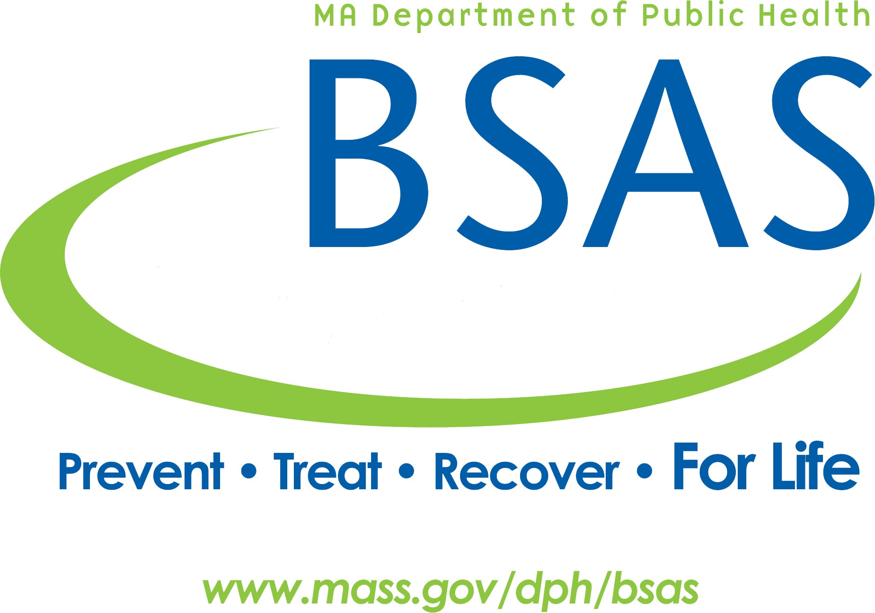Massachusetts Department of Public Health Bureau of Substance Addiction Services Foreign Language Interpretation Services Authorization Request

Version: FY 20, 7-2-19

Request for Interpretation Services must be approved by BSAS before services are administered. Use one form per client.

The primary contact must be available at time of visit.

**Provider Agency**

Requesting agency:

Primary contact:

Address:

City: State: ZIP:

Phone: Ext: E-mail:

*Secondary contact: Phone: Ext: E-mail:*

**Request for Service**

Service request (Service Setting):

Total Sessions:

Max hours/day:

Max sessions/day:

City where services will take place:

Language:Session Start Date: Start time of first visit (AM/PM):

Requested number of days: Sessions per day: Hours per session:

Hours should be entered in fractions e.g. 1 hour & 45 minutes = 1.75

Special Circumstances (Notes):

**This request is complete: ⃝ Date/time Stamp:**

BSAS Foreign Language Interpretation Services

Version: FY 20, 7-2-19

Page 1 of 1