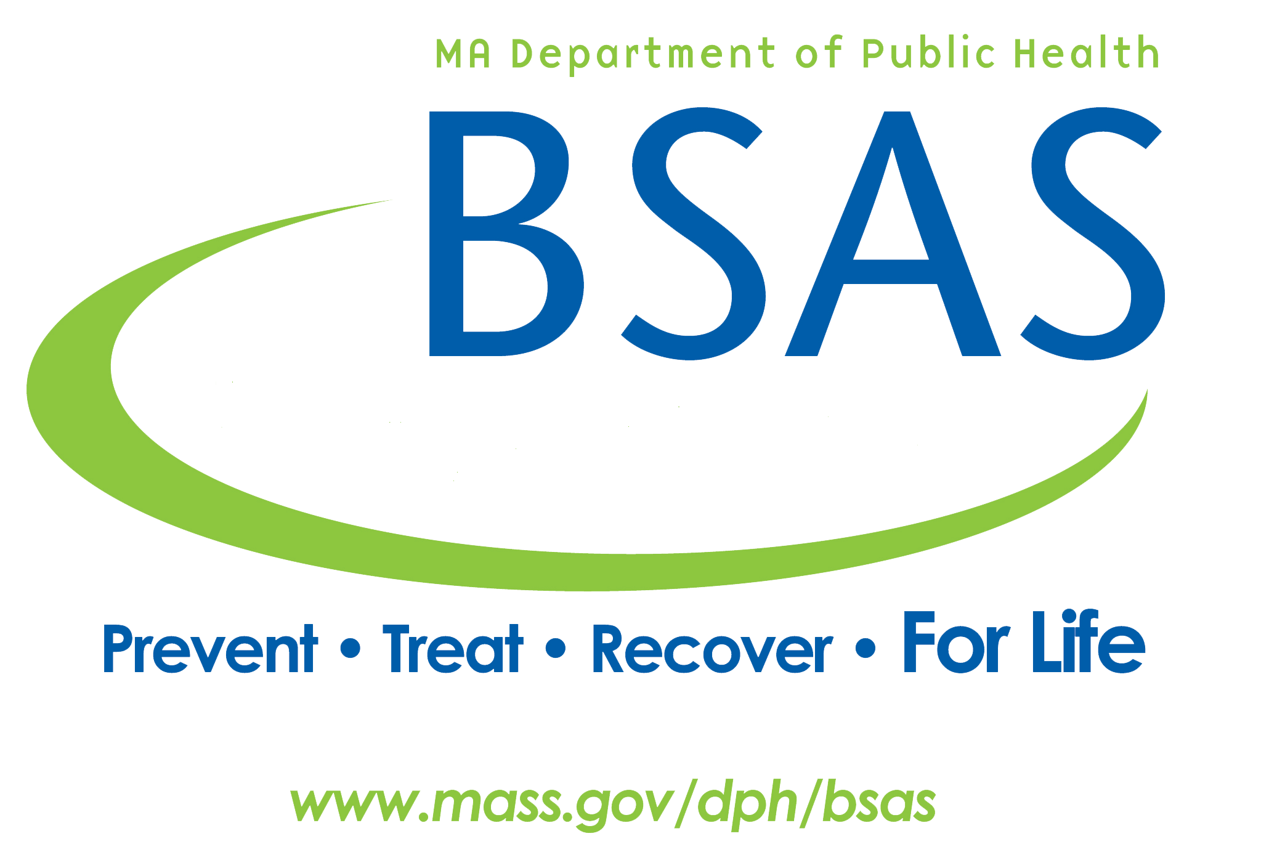

**Manual for Foreign Language**

**Interpretation services**

**in BSAS settings**

**January 2018**



**Table of Contents**

**Instructions for using the Foreign Language Interpretation Services Form**1

**General Instructions**1

**Use the buttons at the bottom of each page** 1

**Processing Instructions**2

**Service Limits**2

**Request Form** 3

**DPH Authorization Request Approval**5

**Request for additional services**6

**Request for additional services approval**8

**Payment Process**9

**Table 1 Substance Abuse Interpreter Service Description Sample Form** 10

**Table 2 List of Interpretation Providers FY 2017**11

**Table 3 All languages translatable by FY 2017 providers** 12

**Glossary of Terms** 13

**Instructions for using the Foreign Language Interpretation Services Form**

To receive foreign language interpretation serves the provider agency must complete and submit the Foreign Language Interpretation Services Form. For the most part completion of the form should be self-explanatory. The instructions below will go over the process and procedures. If you have any questions, pertaining to completing and submitting the Interpretation Services Authorization Request Form, contact the Bureau of Substance Abuse Services via phone at (617) 624-5111 or email BSASInterpreters@MassMail.state.ma.us

**General Instructions**

* All forms must be completed using Adobe Acrobat version 9 or higher. If you do not have the most current version you may download [Adobe Acrobat Reader](http://www.acrobat-pdf-download.com/) at no charge.
* Forms must be submitted via email. There are email buttons at the bottom of each form.
* Save a copy of the completed form before the completed form is emailed.
* Do not include confidential or client information on the form.
* Do not mail or FAX completed form.
* Do not hand-write information on form.
* 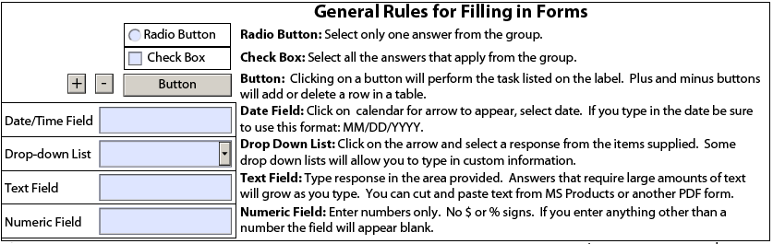Notes fields on the forms will expand to fit the amount of text.

**Use the buttons at the bottom of each page to:**



* **Save** - To save a copy of the form, select the “Save” button at the bottom of the page. Do not select “Save a Copy” from the drop down menu. This will halt your ability to complete the form online
* **Print Form** – To print a copy of the form, select the “Print” button at the bottom of the page
* **Reset Form** *–* Clears all data on the form, excluding the Provider Information entered on the first page. If Provider information changes make the edits manually or use a blank form.

**Processing Instructions:**

* Requests for interpreter services must be submitted and approved, before sessions with a BSAS-provided interpreter can begin
* Completed forms must be received at least 24 hours prior to appointment with the client.
* Cancellation of a scheduled appointment with the interpreter must be at least 48 hours prior to appointment.
* Each client requiring interpreter services must be submitted on separate forms.
* If additional services, beyond the initial request, are required, complete and submit another Interpretation Services Authorization Request Form
* When requesting additional services, check the “Radio” button, indicate a need for additional services, and complete the form with detailed information
* Time sheets and invoices must be submitted for services rendered.

**Service Limits**

The table below represents allowable service types and recommended session limits.

* If your clients care requires more than the recommended session limits complete the special circumstances section on the form.
* If you under estimate on the initial request complete the Additional Services form.

|  |  |  |
| --- | --- | --- |
| **Interpretation service allocation units** | | |
| **Service Descriptions** | | |
| **Type of Service** | **Recommended limits for interpretation sessions/day** | **Total number of days allowed** |
| **Inpatient services** Including: Acute detox, transitional support services, clinical stabilization services, residential homes, Section 35 program, 2nd offender inpatient | 2 | 15 |
| **Counseling sessions** Including: Intake assessment or individual counseling sessions for outpatient, 1st offender driver alcohol education, methadone treatment, juvenile CJ diversion, 2nd offender aftercare, family therapy, in home therapy, gambling treatment | 1 | 15 |
| **Group therapy** including: 1st offender driver alcohol education, methadone treatment, 2nd offender aftercare, gambling treatment, acupuncture | 1 | 15 |
| **Day treatment** | 2 | 15 |
| **Methadone treatment program** | 1 | 15 |
| **Case management** for outpatient services, criminal justice diversion, day treatment, recovery support, 2nd offender aftercare, family intervention, Section 35 aftercare, jail diversion | 2 | 15 |
| **Recovery coaching** | 2 | 15 |
| **Case consultation** | 1 | 15 |

**Request Form**

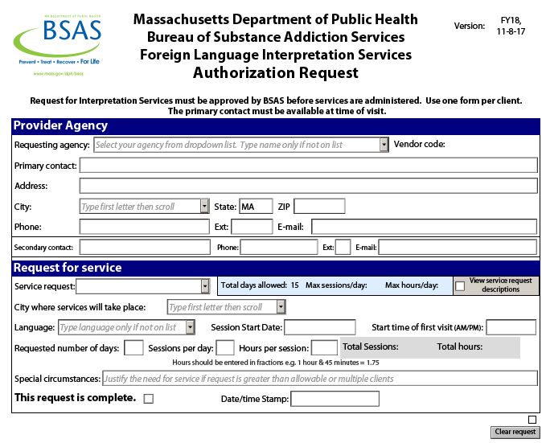

Provide all necessary information requested on the Authorization Request Form

* The form must be completed and approved by BSAS before any services are rendered
  + Requesting agency – Select your provider agency’s name from the drop down list. If your agency is not listed, type your agency’s name in the box. The vendor code for the indicated provider will automatically appear if your agency is on the list.
  + Primary contact – The name of the individual at the requesting agency, BSAS can communicate with regarding the referral.
  + Address, city, state, and ZIP code of the provider agency.
  + Phone, extension, e-mail of the primary contact at the provider agency.
  + Secondary contact – The name of the individual at the requesting agency, who can be contacted in case the primary contact is not available for all sessions requested.
  + Service request – Select from the drop down list.
  + City where services will take place – Select from the drop down list. Indicating this on the form is necessary in making the best available vendor selection.
  + Language - Select the language, from the drop down list, for which interpreter services is necessary. If the needed language is not on the drop down list, type the language in manually.
  + Session start date - First day interpreter services will be needed. Select the date from the calendar or type in manually using MM/DD/YYYY format (e.g 10/21/2016).
  + Start time of first session – Time that the interpreter services are needed.
  + Number of days – The total number of days interpreter services will be delivered. Days do not have to be sequential. Report only days in which interpreter sessions will take place.
  + Sessions per day – How many sessions will take place in one day.
  + Hours per session – How long each session will last
  + Total sessions and total hours will then be automatically calculated.
  + Special circumstances – Complete this area if the request exceeds the maximum allowed sessions or if you need to clarify a request.
* When selecting “Service request” the maximum sessions allowed per day and total days allowed will appear next to the request. To see all service requests, check the “View Service Request Descriptions” box. Checking this box will provide the same information that appears in Service Limit chart. Uncheck the box to close the service descriptions.
* If a client requires more sessions than the daily/total limit allows, provide rationale for additional sessions in the “Special circumstances” box.
* When the Authorization Request Form has been completed, check the box to the right of “This request is complete”. This will lock the form and “Date/Time Stamp” the request. If this needs to be changed before the form is submitted, use the “Clear Request” button to unlock the form.
* Click on the “E-mail completed form to BSAS” to submit the request. Email button will not appear until you check “This request is complete”.

**DPH Authorization Request Approval**

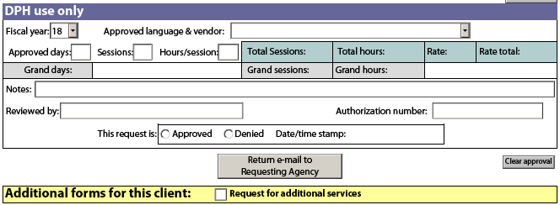

* Upon receiving the authorization request, BSAS will review the request. If “Approved”, BSAS will indicate the “Approved language and vendor”, indicate the “Approved number of sessions”, and assign an “Authorization number”.
* The Authorization Request Approval is emailed to the provider, with a copy also sent to the selected vendor.
* Once approval has been given, the provider may contact the selected vendor and make arrangements for interpreter services.
* If a request is denied, the provider will review the original Authorization Request and resubmit the form with suggested changes provided in the “Notes” section.
* The authorization number must be used on all communications and time sheets for this services rendered to this client.

If the approved initial request for services is not sufficient the provider must submit a request for additional services.

* Open your copy of the approved request.
* Check the box “Request for additional services”, and a new form, Request for Additional Services will appear. (See instructions below)

**Request for additional services**

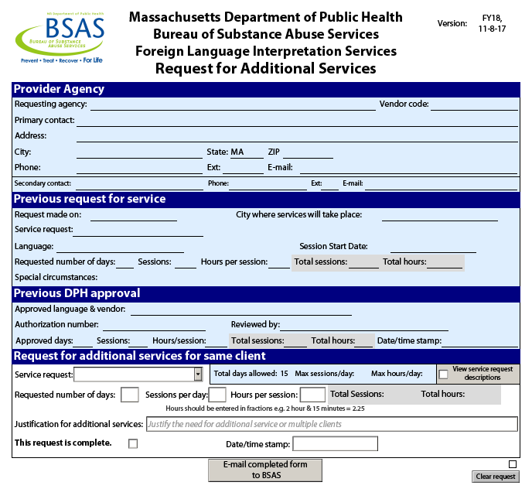

This form should be used only if the approved initial request for services is not sufficient for your client. The Request for additional services must be completed and approved by BSAS before any additional services are rendered.

* Open your copy of the approved request and check the box next to “Request for additional services”.
* A new form will appear on page 2. The information provided on the original Authorization Request form and Authorization Request Approval will prepopulate on this form.
* Complete the information under “Request for additional services for same client”
  + Number of sessions requested – Total number of sessions requested will be at or below the maximum allowed per day, multiplied by the total number of days.
  + Number of days – The total number of days interpreter services will be delivered. Days do not have to be sequential. Report only days in which interpreter sessions will take place.
  + Estimated number of hours – Estimated number of hours all interpreter sessions will take. The figure can be determined by multiplying the average session length by the total number of sessions. Estimated hours must be reported in fractions. E.g. 1 hour and 45 minutes = 1.75.
  + Justification for additional services – Complete this area for all additional services requests, particularly those in which the request exceeds the maximum allowed sessions. In a detailed request, justify the need for additional services.
* When the Request for Additional Services form has been completed, check the box to the right of “This request is complete”. This will lock the form and “Date/time Stamp” the request. If this needs to be changed before the form is submitted, use the “Clear request” button to unlock the form.
* Click on the “E-mail completed form to BSAS” to submit the request.
* Save a copy for your records.

**Request for additional services approval**

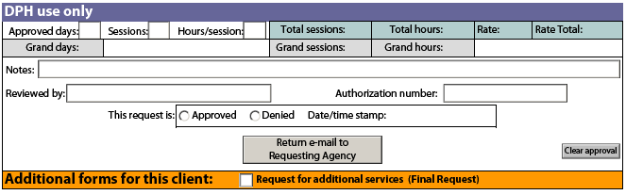

* Upon receiving the Request for Additional Services, BSAS will review the request. If “Approved”, BSAS will indicate the “Approved number of sessions”, and assign an “Authorization number”.
* The Authorization Request Approval is emailed to the provider, with a copy also sent to the selected vendor.
* Once approval has been given, the provider may contact the selected vendor and make arrangements for interpreter services.
* If a request is denied, the provider will review the original Authorization Request and resubmit the form with suggested changes provided in the “Notes” section.

**Payment Process**

In order for DPH/BSAS to process invoices promptly and efficiently, please follow the Bureau’s payment process:

Use the Substance Abuse Interpreter Service Description Form to document services rendered.

Send invoices electronically in PDF format to the following:

* TO field: BSASInvoices@massmail.state.ma.us
* CC field: BSASInterpreters@MassMail.state.ma.us

Attach all files and forms to the e-mail.

* Use the authorization number on all invoices for the client
* PDF files may be created from MS Word documents and MS Excel files
* Scan invoices and save as a PDF file

Payment process may be delayed if documentation is missing or incomplete.

**Table 1**

**Substance Abuse Interpreter Service Description Sample Form**

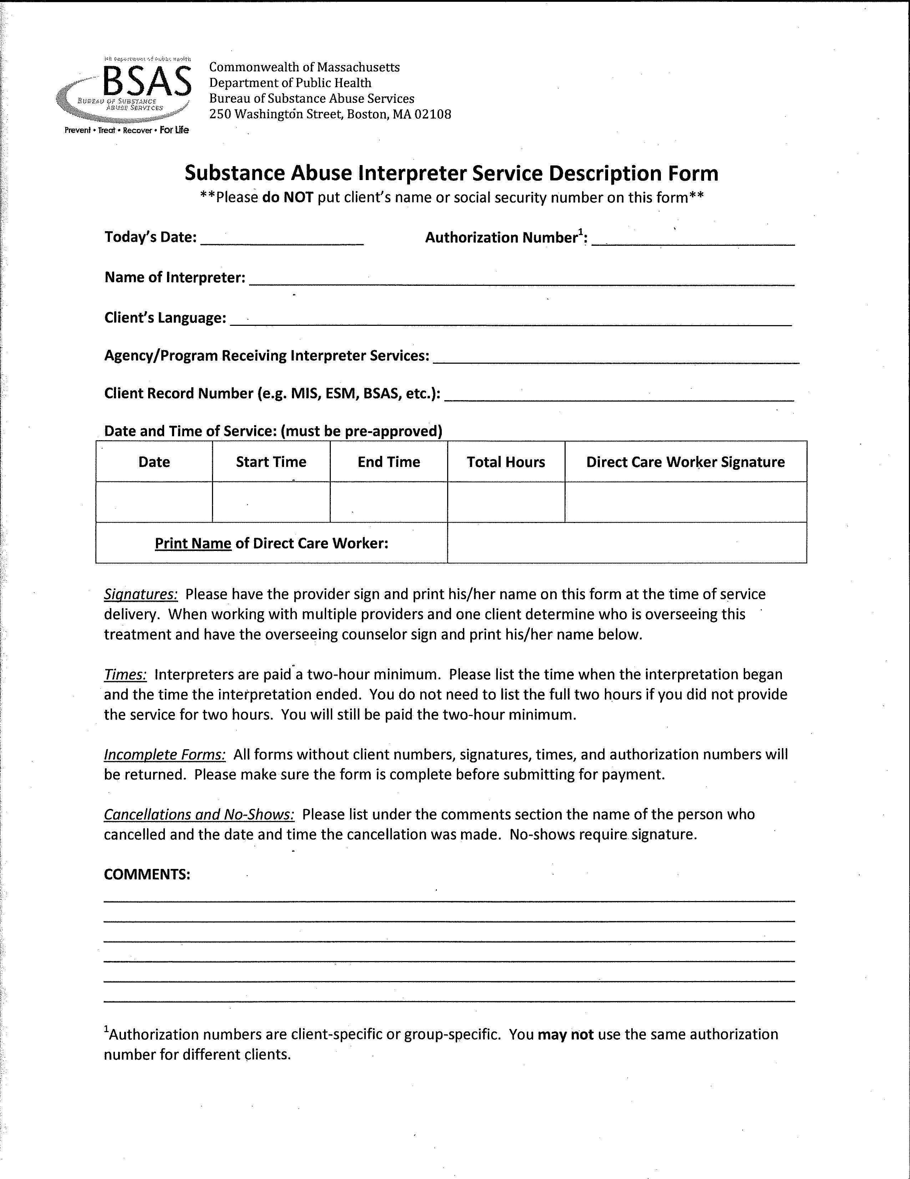

**Table 2**

**List of Interpretation Providers FY 2018**

|  |  |  |  |  |
| --- | --- | --- | --- | --- |
| **Code** | **DPH Interpreter Providers** | **Contact Name** | **Contact Phone** | **Contact Email** |
| BSI | BayState Interpreters Inc | Darrin Brooks | 888-663-8000 | [dbrooks@baystateinterpreters.com](mailto:dbrooks@baystateinterpreters.com) |
| CCC | Cross Cultural Communications | Zarita Araujo-Lane | 781-729-3736 x105 | [zaraujolane@embrancingculture.com](mailto:zaraujolane@embrancingculture.com) |
| IAI | Interpreters Associates Inc | Ana Maria Liebl | 617-886-5110 | [anamaria@interpretersassociates.com](mailto:anamaria@interpretersassociates.com) |
| LB | Language Bridge | Julia Dubinchik | 413-754-3488 | [info@lbridge.com](mailto:info@lbridge.com) |
| TF | TransFluenci LLC | Jessica Ridley | 413-737-1888 | [Jessica@transfluenci.com](mailto:Jessica@transfluenci.com) |

|  |  |  |  |  |  |  |  |
| --- | --- | --- | --- | --- | --- | --- | --- |
| **Table 3**  **All languages translatable by FY 2017 providers** | | | | | | | |
|  |  |  |  |  |  |  |  |
| **Language** | **Predominate Country spoke** |  | **Language** | **Predominate Country spoke** |  | **Language** | **Predominate Country spoke** |
| Albanian | Albania |  | Fulani | Nigeria/Guinea/Mali/Niger |  | Marathi | India |
| Amharic | Ethiopia |  | Fuzhou | China |  | Moldovian | Moldova |
| Arabic |  |  | German | Germany |  | Mongolian | Mongolia/China |
| Arabic (Egyptian) | Egypt |  | Greek | Greece |  | Nepali | Nepal |
| Arabic (Lebanese) | Lebanon |  | Gujarati | India/Pakistan |  | Nigerian | Nigeria |
| Arabic (Moroccan) | Morocco |  | Guarani | Paraguay/Argentina |  | Oromo | Ethiopia/Kenya |
| Armenian | Armenia |  | Haitian Creole | Haiti |  | Panjabi | Pakistan/India |
| Balinese | Bali |  | Hausa | Nigeria/Niger/Chad/Ghana |  | Pashto | Afghanistan |
| Bengali | Bangladesh/India |  | Hebrew | Israel/West Bank/Golan Heights |  | Persian (Farsi) | Iran/Afghanistan |
| Bosnian | Bosnia & Herzegovina |  | Hindi | India |  | Polish | Poland |
| Bulgarian | Bulgaria |  | Hmong | China/Vietnam/Laos |  | Portuguese | Portugal |
| Burmese | Myanmar/Burma |  | Hunanese | China |  | Portuguese (Brazilian) | Brazil |
| Cape Verdean Creole | Cape Verde |  | Hungarian | Hungary |  | Punjabi | Pakistan/India |
| Cebuano | Philippines |  | Igbo | West Africa/Nigeria |  | Romanian | Romania |
| Chinese (Cantonese) | China |  | Indonesian | Indonesia |  | Russian | Russia |
| Chinese (Fukienese) | China |  | Italian | Italy |  | Serbian | Serbia/Bosnia/Herzegovina |
| Chinese (Hunan) | China |  | Japanese | Japan |  | Serbo-Croatian | Serbia/Bosnia/Herzegovina |
| Chinese (Mandarin) | China |  | Javanese | Java |  | Sicilian | Italy |
| Chinese (Simplified) | China |  | Kannada | India |  | Sinhala | Sri Lanka |
| Chinese (Traditional) | China |  | Karen | Burma /Thailand |  | Slovak | Slovakia/Czech Republic/Serbia |
| Creole (Haitian) | Haiti |  | Karenni | Burma /Thailand |  | Somali | Somalia |
| Creole (Krio) | Sierra Leone |  | Khmer | Cambodia |  | Spanish |  |
| Creole (Pidgin) |  |  | Kikuyu | Kenya/Tanzania/Uganda |  | Sudanese Arabic | Sudan |
| Croatian | Croatia |  | Kinyarwanda | Rwanda/Uganda |  | Swahili | Tanzania/Kenya/Congo/  Uganda |
| Czech | Czech Republic |  | Kirundi | Burundi |  | Swedish | Sweden/Finland |
| Danish | Denmark |  | Korean | Korea |  | Tagalog | Philippines |
| Dari | Afghanistan |  | Kpelle | Liberia/Guinea |  | Taiwanese | Taiwan/China |
| Dinka | South Sudan |  | Krio | Sierra Leone |  | Tamil | Sri Lanka/India |
| Dutch | Netherlands |  | Kru | Ivory Coast/Liberia/Burkina Faso |  | Telugu | India |
| Dutch/Flemish | Belgium |  | Kurdish | Iraq/Turkey |  | Thai | Thailand |
| Dzongkha | Bhutan |  | Lao | Laos/ northeastern Thailand |  | Tibetan | Tibet |
| Edo | Japan |  | Latin | Latium |  | Tigrinya | Ethiopia |
| Estonian | Estonia |  | Liberian | Liberia |  | Toishanese | China/Hong Kong |
| Ethiopian | Ethiopia |  | Lithuanian | Lithuania |  | Turkish | Turkey |
| Ewe | Ghana/Togo |  | Luganda | Uganda |  | Twi | Ghana |
| Farsi | Iran/Afghanistan |  | Luo | South Sudan/Ethiopia/Uganda |  | Ukrainian | Ukraine/Crimea |
| Filipino | Philippines |  | Malay | Malaysia/Brunei/Indonesia |  | Urdu | Pakistan |
| Finnish | Finland |  | Malayalam | India |  | Vietnamese | Vietnam |
| French | France |  | Malaysian | Malaysia |  | Wolof | Senegal/Gambia/  Mauritania |
| French (Canadian) | Canada French speaking |  | Mandingo | Sierra Leone |  | Yemeni Arabic | Yemen/Saudi Arabia |
| Fujianese | Indonesia |  | Mandinka | Sierra Leone |  | Yoruba | Benin/Nigeria |

**Glossary of Terms**

**Interpretation**: Interpreting is the process of fully understanding, analyzing, and processing a spoken message and then faithfully rendering it into another spoken language. Interpreters must be able to accurately convey the meaning from one language to another in a culturally appropriate manner, mindful of the setting in which they are rendering their services.

**Provider: Agency that provides direct care services for the client**

**No-Show**: A no-show occurs whenever an interpreter presents for scheduled appointment and the client is not available.

**Translation**: Translators work with the written word, converting text from a source language into a target language. This is far more than replacing one word with another. The translator must also convey the style, tone, and intent of the text, while taking into account differences of culture and dialect. The finished document should read as if it had originally been written in the target language for the target audience.

**Vendor: Outside agency that provides language interpreter services for the provider.**