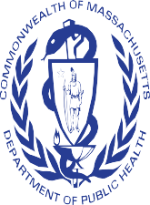

Opioid Recovery and Remediation Fund Advisory Council

Opioid Overdose (Deaths and EMS), Opioid Treatment Provider and Utilization

Deirdre C. Calvert, Director, BSAS/MDPH Sarah Ruiz
Hermik Babakhanlou-Chase

Presentation Overview

Maps of Opioid-overdose related deaths and incidents  - Death Counts and rates by city/town of residence  - Incidents by city/town of occurrence | - Question: Are there any detectable trends in overdose deaths across/between communities?
Maps of BSAS treatment providers delivering opioid use disorder treatment  - Provider lists  - Utilization | - Question: Where are there gaps in BSAS treatment capacity?
Map of DEA waivered prescribers who prescribed in 2021  - Number of providers  - Utilization | - Question: Are there gaps in prescriber availability and/or waiver utilization?
Map of Overdose deaths over-laid with BSAS treatment utilization | - Question: is there any correlation between overdose deaths and utilization of BSAS services.

Opioid-Related Overdose Deaths by Community of Residence

Opioid-Related Overdose Deaths

  - The following three slides show Opioid-Related Overdose Deaths by Community of Residence for CY2019 and CY2020 by:
    - Actual counts of overdose deaths
      - Towns with over 50 deaths are labeled
        - Rates per 100,000 population
      - Towns with 10 or more deaths and a rate of 50/100,000 population are labeled

  - Data for overdose deaths were sources from the 2021 Q1 Opioid Overdose Quarterly Report

Opioid-Related Overdose Deaths CY2019 by Community of Residence
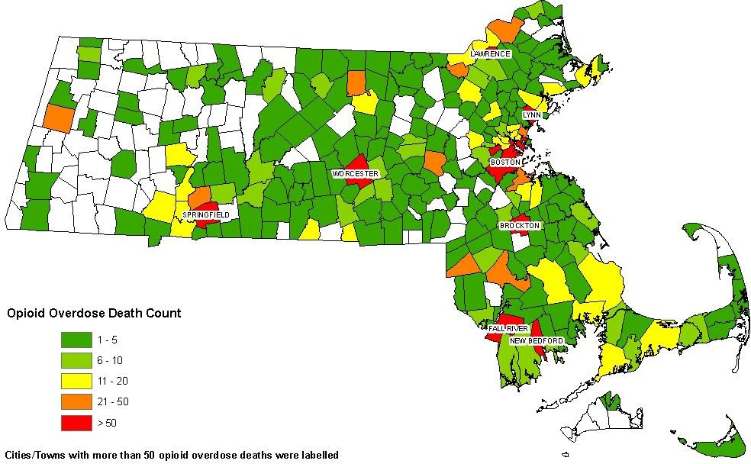
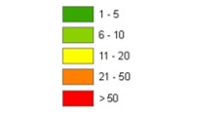
Opioid-Related Overdose Death Count

Cities/Town with more than 50 Opioid-related overdose deaths are labeled

Points to consider:
- The communities with the highest number of opioid-related overdose deaths often represent urban areas.

Opioid-Related Overdose Deaths CY2020 by Community of Residence
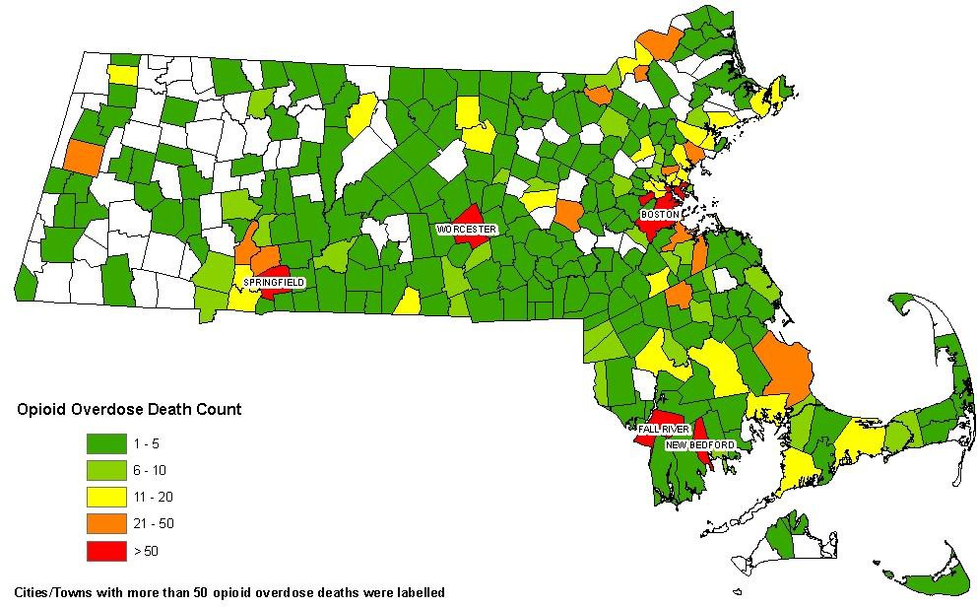
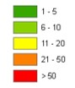
Opioid-Related Overdose Death Count

Cities/Town with more than 50 Opioid-related overdose deaths are labeled

Points to consider:
- The communities with the highest number of opioid-related overdose deaths continue to represent larger urban communities.
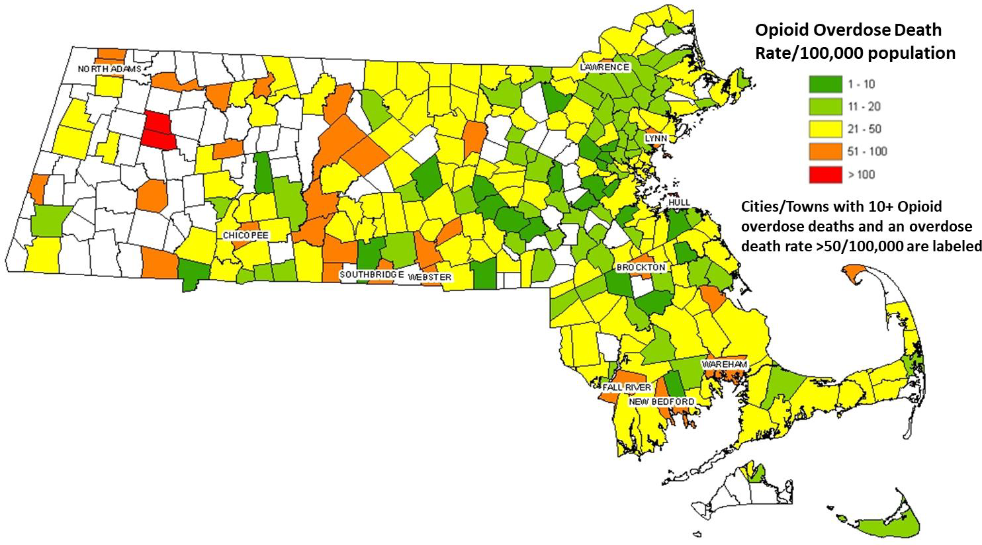
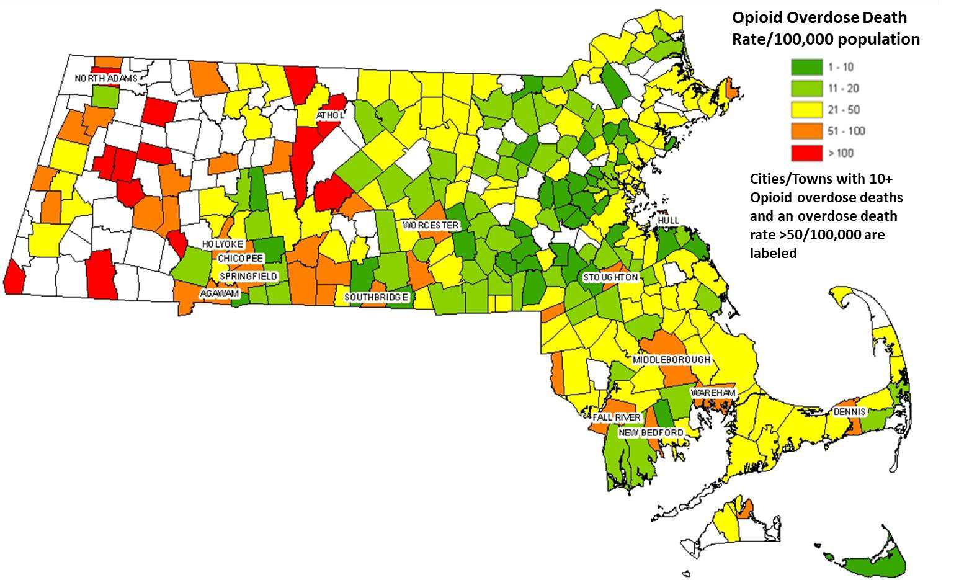

Comparison of Rates of Opioid-Related Overdose Deaths per 100,000 population: CY2019 - CY2020

2019 Opioid-Related Overdose Death Rates per 100,000 Population

2020 Opioid-Related Overdose Death Rates per 100,000 Population

Opioid-Related Overdose Deaths: Change Between 2019-2020

- The list of communities with high number of overdose deaths remain the same from CY2019 to CY2020 with some communities experiencing modest changes while others experienced more significant changes.

- Opioid-related overdose deaths in the city of Boston went up significantly from 173 to 245 deaths while others such as Lawrence went down from 55 to 37 deaths.

- More communities in Western MA show up with higher rates in CY2020 than in CY2019.

- Rolled up to the county level, Hampden and Berkshire have the highest opioid overdose death rates followed up by Bristol, Suffolk and Barnstable.

Opioid-Related Overdose Deaths by Community of Incidence and Race

Black, Non-Hispanic Opioid-Related Overdose Deaths by Community where Incident Occurred, 2020

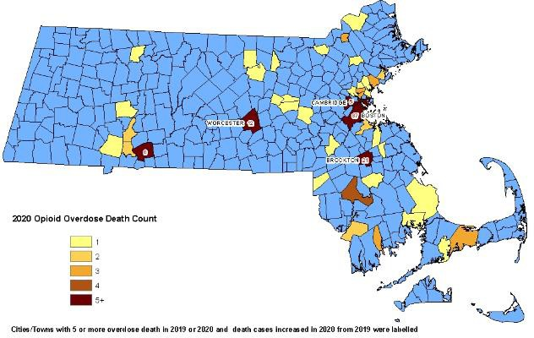
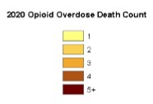
Cities/Towns with 5 or more overdose
deaths and an increase in deaths between
2019 or 2020 are labeled.
.

Hispanic Opioid-Related Overdose Deaths by Community where Incident Occurred, 2020
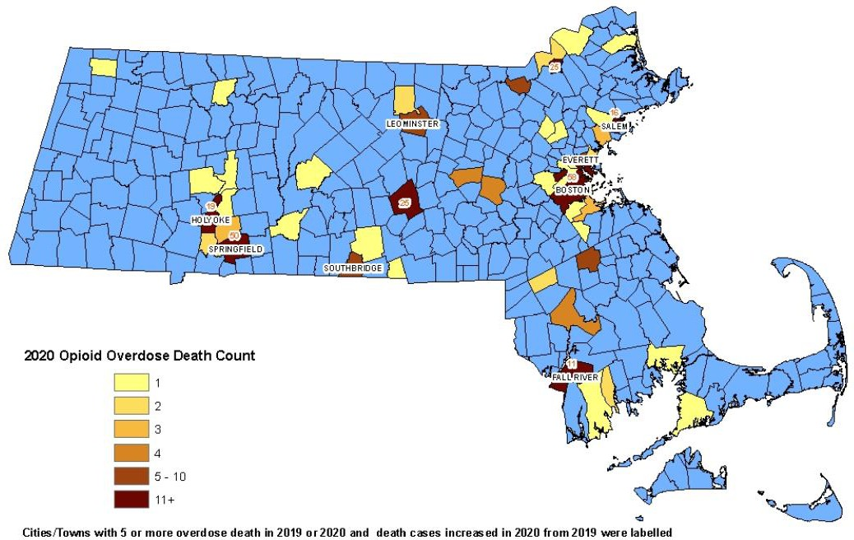

Cities/Towns with 5 or more overdose deaths and an increase in deaths between 2019 or 2020 are labeled.

Change between 2019 and 2020 in Opioid-Related Overdose Deaths by Community of Incidence and Race

City/Town | Overall |  | %  Change | Black, Non Hispanic |  | %  Change | Hispanic |  | %  Change | White/ Other |  | % Change
 | 2019 | 2020 |  | 2019 | 2020 |  | 2019 | 2020 |  | 2019 | 2020
Boston | 258 | 311 | 21% | 51 | 87 | 71% | 52 | 58 | 12% | 155 | 166 | 7%
Brockton | 63 | 80 | 27% | 10 | 21 | 110% | 6 | 6 | 0% | 47 | 53 | 13%
Worcester | 144 | 125 | -13% | 7 | 12 | 71% | 26 | 25 | -4% | 111 | 88 | -21%
Springfield | 103 | 114 | 11% | 10 | 8 | -20% | 31 | 50 | 61% | 62 | 56 | -10%
Overall for MA | 2010 | 2037 | 1% | 123 | 190 | 55% | 269 | 297 | 10% | 1618 | 1550 | -4%

Opioid-Related Overdose Incidents Responded to by EMS by Community Where Incidents Occurred

Opioid-Related Overdose Incidents by Community Where Incidents Occurred

- The following four maps show Opioid-related overdose incidents by community where the incident occurred for CY2019 and CY2020 by:
  - Actual counts of overdose incidents
    - Towns with over 500 incidents are labeled
    - Rates per 100,000 population
    - Cities/Towns with 500+ Opioid Overdose Cases and a rate greater than 500/100,000 are labeled

- Data for Opioid-related overdoses incidents were sourced from the 2021 Q1 Opioid Overdose Quarterly Report

Opioid-Related Overdose EMS Incidents CY2020 by Community where Incident Occurred
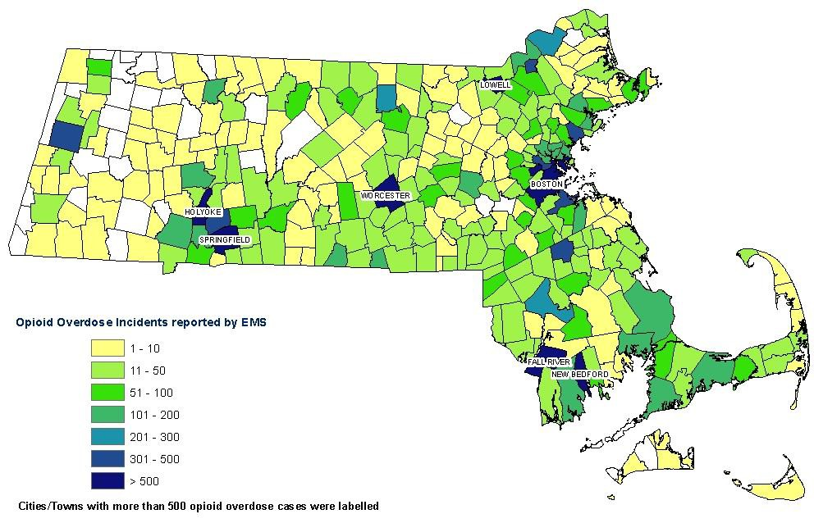
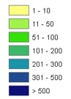
Opioid-Related Overdose Incidents

Cities/Towns with more and 500 Opioid-related overdose cases are labeled

Points to consider:
- While it is noteworthy that overall number of calls decreased in C2020, there are communities that experienced an increase, several of which were located in the western part of the State.

Opioid-Related EMS Overdose Incident Rates CY2020 by the Community where Incident Occurred

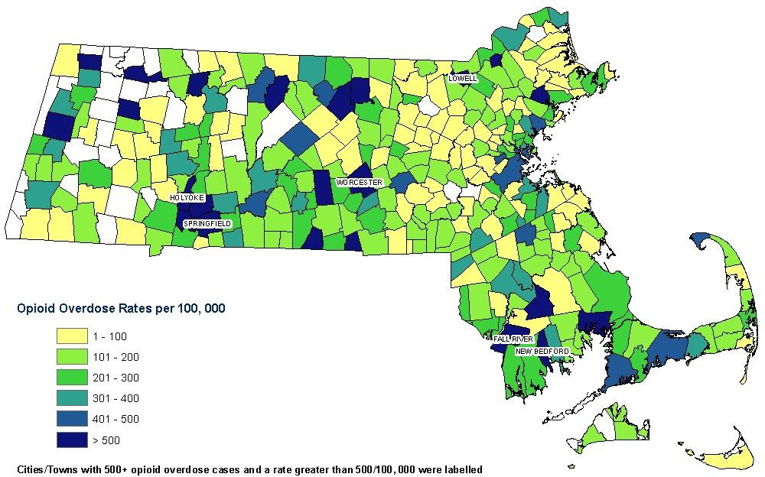
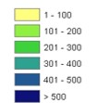
Opioid-Related Overdose Rates per 100,000

Cities/Towns with 500+ Opioid Overdose Cases and a rate greater than 500/100,000 are labeled

Points to consider:
  - Similar to counts, in CY2020 more communities in the Western part of the state reported higher rates of EMS calls as compared to CY2019.

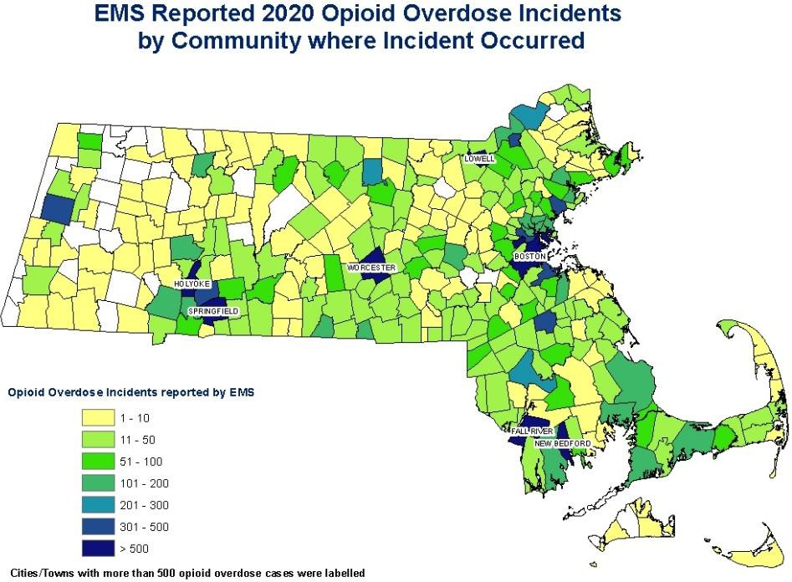
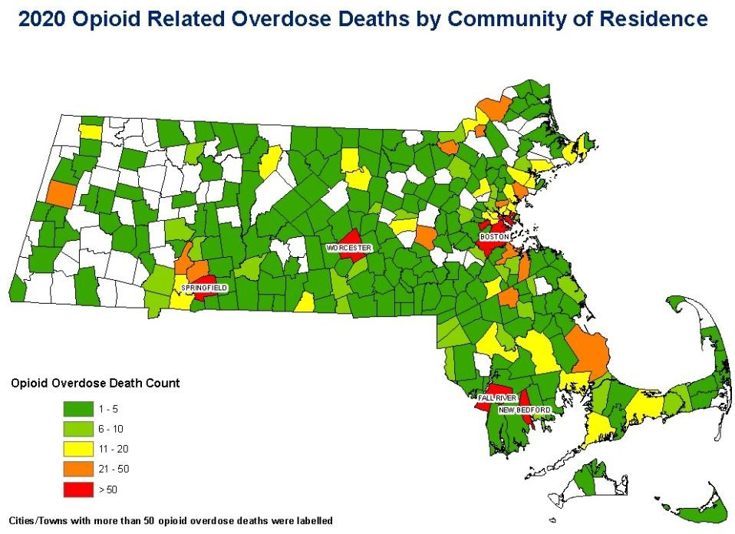

Opioid-Related EMS Overdose Incident Calls and Opioid-Related Overdose Deaths - CY2020

Opioid-Related Incident Calls Opioid-Related Overdose Deaths

Points to consider:
- There is an observed relationship between the total number of EMS calls and overdose deaths within each community, in spite of the EMS calls being based on the community of incident and the overdose deaths being reported by community of residence.

Opioid-Related Overdose Incidents and Death Rates, CY2020

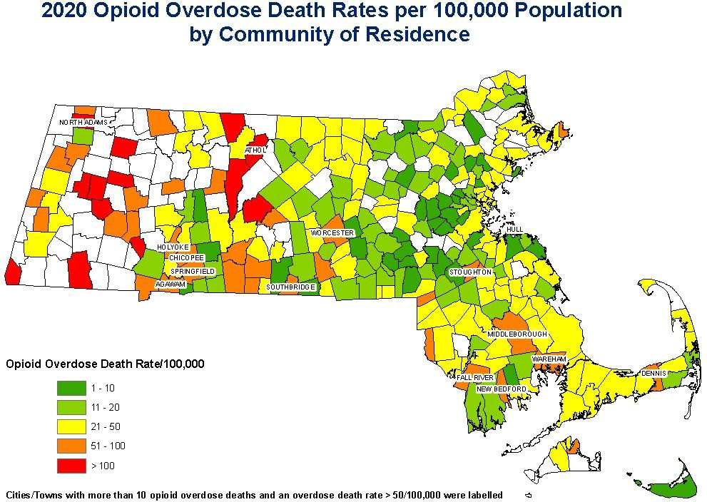
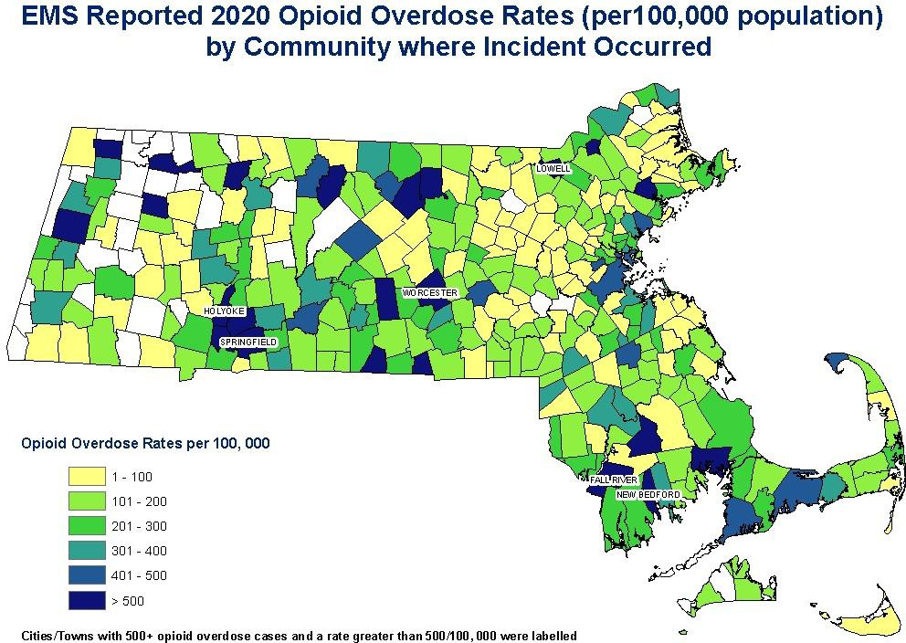
Points to consider:
Opioid-Related Incident Rates
per 100,000 population
Opioid-Related Overdose Death Rates
per 100,000 population
  - Here also we see a relationship between areas of the state that reported high overdose death rates and overdose-related EMS calls, but using this map it is difficult to determine which communities had comparable calls in comparison to their overdose deaths

Distribution of Opioid Addiction Treatment Providers by City/Town
Funded and/or Licensed by the Bureau of Substance Addiction Services

Distribution of Opioid Addiction Treatment Providers
Funded and/or Licensed by the Bureau of Substance Addiction Services

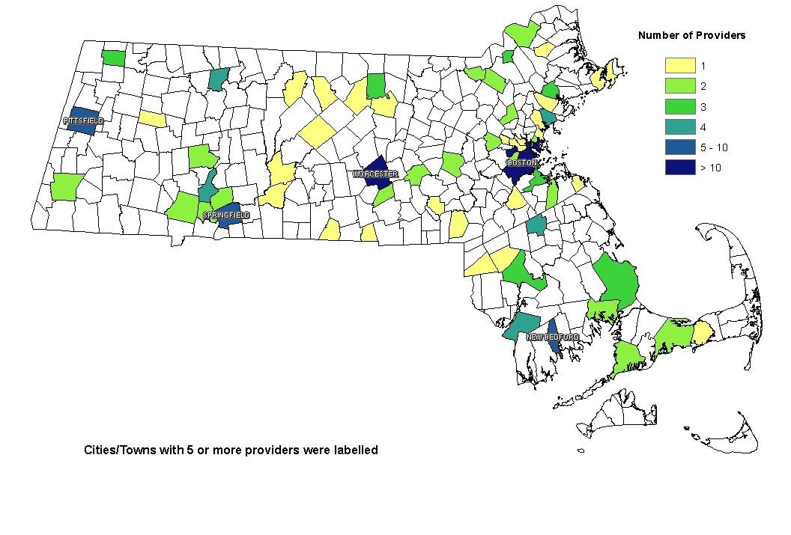
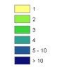
Number of Providers

Cities/Towns with 5 or
more providers are labeled

*Includes OTP, OBOT, OUCC/CTM/TAT
and SAMHSA certified inpatient (ATS) providers

Utilizations of Substance Addiction Treatment Services by Community of Client Residence

Bureau of Substance Addiction Services Treatment Data

- Admissions records are from Bureau of Substance Addiction Services licensed and/or -funded substance addiction treatment programs only.
- “Admissions” refer to the number of new enrollments to
substance addiction treatment services during the calendar year.

- CY2020 utilization rates decreased as compared to previous years due to COVID-19 restrictions. CY2019 data were used for generating the utilization maps.
- Rates were calculated using 2019 Census data.

Source: Treatment statistics prepared by the Office of Statistics and Evaluation, Bureau of Substance Addiction Services, Massachusetts Department of Public Health on 6/1/2021 with data as of 4/30/2021.

Admissions for Patients with Opioid Use Disorder into BSAS Funded/Licensed Substance Addiction Treatment Programs, CY2019

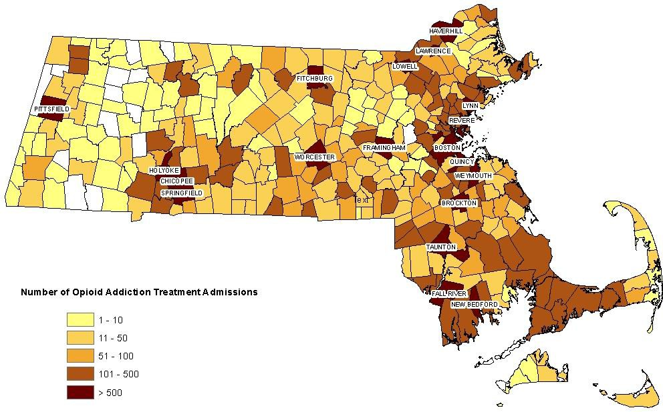
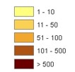
Number of Opioid Addiction Treatment Admissions

Cities/Towns with over 500 Opioid Addiction treatment admissions are labeled

Admissions are based on a client’s residence.

Rates of Admissions for Patients with Opioid Use Disorder into BSAS Funded/Licensed Substance Addiction Treatment Programs, CY2019

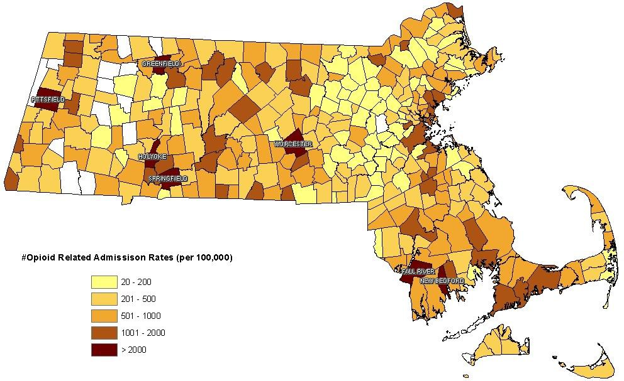
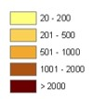
Opioid Related Admission Rate per 100,000 population

Cities/towns that had admission rates of 2000+/100,000 population are labeled

Distribution of DEA Waivered Providers and Number of Prescriptions by County

Distribution of DEA Waivered Providers Who Prescribe Buprenorphine for Substance Use Disorder

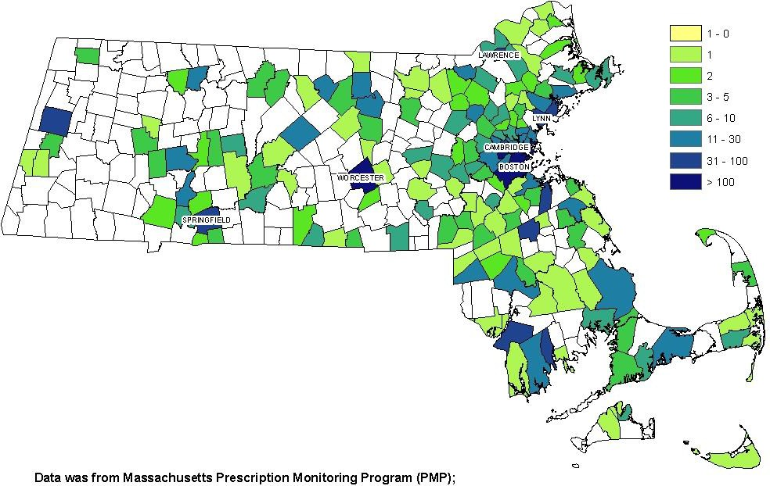
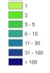
Number of Providers

Cities/Towns with 50+ providers are labeled

Source: Data provided by Prescription Monitoring Program, Bureau of Health Professions Licensure, as of June 3, 2021.

Prescriptions for Buprenorphine for Addiction Treatment, Counts and Rates by County

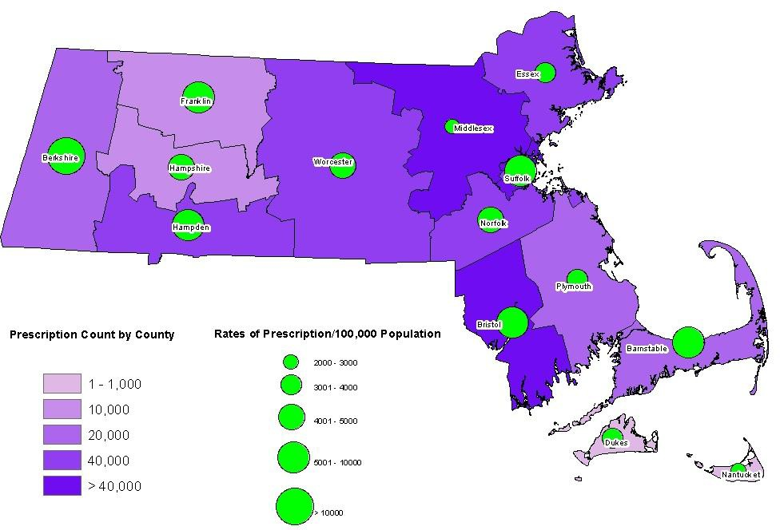
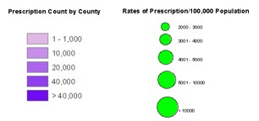

Source: Data provided by Prescription Monitoring Program, Bureau of Health Professions Licensure, as of June 3, 2021.
Prescriptions are by the provider’s county and include data from January 1- June 3, 2021.

Utilization of Opioid Addiction Treatment Services and Opioid Overdose-Related Deaths

by Community of Residence

Utilization of Opioid Addiction Treatment Services and Opioid Overdose Deaths by Community of Residence

The following slides show Opioid-Related Overdose Deaths by community of residence overlayed by Utilization of Opioid Addiction Treatment Services

Sources:
  - Data for overdose deaths were sourced from the 2021 Q1
Opioid Overdose Quarterly Report
  - Treatment statistics prepared by the Office of Statistics and Evaluation, Bureau of Substance Addiction Services, Massachusetts Department of Public Health on 6/1/2021 with data as of 4/30/2021.

Opioid Addiction Treatment Admissions CY2019 and Opioid Overdose Deaths by Community of Residence CY2020
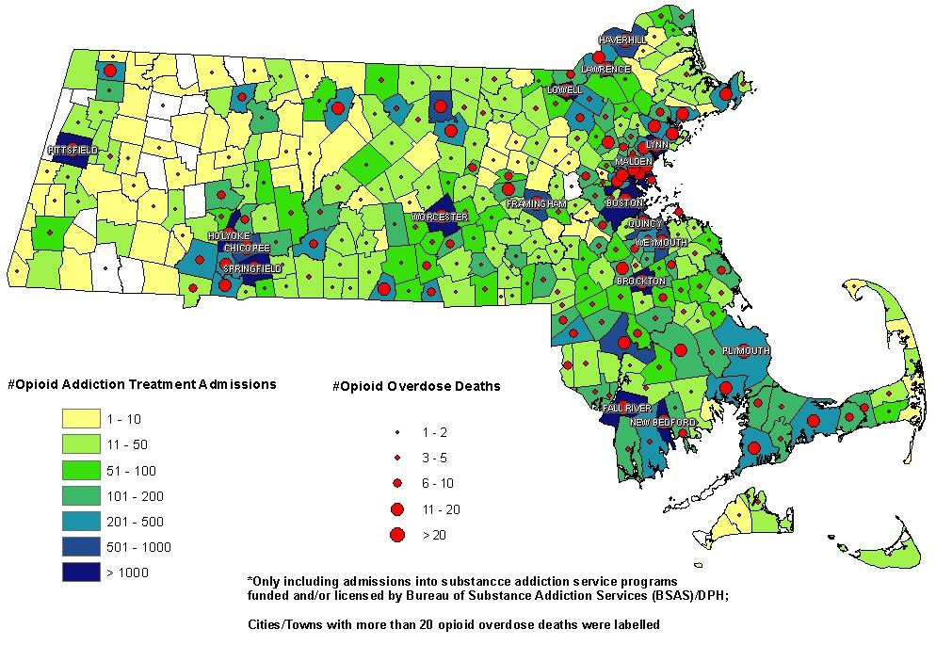

Opioid Addiction Treatment Admissions
Opioid-Related Overdose Deaths

Cities/Towns with 20+ Opioid
Overdose Deaths were labeled

nce Addiction Service Programs funded and/or licensed by the Bureau of Subs

- Includes admissions into Substa tance Addiction Services, DPH

Opioid-Related Treatment Admission Rates and Opioid-Related Overdose Death Rates by Community of Residence, CY2019
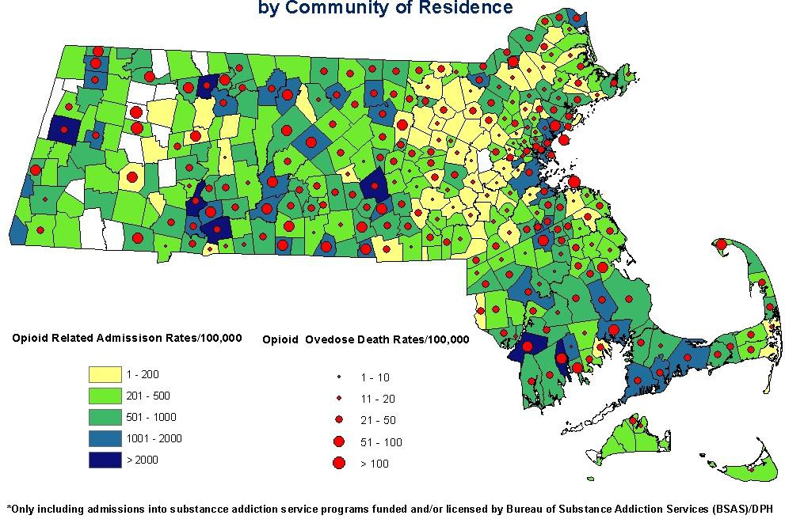
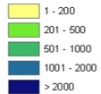
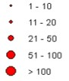

Opioid Related Admission Rates/100,000
Opioid Overdose Death Rates/100,000

Next Steps and Caveats

  - Caveats
    - Treatment data from providers without a BSAS contract not included in the utilization maps
    - OTP data is incomplete due to capacity and/or structural issues
  - Other Data Capabilities
    - Further analysis of treatment utilization and overdose deaths by
race/ethnicity
    - Access to additional utilization data from other sources
    - County level analysis and maps
    - Develop an indicator based framework that incorporates additional and more complete addiction treatment data to systematically identify gaps in the utilization by county
  - Future Steps
    - Collecting Distance to OTP treatment through Central Registry to identify gaps in OTP services

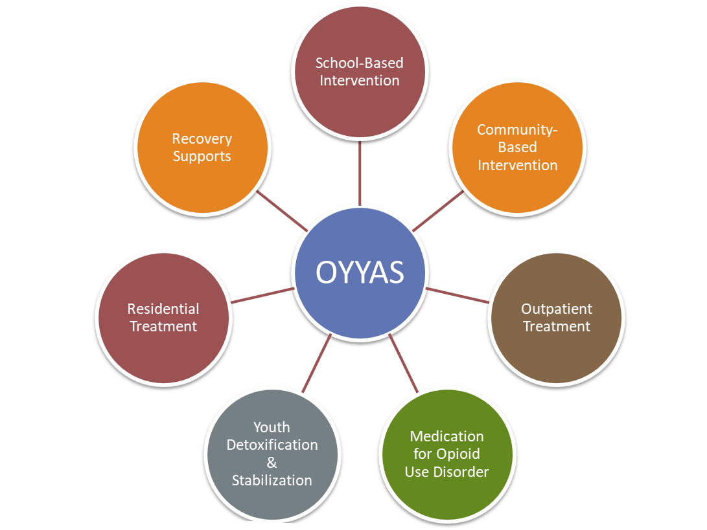

The BSAS Office of Youth & Young Adult Services
  - Offers a full continuum of services including Community & School-based Intervention, Outpatient Treatment, Residential Services and Recovery Supports for Youth and Young Adults (8-26).
  - Mission: To promote personal and family growth by ensuring youth and young adults experiencing substance use and co-occurring disorders have access to developmentally appropriate, culturally responsive, trauma- informed services and supports.

In June 2019, BSAS released Opioid Use Among Adolescents & Young Adults: Toolkit for Pediatric & Primary Care Providers.
34
  - This toolkit was developed specifically for pediatric, primary care, and other health professionals treating adolescents and young adults within their medical practice. This document is currently being updated to include new regulations and protocols.
  - https://massclearinghouse.ehs.state.ma.us/P ROG-BSAS-YTH/SA5829.html

At the same time, BSAS and its supporting partners drafted and released the MAT Practice Guidance Summary.
  - The aim of this document is to enable service providers at all levels to better engage, retain, and support adolescents (ages 16-17) in the treatment process.
  - https://massclearinghouse.ehs.state.ma.us/P
ROG-BSAS-YTH/SA5843.html

