Updating address information in ESM when there is an existing address

- Select [Client] Module.
- Search for client using [ID/ID Type] or [Last Name/First Name].
- From the Search Results, select the Client by clicking on [Last Name] link.
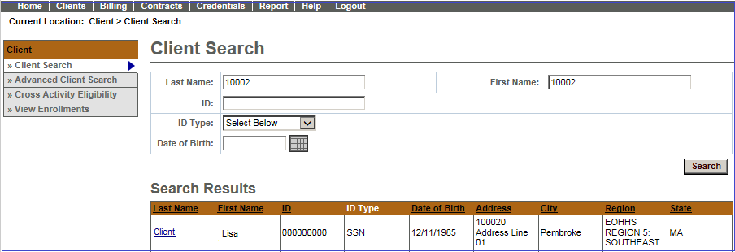
- From the Client Face Sheet Summary, select [Personal Info] from left navigation menu.
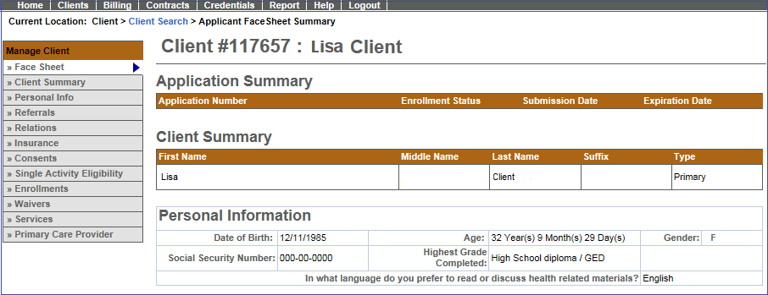
- The Addresses page will display all addresses for that client.
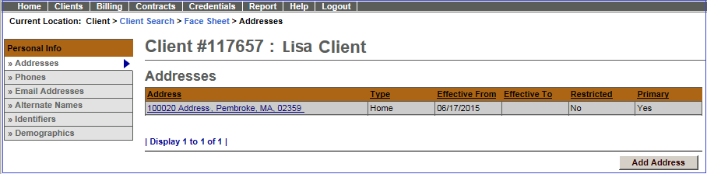

Notes:
- If the address listed is correct, no additional data entry is required.
- If the current address listed is not correct, a new address record will need to be added. Before adding the new address, the current address needs to be closed.
  - Select current record and fill-in Effective To date to close before adding new address.
- If a new address record is needed, select [Add Address] button. See ESM Client Data Entry Transaction Steps (BSAS) Job Aid for steps on adding a client to ESM. When adding a new address, never select existing address and overwrite the existing address. The previous address record will be lost.

Adding a New Address
- Select [Address Type] from drop-down menu.

Note:

If the client is homeless, select ‘Homeless’ as Address Type
  - You will leave the street address blank, but a City and Zip code must be included
  - The address of the facility should never be used as a client’s address
- Enter Address Information (Address Line 1; Address Line 2, if necessary; City)
  - State defaults to MA for Massachusetts
  - A selection of area Zip codes will be generated; Choose the correct one for the client
  - County listing will be generated automatically
- Check the [Primary Address] Flag
  - If you do not select that the address is primary, you will be prompted for an address when you go to enroll the client. This is to ensure that the client has a primary Massachusetts residence.
- Enter [Effective From:]; usually matches enrollment date of client into program.
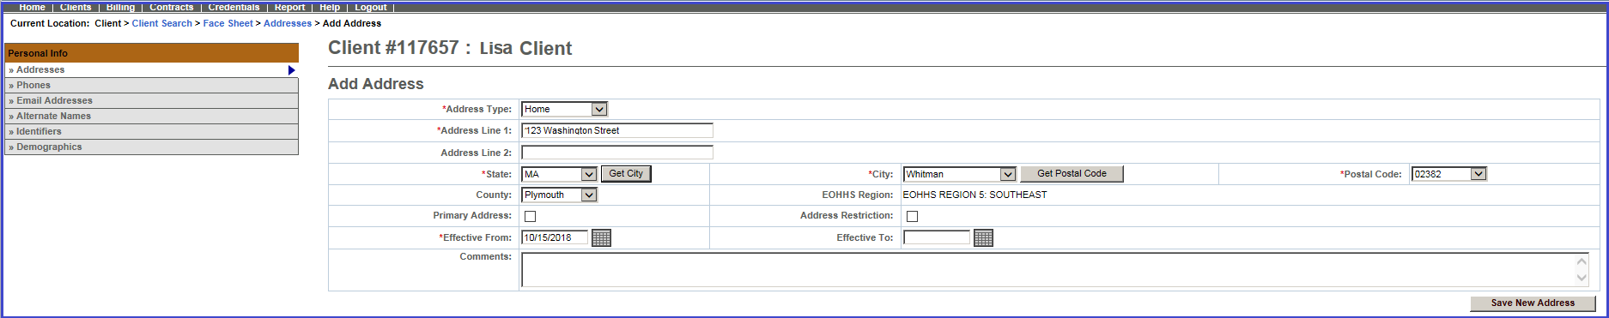

- Click [Save New Address] button
ESM returns you to the Addresses page and displays the new address in the results listing.
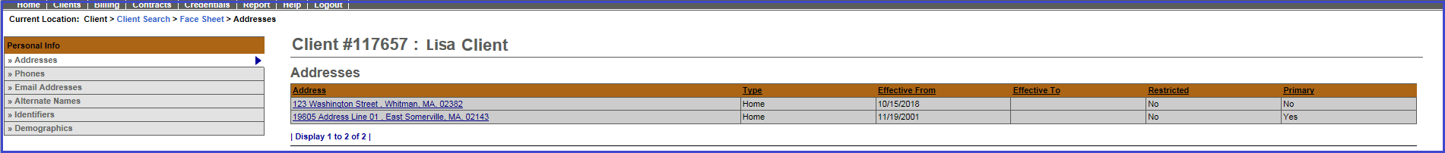
For system and access questions call:

Virtual Gateway Customer Service (www.Mass.Gov/vg): 1-800-421-0938
For program policy or data forms questions call:
DPH Resource Center: 1-800-232-0093

