*** Important Reminders Concerning Insurance Records in ESM ***
- There can only be one active insurance record per client. It is important for all past insurances to have an end date. If an Insurance record does not have an end date, EIM will consider it active and may reject any billing to DPH.
- There must not be any overlap in Insurance dates.
- No insurance record should ever be overwritten, unless you have entered an error and are making a correction.
- The original data cannot be restored once an overwritten record has been saved.

Closing Insurance Records when there are Multiple Open Records

- Select [Client] Module.
- Search for client using [ID/ID Type] or [Last Name/First Name].
- From the Search Results, select the Client by clicking on [Last Name] link.
- From the Client Face Sheet Summary, scroll down to Insurance section.
- Identify insurance record(s) that need to be ‘Closed’ with ‘Effective To’ date
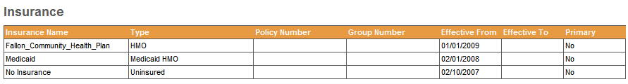
- Select [Insurance] from left-hand navigation menu.
- Click on the [Insurance Name] link that needs the Effective To date filled in.
Note: All insurance records will display, but note that the Effective From date does not display on this page.

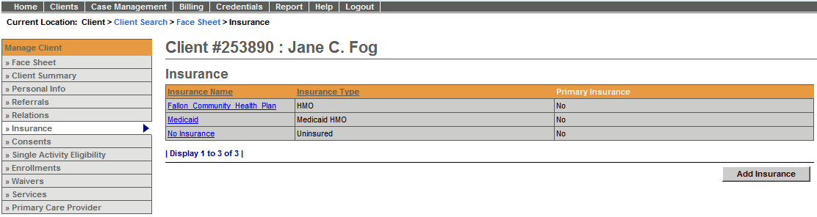
- Fill in the [Effective To] date to close this record. (Note: The insurance must be closed out with a date prior to when the new Insurance begins.)

For example:

Insurance Name | Effective From | Effective To
Fallon Community Health Plan | 01/01/2009
Medicaid | 02/01/2008 | 12/31/2008
No Insurance | 02/10/2007 | 01/31/2008
- Select [Save Changes] button.

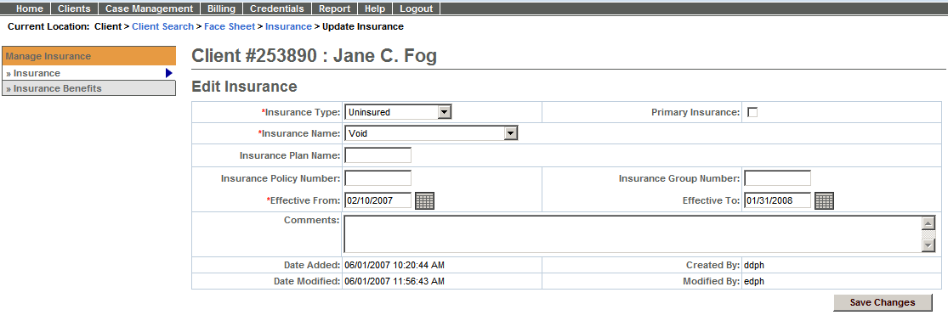

Adding a New Insurance Record if there is no Pre-existing Record
- Select [Client] Module.
- Search for client using [ID/ID Type] or [Last Name/First Name].
- From the Search Results, select the Client by clicking on [Last Name] link.
- From the Client Face Sheet Summary, select [Insurance] from left-hand navigation menu.
Note: A blank screen will display with message in red that says ‘No Insurance Information Found. Please add insurance.
- Click [Add Insurance] link.
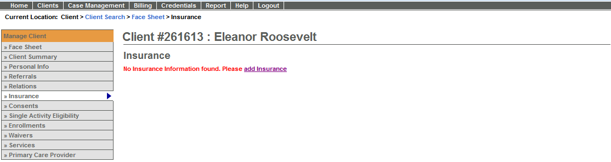
- Select ‘Insurance’ Type from drop-down menu (Note: If the Client has no insurance select ‘Uninsured’ from drop-down menu.)

Definitions of Insurance Type Codes Listed in Table
Insurance Type Codes
Code Value | Description
Uninsured | Uninsured
AP | Auto Insurance Policy
C1 | Commercial
CP | Medicare Conditionally Primary
GP | Group Policy
HM | Health Maintenance Organization (HMO)
IP | Individual Policy
LD | Long Term Policy
LT | Litigation
MB | Medicare Part B
MC | Medicaid
MI | Medigap Part B
MP | Medicare Primary
OT | Other
PP | Personal Payment (Cash - No Insurance)
SP | Supplemental Policy

- Select [Insurance Name] (Note: Not needed if client is uninsured.)
- Check box if the insurance being entered is the [Primary Insurance] (Note: There must be one primary insurance on file per client.) (Note: the system will not allow you to select an “Uninsured” record as primary.)
- Type in [Insurance Plan Name*].
- Type in [Insurance Policy Number*].
- Type in [Insurance Group Number*].
- Type in [Effective From] date.
- Leave [Effective To] date blank if the insurance is active.
- Select [Save New Insurance] button.
*If this information is not available, the record can still be saved.

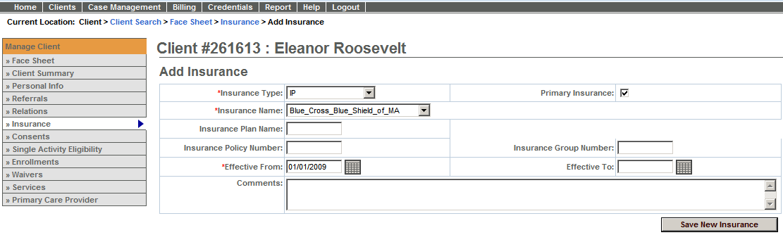
For system and access questions call:
Virtual Gateway Customer Service (www.Mass.Gov/vg): 1-800-421-0938
For program policy or data forms questions call:
DPH Resource Center: 1-800-232-0093

