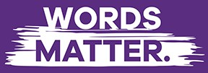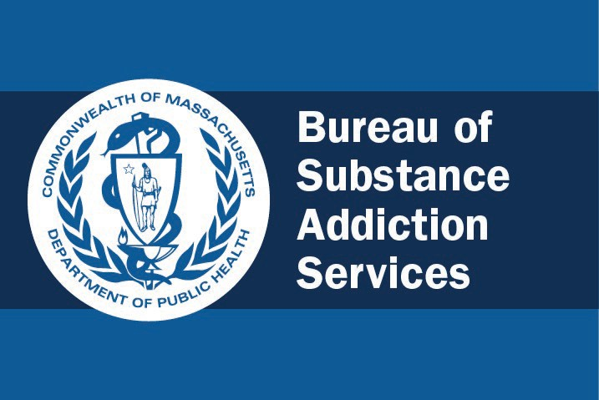What we say and how we say it makes a difference to the people and communities we serve.

At BSAS, one of our core values is **compassion and positive regard** for others in all our efforts. It is at the foundation of our mission to support accessible, effective, and culturally responsive prevention, intervention, treatment, harm reduction, and recovery support principles, programs and practices. This core value should be reflected in the language we use to communicate about the people and communities we serve.

Our words have impact. Language frames what the public thinks about substance use and recovery. It can also affect how individuals, groups, and families think about themselves and intentionally or unintentionally propagate stigma.

Massachusetts is recognized as a leader in the field of substance use services. Innovative resources are available across the Commonwealth, supported by BSAS staff who demonstrate commitment to our shared vision of health and wellness for every individual, family, and community.

One way we can all commit to the BSAS mission and continue to lead this work is by being mindful about the words we use about substance use, both formally through messaging and policies, and informally in conversations with colleagues, providers, and community. This means staying aware of evolving language shifts to model appropriate and accurate terminology and supporting efforts to educate and change the negative attitudes and beliefs that lead to stigma and discrimination. It also means recognizing that while people may use different terms depending on their surroundings or reclaim language, as public servants we are responsible for modeling this culture shift.

**Why is this so important?** Stigmatizing language discourages people from reaching out for help, which can have fatal consequences. People struggling with problematic relationships with substances and their loved ones face discrimination and barriers to getting support.

Stigma can:

* Lead a person to avoid getting help because they are afraid of judgment or negative consequences with work, their loved ones, parental rights, social services, or the law.
* Cause a person to hide their alcohol or drug use, or to use alone.
* Affect a person's ability to access or maintain housing, employment, or education, which impacts their health, wellness, and quality of life.
* Contribute to people who use substances receiving a lower quality of healthcare and experiencing challenges accessing services.

Stigma is not only experienced by those using substances. It has a lasting impact on individuals in recovery, families, and those who support them, both internalized and through continued experiences of discrimination and devaluing attitudes.

When we use non-stigmatizing language in our policies and interactions it serves as a model for others, ensures alignment and accuracy in communicating our goals, and positively changes health-related public norms. We can make it easier to get support by letting people know they are not being judged and that substance use does not define who they are.

As we prepare to celebrate National Recovery Month, the Massachusetts Bureau of Substance Addiction Services commits to the following Words Matter pledge. We further commit to using non-stigmatizing

language in our work, correcting outdated or harmful language in our documents, incorporating the voices of people with lived and living experience (PWLLE) into our decision making, and adjusting our practices as language evolves. These important steps toward our goal of creating a stigma-free Commonwealth are concrete ways that, together, we can show our leadership at this critical time.

**BSAS Words Matter Pledge**

At the Massachusetts Bureau of Substance Addiction Services, we believe that the language used to communicate about substance use is important. Using affirming language helps decrease stigma that can harm people. We pledge to treat all people with compassion, dignity, and positive regard and to respect personal choices, including the language people use to define their substance use or recovery. We believe that words matter, and we pledge to be leaders in reducing stigma by using language that is appropriate and accurate. We pledge to educate others about the use of stigmatizing language wherever it occurs - including in policies, regulations, and guidance as well as in verbal communication with colleagues, providers, and public relations.

This pledge and the following table were developed in partnership with BSAS staff and community members holding lived and living expertise, using language adapted from [NIDA’s “Words Matter”](https://nida.nih.gov/nidamed-medical-health-professionals/health-professions-education/words-matter-terms-to-use-avoid-when-talking-about-addiction) [document](https://nida.nih.gov/nidamed-medical-health-professionals/health-professions-education/words-matter-terms-to-use-avoid-when-talking-about-addiction) and other existing resources and by listening to those we serve. We offer these suggestions knowing that language will continue to evolve, and that we do not intend to shame or police anyone’s language or behavior but rather to ground our work in the use of affirming and positive word choices. We also recognize that the first iteration of this pledge and corresponding guidance apply only to those communicating in English, and commit to working with communities speaking other languages to avoid further perpetuation of stigma.

|  |  |  |
| --- | --- | --- |
| **INSTEAD OF...** | **...CONSIDER USING...** | **...BECAUSE** |
| Substance abuser Drug abuser Alcoholic  Addict User Drunk Junkie  High-risk population | Person with a problematic relationship with substances Person with a substance use disorder (if so diagnosed) Substance use  Person using substances Person who uses drugs (PWUD)  Person with living experience Person at high risk of overdose | Person-first language humanizes individuals and indicates that someone may “have” a problem as opposed to them “being” a problem, while labels can define a person by their substance use. It’s important to note that not all people who use substances have a substance use disorder, and these phrases should not be used interchangeably.  Rather, use language specific to the person being discussed. |
| Addicted babies Babies born addicted | Infants with prenatal substance exposure  Children born with substance dependency  Infant exhibiting withdrawal symptoms | Children born to parents using substances or taking medication often face involvement with social or legal services immediately after birth, significantly increasing their own likelihood of challenges later in life. Non-stigmatizing language framed accurately describes the medical situation of these infants instead of  defining them negatively as soon as they are born. |

|  |  |  |
| --- | --- | --- |
| Relapse Chronic relapse | Return to use Recurrence of symptoms | Substance use disorder often includes recurrence of use, and relapse can imply a failure  instead of simply a symptom of a diagnosed medical condition. |
| Substance abuse Drug habit  Drug problem  Substance misuse as a blanket term | Substance use Chaotic use  Risky, unhealthy, or problematic use  Substance Addiction Substance misuse to indicate using prescribed medication other than prescribed | This language inaccurately implies a person is choosing a problematic relationship with substance and can both suggest or more or less serious situation, depending on the individual’s circumstances. |
| Reformed addict or alcoholic Clean or dirty | Person in recovery  Person with lived experience Person with a healthier relationship to substance(s) Abstinent from substance use Not using alcohol or drugs | While some communities have reclaimed stigmatizing language to celebrate recovery, this nuance is not always understood broadly and can be interpreted as ascribing a moral  value to substance use or abstinence. |
| Substitution  Drug replacement therapy (DRT)  Medication Assisted Treatment On methadone or other meds | Treatment or medication for substance use disorder Medication for Addiction Treatment  Medication for Opioid Use Disorder (MOUD) Medication for Alcohol Use Disorder (MAUD)  Medication Supported Recovery Receiving treatment  Opioid agonist or antagonist medication | Accurate medical terminology allows from appropriate care, while words like “replacement” suggest that a person’s relationship to substances has not changed despite them seeking treatment. It is a misconception that medications merely “substitute” one drug for another. |
| Clean or dirty urine Dirty or clean needles | Positive or negative toxicology screening result  Sterile or unsterile syringes and works/injection equipment  New or used syringes and works/injection equipment | Use clinically accurate, non- stigmatizing terminology the same way it would be used for other medical conditions. |
| Drug dealer Prostitute or hooker Criminal or felon Drug court  Crazy | Underground economy  Sex worker or person with lived experience in sex work Sexually exploited person Trafficked person  Person with legal system involvement  Recovery Court  Person with co-occurring mental health conditions | Behaviors sometimes associated with substance use can be criminalized and highly stigmatized, along with use itself; these occupations or activities do not describe who a person is unless they claim the terms as part of their identity. |