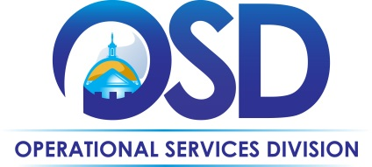

Buy the Way

The Official Newsletter of the Operational Services Division

September 15, 2015

# In This Issue

* Preparing for Emergencies with Statewide Contracts
* FAC85 Statewide Contract Kickoff
* September Training
* MA Supplier Diversity Regional Series
* Upcoming Contract Changes
* September Outreach Events
* Local, Minority, and Women-Owned Supplier Networking Event
* South Shore Round Table

# Preparing for Emergencies with Statewide Contracts

September is [National Preparedness Month](http://www.ready.gov/september), the time designated by the Federal Emergency Management Association (FEMA) to plan for safety in emergencies such as floods, hurricanes, tornadoes, and wildfires. In the Commonwealth, it is essential to include winter preparedness in emergency planning.

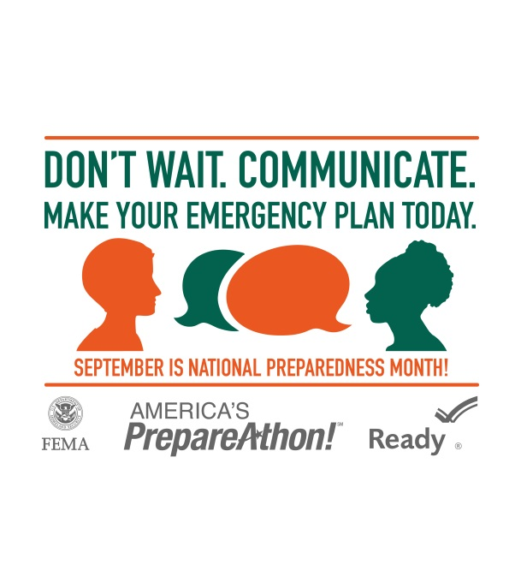

Now that the snow from winter 2015 has finally melted, it is time to start organizing for the upcoming winter season. Fortunately, by ordering from [Statewide Contracts](http://www.mass.gov/anf/budget-taxes-and-procurement/procurement-info-and-res/buy-from-a-state-contract/statewide-contract-user-guides.html), your agency or organization can have the goods and services necessary to weather the storm. To protect from the icy temperatures of winter, it is vital to have proper HVAC system supplies ([FAC76](http://www.mass.gov/anf/docs/osd/uguide/fac76.pdf)), heating oil ([ENE34](http://www.mass.gov/anf/docs/osd/uguide/ene34.pdf)), and portable generators ([FAC76](http://www.mass.gov/anf/docs/osd/uguide/fac76.pdf)). Keep your vehicles stocked with necessities like blankets ([CLT07](http://www.mass.gov/anf/docs/osd/uguide/clt07.pdf)), snow shovels ([FAC76](http://www.mass.gov/anf/docs/osd/uguide/fac76.pdf)), and ice scrapers ([FAC76](http://www.mass.gov/anf/docs/osd/uguide/fac76.pdf)). To recover from snowstorms, be sure to order snow removal supplies and equipment, such as road salt ([VEH95](http://www.mass.gov/anf/docs/osd/uguide/veh95.pdf)), de-icing chemicals ([FAC76](http://www.mass.gov/anf/docs/osd/uguide/fac76.pdf)), and snow blowers ([FAC88](http://www.mass.gov/anf/docs/osd/uguide/fac88.pdf)), or use snow removal services ([FAC77](http://www.mass.gov/anf/docs/osd/uguide/fac77.pdf)).

During other weather-related emergencies, there are a number of essential items to have available, including public safety equipment and supplies ([FIR04](http://www.mass.gov/anf/docs/osd/uguide/fir04.pdf)), batteries ([FAC76](http://www.mass.gov/anf/docs/osd/uguide/fac76.pdf)), and bottled water ([GRO34](http://www.mass.gov/anf/docs/osd/uguide/gro34.pdf)). Services such as tree removal ([FAC77](http://www.mass.gov/anf/docs/osd/uguide/fac77.pdf)) and IT disaster recovery ([ITT46](http://www.mass.gov/anf/docs/osd/uguide/itt46.pdf)) also may be imperative during an emergency. This fall, keep an eye on [OSD’s website](http://www.mass.gov/anf/budget-taxes-and-procurement/oversight-agencies/osd/strategic-sourcing-services.html) and [Twitter](https://twitter.com/Mass_OSD) for an updated and comprehensive Emergency Response Reference Guide to aid in buying on [COMMBUYS](http://www.commbuys.com/) and with Statewide Contracts.

To stay informed throughout National Preparedness Month, follow [@Readygov](http://www.twitter.com/Readygov) and [@PrepareAthon](http://www.twitter.com/PrepareAthon) on Twitter, and use the hashtag [#NatlPrep](https://twitter.com/search?q=natlprep&src=typd) to join the conversation. [FEMA’s business page](http://www.ready.gov/business) boasts several workplace resources, such as risk- and needs-assessment tools. Similarly, the Small Business Administration has aggregated [a list of resources](https://www.sba.gov/content/disaster-preparedness), including tips and checklists for each type of weather-related emergency. Also, check out the [website](http://www.mass.gov/eopss/agencies/mema/), [Facebook](https://www.facebook.com/MassachusettsEMA), [Twitter](https://twitter.com/MassEMA), and [YouTube](https://www.youtube.com/user/MassachusettsEMA) pages of the [Massachusetts Emergency Management Agency (MEMA)](http://www.mass.gov/eopss/agencies/mema/) to learn how to plan better with the Ready Massachusetts emergency preparedness initiative. Finally, download the MEMA-developed app called [Massachusetts Alerts](http://www.mass.gov/eopss/agencies/mema/massachusetts-alerts.html), which will send emergency alerts, as well as information about public safety incidents and disasters, to your phone.



# FAC85 Statewide Contract Kickoff

Within OSD, the [Massachusetts Environmentally Preferable Products (EPP) Procurement Program](http://www.mass.gov/epp/) works to integrate environmentally preferable specifications into Statewide Contracts to help conserve natural resources, reduce waste, protect public health, and promote the use of clean technologies, recycled materials, and less toxic products. As part of this program, the all-green Statewide Contract [FAC85](http://www.mass.gov/anf/docs/osd/uguide/fac85.pdf) was established for Environmentally Preferable Cleaning Products, Programs, Equipment and Suppliers. With more than 6,600 products and 15 vendors, the contract offers an extensive selection of options to implement a green cleaning program. This month, OSD will welcome the buyer and vendor communities to the [FAC85 Statewide Contract Kickoff](http://www.fac85.eventbrite.com/)!

At this exciting event, an expert group of presenters will give insight on their experiences with FAC85. Julia Wolfe, Director of Environmental Purchasing for OSD, and Lana Gunaratne, Contract Manager, will speak about the benefits of the contract, provide tips on purchasing from [COMMBUYS](http://www.commbuys.com/), and address frequently asked questions about [FAC85](http://www.mass.gov/anf/docs/osd/uguide/fac85.pdf). Attendees also will hear from Heidi Wilcox of the Toxics Use Reduction Institute, a green cleaning laboratory at the University of Massachusetts Lowell that works with many state departments on their green cleaning programs. Richard Scott from the Department of Conservation and Recreation will share his experience on how green cleaning products from the [FAC85](http://www.mass.gov/anf/docs/osd/uguide/fac85.pdf) contract have improved public safety at Bradley Palmer State Park. Finally, Ken Wertz from the Massachusetts Facilities Administrators Association will illuminate the advantages of using green cleaning products in schools across the Commonwealth.

Confirmed attendees include the Division of Local Services and the Office of Technical Assistance and Technology, in addition to two third-party certifiers: the EPA Safer Choice Program and GreenSeal. Third party certification is a requirement for many of the chemicals on the contract. Additionally, Environmentally Preferable Janitorial Services ([FAC81](http://www.mass.gov/anf/docs/osd/uguide/fac81.pdf)) contractors have been invited to attend so that attendees may have the opportunity to network with vendors from a complementary contract. You won’t want to miss this event. To register for the kickoff, click [here](http://www.fac85.eventbrite.com/).

Follow us on [Twitter](http://www.twitter.com/Mass_OSD) and use #greenclean to join the conversation. For questions about the event, email [osd-events@state.ma.us](mailto:osd-events@state.ma.us).

## Why should you attend the FAC85 Kickoff?

1. Hear buyer testimonials
2. Access resources to transition to a green cleaning program
3. Speak with FAC85 vendors about green products and services
4. Get tips for purchasing from FAC85in [COMMBUYS](http://www.commbuys.com/)

## [Event Details](http://www.fac85.eventbrite.com/)

Date Friday, September 25

LocationState Transportation Building

10 Park Plaza, 2nd Floor

Boston, MA

### Agenda

9:30 a.m. Vendor Set-up

10:30 a.m. Vendor Contract Overview

11:00 a.m. Buyer Registration& Networking

11:30 a.m. Buyer Meeting

12:15 p.m. Networking

## Tips for Transitioning to a Green Cleaning Program

If your organization has not implemented a green cleaning program, the contracted vendors can help you to establish one. Here are some tips to finding a program/vendor that will work with you:

* There are 15 vendors on the FAC85 contract. Talk with more than one vendor; ideas and services can vary.
* Ask for references.
* Check their green program – inquire about the quality of their staff, training capabilities, etc.
* Ask how they conduct the FREE facility assessment and what this entails.
* Identify the vendor expertise in choosing comparable products.
* Ask to “pilot” products in areas of concern.
* Filter and peruse the “FAC85 Approved Products List” in the Master MBPO.

[Click to download the Environmentally Preferable Products & Services Guide](http://www.mass.gov/anf/docs/osd/epp/vol-39-july-2014.docx)

# September Training

To register, please see the full [Training calendar](http://www.mass.gov/anf/budget-taxes-and-procurement/procurement-info-and-res/osd-training-events-and-outreach/osd-event-calendar.html) unless noted otherwise. Dates are subject to change as courses are added or removed through September.

* COMMBUYS Enhancements: Organization Administrators Readiness
  + September 18, 29 (Webinar)
* Bids with Open and Rolling Enrollments
  + September 16, 18, 22 (Webinar)
* Release RPAs for Statewide Contract Purchases
  + September 17, 21, 24 (Webinar)
* COMMBUYS Organization Administrator Training
  + September 30
* COMMBUYS Purchasing Training
  + September 30
* COMMBUYS Procurement Training
  + September 24
* COMMBUYS Receiving
  + September 16, 17, 22, 29 (Webinar)
* How to Create a Departmental MBPO
  + September 21
* How to Use MBPOs
  + September 25 (Webinar)
* Essentials of State Procurement
  + September 18
* How to Use Statewide Contracts/MBPOs
  + September 28
* Connecting Your Business to the Commonwealth
  + September 16 (New Bedford)
  + [Register here](https://www.sdo.osd.state.ma.us/WorkShop/xwrk_reg.aspx?workshopid=27&sessionid=2491)
* COMMBUYS How to Locate and Respond to Bids
  + September 17 (Webinar)
* COMMBUYS Essentials of Navigation, Searching and UNSPSC
  + September 18
* Basic Supplier Diversity Plan Overview
  + September 22 (Webinar)
* SDO Pre-Certification Session
  + September 25 (Boston), 30 (New Bedford)
  + [Register here](https://www.sdo.osd.state.ma.us/WorkShop/xss_main.aspx?workshopid=24)
* Small Business Purchasing Program Overview
  + September 15 (Webinar)
* E-Rate Program for Schools and Libraries
  + September 22 (Webinar)
  + [Register here](http://r20.rs6.net/tn.jsp?f=001n_asn5dekHnsAcNh7JeAO9NEZc3nLb0D6U2HEv8anCwP39OQs_zlr_QMQ7_iyETgBejn-a3ljtqbBKdT9bhzk6mIvrq9NxELUr46N7AGA7HmRMkDGZSTtXRBU4gFIVbnS5Ec5G_fy7S9XDTLXn-IeZ11yJpJ9fMshg8y8s1cjjB5_9s-WsknnrpFIs7DyNHy7lkED2ne3Q2bY_c2oCebUvF-K2mQFz62L3WRCZT2Q5sxTASv6QVAENDCsPmv8U5brXpK79-UJET-DaN0onorGypEHUnW82SZM0iIsV-qHevU5xy9WRrEtA==&c=hjsR46R_iGS3yzcZrXGTT0VTfkyP7pQ-KeyFQElKNI4uP7sSn9JyyQ==&ch=3ZlXfdCzRz-lulfCBSWzFRdYB6AhT8IrWaStJRmHzp7GcAXt7uD6GA==)

# MA Supplier Diversity Regional Series

The MA Supplier Diversity Regional Series (The Series) is a schedule of five events offering networking and workshops designed to provide capacity building and expanded procurement opportunities for the small and diverse enterprises currently conducting or interested in pursuing supply-chain engagements with state, municipal, or private buyers in the Commonwealth of Massachusetts.

The Series was developed through a collaborative effort by Governor Baker’s [Office of Access and Opportunity](http://www.mass.gov/governor/administration/groups/oao/), the [Massachusetts Office of Business Development](http://www.mass.gov/hed/economic/eohed/bd/), [OSD](http://www.mass.gov/anf/budget-taxes-and-procurement/oversight-agencies/osd/strategic-sourcing-services.html), and the [OSD Supplier Diversity Office](http://www.mass.gov/anf/budget-taxes-and-procurement/procurement-info-and-res/procurement-prog-and-serv/sdo/). The Series aims to develop a partnership between the Commonwealth, local municipalities, and private buyers that will assist small and diverse businesses by:

* Increasing the marketplace of business opportunities for small and diverse enterprises in Massachusetts;
* Convening procurement representatives from state, municipal, and private organizations with small and diverse business owners;
* Promoting networking between small and diverse businesses with buyers and key procurement decision makers; and
* Providing small and diverse businesses with access to capacity-building resources.

The Series kicks off at 9:00 a.m. on October 15, 2015, at the Reggie Lewis Center in Roxbury and will be hosted in partnership with the City of Boston. The Series continues through October and November, traveling to Lawrence (October 27), Worcester (November 3), Springfield (November 4), New Bedford (November 13).

The host municipalities and surrounding communities will be engaged as partners, as will local development and nonprofit organizations that support small and diverse enterprises in Massachusetts.

For more information, please contact OSD Outreach at <osdoutreach@state.ma.us>.

# Upcoming Contract Changes

OSD has issued an RFR for **Security Services and Private Investigative Services under Statewide Contract FAC93.** The bid document is available in [COMMBUYS](http://www.commbuys.com/) under the following UNSPSC commodity codes:

* 92-12-00-00 Security and Personal Safety
* 92-12-15-04 Security Guard Services
* 92-12-16-00 Detective Services

OSD has issued an RFR for **Management Consultants, Program Coordinators, and Planners Services under Statewide Contract PRF61.** The bid document is available in [COMMBUYS](http://www.commbuys.com/) under the following UNSPSC commodity codes:

* 80-10-00 Management Advisory Services
* 86-10-18 In-Service Training/Manpower Dev.
* 86-13-00 Specialized Educational Services
* 77-10-00 Environmental Management

Click [here](http://archive.constantcontact.com/fs106/1109069063782/archive/1122114565803.html) for instructions on finding these opportunities in [COMMBUYS](http://www.commbuys.com/).

**September Outreach Events**September 15 North Shore Executive Director Association Lynnfield

September 18 [Massachusetts Higher Education Consortium Expo](http://www.mhec.net/events/event/expo-2015/) Sturbridge

September 23-24 New England Public Works Expo Boxborough

September 24 [Massachusetts Association of Public Purchasing Officials](http://www.mappo.org/Pages/MAPPO_MonthlyMtg/index)  Boxborough

September 25 [FAC85 Statewide Contract Kickoff](http://www.eventbrite.com/e/statewide-contract-fac85-vendorbuyer-kickoff-event-for-green-cleaning-products-registration-17621642808) Boston

September 30 [Massachusetts Facilities Administrators Association Expo](http://www.massfacilities.org/calendar/conference.html) Hyannis

# Local, Minority, and Women-Owned Supplier Networking Event

On Wednesday, August 19, the Massachusetts [Supplier Diversity Office](http://www.mass.gov/anf/budget-taxes-and-procurement/procurement-info-and-res/procurement-prog-and-serv/sdo/) (SDO) and Northeastern University jointly sponsored the fourth annual Local, Minority, and Women-Owned Supplier Networking event for small and diverse businesses. This year’s event was well attended, attracting more than 250 small and diverse enterprises, providing them with the opportunity to actively market their firms to approximately 20 of Boston’s prominent universities and public agencies that also were in attendance.

In addition to the SDO, Harvard University, Boston College, Boston University, and the MBTA hosted exhibit tables, as did several organizations that provide resources to help businesses grow. These organizations include the Greater New England Minority Supplier Development Council, the Center for Women and Enterprise, and the U.S. [Small Business Administration](https://www.sba.gov/offices/district/ma/boston).

Jabes Rojas, Deputy Chief of the Governor’s [Office of Access and Opportunity](http://www.mass.gov/governor/administration/groups/oao/), addressed the audience, noting the importance of engaging small and diverse businesses. He also announced the Commonwealth’s plan to host additional networking events across the state in the very near future, as described in the article above.

Visit the [SDO website](http://www.mass.gov/anf/budget-taxes-and-procurement/procurement-info-and-res/procurement-prog-and-serv/sdo/) to learn how to apply for minority- and/or women-owned business certifications and also how to become a member of the [Small Business Purchasing Program](http://www.mass.gov/anf/budget-taxes-and-procurement/procurement-info-and-res/sell-to-the-state/sbpp/).

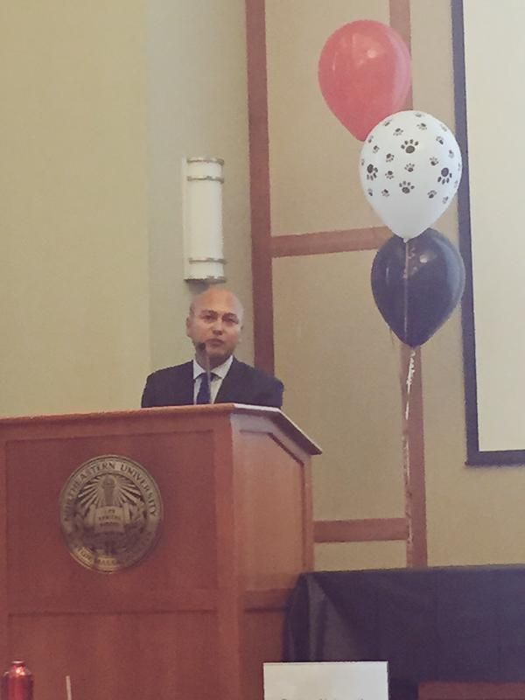

Jabes Rojas, Deputy Chief of the Governor’s Office of Access and Opportunity, addresses the audience.

# South Shore Round Table

On Thursday, August 20, 2015, Patricia Burke and Eric Murphy of the COMMBUYS Enablement Team along with Kathy Reilly, OSD’s Director of [Strategic Sourcing Services](http://www.mass.gov/anf/budget-taxes-and-procurement/oversight-agencies/osd/strategic-sourcing-services.html), hosted a Round Table Listening Session for a group of [COMMBUYS](http://www.commbuys.com/) users from several South Shore municipalities. Eric Hart, Town Accountant and Assistant CPO for the Town of Rockland, graciously hosted the event at Rockland Town Hall and representatives from the towns of Whitman, Nantucket, North Attleboro, Duxbury, and the Plymouth Housing Authority were among the attendees.

The purpose of the Round Table was to help the OSD contingent better understand the needs of the local buying community and their experiences using [COMMBUYS](http://www.commbuys.com/). It was a lively discussion, as the group enthusiastically and candidly shared their questions and suggestions. One idea, embraced by all, was the suggestion of inviting Strategic Sourcing Leads/Contract Managers to the local communities or creating regional events to discuss new or existing Statewide Contracts.

The Town of Nantucket is a role model for successful community adoption.

The Town of Nantucket’s Chief Procurement Officer, Heidi Bauer, shared her [COMMBUYS](http://www.commbuys.com/) experiences with the group. Nantucket’s Procurement Policy mandates that all orders for goods and services that are available through Statewide Contracts must be placed via the [COMMBUYS Market Center](http://www.commbuys.com/). Heidi pointed out some of the advantages Nantucket has gained by using [COMMBUYS](http://www.commbuys.com/), such as attaching Town Contracts, referencing purchase order numbers from their in-house accounting system, and adding vendor instructions to orders, to name a few.

When they first adopted [COMMBUYS](http://www.commbuys.com/), Nantucket relied on in-house expert, Silvio Genao, PE, who provided support and assistance to new users once they had completed [COMMBUYS](http://www.commbuys.com/) training. Nantucket now relies on the [COMMBUYS](http://www.commbuys.com/) Help Desk for End User Support and the OSD training team has traveled to Nantucket twice in the past seven months to deliver purchasing training – a practice that will continue.

The Plymouth Housing Authority, recently adopted [COMMBUYS](http://www.commbuys.com/) and shared that they experienced a significant savings ordering uniforms from Statewide Contract [CLT07](http://www.mass.gov/anf/docs/osd/uguide/clt07.pdf) (Clothing, Uniforms, Footwear, Accessories and Personal Care Hygiene Supplies) and they are excited to continue using [COMMBUYS](http://www.commbuys.com/) for their purchasing and bid needs.

The Round Table concluded with a brief presentation by Patricia and Eric who explained recent [COMMBUYS](http://www.commbuys.com/) enhancements, including the [new Grant UNSPSC Code](http://www.mass.gov/anf/docs/osd/commbuys/grant-opportunities-posted-in-commbuys-seller-version.pdf) that enables notification of grant opportunities, and a debrief on Statewide Contract [VEH95](http://www.mass.gov/anf/docs/osd/uguide/veh95.pdf) (Road Salt Furnish and Delivery).

# Meet the COMMBUYS Help Desk Staff!

From left to right: James Reid, Matthew Chester, Michael Evers (seated), Mike Phillips, Andrew Marra & Patricia Finklea  
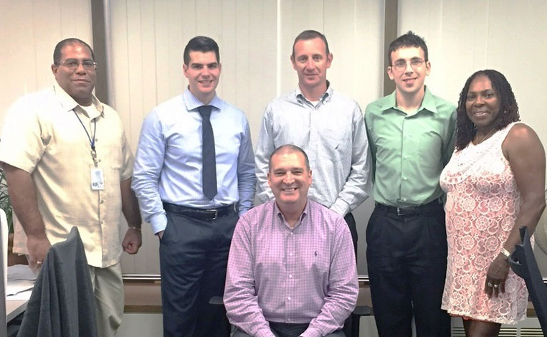

# COMMBUYS Logo

# Help Desk Assistance

Questions about COMMBUYS?  
Contact us for help at 1-888-627-8283 or <COMMBUYS@state.ma.us>.

Staff are available 8:00 a.m. to 5:00 p.m. ET, Monday through Friday.

# Stay in Touch!

[Sign-up](http://visitor.r20.constantcontact.com/d.jsp?llr=gtzv97iab&p=oi&m=1109069063782&sit=tpqgijtgb&f=7cb29d08-a465-46eb-8fa5-04865c0ad8b6) for other email communications!

Follow us on Twitter at [@Mass_OSD](http://twitter.com/mass_OSD)

Connect on [LinkedIn](http://www.linkedin.com/company/ma-osd)

**About**The Operational Services Division (OSD) administers the procurement process for the Commonwealth of Massachusetts’ Executive Agencies by establishing Statewide Contracts for commonly purchased goods and services. OSD’s mission is to help our government and business customers succeed in meeting their goals by providing outstanding customer service, competent advice and guidance, objectivity in our work, and to make available to our customers high quality products and services that exceed the expectations of those whom we serve.



Buy the Way  
is published by:

Commonwealth of Massachusetts

Executive Office for Administration & Finance

Operational Services Division

One Ashburton Place, Room 1017

Boston, MA 02108-1552

(617) 720-3300

[www.mass.gov/osd](http://www.mass.gov/anf/budget-taxes-and-procurement/oversight-agencies/osd/)

Gary Lambert, Assistant Secretary for Operational Services

© 2015 Operational Services Division